Concept Generation and Selection Report

Senior Design Fall 2008
Group 2: 900 MHz NMR Probe Cryogenic Gas Supply System

October 14, 2008

Team Members:

Rebecca Altman
Jason Kitchen
Zachary Stevenson
Jessica Vanterpool

Table of Contents

I. Sponsor Information

II. Product Specifications

III. Heat Exchanger Analysis

IV. Refill System Controller

V. Pressure/Flow Regulator

VI. Liquid Nitrogen Supply System

VII. Gas Transfer System

VIII. Future Plans

IX. Conclusion

X. References

I. Sponsor Information

The group is being sponsored by the National High Magnetic Field Laboratory (NHMFL) Nuclear Magnetic Resonance (NMR) Facility. The liaison engineers that will be assisting and advising for the duration of the project are Dr. William Brey and Peter Gorkov. The NMR Facility researches and fabricates many different types of hardware for NHMFL research. Current projects consist of: Development of Probes for 900 MHz Ultra-Wide Bore (UWB), HTS Probe for Natural Products, Low-E Probes for Biological Solid-State NMR, 29 mm Family of Narrow Probes for High Field 830 MHz and Resistive Magnets, and NMR in Resistive and Hybrid Magnets.

Senior Design Group Two is assisting the NMR Facility with the improvement of an already developed probe for the 900 MHz UWB magnet. This probe allows for magic angle spinning which allows for experiments to take place at very low temperatures. Having a spin angle of 54.74° and a spin frequency ranging from 1 – 70 kHz allows for the study of temperature-dependent behavior to be studied in a variety of materials and other forms. The main goals of our project are to develop a method of maintaining the required temperature of the sample for the duration of the experiment; and to improve upon the connection between the transfer line and the probe dewar.

Also a NHMFL faculty member, Dr. Steve Van Sciver is our FAMU-FSU College of Engineering Faculty Advisor. He is currently teaching Thermal Fluid Design, former Director of Magnet Science and Technology at the NHMFL, considered a leading expert in the cryogenics field, and a named FSU Distinguished Research Professor.

II. Product Specifications

It has been determined the following list of design specifications based on the project description provided by our sponsor, and further detailed from our background research and initial meeting with the sponsor. Our project falls under the adaptive or development design process, since we seek to improve the reliability, ease of use, and efficiency of an existing cryogenic gas delivery platform. At this stage of concept development, we categorize the specifications into the overall platform and subsystems as follows:
Platform Level Specifications
- System shall be capable of providing a cryogenic nitrogen gas stream in order to convectively cool the NMR probe sample to a minimum temperature of 103 K.
- Final sample temperature shall be controlled by an existing closed loop feedback PID resistive heater controller. Operation of the cryogenic gas delivery system must not impede this controller’s tolerance range of + 0.2 K.
- System components stationed inside the field of the 900 UWB must be non-magnetic.
- System shall support nitrogen gas flow rates of up to 2 SCFM.
Subsystem Specifications
1. Heat Exchanger (HX) Dewar Liquid Nitrogen Refill
  - Gas supply platform shall be capable of continuous operation for an indefinite period; therefore liquid nitrogen bath in HX dewar shall be maintained by means of an automatic level controller which is not part of the current system.
  - Change-out of liquid nitrogen cylinders supplying the HX dewar may occur up to once daily, so long as operation of gas delivery platform is not interrupted.
2. Gas Delivery Transfer Line
  - Since nitrogen vapor accumulation from HX dewar boil-off is a possible asphyxiation hazard, the HX dewar must not be located in the confined space pit underneath the 900 UWB magnet. Instead a transfer line of at least 3 m in length shall allow the dewar to be stationed to the side of the magnet outside the pit. Current platform’s transfer line is not long enough to meet this specification.
  - Transfer line and associated fittings shall be well insulated to reduce thermal losses, thereby reducing consumption of liquid and gaseous nitrogen to lower levels than current system.
- NMR Probe Dewar
  - NMR probe has an existing bore tube which accepts a 15 mm diameter probe dewar, therefore any newly designed dewar shall not exceed this diameter constraint for the portion inserted into the probe body.
  - If dewar is made from conductive material, it must not extend farther than 1.41 m up the probe body, so that its presence will not affect the characteristics of the RF transmission line circuit.
  - If probe dewar is constructed from vacuum jacketed tubing, it shall have an operator for periodic pumping to vacuum level pressure.
- Sample Heater
  - A heater shall be incorporated into the platform which is compatible with the Bruker sample temperature controller as noted in specification B. Therefore the heater should have similar electrical resistance and utilize a thermocouple as does the current probe heater.
  - If a newly designed heater is used in this system it shall be fabricated of material which will not oxidize under high temperature so that oxidation residue will not enter the nitrogen gas stream which could contaminate the sample or damage the precision bearings of the MAS rotor and stator.
  - Location of the heater in the system must be close enough to sample thermocouple so that heater controller feedback signal is able to maintain the + 0.5 K temperature tolerance. The location of the current heater in the base of the probe is close enough to meet these criteria.

III. Heat Exchanger Analysis

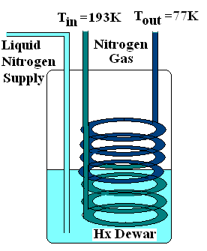
The current heat exchanger system is located inside the heat exchanger (HX) dewar. Presently, there are sixteen copper loops that control how cold the nitrogen gas from the wall supply reaches. The problem with the existing system is that the sample is getting to cold and is not within the required tolerance range specified by the sponsor. In order to achieve the needed temperature, the number of heat exchanger coils needs to be changed. In the current system, the coil count is too high and is therefore resulting in the nitrogen gas getting too cold. Ideally, the temperature input from the supply is 193 K and the temperature output is 77 K. Attaining the required range with ± 0.2 K temperature tolerance is of vital importance.

As the number of loops decrease, the temperature of the gas increases. Since the material of the tubing is already present in the NMR lab, it is unnecessary to do a cost analysis. The next step is to perform detailed design work in order to calculate the number of needed coils based on heat transfer analysis. Using the heat transfer convective heat transfer between the Liquid Nitrogen in the dewar, coil barrier, and supply nitrogen gas the appropriate number of coals can be calculated. It can also be noted that the rate of heat transfer is proportional to the mass flow rate of nitrogen gas through the copper piping.

IV. Liquid Nitrogen Refill Controller System
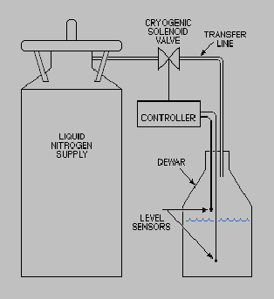
Our background research revealed three types of controllers for automated refill of cryostats, line traps, dewars, and other laboratory hardware containing liquid nitrogen. All three types control a normally-closed solenoid operated valve between the LN₂ supply and destination, as shown in Figure XX. Upon receiving the appropriate signal from the controller, the solenoid valve opens and allows transfer of liquid nitrogen, until another signal closes the valve. Types of controllers include timer-based, high-low sensor feedback, and capacitive sensor feedback.

The simplest controller setup is an open loop timer-based controller, where the user selects a countdown interval between fills and a fill duration interval. These interval lengths must be determined based on experience with the liquid nitrogen depletion rate and the duration necessary to fill the vessel. While this controller might be the most simple to operate and could be the least expensive design option, it has the most potential for either running the HX dewar completely out of nitrogen or overfilling the vessel due to disturbances to the average LN₂ depletion rate.
Figure XX – controller layout. Source: Teragon Research
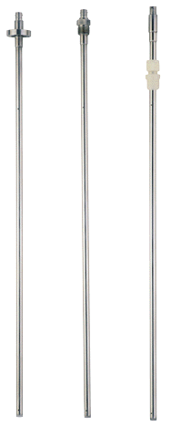
The majority of commercially-available level controllers utilize dual thermistor sensors to register high and low set points in the vessel. The controller uses the change in resistance when these sensors are alternatively in cool nitrogen vapor or very cold liquid nitrogen to determine whether or not each sensor is submerged. A typical cycle opens the solenoid valve to fill the vessel when both sensors are dry, then closes valve upon submersion of the upper or high level sensor. The height placement of the two sensors in the vessel determines the allowable upper and lower limits of liquid nitrogen. This design concept has the advantage of closed loop feedback to minimize the potential for overfills or LN₂ depletion. Both the high-low sensor and timer-based controllers have a disadvantage in that they do not show the actual level of liquid nitrogen in the vessel at any time.
Figure XX – capacitive sensors.
Source: American Magnetics
The third controller type uses a capacitive sensor both to show the actual liquid nitrogen level and to trigger refills at high-low set points similar to the thermistor controllers. As shown in Figure XX, typical capacitive sensors are made of 2 coaxial stainless steel tubes with periodic holes in the outer tube to allow liquid nitrogen to occupy the space between them. An electric voltage potential is applied to the tubes, and the liquid nitrogen acts as a dielectric so that the assembly becomes a capacitor element in the sensor circuit. The change in capacitance with varying LN₂ level is correlated to the level of liquid in the vessel and shown on an analog or digital readout. These controllers allow the user to determine the upper and lower level set points at which the solenoid valve will be open and closed to refill the vessel. This type of controller offers the reliability of a closed loop feedback system with the ability to read the actual level of LN₂ present in the HX dewar at any point in time.

LN₂ Refill Controller Decision Matrix

We created the decision matrix shown in Table XX in order to compare the advantages and disadvantages of each of the three commercially available refill controllers. Weighted factors included system cost, relative performance, reliability, ease of use, and safety. Due to the extra ability of capacitive sensor based systems to display the LN₂ level, this controller had the highest score and has led us to prefer it for our gas delivery system. Table XX shows a cost comparison for commercially available models based on controller type. Note that the units from Quantum Production Limited are not yet quoted as we are awaiting reply from the vendor.

Controller |  | Timer Controller |  | High-Low Controller |  | Capacitive Controller
Controller | Weight | Rating | Weighted Score | Rating | Weighted Score | Rating | Weighted Score
Cost | 0.2 | 3 | 0.6 | 2 | 0.4 | 2 | 0.4
Performance | 0.2 | 1 | 0.2 | 3 | 0.6 | 4 | 0.8
Reliability | 0.2 | 1 | 0.2 | 4 | 0.8 | 4 | 0.8
User Friendly | 0.2 | 4 | 0.8 | 3 | 0.6 | 3 | 0.6
Safety | 0.2 | 1 | 0.2 | 3 | 0.6 | 3 | 0.6
Total | 1.0 |  | 2 |  | 3 |  | 3.2

Table XX – LN₂ Decision Matrix

Controller Type | Manufacturer | Model | Price | Quality  (1-5)
Timer | JC Controls | SNT-7 | $590.00 | 2
High-Low Sensor | JC Controls | SN2-7 | $590.00 | 2
 | Key High Vacuum | LN2-1000 | $595.00 | 3
 | Quantum Production | QAR3030 | RFQ | 4
 | Teragon Research | LC2 | $649.00 | 4
Capacitance Sensor | Quantum Production | QAR3080 | RFQ | 4
 | American Magnetics | 186 | $1315.00 | 5
Table XX – Controller Comparison

Availability of Refill Controllers at NHMFL

At our initial meeting with our sponsors at NHMFL, we were told that they had procured a LN₂ refill controller from an associate at the lab who had not used the unit in almost ten years. The controller is an LN2-1000 thermistor sensor-based controller manufactured by Key High Vacuum. This type of controller scored second in our decision matrix when cost was a factor, but since this unit is free of cost, it clearly becomes the top choice, assuming the unit works in bench tests. Also, last week Dr. Brey told us of the existence of a capacitive nitrogen level sensor in a decommissioned Oxford Instruments superconducting NMR magnet. We obtained the sensor and its display meter and will verify both are operational. Upon reading the instruction manual for the unit, we found that the display meter can output a voltage signal for a high and low user-defined set point, which can trigger a relay to operate the refill solenoid valve. This has led our group to the idea we may be able to recalibrate the capacitive sensor for our HX dewar and use it in place of the thermistor sensors to signal the LN2-1000 when to open and close the solenoid valve for automatic refill, thus allowing us to add the capability to display liquid nitrogen level in our system. Future exploration of this design concept will take place as soon as we can verify operation of both units.

V. Pressure/ Flow Regulation

During tests of temperature stability in the existing cryogenic gas delivery system during the week of October 7, 2008, it was found that when the nitrogen gas was regulated from an inexpensive pressure regulator and attached venturi-style flow meter, the variation in flow led to fluctuations in final probe temperature beyond the + 0.2 K design specification limit – exceeding + 2 K. When the nitrogen gas was routed through a Variable Temperature controller which is part of the NMR spectrometer, temperature regulation was improved and stayed under the + 0.2 K limit. At this time our sponsor has not determined if they prefer the nitrogen gas stream to be independent of the spectrometer or if routing through the BVT3000 Variable Temperature unit is acceptable. If independent routing is preferred, we will need to select a more precise gas regulator and explore the possibility of purchasing a digital or analog gas flow regulator. Precision gas regulators such as the model Type 10 from Bellofram for a cost of approximately $100, have an average variation of 0.005 psig per 25 psig change in supply pressure and only a 0.25 psig variation in pressure per 10 scfm in flow. These specifications would result in much more stable gas flow. If additional stability were desired, a gas mass flow controller such as the FM6502ST from Omega Engineering can provide repeatable gas flow to 2% of full scale, or 2 standard liters per minute for the flow our system requires. Since the unit cost of these controllers is more substantial, $1,695.00 for the above mentioned model, further consultation with our sponsor is necessary as they may have NHMFL facilities budgets pay for and install a network of these flow controllers outside the scope of our senior design project.

VI. Liquid Nitrogen Supply System

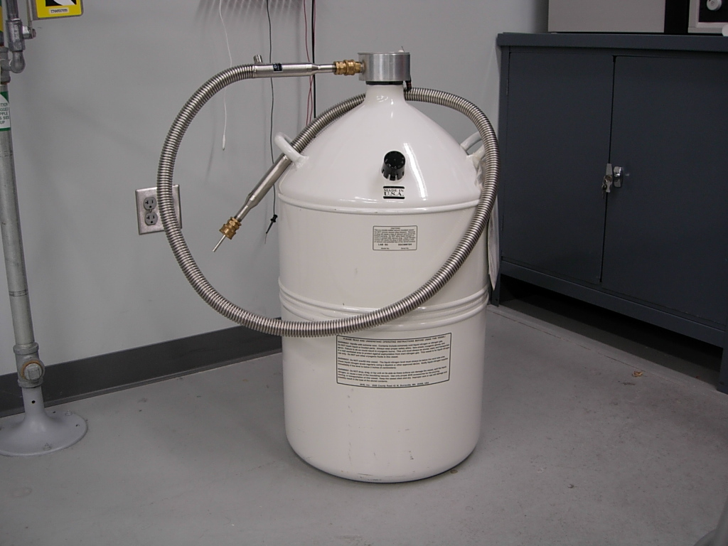
One of the main problems with the current cryogenic gas supply cooling system is its inability to operate for the extended periods of time required by our sponsors. The system is currently employing the use of a heat exchanger in a liquid nitrogen bath to achieve the desired output temperature of the cryogenic gas. However, this set up requires that the heat exchanger be submerged in the liquid nitrogen bath at all times. The current heat exchanger uses a 50 L liquid nitrogen supply dewar, as seen in figure XX, in order to keep the heat exchanger in contact with the liquid nitrogen bath. As the cryogenic gas flows through the heat exchanger, the liquid nitrogen will be boiled off inside the heat exchanger supply dewar. The level of liquid nitrogen will continue to decrease until the heat exchanger no longer reaches down into the nitrogen bath and the system will not function properly. This requires our system to have a way of refilling the heat exchanger dewar using a controller and a refill supply.

Direct refilling
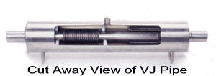
This method of refilling the heat exchanger would eliminate the need for a refill supply tank altogether. This would be accomplished by installing a separate vacuum jacketed pipeline that runs from the National High Magnetic Field Lab’s (NHMFL) 5000 gallon liquid nitrogen supply tank directly to the 900MHz magnet. This pipeline would then be used to directly refill the level of liquid nitrogen in the heat exchanger. The existing pipe was manufactured by Quality Cryogenics, Inc. and is located around the outside of the building and is routed to 2 outdoor fill stations. The current piping consists of a ½” nominal sch 5 inner pipe and a 2” nominal sch 5 outer pipe (Figure XX). The main drawback to this type of system would be the high upfront cost of the pipeline. Quality Cryogenics Inc. provided us a budgetary quote of about $125 per foot of vacuum jacketed pipeline installed. This design would also require installing about 200 feet of vacuum jacketed pipe which would cost about $25,000. This amount completely exceeds our budget. This system would also be stationary and unable to be used with any of the other equipment out at the NHMFL.

Single refill supply tank
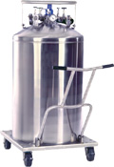
This method of refilling the heat exchanger calls for the use of a liquid nitrogen refill supply tank to regulate the amount of nitrogen in the heat exchanger supply dewar. The NHMFL currently uses several supply tanks manufactured by Chart Industries. The supply tank we would be using is the Cryo-Cyl 230, which is a 230 L low pressure liquid cylinder (Figure XX). These tanks have a rate of loss of 1.5% of their contents per day. This supply tank would allow for up to 4.6 complete refills of the heat exchanger dewar before running out. However, the system will still need a larger supply of liquid nitrogen in order to run for the required amount of time. This is remedied by allowing for the exchange of the supply cylinders up to a maximum of once daily, as outlined in the project scope. Each day the user would be required to replace the empty refill supply tank with a full one. The transfer line between the supply cylinder and the heat exchanger dewar will only have nitrogen flow through it once the controller solenoid valve is activated and opens to allow for the nitrogen to flow between the tanks, refilling the heat exchanger. Exchanging an empty tank for a full tank can only occur when the supply transfer line is not in use and must not interfere with the operation of the system. This would allow for the continuous operation of the system for an indefinite period of time.

Multiple refill tanks
This method of refilling the heat exchanger is the same as above, but uses multiple Cryo-Cyl 230 supply cylinders working together. By using several supply cylinders, the overall capacity of the liquid nitrogen refill system is raised. If enough supply tanks are prepared in advance, the need for the daily exchange of supply cylinders in the system would be eliminated. This would require less user input and would be safer because the refill supply will never be disconnected from the system. However, the duration of the systems use might require such a large amount of liquid nitrogen supply that this design becomes impractical.

Liquid nitrogen supply system decision matrix
These three liquid nitrogen supply system concepts were all compared and analyzed using the following decision matrix (Figure XX). Some of the weighted decision factors included cost, mobility, system running duration, and safety. Based on these criteria the single refill supply tank scored the highest and would be the best choice for use in the overall cooling system.

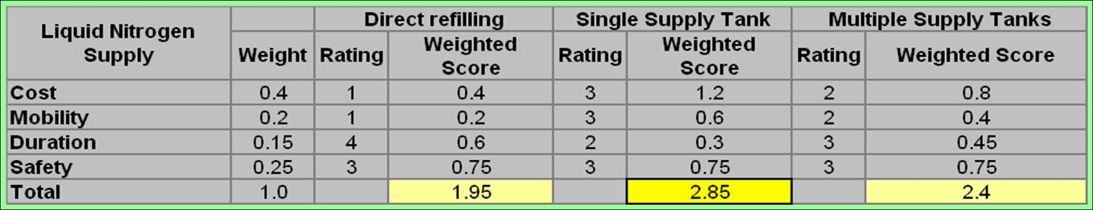

VII. Gas Transfer System

The current gas transfer system consists of a heat exchanger (HX) dewar, transfer line, and probe connection. The heat exchanger dewar converts the liquid N2 into a gas which then goes into the stainless steel transfer line of which is connected into the probe. The thermal transfer line is vacuum insulated for higher thermal efficiency. The exit of the transfer line is a brass quick-disconnect fitting.
Pressure Readout
Large Dewar Refill station
On/off
Solenoid
LN2 controller valve
LN2 Level Sensor
Refilling tube
Evacuated Tx line
Water chiller valve
Wall air supply valve
Hi
Low
NMR probe
T= -70 ºC
T=-23 ºC valve
T= -150 ºC
T= -180 ºC

Fig. 1

Fig. 1.A

Fig. 1 shows a drawing of the complete system. The gas supply system is highlighted by the use of thick black arrows located on the left side of the drawing. Fig. 1.A shows the actual heat exchanger dewar with the insulated transfer line connected to it.

Problem:

1. One of the main problems with the gas transfer system is its location. It is currently located underneath the 900 UWB magnet in a pit, which increases concern for causing asphyxiation to anyone in the area while an experiment is being run. Asphyxiation could be caused from nitrogen vapor accumulation from the HX dewar.

2. Another concern is thermal losses which are due to the insulation of the transfer line as well as the fittings associated with the connection. This reduces consumption of liquid and gaseous nitrogen to lower levels. The leaking of N2 also causes ice build up, and loses of money from losing N2.

Customer needs:

The main concern of the customer in terms of the transfer line is to fix the problems listed above. The customer would like for us to find a way to reduce the thermal losses that are caused by the transfer line exit connection. A possible heater addition was suggested to the group; however where to place the heater in the transfer line is a major issue. Depending on where it is placed it could case more problem, or it actually help the only way to find out where to place it is through experimentation. Also another suggestion that was made was to have the dewar connected to the transfer line a different material. It is currently made of glass, but we would like to experiment using stainless steel for the portion underneath the Teflon clamp which is shown in fig. 2 below. The customer also suggested using a 3 m long transfer line so that it won’t be located in the pit.

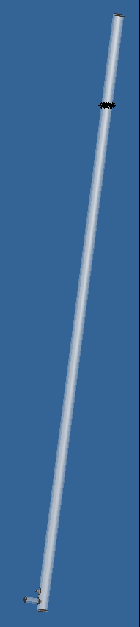
Teflon clamp
Glass
Stainless steel
Glass
Stainless steel

fig. 2 fig. 2.a fig. 2.b

Concepts:
Below is a decision matrix made for the Gas transfer system. We were able to come up with three different concepts that could improve the thermal loss and temperature control.

1. The glass dewar:
The glass dewar is the current system which is shown in fig. 2. Due to thermal losses the glass dewar lacks accuracy in temperature. The leaking of N2 is also another problem which causes the ice build up.

2. Stainless Steel (SS) Dewar:
The SS dewar shown in fig. 2.a is designed in such a way that will allow the transfer line connection to the dewar become more feasible. Instead of having to screw on the transfer line into the dewar, the transfer line would just be placed into the dewar.

3. Stainless Steel with transfer line:
The option shown in fig. 2.b is similar to the design for number two however; the transfer line and dewar would become one whole piece. This would be done by welding the two pieces together. The only concern with this is where to place the heater. Another concern is the level of difficulty in retrieving the heater if repairs needed to be done on it.

Decision matrix

Probe Dewar |  | Glass Dewar |  | Stainless Steel Dewar |  | SS Dewar with Transfer Line
Probe Dewar | Weight | Rating | Weighted Score | Rating | Weighted Score | Rating | Weighted Score
Cost | 0.2 | 3 | 0.6 | 2 | 0.4 | 1 | 0.2
Thermal losses | 0.2 | 1 | 0.2 | 2 | 0.4 | 3 | 0.6
Sample Temp. Accuracy | 0.2 | 2 | 0.4 | 1 | 0.2 | 3 | 0.6
Durability | 0.2 | 1 | 0.2 | 2 | 0.4 | 3 | 0.6
Safety | 0.2 | 1 | 0.2 | 3 | 0.6 | 4 | 0.8
Total | 1.0 |  | 1.6 |  | 2.0 |  | 2.6

The winning concept/design is the SS Dewar with transfer line obtaining a weighted score of 2.6. There are currently two welders located at the Magnetic Lab. Due to this making the SS dewar with transfer line connected would be low in cost. The fact that the dewar and transfer line are connected will hopefully reduce thermal losses. The dewar being made of stainless steel would increase its durability which is why design three received the highest ranking for durability.

VIII. Future Plans

In the coming weeks, the design detail work will be finalized so that the needed materials and components can be ordered before winter break. To show careful consideration for all factors involved in the project, many different methods of analysis will be utilized to show the intricate detail needed to have a valid design. This work will be shown through CAD drawings (PRO-E, Inventor, and AutoCAD), and Thermal Analysis (Pipe-Flo and MathCAD).

To attain the goal of ordering all needed components and materials before winter break; it is necessary to research the different vendors to make an educated decision for the cost analysis. Once this process is complete, the group will order the needed materials through the NHMFL purchasing department. At then end of this step, the needed work for the fall semester will be complete and a spring proposal will be drafted.

IX. Conclusion

Senior Design Group 2 was given the task from the NHMFL NMR Facility to develop a method of maintaining the required temperature of the sample for the duration of the experiment; and to improve upon the connection between the transfer line and the probe dewar. The major subsystems that we are responsible for ameliorating include: Refill System Controller, Liquid Nitrogen Supply System, and The Gas Transfer System. The minor subsystems that we are responsible for include: Heat Exchanger and the Pressure/Flow Regulator. The major subsystems required a decision matrix to solve the problems where the minor subsystems the solution was straightforward.

Collectively, we have chosen to implement the Capacitive Controller, Single Refill Supply Tank, and Stainless Steel Dewar with Transfer Line into the project to solve the sponsor’s problem based on the sponsor’s needs. Our major goals include: Must be able to support the experiment without interruption, increase the precision of the current pressure regulator (flow controller), properly connect with the HX Dewar and have negligible heat transfer losses, and efficiently and effectively regulate the sample temperature within the required range. Given where the team is now, we are well on our way to not only meeting the sponsor’s requirements, but going well beyond them.

X. References

American Magnetics, manufacturer of liquid nitrogen refill controllers:

Teragon Research, manufacturer of liquid nitrogen refill controllers. http://www.trgn.com/

Nitrogen Level Meter NLM2 Instruction Manual. Issue 2, July 1990. Oxford Instruments Limited

