Florida Department of health
User Manual
Radon Mitigation using Ventilation Assessment Tool
Team 09 – Florida Dept of Health: Radon Mitigation using Ventilation
4/7/2009

Table of Contents
I. Setup 9
II. Leakages Sheet 12
III. Look up location on weather map 18
IV. Enter weather information and other variables 19
V. Reading the results 21
VI. Troubleshooting 21
VII. Abstract 22
A. Design Methods 22

This user manual will help you properly utilize the Ventilation Assessment Spreadsheet. In order to use this spreadsheet to its full capacity you will have to follow these steps in this exact order.

Setup

Open the spreadsheet

In order to fully utilize this spreadsheet, the security settings for macros will need to be changed. If using Microsoft Office Excel 2003 a warning window like (Fig. 1) will appear when opening the spreadsheet. Click OK. If using Microsoft Office Excel 2007 a window like (Fig. 2) will appear when trying to use the spreadsheet. Click OK

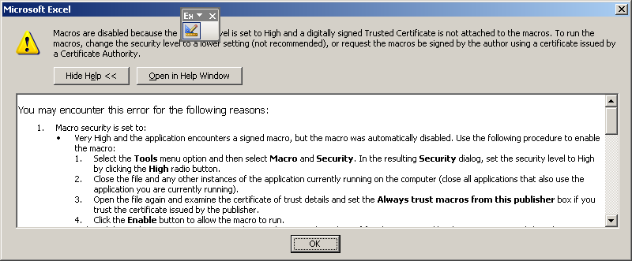
Fig. 1

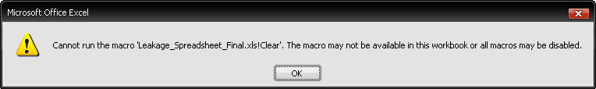
Fig. 2

For Microsoft Office Excel 2003 open the spreadsheet. Click Tools at the top of the windows. Hover the mouse cursor over the Macro menu, when the sub menu shows up, click Security… (Fig. 3). For Microsoft Office Excel 2007 click on the Developer tab then click on the Macro Security option (Fig. 4).
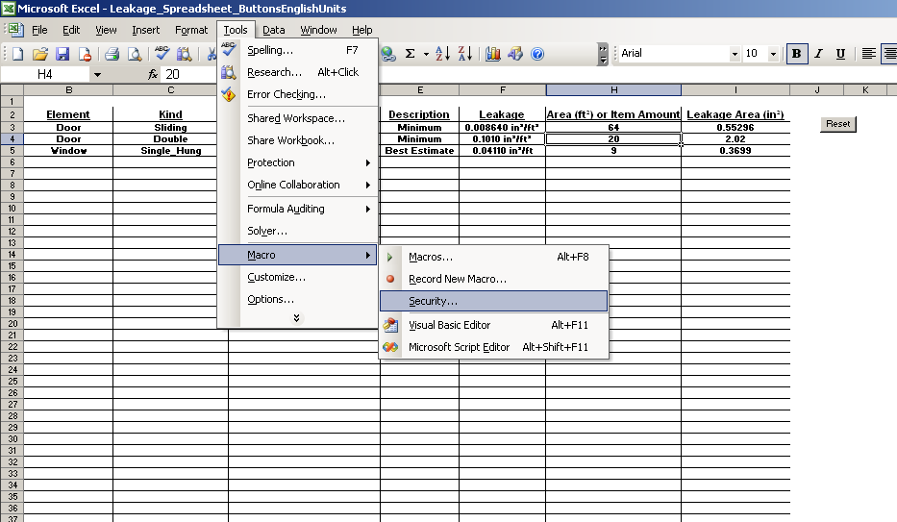
Fig. 3
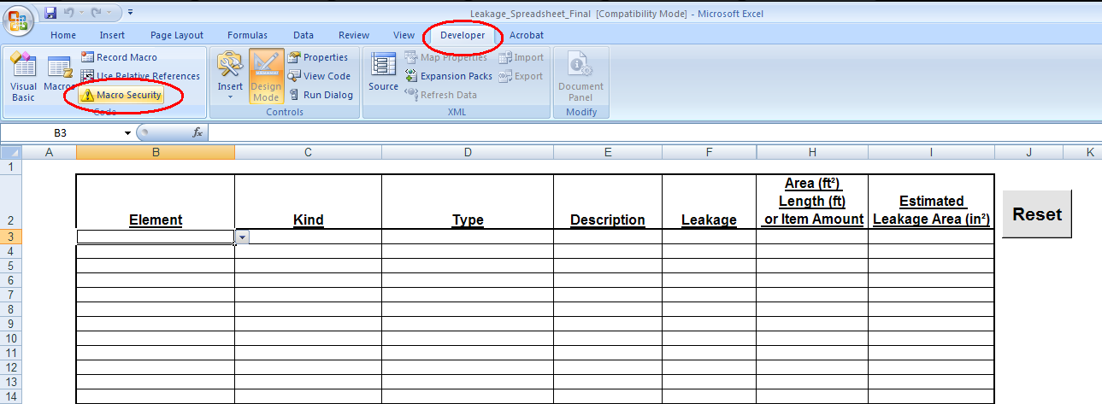
Fig. 4

For Microsoft Office Excel 2003 change the security level to Low. This allows you to utilize the macros stored within the spreadsheet (Fig. 5). For Microsoft Office Excel 2007 change the security level to Enable all macros (Fig. 6)

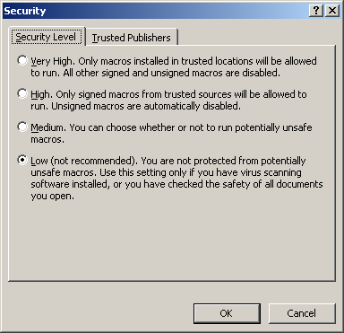
Fig. 5
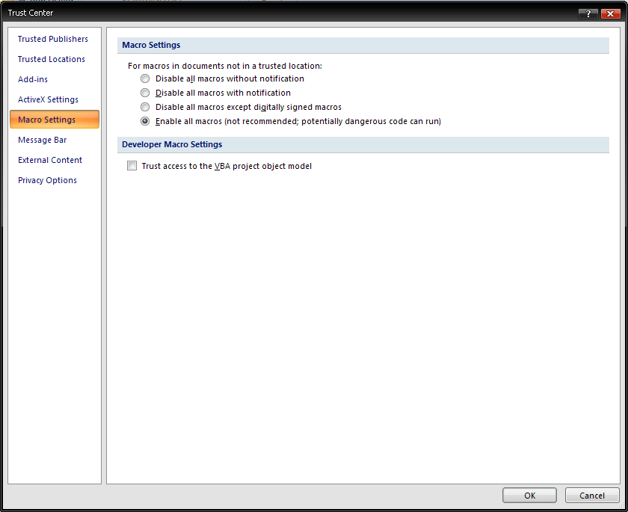
Fig. 6

Now close Excel without saving changesd and reopen the spreadsheet. Now you are ready to use the spreadsheet.

Leakages Sheet

First choose the element by clicking the first cell underneath the Element column then click the arrowhead pointing down and choose the name of the element. (Fig. 7)
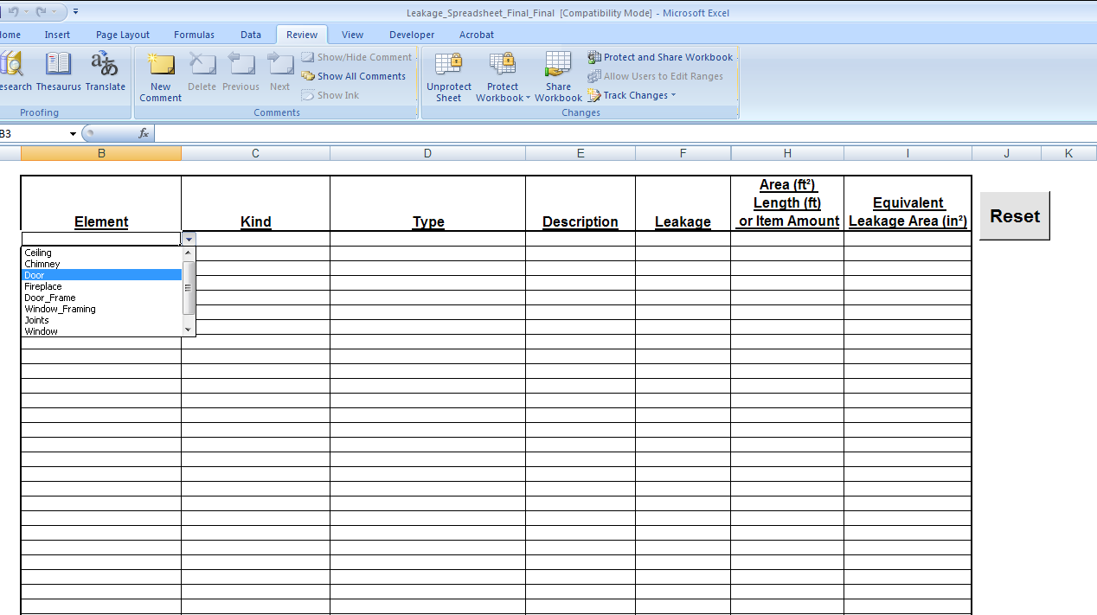
Fig. 7

Click the adjacent cell under the Kind column to the right of element you chose. Click the arrowhead pointing down and choose the appropriate characteristic that applies to your element. (Fig. 8)
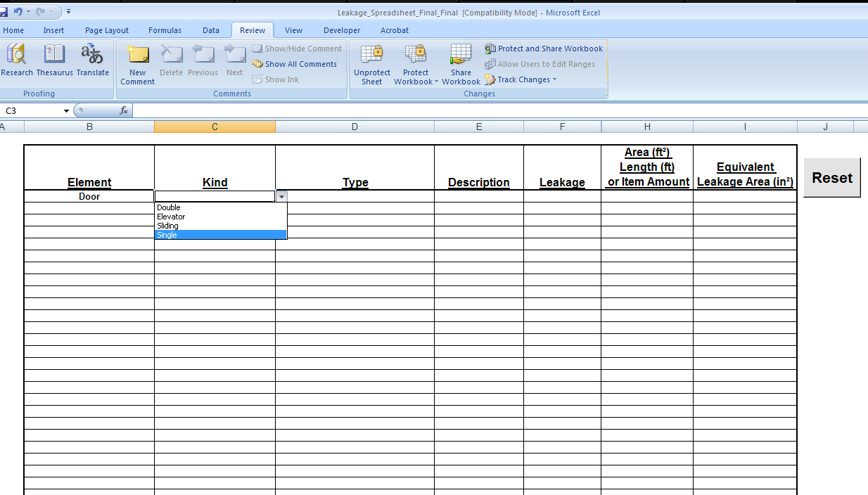
Fig. 8

Click the adjacent cell under the Type column to the right of the characteristic you just chose. Click the arrowhead pointing down and choose the appropriate characteristic that applies to your element. (Fig. 9)

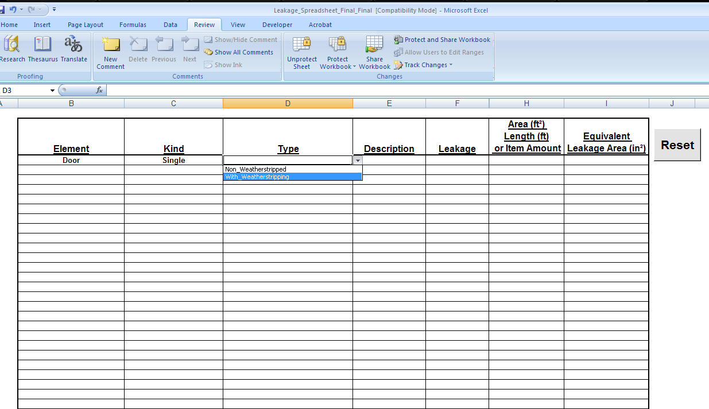
Fig. 9

Click the adjacent cell under the Description column to the right of the characteristic you just chose. Click the arrowhead point down. You will have 3 choices each pertaining to the leakage area associated with the element. (Fig. 10)

Best Estimate: This means the element has an average leakage area.

Minimum: This means the element has a minimum leakage area.

Maximum: This means the element has a maximum leakage area.

Note: If unsure about which option to choose, click on one option, look at the leakage amount that is output, then choose the other options, compare these numbers and choose accordingly.

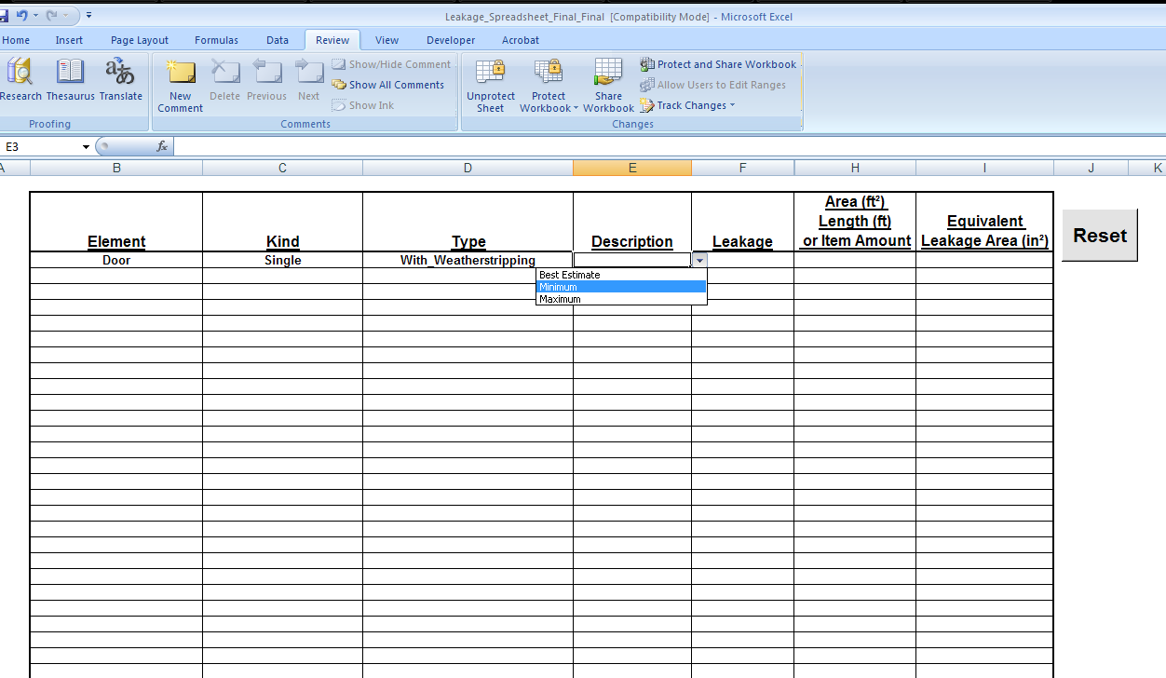
Fig. 10

Enter the area, length, or item amount in the cell adjacent to the leakage cell under the Area (ft²) Length (ft) or Item Amount column. The leakage for the element under the leakage column will show what is needed to be input.

For example, Fig. 11 shows that the leakage has the units in²/item this means that you only need to input the number of those elements that are present. (These units are for standardized sizes)

For the units shown in Fig. 12 (in²/ft) you enter the horizontal length of the window.

For the units shown in Fig. 13 enter the area of the element chosen. The number you enter will be multiplied by the number in the Leakage column.

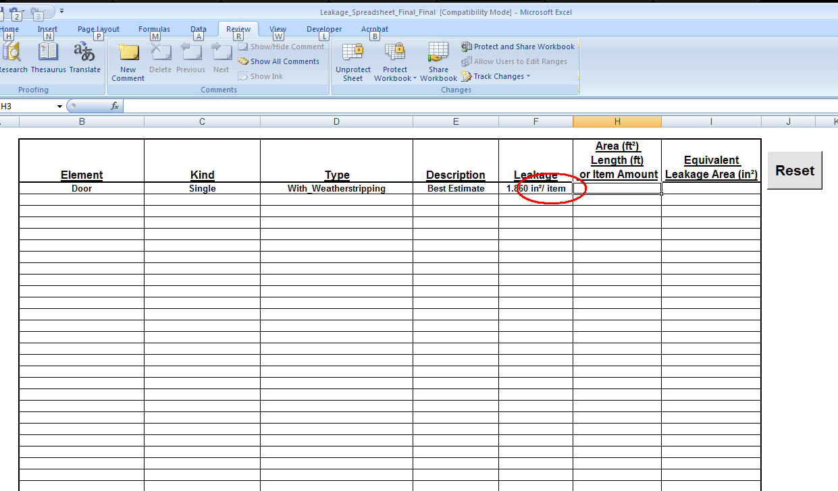Fig. 11

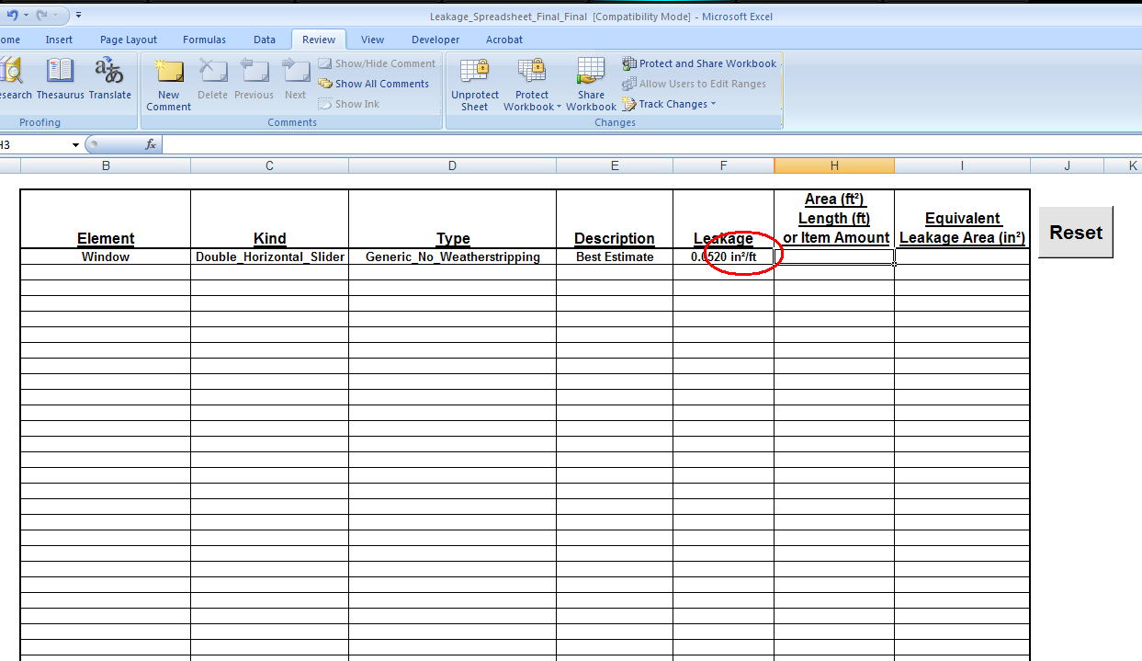Fig. 12

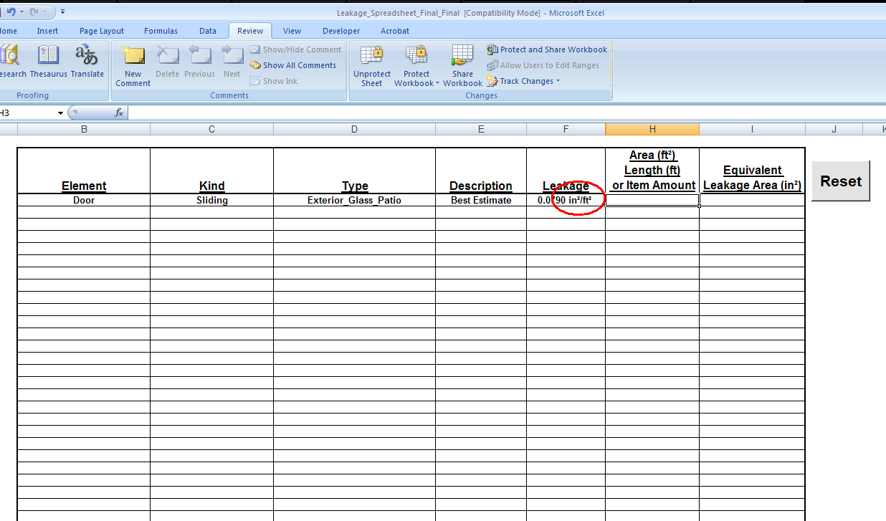Fig. 13

Repeat steps A through E until all elements are input into the spreadsheet.
Note: The reset button will clear all elements.

Look up location on weather map

Click on the Weather tab at the bottom of the window, this will open up the weather sheet. If you see the city which the unit you are testing is located in the table at the top right you will use the corresponding number. This is the weather factor which will help determine the natural ventilation rate for that region of Florida (Fig. 14).

If your location is not on the top right legend then you will need to look at the map and find the location. When you find your location on the map use the legend to determine your weather factor according the color your location lies in (Fig. 14).

Fig. 14

Enter weather information and other variables

Click on the Inputs tab at the bottom to open the Inputs sheet.

You will need to input the floor area of the unit you are testing, the ceiling height (the volume will automatically be calculated), your weather factor found from section III, and your initial and target concentrations of radon. (Fig. 15)

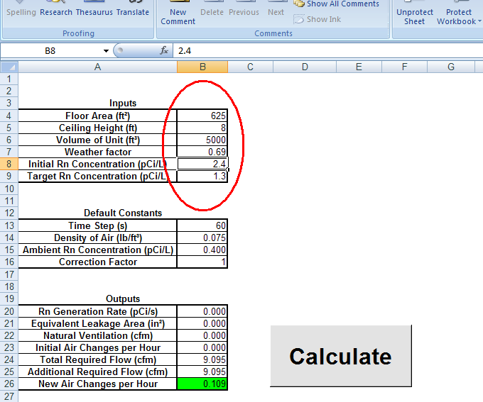Fig. 15

Press the calculate button

Reading the results

After hitting the calculate button, the outputs table will show the generation rate of Rn, the equivalent leakage area, the natural ventilation, the initial air changes per hour, the total required flow, the additional required flow, and the new air changes per hour.

Generation Rate: This is the rate at which the target unit is generating radon in pCi/s (pico Curies per second).

Equivalent Leakage Area: This is the sum of all the leakage areas throughout the unit.

Natural Ventilation: This is the rate which the target unit is ventilated naturally in cfm (cubic feet per minute).

Initial Air Changes per Hour: This is the rate which the target unit is changing air with the outside zone per hour (ACH). For example if the unit has one air change per hour that means that all the air in the unit will change every hour.

Total Required Flow: This is the total flow required to ventilate the radon to the target concentration (cfm).

Additional Required Flow: This is the amount of flow that needs to be added to the unit to ventilate the radon to the target concentration.

New Air Changes per Hour: This is the rate of air changes per hour after the additional required flow is implemented. This cell on the table will turn red if a value of .35 or higher is output, it will turn yellow if a value greater than .32 and less than .349 is output, and it will turn green if a value less than .319 is output. (According to an energy efficiency building code an ACH of .35 or higher is inefficient and contradicts the Florida building code.)

Click the Radon Mit tab at the bottom of the window to open the radon mitigation sheet. This sheet has a graph that shows the rate that the radon concentration is lowered in the unit.

Troubleshooting

If you hit the calculate button with no elements chosen on the leakages sheet an error will occur.

To fix this error you will have to close the spreadsheet WITHOUT saving then reopen it. The leakages ALWAYS have to be input before hitting the calculate button.

Abstract

Design Methods

The drop down menus on the leakages sheet were created by defining names, manipulating formulas, and using the data validation tool. If you want to add more leakage values or edit these drop down menus, it would help to know how they were created.

An example spreadsheet has been made to show how these drop down menus were created and how they read from a data table. First you have to define names by clicking the Insert tab then hovering over the Name option then click Define… on the sub menu (Fig. 16).

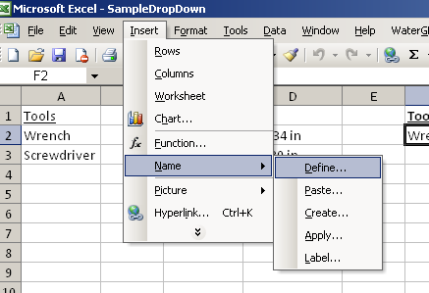
Fig. 16

These names need to be defined a certain way. In this example we want the first drop down menu to contain the names in the Tools column so when adding the name Tools it needs to refer to the two names in the column. (Fig. 17).

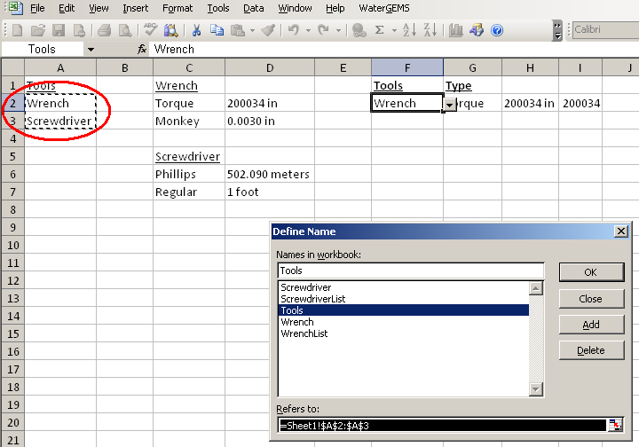Fig. 17

For our next drop down menu, we want it to change depending on what was chosen for the first drop down menu. So when defining the names for these, make sure the names you define match the names underneath the Tools column. For example, in Fig. 18 we define the name Wrench and have it refer to the two items below the Wrench column title. You would repeat this same step when defining the name Screwdriver but have it refer to the two items below the Screwdriver column title.

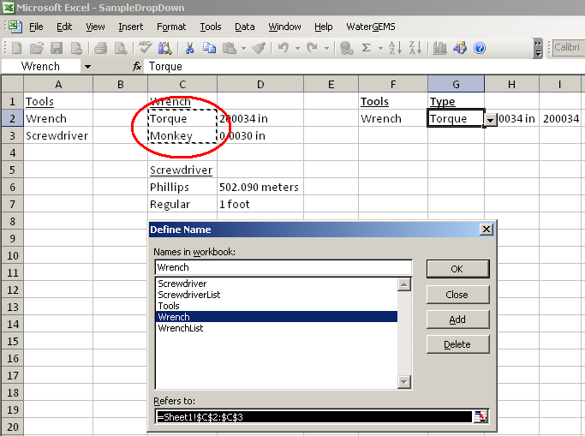
Fig. 18

The next names that need to be defined are defined so the non-drop down menu cells next to the drop down menus can output the number values on your data table. So define the name WrenchList and have it refer to Torque and Monkey as well as the number values adjacent to those items (Fig. 19). Repeat this step for the screwdriver items.

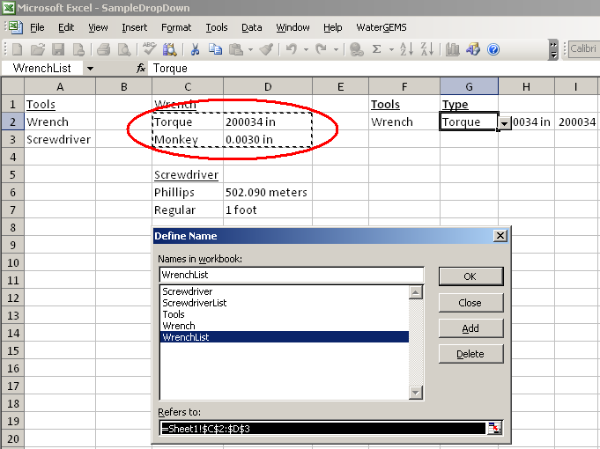
Fig. 19

You need to use the Data Validation tool now. Click on the cell that you want a drop menu to be on then click on Data then click Validation… (Fig. 20).
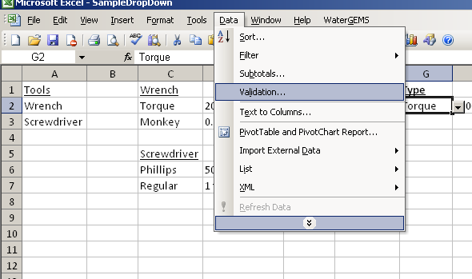
Fig. 20

When the window pops up click on the drop down menu under Allow: and click List. Now a Source: option will become available type in that box “=Tools” without quotations, this is telling the spreadsheet that you want a list of the items that were defined by the name Tools (Fig. 21).
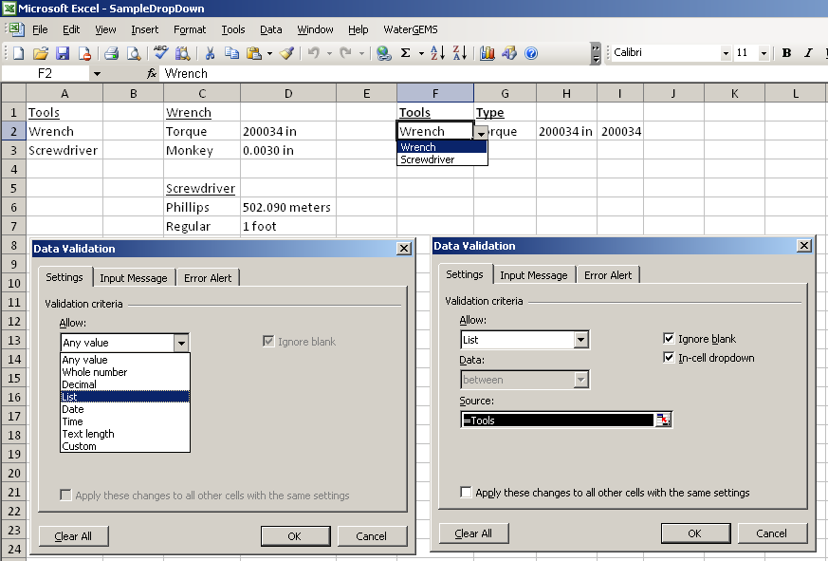
(Fig. 21)

Now click on the cell where you want your second drop down menu. Now open the Data Validation window again and once again click the List option under the Allow: menu. This time you will type “=INDIRECT(F2)” without quotations. Notice that the cell number F2 is referring to the first drop down menu. With the INDIRECT function you are telling the spreadsheet to refer to the name that the first drop down menu has selected then refer to that selections definition. For example, in Fig. 22 the Type drop down menu is referring to the items that were defined with the name Wrench.

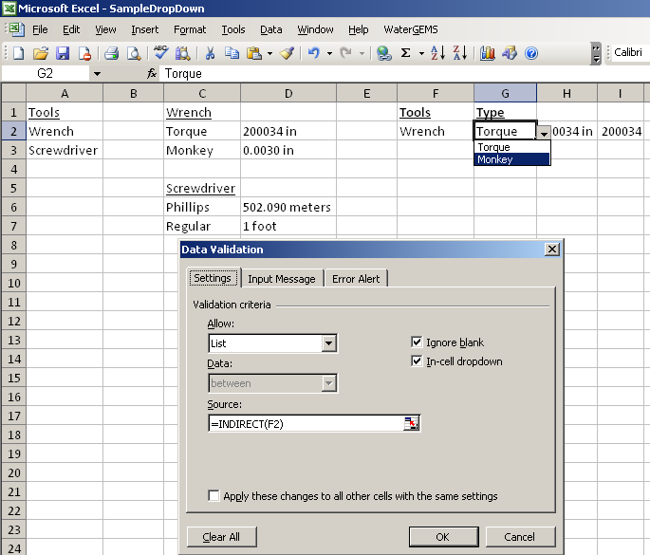
Fig. 22

Now to have the spreadsheet readout the units or values next to your selection you need to use a formula. In Fig. 23 the cell next to the drop down menus has a formula in it.
=IF(G2="","",VLOOKUP(G2,INDIRECT(F2&"List"),2,FALSE))
This formula is telling the spreadsheet that if G2 is blank, then leave this cell blank, if not then lookup the name Torque then lookup the number next to it from the WrenchList definition.

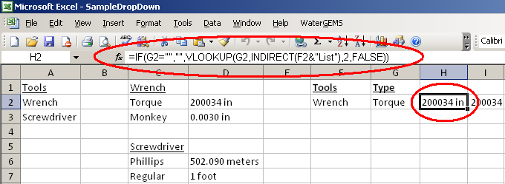
Fig. 23

The cell adjacent to the last one has a formula in it that eliminates the test within that previous cell.
=IF(H2="","",(--MID(H2,MIN(SEARCH({0,1,2,3,4,5,6,7,8,9},H2&"0123456789")),SUMPRODUCT(LEN(H2)-LEN(SUBSTITUTE(H2,{0,1,2,3,4,5,6,7,8,9},""))))))

For example Fig. 24 shows 0.0030 in and the next cell outputs it as 0.003. In order for this to work properly some numbers in your data sheet need to be modified. This formula cannot properly read decimal values so in your data sheet a 0 needs to be added to the front and back of the value for example .003 in needs to be input as 0.0030 in. Another example would be 30.002 ft, this would need to be input as 30.0020 ft in order for the formula to remove the text properly.

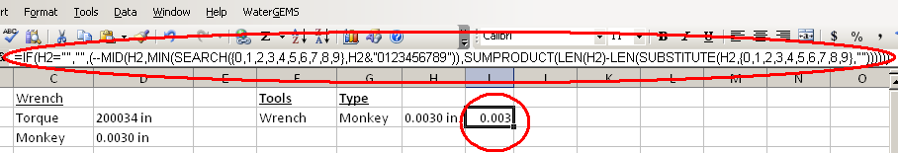
Fig. 24

