**One Box Gunnery Trainer**

***Sponsored by***

***Group 10***

***Anthony Muller***

***Gerald Tyberghein***

***Joshua Wood***

**Table of Contents**

**Project Statement**

Lockheed Martin Simulation, Training, and Support in Orlando makes portable military simulators for a vast amount of armed vehicles. The Tabletop Advanced Gunnery Trainer System (TAGTS) is a compact and cost effective tabletop system that allows troops to train anywhere rather than using an actual armed vehicle. Currently, the portable gunnery simulators are of the “joystick and monitor”. Some systems do have the actual gunner handle mounted in front of a touchscreen monitor which allows for a more realistic training experience, however the sights are not accurate, as seen in Figure 1. In order to make a more realistic trainer, the sights will be added in our design in correct tactical position with respect to the gunner and handle.

Another issue with the current setup is the fact that all of the components must be taken out of a case and assembled on a table. This leaves wires exposed and takes up space on the table which may not be available. This addresses the need of a more compact and portable case setup which will actually mount the components into a heavy duty case, eliminating the need for individual component assembly.

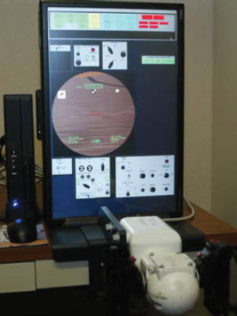

**Figure 1: Current TAGTS**

**(reference)**

**Current Setup**

The current design is made up of several components which will be integrated into our redesigned case and mounting system. Seen in Figure 2 is a Pro Engineer model of the current system showing the assembled system. The components, which all require some kind of mounting or storage in the case in which we are designing for, are the monitor, the computer chassis, the gunner handle, the mouse and keyboard, the power strip, and the headphones. The keyboard and mouse are not significant components in this system since they are used only to log in and select the simulator, whereas any input from the user in the simulator is from the gunner handle. In effort to save room, sometimes a rubber keyboard and mouse is used. It would be more desirable to have a normal keyboard and mouse which can be mounted inside a case, given enough space. All of these components add up to about 50 lbs total.

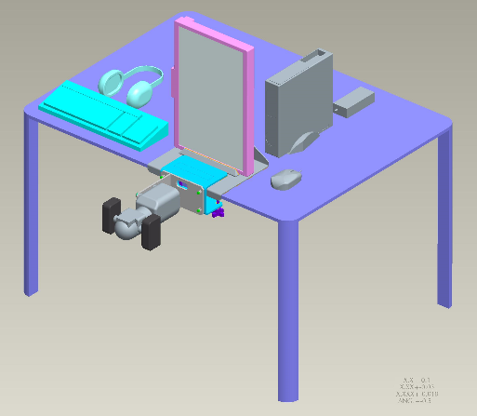

**Figure 2: Pro Engineer model of current setup**

**Concept Generation**

With the initial project statement, it is possible to come up with several possible designs; however more specific design parameters are needed. A major specification is that the case must not exceed 100 lbs, giving us about 50 lbs to work with a case and any hardware used in mounting. Our sponsor has spoken with some marines that use the TAGTS and their main concern was that the case must be below 100 lbs, even if functionality is traded off. We wanted to take this specification and address it without trading off any functionality. In our design, we wish to address these issues:

* System weighs less than or around 100 lbs.
* The system is stable when assembled.
* Sights and handles must be tactically correct in position.
* The equipment will be protected inside the case while being transported.
* System is quick and easy to assemble and dissemble.
* The wiring remains protected.
* The system must be durable.
* Packaging does not interfere with the components’ cooling.
* Meets or exceeds the MIL-STD-810 transportation and handling test.
  + The MIL-STD-810 test is a United States Military Standard test which emphasizes testing certain limits under environmental conditions.

Designing around these specifications allowed us to conceptualize 4 ideas. We will analyze these ideas in terms of durability, stability, ease of assembly, and complexity. A major decision which we will make is whether to have a “box on floor” setup or a “one case tabletop” setup. For the former, a case will rest on the floor and all of the components will come out of the case and up to the user in the tactical position. In a “one case tabletop” setup, the case will sit on a tabletop and most of the components can stay inside the case to be used, while the gunner handle can be put into tactical position.

**The Case**

Before introducing concepts, it is important to explain what kind of case will be used to house all of the components. Our group has been generously given the opportunity to pick a Pelican-Hardigg case which will be provided for us. These cases are very durable, tested, and G rated. All of the cases go through rigorous, computer aided tests in order to provide the best protection for fragile components. In our project, we will be looking at two different types, the single lid case, and the double lid case.

**Single Lid Cases**

Single lid cases have no rack mounting system, which means that components must be mounted by other means. Also, this means that any shock protection would have to come from foam lining the walls which could be placed in between the case wall and possibly a sheet of metal for mounting. Seen below in Figure 3 is a Pro Engineer model of a single lid case in an open position. It can be seen that there are wheels on one side of the bottom, which allows the user to wheel the system around conveniently Figure 4.

Because our project involves so many fragile and electrical components, the single lid system seems like it may fall short in meeting significant requirements, however it is much more convenient and easy to assemble.

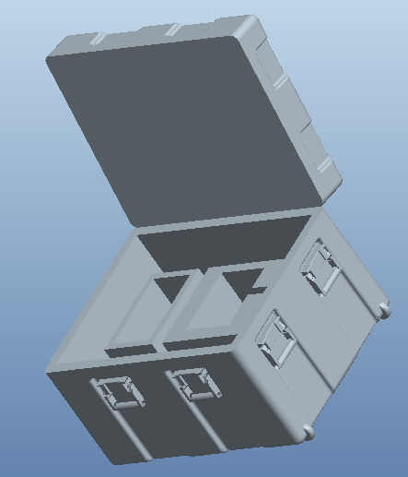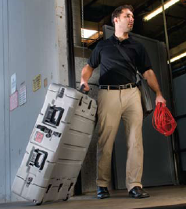

**Figure 3: Pro E model of Single Lid Case Figure 4: Wheels for easy transport**

**(Pelican Hardigg Cases)**

**Dual Lid Cases**

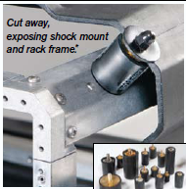 Dual lid cases are restricted to tabletop, or a mounted leg system. However, the dual lid cases allow for a better flow of air when both lids are open, which is key since a whole computer system will be inside. If these systems run for a long time for a few months or years without being replaced, the internal fans in the computer chassis will not provide enough air circulation. Also, an internal mounting rack, the mack rack, is included in dual lid cases. This is extremely beneficial considering our project involves mounting several components. On top of already having a mounting rack, this rack is also shock mounted, denying any damage to the components mounted inside. The shock mounts provide protection up to a certain G rating, which varies by the case size or specification. The shock mounts are seen in Figure 5. The heaviest duty case can be rated all the way up to 120 G.

**Figure 5: Shock Mount**

**(Pelican Hardigg Cases)**

The image below (Figure 6) shows the dual lid case’s component’s. This view showcases the rack mount along with the shock mounts. Along each bar of the mount are several holes which allow for mounting. This would allow us to bolt in the monitor, computer chassis, etc. with ease. Also, using this rack mount, we can implement a sliding mount which would allow for us to slide the monitor or handle out into a desired position.

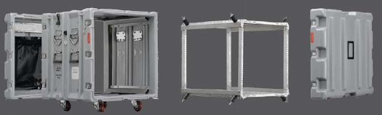**Figure 6: Dual lid case – exploded view**

**(Pelican Hardigg Cases)**

**Concept 1: Current Setup in Case**

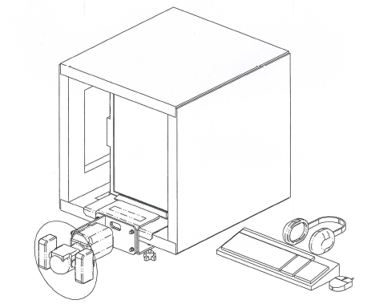

**Figure 7: Concept 1**

This concept was provided by our sponsor Jeffrey Payne, in order to give us a basic representation of what our design should be. It utilizes a single lid case in which the monitor is mounted and the gunner handle is mounted on the edge. The size of the case allows for ease of monitor mounting and use, since it does not have to rotate or slide out.

*Durability* – This concept has very high durability since the mounts are either rigid or with very few degrees of freedom. The handle is taken out and clamped to the tabletop, allowing for easy use and very little room for any unwanted movement. Because it is a single lid case, however, there are no built in shock mounts into the case. This would require a custom shock absorber added along the walls inside the case to protect all of the components.

*Stability* – The stability in this system is very high since first of all, it is sitting on a table. The main part of stability will come from whether or not the table’s legs are sturdy. Second of all, the handle is rigidly mounted to the edge of the table, which means that there will be no tipping from the handle.

*Ease of Assembly* – This concept has various parts that must be assembled. The handle must be taken from the case and mounted on the edge of the table, and the keyboard and mouse must somehow be placed in a spot that does not get in the way of training, while maintaining connection to the computer.

*Complexity* – The complexity of this design would be relatively high since there is no internal rack mount in single lid cases.

**Overall Pros :**

* Monitor is already in upright position
* Mounted gunner handle does not add tipping weight
* High durability

**Overall Cons:**

* Keyboard and mouse are not easily accessible and are off to the side
* Single lid prevents better air flow
* Gunner handle must be mounted manually
* Longer assembly time

**Concept 2: TableTop Case**

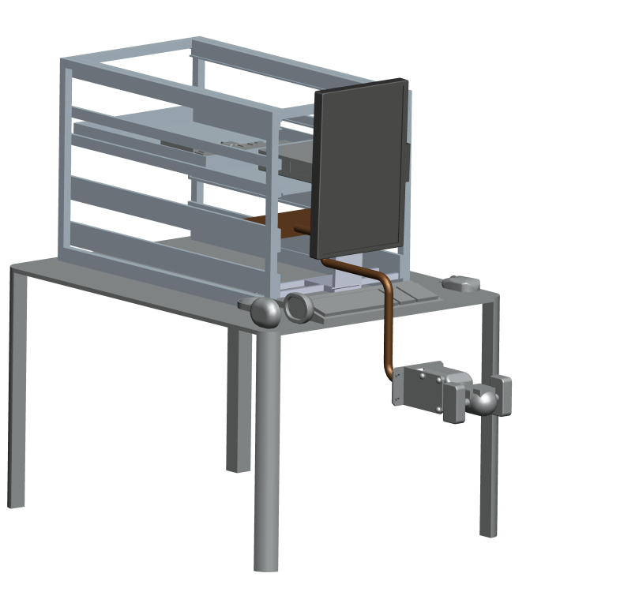 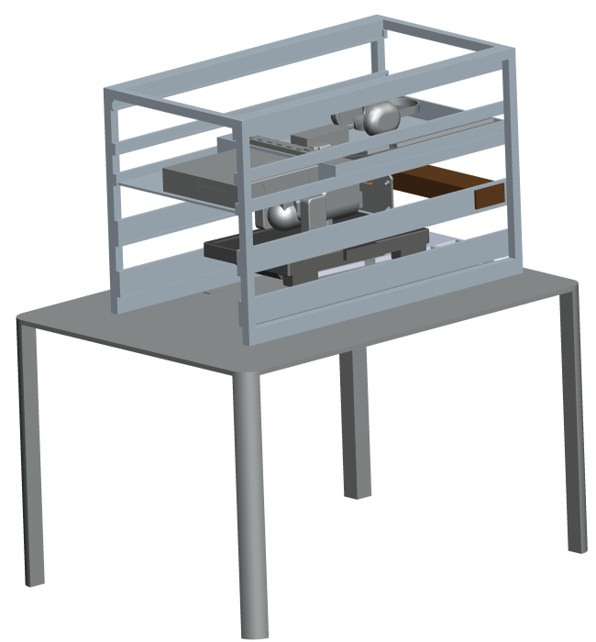

**Figure 8: Concept 2 Deployed Figure 9: Concept 2 Retracted**

This concept is essentially the current simulator mounted on rails in a dual-lid case. This is a highly portable model that drastically reduces setup and breakdown time, but still requires the use of a table.

*Durability* – This concept has medium durability. Most moving parts are limited to a single degree of freedom, however the handle is mounted to a tube section that has multiple rotation points, leading to the possibility of damage over time.

*Stability* – This system is rather stable, with the user needing to move approximately 100 pounds in order to slide the system on the table. There is very little possibility of tipping and the computer is mounted directly onto the case

*Ease of Assembly* – The ease of assembly of this concept is medium. The monitor must be slid out and rotated to an upright position, the mouse, keyboard and headphones must be removed from the storage space in the rear of the case and placed onto the desk within reach. The training gun must be pulled forward and extended to the operating position..

*Complexity* – The complexity of this case is medium. Major objects needing to be moved are on rails with the exception of the mouse, keyboard and headphones.

**Overall Pros :**

* High portablity
* Fairly easy to setup and breakdown
* System well protected during travel

**Overall Cons:**

* Gunner handle mount is subject to wear and tear
* Double lid adds weight
* Table is required for use
* Keyboard, mouse and headphones must be removed from rear compartment before use

**Concept 3: Hybrid Case**

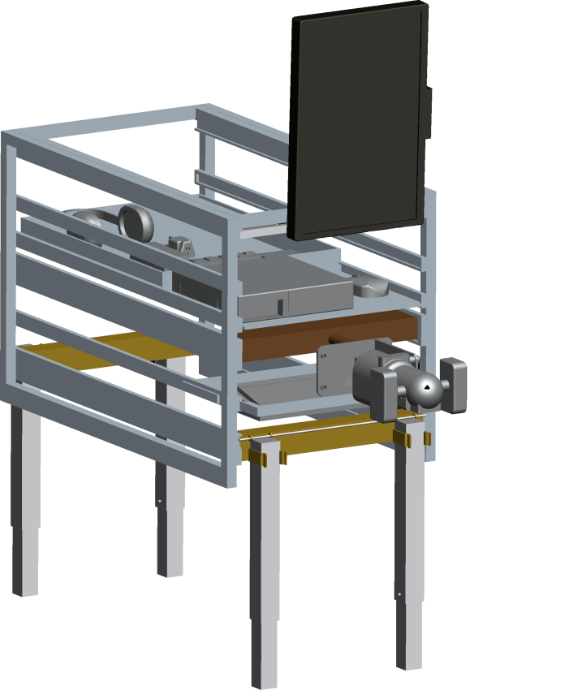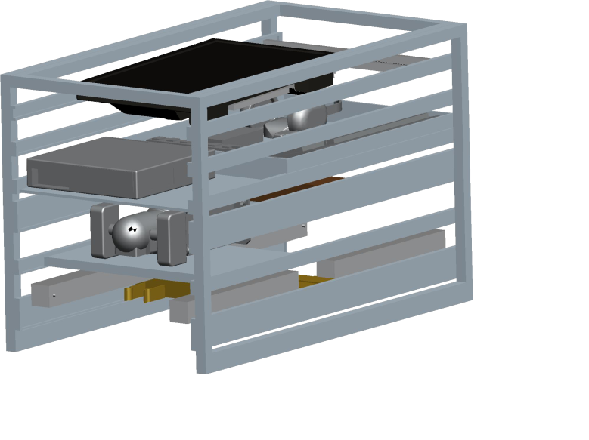

**Figure 10: Concept 3 Deployed Figure 11: Concept 3 Retracted**

This concept is a combination of the table top concept and the floor box concept. It has retractable, adjustable legs allowing the user to setup the unit anywhere there is solid ground. However, this extreme portability comes at the cost of durability.

*Durability* – This concept has low durability. Though most moving parts are limited to a single degree of freedom, The legs experience much higher stresses than any other portion and the clips that hold the legs in place will fatigue over time, leading to increased instability.

*Stability* – While initially stable, the fatigue of the leg clips leads to early instability when compared to the other cases. Also, the reduced with of the legs in relation to the table designs leads to possible tipping.

*Ease of Assembly* – The ease of assembly of this concept is easy. The monitor must be slid out and rotated to an upright position, the mouse, keyboard and headphones must be removed from the storage space in the rear of the case and placed at their respective positions. The training gun must be pulled forward, but is already at the tactical position. The legs must be extended, either by tilting the case on its side and clipping the legs into place or by lifting the cast up after pulling the legs up and swinging the legs into position.

*Complexity* – The complexity of this case is medium due to the retractable legs. Major objects needing to be moved are on rails with the exception of the mouse, keyboard and headphones, but they are in easier reach than the previous two concepts.

**Overall Pros :**

* Extremely portable
* Very fast setup and breakdown
* No table needed

**Overall Cons:**

* Leg clips lead to durability concerns
* Double lid and retractable legs add weight
* More easily tipped.
* Keyboard, mouse and headphones must be removed from rear compartment before use

**Concept 4: Box on Floor**

This design would take away the need for a table, leaving only the user sitting in a chair with a single lid case in front of him on the floor. The monitor, handle, keyboard, and mouse would need to come out of the case and into correct position ready to use.

*Durability* – This box on floor approach has somewhat low durability in the mounting system. Since it would have to be designed and implemented in the case, as well as install a foam liner to absorb shock, it will not be as durable as a case that has an internal Mack Rack mount.

*Stability* - The main issue with stability in this design is the fact that the gunner handle will have to rise up and swing out to the user. This causes weight to be hanging over the edge, would could lead to tipping. However, since the case is resting on the floor, it will most likely not tip since the case is so heavy.

*Ease of Assembly* – Theoretically, this setup will not require any additional assembly since it is on the floor and does not have a table to allow anything to sit on. This design calls for the necessity of mounting every component in a useful position.

*Complexity –* The complexity of this case is only in the design aspect. This concept would be the most difficult to design because we would have to design and machine our own internal rack mount which would “open up” into assembled position.

**Overall Pros :**

* No table needed
* Sturdy, rests on floor

**Overall Cons:**

* Awkward when it comes to leg room
* No shock rated rack mount

**Selection Matrix**

**References**

Lockheed Martin. *The Advanced Gunnery Trainer System (AGTS) Tabletop Trainer*. Lockheed Martin. *Www.lockheedmartin.com*. Web. 10 Oct. 2010.

Pelican. *Pelican Hardigg Cases*. Pelican, 2010. *Www.pelican.com*. Web.