Group 11 Final Report Fall 2010

Side Under-ride Guard/Aerodynamic Fairing

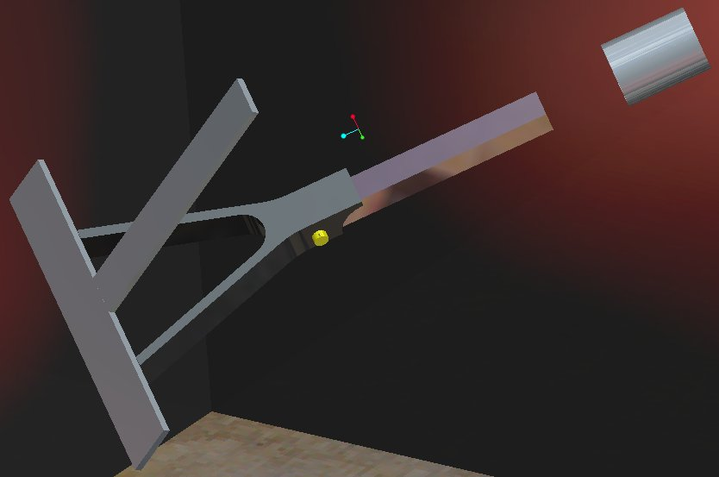
Kenji Petrucci
Cody Jones
Sam Murphy

Sponsored by: Seven Hills Engineering

December 03, 2010

Table of Contents
Introduction 1
Justification/Background 2
Problem Statement/Objective 2
Product Specifications 2
Concept Development 3
Concept A 5
Concept B 6
Concept C 8
Final Design 10
Fabrication/Testing Plans 13
Acknowledgements 14
Sources 14
Appendix A: Calculations 15
Appendix B: Stress/Deflection Analysis 16
Appendix C: Materials/Cost 23
Appendix D: Part Drawings 24

Introduction
Of the 15.5 million trucks operating in the United States, roughly 2 million (13%) of them are tractor trailers. These tractor trailers haul/transport about 70% of all freight in the U.S. which totals around $671 billion in goods. Despite the crucial role these “big-rigs” play in transportation, tractor trailers can be extremely dangerous on the roadways; their heavy weight and large size can increase the severity of even the most common traffic accidents. The US Department of Transportation reports that 98% of all semi-trailer crashes result in at least one fatality. In 2003 there were 4669 accidents with big-rigs that resulted in at least one fatality. Fatal tractor trailer accidents cost Americans more than $20 billion each year, $13.1 billion of which is the cost associated with loss of quality of life.
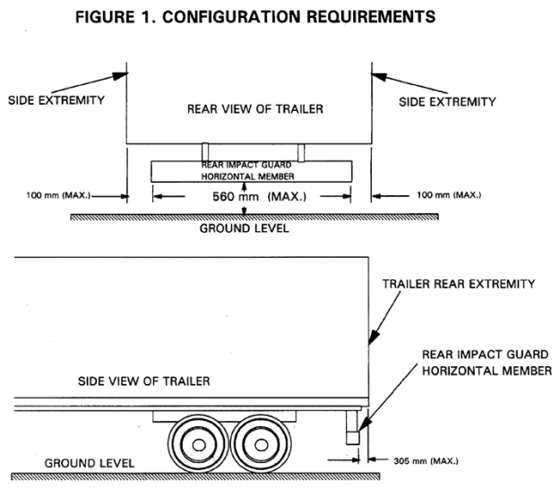
Of these collisions, many fatalities are caused from under-ride (both rear and side) of the passenger vehicle. It was estimated that in 1989 that approximately 700 car and truck fatalities were due to side and rear under-ride. It wasn’t until 1998, however, that the National Highway Traffic Safety Administration (NHTSA) required all tractor trailers to install a rear under-ride guard with a clearance of no more than 22 inches above the ground. In 2004, 16% of fatal crashes with semi-trucks were due to side under-ride and approximately 224 people die annually due to side under-ride alone.
figure 1
Configuration of requirements (existing rear guard design)

Justification/Background
Vehicle under-ride causes a significant risk of injury or death to occupants of vehicles that collide with trailers. The relatively high floor of a box trailer poses a unique risk of passenger compartment intrusion (PCI) for these types of collisions and typically result in serious head/neck injuries (brain damage, paralysis, etc) or death.
In recent years there has been a push for companies and individuals to be more environmentally conscious. The additional function of an aerodynamic fairing will serve as an incentive for owners to purchase and install the under-ride guard.
There are some aerodynamic fairings that exist which boast the ability to increase fuel efficiency up to 5%. These fairings, however, lack the structural strength to withstand the fatigue of daily highway driving. Problems exist due to the high, sustained wind speeds of constant highway travel as well as turbulence created by passing cars, etc. These fairings, when operating at ideal conditions, can dramatically increase fuel efficiency, however, a balance between weight and strength is needed to ensure that the structural integrity of the existing design is not compromised.

Problem Statement/Objective
Design, build, and test a device that will easily attach to the bottom of a standard trailer that restricts light-duty vehicles, traveling 35 miles-per-hour, from under-riding the trailer. The installation of this device will detract from the total cargo/weight hauling capacity of the trailer creating the need for the guard to be as aerodynamic as possible thereby saving the customer money spent in fuel. Ideally, the increase in fuel efficiency due to the aerodynamic properties of the fairing will fully compensate for the additional cost incurred by the installation and operation of the under-ride guard. The design will be for an aftermarket “kit” that can be purchased by the owner of a trailer and installed with little to no fabrication required by the customer.

Product Specifications
The main specification for this project is to design a system to effectively absorb the energy of a vehicle impact while directing the associated force away from the undercarriage of the trailer. For this design a light duty vehicle, defined as having an average weight of 6,000lbs and a width of 6ft, will be considered traveling at a maximum speed of 35mph at the time of impact. A secondary component of this design is to make this system as aerodynamic as possible to increase the fuel efficiency of the vehicle to which the system is installed. The end product must be fully fabricated prior to shipment and therefore will require minimal labor for installation. Integration and utilization of the trailer’s existing support structure will provide a sound foundation to which this design will be anchored to. Due to the uncertainty and variability of dynamic impact load testing and analysis, a safety factor of two will be used for a static load analysis in place of dynamic loading. Table 1 below shows the data and unit conversions used in equation 1 (appendix A).
Table 1
 | English | SI
Mass | 6000lb | 2722kg
Velocity | 35mph | 15.65m/s
Δt | 0.2s | 0.2s
Δv | 35mph | 15.65m/s

The design must also be modular so customers may purchase and install separate pieces to accommodate specific, varying circumstances. This will reduce overall weight, cost, and will allow for the repair of only affected/damaged sections when necessary. The spacing of each individual module is to be such that an impact from a vehicle will always occur on two sections; no single section will receive the full force of a vehicle impact. Under these constraints, and maintaining a safety factor of two, the average force per unit (static load) is approximately 50,000lbs (213kN).

Concept Development
Each design concept will utilize the same basic mounting procedure/apparatus with only small changes in bracket/support mounting and geometry. The existing framework structure within the trailer will be the main support points for the under-ride guard. There is a potential risk of damage to the frame of the trailer under extreme impact loads however, for the scope of this project, the load is assumed to be absorbed entirely by the guard structure and therefore the associated risk is neglected.
There are two major components of design under consideration: the structure of the guard itself and the aerodynamic properties associated with the fairing. The method of mounting the fairing to the guard structure is a sub component and for all designs listed the fairing is designed to be mounted to the exterior face of the guard structure.
Several designs were conceived ranging from single truss structures to modular guard units. As was mentioned earlier, a modular approach has significant advantages over non-modular designs as will be demonstrated here.
A force analysis of the selected design is required to study the performance (deflection/deformation) of the support structure under the loading conditions specified by the client. A light duty vehicle traveling up to 35mph will create a significant load upon impact and the guard structure must absorb this force without any detrimental damage to the trailer itself. CAD modeling and, if possible, scale testing will be performed to provide said analysis.

Concept A
This concept will utilize a design similar to that used for the existing rear under-ride guard for the trailer. The support brackets will be re-designed to accommodate the heavy impact loads associated with a vehicle crash. This design incorporates a joint system in the support structure to allow for the guard to be folded under the trailer in the event of the trailer “bottoming out.” The aerodynamic fairing for this design will be a lightweight aluminum sheet to be mounted to the guard structure.
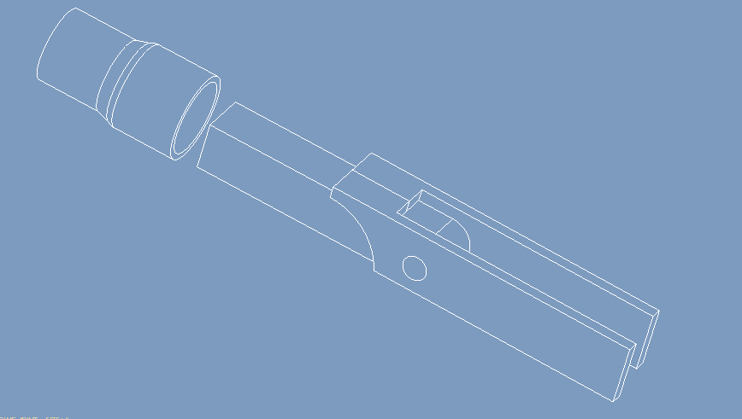
figure 2
Folding Joint Mechanism
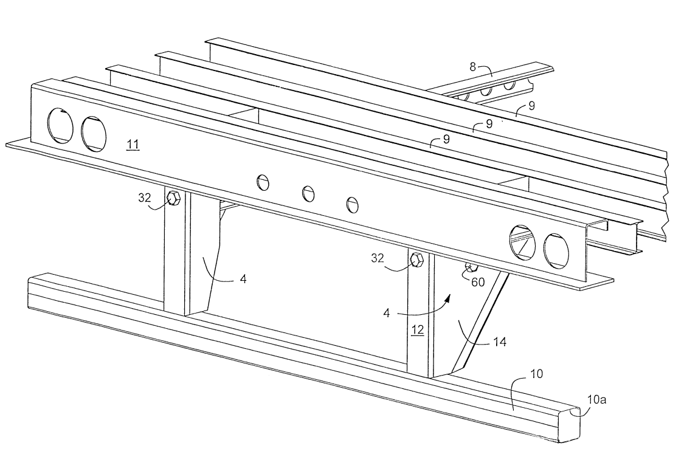
Figure 3
Standard Rear Under-Ride Guard
This design is very straightforward and would require only a “bolt on” installation by the end user. Fabrication may prove to be slightly more complex (welding vs. bracketing), however the design is simple in nature and as such provides a relatively low level of complexity; the bolt on application means that most, if not all, drivers will be able to easily install the product with minimal tools and no engineering/fabrication knowledge. Installation instructions will provide adequate direction for proper installation and operation.
All parts utilized in this design are readily available from a number of distributors and retailers. The most difficult part(s) to acquire will be the joint system; this may need to be custom fabricated. Custom fabrication is costly and time consuming so effort will be made to avoid this however, due to the large forces associated with vehicle impact, this may prove necessary.

Concept B
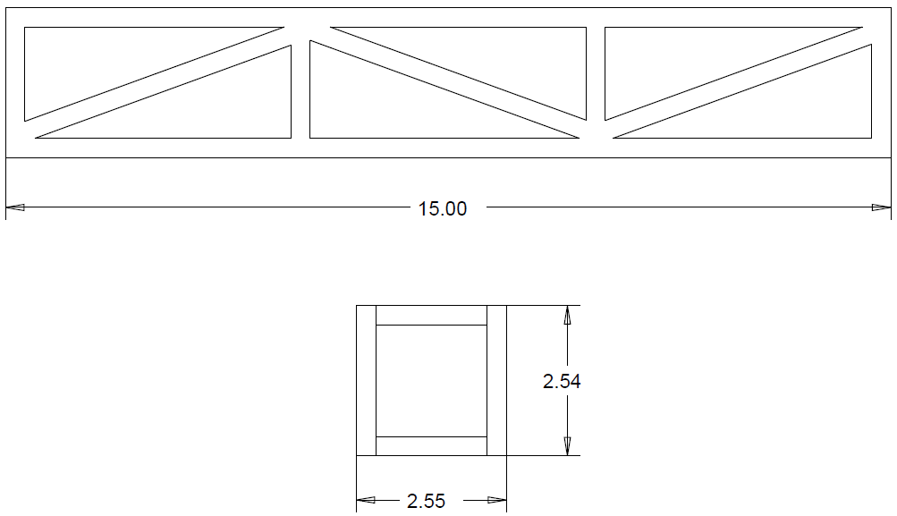
This concept looks, and is, very similar to that of a truss bridge; each of the trusses will distribute the force of the impact instead of one single beam.

figure 4
Truss design concept B

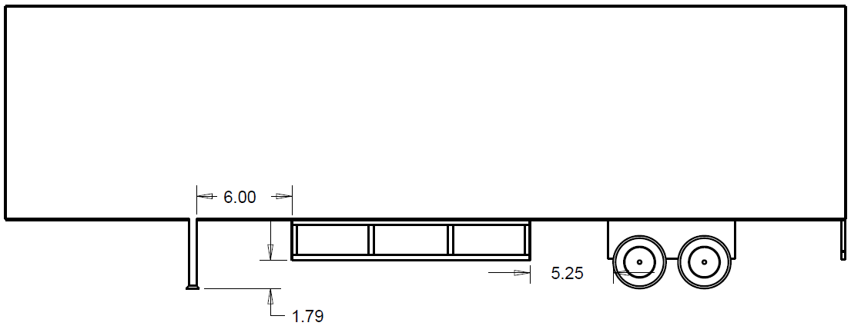
figure 5
Side view concept B

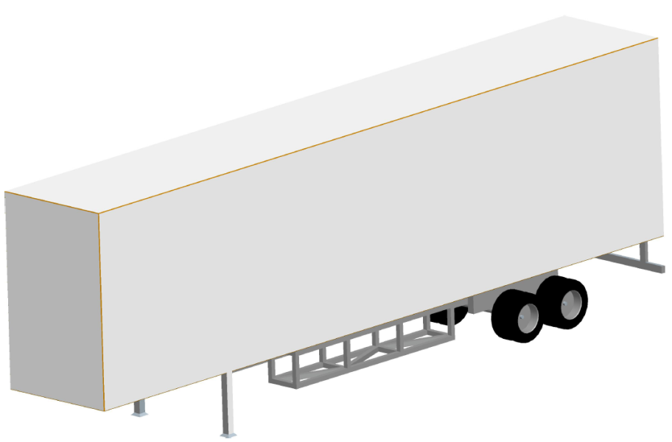

figure 6
Isometric view concept B
The installation of this design is fairly complicated and may act as a deterrent for potential customers. To assemble one side guard, one must first attach the two trussed parts together with the 8 beams that run in between them then steadily raise the whole design up to the bottom of the trailer with a few floor jacks while someone bolts them to the bottom of the trailer. Although the strength of this design will be very high, the complexity will be greater than most of the others as well.

Concept C
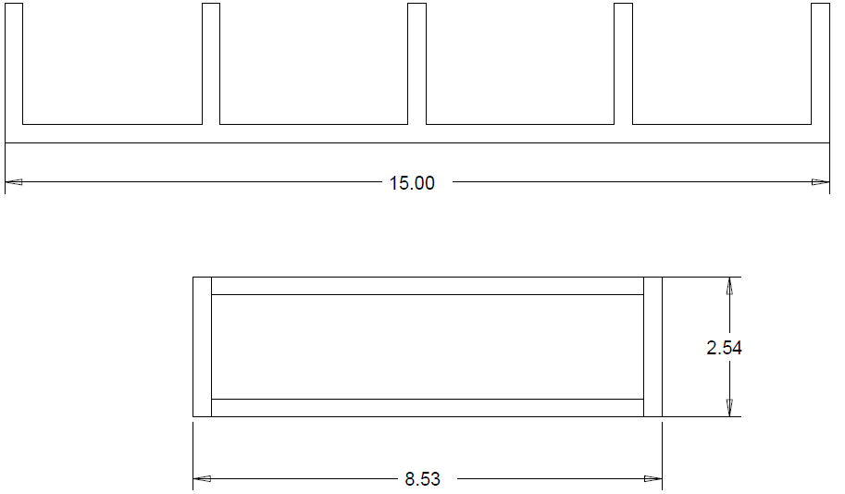
This concept looks very similar to the rear under-ride guard and is a modified version of that design. With the same thickness of the beams, the only difference is the length and the supporting beams that run perpendicular underneath the trailer.

figure 7
Truss design concept C

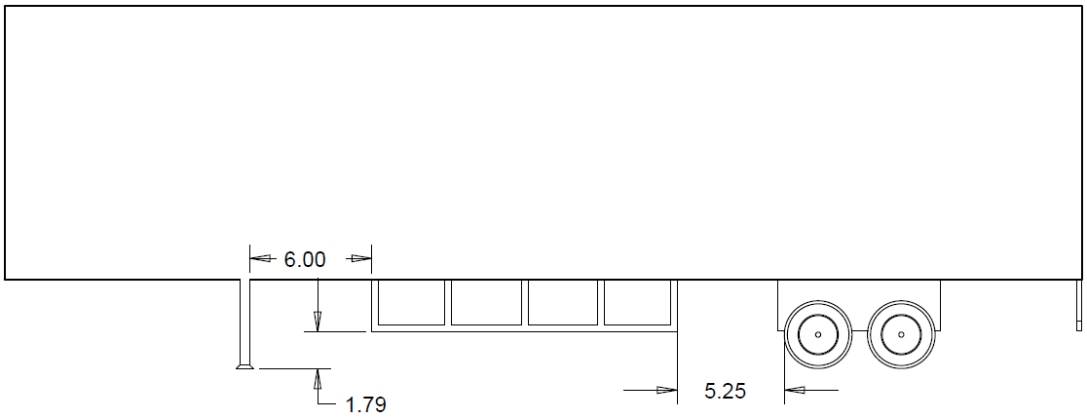
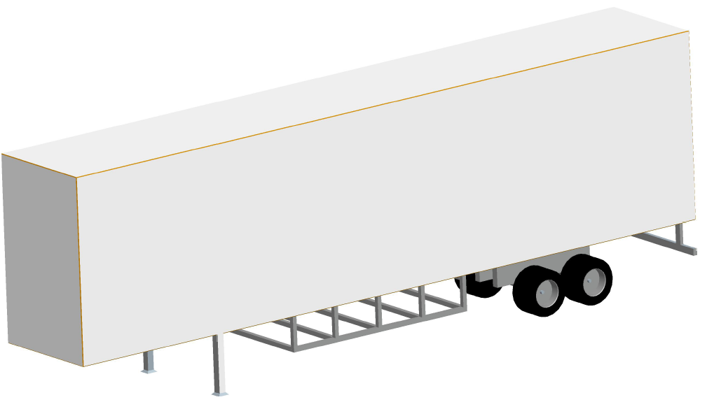

figure 8
Side and isometric views concept C
This design would be slightly easier to assemble and install than concept B. The two side guards could be raised into place with a floor jack, then the four cross braces could be attached to the side guards simply by bolting them together. This design is perhaps the simplest design. There are only two sides with middle beams for inner support.
The performance of this design will most likely not be as desirable as the previous design due to the fact that there are no supporting trusses. However, there are longer supporting beams between each side of the trailer that run the entire width of the trailer. These will give the design far more support than the rear under-ride guard which it is designed after.

Final Design
The chosen design is a modular design employing a joint mechanism to allow for the guard to fold under the trailer when needed. Each section is designed to be 2ft wide by 2ft tall (hanging below the bottom of the trailer by 2ft) and will be spaced 2ft apart from one another. Given that the average vehicle width is 6ft this spacing allows the optimization of maximum coverage and material used while ensuring the force of impact will always be distributed among at least 2 sections. As previously mentioned the modular design reduces material used and therefore reduces the overall weight and cost of the structure. It also allows for precise repair/replacement of only the necessary sections after an impact. The guard support structure will be made of 6061-T6 Aluminum plates and square tubing. Steel pins and brackets will be used to mount to the existing framework of the trailer. As can be seen in the included stress and deflection analysis (appendix B), the maximum stress imposed on the impact bar during loading is approximately 160,000psi. This correlates to a material failure at the stress concentration points on the impact bar. However, the remaining structure sees only a maximum stress of 60,000psi with a majority of the structure experiencing well under 50,000psi of stress during loading. These values sit right on the cusp of the tensile and compressive material strengths for the chosen aluminum alloy and represent a worst case scenario during impact. The included safety factor of two in the analysis ensures that the chosen material will effectively absorb and deflect the energy of a vehicle impact under the maximum design constraints despite the potential failure at the impact surface.
The joint structure consists of three joints for the desired movement. A hinge will be the method of mounting the impact bar to the underside of the trailer. The wishbone joint will be pinned to the straight square tubing that will be pinned to a steel clevis bracket mounted to the frame structure of the trailer (exploded view included in appendix C). It should be noted that the guard will not fold completely flat under the trailer; a 4th joint would be necessary and would greatly reduce the strength of the overall structure. For this reason, the structure will fold under the trailer incompletely. However, the purpose of the folding motion is to eliminate the risk of damage due to bottoming out and even with incomplete folding there will be adequate movement to achieve this goal.
The aerodynamic fairing will be modular in design as well to pair with the modular guard structure. The impact bar will have pre-drilled holes to allow for the fairing to be easily mounted to it. The fairing will consist of three main sections: a front and rear section and a middle section that will span the gap between the front and rear. Figure 9 shows the front section and as can be seen there is a lip (figure 10) to eliminate any gap that may exist between the front/rear sections and the middle span. The front and rear sections can be fabricated from aluminum sheeting or from a composite plastic material depending on customer needs. The middle span will be a composite plastic that can be purchased in rolls of varying lengths in order to accommodate different guard arrangements.
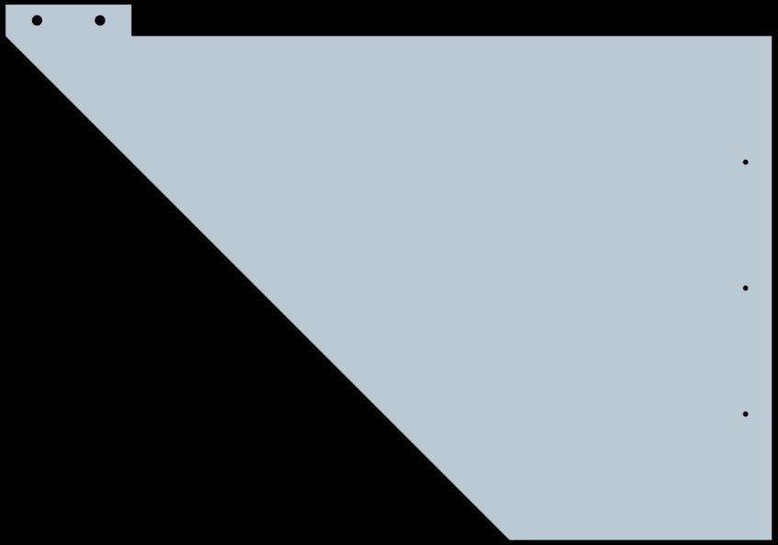

figure 9
Front fairing structure

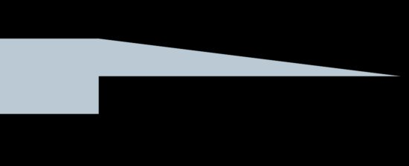

figure 10
Side view of overlap flap
figure 11
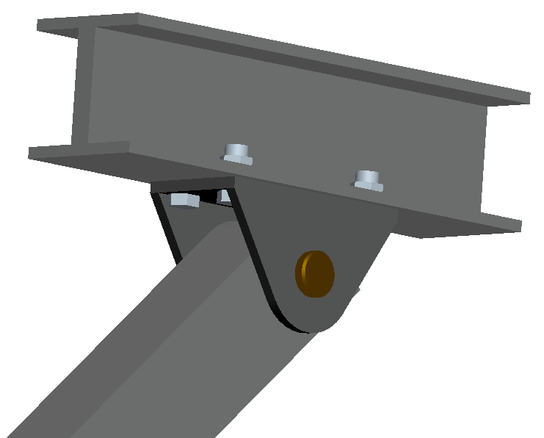
Guard unit

figure 12
Attachment to I-beam floor support of trailer

Fabrication/Testing Plans

Having run a structural analysis, it is possible to begin purchasing parts in order to fabricate a full size prototype for testing. Purchasing will be completed no later than December 10, 2010 in order to allow time for assembly. Assembly will be completed no later than February 14, 2011. This schedule allocates 6 weeks for assembly; upon completion of the assembly phase plans will be made with our sponsor, Seven Hills Engineering, to crash test the full scale prototype. Time permitting, after full scale testing; alterations/adjustments will be made to the final design where necessary to correct any flaws that may present themselves during testing.

Acknowledgements

Dr. Hollis
Faculty Advisor

Perry Ponder
Andrew Magaletti
Sponsors

Sources

Çengel, Yunus A., Robert H. Turner, and John M. Cimbala. Fundamentals of Thermal-fluid Sciences. 3rd ed. Boston: McGraw-Hill, 2008. Print.

Wolfson, Richard. Essential University Physics. 1. San Francisco: Pearson Addison Wesley, 2007. Print

www.onlinemetals.com

Appendix A: Calculations

$\begin{aligned}\text{1 kg }=\text{ 2}\text{.}\text{2046lbm} \\ m=\frac{\text{6000}\text{lbm}}{2\text{.}\text{2046}\text{lbm}}∗1\text{kg}=\text{2721}\text{.}\text{58}\text{kg}≈\text{2722}\text{kg}\end{aligned}$

$F_{\text{avg}}=\frac{mΔv}{Δt}=\frac{\text{2722}∗\text{15}\text{.}\text{65}}{0\text{.}2}\frac{{\text{kg}∗m}/s}{s}=\text{213}\text{kN}=\text{47},\text{844}\text{lbf}$$\begin{aligned}1\text{mph}=0\text{.}\text{44704}m/s \\ v=\text{35}\text{mph}∗\frac{0\text{.}\text{44704}m/s}{1\text{mph}}=\text{15}\text{.}\text{6464}m/s≈\text{15}\text{.}\text{65}m/s\end{aligned}$$Δt=\text{200}\text{ms}=0\text{.}2s$

$\text{Impulse}=J=F_{\text{avg}}Δt=mΔv$

………………………eq (1)

- Δv is 15.65m/s due to the fact that the vehicle will decelerate to 0mph upon impact
- Safety factor of two requires that this average force be multiplied by two before analysis is conducted. However, since the design is such that the force of impact will always be distributed between at least two guard structures it is appropriate to divide the doubled force by two, leading back to the original force of 213kN. This value includes a safety factor of two and is representative of the load that each bar will experience under maximum loading conditions.

Appendix B: Stress/Deflection Analysis

Assembly Stress Analysis 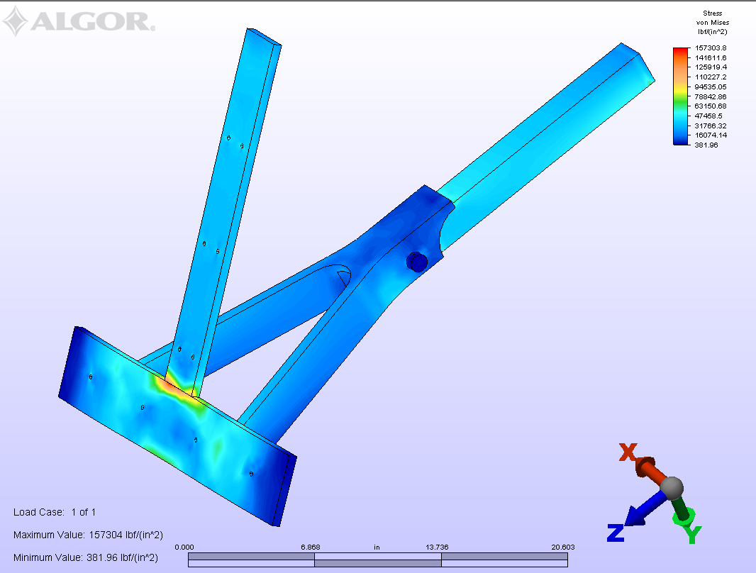Impact Bar Stress Analysis 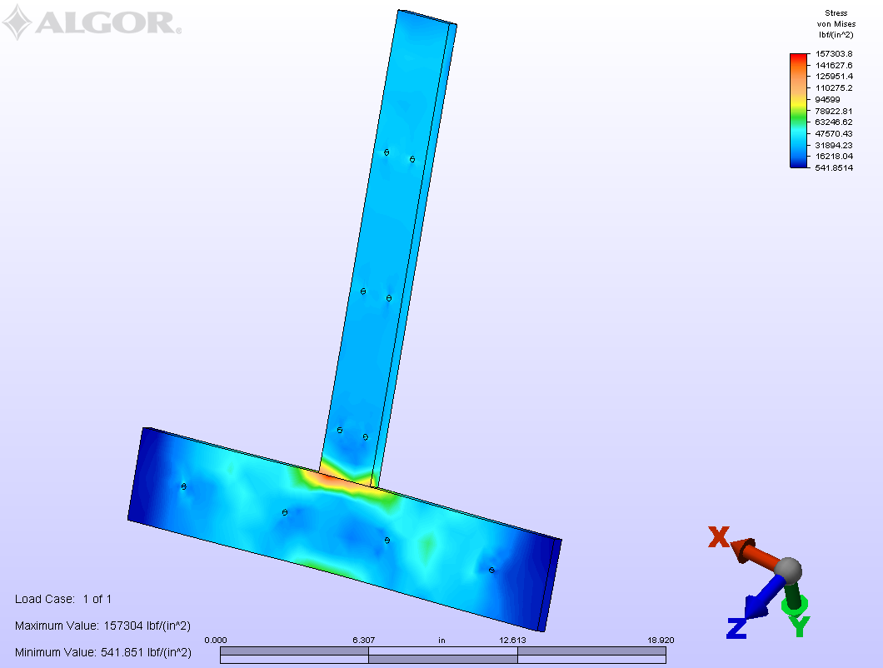Wishbone Joint Stress Analysis 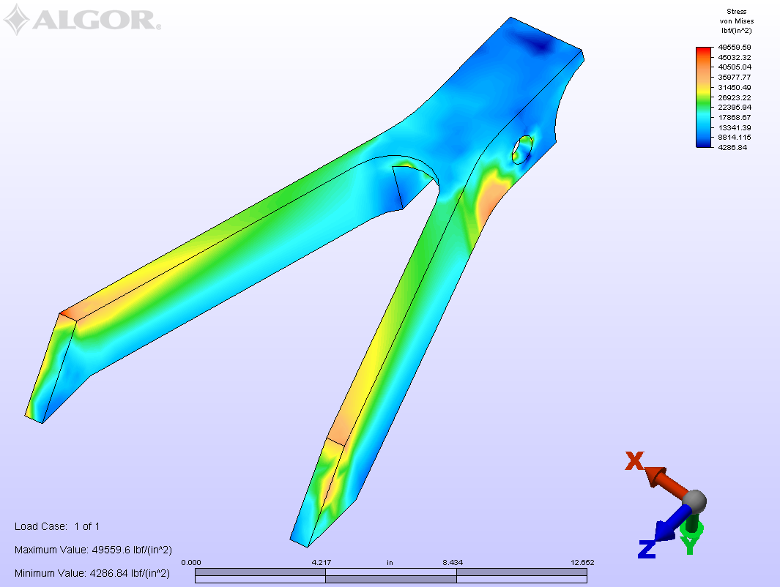Straight Joint Stress Analysis 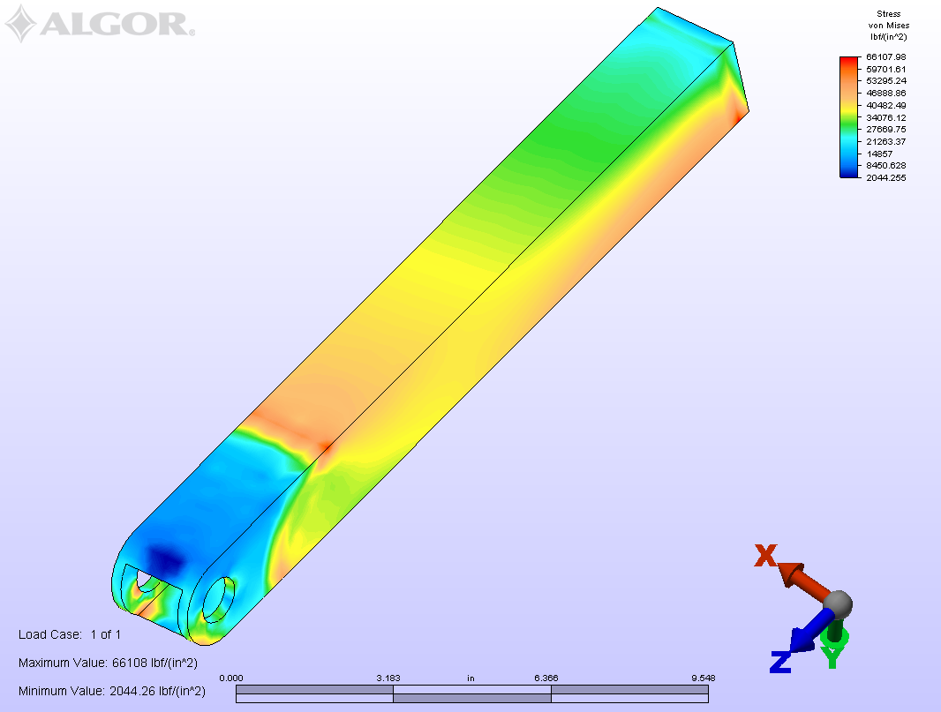Pin Stress Analysis 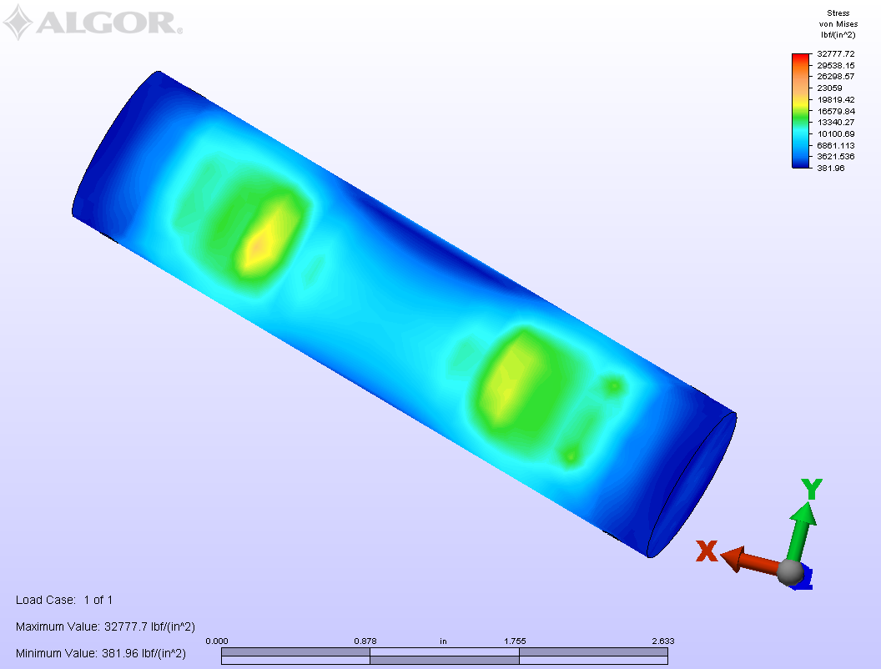Assembly Deflection Analysis 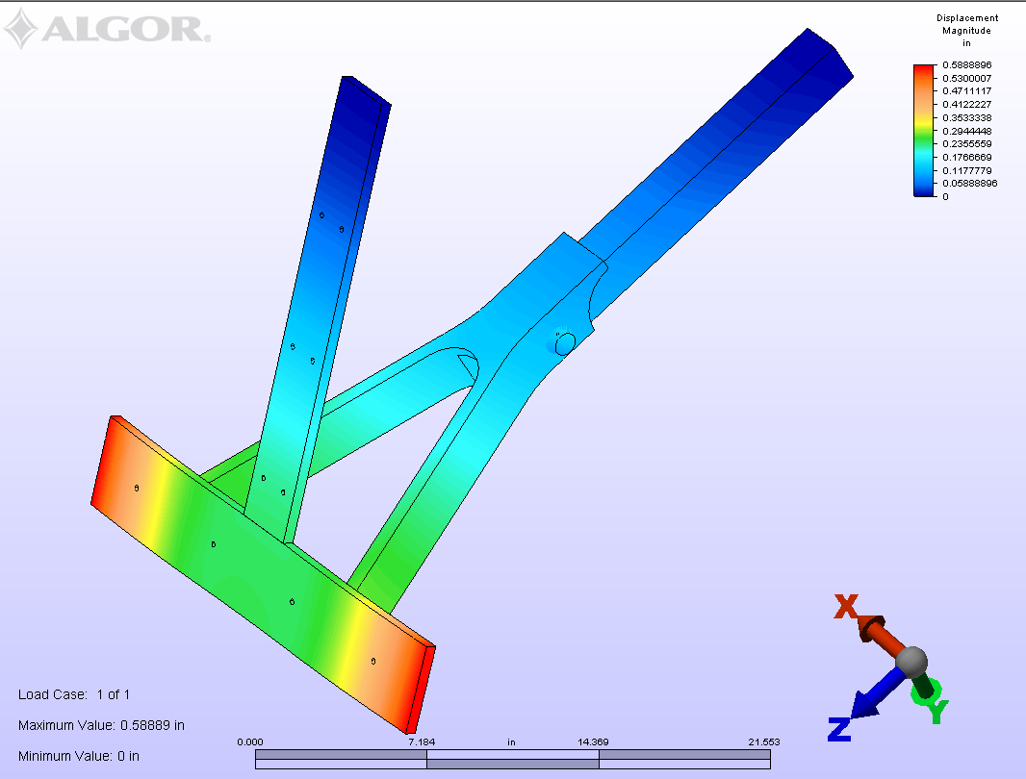

Appendix C: Materials/Cost

Bill of Materials
2
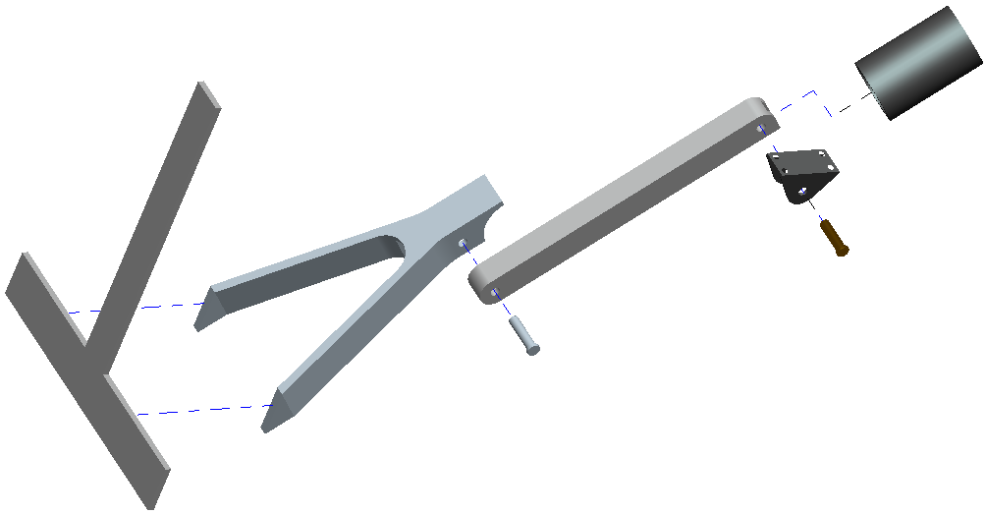
5
4
1

6
Part#/Description | Length | Width | Height | Thickness | Quantity | Price
1-Square Tubing | 17” | 2” | 2” | 0.25” | 7 | $149.94
5-Impact Bar | 24” | 0.5” | 4” | N/A | 7 | $146.16
5-Impact Support Bar | 24” | 0.5” | 3” | N/A | 7 | $109.62
4-Wishbone Joint | Quote Pending |  |  |  | 7
Hitch Pin | Quote Pending |  |  |  | 7
Cotter Pin | Quote Pending |  |  |  | 14
Pivot Pin | Quote Pending |  |  |  | 7
6-Bracket | Quote Pending |  |  |  | 7
 | Length | Inner Diameter |  | Thickness | Quantity | Price
2-Collar | 6” | 4” |  | 0.25” | 7 | $unknown
3

Appendix D: Part Drawings

Structural analysis performed using ALGOR and Pro-Engineering software

