**FAMU-FSU College of Engineering   
Department of Electrical and Computer Engineering**

**CONCEPTUAL DESIGN REVIEW**

**EEL4911C – ECE Senior Design Project I**

Project title: **Formula Hybrid Car 2010-2011**

Team #: 3

Student team members:

− **Israel Daramola**, Electrical Engineering (Email: iod07@fsu.edu)   
− **Thomas Emerick**, Mechanical engineering (Email: tme06@fsu.edu)   
− **Stephanie Medina**, Computer Engineering (Email: [sm07h@fsu.edu](mailto:sm07h@fsu.edu))

− **Lorenzo Neal**, Electrical Engineering (Email: lmn09@fsu.edu)   
− **Philip Young**, Mechanical Engineering (Email: pay07@fsu.edu)  
− **Ryan Zombek**, Mechanical Engineering (Email: [rmz07@fsu.edu](mailto:rmz07@fsu.edu))

Senior Design Project Instructor: **Dr. Bruce Harvey**

- Dr. Chris S. Edrington, Electrical Engineering Technical Advisor

- Dr. Chiang Shih, Mechanical Engineering Advisor

Submitted in partial fulfillment of the requirements for

EEL4911C – ECE Senior Design Project

January 22, 2011

# Project Executive Summary

The Formula Hybrid is an annual international collegiate competition striving to build a formula style, gas-electric hybrid vehicle. This year’s competition takes place in Louden, NH on May 1st, 2011 and is sponsored by IEEE, SAE, and many other corporate entities. The competition consists of a static portion and a dynamic portion, which includes acceleration, autocross, and an endurance race. The static portion will involve a series of in-depth questions that design judges will be asking to all team members. These questions will test all members’ knowledge on the analysis and reasoning of implementation on the vehicle. The acceleration, autocross and endurance tests primarily consist of ranking the vehicles in order of time finished and suitably assigning points.

As mentioned in previous documentation, the current students working on this project are a combination of computer, electrical and mechanical engineering students. In order to achieve the project’s main objectives; maximum fuel efficiency, the increase in performance of the vehicle and the innovation of the drive-train configuration, certain major goals are being fulfilled. These goals involve the integration of the internal combustion engine, the implementation of the Battery Management System, the redesigning of the suspension, braking system and I.C.E clutch, and the testing and incorporation of the cockpit sensors and paddle-shifting for the formula vehicle.

Currently, the team is in the progress of achieving several of these milestones. The computer engineer on the team is in the process of analyzing and ordering the Elithion-Lithiumate Battery Management System but the progress is being delayed due to insufficient funds, therefore other options are being considered. The mechanical engineers have analyzed the suspension of the vehicle and have decided to modify the curved hollow-tubing with straight solid tubing to strengthen the struts of the car. The suspension will also be redesigned to be adjustable in order to facilitate any further use of the chassis. The braking system has been examined as well and the main alteration within this component will be the replacing of calipers and uprights. The uprights are being changed as to where a steel bar is welded to it to hold the new calipers in place.

Cockpit sensors involve a combination of the speedometer, rpm sensors, tachometer, and radiator temperature gauge. The first three cockpit sensors have been purchased but need to be installed into the vehicle. In regards to the radiator temperature gauge, the electrical engineers are investigating different pricing options to integrate it into the car. In addition, the mechanicals are waiting on the response of Agni Motors Company to see if the 6,000 rpm limit on the electric motor (E.M.) is due to electrical or mechanical failure. The I.C.E clutch and paddle-shifting go hand in hand, as the I.C.E clutch will enable the changing of different gear levels in regards to the paddle-shifting.

More so several of these goals run the risk of not being fulfilled due to financial obligations. Therefore, the engineers on the team are still researching potential sponsors. Two of the sponsors are in the process of reviewing the formula vehicle proposal and giving the team a final decision. Furthermore, the team is in the process of having one of the design judges from the SAE competition come to the FAMU-FSU COE to give a workshop on the vehicle, analyze it and give the team suggestions. **Table of Contents**

Project Executive Summary ii

Table of Contents ………….…………………………………………………………………..iii

1 Introduction 4-6

1.1 Acknowledgements 4

1.2 Problem Statement 4-5

1.3 Operating Environment 5

1.4 Intended Use(s) and Intended User(s) 5

1.5 Assumptions and Limitations 6

1.6 Expected End Product and Other Deliverables 6

2 System Design 7-12

2.1 Overview of the System 7-8

2.2 Major Components of the System.. 8-10

2.3 Performance Assessment 10-11

2.4 Design Process.. 11-12

3 Design of Major Components 12-30

3.1 DriveTrain 12-16

3.2 Battery Management System.. 16-20

3.3 Chassis 20-30

4 Schedule 31-35

4.1 Original Schedule 31-33

4.2 Current Schedule.. 34-35

5 Budget Estimate 36-43

5.1 Original Budget 36-40

5.2 Current Budget.. 41-43

6 Overall Risk Assessment 44-55

6.1 Technical Risks 44-49

6.2 Schedule Risks.. 49-52

6.3 Budget Risks 52-55

6.4 Summary of Risk Status.. 55

7 Conclusion 56

8 References 57

9 Appendices 58-65

9.1 Chassis Equations 58-59

9.2 Resumes.. 60-65

# Introduction

## Acknowledgements

The 2010 Formula Hybrid Car team would like to thank Dr. Bruce Harvey and the team members of the 2009 Formula Hybrid Vehicle Team from the FAMU-FSU College of Engineering for their direction and general advising with regards to the vehicle design. Team 5 would also like to officially acknowledge Lei Wang and Xiaohu Liu for their research and guidance in the determination of the drive-train configuration for the vehicle the first year. The team would also like to thank Dr. Chris S. Edrington and Dr. Chiang Shih for their assistance in the fundraising and mentoring of the project. A special gratitude would also like to be extended towards the SASE program at the Florida State University for their assistance in developing a sponsorship plan for Student Government Association. The team has also received tremendous fabrication support and advice from Jeremy Phillips and John Rushing from the car shop and would therefore like to show their immense appreciation to them. A special thank you would like to be extended as well to the dean of the College of Engineering, Dr. Ching-Jen Chen, for paying the registration fee for the SAE 2010-2011 competition. In addition, the team of students would like to express their sense of gratitude to the following potential sponsors for their donations and support: Dr. Dave Cartes, IESES, Student Government Association and the FAMU Foundation. Without all of these potential sponsors, the project will be unable to achieve its’ success!

## Problem Statement

The 2011 FAMU-FSU Formula Hybrid Car Team believes in reducing, reusing and recycling. More so, the “GO GREEN” initiative is what is driving the team to continue the structure of a full hybrid-electric vehicle that will abide by the 2011 SAE/Dartmouth Formula Hybrid Competition rules and guidelines. This project consists of one computer engineering student, two electrical engineering students and three mechanical engineering students. The team is engaging in the project to design and implement a fuel efficient hybrid vehicle to serve three main objectives such as the following: the reduction of fuel consumption, the improvement of performance on the vehicle and the innovation of the drive-train within the vehicle.

The SAE Dartmouth 2011 competition consists of three main tests in which the vehicle will need to perform exceptionally well in. The three main events of the competition will involve the acceleration, autocross and endurance examinations. The previous year’s main challenge was the constructing of the hybrid-in progress vehicle. On the other hand, this year the team is concentrating on the incorporation of the internal combustion engine (I.C.E) along with the electric motor (E.M.) to make the vehicle a “full-hybrid car”.

In addition, a challenge the team endeavored last year was the uneven charging of batteries within the vehicle. This struggle along with the requirement of the end product having to be battery powered has led the team to implement the Battery Management System, which will manage the ability to recharge the battery pack by surveying, protecting and balancing its’ state. The computer engineer on the team is currently analyzing the Elithion-Lithiumate Battery Management System but since the advancement of the goal is being setback due to the shortage of funds, other BM Systems are being considered.

The mechanical engineers are facing challenges on their side of the team as well. They are currently analyzing the suspension and braking system of the vehicle. Not only have these students decided to change the curved hollow-tubing on the suspension to straight solid tubing but have also come to the conclusion of making it adjustable, which will be quite a tedious task. These changes will facilitate the further use of the chassis and strengthen the struts on the vehicle. Calipers and uprights are being replaced in order to weld a steel bar to the uprights to hold the new calipers in place. Additionally, to efficiently fulfill the redesigning and replacing of the suspension, uprights and calipers, Pro-ENGINEER and COMSOL programs are currently being utilized to visually comprehend and illustrate additional difficulties to the components.

Other goals that are being delayed involve the I.C.E clutch and paddle-shifting incorporation. The mechanical engineer in charge of this task is currently waiting on the response of Agni Motors Company to determine if in fact the 6,000 RPM limit on the E.M was due to electric or mechanical failure. The I.C.E clutch and paddle-shifting go hand in hand, as the I.C.E clutch will enable the changing of different gear levels. On the other hand, the electrical engineers on the team are presently exploring various pricing options for the radiator temperature gauge as this is the only sensor that has not been purchased thus far. The BMS sensors which will be integrated with the BMS will be decided upon once the team purchases the BMS. Cockpit sensors include the speedometer, rpm sensors and ammeter but these only need to be installed and tested onto the vehicle as they have already been acquired.

Ideas that have been generated to resolve the problems or delays of these goals include analyzing the basic concepts behind all the main goals, while the company responses are received. Additionally, general problems that overlap among all these components include the lack of insufficient funds, therefore the team is still locating potential sponsors. Two of the potential sponsors are in the process of reviewing the formula vehicle proposal and giving the team a final decision. Furthermore, the team is also in the process of contacting one of the design judges from the SAE competition to come to the FAMU-FSU COE to give a workshop on the vehicle, analyze it and perhaps give the team suggestions on it. Aside from these options, all team members are contacting companies to possibly fund the project as well.

## Operating Environment

The operating environment for the Formula Hybrid car is a flat racetrack or drag strip. The vehicle must and will be operable in a wide variety of climate conditions such as cold, hot, wet, dry, and dusty environments. The vehicle will not be driven off the road at any point. More so the vehicle must be able to operate under high acceleration turns and maintain the safety of the driver and vehicle integrity. One of the vehicle’s desired capabilities will involve the control displays being incorporated into the formula vehicle. Controls for ignition and emergency shutdown are being incorporated into the car. Additionally, the formula vehicle is not in danger of being dropped or thrown, however there is the risk of crashing the vehicle. This danger can lead to the puncturing of the batteries or gas tank and cause a serious hazard.

## Intended Use(s) and Intended User(s)

The intended user(s) of this product will be two team members who will perform as the drivers of the vehicle. Conversely, other team members will pilot the testing of the car. In accordance to the rules and regulations of the SAE rulebook, the vehicle must be designed to fit the largest 5th percentile of men and the smallest 5th percentile of women. The driver must fit the size constraints as set forth by the 2010-2011 Formula Hybrid Rules 3.3.4.1, have a valid driver’s license and motor skills prompt enough to navigate the flat track. The driver’s motor ability level will be measured by the team, although there is not an education requirement on the driver. Other user(s) of the vehicle may vary between the design judges in the actual competition and any potential or present sponsors.

The end uses for this project include competing in two static events and three dynamic events at the 2011 Formula Hybrid International Competition. As mentioned previously, the static events include a design inspection and team presentation. The dynamic events consist of a drag race (75m in ten seconds or less), an autocross and endurance race. This vehicle will also be utilized by the design team to stimulate the interest of students leading to further support, to perhaps gain further sponsoring within the SASE organization and for other potential sponsorship opportunities.

## Assumptions and Limitations

Assumptions: The maximum number of operators at one time will be one. The entire team will travel to Loudon, New Hampshire in May 2011 for the competition. Hybrid team sponsors will be displayed on the vehicle, apparel, banners and on the website which is currently under construction. The team has decided to go with the Elithion Battery Management System due to attractive features it offers but this task is being delayed due to financial obligations so other options are being analyzed as well. Other decisions that have been determined include the purchasing of the radiator temperature gauge. Solid straight tubing will be used for the suspension instead of the curved hollow tubing that is currently on the vehicle. The team is forming a group of students from the SASE organization to help develop the website for the formula project and prepare them for the business presentation to be given at the competition.

Limitations: The total project needs to be completed before May, 2011 and the total cost must fit within the final agreed budget. The total weight of the Formula Hybrid Vehicle should not exceed 700 lbs. The operator must fit within the 95th percentile of men and 5th percentile of women. The battery bank should deliver a minimum of 72 V to the electric motor (E.M) controller. The drive train system must fit within the dimensions of the chassis. The motor controller cannot attempt to draw more power than provided by the battery bank. The E.M and I.C.E must be in sync with one another when in operation. The Elithion Battery Management System currently being analyzed cannot be purchased, if the potential sponsor designated for it does not go through with the process. If no additional funding opportunities transpire, the team will be limited to just fulfilling the basic needs of the vehicle with only $5,000, which is what the team presently has.

## Expected End Product and Other Deliverables

The expected end product for this project will be a Full Hybrid vehicle, with a parallel drive train configuration. This vehicle will be able to accelerate 75 meters in less than 10 seconds and complete a 22 km track within a reasonable time to compete against the rest of the competitors. The end product will include an external charger, which will be utilized to charge the battery bank in the vehicle. It will fully charge the entire battery bank in less than 5 hours. A user manual will be provided along with all the design reports and milestone statuses of the progressing project. In addition, the final project reports and manual will be delivered on April 18, 2011.

# System Design

Currently, the 2011 Formula Hybrid team is approaching the midway point for the project. Although there is still a lot to be completed, the group has made tremendous progress towards the ultimate goal of the project; competing at the highest level possible and bringing recognition to FAMU-FSU COE as it deserves. To ensure that these goals are met, the team has analyzed the components of the vehicle that were given to the group via last year’s competition. Additionally, the team has made engineering judgments on what components needed to be further adjusted to aid the team in winning the upcoming event. From these judgments, sub-tasks were created and strategies were put in place to help focus the group’s attention on the main components to be changed this year and thus, giving the group the best chance at getting 1st place in the overall hybrid design of May 2011.

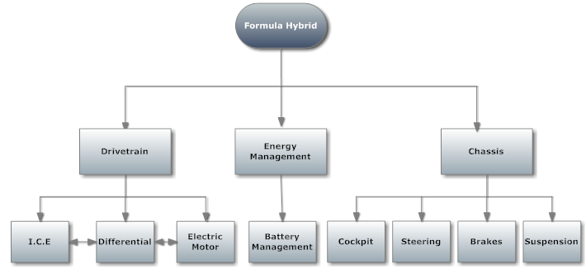

# Figure 1: System Design

## Overview of the System

To give the FAMU-FSU COE an edge against the competition, the group decided a parallel hybrid would be the best decision. The advantages for a parallel system compared to a series system are that parallel systems are more energy-efficient and have better overall performance as compared to hybrids in series. The drawback pertains to the complication of coupling the two different energy sources and making sure that a smooth transition between the two is fast, safe and easy to accomplish. This task may be accomplished through a clutch on the electric motor as well as rpm gauges and an I.C.E clutch to aid the driver through the proper gear ratios of the coupling. As well as drivetrain additions, the group will also make significant suspension changes. These changes will allow for a more reliable system as well as the earning of style points in the design portion of the competition for having the suspension fully adjustable. Another major addition the group feels is necessary is a cockpit dashboard. It is potentially possible for the E.M to fail due to its’ maximum RPM limit. Driver error can occur and cause unnecessary failure if the driver is not properly informed on the vital signs of the propulsion systems. These sensors will aid the driver and will ensure that the proper use of the vehicle is being implemented. The most important of these sensors and one of the most innovative features being implemented this year is the Battery Management System. This system will not only allow the vehicle to be better managed during charging and discharging, but it will also greatly help the design portion of the competition with style points as well.

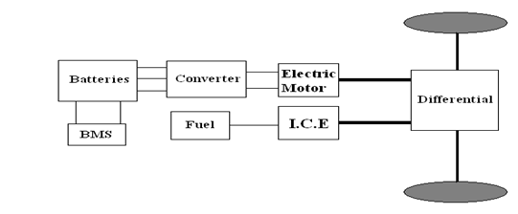

**Figure 2:** Overview of Parallel System Hybrid

## Major Components of the System

Being that this is a hybrid competition; two energy sources are required to be able to compete. The electric energy source has been designed and implemented already, thus leaving this year’s team the implementation of the internal combustion engine. Hence the I.C.E is one of the most important components of the hybrid system. With that being said, the group has to implement a Kawasaki Ninja 250 R engine into the vehicle. Even though this engine was inherited from last year, the decision was made to keep it because all the necessary add-ons have already been purchased and are functional, i.e. radiator, gauges, clutch and fuel tank. This engine was also chosen because its’ power to weight ratio is optimal and also serves as the maximum size allowable for the competition (250cc) and gives the group the best chance of winning. The methods to which the I.C.E will be coupled to the E.M is via the differential. A chain and sprocket system will link the I.C.E’s output shaft directly to the differential housing itself. Through the proper gear ratios and clutch, the vehicle will be able to shift seamlessly from electric propulsion to combustion propulsion.

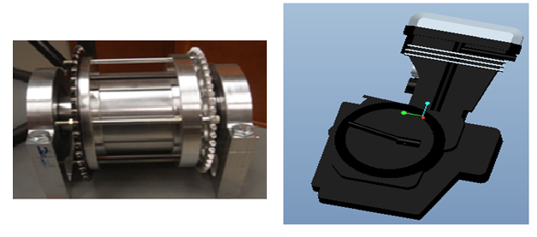

**Figure 3. Left:** The I.C.E sprocket coupled with the E.M via the differential.

**Right:** The Pro-Engineering model of the Kawasaki 250cc internal combustion engine being retrofitted into the vehicle.

Another major component of the vehicle is the Battery Management System. This system is responsible for taking individual voltage readings from the 120 individual batteries and sending that information to the BMS controller. The objective of the BMS is to manage the recharging of the battery packs within the vehicle as well as monitor, protect and balance the state of the Venom 5S 5000mAh batteries. The Battery Management System will also include voltage and current sensors that will display the amount of voltage and current left. Currently, after doing some research and viewing funding options, the CPE/EE side has been focusing on one system that caught their attention, the Elithion-Lithumate Battery Management System. This system offers several attractive features to it which include versatility, relatively easy means of installation and safety. After analyzing several design options, the team determined that the best option is the Elithion Lithiumate BMS from Evolve Electronics and that is the system currently being retrofitted into the hybrid vehicle.

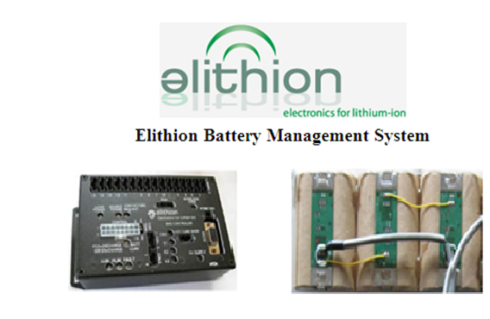

**Figure 4. Left:** The CPU resposible for making adjustments in the rate of charging and dishcarging the batteries.

**Right:** The picture of the setup being implemented on the batteries to connect the voltage sensors in series for all the litium batteries.

Another major component of the vehicle is the suspension. Currently the tubing that is responsible for the frame is over ten years old and is comprised of hollow steel tubes with multiple bends in it. This year the group is implementing a much more innovative yet stronger design, straight solid tubing. The previous idea of A-arms was redesigned and now straight bars will be installed instead. Not to mention solid steel tubes will be used, as well as the ability to adjust the suspension on the fly. This is accomplished by installing opposite threading hind joints on each strut bar. With a notch cut in the center of the bars a wrench can be used to turn the bar along its parallel axis. By doing, so the opposite threaded hind joints will either extend in, when turned counter clockwise or contract in when turned clockwise. In either mode the length of the bar will change and thus the group can adjust the toe and camber of each tire with simple tools and effort. This should greatly impress the design judges and should help the group’s chances of winning for the best overall hybrid engineering design. Another suspension modification will be implemented on the uprights for the vehicle. These uprights will be made of lightweight aluminum and will a serve as a strong connection between the struts from the chassis to the tires of the vehicle.

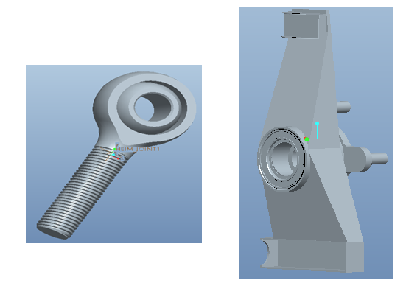

**Figure 5. Left:** An opposite threaded hind joint used for the suspension adjustment.

**Right:** The upright modeled with aluminum and extra support around the hind joints.

Another major component of the vehicle is the brakes. As stated in the rulebook, the vehicle must be able to stop after an acceleration run and also have the ability of locking up all four tires. Previously, the vehicle had only one rear brake that acted on the differential. This was an acceptable design for the competition, however after engineering analysis it was found that the I.C.E sprocket will need to connect to the differential, where the current rear braking system is located. Hence, a new and innovative design was needed and the solution that arose was a duel rear braking system. This will free the space needed on the differential for the I.C.E sprocket, as well as meet the rulebook requirements for having the ability to lock all four wheels after a panic stop is executed.

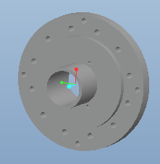

**Figure 6.** Pro-E drawing of the disc rotor needed for our system.

Another major addition to the vehicle is the steering stops. In order to limit driver error, steel blocks will be welded on the rack of the steering system to limit the travel of the pinion. By doing so, the wheels will not be able to overturn as the stops will be preventing the pinion to travel any further on the rack. Since this system is not required for the competition, the group is hoping to impress the design judges and stand out from the others in the competition. This implantation will also serve as an added safety feature, being the ability to overturn the steering wheel that will no longer exist.

*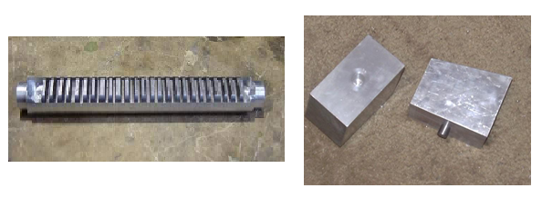*

**Figure 7. Left**: The pinion of the Formula’s Hybrid steering system.

**Right:** The steering stops currently being implemented on the pinion.

Another major addition that will be added to the vehicle this year is the cockpit system. Being that the failure of the propulsion system can occur if the I.C.E is over driven, gauges monitoring these vital readings will be implemented into the cockpit for the driver to easily see. As well as an rpm sensor for the internal combustion engine, there will be several other gauges installed in the cockpit. These include a radiator temperature gauge and an rpm sensor for the E.M. These sensors will help ensure that the proper use of the vehicle is being maintained.

## Performance Assessment

## For the 2011 Hybrid Competition, there will be four categories for which the judges will be examining the overall performance of the vehicle. This include an acceleration run, endurance run, autocross run as well as an overall engineering design portion. To ensure the highest possible score within each category, the team has implemented certain components specially designed to enhance these scores. For example, in the acceleration category, the group has implemented the maximum allowable combustion engine into the vehicle (250CC), based on hoping to improve the vehicle’s overall performance. For the endurance run, the team will implement a Battery Management System that will monitor the battery’s performance, as well as prolong the overall life span of the batteries. Another major category in the competition is the autocross event. This year major improvements were made to ensure that the teams’ autocross lap times minimize as compared to last year’s competition. To accomplish this, the vehicle was retrofitted with a new suspension system, new front and rear brakes and improvements to the steering of the car. All of which will allow the car to have better high speed turning capabilities and allow a lower overall lap time. The last major category to which the judges will be reviewing the vehicle is the static design portion of the competition. This is where the judges give points for new and innovative ideas as well as the overall engineering design of the vehicle. To ensure that the group performs outstandingly in this category, several components were installed on the vehicle to aid this idea. These systems include the Battery Management System, a newly designed brake system as well as a fully adjustable suspension, a cockpit system to display all the vital propulsion readings to the driver and a seamless means of coupling between the E.M and I.C.E. With the implementations of these systems, the group feels confident in the overall design of the vehicle and expects only the highest results from this competition.

## Design Process

Currently the hybrid team is in the position to make significant improvements to the overall vehicle’s performance. After a semester of research, major decisions have been made and are ready to be implemented into the vehicle pending the ordering and installation process. These improvements should increase the overall performance of the vehicle as well as impress the design judges with the team’s new and creative designs. The most important decision that the team had to tackle this year was the means of coupling between the I.C.E to the E.M. Although this decision still remains on being decided, the group has two different concepts that will work and further research is needed before one system can be chosen. The easier of the two solutions involves two mechanical clutches, one two disengage the electric motor from the drivetrain and the other to shift through the I.C.E gears like a manual vehicle. Although the implementation is easy, the means to drive the vehicle becomes more complicated and adds a lot of unnecessary driver error into the vehicle. The latter of the two solutions involves a motor controller installed on the electric motor and I.C.E drivetrain to match the different torque outputs into a continuously uniform torque output. Although this solution sounds ideal, the lack of complete knowledge on this process as well as limited funds, makes this solution more complicated than the previous. With all this said, this decision remains to be undecided and a solution is forthcoming pending more engineering analysis and respones from certain companies.

Another decision that was made by the group was to keep the current frame of the vehicle the same without adding extra support, even through extra weight is being added to the system. To arrive at this conclusion, engineering analysis was performed and it was found that a 13% increase in weight with respect to the vehicle is negligible and can be neglected.

One of the most innovative decisions was that of choosing the Battery Management System, which shall be implemented onto the vehicle. Being the electric propulsion system was already installed on the vehicle, the decision in choosing a BMS system mainly relied on the ability for both systems to be compatible. After several contacts with Evolve Electronics, it was concluded that their Elithion Lithiumate BMS will be compatible with the system currently installed on the Formula Hybrid and the decision was made to implement this system. This system should greatly improve the overall life and performance of the batteries, as well as impress the design judges with a innovative idea.

The last major decision which should help improve the group’s overall performance is the addition of a new suspension and braking system. After performing some necessary performance tests on the vehicle, it was concluded by the group that this addition was needed. Not only will the previously suspension be removed and reinstalled but the significant improvement of a fully adjustable suspension will be implemented. As well as the suspension, the braking system was also decided unanimously to be ineffective and to be lacking the performance needed to perform at a high level. As a result of this, a dual rear braking system will be implemented onto the vehicle as well as bigger rotors and brake pads then were previously installed. This should greatly improve the vehicle’s ability to take turns at higher rates of speeds and will also assist in the overall design portion of the competition as well.

# Design of Major Components

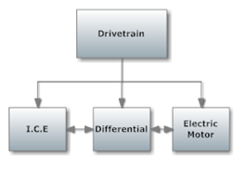

**Figure 8**. Block Diagram for the Drivetrain

## Drivetrain

The coupling of the E.M with the I.C.E is currently in the research and concept generation phase of the design process. A wide range of concepts have been generated to complete the task of coupling the two motors. The concepts that have been generated depend on multiple constraints, one of which is the maximum rpm that the electric motor can operate at before mechanical failure occurs. The possibility of burning up the E.M by means of the I.C.E is another constraint that the team must design the coupling around. Limiting the risks of the electrical motor failure is discussed in **Section 6.1: Technical Risk 6**. The simplification of the control and driver interaction of the operational features of the two motors is considered during the design process. Ensuring a smooth transition from electric power to gas power and vice versa is desired in the coupling design.

The concepts generated below involve the coupling of the E.M with the I.C.E through the differential. The current drivetrain has been designed so that the driven sprockets from the E.M and the I.C.E are installed on opposite sides of the differential. The gearing ratios have been chosen and the sprockets have been manufactured. Table 3.1 shows the gear ratios for the electric motor (E.M) (5.2:1) and gas engine (I.C.E) (45:14). The gear ratio is dependent on the number of teeth on the driving and driven sprockets. This value corresponds to the first row of numbers in Table 3.1. The table shows the gear ratios for each of the six gear s in the I.C.E’s transmission. Table 3.1 displays the value of the rpm of the two driving and driven sprockets. Note that the driven sprockets on the differential have the same rpm value. The table shows the operating conditions for the I.C.E at a max rpm of 12,000 and a mid rpm of 7,000. The risks assessment for the I.C.E is further discussed in **Section 6.1: Technical Risk 3** in regards to any faulty components orerrors within it.

**Table 3.1** Electric Motor (E.M) and Internal Combustion Engine (I.C.E) Gear Ratios

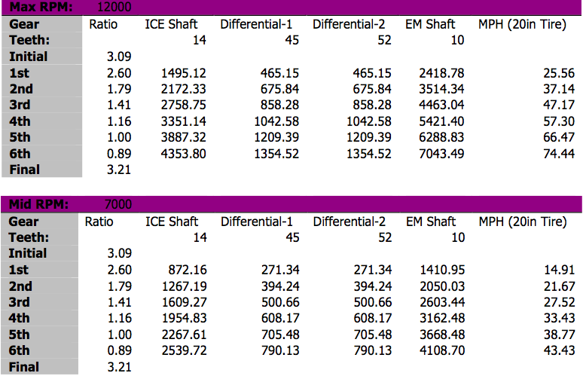

A design concept generated to couple the two motors involves the use of a motor controller to automatically match the rpm of the driven sprocket of the electric motor to the rpm of the driven sprocket from the I.C.E. The current motor controller is programmed using torque control to deliver a specific amount of torque from the electric motor during operation. Rev matching the two motors would allow for the driver to use one throttle to operate both of the motors and would simplify driver interactions and control. Programming and implementation of a motor controller to compute the algorithms involving the rpm and six different gear ratios of the I.C.E and then functionally matching the rpms of the electric motor, involves complex programming and expensive components.

The complex programming poses a risk to the limited schedule that the team’s work is dependent of. The team members are also concerned that employing this method of coupling the I.C.E with the EM may be beyond current members’ knowledge and ability. The driver would not be able to operate the I.C.E in a manner that would cause the electric motor to spin faster than its maximum rpm of 6,000. This effect will limit the I.C.E operating rpms and cause it to be unable to reach its maximum power delivery potential. Therefore, the rpm limit for the electric motor will be given by the manufacturer, Agni Motors, but whether the limit corresponds to a mechanical failure or electrical burn up is unclear. The manufacturer has been recently contacted and the team is waiting on the reply.

A second design concept generated by the formula hybrid team involves the use of mechanical clutches on both the I.C.E and EM. The I.C.E uses a manual six gear transmission and is outfitted with a mechanical clutch. This feature allows the driver of the vehicle to operate the EM with no effect on the I.C.E. The electric motor is not outfitted with a clutch, meaning that when the driver operates the I.C.E, they are directly spinning the shaft of the EM. A proposed design is to implement a mechanical clutch onto the electric motor and allow the driver to operate the two motors using two throttles independently with no effect on each other. The driver is also able to operate the motors simultaneously if chosen to do so. This design limits the possibility of mechanical failure and electrical burn up of the electric motor. The only possibility of mechanical failure or electrical burn up of the EM occurs when the driver disengages the clutches of both motors and both are powering the vehicle. This scenario requires that the driver be aware of what I.C.E rpm’s in each gear will cause the EM to spin at its maximum rpm of 6,000 and won’t accelerate the I.C.E to an rpm greater than this value.

The implementation of a clutch onto the electric motor is possible, with constraints being the limited space around the electric motor where the clutch would be installed and the keeping of operating controls being simple and easy to use. A proposed idea to keep the operations easy to use is to utilize an electrical solenoid to operate the clutch on the electric motor. This design features a simple pushbutton on the steering wheel that triggers a voltage and coincidently causes the solenoid to engage the clutch. Using a solenoid will allow the driver to operate the clutch without having to continuously keep pressure on a clutch pedal or handle like a standard clutch would operate. This feature will make powering the vehicle under only gas power, making it easy and make it convenient for the driver. In this manner, when the driver wants to use electric power, they simply press the pushbutton once. This will then trigger the solenoid and disengage the clutch on the electric motor.

A third design approach of coupling the electric motor and combustion engine involves no clutch on the electric motor. The team is awaiting the reply from Agni Motors in regards to the maximum rpm of the electric motor and whether it corresponds to electrical or mechanical failure. If the response from Agni is that it is purely an electrical failure, then the team can avoid this and free spin the electric motor faster than its’ limit of 6,000 rpm via the I.C.E by cutting the current to the motor. This design involves using two independent throttles. On the other hand, if the maximum rpm limit of the EM corresponds to mechanical failure, this approach will require that the driver does not operate the I.C.E to an rpm value greater than that, which will cause the EM to reach its maximum rpm under any condition. This design approach may require that the driver prevents the current flowing to the electric motor when they are shifting gears on the I.C.E. This operation method may need to be implemented to prevent the chain on the I.C.E’s sprockets from possibly snapping due to a constant torque delivered by the electric motor. Multiple and disagreeing opinions on this matter have been received by the team from faculty and past years’ team members and further testing will be done to verify or deny the matter.

A combination of the design ideas previously proposed is also another possibility. This includes rev matching the motors using a motor controller and also the installment of a clutch on the electric motor. This design would allow the driver to operate the I.C.E to its full potential without burning up or causing mechanical failure to the electric motor. The same risks and benefits as stated earlier associated with rev matching using a Motor controller or PC, are present.

The decision matrix below compares the concepts developed for the coupling of the electric motor with the internal combustion engine. The most important factor for the design is performance. Ease of implementation and operation are weighted equally and more importantly than total cost. These weighting factors were chosen because the coupling is required and the team is willing to allocate a substantial portion of the budget if the implementation is ensured. The decision matrix reveals that the use of an electric motor clutch is the best coupling design. The use of an electric motor clutch did not rank the highest in any of the judging categories but had the greatest overall value. This result will greatly influence the team’s decision for the coupling design.

**Table 3.2** Decision Matrix of Electric Motor and I.C.E Coupling

|  |  |  |  |  |  |
| --- | --- | --- | --- | --- | --- |
| Design Options | Total Cost | Ease of Implementation | Ease of Operation | Performance | Total |
| Weight | 10% | 15% | 15% | 60% | 100% |
| Automatic Rev Matching | 0 | 0 | 1 | 0.5 | 0.45 |
| No Clutch on Electric Motor | 1 | 1 | 0.8 | 0.5 | 0.67 |
| Electric Motor Clutch | 0.8 | 0.8 | 0.7 | 0.9 | 0.845 |
| Automatic Rev Matching with Clutch on EM | 0 | 0 | 0.8 | 1 | 0.72 |

***I.C.E Clutch and Throttle***

The I.C.E clutch and throttle acquired are pull chord actuated and will be converted from handle actuation to floor foot pedal actuation. The floor foot pedals have been installed into the vehicle and cable clutch and throttle lines will be connected. This approach was taken to simplify controls for the driver and to replicate the clutch and throttle layout in a standard vehicle.

***I.C.E Gear Shifting***

The I.C.E’s six gear manual transmission requires that the team implements a simple and easy to operate method of shifting gears. There are two approaches to shift gears for the I.C.E. The first being the use of a standard manual lever located in the cockpit. The other approach is to integrate paddle shifting to shift gears. Paddle shifting allows the driver to actuate an electrical solenoid by means of an electrical relay triggered by a pushbutton. A schematic of this is shown in Figure 9. The solenoid uses a spline shaft connector that connects to the spline shaft on the transmission of the I.C.E. The team has decided to implement paddle shifting and agreed that manually shifting the gears without the use of paddle shifting will be too difficult for the driver to control and race competitively at the same time. Table 3.3 is a decision matrix that shows how the team came to this decision. The ease of operation and performance have the highest weighting factors. Paddle shifting components are currently being researched from suppliers online.

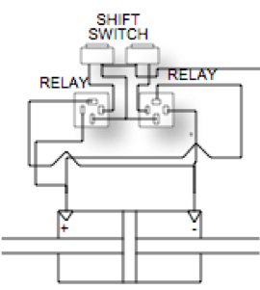

**Figure 9:** Paddle Shifting Schematic

**Table 3.3** Decision Matrix of Gear Shifting

|  |  |  |  |  |  |
| --- | --- | --- | --- | --- | --- |
| Design Options | Total Cost | Ease of Implementation | Ease of Operation | Performance | Total |
| Weight | 10% | 10% | 35% | 35% | 100% |
| Paddle Shifting | 0 | 1 | 1 | 1 | 0.8 |
| Standard Shifting | 1 | 1 | 0 | 1 | 0.55 |

## Battery Management System

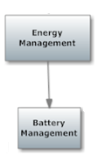

**Figure 10:** Block diagram for the battery management system.

The objective of the BMS is to manage the rechargeability of the battery packs within the vehicle. The BMS will basically monitor, protect and balance the state of the Venom 5S 5000mAh batteries. This also entails to no one battery being used more than another. This will be accomplished using a programmed microcontroller as well as voltage and current sensors. The voltage and current sensors will relay the levels of each battery back to the controllers. In other words, the ammeter checks the current from the batteries and determines how much current is sent to the electric motor, whereas the voltmeter would be additional and would operate the same as the ammeter but with voltage.

The programming of the controller will then dictate which batteries, if any, need to be charged or discharged first. Options for the Battery Management Systems include purchasing one already programmed and adding minor details to it or designing and creating one as a team. The Battery Management System was started last year by Mark Church, one of the former members on the project from last year. He was trying to implement the system from scratch but had several difficulties and was unable to finish due to lack of time.

More so, aside from Mark Church’s step in the integration of the BMS**,** a wide range of concepts were considered when debating on which type to go with. Ultimately, since it was decided that the batteries used the previous year would be utilized this year, a Lithium-Ion BMS was chosen. Primarily, this type of BMS was chosen for two main reasons. One, lithium-ion type batteries currently on the vehicle are most compatible and function best with the Elithion Lithiumate BMS. In addition, these type batteries perform more efficiently than other batteries although they are more costly. The manner in which the various options were weighed out is illustrated in Figure 11 below.

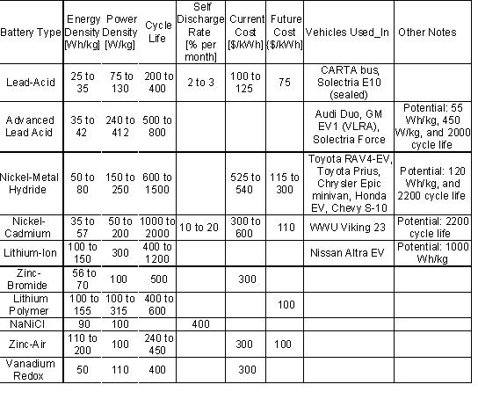

**Figure 11:** Different specifications for various batteries used in the BMS system.

The Lithium-Ion displays characteristics that are much more attractive to the formula hybrid team, in the realm of energy, power and cycle life. The way the cells are set up in the battery is that the cells are shrink-wrapped in groups of 5 and the idea is that with the BMS, when one battery cell doesn’t have enough potential, it pulls from another cell that has a higher voltage. Once there isn’t enough voltage from the system to provide 12 V to the electric motor, the BMS should shut down the batteries’ system. The providing of 12 V comes from the electric motor since it’s what controls the BMS.

In order for the BMS to function appropriately with the car, a cell board needs to be wired to each cell. The only way to accomplish this would be to unwrap the cells and use each individual battery, so that each cell can have direct contact with the sensors. Basically, once the shrinkage of cells is unwrapped, there will be two big battery packs on opposite sides of the vehicle so that each pack contains 60 cells, giving a total of 120 cells on the vehicle.

Another alternative involves utilizing a non-distributive BMS system, which would allow the current system to remain the same. However, this would entail to not having each cell in direct contact with the BMS. This led to another major decision made based off several engineering options that were considered. When Elithion Electronics was contacted, it was brought to the team’s attention that their system would be incompatible with the vehicle since it required having direct contact with individual cells. As mentioned previously, the way the cells are arranged currently is that there are groups of 5 cells per battery, leaving a total of 120 cells in series. Therefore, it was suggested to determine whether the team would go with a Non-distributed BMS or Distributed BMS.

Basically, having cells in individual direct contact with the BMS controller is a Distributed BMS while the packs of cells currently in the vehicle are for a Non-distributed BMS. The electrical and computer engineers in charge of this task determined that if a Non-Distributed BMS was purchased, then the BMS would be unable to monitor the temperature of the cells. This is a major aspect that the BMS must perform; therefore the Non-Distributed BMS was out of the question. In addition, it was concluded that if and when the shrinkage of cells was unwrapped, then the Distributed BMS being the Eltihion Lithiumate BMS would be compatible with the vehicle.

To further analyze this decision, the two alternatives were contemplated via a decision matrix. As shown below, a distributive BMS would be the best fit for the vehicle. This decision was based off the performance being the number one priority as shown in Table 3.4 below.

**Table 3.4** Decision matrix for the BMS

|  |  |  |  |  |
| --- | --- | --- | --- | --- |
| Design Options | Total Cost | Ease of Implementation | Performance | Total |
| Weight | 20% | 20% | 60% | 100% |
| Distributive BMS | 0 | 0 | 1 | 0.6 |
| non-Distributive BMS | 1 | 1 | 0 | 0.4 |

In regards to the voltmeter and ammeter, a digital display would be most preferred for its accurate readings, which is much more necessary. The car currently comes with an ammeter, therefore if necessary a voltmeter would need to be soughted out.

Previously, the plan was to contact Elithion Electronics for Lithion-Ion in regards to the Elithion-Lithumate Battery Management System. Their system offers several attractive features to it being that the system is versatile, easy to install, safe and life prolonging. It’s fully configurable, supports all cell form factors, protects battery packs from over current, has few wires, and has single wire to adjacent cell boards. Most importantly of all, this system will incorporate what Mark Church was trying to attempt being the monitoring of the batteries. In addition, the system will also balance the system’s state of charge by the cells in the batteries and will protect the packs from under and over voltage, charge and temperature. Elithion provides a Lithium-Ion BMS with the following characteristics:

* Ideally matched to work in high power Lithium-Ion battery packs
  + Up to 255 cells in series (~840 V), no limit to cells in parallel, isolated
  + No limit to cells in parallel, up to 600 A (higher currents available)
  + Includes a contactor drivers, a cooling fan interface and an interlock input
* Ideally matched to
  + Lithium-ion Polymer(LiPo)
  + Standard lithium-cobalt-oxide (LiCoO2)
  + Lithium-Manganese-Nickel-Cobalt (LiMnNiCo)
  + Nano-phosphate / lithium-iron-phosphate / lithium-ferro-phosphate (LiFePO4)
  + Lithium-manganese-oxide (LiMnO2)
  + (Not compatible with lithium-titanate cells)
* Compatible with [a range of chargers, motor drivers, displays](http://liionbms.com/php/std_bms_compatibility.php)
* Optimized for automotive applications
  + CAN bus, ignition line input, 12V power
* Performs monitoring, evaluation, communication, balancing and protection
  + Monitors the voltage and temperature of each set of parallel cells, and the pack current
  + Evaluates SOC (State Of Charge), DOD (Depth Of Discharge), and SOH (State Of Health)
  + Calculates the pack's internal resistance
  + Determines appropriate CCL (Charge Current Limit) and DCL (Discharge Current Limit)
  + Detects any abnormal conditions and sets a fault accordingly
  + Communicates through a serial port and through a CAN bus, reporting above data
  + Balances the charge through dissipation of excessive energy in most charged cells
  + Protects against over and under-voltage, over and under-temperature, over-current
  + Optional HV Front End tests for loss of isolation and end of precharge current (using a precharge resistor, not supplied)
* Plug and play (for "mules" and proof-of-concept products)
  + Lets you refine your product at your own convenience
* Distributed: electronic assemblies are mounted on cells
  + Consists of: one or more [Cell Boards](http://liionbms.com/php/cell_boards.php) and a [BMS controller](http://liionbms.com/php/controllers.php)
  + Mechanically matched with cylindrical, pouch or prismatic cells
  + Minimal wiring (no "spaghetti"); individual cell voltage and temperature
  + Controller communicates with Cell Boards on cells, and with external system
* As well as the following specs show below in Figure 12.

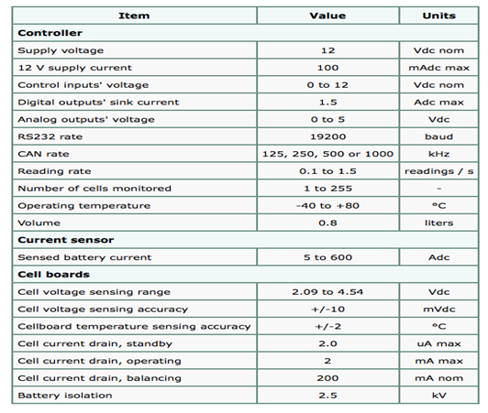

**Figure 12:** Specifications for the cell board for the BMS

More so the team contacted the company to learn of the compatibility of the system and type batteries. The cost for this BMS would run the team around $6,229. This amount includes the cost of 120 cells in series, the “volume compensating fee” of $1,500 and $1,000 for being a first time order. All this is in addition to $70 for an SOC Display. After being in continuous contact with Elithion Electronics, Evolve Electronics was mentioned to sell the exact BMS Eltihion did but at a much more reasonable price. After analyzing several design options such as Mark Church’s attempt last year and the Elthion BMS from Elithion Electronics, the team determined that the best option is the Elithion Lithiumate BMS from Evolve Electronics.

Formerly, after contacting the company Elithion Lithiumate and determining if our battery set up and type batteries were compatible with the vehicle, the budgeting and testing phases would be approached. Once the pricing was determined and if in fact the team would select this system, the actual testing of the system before installing and integrating it into the vehicle would follow. The testing phase shifted to the following steps. The computer and electrical engineers on the team must first determine if there will be sufficient funds for the system based off a potential sponsor the team is still in the process of obtaining. If the sponsorship is approved, the team will go ahead and continue the purchasing of the BMS from Evolve Electronics and proceed with the unwrapping of the cells. Once this occurs and the system has been purchased, the following tests will be performed.

The first phase of the testing is to examine and analyze the system with the batteries before integrating it into the car. The team will complete all necessary wiring and hook it up to two batteries. The batteries will then be connected to two different resistor values and the discharge rates will be analyzed. This discharge rate is a function of the current obtained from the resistance value. The discharge rate will be obtained from the current and voltage values. At this point, the BMS should balance out the batteries. Once the results of this phase are completed, the second phase will be performed where one-fourth of the batteries are connected to resistor values as well and these are proven to be balanced through the BMS. The third will entail to charging half of the batteries to a full potential. The electrical and computer engineers will then drive the vehicle and evaluate the BMS by testing the potential at each battery that wasn’t charged. Therefore, the BMS should once again rebalance them but with the difference that all the batteries on the vehicle are being utilized.

Risk assessments for the BMS are considered critical risks. During the testing process there may be many complications either from error testing, incorrect setup or faulty components/wiring in the BMS. Both of these issues can lead to the retesting of the system or a possible reordering. This issue is further discussed under Section **6.1: Technical Risk 1** and **6.1: Technical Risk 8.**

The outcomes of this BMS, if successful will be to prolong battery life and monitor the voltage and current outputs from each battery. More importantly, the system will resolve the two main issues being the uneven charging of cells within the batteries and the danger of the unacceptable voltage levels being reached. Based on the heavy analysis currently being done to the BMS, the formula hybrid team is coming to a coherent understanding of how it functions and what the best plan of action will be.

## Chassis

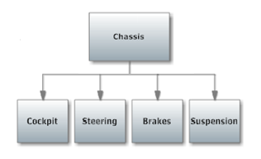

**Figure 13:** Block diagram for the Chassis.

***Cockpit***

The cockpit is expected to contain at five sensors: an rpm sensor for the I.C.E. and the electric motor, a speedometer, and a temperature sensor for the radiator. For the RPM gauge, also known as a tachometer, this sensor measures the number of rotations per mile of the formula hybrid vehicle. When it comes to the speedometer, it measures the instantaneous speed of the vehicle. With the radiator temperature gauge, it determines the temperature of the fluid passing through the radiator indicating when the vehicle is overheated.

Wide ranges of ideas were considered when dealing with the cockpit and dashboard arrangements. Since the dashboard has a specific height that it is required to reach and not exceed, there was only so much room to fit all the sensors, so height and size were very important factors to consider. Since these sensors/gauges work the same way regardless of where they’re bought, the pricing and size are the bigger key factors. For a speedometer, there are two different alternatives to choose from: mechanical or electrical. For a mechanical speedometer, also known as an eddy-current speedometer, the [transmission](http://auto.howstuffworks.com/transmission.htm) and driveshaft are rotating at a speed that corresponds to the vehicle speed. Also the mandrel in the speedometer's drive cable -- because it's connected to the transmission via a set of gears -- is also rotating at the same speed. Finally, the permanent magnet at the other end of the drive cable is rotating. As the magnet spins, it sets up a rotating magnetic field, creating forces that act on the speedcup. These forces cause electrical current to flow in the cup in small rotating eddies or eddy current.

For an electrical speedometer, data is gathered from a **vehicle speed sensor** (VSS), not a drive cable. The VSS is mounted to the transmission output shaft or crankshaft and consists of a toothed metal disk and stationary detector that covers a magnetic coil. As the teeth move past the coil, they disrupt the magnetic field, creating a series of pulses. For each 40,000 pulses from the VSS, the trip and total odometers increase by one mile. Speed is also determined from the input pulse frequency. The circuit electronics in the car is designed to display the speed either on a digital screen or on a typical analog system with a needle and dial. The pros and cons between the two are evaluated through a decision matrix via Table 3.5 shown below.

**Table 3.5** Decision Matrix for the Cockpit gauges

|  |  |  |  |  |
| --- | --- | --- | --- | --- |
| Design Options | Total Cost | Ease of Implementation | Performance | Total |
| Weight | 20% | 30% | 50% | 100% |
| 4-in-1 gauge | 5 | 7 | 9 | 21 |

As evidenced above, a mechanical speedometer is the right choice for this vehicle; it’s a lot more cost efficient, easier to install and works much better for this type of vehicle. For the tachometer, the only types to choose from are analog and digital tachometers, which provide no difference in performance but show a change in aesthetics below in Table 3.6 below.

**Table 3.6** Decision Matrix for thermocouple

|  |  |  |  |  |
| --- | --- | --- | --- | --- |
| Design Options | Total Cost | Ease of Implementation | Performance | Total |
| Weight | 10 % | 40 % | 50 % | 100 % |
| Thermocouple probe | 10 | 6 | 8 | 24 |

The only real added benefit of using an analog tachometer would be that it is cheaper, which is good considering the money being spent on everything else. There aren’t really any differences between temperature gauges. They’re really just dependent on size and the size that’s chosen will be based on the specs for the car dashboard.

The risk assessments for the sensors in the cockpit are pretty moderate risks. There may be issues with faulty equipment or misreading from the gauges or devices installed. Also issues may arise due to the setup and wiring of the gauges to the dashboard. For more detail on the risks for sensors, please refer to **Section 6.1: Technical Risk 5**.

***Rear Brakes***

The rear braking system on the vehicle will be the main focus of the team as this is where the present design options are. The front brakes can only be outboard brakes and thus there are no decisions to be made on them, independent of the rear. Therefore, the rear brakes will be discussed and all conclusions will be applied to the front brakes as well. This block will be broken down with a discussion of an inboard design versus an outboard design followed by the discussion of each of the major components of the design.

***Overall Brake Design***

The functional requirements of the braking system are drawn from the rulebook of the competition. These requirements include that the braking system must be adequate enough to lock all four wheels of the vehicle, immediately after an acceleration run. This task will be accomplished through the success of the components that make up the braking system and will be discussed in subsequent sections.

The most important constraint on the design of the braking system is cost. This is due to the fact that the final budget for the team is not currently secured and with the amount of work that is desired to be completed, most tasks will have to be low cost. The other important constraint on the decision is the amount of effort and time that the design will require. Since the team has the major task of implementing the internal combustion engine within the vehicle this year, this is where most of the effort will be placed. Therefore, other tasks will have to be considered second to this and thus won’t have as much time allotted to them.

The two design options that are available for the rear braking system of the vehicle include the inboard brake design or the outboard brake design. The inboard brake design is a design that has one brake acting on the differential, while the outboard brake design has one separate brake acting on each wheel. These two design options were evaluated using a decision matrix that can be seen below in Table 3.7.

The criteria included in the decision matrix include the price, ease of implementation, and the performance, each with a weight decided by the team. A scale of 0 to 1 was used for the rating in each category, where a 1 is the best in that category and a 0 is the worst. In Table 3.7, it can be seen that the outboard brake design is the design that the team has decided to implement. This outboard brake design was chosen mainly because of its ease of implementation. The cost of the two designs were determined to be about equal, thus not having an effect on which design the team would move forward with. For the inboard brake design, the team would have to redesign and rebuild differential parts. The redesigning of these differential parts would be necessary if the inboard design was kept because the bolts that secure the brake caliper to the differential were not deemed thick enough to withstand the braking force.

Therefore, these bolts would need to be thickened and the differential plates that they connect to would also have to be remade to fit these new bolts. The cost of the materials alone that it would take to rebuild the necessary differential components would be about $100. On top of this cost, new sprockets for the internal combustion engine and electric motor would have to be purchased in order to fit onto the new differential casing. This adds up to about the same cost of a new brake caliper and rotor set. Since the original brake rotor and caliper were already decided upon to be replaced by the team, this brings the total cost to about the same as for the outboard design.

The ease of implementation follows the same logic as the cost because the team does not have to take apart the differential, rebuild it and reassemble it if going with the outboard design as would be necessary if going with the inboard design. Finally, the inboard brake was decided to be the better design in terms of performance because it decreases the amount of unsprung weight on the vehicle. This is because the inboard brake design is supported by the suspension as opposed to the outboard design, in which the brake calipers are not supported by the suspension. The more unsprung weight a vehicle has, the less handling and suspension performance it has.

**Table 3.7** Decision Matrix for the overall brake design

|  |  |  |  |  |
| --- | --- | --- | --- | --- |
| Design Options | Total Cost | Ease of Implementation | Performance | Total |
| Weight | 40% | 40% | 20% | 100% |
| Outboard Brakes | 0.5 | 1 | 0 | 0.6 |
| Inboard Brake | 0.5 | 0 | 1 | 0.4 |

Since this overview discussion for the braking system is only about making the decision to use inboard or outboard brakes, there is no analysis that is to be made here. The decision to use outboard brakes has been made, as show above in Table 3.7, and the analysis and assumptions for each component of this system will be discussed in the following subsections. The assessment of the outboard design to satisfactorily meet the functional requirements assigned to it is also based on its’ subcomponents. If each of its’ subcomponents are able to meet their functional requirements, then the overall brake design will be a success. These individual assessments will be discussed in the following subsections.

The failure of the braking system is a great risk that the team has to consider when preparing for the competition. If the braking system were to fail, the team would most likely not be able to lock the wheels of the vehicle as required and would thus be disqualified from the competition. This is a low risk, due to the fact that the braking components are being purchased. This could have severe consequences. Please refer to **Section 6.1: Technical Risk 4** for more information.

***Master Cylinders***

The master cylinders that were purchased by the previous team are going to be utilized by the team this year, as they are sufficient in providing enough brake pressure to the calipers. This will be shown in the caliper section analysis, as these cylinders were used in making the calculations for the brake calipers that are to be utilized. Therefore, the calipers that will be utilized and their success, are based upon these master cylinder dimensions.

***Brake Rotors***

The brake rotors serve the purpose of converting the force provided by the brake calipers into a torque applied to the vehicle’s axle, while also dissipating the heat created by these pads. Therefore, their most important functional requirement is that they provide a long enough moment arm to create a large enough torque to lock the vehicle’s wheels as required by the competition rulebook.

As already mentioned in the overview discussion of the braking system, pricing is the major constraint on any decision that the team has to make. This is no different for the decision on which brake rotors the team is to use. The second most important constraint on the brake rotors is the size limitations. Since the outboard brake design was decided upon by the team, the brake rotors and calipers will be placed inside the wheel wells of the vehicle. This means that the rotors as well as the calipers must fit inside the wheel wells, thus limiting the diameter and thickness of the rotors that can be utilized.

Brake rotors are specially made to handle the high heat that is conducted to them through the brake pads. For the team, this means that the brake rotor is an item that must be purchased and not designed or fabricated. For this reason, the only design option that the team has to consider when deciding upon the brake rotors, is the diameter of the rotor. Since the radius of the rotor is the length of the moment arm that the braking force is using to create the torque, which will stop the axle, the rotor with the largest possible diameter will be chosen. This will provide the largest possible torque and thus, decrease the amount of force that the brake calipers need to supply. Given that the team is already purchasing its brake calipers from Wilwood Engineering, as mentioned in the following section, the rotor will be ordered from them as well to simplify the ordering process.

The analysis performed on the brake rotors is discussed into the analysis for the brake calipers in the following section. This analysis only consists of calculating the amount of torque that the rotors generate based upon the amount of force delivered to them by the brake calipers. Due to the rotors being purchased by a proven manufacturer, they can be deemed safe in terms of thermal and mechanical failure for the considered application. Therefore, the torque calculation is all that is necessary for the brake rotors in terms of analysis. As shown in the numerical calculations, found in the Appendix, it can be seen that the rotors provide a long enough moment arm to calculate the necessary torque needed to lock the wheels of the vehicle. This shows that the rotors will be very successful in fulfilling their functional requirements as defined by the team. The specific brake rotor selected by the team for this year’s vehicle is shown in Figure 14.

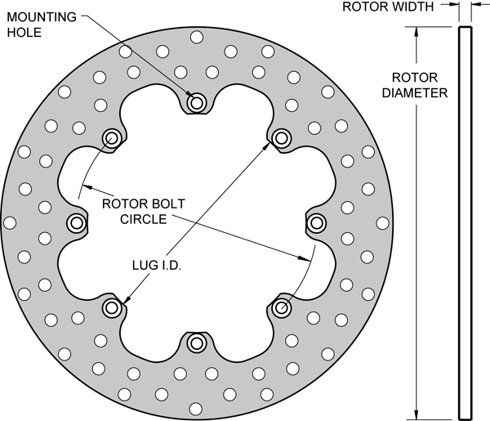

**Figure 14:** Drawing of the brake rotor to be used by the team

The brake rotors are not being considered in the risk assessment due to the fact that they are professionally manufactured and are not being used at the high level that they are designed for.

***Brake Calipers***

The most important requirement for the braking calipers is that they are able to apply enough force to the brake rotors in order to lock all four wheels of the vehicle immediately after an acceleration run. This will be the key determinant in the selection of the calipers. The most important constraint on the brake calipers is the price, as stated previously. First-stage selection screening will also begin with price because mid-range calipers are all that is necessary. Higher end calipers will be excessive and unnecessary. The next most important constraint on caliper selection is rotor selection. Brake calipers are designed to operate up to a maximum rotor diameter and width. Therefore, rotor selection limits caliper selection greatly. The next most important constraint on brake caliper selection is the size of the calipers. Due to the limited amount of space inside the wheel wells, selection is limited to the calipers that will fit comfortably within the well, without interfering or making contact with any other components inside it. The current design, as employed by the previous team, had this dilemma as some of the calipers rub on the inside of the wheel well. This created undesirable wear on the calipers and wheel well, along with unnecessary friction. The final constraint on the caliper selection is the least important and is a constraint that is imposed on by the team; this is the constraint on the number of pistons in the caliper. The calipers are limited to a maximum of two pistons per caliper as this is all that is necessary. Any caliper with more pistons than this will be redundant in terms of performance and will only add to the size and cost of the caliper.

When considering design options for the brake calipers, only two options are available. Brake calipers come in either the floating or fixed type. The decision matrix for choosing which type of caliper to use is shown below in Figure 3.8 and will be briefly explained. The decision criteria chosen for comparing the brake caliper types are price, ease of installation, user interaction, and performance. Since price is a major constraint on the team, price was given a weight of 30%. Ease of install is convenient but not a major deciding factor, thus it was given 10%. User interaction and performance are both major decision factors due to their influence on performance and driver safety, thus they were weighted just as heavily as the price of the caliper. The team used the same scale from 0 to 1 as described earlier. For the scoring, floating calipers won the category for price and ease of install. Floating calipers are usually easier to manufacture because of their larger manufacturing tolerances, hence they are generally cheaper. In addition, are also very forgiving during installation because their ability to float makes them very generous, when it comes to caliper-rotor alignment.

On the other hand, fixed calipers won the categories of user interaction and performance. Since fixed calipers have at least one piston on each side, they are less tolerant to caliper-rotor alignment. These results in a brake pedal have very little play and an almost perfectly linear relationship between pedal travel and fluid pressure. This gives the driver a high-quality feel in the brake pedal and allows for accurate braking.

**Table 3.8:** Decision Matrix for caliper type.

|  |  |  |  |  |  |
| --- | --- | --- | --- | --- | --- |
| Type of Caliper | PrI.C.E | Ease of Install | User Interaction | Performance | **Total** |
| Weight | 30% | 10% | 30% | 30% | 100% |
| Floating Caliper | 1 | 1 | 0 | 0 | 0.4 |
| Fixed Caliper | 0 | 0 | 1 | 1 | 0.6 |

In order to verify that the chosen brake system would be adequate in meeting its functional requirements, the system had to be analyzed. This analytical process will be briefly described with the actual calculations given in the Appendix. In order to lock the wheels of the vehicle as required, the calipers would have to apply enough torque to the rear axle to match the torque created by the force responsible for stopping the vehicle. The only force that is responsible for stopping the vehicle when the brakes are applied is the frictional force between the tires and road. This can be seen below in Equation 1.

$F=μ_{s}∙N$ (**Equation 1**)

Where,

F is the force due to friction,

µs is the static coefficient of friction,

N is the normal force of the car

The static coefficient of friction was used to calculate this force because it yields the largest value for the friction force, thus guaranteeing the maximum torque is accounted for. The total frictional force is then divided up between the front and rear axle. Then the left and right wheels based upon the vehicle’s dynamic weight distribution. The vehicle’s static weight distribution is determined using scales, whereas the dynamic weight distribution is determined using Equation 2 below.

$W_{r}^{'}=W_{r}+\frac{m∙a∙h}{L}$ (**Equation 2**)

Where,

Wr is the static weight distribution of the vehicle,

m is the mass of the vehicle,

a is the acceleration due to braking,

L is the wheelbase of the vehicle

Dividing the dynamic weight by the total weight will give a percentage that is to be multiplied by the static friction force. This force is then multiplied by the distance to the center of the axle to give the amount of torque it generates on the axle. This is the torque that the calipers need to match in order to lock the wheels. This is given by the equation for torque shown in Equation 3.

$T=F∙d$ (**Equation 3**)

Where,

T is the torque created,

F is the force that is creating the torque,

d is the distance between the axle and the application of the braking force

To determine if the selected calipers can generate the necessary torque to counter act the friction torque, the analysis must now go to the pedal. Using a typical value for the force exerted by a driver during a panic stop and multiplying this by the mechanical advantage provided by the brake pedal, the force on the master cylinder can be obtained. The pressure that this force creates inside the master cylinder can then be calculated using Equation 4 below.

$P=\frac{F}{A}$ (**Equation 4**)

Where,

P is the pressure of the brake fluid acting on the piston,

F is transmitted by the piston,

A is the cross sectional area of the piston

This pressure is then multiplied by the area of the brake pads and then multiplied by the number of pads that the caliper has. This value will give the total force of the calipers on the rotor. This force is then multiplied by the equivalent distance between the application of the caliper force and the axle, to yield the torque generated by the caliper. This torque equation for calipers is given below in Equation 5.

$T=\frac{F∙(D+d)}{4}$ (**Equation 5**)

Where,

T is the torque generated by the calipers,

F is the force created by the calipers,

D is the diameter to the top of the brake pad,

d is the diameter to the bottom of the brake pad

This equation takes into account the shape of the brake pad when considering where to apply the force created by the pad.

When performing the analysis on the braking system of the vehicle, several assumptions were made to allow for simplification. First of all, it was assumed that the frictional force slowing down the vehicle was purely static friction. This was assumed because it yielded the highest value of torque on the axle, thus ensuring that the calipers can lock the wheels if the calculations demonstrated they should. The second assumption made was that the coefficient of friction between the tires and the road is the same as the coefficient of friction between rubber and asphalt. This was assumed because the exact coefficient between the specific tires used and asphalt was not provided by the manufacturer. This value should be very close to the actual value and thus should not affect calculations by much. It was also assumed that the force created by the brake pads acted at the center of the pad itself. This simplified the calculations of the torque generated by the calipers without affecting the results very much. The final assumption in the analyzing of the brakes was that the force exerted by a driver on the brake pedal, while performing a panic stop is equal to 25 pounds. This is an average value that could be exerted by either a male or female driver.

Based on the calculations described above and shown in the Appendix, the team is very confident that the brake calipers chosen will perform as expected. For the rear brakes, the calculations of the torque generated by the frictional force acting on the rear axle yields a value of 1,565 in\*lbf, while the torque generated by the brake calipers was calculated as 1,947 in\*lbf. For the front brakes, the required torque is 1,847 in\*lbf while the torque created by the calipers is 2,010 in\*lbf. This shows that the brake calipers can provide the minimum amount of torque needed to lock the wheels of the vehicle as required by the competition.

The brake calipers chosen by the team are shown below in Figures 15 and 16. The calipers are provided by Wilwood Engineering.

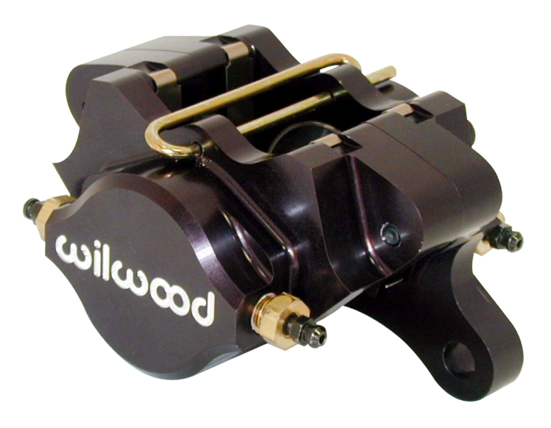

**Figure 15:** Picture of the brake caliper to be used by the team

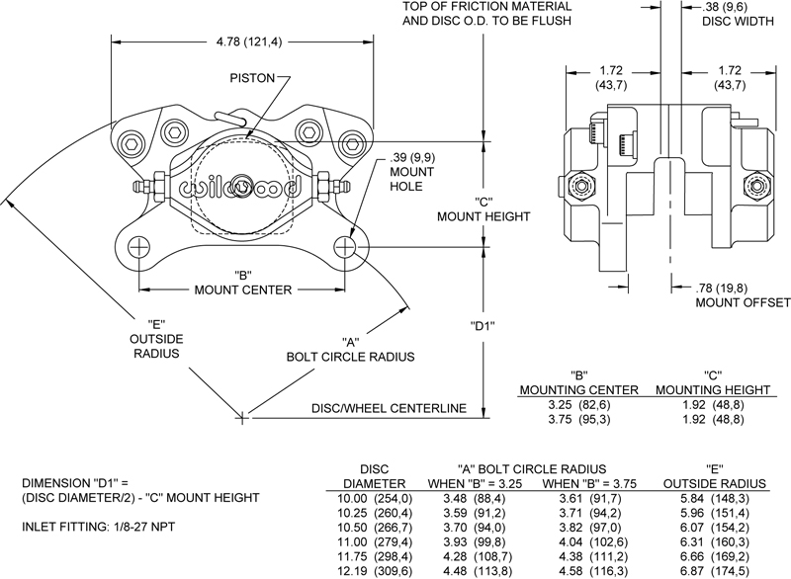

**Figure 16:** Drawing of the brake caliper to be used by the team

The risk assessment for the brake calipers are the same as for the overall brake designed and can be found in **Section 6.1: Technical Risk 4**.

***Uprights***

The uprights on the formula hybrid vehicle are responsible for connecting the wheel assembly and the suspension together. This is the most important functional requirement of the uprights. The uprights also take a lot of load from the vehicle as its weight is shifting throughout the competition. This means that they must be durable enough to take these loads without inducing any plastic deformation during use. The uprights are mainly constrained by the amount of space inside the wheel well because they fit completely inside it. Other than this, the uprights are also constrained by the calipers chosen by the team. This is because the brake calipers mount directly to the upright, thus requiring the uprights to be designed accordingly to allow for this. When designing the uprights, there are no real different options to consider. Every upright is the same in that they are simply a large piece of metal, which have mounting points for the suspension and brake calipers. Therefore, the team will simply design an upright that is as small and lightweight as possible, which will allow for these necessary mountings.

The uprights’ analysis hasn’t been completed since the uprights haven’t yet been designed. This is due to the priorities of the team. The coupling of the internal combustion engine with the electric motor is the major priority for the team, as it determines whether the team can even compete or not. Consequently, this is where much of the team’s effort has been thus far. On the other hand, the design of the uprights is a fairly trivial and quick task when considering the major design decisions already made by the team regarding them. When an upright design is finished and is ready to be tested by the team, the design will be analyzed using the finite element analysis package of Pro-ENGINEER. The team will assume that there’s a generous load to be applied on the mounting locations on the upright, to determine if the design is strong enough and adequate for the competition. Based on these test results, the team will then be able to make a very good assessment of the upright ability in order to perform at the competition and fulfill all necessary requirements.

The main risk associated with the uprights on the vehicle is failure at the joints. This can occur at either the brake caliper joints or at the suspension joints. The effects of this risk would be severe but the probability of it happening is low. This is because the uprights will be thoroughly tested using finite element analysis, thus ensuring a sufficient design. Refer to **Section 6.1: Technical Risk 4** for more information, as this is applicable for the uprights as well as the brakes.

***Suspension***

The suspension on the formula hybrid vehicle serves the purpose of keeping the entire vehicle stable, while it undergoes the dynamic weight transfers created by the accelerations of racing. This is the single most important functional requirement and can be quantified by the team during testing. This quantification will be in terms of the amount of roll that the frame and everything inside it exhibits when the suspension is tested. This will be discussed further in later sections. Another very important functional requirement comes from the rulebook of the competition. This states that the suspension travel is limited to one inch of jounce and one inch of rebound. This means that the wheel cannot travel more than two total inches, with one inch in each direction. These are the two functional requirements of the suspension that will serve as benchmarks for evaluation.

When designing any suspension, there are many constraints on the process in terms of other components. The most important constraint on the design process of a suspension is the completion of the wheel packaging. Before the suspension can even be created, the available locations of where it attaches to the wheel package must be determined. These locations come from the design of the uprights, as this is where the suspension connects to. In order to design the uprights and figure out where the suspension can be attached, the brake disk and calipers have to be mounted. This will complete the wheel packaging and the suspension will then be able to be designed. Besides being limited to the number of connection points between the suspension and uprights, the suspension is also constrained by the design of the vehicle’s frame. The suspension will need to be designed in order to allow for it to properly connect to the frame. The least important constraint on the suspension is development cost. Although this is a very important constraint in many of the other component designs, it is not so important here because there isn’t much of a choice, when it comes to suspension component purchasing. In order to rebuild the suspension, materials are the only components needed to be purchased by the team. The springs and shocks were purchased last year and are more than adequate for this year. With this being said, there isn’t much difference in the cost of materials based on manufacturers. The cost of the materials needed is basically going to be a fixed amount, regardless of where it’s acquired from.

When considering the redesigning of the suspension on the vehicle, research was done to determine what types of suspension are usually present in racing applications. Almost every source stated that the double wishbone design is the suspension that should be utilized in racing applications. This type of suspension is the same suspension that is used by Formula 1 racers across the world, as well as almost all of the competitors in the Formula Hybrid competition. The double wishbone suspension is so ideal for racing applications because it offers the most user-control out of any type of suspension. The geometry of the arms and the elasticity of the joints gives engineers superior control over a wide variety of aspects of the wheels and vehicle. They include the various angles of the wheel and the vehicle dynamics, such as squat and lift. Control is such an important factor for the hybrid vehicle’s suspension because of the high performance that is expected of it. With speeds of to 60 miles per hour and all of the braking and turning that is required by the competition, the suspension design that offers the most control is the smartest decision to go with. Due to all of these factors, the double wishbone suspension system is the design that will be implemented this year as it was last year. The dampers and springs in a Formula 1 suspension are also different from that of other suspension types in that they are placed along the length of the vehicle. To do this, they utilize a pushrod and ternary link to translate the up and down motion of the wheels into front and back motion. This placement of the springs and shocks offers the benefit of less drag. Since the Formula Hybrid competition rulebook states that each team’s vehicle must be open-wheel, this same placement strategy will be utilized by the current team. This will ensure that the suspension is as aerodynamic as possible.

The suspension this year will differ from last year’s design in that last year the team used hollow steel rods for the arms, whereas this year the team will utilize solid aluminum arms. The solid rods will increase the strength of the system, while the aluminum will make it more lightweight. The rods used last year were also made from leftover material, found by the teams, which were about 10 years old. As a result of the team not being certain of where the materials came from or what they have been through, it seems very unsafe to use them any longer.

The final design consideration for suspension is adjustability. Using opposite handed threads on either side of each of the suspension arms, the team will allow each suspension arm to be easily modified. Not only will this score significant points in the design phase of the competition, but it will also allow future teams to adjust the suspension by how they see it. These adjustments may be necessary if the suspension naturally strays from its initial settings over time or if the future teams decide they want to try different tire angles to get different performance out of the vehicle. Either way, adjustability is a good design option to implement.

The analysis for the suspension has not been performed yet due to the constraints on it. As stated before, the uprights must be designed and tested before the suspension. The current progress by the team includes the recent finishing of the entire brake design, but not yet the finishing of the uprights. As stated before, the shortcoming of the design progress in this area of the project is due to the priorities of the team. The design of the suspension is also a fairly trivial task when considering the major design decisions already made, therefore the team is not considered to be off-schedule. Once the uprights are finished and the suspension is ready to be designed, they team will use the front view swing arm and side view swing arm method for creating the suspension. This involves a series of calculations and geometric steps that will result in a three-dimensional model of the suspension arms. The suspension will then be modeled using MSC ADAMS to verify that the correct motion and characteristics are produced. Necessary adjustments can then be made to the suspension model to ensure that the final model behaves exactly as the team desires. Once the final suspension adjustments are made and the team is satisfied with the design, the team will then use finite element analysis to ensure that it can withstand the forces applied to it during the competition. These forces can be pulled directly from ADAMS and used in Pro-ENGINEER. The team will constrain one end of the suspension and apply the maximum load determined by ADAMS, to ensure that the suspension can withstand the loads to which the suspension will be subjected to.

The technical risk for the suspension is very low due to the high amount of analysis that the team will perform on the design before it is built. The only failure for the suspension will be in the joint connections between it and the uprights. Therefore, **Section 6.1: Technical Risk 4** can be referred to for the suspension.

In regards to the overall risks assessment for the Chassis which consists of all the previous parts discussed being the cockpit, uprights, overall brake system and suspension, these are discussed in **Section 6.1: Technical Risk 7.**

# Schedule

## Original Schedule

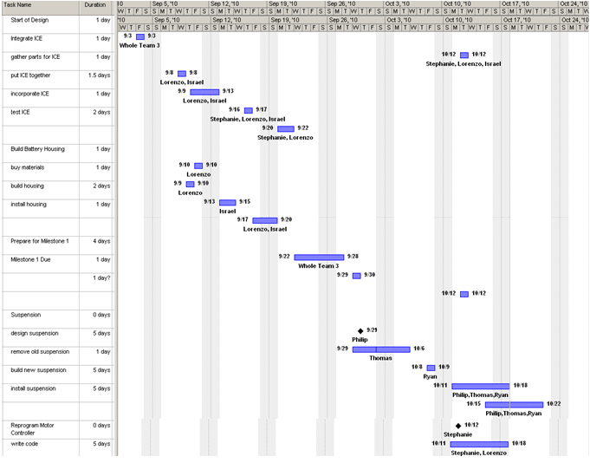

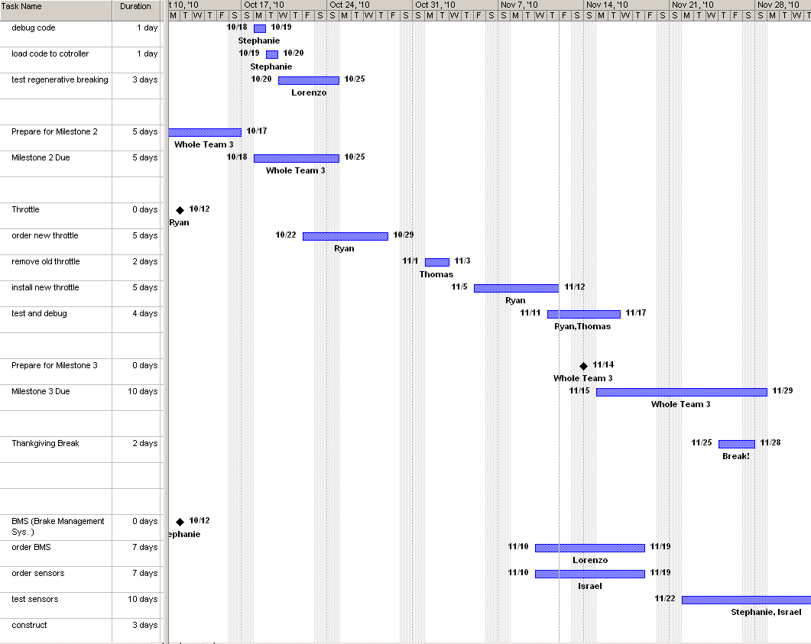

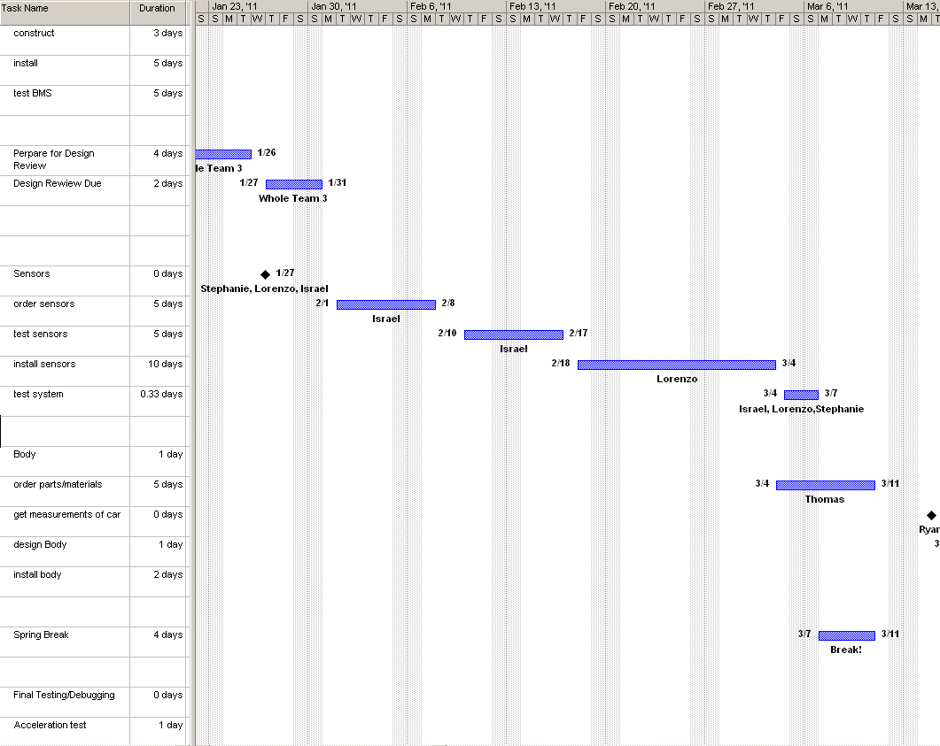

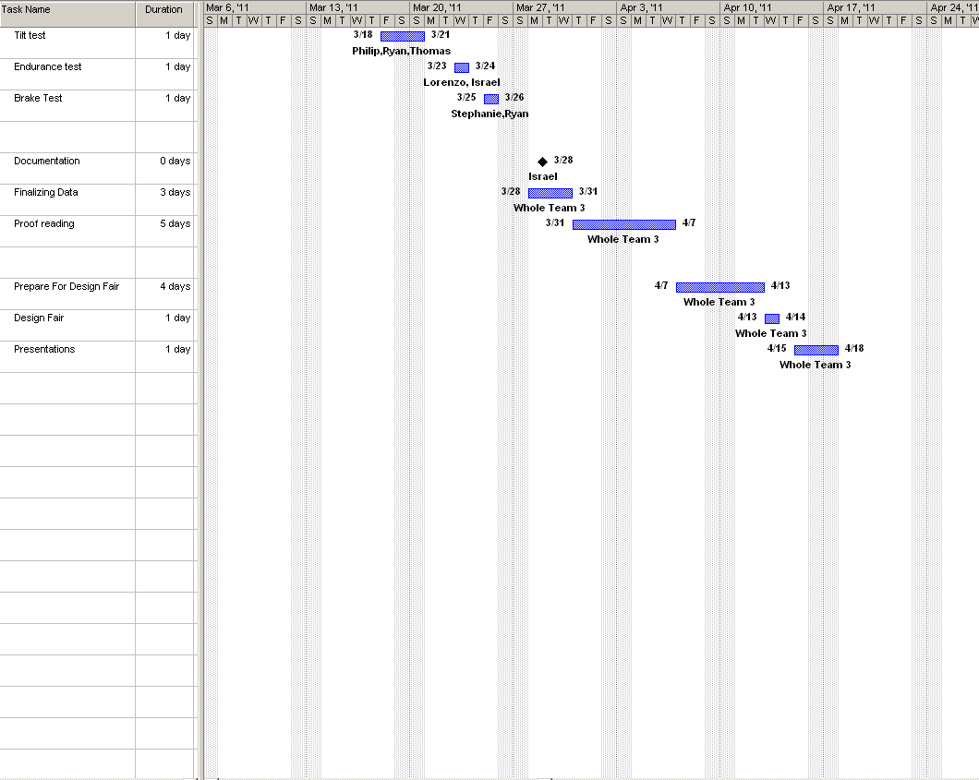

# Milestone 1: Needs Requirements and Specifications

**Milestone 2: Project Proposal and Proposal PowerPoint Presentation**

**Milestone 3: System Design Review Report and PowerPoint Presentation**

**Milestone 4: Detailed Design Review and Detailed Presentation**

**Milestone 5: Design Fair and Final Hardware Demo**

**Milestone 6: Final Oral Presentations and Competition**

## Current Schedule

# 

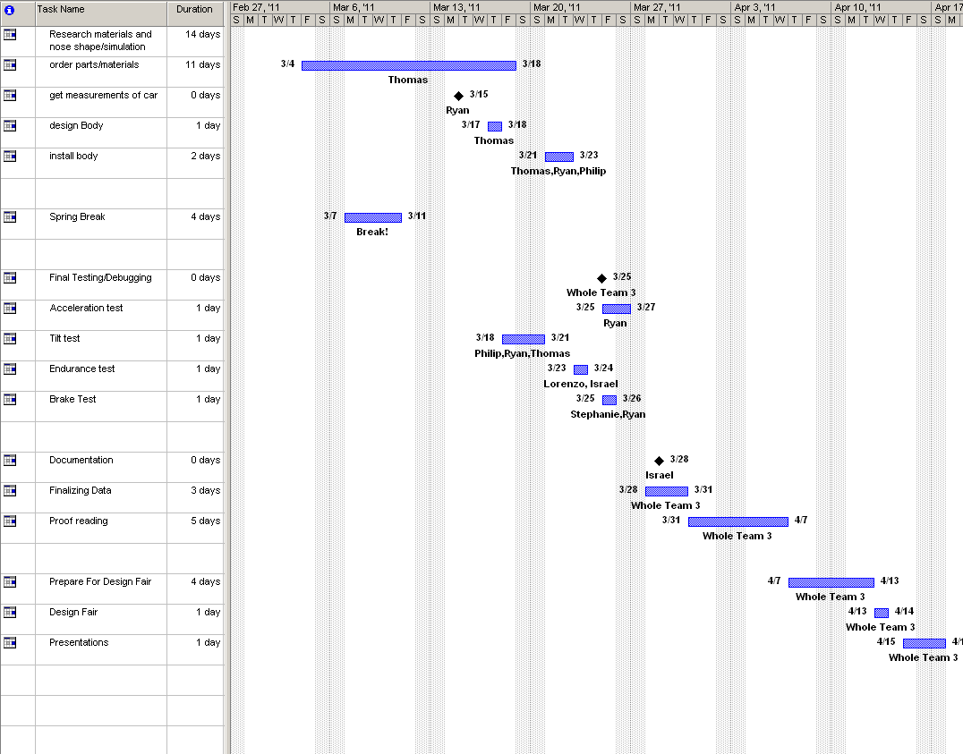

According to the proposed schedule that was presented at the beginning of the semester, the Formula Hybrid Team is currently on schedule. There were a few changes made to the schedule due to the changing of goals and re-prioritizing. The most important change is that the regenerative braking was removed completely from the schedule. This objective was removed because the proposed time frame was inaccurate and the implementation of regenerative braking would have prolonged the project beyond the April deadline. Instead of introducing regenerative braking into the car this year, the team decided to implement a paddle shifter. The implementation of the paddle shifter can be done in the original proposed time allotted for the regenerative braking on the original schedule. Since the group is currently on time, it is very possible that the objective will be completed before time. If the objectives are completed with enough time remaining, the team has decided to attempt the start of implementing regenerative braking into the vehicle.

# Budget Estimate

## Original Budget

|  |  |  |  |
| --- | --- | --- | --- |
| **A: Engineers** | **Total Hours** | **Base Pay** | **Total Pay** |
| **Computer/Electrical** |  |  |  |
| Lorenzo Neal | 384 | $ 30.00 | $ 11,520.00 |
| Stephanie Medina | 384 | $ 30.00 | $ 11,520.00 |
| Isreal Daramola | 384 | $ 30.00 | $ 11,520.00 |
| **Mechanical** |  |  |  |
| Phillip Young | 384 | $ 30.00 | $ 11,520.00 |
| Thomas Emerick | 384 | $ 30.00 | $ 11,520.00 |
| Ryan Zombek | 384 | $ 30.00 | $ 11,520.00 |
|  |  |  |  |
| **Subtotal A** |  |  | $ 69,120.00 |
| **B: Fringe Benefits** |  | **29% of A** | $ 20,044.80 |
| **C: Total Personnel Costs** |  | **A+B** | $ 89,164.80 |
|  |  |  |  |
| **D. Expense** | **Quantity** | **Unit PrI.C.E** | **Total Cost** |
| **i) Braking** |  |  |  |
| 2) Servo Unit | 1 | $ 50.00 | $ 50.00 |
| 3) Master Cylinder | 1 | $ 200.00 | $ 200.00 |
| 4) Brake Lines | 4 | $ 62.50 | $ 250.00 |
| 5) Brake Hoses | 4 | $ 25.00 | $ 100.00 |
| 6) Brake Disks | 4 | $ 62.50 | $ 250.00 |
| **Subtotal** |  |  | $ 850.00 |
|  |  |  |  |
| **ii) Chassis** |  |  |  |
| 2) Labor | 1 | $ 1,300.00 | $ 1,300.00 |
|  |  |  |  |
| **iv) Suspension** |  |  |  |
| 1) Spring/Dampers | 1 | $ 1,000.00 | $ 1,000.00 |
| 2) Heim Joints | 8 | $ 10.00 | $ 80.00 |
| 3) Steel (for control arms) | 30 | $ 15.00 | $ 450.00 |
| 4)Bellcranks | 4 | $ 25.00 | $ 100.00 |
| **Subtotal** |  |  | $ 1,630.00 |
|  |  |  |  |
| **v) Fiberglass/Resin** | 1 | $ 500.00 | $ 500.00 |
|  |  |  |  |
| **vii) Charger** |  |  |  |
| 1) AC-DC Li-Ion Charger | 1 | $ 550.00 | $ 550.00 |
|  |  |  |  |
| **viii) Safety Equipment** |  |  |  |
| 1) Helmet | 1 | $ 150.00 | $ 150.00 |
| 2) 3-point harness | 1 | $ 120.00 | $ 120.00 |
| 3) ProFox Kit (suit, gloves, shoes) | 1 | $ 350.00 | $ 350.00 |
| 4) Hood | 1 | $ 30.00 | $ 30.00 |
| **Subtotal** |  |  | $ 650.00 |
|  |  |  |  |
| **ix) Wheels** |  |  |  |
| Tires | 4 | $ 100.00 | $ 400.00 |
| Rims | 4 | $ 100.00 | $ 400.00 |
| **Subtotal** |  |  | $ 800.00 |
|  |  |  |  |
| **x) Microcontroller** | 1 | $ 250.00 | $ 250.00 |
|  |  |  |  |
| **xi) Miscellaneous** | 1 | $ 2,000.00 | $ 2,000.00 |
|  |  |  |  |
| **xii) Travel** | 1 | $ 5,000.00 | $ 5,000.00 |
|  |  |  |  |
| **xiii) Registration** | 1 | $ 1,500.00 | $ 1,500.00 |
|  |  |  |  |
| **Subtotal of D** |  |  | $ 15,030.00 |
|  |  |  |  |
| **E. Total Direct Costs** |  |  | $ 104,194.80 |
|  |  |  |  |
| **F. Indirect Costs** |  | **45% of E** | $ 46,887.00 |
|  |  |  |  |
| **Equipment** |  |  |  |
| **i) Internal Combustion Engine** |  |  |  |
| 1) Engine/Transmission | 1 | $ 1,000.00 | $ 1,000.00 |
| 2) Cooling System | 1 | $ 150.00 | $ 150.00 |
| 3) Exhaust System | 1 | $ 300.00 | $ 300.00 |
| **Subtotal** |  |  | $ 1,450.00 |
|  |  |  |  |
| **ii) Electric Motor** |  |  |  |
| 1) Motor | 1 | $ 1,200.00 | $ 1,200.00 |
| 2) Motor Controller | 1 | $ 550.00 | $ 550.00 |
| **Subtotal** |  |  | $ 1,750.00 |
|  |  |  |  |
| **iii) Chassis** |  |  |  |
| 1) Steel Stock | 1 | $ 1,500.00 | $ 1,500.00 |
| **Subtotal** |  |  | $ 1,500.00 |
|  |  |  |  |
| **iv) Accumulator** |  |  |  |
| 1) Li-Ion Battery | 2 | $ 1,125.00 | $ 2,250.00 |
| 2) Housing | 1 | $ 75.00 | $ 75.00 |
| **Subtotal** |  |  | $ 2,325.00 |
|  |  |  |  |
| **G. Total OCO** |  |  | $ 7,025.00 |
|  |  |  |  |
| **H. Total Project Costs** |  | **E+F+G** | **$ 158,106.80** |
|  |  |  |  |
| **I. Donated Parts** |  |  |  |
| Internal Combustion Engine |  | $ 1,450.00 |  |
| Tires/rims |  | $ 800.00 |  |
| Microcontroller |  | $ 250.00 |  |
| Chasis |  | $ 1,300.00 |  |
| Charger |  | $ 550.00 |  |
| Electric Motor |  | $ 1,750.00 |  |
| **Subtotal** |  |  | $ 6,100.00 |
| **J. Overall Total Project Costs** |  | **E+F+G-I** | **$ 152,006.00** |

## Current Budget

|  |  |  |  |
| --- | --- | --- | --- |
| **A: Engineers** | **Total Hours** | **Base Pay** | **Total Pay** |
| **Electrical/ Computer** |  |  |  |
| Lorenzo Neal | 384 | $ 30.00 | $ 11,520.00 |
| Stephanie Medina | 384 | $ 30.00 | $ 11,520.00 |
| Isreal Daramola | 384 | $ 30.00 | $ 11,520.00 |
|  |  |  |  |
| **Mechanical** |  |  |  |
| Phillip Young | 384 | $ 30.00 | $ 11,520.00 |
| Thomas Emeric | 384 | $ 30.00 | $ 11,520.00 |
| Ryan Zombek | 384 | $ 30.00 | $ 11,520.00 |
|  |  |  |  |
| **Subtotal A** |  |  | $ 69,120.00 |
| **B: Fringe Benefits** |  | **29% of A** | $ 20,044.80 |
| **C: Total Personnel Costs** |  | **A+B** | $ 89,164.80 |
|  |  |  |  |
| **D. Expense** | **Quantity** | **Unit PrI.C.E** | **Total Cost** |
| **i) Braking** |  |  |  |
| 2) Servo Unit | 1 | $ 50.00 | $ 50.00 |
| 3) Master Cylinder | 1 | $ 200.00 | $ 200.00 |
| 4) Brake Lines | 4 | $ 62.50 | $ 250.00 |
| 5) Brake Hoses | 4 | $ 25.00 | $ 100.00 |
| 6) Brake Disks | 4 | $ 62.50 | $ 50.00 |
| **Subtotal** |  |  | $ 850.00 |
|  |  |  |  |
| **ii) Chassis** |  |  |  |
| 2) Labor | 1 | $1,300.00 | $ 1,300.00 |
|  |  |  |  |
|  |  |  |  |
| **iv) Suspension** |  |  |  |
| 1) Spring/Dampers | 1 | $ 1,000.00 | $ 1,000.00 |
| 2) Heim Joints | 8 | $ 10.00 | $ 80.00 |
| 3) Steel (for control arms) | 30 | $ 15.00 | $ 450.00 |
| 4)Bell cranks | 4 | $ 25.00 | $ 100.00 |
| **Subtotal** |  |  | $ 1,630.00 |
|  |  |  |  |
| **v) Fiberglass/Resin** | 1 | $ 500.00 | $ 500.00 |
|  |  |  |  |
|  |  |  |  |
| **vii) Charger** |  |  |  |
| 1) AC-DC Li-Ion Charger | 1 | $ 550.00 | $ 550.00 |
|  |  |  |  |
| **viii) Safety Equipment** |  |  |  |
| 1) Helmet | 1 | $ 150.00 | $ 150.00 |
| 2) 3-point harness | 1 | $ 120.00 | $ 120.00 |
| 3) ProFox Kit (suit, gloves, shoes) | 1 | $ 350.00 | $ 350.00 |
| 4) Hood | 1 | $ 30.00 | $ 30.00 |
| **Subtotal** |  |  | $ 650.00 |
|  |  |  |  |
| **ix) Wheels** |  |  |  |
| Tires | 4 | $ 100.00 | $ 400.00 |
| Rims | 4 | $ 100.00 | $ 400.00 |
| **Subtotal** |  |  | $ 800.00 |
|  |  |  |  |
| **x) Micro controller** | 1 | $ 250.00 | $ 250.00 |
|  |  |  |  |
| **xi) Miscellaneous** | 1 | $2,000.00 | $ 2,000.00 |
|  |  |  |  |
| **xii) Travel** | 1 | $5,000.00 | $ 5,000.00 |
|  |  |  |  |
| **xiii) Registration** | 1 | $1,500.00 | $ 1,500.00 |
|  |  |  |  |
| **Subtotal of D** |  |  | $ 15,030.00 |
|  |  |  |  |
| **E. Total Direct Costs** |  |  | $ 104,194.80 |
|  |  |  |  |
| **F. Indirect Costs** |  | **45% of E** | $ 46,887.00 |
|  |  |  |  |
| **Equipment** |  |  |  |
| **i) Internal Combustion Engine** |  |  |  |
| 1) Engine/Transmission | 1 | $1,000.00 | $ 1,000.00 |
| 2) Cooling System | 1 | $ 150.00 | $ 150.00 |
| 3) Exhaust System | 1 | $ 300.00 | $ 300.00 |
| **Subtotal** |  |  | $ 1,450.00 |
|  |  |  |  |
| **ii) Electric Motor** |  |  |  |
| 1) Motor | 1 | $1,200.00 | $ 1,200.00 |
| 2) Motor Controller | 1 | $ 550.00 | $ 550.00 |
| **Subtotal** |  |  | $ 1,750.00 |
|  |  |  |  |
| **iii) Chassis** |  |  |  |
| 1) Steel Stock | 1 | $1,500.00 | $ 1,500.00 |
| **Subtotal** |  |  | $ 1,500.00 |
|  |  |  |  |
| **iv) Accumulator** |  |  |  |
| 1) Li-Ion Battery | 2 | $1,125.00 | $ 2,250.00 |
| 2) Housing | 1 | $ 75.00 | $ 75.00 |
| **Subtotal** |  |  | $ 2,325.00 |
|  |  |  |  |
| **v) Battery Management System** |  |  |  |
| 1) First order Fee |  | $1,000.00 |  |
| 2) Compensation Fee |  | $1,500.00 |  |
| 3) Control Unit (120 cell in series) |  | $3,729.00 |  |
| **Subtotal** |  |  | $ 6,229.00 |
|  |  |  |  |
|  |  |  |  |
| **G. Total OCO** |  |  | $ 13,254.00 |
|  |  |  |  |
| **H. Total Project Costs** |  | **E+F+G** | **$ 164,335.80** |
|  |  |  |  |
| **I. Donated parts** |  |  |  |
| Internal Combustion Engine |  | $1,450.00 |  |
| Tires/Rims |  | $ 800.00 |  |
| Microcontroller |  | $ 250.00 |  |
| Chasis |  | $1,300.00 |  |
| Charger |  | $ 550.00 |  |
| Electric Motor |  | $1,750.00 |  |
| **Subtotal** |  |  | $ 6,100.00 |
|  |  |  |  |
| **J. Overall Total Project Costs** |  | **E+F+G-I** | **$158,235.80** |

# Overall Risk Assessment

## Technical Risks

Being some of the major components of the hybrid vehicle are being redesigned with new and innovative technology, some technical risks are to be assumed. To name a few, the coupling between the I.C.E and the E.M poses a threat for success and is the main technical risk associated with the team this year. Another major new and innovative feature being installed is the Battery Management System. Due to the complicity of the system, this also poses a significant threat to the group and strategies must be employed to eliminate any threats that could hinder the group’s chances of winning the competition in New Hampshire come May 2011.

### *Technical Risk 1: BMS Failure*

|  |  |
| --- | --- |
| **Risk** | Faulty sensor information as well as improper charging &discharging of the batteries |
| **Probability** | Moderate |
| **Consequence** | Mild |
| **Strategy** | Proper installation and programming |

Description

The Battery Management System is responsible for making sure that the batteries in the vehicle are all charged and discharged equally. This means that no one battery will be used more than another and that over time the batteries will experience a prolonged life. In addition the BMS will provide a cockpit sensor that will indicate the battery voltage reaming, which in turn can be used to estimate the life left in the batteries. In the event of failure of this unit or parts of it, individual batteries may be overcharged or undercharged, which in turn could affect the vehicle’s overall performance in such events as the restricted electric only run or endurance run.

Probability: Moderate

Currently there are 120 individual cells all wired in series on the Formula Hybrid vehicle. With that many variables, the technical risk was labeled moderate for a failure of one of such component. In addition, the microcontroller will require rather complex computer programming to adjust for the added sensors installed on the cells.

Consequences: Mild

The consequence for a complete BMS failure is mild. Reduced battery life cycle and the inability to monitor charging capabilities will be the main consequences. Both of which will mildly affect the team’s results in the 2010-2011 Hybrid Competition.

Strategy

To alleviate the problems associated with a BMS failure, a programmable microcontroller with individual voltage and current sensors will be implemented on each battery unit. The voltage and current sensors will relay the levels of each battery back to the controllers. The programming of the controller will then dictate which batteries, if any, need to be charged or discharged first.

### *Technical Risk 2: Differential Failure*

|  |  |
| --- | --- |
| **Risk** | The inability to maneuver high speed turns effectively |
| **Probability** | Low |
| **Consequence** | Moderate |
| **Strategy** | Ensure the Hybrid vehicle is driven as required |

Description

Failure of the differential includes seizing of the gears due to lack of lubrication or the stripping of the chain belt that is connected to the differential via the sprocket. Both would occur in the event of human error and improperly using the vehicle.

Probability: Low

The probability of this occurrence is low due to the fact the differential was designed to withstand the forces generated by the coupling of the two different energy sources. All gear ratios have been designed and are in place so that the user error is at its minimum. Also proper lubrication will be regularly maintained by the mechanical engineers leading up to and during the competition.

Consequences: Moderate

Upon failure of the differential, the rear axle would no longer be able to transfer power to the rear tires effectively. Although the ability to drive will remain, the ability to apply different torques to each rear tire on turns will not. This will in turn cause the tires to slip and greatly reduce the vehicle’s ability to maneuver high speed turns effectively.

Strategy

Careful precautions will be implemented by all drivers of the vehicle to ensure the proper usage of the clutch and shifting paddles is used, as well as the ability to shift through the gears of the I.C.E smoothly and under the desired max RPMS. Also using an appropriate lubrication oil when needed, will help ensure that a differential failure does not occur.

***Technical Risk 3:*** ***I.C.E Failure***

|  |  |
| --- | --- |
| **Risk** | Complete shutdown of the I.C.E and its components |
| **Probability** | Mild |
| **Consequence** | Critical |
| **Strategy** | Install rpm and temperature sensors to monitor vital readings from the I.C.E during operation |

Description

There are many failures that can occur and are associated with the internal combustion engine. These include piston failure, the overheating of the coolant and exceeding the top end of the engine.

Probability: Mild

The probability of this event is mild due to the fact that every driver will be well informed on the operating conditions of the engine and only these specified drivers will be allowed to operate the vehicle, under full hybrid conditions. Also with the aid of dash gauges, the driver will be well aware of coolant temperature and other vital readings such as the rpms and speeds of both the I.C.E and the electric motor.

Consequences: Critical

If the I.C.E should fail and the team was unable to install a new one before the competition, the team would be unable to compete as a full hybrid. With this being the second year the vehicle will compete, the only category available is a full hybrid. Thus, just an electric vehicle would not sufficient to compete in the competition of May 2011.

Strategy

The strategy to prevent complete failure of the I.C.E will rely solely upon the driver of the vehicle. Being the internal combustion engine is a motorcycle engine, it’s capable of 13,000 RPM’s. To safely operate the vehicle, the user must ensure that the I.C.E doesn’t reach this limit. If this rpm limit is reached for the duration of time, catastrophic failure will be imminent. Also the driver must be aware of the dash gauge for engine temperature, ensuring it’s operating below its desired temperature.

***Technical Risk 4: Rear Brake Failure***

|  |  |
| --- | --- |
| **Risk** | Having the inability to lock all four wheels and stop in the required distance |
| **Probability** | Low |
| **Consequence** | Severe |
| **Strategy** | Professional Welding and the use of gussets to help reinforce the calipers to the uprights |

Description

Being the rear brake has been relocated to the back wheels, the connection between the disc brake mount and the uprights must be secure enough to ensure failure does not occur. Should failure occur, the vehicle would have the inability to lock all four wheels and would be disqualified from the competition.

Probability: Low

The possibility of the weld between the upright and disc brake mount failing is low because the group can lay multiple welds on top of each other for extra layer of redundancies.

Consequences: Severe

Consequences for brake failure would be severe if the group was unable to make changes before the competition. A weld failure could be fixed on site, permitting there be the appropriate tools available, allowing for re-entry into the competition.

Strategy

To reduce the risk of failure, gussets will be used to reinforce the connection between the caliper and the upright hub. The team will also employ a professional welder using modern technology to ensure the welds are of the utmost standard. Testing the vehicle under dynamic conditions should allow insight on whether failures will occur and if modifications are needed.

***Technical Risk 5: Faulty Sensors***

|  |  |
| --- | --- |
| **Risk** | Incorrect measurements which could lead to the misuse of the propulsion systems onboard |
| **Probability** | Mild |
| **Consequence** | Moderate |
| **Strategy** | Correct installation as well as verification measurements to ensure the vehicle’s sensors are outputting the correct data |

Description

The cockpit sensors will relay vital information to the driver such as, voltage and current to the motor, rpm and temperature of the I.C.E, the speed of the vehicle as well as the miles traveled. If the sensors are returning false information to the driver, then the risk of over using the vehicle’s critical components will increase.

Probability: Mild

The probability of faulty sensors causing critical damage to our vehicle and hurting our chances of winning the competition is mild. Experienced drivers will hear the wind up of the I.C.E and know intuitively when it’s appropriate to shift gears. In the event of catastrophic failure of the sensors, the group will still be able to compete in New Hampshire.

Consequences: Moderate

The consequences of faulty sensor information can lead to the overheating of the I.C.E, as well as exceeding the rpm’s on the electric motor. However, these conditions only exist when driving the vehicle in extreme conditions. An experienced driver knowing the capabilities and limitations of the vehicle would be able to drive the vehicle competitively, without the aid of sensors if need be.

Strategy

Each sensor will be installed accordingly to the manufacturer’s guide to ensure the proper setup is used. To ensure that the sensors are not reading false information, each sensor will be tested with similar devices. Results will be compared for accuracy.

***Technical Risk 6: Damaging Electric Motor (E.M)***

|  |  |
| --- | --- |
| **Risk** | Overheating and destroying the electric motor |
| **Probability** | Medium |
| **Consequence** | Severe |
| **Strategy** | As long as the electric motor is run under 6,000 rpm, catastrophic failure will not occur |

Description

Currently the hybrid vehicle has a 95 series Agni motor installed with a maximum revolution of 6,000 rpm. If this number was to be exceeded for a short duration of time, the electric motor could run the risk of overheating and even failing.

Probability: Medium

The probability of exceeding the capabilities of the Agni 95 motor is medium. This is due to the complicated methods to which the vehicle must be strictly driven. If the driver was to misread his rpm gauges mounted in the cockpit, or misuse the mechanical clutch, a damaged electric motor is probable.

Consequences: Severe

Being the Agni motor is one of the most expensive and critical components on the hybrid vehicle, a replacement would be unlikely. Depending on time and available funds, a replacement can be found and installed prior to the competition. However, the performance will be greatly reduced which will in turn hurt the team’s chances of winning this competition.

Strategy

To minimize the error associated with driving the vehicle, several gauges will be placed directly in front of the driver on the dashboard. Gauges such as, rpm’s of the I.C.E as well as the E.M, voltage and current supplied to the motor, radiator temperature and velocity of the vehicle will aid the driver to make the most informed decision on the proper timing to shift gears.

***Technical Risk 7: Chassis Failure***

|  |  |
| --- | --- |
| **Risk** | Failure of a structural member of the vehicle |
| **Probability** | Minimal |
| **Consequence** | Severe |
| **Strategy** | Structural analysis was performed on the frame of the vehicle taking in consideration for the added weight of the I.C.E and its components, consequently it was found safe and the weight can be neglected |

Description

The chassis is a component that was designed and implemented by last year’s team. The welds that hold the chassis together are critical to the results of the competition and thus will require some attention to ensure the structural integrity still remains. However, being last year’s team passed a full body inspection by a licensed formula hybrid judge and achieved 1st place in hybrid in progress, little if any modifications will be made to the frame itself.

Probability: Minimal

The probability of a chassis failure is minimal at best. If a failure was to occur on the frame due to faulting welds, visual evidence would be clear by now.

Consequences: Severe

Due to the fact that the chassis was one of the most complicated and expensive components on the vehicle, a complete failure would be disastrous. Little time or money is left to allow for such a major malfunction to occur and the consequences for this failure would be to officially withdraw from the competition which is out of the question.

Strategy

The chassis was modeled in Pro-ENGINEER taking in consideration for the added weight of the I.C.E and its components and it was found that a 13% increase in mass with respect to the car can be neglected. In turn, the chassis’s factor of safety using the added weight of the I.C.E was still safely over 2.0, which instills confidence that the frame will perform as designed.

***Technical Risk 8: Overcharging/Undercharging of Batteries***

|  |  |
| --- | --- |
| **Risk** | The risk of destroying one or more of the lithium batteries thru misuse or neglect |
| **Probability** | Mild |
| **Consequence** | Medium |
| **Strategy** | Installation of a Battery Management System to monitor and display vital battery measurements |

Description

As the main means of propulsion and acceleration for the Hybrid vehicle, the car relies on 120 individual lithium polymer batteries. These batteries have a maximum and minimum voltage level that needs to be maintained in order for the vehicle to run properly. If a failure was to occur in one or more components of the batteries, the overall performance of the vehicle and even our results in the competition could be altered.

Probability: Mild

Currently the 2010-2011 Hybrid group is working on installing a Battery Management System on the vehicle. This system will relay the voltage from every cell and display the amount of overall performance left in the batteries. These readings along with the attention to detail, the group feels the probability of overcharging/undercharging the batteries is mild at best.

Consequences : Medium

Depending on the magnitude of the failure, the group would still be able to compete in the Hybrid competition if one or two of the batteries would fail. However, if a catastrophic battery failure were to occur, the group would be unable to complete the electric only run of 75 yards in less than 10 seconds and thus eliminate the group from the competition.

Strategy

To ensure the batteries are being properly charged and discharged, a Battery Management System is currently in the process of being purchased and will then be installed onto the vehicle. This system will rely the voltage from the individual cells and draw power according to the voltage levels of each unit. This will ensure all batteries are discharging equally and that one battery is not being used than any other. In addition, an average voltage reading gauge will be installed in the cockpit to allow the driver to view his power level ensuring the minimum voltage value is not being reached.

***Technical Risk 9: Steering Failure***

|  |  |
| --- | --- |
| **Risk** | Failure of the welds on the pinion ensuring that over steering cannot occur |
| **Probability** | Mild |
| **Consequence** | Medium |
| **Strategy** | Proper installation and excessive welds will be used to ensure steering failure does not occur |

Description

Steering stops on the rack and pinion will be implemented to limit the movement of the front tires. These will ensure that the driver does not have the ability of overturning the wheels into the suspension causing chassis failure.

Probability: Mild

The overall probability of these welds failing is mild. Once installed, these stops will not experience great forces and thus should remain intact indefinitely.

Consequences: Medium

Should the welds fail, the ability for the driver to overturn the wheels into the suspension shall exist. For an inexperienced driver not familiar with this car this, a medium technical risk could arise. However, as long as the driver maintains the proper wheel angle throughout turns, the consequences for a steering stop failure are minimal.

Strategy

For redundancy, the group plans on laying an excessive amount of welds on each steering stop to the rack of the steering system. Being the stops will not be under any static or dynamic forces for the majority of its lifespan these welds should suffice.

**6.*2 Schedule Risks***

Being some of the major components of the Formula Hybrid, depend of factors that our out of the team’s control, schedule delays are inevitable. If a shipping error were to occur on a time sensitive component, a delay could occur that would halter the work of sequential parts and in turn cause a schedule delay. Another major schedule risk is having the availability to work on the vehicle when needed. Currently there are at least five projects coinciding with the Formula Hybrid and the availability for shop time can be limited and hence pose a schedule threat.

***Schedule Risk 1: Parts Arriving Late/Reorder***

|  |  |
| --- | --- |
| **Risk** | Critical components are unavailable for installation due to unforeseen shipping errors |
| **Probability** | Likely |
| **Consequence** | Moderate |
| **Strategy** | Taking in consideration for parts arriving late, time sensitive components will be ordered well in advance allowing for foreseen shipping errors to occur |

Description:

Due to the fact that the majorities of the parts needed for the vehicle are specialty parts and may not be carried in stock, amble time is needed for purchasing orders to ensure schedule delays do not occur. Also attention must be given to the accuracy of PO’s, as this could also lead to wrong parts and schedule delays.

Probability: Likely

Since most parts will be ordered over the busy holiday season, delays from the shipping process should be expected and compensated for. The specialty parts needed and the probability of parts arriving later than anticipated is likely.

Consequences: Moderate

The consequences for parts arriving late would be the delay in the schedule and the project as a whole. Some delays are manageable and easy to overcome, however more important aspects of the project cannot afford a shipping/ordering error and extreme caution must be taken when ordering these parts.

Strategy:

In order to eliminate the risks associated with purchase orders/shipping orders, time sensitive parts will be ordered well in advance and will take in consideration for the possibility of shipping delays to occur.

***Schedule Risk 2: Treasury Access***

|  |  |
| --- | --- |
| **Risk** | Having the inability to purchase necessary equipment due to the lack of vendors’ compliance with FAMU’s purchase ordering system |
| **Probability** | Definite |
| **Consequence** | Medium |
| **Strategy** | Ordering parts in advanced and purchasing the best option available to the group will be the best strategy to combat this schedule risk |

Description:

For the 2011 Hybrid competition, FAMU has placed $5,000 into a FAMU account. This poses a schedule risk because currently only one member of the Formula Hybrid team is a FAMU student. Hence, all purchase orders will have to be assigned to one student and that can complicate the reimbursement process, adding unnecessary delays into the schedule.

Probability: Definite

Being the group has already encountered this problem several times this semester, the probability of treasury access posing a schedule risk is definite.

Consequences: Medium

The consequences of having limited treasury access are a delay in the schedule and the possibility of not completing the vehicle before the competition is as well.

Strategy:

Although the consequences for this risk could be severe, the group understands the process well enough to leave amble time for purchase orders and reimbursements to take place.

***Schedule Risk 3: Sick or Absent Team Member***

|  |  |
| --- | --- |
| **Risk** | Losing a team member for an extended amount of time due to illness or unforeseen circumstances |
| **Probability** | Mild |
| **Consequence** | Medium |
| **Strategy** | The schedule risk associated with the loss of a team member would depend on the remaining tasks to be completed, measures would need to be taken by the remaining group members to ensure the ultimate goal of the hybrid project is executed |

Description:

Currently there are six engineers assigned to the Formula Hybrid Project. If one or more members became ill or had to leave town due to unforeseen circumstances, the extra load for the remaining engineers would in turn create a delay in the schedule and could possibly hinder the completion of the project.

Probability: Mild

The probability of one or group members becoming mildly ill is adequate. However, the probability of one or more group members becoming ill for a sustained amount of time is mild and therefore not a major concern.

Consequences: Medium

Being the Hybrid project is very complex project, a lost team member would result in a tremendous amount of work to do by the remaining group members. New tasks would need to be assigned and the overall scope of the project would have to be adjusted accordingly.

Strategy:

The strategy to ensure that the schedule stays on task in the event of a sick or absent group member would mainly rely on the students still assigned to the project. Depending on the tasks left to accomplish when the group member is absent, new goals and priorities may need to be set to ensure the ultimate goal of competing competitively in the competition come May, 2011.

***Schedule Risk 4: Availability of Support***

|  |  |
| --- | --- |
| **Risk** | Having the inability to access tools necessary to complete vitals task associated with the vehicle |
| **Probability** | Medium |
| **Consequence** | Severe |
| **Strategy** | Factor in the schedule the probability of the workshop being booked when the group needs to access it |

Description

Currently there is at least five multi-disciplinary projects going on that require the machines and tools located in the mechanical engineering shop to complete a project of this scope. Being the shop cannot handle the volume of all the groups at once, a conflict can arise. If the group was unable to use the tools needed to complete a task, a schedule delay could occur and hinder the progress of the project.

Probability: Medium

The probability of a schedule delay occurring from the inability to access the tools and machines needed to complete a task is medium. With limited tools and space and a handful of projects to complete in a short amount of time, it’s likely that multiple groups will want to work on their projects at similar times.

Consequences: Severe

Being certain components on the vehicle require specialty tools for installation, limited access to these resources would hinder the group’s ability to complete certain tasks crucial for the completion of the project. This would be a severe consequence and could alter the results of the competition.

Strategy

In order to ensure that the availability of support is not a schedule risk, the group has allotted extra time in the schedule for the anticipation of limited access to the workshop. For an unforeseen event to occur, the group could make new time/date arrangements for the workshop and still be on schedule.

## Budget Risks

As of currently, the budget for the hybrid project is $5,000. With such expensive components to purchase and not to mention the need for travel expenses, its obvious why the group is concerned with the budget. Not only is the risk of insufficient present but the risk of a component failure is as well. If one such component failed and the lack of funds to purchase a replacement existed, the group’s chances of winning this event would be diminished.

### *Budget Risk 1: Major Component Failure*

|  |  |
| --- | --- |
| Risk | Failure of major component can lead to an immense amount of money |
| Probability | Low |
| Consequence | Severe |
| Strategy | 1 .Components will be operated within nominal operating range |

Description

Any component failure requires that the team replaces the parts. For minor component failures and miscellaneous parts, the team has budgeted $2000. However, if major components (such as EM, I.C.E, or the BMS) fail, then the team would have to pay a substantial amount of money to replace any of the components.

Probability: Low

The probability of this occurrence is low, because the team is designing all of the components to easily handle the stress load. There should never be a time when a component will exceed its operating stress threshold.

Consequences: Severe

The consequences of having major component failures can lead to the withdrawing from the competition which can be quite severe. Other options include to replace these major component failures but to do so with require more funds with which the team doesn’t count with at the moment.

Strategy

In order to prevent major component failure, the components will always be operated well within their nominal operating range.

### *Budget Risk 2: Under Budgeting*

|  |  |
| --- | --- |
| Risk | Under budgeting due to underestimating costs of components |
| Probability | Low |
| Consequence | Severe |
| Strategy | 1 .Research several options for specific component  2. Order parts early  3. Test compatibility  4. Order components less than or equal to projected cost |

Description

There are many components that are involved with building a formula hybrid car. Many of these components can be extremely expensive or inexpensive. In order to initiate this project, the team was instructed to determine a budget for this year. The budget that was calculated was a total of estimated costs for some of the components to be implemented this school year. Since the expenses were an approximation, there remains the risk of components in the process of being purchased resulting to cost more than expected. Hence, if too many of the components cost more than assumed, the possibility of under budgeting is quite possible.

Probability: Low

The probability of this occurrence is low, because the team has already researched the components that they will be utilizing this year. Since the components and materials have already been researched and determined, the team has a more realistic idea of what the actual costs will be.

Consequences: Severe

If in fact the project does go over budget, then the difference comes out of the team’s pocket. This can be a major problem since all team members are college students and will therefore not have the necessary funds to pay for these components and materials.

Strategy

In order to prevent under budgeting, the engineers on the team will research several different options and order their proposed components and materials early. More so if the proposed materials or components are not compatible with the vehicle, then the team will only order items which are less than or equal to the projected cost.

### *Budget Risk 3: Lack of Donations*

|  |  |
| --- | --- |
| Risk | Potential sponsors declining to contribute to project |
| Probability | Moderate |
| Consequence | Severe |
| Strategy | 1 .Remain in continuous contact with potential sponsors  2. Provide monthly reports and all necessary factors sponsors require |

Description

There are a few potential sponsors that are willing to donate to this year’s Formula Hybrid Team. So far the team has $5,000 that was donated this year from FAMU. One of the potential sponsors such as Dr. Cartes informed the team on his proposed donation of $6,000. Another immense help is a secondary potential sponsor, Mr. Spencer, president of the SASE organization who is currently assisting the team on receiving additional funds from FSU’s student government. The funds donated by FSU SGA may potentially match those donated by Dr. Cartes. In addition, Dr. Zheng and Dr. Wheatherspoon are also in the process of reviewing our vehicle proposal to possibly donate an additional $1,500 to the project. Based on all these possible donations, the team could potentially receive $18,500 in donations. If for some reason any of our sponsorship donators are unable or unwilling to donate to this project, the team will be unable to complete most of the objectives proposed for this year. Furthermore, not receiving these funds can prevent the team from performing successfully at the 2011 SAE Competition or from being able to compete at all.

Probability: Moderate

The probability of this occurrence is moderate for two main reasons. The main one being that although the team has been constantly researching potential sponsors either through technical competitions, the Dean of the College of Engineering or by contacting different professors possibly interested in the project ,several of these sponsors as mentioned previously are not 100 % for sure. One of the biggest contributors being Dr. Cartes, is still in the process of reviewing the formula vehicle proposal due to a misunderstanding between the team and him. Another disappointment has been that the team still has not heard back from the technical paper competition entered back in August. More so Dr. Zheng and Dr. Weatherspoon are currently determining if they will donate as well. Now although it has been a struggle to get the potential sponsors for the team, Dr. Cartes seems like he is most likely going to donate to the team the $6,000 because his main research involves energy efficiency and he would be directly supporting it if decided to donate to the team. There also lies the reason that this professor contributed to the Formula Hybrid Vehicle last year so this increases the chances of him donating to the project again.

Consequences: Severe

If the project happens to exceed the current budget of $5,000, the students will have to come up with the difference out of their own pockets. Perhaps even host a couple fundraisers to make up for the funds needed. The last consequence can lead to re-prioritizing the goals of the car and just leaving the objectives that can be fulfilled with just the $5,000. As one can see, if the team is unable to allocate the necessary funds for the current goals through either of these options, the project will suffer greatly.

Strategy

In order to prevent this risk from occurring, the team will continue to remain to be in continuous contact with the potential donators and be providing each one with a monthly report and any other necessary factors needed.

## Summary of Risk Status

To ensure that the 2011 Formula Hybrid vehicle competes at the highest level, all risks associated with the vehicle must be examined prior to the competition. These risks can include the technical risks of the vehicle, the budget risks and also the schedule risks of the vehicle, all of which pose a significant threat to the completion of the project, if not properly examined. The goal of examining the overall risk assessment of the vehicle is to ensure plans and strategies are in place to mitigating the problems that should arise throughout the project.

Technical risks by nature occur when the physical development begins. As parts arrive and are integrated into systems, the technical risks can develop into real problems. However, the groundwork for a future problem is laid out in the design process, the portion of the project that the team is in currently. By anticipating the risks from the previous sections in the design, the team can eliminate risks before they become an issue. Thus, the status of the technical risks is that they are still an inactive threat but steps are being taken to eliminate them.

Many of the current schedule risks are affected by ordering and shipping large scale items. Much of the scheduled work cannot occur after parts such as the battery management system and the paddle shifter. Thus, the success of the schedule depends heavily on how soon the parts are ordered and if there are any issues with the parts that were ordered. The current status of the schedule is that it is on time but the team is being cautious for schedule disruptions.

The current budget risks are associated with component failure, lack of donations, and under budgeting. The current status of the budget is that there is not enough money for most of the parts that are being ordered as of right now. If the proposed donations are received, then the budget will exceed the current cost of items and materials to be ordered this year so far. Thus, if a component were to fail there would not be enough money to correct minor problems as of right now but there will be enough funds in the budget if further donations are received. With that being said, it is safe to conclude that there are risks that the project team needs to get further assistance with in order to be able to manage them.

# 7 Conclusion

The FAMU-FSU Hybrid Team is proceeding swiftly through the development of a competitive hybrid race vehicle. At the present moment, the vehicle’s top level designs are completely finished. Most of the sublevel designs and individual components are still being considered. Components are in the process of being ordered and purchased to soon be tested onto the vehicle.

As mentioned previously, one of the main constraints on the project is insufficient funds. The team is still awaiting responses on potential sponsors for the project, in order to fulfill most of the goals for the project. More so, while waiting on the outcome of these responses, several other accomplishments have been made. These accomplishments include the registration fee that was paid for by the Dean of the COE. In addition, once the electrical and computer engineers fully determine the integration of the BMS and response from Evolve Electronics, these engineers will be able to proceed with the handling of separating all individual cells to be compatible with the BMS. More so, once the sensors that are already integrated with the BMS are decided upon; the sensors for this year will be complete, aside from the radiator temperature gauge, which is in the process of being purchased as well. The mechanical engineers are beginning to initiate the redesigning of the brakes and suspension through Pro-ENGINEER. In regards to the electrical and I.C.E clutch, a response from AGNI Motors is awaiting and this will lead the team on which coupling method to implement. .

Aside from these goals, the engineers on the team are still researching potential sponsors at local sites. The contact from General Motors has been contacted by the Program Managers on the Formula Hybrid and Solar Car Projects to get in contact with the design judge from the SAE competition in regards to the status on the workshop to be conducted soon. Furthermore, the Formula Hybrid Vehicle is well on its way to a complete design. With the help of the sponsors and team members on the project, the designs being created now will materialize into systems which can then be integrated with each other to create a fully functional hybrid race car that will win the 2010-2011 SAE Competition!

# References

[1] "Formula Hybrid Forums :: View Topic - Hybrid Powertrain Configurations." *Formula Hybrid*. SAE International IEEE, 26 Feb. 2008. Web. 13 Sept. 2010. [http://www.formula-hybrid.org/forums/viewtopic.php?t=160](http://www.formula-hybrid.org/forums/viewtopic.php?t=160" \t "_parent)

[2] Nice, Karim.  "How Differentials Work"  02 August 2000.  HowStuffWorks.com. 17 September 2010 [http://auto.howstuffworks.com/differential.htm](http://auto.howstuffworks.com/differential.htm" \t "_parent)

# [3] SAE International. "2011 Formula Hybrid Rules." (2011): 1-124. Web. 24 Sept. 2010. <http://www.formula-hybrid.org/pdf/Formula-Hybrid-2011-Rules.pdf>

# [4]  "Elithion - Lithiumate™ - Distributed Li-Ion BMS." *Elithion - Electronics for Lithium-Ion*. 14 June 2010. Web. 26 Oct. 2010. <http://www.liionbms.com/php/liionbms.php>

[5] Boxall, By Andy. "How Does a Car Chassis Work? | DoItYourself.com." *DIY Home*

*Improvement Information | DoItYourself.com*. Web. 15 Nov. 2010 <http://www.doityourself.com/stry/how-does-a-car-chassis-work>

[6] *AGNI Motors*. 2009. Web. 15 Nov. 2010. <http://www.agnimotors.com/home/index.php?option=com_frontpage&Itemid=47>

[7] "1965 Scout Parts 152/T90/D20 Radiator/gauges/ Power Steering - Binder Bench." *Just Internationals*. 24 July 2009. Web. 15 Nov. 2010. <http://www.justinternationals.org/Binder-Bench/showthread.php?t=11617\>

# Appendix

## Chassis Equations

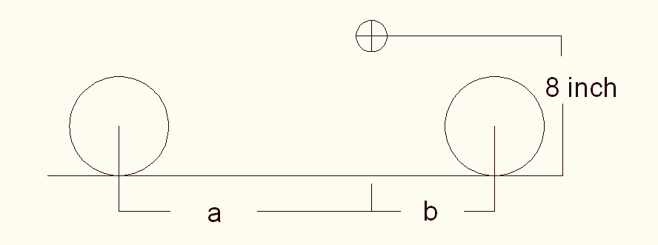













= (wheelbase)





**Static weight distributions**









**Dynamic Weight Distributions**









**Braking Forces on Front and Rear Wheels**





**Torque on Rear Wheels from Braking**







Starting from pedal



























## Resumes

**STEPHANIE MEDINA**

1325 West Tharpe St. #912 Tallahassee, FL 32303

[**sm07h@fsu.edu**](mailto:sm07h@fsu.edu)

(239) 398 – 0996

**OBJECTIVE:** Seeking to obtain a challenging internship position in the field of Computer Engineering and be a valuable asset to a company.

**EDUCATION:**

**Bachelors of Science in Computer Engineering December 2011**

College of Engineering; Florida State University; Tallahassee, FL

G.P.A: **3.08**

**SKILLS:**

* C++,Visual Basic, MATLAB, PSPICE, Exam DiffPro, Beyond Compare, Razor
* Microsoft Word, PowerPoint, Excel, Outlook
* Bilingual (Spanish)

**RELEVANT COURSES:**

* Senior Design1, Circuits 1-2, Electronics
* Object-Oriented Programming, Data Structures
* Microprocessors, FPLDS, Computer Architecture
* Signals & Systems, Communications, Statistical Topics in CPE/EE, Fields

**EXPERIENCE:**

**Senior Design (Formula Hybrid Car), Tallahassee, FL Program Manager/Lead Engineer August 2010 - April 2011**

* Lead team of six to compete in the 2011 Formula Hybrid International Competition
* Responsible for the implementation of the Battery Management System
* Program the Microcontroller for the coupling of the I.C.E with the electric motor

**Lockheed Martin MFC, Orlando, FL INROADS Software &Systems Intern May 2010 - August 2010**

* Designed and developed software solutions for 10 *JASSM Mission Planning* problems
* Performed testing to verify compliance of the system’s requirements for the JASSM missile
* Interfaced with various missile programs to gain a better understanding of daily operations
* Maintained communication with team members to accomplish assigned tasks
* Obtained a DoD Secret Security Clearance

**FAMU-FSU College of Engineering, Tallahassee, FL Undergraduate Research Assistant May 2009 - August 2009**

* Learned about different functions in MATLAB and applied them
* Created and wrote a program in MATLAB based on the Pattern Recognition System

**ACTIVITIES / AWARDS:**

* SHPE Conference/HENAAC Scholarship : Lockheed Martin recipient **August 2009 - Present**
* Hispanic College Fund Scholarship : Lockheed Martin recipient **August 2007 - Present**
* Society of Hispanic Professional Engineers : Outreach, Fundraising,

Corporate Sponsorship Chairs **September 2007 - Present**

* Phi Eta Sigma Honor Society : member **August 2009 - Present**
* Women in Math, Science and Engineering Program : member **August 2007 - Present**
* CARE Summer Bridge Program : member **June 2007 - Present**
* Bright Futures Scholarship recipient **May 2007 - Present**
* PEO Scholarship recipient **May 2007 - April 2009**
* Titan Way Scholarship recipient **May 2007 - April 2008**
* Naples Yacht Blue Gavel Scholarship recipient **May 2007 - April 2008**
* Scholars Club Scholarship recipient **May 2007 - April 2008**
* Golden Gate Women’s Club Scholarship recipient **May 2007 - April 2008**

Philip Young

12153 Monroe Street, Wellington, FL, 33414 • (561) 319-3985 •pay07@fsu.edu • U.S. Citizen

## OBJECTIVE:

To obtain a full time or internship position at a respectable engineering firm where my skills and knowledge of mechanical engineering can be utilized and challenged to further increase productivity and success of the company.

### EDUCATION:

Florida State University, Tallahassee, FL 08/2007-Present

### Bachelors of Science in Mechanical Engineering • Graduation: April 2011

### Overall GPA: 3.644, Engineering GPA: 3.615

Dean’s List - 5 Semesters

**Technical Elective Courses**: Design Using Finite Element Method, Vehicle Design (Graduate Level),

Gas Dynamics, Energy Conversion Systems for a Sustainable Future

**SENIOR DESIGN PROJECT:**

***Society of Automotive Engineers (SAE) Hybrid Formula Racer*** 08/2010-Present

FAMU-FSU College of Engineering; Tallahassee, FL

* Continue design and construction of a hybrid formula racer to participate in the nationwide SAE competition.
  + Mechanical Engineering Team Lead
  + Integrate and couple internal combustion engine with electric motor.
  + Redesign and analyze vehicle suspension, braking system, and differential.

### EXPERIENCE:

***Teaching Assistant*** 09/2009-Present

Mechanical Engineering Help Center; FAMU-FSU College of Engineering; Tallahassee, FL

* Assist students with academics by explaining difficult topics, helping with coursework, and preparing them for exams and presentations in various mechanical engineering courses.

***Research Intern*** 05/2010-08/2010

Keuka Wind/Center for Advanced Power Systems**;** Interlachen, FL

* Collaborated with fabricators and machinists to develop various 3D models using Pro/ENGINEER including company construction barge, compressed air storage tank, and multi-blade wind turbine (U.S. Patent Number 7399162).
* Developed MathCAD spreadsheets to calculate drag forces on multiple wind turbine designs at various wind speeds and pressure forces on the inside of compressed air storage vessels.
* Employed calculated forces in Pro/MECHANICA to perform finite element analysis on created models in order to determine stress and deflection levels given various conditions.
* Produced various presentations on progress and presented these to supervisors and superiors.

***Research Volunteer*** 11/2009-05/2010

Scansorial and Terrestrial Robotics and Integrated Design Laboratory; FAMU-FSU College of Engineering

Tallahassee, FL

* Assisted in construction of iSprawl robot and Integrated Climbing Arboreal Robotic Ornithopter System (I.C.A.R.O.S.) project.
* Utilized Pro/ENGINEER to construct 3D computer models of robot components.
* Analyzed fluid flow over different wing designs to determine optimal design for performance.

**EXTRACURRICULAR ACTIVITIES:**

Society of Automotive Engineers, Member 08/2010-Present

Tau Beta Pi, Engineering Honor Society; Member 01/2009-Present

* Professor Recognition Committee; Coordinator 01/2010-5/2010

Pi Tau Sigma, Mechanical Engineering Honor Society; Member 08/2009-Present

* Fundraising Committee; Coordinator 08/2010-Present

**TECHNICAL SKILLS:**

Pro/ENGINEER, MathCAD, LabVIEW, MATLAB, CodeBlocks, CodeWarrior, Working Model 2D, Microsoft OffI.C.E 2003/2007

*References available upon request.*

**Ryan M. Zombek**

913 Barrie Ave Tallahassee, Florida 32303 (561) 289-9391  rmz07@fsu.edu

## OBJECTIVE:

## Full time mechanical engineering position that will allow me to utilize the skills I haveaccumulated over the course of my college career. Open to relocate.

## SUMMARY:

* Mechanical Engineering internship with Teligent EMS Technologies in Havana Fl.
* Proficient with Office, CorelDraw, Mathlab, Comsol, Pro Engineering, MathCAD and Matlab.

## EDUCATION:

## Tallahassee Community College, Tallahassee FL

## AA Degree, General Transfer 2007.GPA 3.2 from Fall 2004-Summer 2007.

## Florida State University, College of Engineering, Tallahassee FL B.S. Mechanical Engineering with a Minor in Physics, April 2011.

*Relevant Courses*:

-Finite Element Analysis -Design of Fluid Thermal Systems

-Engineering Math -Mechanical Systems

-Material Science -Dynamic Systems

-Computer Programming -Computer Aided Design

*Relevant Projects*:

* + Drafted, built and tested a stirling engine.
  + Drafted, built and tested a basic solar heating system.
  + Programmed, tested and ran a robot using Dragon-Board code in spring 2009.
  + Design, built and competed a Hybrid Formula Racecar in the A.S.E competition in New Hampshire for my Senior Design Project.

*Educational Strong Points:*

* Finite element modeling 1D or 2D systems with or without Comsol.
* One or two dimension heat transfer with open or closed systems.
* Design of thermal fluid systems such as HVAC.
* Dynamics, Vibrations and Controls.
* Equations of motion for mechanical, electrical, and electromechanical systems.
* Statics, standard deviation and Optimal Design.

## EXPERIENCE:

**Teligent EMS Technologies (Havana, FL) 01/09 – 01/10**

### *Mechanical EngineeringInternship*

* Responsible for editing and insuring accuracy for the company’s Class 4 Military MPIs.
* Assisted with manufacturing Class 3 Military mechanical builds.
* Assisted with the design, procurement, and assembly for the department’s new manufacturing prep area.
* Head lead for printing all serial numbers on each of the company’s electronic circuit boards.

From the desk of

(850)766-5434 israel daramola iodaramola@gmail.com

2700 W. Pensacola st. Tallahassee, Florida 32304

# Education BACHELORS OF SCIENCE; ELECTRICAL ENGINEERING

## Florida State University; Tallahassee, FLMay 2011

Learned circuitry, computer programming, and completed an electric RC plane

# Experience OPS Research intern

## Florida A&M University; Tallahassee, FLJun2009-Present

Working with the computer program GENIE 3000, a gamma acquisition program that inspects spectroscopy data from medical patients; Making frequent trips to the Tallahassee Memorial Hospital facility in Quincy, Florida to complete this task; Researching gamma rays, their purpose and what they tell about the subject giving off these rays.

# Cashier

## TEMOJ International; Tallahassee, FLAug 2005- May 2009

Working the cash register and answering the telephone for TEMOJ, an African clothing boutique. I would also fill in for the managers during emergency situations when they could not be at work.

# Computer Research Student

## National Oceanic & Atmospheric Administration; Tallahassee, FLJan 2006- Aug 2007

Using computer programs to so research and studies on the environment and ocean life. I, along with a few other students also worked together on a presentation for the NOAA committee which earned us a higher pay raise.

# SOFTWARE SKILLS

## Microsoft Works, Microsoft Office, Microsoft Publisher, Adobe Photoshop, Adobe Illustrator, C++, Binary Language

RELEVANT COURSES

Calculus 1,2,3; Physics 1,2; Chemistry; Engineering Math 1,2; Circuits 1,2; Electronics; Digital Logic Design; Signals and Systems; Communications; Thermodynamics; All-Electric Aircraft

LEADERSHIP EXPERIENCE

HISTORIAN

*PROGRESSIVE BLACK MEN, INC.*Jun 2009- Apr 2010 Revived a dying position within the organization, remade the the organization scrapbook and was rewarded with the Committee Of The Year award. PHOTOGRAPHER *SYNERGY* Jan 2010-current Helped organize the Synergy Unity Walk on FSU’s campus.

MENTOR *BSU FRESHMEN FIRST* Sept 2009- Apr 2010 Mentored first year students at FSU MENTOR *FAIRVIEW MIDDLE SCHOOL* Sept 2009 Helped kids with their homework or projects and studying for tests

|  |  |
| --- | --- |
| 2125 Jackson Bluff Rd. Apt J202 Tallahassee, FL 32304 | (803)553-3409 Neal\_Lorenzo@yahoo.com |

Lorenzo Neal

|  |  |
| --- | --- |
| Professional Profile | Seeking for an entry level position of electrical engineer where I can use my skills to develop my career. Able to display and video circuit designs. As well as to work independently and able to manage priorities and tasks. Excellent ability to express ideas. Able to build, customize and troubleshoot electrical designs.  Excellent communication, organizational and interposal skills. |
| Experience | June 2010-present **Gate Petroleum** Tallahassee,FL  **Cashier**   * Two time employee of the month * In charge of keeping an accurate cash drawer and safe * Maintaining a clean and well kept store   May 2008-August 2009 **Picture Me Portrait Studio** Columbia, SC  Studio Manager  Second place in regional sales average  Managed 3 employees  Maintained a profitable studio |
|  | October 2007-Janurary 2008 **Champs Sports Store** Tampa, FL  Stockroom Manager  Managed 2 employees  Checking in new shipments  Maintaining neat and well organized stockroom |
|  |  |
|  |  |
| Education | 2004-present Florida A&M University Tallahassee, FL  Electrical Engineering |
| Interests | IEEE, running, fishing, family, computers. |
| References | Available upon request |

**Thomas Michael Emerick II**

tme06@fsu.edu

**Present Address Permanent Address**

306 Lipona Road 465 12th Place SE

Tallahassee, Fl 32304 Vero Beach, Fl 32962

(772) 633-7345 (772) 569-5153

**Objective**: Masters Degree in Mechanical Engineering

**EDUCATION**

FLORIDA STATE UNIVERSITY, Tallahassee, Fl

Major: Mechanical Engineering

G.P.A : 3.37

Dean’s List

ASME Member

Sigma Alpha Lambda honor society member

**Interests**

* Aerodynamics
* Flow Visualization and Experimentation

**Computer skills**

* Pro Engineering, MathCad, MatLab, LabView, Programming in C

**WORK EXPERIENCE**

**Florida Center for Advanced Air Propulsions** May 2010-Present

*Fluid Flow Visualization*

* Develop techniques for shock shaping

**Eclipse Marketing** Summer 2008

*Door to Door Sales Contractor*

* Collect payment, assist customer’s needs, schedule servI.C.E dates
* Overcome rejection and fine tune communication skills