Power Regulation

Overview:

The purpose of a power regulation system is to supply power to all components of the system in the most efficient and reliable manner. Depending on specific circumstances, a power regulation system can be engineered with different objectives in mind. Several of these objectives are costs, reliability and weight.

System Options:

In designing a robot with several different components with varying power requirements, a power source must be implemented to adequately power each or all components. The power distribution options available for this particular project is to use the 40V/15A power source available through tether, to implement a battery pack source on the robot itself, or to use a combination of the tether with an additional battery pack.
A source alone is not enough to satisfy the power requirements because the robot components will be rated at different voltages. A couple options to satisfy this demand are to design one power electronic circuit to deliver appropriate voltages to all devices, or, to use multiple power circuits with separate battery sources. If one circuit with one power source is desired, switching regulators must be implemented to step down the voltage to comply with the different devices. If multiple battery sources are to be utilized then the only requirement is to use an appropriate battery for each device.
The final set of options to consider is the exact type of battery source. The following list presents the top three types of batteries chosen for this project’s specific purposes.

Lithium-Ion – Lightweight, comparatively expensive, fast charge with zero memory effect.
Lead Acid – Large and heavy, comparatively inexpensive, high current output.
Lithium-polymer –Similar to Lithium-Ion with higher current output but less energy density.

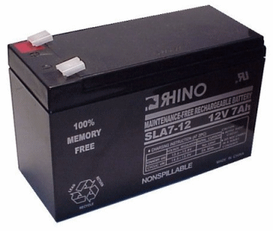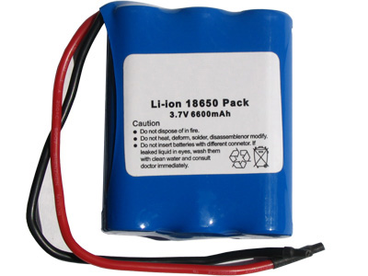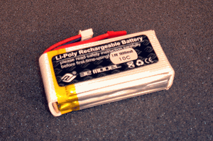

(Lead-acid) (Lithium-Ion) (lithium-Ploymer)

Concept Selection and Limiting Factors:

Power Source:

The existence of a power source tether is ambiguous throughout different editions of the rule set. Due to the uncertainty of such a source, at this point in time it is sensible to pursue the battery pack source option.

Power Distribution:

The optimal choice for reliability is to use a separate power source for the motors and a separate power source for the MCU and sensors. The optimal choice for a minimal weight and cost design would be to implement one power electronic circuit utilizing one or more switching regulators to step down the voltage.

Battery Option:

The optimal choice for weight minimization is to use lithium-polymer or lithium- Ion Batteries. If cost is the largest limiting factor, Lead Acid batteries should be used. Lead Acid also has the greatest energy density and current output versus cost and will be the more effective choice so long as weight is not restricted.

Power Distribution Concept: (Low Cost)

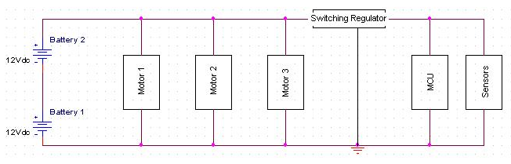

This design consists of one or more Lead Acid batters connected in series to produce an appropriate voltage (this specific voltage will rely upon the torque requirements of the motors). The source is then connected in parallel with the motor controllers and in series with an adjustable switching regulator to output a lower voltage for the MCU and sensors.

It is currently decided upon that the greatest limiting factor for the design is going to be money. Therefore the power distribution method of lowest cost has been implemented while still retaining the ability to adapt into a more costly yet reliable system such as the multiple source/circuit concept.

Final Design:

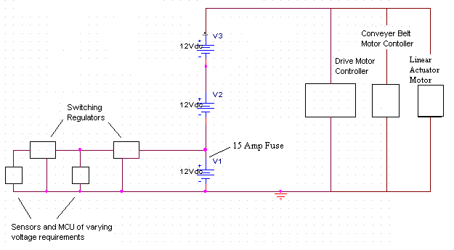
The final power system design is as follows:

In this design, the power system will be comprised of three 12V lead-acid batteries. The motors will be connected across all three batteries resulting in a total voltage of 36V across each motor. The sensors and MCU will be connected across one of the 12V with adjustable switching regulators to step down the voltage to the appropriate levels. The exact parts and weight can be viewed in the following table:

A Pspice simulation was performed on this circuit to demonstrate that the voltages across the motors will be 36V and that the voltage across the MCU and sensors would be 12V prior to implementing the switching regualtors. This Pspice schematic and simulation is as follows:
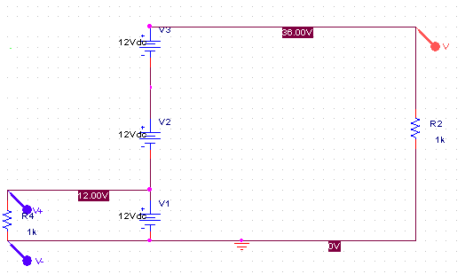

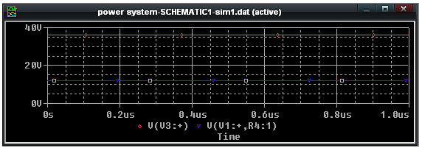

According to the rules of the competition, there will be a required fuse of 15A placed on the power supply. This fuse will have to be attached just above the “V1” battery in the above schematic. This means that the total current draw from all of the motors, plus the current draw of the sensors and MCU must never exceed 15A.

In calculating the maximum current draw of each component due to the current restriction, it is important to figure out which motors will be running simultaneously and which will not be. This was done by dividing the operation of the robot into two phases. These phases are regolith collection and regolith deposit. In regolith collection, the two drive motors as well as conveyor belt motor will all be operating, the linear actuator however, will be off. In the regolith deposit phase, the drive motors as well as conveyor motor will be off while the linear actuator will be on. The MCU and sensors will remain on throughout the entire operation. Using this phase analysis, the following charts were creating displaying the maximum current draw that the power system can supply for each component.

RULE CHANGE MODIFICATIONS:

The most recent rule update did not specify any sort of power limitation. This means that a power supply can be of any voltage and no particular fuse level is required. The power system design will remain the same but allow much high currents to flow to the motors without the fuse. High current into the motors means that the robot will be able to move faster and thus be able to excavate more regolith.

If the rule changes back to a required fuse and it is noticed that there will not be enough current draw to move the robot at a desirable speed, the power system will be broken up into separate systems. This means that each motor will contain its own battery source and thus be able to draw higher currents. The final design of this power system cannot be complete until the rules are finalized.

Motor Selection

Due to the fact that the rule set is not finalized, exact motor selection is not possible. The drive motors selected for the current power system is the Brushless Maxon 136211 motor. This motor is rated at 36V with continuous nominal current of 10A. Depending on the final rule requirements, this motor current draw may have to be limited.
The conveyor motor will be brushed and either rated at 24V or 36V and selected based on the final rule set. The linear actuator to be used will be the SuperJack 3618 Linear actuator. This actuator will be capable of lifting the 100kg ( at maximum capacity) bucket up to 27.38” and rated at 250W.
The current motor selection is based on the current rule set and is not finalized. This portion of the design will have to be completed in the future because further action on this sub-system may result in the loss of time and resources.

