|  |
| --- |
| **NASA Exploration System Mission Directorate Higher Education Project** |
| F:\logos.jpg |
| Concept Generation and Selection |
| Lunar Regolith Excavator Student Competition  ME Team #8 / ECE Team #1 |
|  |
| **FAMU-FSU College of Engineering** |
| 2525 Pottsdamer Street  Tallahassee, Florida 32310 |

|  |  |
| --- | --- |
| James Dickson | Jennifer Schrage |
| Anthony Gantt | Nick Stroupe |
| Christopher Loftis | Lindsey Alan Williams |
| Jeremy Nagorka |  |

**Table of Contents**

**Introduction** 3

Introduction 3

Background 4

Problem Statement 5

Project Objectives 5

**The Systems Engineering Method and Concept Development** 7

Excavation Subsystem Concepts 7

Obstacle Avoidance Subsystem Concepts 13

Locomotion Subsystem Concepts 15

Power Subsystem Concepts 18

Micro-controller & Communications Subsystem Concepts 20

Navigation & Sensors Subsystem Concepts 23

Conclusions 26

**References** 27

**Appendix** 29

Excavation Selection Matrix 30

Excavation House of Quality 31

Locomotion Selection Matrix 32

Locomotion House of Quality 33

**Introduction**

NASA is hosting the first Lunabotics Mining Competition in May 2010. This will be held at Kennedy Space Center and is geared towards undergraduate and graduate students. There is another similar competition entitled NASA Regolith Excavator Centennial Challenge, and has been previously held at the California Polytechnic State University in San Luis Obispo, California. In both cases NASA is hoping to find innovative ideas on how to excavate the surface of the moon. In the Lunabotics Mining Competition the primary goal is to educate students in engineering, math, sciences, and project management in a competitive setting.

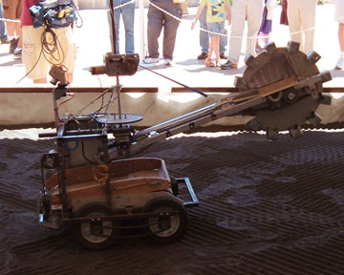

**Figure 1.** A robot presented at the 2008 NASA Regolith Excavator Centennial Challenge [1].

Each team will be given thirty minutes to excavate as much regolith as possible. To be considered for placing in the competition the robot must excavate at least 150 kilograms. The robot must have a mass of less than 80 kilograms, be no taller than 2.4 meters and no wider than 1.3 meters. During the competition there will be a time delay of at least two seconds to simulate the delay that would be present if the robot was on the moon and signals were being transmitted from earth. The maximum power that can be supplied is 40 volts and 15 amps. Before and after the competition each team will have ten minutes to setup and take down the excavation equipment. After every team has competed a winner will be announced and receive $5,000 and VIP launch tickets. There are minor prizes given to teams that win other categories such as a system engineering paper, outreach to informal education, and the team spirit competition.

**Background**

Interest in lunar exploration began right before the 1960s. In 1959 the Soviets designed Luna 1, the first of the Luna series and the first spacecraft to fly by the moon. Luna 2 was the first spacecraft to impact the moon later that same year. Between then and 1966 both the United States and the Soviets had many missions that sent spacecrafts to the moon.

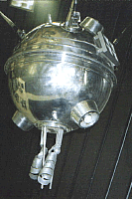

**Figure 2.** Luna 1 was a spacecraft developed by the Soviet Union and the first to fly by the moon in January 1959 [2].

The first American missions were designed to test the technology and after a year of testing the goal shifted to landing on the moon. In many of these missions Soviet and American spacecrafts impacted the moon instead of a soft landing. Not until 1966 was there a soft landing. This is when Luna 9 landed on the moon. From this mission the first photographs of the moon’s surface were achieved. Only two years later in 1968, the Apollo 8 mission had the first humans orbited the moon. The following year the first humans landed on the moon. The Apollo 11 mission was the first time lunar geologic samples were taken

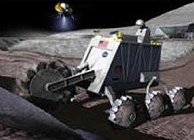

**Figure 3**. Artist’s Conception of Lunar Mining [1].

Recently interest has shifted from short missions to the moon to longer more permanent missions. Because of this, interest in excavation of the moon has increased. The reason behind these long-term projects is to perform longer supervised scientific studies. NASA hopes that by excavating the moon natural resources will be found and help make the moon a place where humans can survive. The reason NASA wishes to use the regolith to get these resources is because getting oxygen and other means to the moon can become very expensive. The main resource that can be used from the moon is the regolith, or lunar sand. Previous testing of the regolith has proven that it contains oxygen, silicon, aluminum, calcium, iron, and magnesium as well as very small amounts of titanium, sodium and sulfur. Besides extracting elements from the regolith it will be used to protect the astronauts from radiation as well as a building material for the lunar camp.

NASA has developed a product called JSC-1 that contains similar properties to regolith and can help in the development and testing of an excavator.

**Problem Statement**

The competition is designed to promote the development of mechanical designs to excavate lunar regolith. Each team that can, using telerobotic or autonomous operation, excavate the most lunar regolith stimulant (above the Minimum Excavation Requirement of 150.0 kg and within the Excavation Hardware mass limit of 80.0 kg) from a supplied quantity of regolith within a specified time limit of 30 minutes will win the competition.

**Project Objectives**

The motivation for the project is for lunar exploration and colonization. NASA’s Constellation Mission Program is designed to return humans to the moon within the next 20 years. As part of the Constellation Program, human settlements will be set up creating a permanent moon base. Autonomous, telerobotic, and direct control excavation and construction vehicles will be necessary for moon colonization. Lunar regolith, or top soil, can be utilized for many uses including resources, construction, and protection.

The focus for a Lunar Excavating robot will be to excavate regolith for use in construction and resource mining. The construction of regolith over living quarters adds a layer of protection against solar radiation and micro-meteorites. Other construction uses for regolith include creating blast burms for landing pads. Lunar regolith also has a very important role in creating oxygen and water, as lunar regolith has a high percentage of oxides that can be extracted and converted to useable resources.

The primary objective of this project is to design and build a telerobotic system capable of exceeding competition requirements to allow a solid win at the Exploration Systems Mission Directorate Lunar Regolith Excavator Student Competition at Kennedy Space Center in May 2010. The secondary objective of the project is to create a useful robotic system that can easily be implemented for lunar excavation, exploration, and construction.

**The Systems Engineering Method and Concept Development**

Systems engineering presents a useful method for accomplishing all tasks necessary in the design and manufacture of the Lunar Excavating Robot discussed above. Systems engineering focuses on identifying and analyzing customer needs early in the development process, documenting requirements, and then identifying necessary subsystems and proceeding with design synthesis [3]. In this project, systems engineering is an important aspect of the development of the robot due to the complexity of locomotion, excavation, control, and power. Each complex system is identified, and a team is assigned to solve the technical challenges presented. Each system is developed to be integrated into one coherent product in the final manufacturing process.

In the development of the Lunar Excavating robot, 6 subsystems were identified as high priority design aspects. The subsystems are locomotion, excavation, navigation, power, obstacle avoidance, and micro-controllers & communications. These subsystems represent important facets of the final product, and thus warrant more detailed design.

**Excavation Subsystem Concepts**

**Bucket Chain**

The bucket chain is a combination of the two primary functions of the excavation subsystem – excavation and transport to the holding bin. A conveyor belt with digging buckets removes material and carries it directly to the bin. The bucket chain in Figure 4 can excavate in a large swath below the level of the crawlers tracks. This is used to dredge canals and shape material stockpiles.

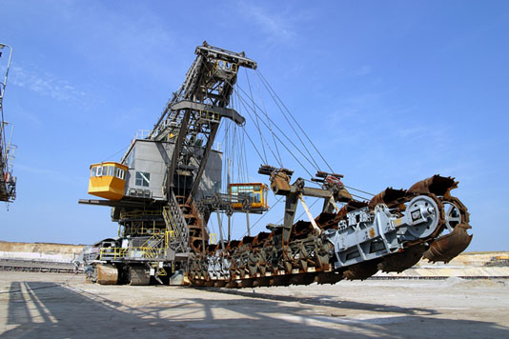

Figure 4. Commercial bucket chain excavator [29].

The main advantage of this method is the immediate transport of removed material to the bin. There is no need to synchronize the excavating mechanism with a separate conveyor. Also, there is less material lost during transport to the bin. The disadvantages include high inertia and power requirements due to the number of buckets on the chain and the digging action of multiple buckets. The weight and power increase over a conveyor and digging system necessitate a much stronger chain and supporting framework.

**Clam Shell**

The clamshell is a pivoting split bucket that excavates and removes material by closing the bucket on the material to be removed. The bucket is then moved over a collection bin and opened to release the material. A common use of a clamshell is to excavate material from the bottom of a shaft or caisson.

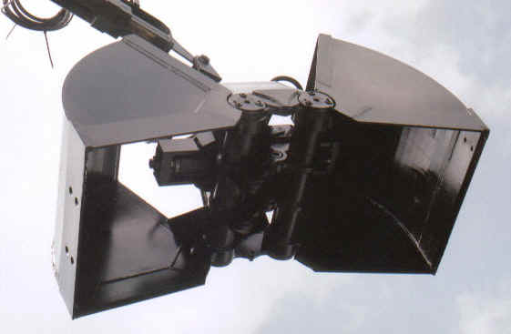

Figure 5. Clamshell attachment for backhoes [30].

Due to its split bucket design, the clamshell can develop high excavation force without a backward reaction force. As seen in Figure 5, the clamshell has three moving parts – the shell halves and the hydraulic actuator. It is also highly maneuverable and can deposit the excavated material in a bin without an extra conveyance device. The main drawback to the clamshell is that it requires a rigid articulated arm to supply the downward force needed to penetrate the ground. This articulated arm is difficult to control remotely due to its many degrees of freedom.

**Powered Brushes**

This method is commonly seen in street sweepers. There are two different types of brushes used to move material, circular and cylindrical. The circular brushes (right side, Figure 6) are spun at angles to bring material inward while the cylindrical brush (left side, Figure 6) is used to pick the material up onto a conveyor.

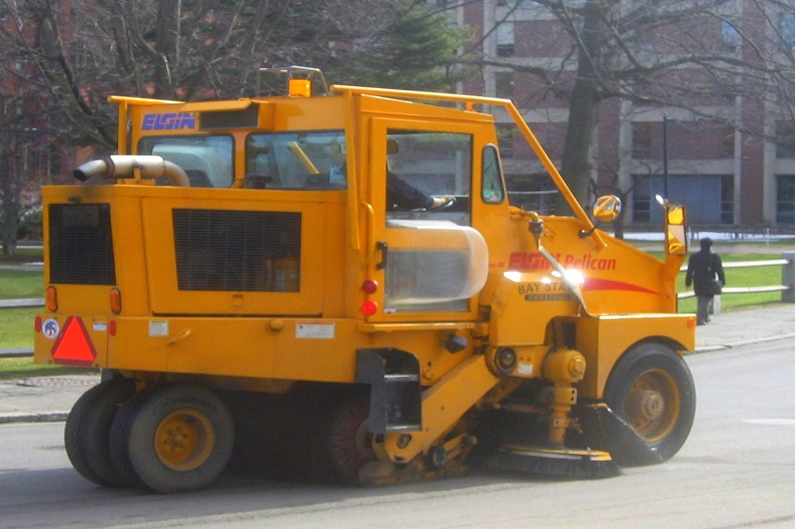

Figure 6. Elgin street sweeper [31].

The ease of implementation and control is the main selling point of this design. It also works very well when picking up loose debris from a hard surface. Unfortunately, the processes of spraying water and vacuuming to reduce the dust will not work in a lunar environment. This will lead to a large amount of material being lost before reaching the bin. Due to the origin and design of the sweeper, it has neither the capacity nor efficiency to serve as an excavator.

**Boring**

The most unconventional idea conceived was thought up in conjunction with the worm locomotion method. Taking cues from tunnel digging (Figure 7), mechanically boring through the sand was proposed, since vacuum methods will not work on the atmosphereless moon. The ingestion of material would occur as the robot moved through the sand, clearing a path for the framework to follow. The material would be transported through the robot to a bin above the surface or directly deposited into the collection bin. It was decided that such a device would not be feasible within the scope and timeframe of this project.

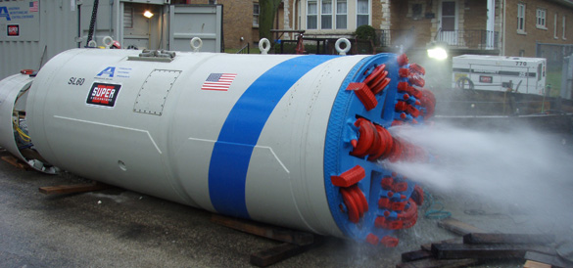

Figure 7. Microtunneling Boring Machine [32].

**Bucket-wheel Excavator**

The bucket-wheel excavator is one of the primary excavation tools used in surface mining. Figure 8 below is an example of a very large bucket-wheel excavator used in mining. A bucket-wheel consists of a large wheel fitted with digging buckets located around its circumferences. The bucket-wheel is connected to the main body via a large boom. Within this boom is a conveyor system which transports excavated material to the main body where it is collected.

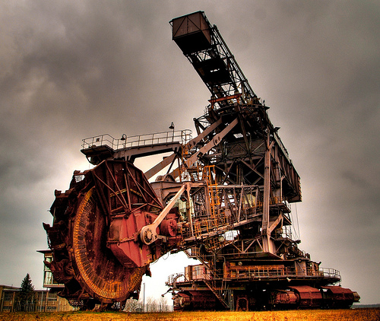

**Figure 8.** A giant bucket-wheel excavator [23]

The advantages of the bucket-wheel excavation method are that it is highly efficient, excavates uniformly, easily scalable, offers excellent controllability, and is a proven excavation method. The disadvantages of this excavation method are that there are very few off-the-shelf parts available on the scale we need to work with. This in turn makes this design more costly, and time consuming to develop when compared to some other proposed methods of excavation. Another disadvantage of this design is that it does not handle large object well. On the scale of the bucket-wheel excavator in figure 8 above, a large boulder could cause major damage to the mechanical components of the excavation system. On the scale in which we will be operating during competition, the rocks placed within the regolith box pose an equal threat to our vehicles excavation components.

**Split V-plow**

V-plows are primarily used in the removal of debris from roadways. An example of this application is shown in figure 9 below. Inward v-plows are far less common, since it focuses debris toward the middle of the plow as opposed to forcing debris off to the sides, which is generally considered more desirable.

Our design requires that debris be focused inward toward the centerline of the vehicle, as this is where the regolith will be collected. By separating the inward v-plow into two halves with ato be determined gap width, we are able to achieve this desired design characteristic. As the vehicle is moved forward, the regolith is funneled by the plow blades to the center mounted conveyor belt which transports the regolith to the collection bin.

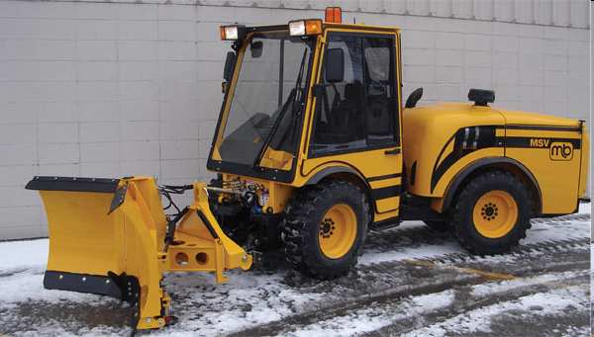

**Figure 9.** An adjustable v-plow in inward-v position [24].

The advantages of this excavation method are that it is a fairly simple design with few moving components, low cost, excavates uniformly, and ease of fabrication. The disadvantages of this design are that it is unproven, it places additional loads on the drive train, and its excavation effectiveness is directly correlated to the performance of the drive system. Through the use of a decision matrix we determined the split inward v-plow to be our best option for excavation.

**Backhoe**

The backhoe excavation method is one most people are familiar with. In figure 10, a backhoe mechanism is attached to the rear of a tractor. It consists of a two-part articulating mechanical arm with an attached bucket at its end. Backhoes are commonly used in the construction industry and perform very well as hole diggers. They work by forcing the leading edge of the bucket into the ground and then drawing it toward the vehicle, effectively taking a “scoop” out of the soil.

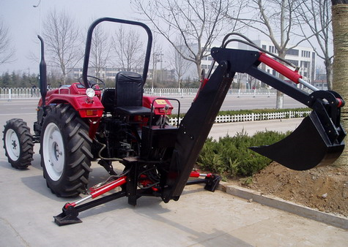

**Figure 10.** A standard backhoe mounted to a tractor [25].

The advantages of a backhoe are that it is a proven design, and low cost. The disadvantages of this design are that it has a low excavation rate, complicated controls, and a low volume bucket.

**Paddle belt**

Paddle belt excavation is very similar to bucket-chain excavation in that it excavates and transports the material in one process. The paddle belt excavator is essentially a paddle belt conveyor that is angled into the ground such that when in operation, the paddles on the belt scoop up the regolith and transport it to the collection bin. Pictured below in figure 11 is an example of a paddle belt conveyor that could be adapted to excavate regolith.

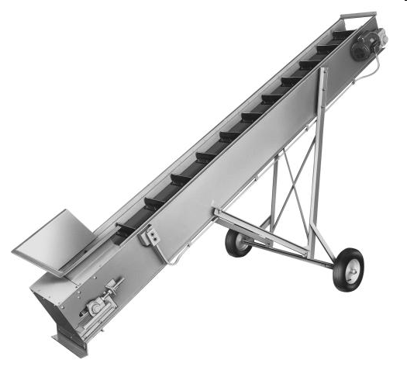

**Figure 11.** A paddle belt conveyor [26].

One advantage of the paddle belt excavation method is that it eliminates the need for an additional means of material transport since the paddle belt acts as the excavator and material transport system. Other advantages attributed to this design are its simplicity, variable speed capability, few moving parts, and the need for only on motor drive. A disadvantage of this design is, that while very similar to the bucket-chain, the paddle belt is an unproven excavation method since it is not currently used as such in any industry. Another disadvantage of this design is that few off-the-shelf parts exist on the scale in which we will be operating.

**Front loader**

A front loader consists of a large bucket attached by mechanical arms to the main body of the vehicle. The front-loader is generally used in the loading of material onto dump trucks, railcars, etc, and is not usually considered excavation equipment. In our case, the front-loader system will be used to excavate regolith by positioning buckets’ leading at ground level, and moving bucket through the regolith via the vehicles forward motion. Once the bucket is filled, it would be lifted up above the vehicle and dispense the regolith into collecting bin.

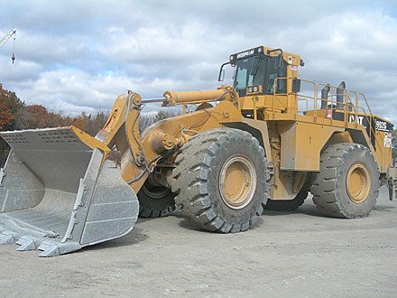

**Figure 12.** A large excavation front loader from Caterpillar [27].

The advantages of using a front-loader for the excavation of regolith are that it is a proven, simple design, excavates a large volume of regolith per scoop, low cost, low maintenance, and offers good controllability. Two disadvantages of this design are that the rate of excavation is directly correlated to the performance of the drive system, and that few off-the-shelf parts exist outside of heavy machinery applications as seen above in figure 12.

**Obstacle Avoidance Subsystem Concepts**

**Bumper/Pilot/Angled Plow**

This is the simplest method of protecting a device from damage due to collision. It is widely used in industrial robotics and automobiles. A wraparound bumper similar to the one in Figure 13 will allow the robot to excavate without having to worry about rock positioning or tracking. It is also easy to manufacture, low cost, and easy to implement. The major drawback to the plain bumper is the flat front. A rock could stay in front and contribute drag to the robot for a long period of time. This can be alleviated with the use of a pilot, colloquially known as a cowcatcher. The sloped and slanted front shown in Figure 13 would divert the rock to one side of the robot. In conjunction with a wraparound bumper protecting the locomotion system, the pilot would minimize contact time with the rock, reducing power loss. Manufacturing wise, a pilot is still inexpensive, but would require more fabrication time than a plain bumper. The angled plow is a combination of the bumper and the pilot, but only slanted in one direction. If programmed correctly, the known slant will allow the rocks to be moved in a specific direction, or even to a specific area of the regolith box. This can minimize subsequent contact with the rocks and allow the robot to maintain full excavation speed for a longer period of time. The angled plow is a minor variation on the plain bumper, thus sharing all of its benefits and lessening the severity of its major downside. These methods can be easily implemented for the limited movement excavation methods of the V-plow, front loader, bucket chain, paddle belt, and powered brushes.

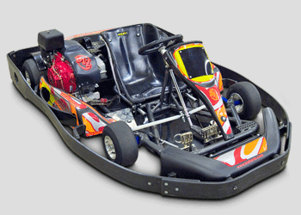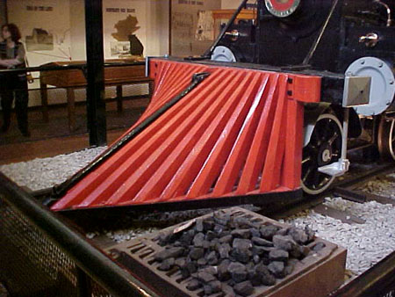

Figure 13. (left) Wraparound bumper on go-kart. (right) Pilot (cowcatcher) on locomotive [33,34].

**Post-excavation**

In lieu of deflecting or avoiding the rocks, they can simply be picked up by the excavation method. The methods most suited to this approach are the V-plow and the paddle belt. One possibility is to ignore the rocks completely, allowing them to end up in the dump bin. This is the simplest method of dealing with the rocks. The drawback is that they take up space in the dump bin and do not count toward our excavated mass. Another variation on this method is to reject the rocks with an angled bumper or grate at the top of the conveyor. This will allow the excavation mechanism to work nonstop and the rocks will be rejected before they reach the bin. This method has the advantage of keeping unnecessary mass out of the dump bin and allowing the robot to collect only regolith.

**Catapult**

Figure 14 is an example of the only active rock handling method devised. It involves using a catapult on the front of the robot to physically remove rocks from the competition area. Unfortunately, it was deemed unnecessarily complex and hazardous to be pursued any further.

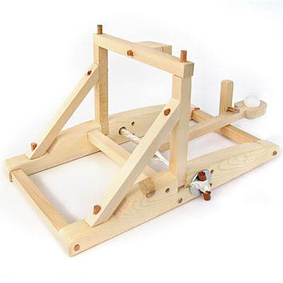

Figure 14. Toy catapult [35].

**Avoidance**

The only non-physical method for dealing with rocks is avoidance. This relies on sensors and navigation commands to avoid both rocks and walls. As such, this concept will be covered in the sensor and navigation subsections.

**Locomotion Subsystem Concepts**

The locomotion subsystem presented technical challenges separate from the excavation and navigation subsystems. Six strategies were developed to meet the challenges presented, each implementing a different mode of locomotion. These strategies were compared through ranking with engineering quality characteristics. The requirements ranked include traction, stability, maneuverability, speed, power, cost, simplicity, maintenance, and dust resistance. The six ideas developed were wheels (4 and 6), tracks, C-legs, iSprawl legs, and a digging/locomotion system similar to a worm.

The ideas were created based on the strategy of using speed as a portion of the excavation system. Since the competition requires that 150 kg of regolith (JSC-1 regolith simulant) be excavated in 30 minutes, speed is extremely important to the development of the robotic platform. To maximize efficiency, cross development of sub-systems may be desirable. Matching a semi-passive excavation system, such as plows, with a faster and powerful locomotion system would reduce the amount of motors required in the system. This consideration, along with the above engineering quality characteristics, were used in comparing each locomotion subsystem.

The four wheels are the standard locomotion system employed by modern passenger vehicles and many military vehicles [2]. Equipped with proper off-road tires, and coupled with strong motors, the four wheel design presents a strong option for non-uniform surface operations in soft sand environments. The positives of the four wheel design include simplicity of form, stability, ease of control, smaller physical size, and lower cost. The cons of a four wheel design include lower traction, less stability than other options, and lower power to ground. Figure 15 shows an example of an off-road vehicle capable of traversing rough terrain and non-uniform surfaces.

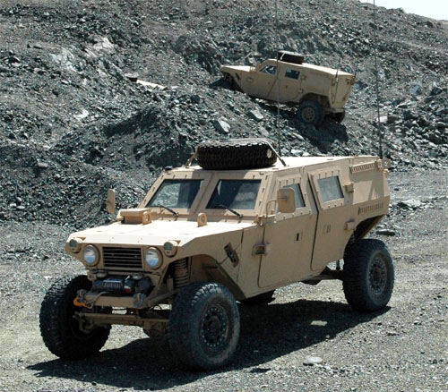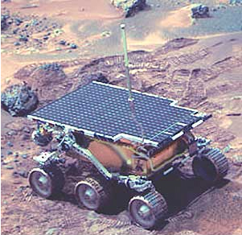

**Figure 15.** (left) A four wheeled, off-road, military vehicle used in the Afghanistan theatre of war by the United States Army [2]. (right) The Mars Rover Pathfinder, Sojourner developed by NASA [1].

The six wheel design is a standard locomotion system for larger vehicles including transport trucks, Martian rovers, and off-road vehicles. A six wheel design, with proper treaded wheels and a good suspension system, is a good option for off-road operation on surfaces that have large variations in topography [1]. The positives of a six wheel design include stability, traction, redundancy, and lower cost parts. The cons of a six wheel design include more parts, difficulty of control, and larger power requirements. Figure 15 shows an example of a six wheeled Martian rover known as Sojourner, capable of slow traversal of rough terrain.

Track designs have been utilized on off-road and all terrain vehicles including tanks and personnel carriers. A tracked system offers great off-road and sand traction performance as well as stability and ease of control. The positives of a tracked system include high traction, large power to ground ratio, ease of control. The cons of a tracked system include more parts, complicated construction, and higher cost. Figure 16 shows a standard example of tracks implemented on a military tank as well as the adaptability of tracks for use on vehicles that typically use wheels.

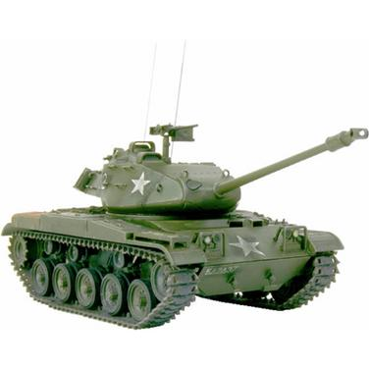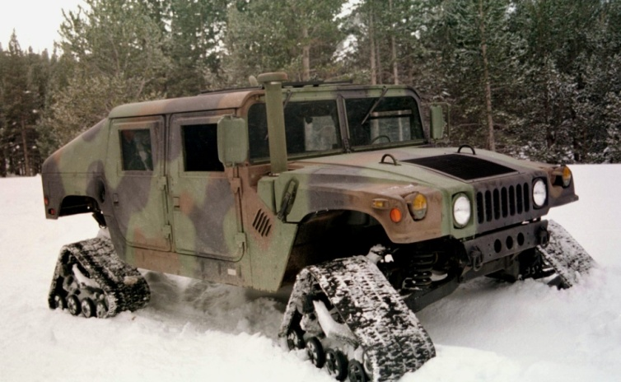

**Figure 16.** (left) Tracks have been implemented on military vehicles such as tanks for almost a century [4]. (right) Tracks have been adapted to a variety of vehicles and uses, as shown being utilized by a humvee for off-road, winter conditions [3].

Biomimetic robotics has developed two systems of legged locomotion recently. The first system, known as C-legs, was developed and implemented on a robot known as RHex, a rotary hexapod robot [6]. RHex offers a stable, tripod gait as well as speed and ability to adapt to different surface topographies [6]. The positives of a C-leg system would be stability, adaptability, speed, and dust resistance. The downside of a C-leg system would be complexity, cost, vertical perturbations due to gait changes, and reduced traction. Figure 17 illustrates the C-leg system as implement on the RHex robotic platform.

The second system developed through biomimetics is similar to a cockroach leg, first implemented on the Sprawl family of robots [5]. Sprawl legs are actuated using pistons pushing on compliant flexure legs, causing movement up and down [5]. These legs provide high speed, agility, adaptability, and high dust resistance. The cons of this design include difficulty with dynamic scaling, low payload capacity, low traction in sand, and difficulty adapting to excavation functions. Figure 17 shows the completed first generation Sprawl robot that uses prismatic actuators to flex compliant legs.

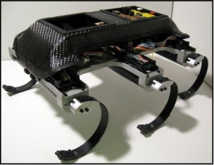

**Figure 17.** (left) RHex, a rotary hexapod robot (shown here as the EduBot version), uses six c-legs with an alternating tripod gait for stable locomotion over rough terrain [6]. The Sprawl family of robots use 6 legs with prismatic actuation to move with speed and agility [5].

The final design considered has been dubbed the “worm” system. The worm moves in a similar fashion to its biological counterparts [7]. The primary purpose of such a system would be to propel the robot through the sand, under its surface, while using an excavation system that would funnel sand into the center of the robot. The positives of such a design would be that it could simplify the excavation process, combining locomotion and excavation. The cons, however, would include developing new technologies, low dust resistance, higher cost, extreme complexity, and time constraints. Figure 18 shows current research designs of robots that use snake and worm inspirations for locomotion.

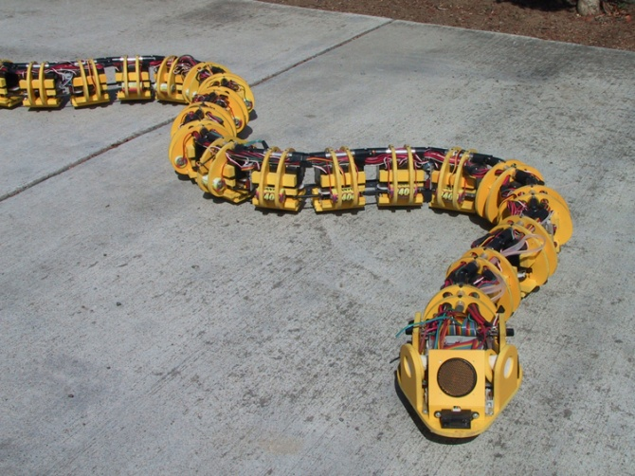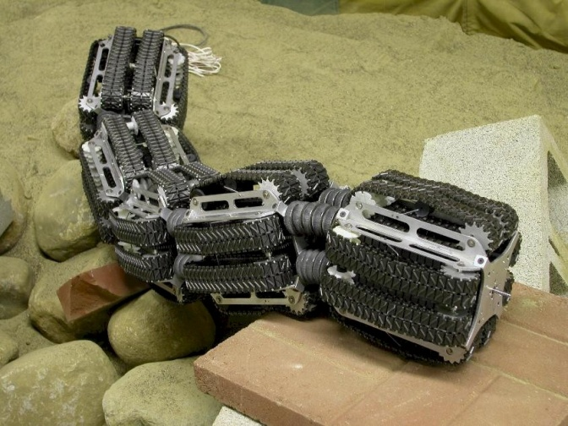

**Figure 18.** (left) Example of worm-like locomotion in SnakeBot [8]. (right) Another example of possible worm locomotion using multiple tiers of tracks on the OmniTread Serpentine Robot [7].

The six designs were compared in a selection matrix and a House of Quality. Each design was compared to the others by ranking each system on the above stated engineering quality characteristics. After careful consideration, the tracked system was the final choice for the locomotion subsystem due to its traction, stability, and ease of control characteristics. The next two choices were a four wheel system followed by a six wheel system for ease of control, dust resistance, and simplicity. Table 2 shows the selection matrix used for the decision of which design for locomotion would be the best choice. The relative ranks were chosen for importance to the overall project, including strategies for excavation as well as the competition scoring rubric.

|  |  |  |  |  |  |  |  |  |  |  |  |  |  |
| --- | --- | --- | --- | --- | --- | --- | --- | --- | --- | --- | --- | --- | --- |
|  | | **Concepts** | | | | | | | | | | | |
| **Tracks** | | **4 Wheels** | | **6 Wheels** | | **C-Legs** | | **iSprawl Legs** | | **Worm** | |
| **Specifications** | **Importance Weight** | **Rating** | **Weighted Score** | **Rating** | **Weighted Score** | **Rating** | **Weighted Score** | **Rating** | **Weighted Score** | **Rating** | **Weighted Score** | **Rating** | **Weighted Score** |
| **Traction** | 20.00% | 5 | 1 | 2 | 0.4 | 3 | 0.6 | 0 | 0 | 1 | 0.2 | 4 | 0.8 |
| **Stability** | 10.00% | 5 | 0.5 | 3 | 0.3 | 4 | 0.4 | 1 | 0.1 | 2 | 0.2 | 0 | 0 |
| **Maneuverability** | 15.00% | 4 | 0.6 | 3 | 0.45 | 2 | 0.3 | 1 | 0.15 | 5 | 0.75 | 0 | 0 |
| **Speed** | 15.00% | 2 | 0.3 | 4 | 0.6 | 3 | 0.45 | 1 | 0.15 | 5 | 0.75 | 0 | 0 |
| **Power** | 10.00% | 5 | 0.5 | 3 | 0.3 | 4 | 0.4 | 2 | 0.2 | 1 | 0.1 | 0 | 0 |
| **Cost** | 10.00% | 3 | 0.3 | 5 | 0.5 | 4 | 0.4 | 2 | 0.2 | 1 | 0.1 | 0 | 0 |
| **Simplicity** | 10.00% | 2 | 0.2 | 5 | 0.5 | 4 | 0.4 | 3 | 0.3 | 1 | 0.1 | 0 | 0 |
| **Low Maitenance** | 5.00% | 2 | 0.1 | 4 | 0.2 | 3 | 0.15 | 5 | 0.25 | 1 | 0.05 | 0 | 0 |
| **Dust Resistance** | 5.00% | 2 | 0.1 | 4 | 0.2 | 3 | 0.15 | 5 | 0.25 | 1 | 0.05 | 0 | 0 |
|  | **Score** |  | 3.6 |  | 3.45 |  | 3.25 |  | 1.6 |  | 2.3 |  | 0.8 |
| **Selection** | 1st | | 2nd | | 3rd | | - | | - | | - | |

**Table 1.** Selection Matrix used for determination of best designs for locomotion.

**Power Subsystem Concepts**

The purpose of a power regulation system is to supply power to all components of the system in the most efficient and reliable manner. Depending on specific circumstances, a power regulation system can be engineered with different objectives in mind. Several of these objectives are costs, reliability and weight.

In designing a robot with several different components with varying power requirements, a power source must be implemented to adequately power each or all components. The power distribution options available for this particular project is to use the 40V/15A power source available through tether, to implement a battery pack source on the robot itself, or to use a combination of the tether with an additional battery pack.

A source alone is not enough to satisfy the power requirements because the robot components will be rated at different voltages. A couple options to satisfy this demand are to design one power electronic circuit to deliver appropriate voltages to all devices, or, to use multiple power circuits with separate battery sources. If one circuit with one power source is desired, switching regulators must be implemented to step down the voltage to comply with the different devices. If multiple battery sources are to be utilized then the only requirement is to use an appropriate battery for each device.

The final set of options to consider is the exact type of battery source. The following list presents the top three types of batteries chosen for this project’s specific purposes.

*Lithium-Ion* – Lightweight, comparatively expensive, fast charge with zero memory effect.

*Lead Acid* – Large and heavy, comparatively inexpensive, high current output.

*Lithium-polymer* –Similar to Lithium-Ion with higher current output but less energy density.

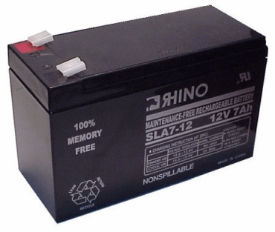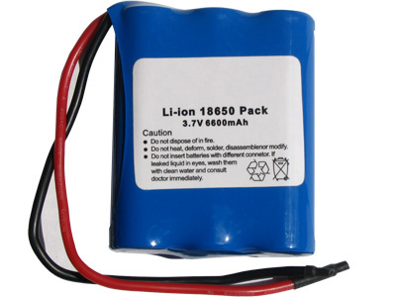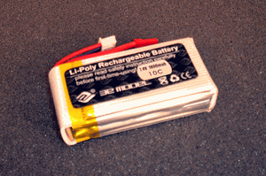

(Lead-acid) (Lithium-Ion) (lithium-Ploymer)

**Power Source**

The existence of a power source tether is ambiguous throughout different editions of the rule set. Due to the uncertainty of such a source, at this point in time it is sensible to pursue the battery pack source option.

**Power Distribution**

The optimal choice for reliability is to use a separate power source for the motors and a separate power source for the MCU and sensors. The optimal choice for a minimal weight and cost design would be to implement one power electronic circuit utilizing one or more switching regulators to step down the voltage.

**Battery Option**

The optimal choice for weight minimization is to use lithium-polymer or lithium- Ion Batteries. If cost is the largest limiting factor, Lead Acid batteries should be used. Lead Acid also has the greatest energy density and current output versus cost and will be the more effective choice so long as weight is not restricted.

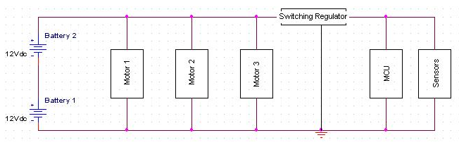**Figure 19.** Final Power subsystem design

This design consists of one or more Lead Acid batters connected in series to produce an appropriate voltage (this specific voltage will rely upon the torque requirements of the motors). The source is then connected in parallel with the motor controllers and in series with an adjustable switching regulator to output a lower voltage for the MCU and sensors.

It is currently decided upon that the greatest limiting factor for the design is going to be money. Therefore the power distribution method of lowest cost has been implemented while still retaining the ability to adapt into a more costly yet reliable system such as the multiple source/circuit concept.

**Micro-controller & Communications Subsystem Concepts**

The robot is useless without something to control all its various sensors and motors. The microcontroller is a chip with a processor, memory and I/O that can perform all these tasks. It needs to read in the data from all of the sensors and make sense of that data then use that to make decisions and drive the motors accordingly. The type of controller is heavily dependent on the sensors and motors that the robot uses but the general type at least can be selected.

First up are FPGAs. These are technically not microcontrollers but they can perform the same functions in a robot. An FPGA is purely hardware; It's a box of logic gates where the connections between gates can be programmed. There's no software so they are usually very fast and can even perform multiple operations at once. They typically have plenty of I/O pins and being hardware, are very good at performing the low level functions of sensor reading and motor control. There are plenty of downsides though. The biggest is that the programming is far more complicated than software programming. There's nothing prebuilt so everything that is already in a microcontroller has to be programmed from the ground up. There are also usually horrible timing issues that take forever to debug. If this weren't enough, they also have to be reprogrammed every time they're turned off, they don't have any analog inputs and don't have standard 5V I/O pins.

Getting to microcontrollers, they can be split up by bus size, 8-bit and 32-bit. 8-bit microcontrollers are what are typically used for robot control. They are very good at doing all the useful functions for interfacing with other components. Analog to digital converters for reading in analog sensors, pulse width modulation for various types of motor control, and plenty of timers and interrupts. The type currently being looked at is the AVR ATMEGA line. It is especially popular with hobbyist robotics so there is a wealth of information about using them for robot control. Because of this, they also have plenty of different easy to use development boards available for the microcontroller. The downsides are few and hopefully shouldn't be an issue. They are fairly slow at about only 16MHz and have very small amounts of memory. If some kind of complicated program is needed, using tons of floating point operations or too many variables, something more powerful would be needed. So far though, the control isn't being foreseen as being too complicated so these should be fine.

There is a fairly large gap between 8-bit and 32-bit microcontrollers. The 32-bit ones are more like small computers, the larger bus size and faster clock speed make them much faster, have more I/O pins and they typically even have their own operating system. This makes them more useful in areas needing more processing power like image and audio processing and typically show up in cell phones and the like. They aren't as popular for robotics because most projects don't need the extra power, so there's not as much in the way of resources available. The selection of development boards is also worse as they're usually packed with extra devices and buttons. The low level functions are also not as good and few boards are intended for robotics. The added difficulty and complexity doesn't seem worth it if we aren't even going to need the extra processing power.

Trying to decide which type to use is easy, 8-bit microcontrollers win out by a long shot. FPGAs are out right off the bat and weren't really considered. FPGAs are used more for digital signal processing where their high speed and parallelability is useful. That isn't as useful for a robot and the added complexity and time needed to program the device definitely isn't worth it. No one on the team is really good at VHDL anyway. 32-bit microcontrollers were also eliminated. The main advantage of more processing power shouldn't be needed and isn't worth the increased complexity and cost. They might be useful later on if it is found that more processing power is needed. Then the robot can have a low level 8-bit doing the low level control, and a 32-bit doing the high level calculations and decision making. Right now though, the plan is for a single 8-bit microcontroller and to add additional controllers if speed, memory or number of pins becomes an issue.

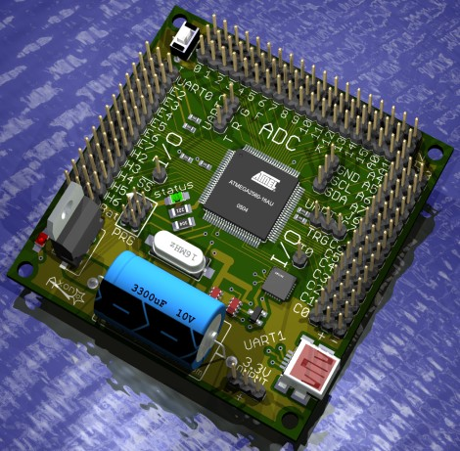

**Figure 20.** Axon, development board for the AVR ATMEGA 640 [19].

**Telerobotic Interface:**

The robot needs to have some kind of remote control, even if that is just turning it on and off. Some way of communicating with the robot remotely is needed. Very little can be done with this because of the enforced 2s delay both ways on the line and the maximum bandwidth of 1Mb/s. This delay is provided by a computer provided at the contest which runs an emulated wide area network. The robot then must have a way of connecting to this network and somehow communicate with the operator on a computer on the other side of the network.

The first question is wired or wireless. A wired connection with Ethernet cable would be ideal, as wired connections are much simpler and faster than the equivalent wireless. This poses the obvious problem of dealing with the wire and avoiding getting it stuck or caught on anything. Originally, in the rules the robot was to be provided with a tether supplying power from an overhead scaffold. Then communications cable could then just use the same scaffold. It's unclear now if the robot gets a tether or not so some kind of wireless connection will most likely be needed. The three main wireless protocols available are Zigbee, Bluetooth and Wi-Fi and they all have various pros and cons.

Zigbee is fairly new, inexpensive and focuses mainly on connecting multiple remote sensors into a network. This means the speed isn't that great and maxes out at 250Kb/s ¼ of the maximum bandwidth. This and that they would have a hard time connecting to the WAN doesn't make them very promising.

The next option is Bluetooth which is the next step up from Zigbee in terms of speed and cost. Their maximum speed is 1-3Mb/s which is perfect given the maximum usable is 1Mb/s. Bluetooth is also set up to act similar to serial only wireless. This means the interface with the microcontroller should be simple and easy to use. The problem is interfacing with the WAN. Bluetooth is a personal area network so it will need some kind of router to connect to the WAN. This will likely be a laptop getting data from the robot via a Bluetooth USB dongle then acting as a server and relaying the data through the WAN.

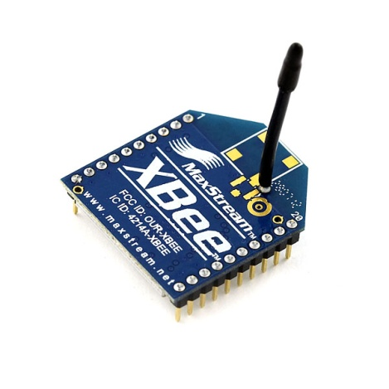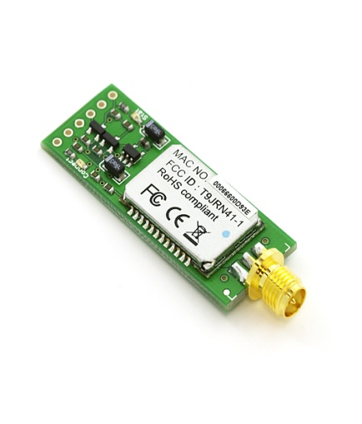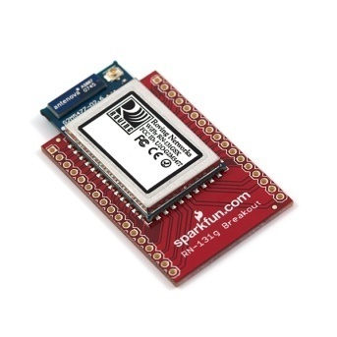

**Figure 21**. Modules for interfacing a microcontroller with Zigbee, Bluetooth and Wi-Fi respectively [20, 21, 22].

Most expensive and powerful is the standard Wi-Fi. It's incredibly fast compared to the other two at 56Mb/s but most of that is useless given the bandwidth limit. Even without the limit the bottleneck is the serial interface with the microcontroller which caps out at about 1Mb/s The interface is mostly the same as Bluetooth. Wi-Fi also uses the most power for its strong signal with is mostly a waste because all three have a range of at least 10 meters which is plenty for this robot. The one advantage is that Wi-Fi is already the same kind of protocol as the network and so should be able to connect directly to the WAN.

**Figure 22.** Proposed communication system.

Zigbee is dropped right away as it's too slow and more suited for distributed networks rather than data transfer. So far both Wi-Fi and Bluetooth should work for the requirements but it's hard to tell this early which will be easiest to implement. This system though should work with both so all of this applies to both.

The microcontroller connects to a Bluetooth modem which sends data to a laptop outside of the collection area. That laptop then makes sense of the data and sends it through the network. 2 seconds later an operator controlling the robot receives that data at the interface laptop. This has the advantage of relying on laptops for the WAN connection because they're already built to do this and essentially free because the team already has laptops. Also, if needed, the server laptop could run code for the microcontroller if there is something computationally draining that it needs. It would be tricky working out the communication to do that but it’s possible if we really need it. After all, a laptop is going to be more powerful than most affordable microcontrollers.

**Navigation Sensor Subsystem**

The purpose of the navigation system is to provide the robotic device with the means of making automatic decisions within their environment. In order to accomplish this goal the robotic device is going to require a collection of sensors. Without sensors, a robot could not react or respond to changes within their environment causing them to be considered a machine which is capable of moving only by predefined movements. A sensor is a device that measures physical quantities and converts it into a signal which can be read by an observer or by an instrument. For a sensor to sufficiently work it must measure for system errors; once an errors is found by the sensor the robot is able to correct them for the desired outcome. A sensor that is sensitive to the measured property, insensitive to any other property, and does not influence the measured property is consider as a good sensor.

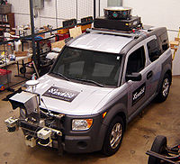  
**Figure 23.** Example of Sensors used on a vehicle

In determining different methods for controlling the navigation of the robotic the following concept were generated:

* **Pre-programmed path** – deals with encoding the robotic device with a path which is already determined. The device should not deviate from the planned path.
* **Mapping** – deals with the ability to make a map of the present environment and make concentrated movements within it.
* **Random path** – the device will maneuver randomly within a fix area. The movements are recorded and calculated to prevent repetition to the same position.

To determine which method or collection of methods works best, the path planning must consider the following:

* **Work space:** The work space is the geometric space in which a robot operates. It consists of obstacles and empty space that may be occupied by the robot.
* **Configuration:** A configuration of the robot is a full description of the robot's state, including its position, orientation, and the states of any internal degrees of freedom (such as revolute joint angles).
* **Collision:** A configuration is said to be in collision if any part of the robot overlaps with either another part of the robot or with a work space obstacle.
* **Free:** A configuration is said to be free if it is not in collision.
* **Configuration space (C-space):** The space of all configurations of the robot annotated by whether the robot is in collision or free at each configuration.
* **Free space:** The space of all free configurations.

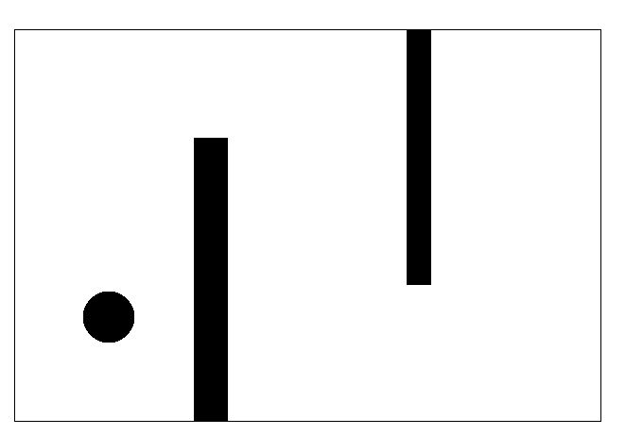

**Figure 24.** (left) Work space which a robot can operate in. (right) Configuration

space which a robot can operate in.

Now the method for navigating has been considered, determining what devices will be used to perform the desired designer’s tasks; this leads to the type and functions of different sensors.

**Types of Sensors**

* + - Position, angle, displacement, distance, speed, acceleration
    - Acoustic, sound, & vibration
    - Navigation instruments
    - Optical, light, imaging
    - Proximity, presence
    - Electric current, magnetic, radio, voltage
    - Pressure, force, density, level
    - Environment, weather

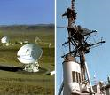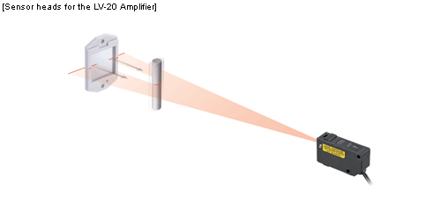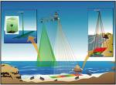

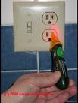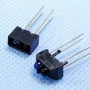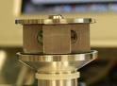

**Figure 25.** Examples of sensors are shown: (top left) radar device, (top center) laser sensor, (top right) lidar sensor, (bottom left) voltage sensor, (bottom center) optical sensors, and (bottom right) beacon sensor.

The following sensors present themselves as the most beneficial for navigation, current control, weight control and positioning of the robot:

**Inertial Sensor** – used to measure the pitch, yaw and roll of the robot.

**Digital Scale** – used to measure the amount of regolith collected.

**IR Beacon Sensor(s)** - works by sending infrared light in all directions to a receiver(s).

**Current Sensor(s)** – used to control current used in the robot to prevent the damaging fuses.

**Relative Sensor(s)** – used to measure the absolute or relative location of the robot.

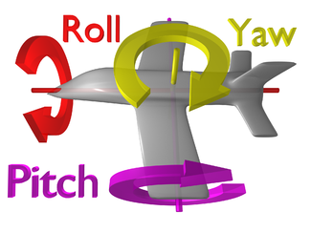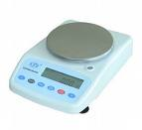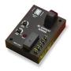

**Figure 26.** (left) Spatial measurements calculated by INS, (center) Digital Scale, (right) Current Sensor

**Conclusions**

The final concept generated for the development of the Lunar Regolith robot will be the combination of the selected best fit solutions. The concept will include a split, inward v-plow for excavation purposes. For locomotion, it will utilize tracks for increased traction, speed, and maneuverability. For power subsystems, the final design including batteries was developed, and microcontrollers and navigation subsystems have identified strong possibilities for the technical challenges presented. Each chosen design will be tested to ensure it will operate in the intended way. At any time, if the chosen design is found to be deficient, the next best concept will be prototyped and tested for the most efficient operative lunar regolith robot.

**References**

1. D. Beale. *Fundamentals of Lunar and Systems Engineering for Senior Project Teams, with application to a Lunar Excavator*, Auburn ESMD Course, <” <http://education.ksc.nasa.gov/esmdspacegrant/LunarRegolithExcavatorCourse/index.htm>”>
2. Lunar and Planetary Institute. Lunar Mission Summaries, Lunar Science and Exploration, <”<http://www.lpi.usra.edu/lunar/missions>”>
3. S. Ramo, and R. St.Clair. The Systems Approach: Fresh Solutions to Complex Problems Through Combining Science and Practical Common Sense, Anaheim, CA: KNI, Inc.
4. Rover Team. *Characterization of the Martian Surface Deposits by the Mars Pathfinder Rover, Sojourner*, Science, 5 December 1997.
5. J. Sheldon. Off*-Road Prototype Vehicles Test in Afghanistan*, Army.Mil/News, June 09, 2008.
6. J. Geiger. Auto Industry Insider: Hummer, Consumer Guide Automotive, <<http://consumerguideauto.howstuffworks.com/industry-insider-hummer-cga.htm>>.
7. Picture Dicitionary, dicts.info. Armored Combat Vehicle. <”[www.dicts.info/picture-dictionary.php?w=army](http://www.dicts.info/picture-dictionary.php?w=army)”>.
8. J. Cham, S. Bailey, J. Clark, R. Full, and M. Cutkosky. *Fast and Robust: Hexapedal Robots via Shape Deposition Manufacturing*, International Journal of Robotics Research, 2002.
9. B. Potsaid, and J. Wen. *EduBot: a Reconfigurable Kit for Control Education – Part I: Mechanical Design*, IEEE International Conference on Control Applications, September, 2000.
10. G. Granosik, M. Hansen, and J. Borenstein. *The OmniTread Serpentine Robot for Industrial Inspection and Surveillance*, International Journal on Industrial Robots, Special Issue on Mobile Robotics, March 18th, 2005.
11. G. Miller. *Snake Robots*, SnakeRobots.com.
12. http://www.takraf.com/images/m-produkte/ers710_nochten_3_534px.jpg
13. <http://www.grapples.us/_borders/cbucket1.jpg>
14. <http://upload.wikimedia.org/wikipedia/commons/thumb/2/23/Street_sweeping_machine.jpg/713px-Street_sweeping_machine.jpg>
15. <http://upload.wikimedia.org/wikipedia/en/c/ce/Sandwormmouth.jpg> from the movie Dune
16. <http://www.karting.uk.com/images/kartEvo.gif>
17. <http://www.locomotivegeneral.com/generalparts/images/CowCatcher.jpg>
18. <http://i303.photobucket.com/albums/nn125/SpectrumSci/catapult_400.jpg>
19. <http://www.societyofrobots.com/axon/images/axon3D.jpg>
20. <http://www.sparkfun.com/commerce/images/products/08665-03-L.jpg>
21. <http://www.sparkfun.com/commerce/images/products/00158-03-L.jpg>
22. <http://www.sparkfun.com/commerce/images/products/09333-1.jpg>
23. <http://farm3.static.flickr.com/2355/2261905391_9e622d172d.jpg>
24. <http://www.m-bco.com/_layouts/media/msv/MSV-Folding-V-Plow_a.jpg>
25. <http://www.made-in-china.com/image/2f0j00GCnTKcWUJEbuM/Backhoe-For-Tractor-LW-6-LW-7-LW-8-.jpg>
26. <http://www.hcdavis.com/all%20pics/1318conveyor_bg.jpg>
27. <http://www.passenlaw.com/blog/wp-content/uploads/2009/08/front-loader-death.jpg>
28. K. Haddock. *The Earthmover Encyclopedia: The Complete guide to heavy equipment around the world*, 2002, Googlebooks.
29. http://www.takraf.com/images/m-produkte/ers710_nochten_3_534px.jpg
30. <http://www.grapples.us/_borders/cbucket1.jpg>
31. <http://upload.wikimedia.org/wikipedia/commons/thumb/2/23/Street_sweeping_machine.jpg/713px-Street_sweeping_machine.jpg>
32. http://www.akkerman.com/images/products_mt_header.jpg
33. <http://www.karting.uk.com/images/kartEvo.gif>
34. <http://www.locomotivegeneral.com/generalparts/images/CowCatcher.jpg>
35. http://i303.photobucket.com/albums/nn125/SpectrumSci/catapult_400.jpg
36. <http://img.directindustry.com/images_di/photo-g/mobile-screen-387429.jpg>

**APPENDIX**