NASA Exploration System Mission Directorate Higher Education Project

Project Funding Proposal
Lunar Regolith Excavator Student Competition
ME Team #8 / ECE Team #1
The ARTEMIS Project

FAMU-FSU College of Engineering
2525 Pottsdamer Street
Tallahassee, Florida 32310

James Dickson | Jennifer Schrage
Anthony Gantt | Nick Stroupe
Christopher Loftis | Lindsey Alan Williams
Jeremy Nagorka

Contents
I. Summary 3
II. Introduction 4
III. Needs/Problems 5
IV. Goals/Objectives 6
V. Procedures/Scope of Work 6
VI. Timetable 8
VII. Budget 9
VIII. Key Personnel 10
IX. Evaluation 11
X. Endorsements 11
XI. Next Steps 11
XII. Appendix 12

Summary

The ARTEMIS Project consists of students from Florida A & M University and The Florida State University, majoring in Electrical, Computer and Mechanical Engineering. In May 2010, the National Aeronautics and Space Administration (NASA) will be hosting its annual Lunabotics Mining Competition. The team’s goal is to design a robot that will result in innovative ideas and solutions that could possibly shape the future of lunar missions performed by NASA. The team’s mission is to design and build a robot that can excavate regolith (lunar soil). The robot will be competing in a box containing eight tons of simulated regolith. The box is four meters square and one-half meter deep. The team must collect a minimum of 10 kilograms (kg) of regolith and transfer it to a container within 15 minutes. Along with the fabrication of a lunar mining robot, the team will perform community outreach for K-12 grade students in the areas of Science, Technology, Engineering, and Math (STEM). The total amount of funds raised to date is $6,500. The members of the Artemis Project anticipate a total budget of $8,000. Any denomination or material(s) donated will go directly towards the construction of the robot and community outreach.

Introduction

This year, the Florida A & M University-Florida State University College of Engineering is conducting its’ first interdisciplinary collaboration between the Electrical/Computer and the Mechanical Engineering Departments for the Senior Design Project. The goal of the project is to expose senior students to the concepts of design, project management, engineering team organization, and professionalism. Seven students from both universities have been selected to participate in this project. The requirements of the Lunar Regolith Excavator Student Competition are as follows: design a robot to excavate 10 kgs of regolith in 15 minutes while weighing less than 80 kgs.
The Artemis Project is tasked with creating a robot capable of meeting and exceeding all requirements set forth by NASA for the competition. As the students are designing, constructing, synthesizing and analyzing their robot, they will perform community outreach for K-12 grade students in the areas of Science, Technology, Engineering, and Math (STEM).

Needs/Problems

With increased interest in returning man to the moon and the possibility of future inhabitation, many complex problems arise that must be addressed. In the not too distant future the United States, as well as several other countries, may desire to place an outpost on or below the surface of the moon. This creates a need for the excavation and removal of regolith. The focus for a lunar excavating robot will be to excavate regolith for use in construction and resource mining. The construction of layers of regolith over living quarters adds a layer of protection against solar radiation and micrometeorites. Other construction uses for regolith include creating blast berms for landing pads. Lunar regolith also has a very important role in creating oxygen and water, as it has a high percentage of oxides that can be extracted and converted to useable resources.
The moon is a completely different environment than that of earth and as such requires a different approach to excavation. Autonomous robots allow the excavation of lunar regolith from secure locations and as a result, eliminate the need for astronauts to operate machinery in the hazardous conditions found on the lunar surface. Excavation in lunar conditions poses several problems to a robot, including extreme temperatures, radiation interference, and isolation. Autonomous robots operating under these conditions have to account for the extremes of the lunar environment, while being as compact and light as possible due to limited space and payload capacity. Due to the remoteness of the moon, any robot sent must be highly efficient and durable, as repair and alterations in the lunar environment are not feasible. Because of the future need for autonomous lunar excavators, NASA has developed the Lunar Regolith Excavator Student Competition in hopes of obtaining new and innovative design solutions.

Goals/Objectives

The main objective of this project is to compete and win in the Lunabotics Mining Competition hosted by NASA on May 27-28, 2010. The ARTEMIS Project views this competition as not only an opportunity for prestige among its members, but also an opportunity to bring pride to our universities, aid in space research and serve as a means of outreach to the public. Similar to an objective of the NASA sponsored competition itself, The Artemis Project is highly motivated in awaking the public through outreach on the real possibility of space exploration and the importance of science and educational programs in America. Educational programs to be involved with include demonstrations at the Challenger Learning Center, presentations at the Mary Brogan Museum, interactive activities at local schools, and working with engineering student organizations to develop lasting outreach activities.
In order for this objective and vision to become a reality, several goals must be accomplished, these goals are as follows:

- Construct a solid, reliable, automated excavator by May 24, 2010 to compete in competition
- Write a concise, comprehensive paper on the systems engineering based design by April 15, 2010
- Compose a slide presentation outlining the methodology behind the project by April 15, 2010
- Perform various community outreach activities to excite and educate the public on the importance of science and education
- Submit a report detailing the team’s community outreach by April 14, 2010
- Create and submit a video documenting the process and creation of the excavator by May 24, 2010
- Demonstrate team cohesion and spirit at all times during the competition
- Actively update our website detailing the team’s vision and progress

Procedures/Scope of Work

The design team will be applying the systems engineering approach to the development of the robotic platform. The approach of incorporating a multidisciplinary engineering team is the first step toward successful systems engineering. Subsystems of the project have been identified as Excavation Subsystems, Locomotion Subsystems, Power Subsystems, Micro-Controller & Communications Subsystems, and Control Subsystems. These subsystems cover the required functions of the platform and all solutions will be integrated into a single functional body.
This project is included as a Senior Design Capstone Project and as such follows a rigorous schedule of deliverables and presentations. The design team is following typical systems engineering procedures for the concept generation, selection, prototyping, manufacturing and testing. The schedule of the class provides a timetable for each portion of the design process to be completed.
The team will not only apply the systems engineering approach to the design and fabrication of the Lunar Excavator, but will also consider the life cycle of the platform. These considerations include verifying that the excavator performs the specified functions in the intended, designed manner, as well as review the operational controls and autonomous functions. The team will also ensure the robotic platforms’ interchangeability during design by using standard electrical fittings and circuit boards, reducing the amount of custom-made parts, and allowing for easier adaptability and repair of the robot. As required, the design team will document and report all design procedures, fabrication, and operations of the excavator via photographs, video, papers, and operations manuals.

Timetable

 | Description of Work | Start and End Dates
Phase One | Needs Assessment Report/ Project Scope Report | 01 Sep 2009 – 15 Sep 2009
Phase Two | Product Specification  Project Procedures/Product Plan (schedule) | 15 Sep 2009 – 29 Sep 2009
Phase Three | Concept Generation and Selection | 29 Sep 2009 – 13 Oct 2009
Phase Four | Interim Design Review | 13 Oct 2009 – 03 Nov 2009
Phase Five | Final Design Review  - Final Design Package  - Spring Proposal | 03 Nov 2009 – 01 Dec 2009
Phase Six | Ordering Parts | 01 Dec 2009 –15 Feb 2010
Phase Seven | Construction of Robot | 16 Jan 2010 – 28 Mar 2010
Phase Eight | Final Testing and Debugging | 15 Mar 2010 – 23 Apr 2010
Phase Nine | NASA Reports  - Collaboration Notification  - Competition Registration  - System Engineering Paper  - Outreach Report | 01 Sep 2009 – 15 Apr 2010
Ongoing | Community Outreach  - Lego mind storm  - Math is Fun (K-5)  - Zoom (6-8)  - Outreach at the Mary Brogan Museum | 01 Nov 2009 – 15 Apr 2010

Budget

Category | Description | Cost of Part
Motors | (2) Drive Motors  - Linear Actuator  - (2) Auxiliary Motors | $400.00  $200.00  $200.00
Batteries | (6) 12 volt  Connector  Charger  Wiring | $250.00  $50.00  $150.00  $100.00
Electronics | Microcontrollers  Gyro(s)  Accelerometer  Pressure Sensor  Beacon(s)  Communication Link  Motor Controllers | $300.00  $50.00  $150.00  $50.00  $100.00  $100.00  $600.00
Locomotion | Conveyor Belt  Tracks | $400.00  $800.00
Raw Materials | Cutting Tools  Steel  Plastic  Aluminum | $750.00
Sandbox | Regolith  Sand  4 x 8 Plywood  2 x 4 Wood  2 x 6 Wood | $425.00  $400.00  $125.00  $100.00  $100.00
Travel | (2) Vehicles x 5 days  Fuel for 600 miles  (4) Rooms x 5 days | $700.00  $200.00  $1600.00
Outreach | Props and travel | $1500.00
Total |  | $9800

Key Personnel
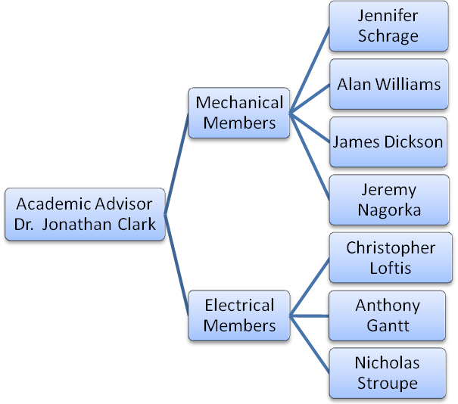

Contact
Mechanical
James Dickson jdickson@fsu.edu
Jeremy Nagorka jn07f@fsu.edu
Jennifer Schrage jls06n@fsu.edu
Alan Williams law07d@fsu.edu
Electrical
Anthony Gantt ajg08j@fsu.edu
Christopher Loftis cdl05c@fsu.edu
Nicholas Stroupe nps06c@fsu.edu

Evaluation

Progress will be gauged against the completion of objectives as outlined in the predetermined timeline. Regular monthly meetings with our academic advisor will ensure adherence to all deadlines. Individual tasks are assigned and accounted for by group consensus.

Endorsements

National Space Grant Consortium – Monetary donation
FAMU/FSU College of Engineering – Monetary donation, Research facilities
STRIDe Lab – Workspace, Tools
Evolution Model Technology Robotics – Sponsorship towards locomotion subsystem

Next Steps

Contact James Dickson at jdickson@fsu.edu or (727) 580 - 8678 for further details and sponsorship opportunities. We will be happy to answer any remaining questions regarding sponsorship of the project.

Appendix

Lunabotics Mining Competition
May 25-28, 2010
Kennedy Space Center
Astronaut Hall of Fame

Introduction

NASA’s Lunabotics Mining Competition is designed to promote the development of interest in space
activities and STEM (Science, Technology, Engineering, and Mathematics) fields. The competition uses
excavation, a necessary first step towards extracting resources from the regolith and building bases on
the moon. The unique physical properties of lunar regolith and the reduced 1/6th gravity, vacuum
environment make excavation a difficult technical challenge. Advances in lunar regolith mining have the
potential to significantly contribute to the Nation’s Space Vision and space exploration operations.

The competition will be conducted by NASA at Kennedy Space Center. The prize funding for the
Lunabotics Student Mining Competition is provided by NASA. The teams that can use telerobotic or
autonomous operation to excavate the most lunar regolith simulant within a 15-minute time limit will win the competition. The minimum excavation requirement is 10.0 kg, and the excavation hardware mass limit is 80.0 kg. Winners are eligible to receive first, second, or third prize of $5,000, $2,500, and $1,000, respectively. Rules for the competition are explained below.

Rules Draft 11/16/09

Game Play Rules
1) These rules and specifications may be subject to future updates by NASA at its sole discretion.
2) Teams will be required to perform one official competition attempt using lunar regolith simulant,
sandbox and collector provided by NASA. NASA will fill the sandbox with lunar regolith simulant,
compact it according to the Lunar Sourcebook: A User's Guide to the Moon, edited by G. H. Heiken,
D. T. Vaniman, and B. M. French, copyright 1991, Cambridge University Press, and place obstacles
in the sandbox. Each competition attempt will occur with two teams competing at the same time.
After each competition attempt, the obstacles will be removed, the lunar regolith simulant will be
returned to a compacted state, and the obstacles will be returned to the sandbox.
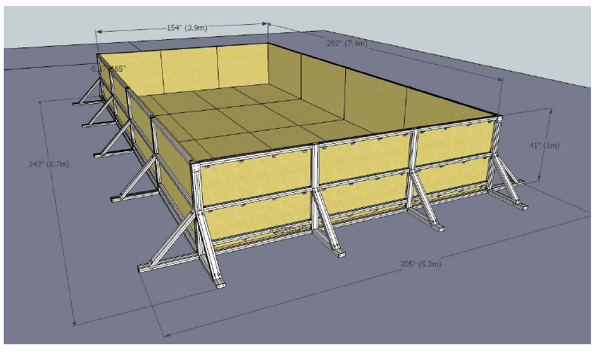

3) In the official competition attempt, the teams that acquire the first, second, and third most mass by
excavating the lunar regolith simulant mass over the minimum excavation requirement (10 kg) within
the time limit (15 minutes) will respectively win first, second, and third place prizes. In the case of a
tie, the teams will compete in a head-to-head round, where the team that acquires the most lunar
regolith simulant in that round wins.
4) All excavated mass deposited in the collector during the official competition attempt will be weighed
after completion of the competition attempt. Any obstacles deposited in the collector will be removed
from the lunar regolith simulant collected.
5) The excavation hardware shall be placed in the randomly designated starting areas. The order of
teams will be randomly chosen throughout the competition.
6) A team’s excavation hardware shall only excavate lunar regolith simulant located in that team’s
respective mining area at the opposite end of the sandbox from the team’s starting area.
7) The excavation hardware is required to move across the obstacle area to the mining area and then
move back to the collector box as illustrated (not to scale) below. The dotted lines inside the sandbox
are imaginary and may be crossed when safe to do so.
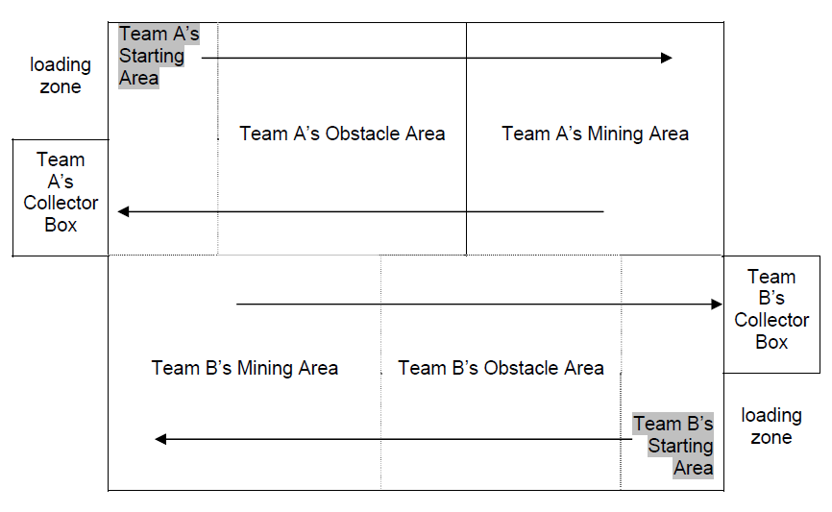

8) Each team is responsible for placement and removal of their excavation hardware onto the lunar
regolith simulant surface without the use of a ramp. There must be one person per 23 kg of mass of
the excavation hardware, requiring 4 people to carry the maximum allowed mass. Assistance will be
provided if needed.
9) Each team is allotted a maximum of 10 minutes to place the excavation hardware in its designated
starting position within the sandbox and 5 minutes to remove the excavation hardware from thesandbox after the 15-minute competition attempt has concluded.
10) The excavation hardware operates during the 15-minute time limitof the competition attempt. The
15-minute time limit will be reduced if a team is not ready at the team’s competition attempt start time.
Time will start even if a team is still setting up their excavator after the 10 minute setup time period
has elapsed. The competition attempt for both teams in the sandbox will end at the same time.
11) The excavation hardware will end operation immediately when the power-off command is sent, as
instructed by the competition judges.
12) The excavation hardware cannot be anchored to the lunar regolith simulant surface prior to the
beginning of the competition attempt.
13) Each team will be permitted to repair or otherwise modify the excavation hardware after the team’s
practice time. The excavation hardware will be inspected the evening before the competition takes
place and quarantined until just before the team’s competition attempt.

Field Rules
14) At the start of the competition attempt, the excavation hardware may not occupy any location outside the footprint defined by the area of the starting area, the top surface of the sandbox and collector walls, and an 8 cm buffer around the inside surface of the sandbox. A target may be attached to the collector for navigation purposes only. This navigational aid must be attached during the setup time and removed afterwards during the removal time period.
15) The collector will be placed so that it is adjacent to the side walls of the sandbox without a gap.
16) There will be a variety of obstacles placed on top of the compressed lunar regolith simulant surface
within the obstacle area before the competition attempt is made. The placement of the obstacles will
be randomly selected before the start of the competition and will be identical for every competition
attempt. Each rock will have a diameter of approximately 20 to 30 cm and an approximate mass of 7
to 10 kg. Rocks placed in the collector will not be counted as part of the excavated mass. Craters will
be of varying depth and width, being no wider or deeper than 30cm.
17) Excavation hardware must operate within the sandbox: it is not permitted to pass beyond the confines of the outside wall of the sandbox and the collector during the competition attempt. The regolith simulant must be collected in the mining area allocated to each team and deposited in the collector. The team may only dig in its own mining area. The simulant must be carried from the mining area to the collector by any means as long as the team avoids the other team’s excavator during the traverse through the rock field. The excavator can separate intentionally, if desired, but all parts of the
excavator must be under the team’s control at all times.
18) The excavation hardware must not push lunar regolith simulant up against the wall to accumulate
lunar regolith simulant.
19) If the excavation hardware exposes the sandbox bottom due to excavation, touching the bottom is
permitted, but contact with the sandbox bottom or walls cannot be used at any time as a required
support to the excavation hardware. Teams should be prepared for airborne dust raised by either
team during the competition attempt.

Technical Rules
20) During the competition attempt, excavation hardware is limited to autonomous and telerobotic
operations only. No physical access to the excavation hardware will be allowed during the
competition attempt. In addition, telerobotic operators are only allowed to use data and video
originating from the excavation hardware. Visual and auditory isolation of the telerobotic operators
from the excavation hardware in the Mission Control Room is required during the competition attempt.
The Mission Control Room is approximately 12 meters from the sandbox. Telerobotic operators will
be able to see the excavation hardware through fixed overhead cameras on monitors that will be
provided by NASA in the Mission Control Room. The walls of the Mission Control Room are metal
framed with 5/8” wall board on both sides of the framing.
21) Mass of the excavation hardware shall not exceed 80.0 kg. Subsystems on the excavator used to
transmit commands/data and video to the telerobotic operators are counted towards the 80.0 kg mass
limit. Equipment not on the excavator used to receive commands from and send commands to the
excavation hardware for telerobotic operations is excluded from the 80.0 kg mass limit.
22) The excavation hardware must be equipped with an easily accessible red emergency stop button on
the surface of the excavator. This kill switch must require no steps to access.
23) The communications link used for telerobotic operations is required to have a total bandwidth of no
more than 5.0 megabits/second. Teams will be required to demonstrate compliance prior to starting
the competition attempt. Wi-Fi infrastructures will be provided and monitored by NASA: one for
practice and one for the competition attempt. IP addresses will be provided and managed by NASA.
Each team must request anticipated IP address requirements by January 15, 2010 by e-mailing
Susan Sawyer at Susan.G.Sawyer@nasa.gov. Allow two weeks for IP address requests to be
processed. NASA anticipates a minimum of two IP addresses for each team. NASA technical
experts will offer feedback on real-time networking performance during practice attempts. There will
be no lunar latency time delay imposed on teams by NASA this year.
24) The excavation hardware must be contained within 1.5m width x .75m length x 2m height. The
hardware may deploy beyond the 1.5 m x .75 m footprint after the start of the competition attempt, but
may not exceed a 2 meter height to avoid potential interference with the surrounding tent. The team
must declare the orientation of length and width to the inspection judge. Because of actual lunar
hardware requirements, no ramps of any kind will be provided or allowed.
25) To ensure that the excavation hardware is usable for an actual lunar mission, the excavation
hardware cannot employ any fundamental physical processes (e.g., suction or water cooling in the
open lunar environment), gases, fluids or consumables that would not work in the lunar environment.
For example, any dust removal from a lens or sensor must employ a physical process that would be
suitable for the lunar surface. Teams may use processes that require an Earth-like environment (e.g.,
oxygen, water) only if the system using the processes is designed to work in a lunar environment and
if such resources used by the excavation hardware are included in the mass of the excavation
hardware.
26) Components (i.e. electronic and mechanical) are not required to be space qualified for the lunar
vacuum, electromagnetic, and thermal environments.
27) The excavation hardware may not use any process that causes the physical or chemical properties of
the lunar regolith simulant to be changed or otherwise endangers the uniformity between competition
attempts.
28) The excavation hardware may not penetrate the lunar regolith simulant surface with more force than the weight of the excavation hardware before the start of the competition attempt.
29) No ordnance, projectile, far-reaching mechanism, etc. may be used (excavator must move on the
lunar regolith simulant).
30) No excavation hardware can intentionally harm another team’s hardware. This includes radio
jamming, denial of service to network, regolith simulant manipulation, ramming, flipping, pinning,
conveyance of current, or other forms of damage as decided upon by the judges. Immediate
disqualification will result if judges deem any maneuvers by a team as being offensive in nature.
Erratic behavior or loss of control of the excavation hardware as determined by the judges will be
cause for immediate disqualification.
31) Teams must submit documentation containing a description of the excavation hardware, a description of its operation, a description of potential safety hazards, a diagram, and basic parts list. Each team will deliver the team’s written documentation in .pdf format by April 15, 2010 to
Susan.G.Sawyer@nasa.gov.
32) Teams must submit video documentation containing no less than 30 seconds of excavation hardware operation and at least one full cycle of operation. One full cycle of operations includes excavation and depositing material. Each team will deliver their video documentation by May 10, 2010 to Susan.G.Sawyer@nasa.gov. This video documentation is solely for technical evaluation of the
team’s excavation hardware. It is not for the video category in the overall Lunabotics Mining
Competition.

Video specifications:
Formats/Containers: .avi, .mpg, .mpeg, .ogg, .mp4, .mkv, .m2t, .mov; Codecs: MPEG-1, MPEG-2,
MPEG-4 (including AVC/h.264), ogg theora; Minimum frame rate: 24 fps; Minimum resolution: 320 x
240 pixels

Definitions

Collector – A device provided by NASA for the competition attempt into which each team will deposit
excavated regolith simulant. The collector will be large enough to accommodate each team’s excavated
regolith simulant. The collector will be stationary and located adjacent to the sandbox. Excavated regolith simulant mass will be measured after completion of the competition attempt. The collector mass will not be counted towards the excavated mass or the mass of the excavation hardware. The collector will be sized 1.65 meters long, and .48 meters wide. The collector walls will rise to an elevation about 1 meter above the average elevation of the regolith simulant surface closest to the collector.

Competition attempt – The operation of a team’s excavation hardware intended to meet all the
requirements for winning the competition by performing the functional task. The duration of the
competition attempt is the 15-minute time limit.

Excavated mass – Mass of the excavated lunar regolith simulant delivered to the collector by the team’s
excavation hardware during the competition attempt, measured in kilograms (kg) with official result
recorded to the nearest one tenth of a kilogram (0.1 kg).

Excavation hardware – Mechanical and electrical equipment, including any batteries, gases, fluids and
consumables delivered by a team to compete in the competition.

Functional task – The excavation of regolith simulant from the sandbox by the excavation hardware and
deposit from the excavation hardware into the collector box.

Lunar regolith simulant – Specific lunar regolith simulant provided by NASA during the competition
attempt is to be determined. Small samples will be provided to each registered team.

Minimum excavation requirement – The total excavated mass, 10.0 kg, which must be met in order to
qualify to win the competition.

Power – All power shall be provided by a system onboard the excavator. No facility power will be
provided to the excavator.

Practice time – Teams will be allowed to practice with their excavators in the sandbox on May 25 and 26, 2010. NASA technical experts will offer feedback on real-time networking performance during practice attempts.

Reference point – A fixed location on the excavation hardware that will serve to verify the starting location and traversal of the excavation hardware within the sandbox.

Sandbox – An open-topped container (i.e., a box with a bottom and four side walls only), containing
regolith simulant, within which the excavation hardware will perform the competition attempt. The
dimensions of the sandbox will be 3.9 meters wide and 7.4 meters long, and one meter in depth. The
sandbox for the competition attempt will be provided.

Telerobotic – Communication with and control of the excavation hardware during the competition attempt must be performed solely through the provided communications link which is required to have a total bandwidth of no more than 5.0 megabits/second on all data and video sent to and received from the excavation hardware.

Time Limit – The amount of time within which the excavation hardware must perform the functional task, set at 15 minutes; set up excavation hardware, set at 10 minutes; and removal of excavation hardware, set at 5 minutes.

