**Team Building Activity**

**Team 8: Lunar Excavator Project**

|  |  |
| --- | --- |
| James Dickson | Jennifer Schrage |
| Anthony Gantt | Nicholas Stroupe |
| Christopher Loftis | Lindsey A. Williams |
| Jeremy Nagorka |  |

**Faculty Advisor**

Dr. Jonathan Clark

The team was presented with the problem to design a fastening system that does not use metal fasteners that still is easily reversible. The team was brought together at a brainstorming meeting to discuss possibilities for solving the problem. During the meeting, there was coke and cupcakes served and general introductions made. Figure 1 shows the team hard at work brainstorming to solve the problem. The team brainstormed multiple ideas for solving the problem presented for the team building activity. These ideas include twist lock, spring lock, and adhesive.

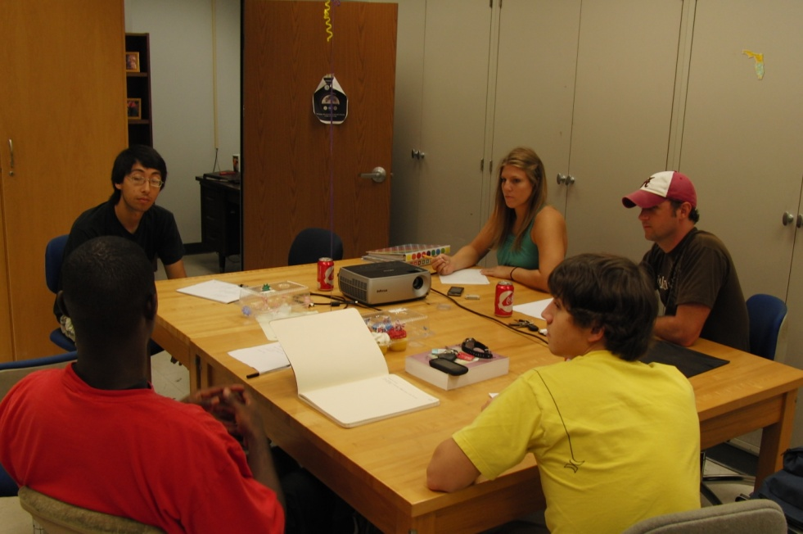

Figure 1. The Lunar Excavator Project Team hard at work brainstorming.

The twist lock contained a square top that was the same size as the piece adjoining it. These two pieces are then aligned and fitted together. Once they are together the lock is twisted into place; the pressure from fitted pieces pushes out on the lock to hold the piece in place. This can be removed easily by twisting the two pieces back into alignment and sliding them apart.

A silicone based adhesive can be placed between the two pieces that are to be joined. Once pressure is applied the silicone is smoothed over all the edges. If this is to be taken apart a knife or a solvent that will dissolve the adhesive can be used. An example given during brainstorming is the adhesive used to secure windshields.

The spring lock is a plastic piece molded from original part with two columns extruded from the surface of the piece with triangular heads. A rectangular hole in the adjoining part allows for the two columns to slide into the piece. As the piece is placed together the lock deflects to allow the piece over the tip and then springs back to original position to hold adjoining piece in place with the triangular tips. It this is necessary to be removed one would have to push the two columns towards each other at the triangular tips and as the tips move off the surface of adjoining part they can slide through the rectangular hole.

The final chosen design was that of the spring lock. The spring lock presented the most easily manufactured and reversible choice of any of the brainstormed ideas. The design is more robust than the twist lock, and more easily reversible than the adhesive. Figure 2(a) and 2(b) show the CAD representation of the final design.

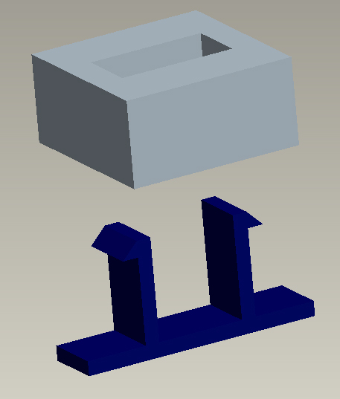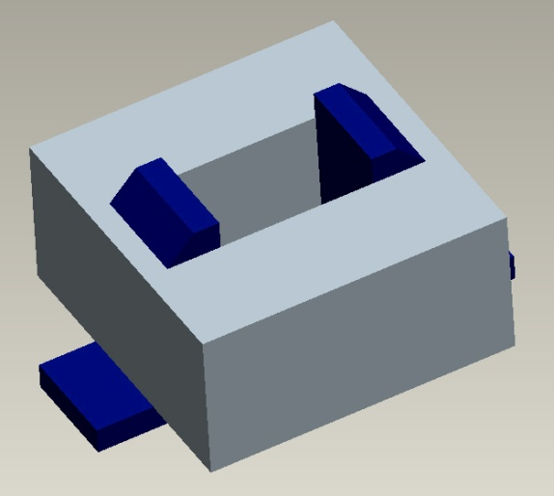

Figure 2. (a) The two adjoining pieces separate.

(b) The two adjoining pieces fitted together and locked.