**The Florida State University – FAMU**

**College of Engineering**

Department of Mechanical Engineering

EML4551 Senior Design Project II

Group # 4

**The CRUSHED Experiment**

**Sponsored by Eglin Air Force Base**

**Deliverable 1:** Restated Project Scope and Project Plan

Members:

* Phillip Munday
* Justin Roose
* Carlos Sanabria



# Initial Requirements and Design specifications so far

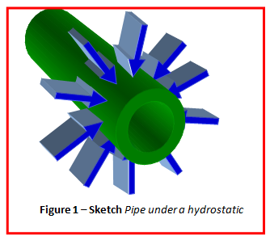

AFRL is interested in studying the mechanical and dynamic properties of a steel pipe as it undergoes an external quasi-hydrostatic pressure. This research will work in conjunction with a proposed basic research project that the Air Force has currently proposed. The purpose is to be able to apply a variety of compressive forces (i.e. – pressures) at varying lengths along the pipe. A series of dynamic tests would then be performed on the cylinder to determine the system behavior under these loading conditions.

The initial requirements were to obtain a surface pressure of 10,000 psi and the design was based around these requirements. The design is explained below:

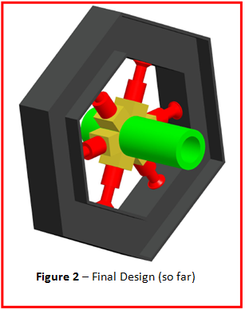Figure 2 shows a sketch of the final design. This outer frame (in gray) will be constructed with I-beams, and the force will be applied by six hydraulic cylinders. We believe that this design is the most effective, safe, and user friendly way to perform these experiments. The use of six sections is the optimum amount to get the most quasi-hydrostatic pressure applied to the pipe without having to create too many sections. We also did enough analysis to find out that the most effective way to apply the pressure is with hydraulics instead of using bolts. The bolts would be too difficult to tighten down on because the required torque is too great for a torque wrench.

# Problems encountered last semester

|  |  |
| --- | --- |
| Table 1 | |
| Hydraulic Piston | |
| Overall length | 3.57 in. |
| Stroke | 0.50 in |
| Max psi | 5000 psi |
| Oil Displacement | 0.884 in3 |
| Price | $181.03 |

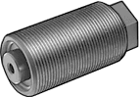We did some research looking for hydraulic actuators in the market and the best option we could find, given our budget, are the actuators in Figure 3. The specifications are listed in Table 1. The biggest problem we are facing right now is that the maximum pressure that each one of these actuators can apply is about 5000psi, leading to an overall pipe surface pressure of a value much less than the desired 10,000 psi. The actuators themselves are also a lot smaller than we calculated the original dimensions to be and therefore we will be able to save more space.

**Figure 3 –** Pressure actuator

After having a discussion with our sponsor about the fact that we have smaller forces and dimensions, we came to the agreement that due to our small budget we are going to have to bear with these problems and design the device for as much pressure as we can with our budget.

What does this mean? Well we are currently working on finding new dimensions for the outer (supporting) ring with the new specifications.

# Conclusion

Given the fact that we are restricted to a compressive force of 5000 psi out design will significantly reduce in size and materials needed. We still have to look into safety factors and ways to reduce the dangers involving the (still) high pressures that are going to be dealt with.

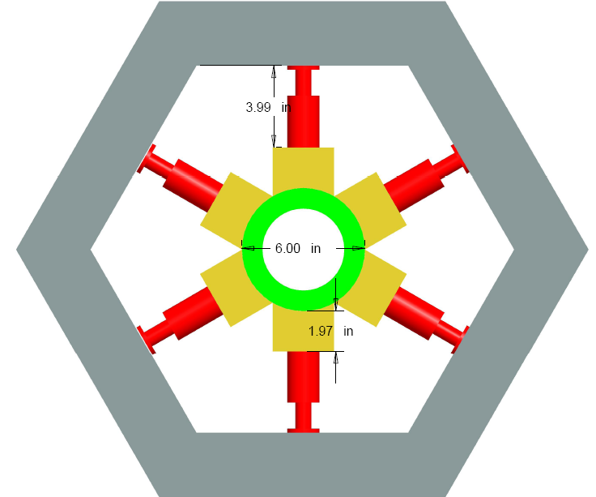 The pipe itself is still the same size that we have used before; therefore we keep the inner dimensions as they are but the hexagonal outer ring will reduce its size significantly. Figure 4 displays the dimensions that we have calculated so far now that we have the actuator dimensions. The thickness of the I-beam will be calculated later on. We are working on it.

Other than that, there have not been any other changes in the design. We still have to deal with the challenges we foresaw last semester listed below:

* How to attach the actuator to the I-beam
* Make sure the welding in on the hexagon are strong enough
* Implement something like natural rubber between the pipe and the sections to ensure a uniform pressure

**Figure 4 –** New preliminary Dimensions

We are working on it!