Oct 07 11

Time: 2:00pm-3:50pm

**-Old Business**

     *NAPS complete

     *Calendar updated

**-New Business**

     *Buy training aircraft

     *Project Plan

     *Next project (Project Specs)

     *Website

**-Meeting Ideas**

*thin film solar panel on horizontal surfaces <http://en.wikipedia.org/wiki/Thin_film_solar_cell>

     *looking for the best board

     *<http://www.gumstix.com/>

**-Project subsystem design deadlines**

*Project Specification: 10/7-10/13

     *Concept Generation: 10/13-10/20

     *Concept Selection: 10/20-10/25

     *Interim design: 10/25-11/17

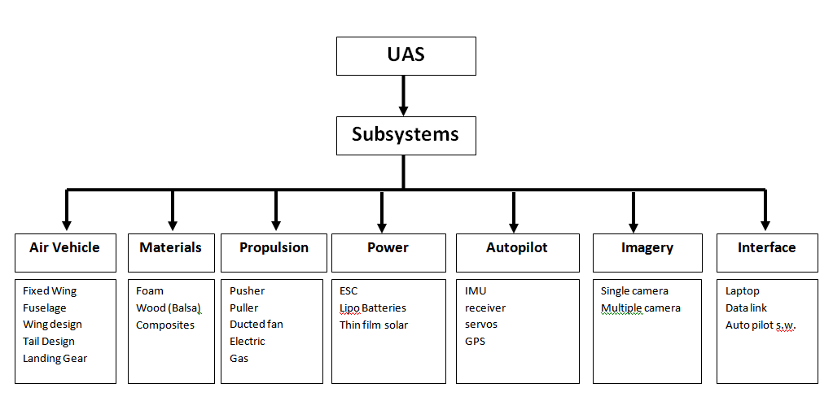

**-Plane Requirements**

*payload (weight)

     *payload (volume)

     *performance: (range and endurance)

     *Speed: (takeoff, landing, cruising)

     *Stability

     *Controllability

     *Flying quality (COG)