**Nov 8 11**

**Senior Design meeting**

Time: 6:00pm-7:20pm

**-Old Business**

*Team Evals

     *Concept Generation complete

**-New Business**

*motorcalc

     *Meeting with Dr. Kumar at main campus 2:00pm FCAAP

     *Weight problems with design

     *Weight estimation

     *Looking at training Plane: <http://www.nitroplanes.com/93a1403-1400-j3-yellow-rtf-24g.html>

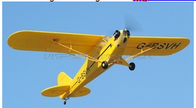

**-Power Consumption Estimation: for 20 lb aircraft**

*Motor take off: 1000 watts/~10 volt supply/

     *Motor Cruise: 500 watts/~10 volt supply/

     *autopilot:6.1V → 18V/ 40 mA

     *camera: 6 to 12 V DC/1.5 W (motors inactive), 2.0 W (motors active)

     *Law mate: 5V/ 500 mA (Video TX)

     *XBEE: 3.0 - 3.6 VDC/ 210 mA @ 3.3 V (AP TX)

     *CS servos: 4V-7V/ 160mA

     *Gimble servos: 4V-7V/ 50mA

**-Weight estimation minus aircraft materials = apprx. 5 lbs**

