FAMU-FSU College of Engineering
Department of Electrical and Computer Engineering

PROPOSAL

EEL4911C – ECE Senior Design Project I
Project title: SOLAR CAR PROJECT PROPOSAL
Team #: 02

Student team members:
Patrick Breslend, electrical engineering, (Email: pb06@my.fsu.edu)
Brad Burke, mechanical engineering, (Email: bab08s@fsu.edu)
Jordan Eldridge, electrical engineering, (Email: jee06c@my.fsu.edu)
Tyler Holes, mechanical engineering, (Email: tjh07e@fsu.edu)
Valerie Pezzullo, mechanical engineering, (Email: vnp07@fsu.edu)
Greg Proctor, electrical engineering, (Email: gcp09@my.fsu.edu)
Shawn Ryster, electrical engineering, (Email: sar09d@fsu.edu)
Senior Design Project Instructor: Dr. Michael Frank

Electrical Engineering Faculty Advisor: Dr. Chris Edrington

Mechanical Engineering Faculty Advisor: Dr. Patrick Hollis

Submitted in partial fulfillment of the requirements for
EEL4911C – ECE Senior Design Project I

October 20, 2011

Project Executive Summary

The FSU College of Engineering has provided this team of engineers with the challenge of completing the ECE Solar Car. The goal of this year’s team is to build a vehicle that will be a catalyst for the inception of a college wide multi-departmental “Solar Car Club”. The team will provide a solar car that is capable of running exclusively off solar power. The solar car is a light weight, three wheeled, one man automobile that is capable of traversing long distances such as the American Solar Challenge race. The America Solar Challenge is a race from Texas to Canada that the car will be gear toward competing in for future generations of the solar car team. The car will be capable of handling diverse weather conditions as well as any road conditions that a modern day car would encounter in its excursions such as the one from Texas to Canada.

The teams approach to the project provided by the FSU College of Engineering will be to take a modular approach that allows for future changes to be made to the vehicle. The team plans on completing multiple tasks that are required for the completion of the car. The most pertinent task will be to replace the current broken motor with a lynch style dc brush motor. With replacing the motor, a new motor controller is required that is compatible with the new motor. The rear suspension and rear arm will be redesigned to be compatible with the new motor. Furthermore, the solar array will be mounted to the vehicle. The PV arrays need to be designed to meet the demands of the electrical systems of the vehicle. Once the PV array is implemented a max power point tracker is required to provide efficient power to the battery system. The MPPT is a keystone to having a fully functional efficient solar vehicle. For the completion of this vehicle the driver encasement (bubble) is required for the functionality of the car in future racing endeavors. Driver’s safety is the most important consideration when designing a vehicle, the being said a parking brake, bubble, climate control, and latching of the shell will be utilized. Having the driver bubble will not only protect the driver, but it will allow for climate control in the vehicle for both the driver and the electrical components as well as bring the car one step closer to being race ready.

The solar car projects other objective is to be able to bring in future sponsors for the Solar Car Club. The team’s website will be a cornerstone for the procurement of funds as it will act as a medium that the public can both get involved in the project and view the cars progress throughout the years. The website will also help give credit to contributors of the project by displaying their information with links to their website.
Table of Contents

Project Executive Summary ii
1 Introduction 6
1.1 Acknowledgements 6
1.2 Problem Statement 6
1.3 Operating Environment 7
1.4 Intended Use(s) and Intended User(s) 7
1.5 Assumptions and Limitations 7
1.6 Expected End Product and Other Deliverables 8
2 Proposed Design 10
2.1 Overview 10
2.2 Top Level Design 10
2.2.1 Motor and Suspension Design 11
2.2.2 Latch and Hinge 12
2.2.3 Bubble 13
2.2.4 Air Ventilation 13
2.2.5 Parking Brake 14
2.2.6 Regenerative Brakes 14
3 Statement of Work (SOW) 15
3.1 Task 1: Project Management 15
3.1.1.1.1 Objectives 15
3.1.1.1.2 Approach 16
3.1.1.1.3 Managerial duties 16
3.1.1.1.4 Engineering responsibilities 16
3.1.1.1.5 Website 16
3.1.1.1.6 Finance and Fundraising 16
3.2 Task 2: Motor Replacement 16
3.2.1 Objectives 16
3.2.2 Approach 17
3.2.2.1 Subtask 2.1: Research and Design 17
3.2.2.1.1 Objectives 17
3.2.2.1.2 Approach 17
3.2.2.1.3 Outcomes of Task 17
3.2.2.2 Subtask 2.2: Implementation 17
3.2.2.2.1 Objectives 17
3.2.2.2.2 Approach 18
3.2.2.2.3 Test/Verification Plan 18
3.2.2.2.4 Outcomes of Task 18
3.2.2.3 Subtask 2.3: Testing 18
3.2.2.3.1 Objectives 18
3.2.2.3.2 Approach 18
3.2.2.3.3 Outcomes of Task 18
3.3 Task 3: PV array 18
3.3.1 Objectives 18
3.3.2 Approach 19
3.3.2.1 Subtask 3.1: Research and Design 19
3.3.2.1.1 Objectives 19
3.3.2.1.2 Approach 19
3.3.2.1.3 Test/Verification Plan 19
3.3.2.1.4 Outcomes of Task 19
3.3.2.2 Subtask 3.2: Implementation 19
3.3.2.2.1 Objectives 19
3.3.2.2.2 Approach 19
3.3.2.2.3 Test/Verification Plan 20
3.3.2.2.4 Outcomes of Task 20
3.3.2.3 Subtask 3.3: Testing 20
3.3.2.3.1 Objectives 20
3.3.2.3.2 Approach 20
3.3.2.3.3 Outcomes of Task 20
3.4 Task 4: Maximum Power Point Tracker 20
3.4.1 Objectives 20
3.4.2 Approach 21
3.4.2.1 Subtask 4.1: Research and Design 21
3.4.2.1.1 Objectives 21
3.4.2.1.2 Approach 21
3.4.2.1.3 Test/Verification Plan 21
3.4.2.1.4 Outcomes of Task 21
3.4.2.2 Subtask 4.2: Implementation 21
3.4.2.2.1 Objectives 21
3.4.2.2.2 Approach 21
3.4.2.2.3 Test/Verification Plan 22
3.4.2.2.4 Outcomes of Task 22
3.4.2.3 Subtask 4.3: Testing 22
3.4.2.3.1 Objectives 22
3.4.2.3.2 Approach 22
3.4.2.3.3 Outcomes of Task 22
3.5 Task 5: Latch/Hinge 22
3.5.1 Objectives 22
3.5.2 Approach 22
3.5.2.1 Subtask 5.1: Hinge 22
3.5.2.1.1 Objectives 22
3.5.2.1.2 Approach 23
3.5.2.1.2.1 Research and design 23
3.5.2.1.2.2 Implementation and testing 23
3.5.2.1.3 Outcomes of Task 23
3.5.2.2 Subtask 5.2: Latch 23
3.5.2.2.1 Objectives 23
3.5.2.2.2 Approach 23
3.5.2.2.2.1 Research and design 23
3.5.2.2.2.2 Implementation and Testing 23
3.5.2.2.3 Outcomes of Task 23
3.6 Task 6: Driver Encasement (Bubble) 24
3.6.1 Objectives 24
3.6.2 Approach 24
3.6.3 Research and Design 24
3.6.4 Implementation and Testing 24
3.6.5 Outcomes of Task 24
3.7 Task 7: Parking Brake 24
3.7.1 Objectives 24
3.7.2 Approach 25
3.7.3 Research and Design 25
3.7.4 Implementation and Testing 25
3.7.5 Outcomes of Task 25
3.8 Task 8: Regenerative Braking 25
3.8.1 Objectives 25
3.8.2 Approach 25
3.8.3 Research and Design 25
3.8.4 Implementation and Testing 26
3.8.5 Outcomes of Task 26
3.9 Task 9: Rear Suspension and Rear Arm 26
3.9.1 Objectives 26
3.9.2 Approach 26
3.9.2.1 Subtask 9.1: Rear Arm 26
3.9.2.1.1 Objective 26
3.9.2.1.2 Approach 26
3.9.2.1.2.1 Research and Design 27
3.9.2.1.2.2 Implementation and Testing 27
3.9.2.1.3 Outcomes of Task 27
3.9.2.2 Subtask 9.2: Rear Suspension 27
3.9.2.2.1 Objective 27
3.9.2.2.2 Approach 27
3.9.2.2.2.1 Research and Design 27
3.9.2.2.2.2 Implementation and Testing 27
3.9.2.2.3 Outcomes of Task 28
3.9.2.3 Implementation and Testing 28
3.9.3 Outcomes of Task 28
3.10 Task 10: Air circulation system 28
3.10.1 Objectives 28
3.10.2 Approach 28
3.10.2.1 Research and Design 28
3.10.2.2 Implementation and Testing 29
3.10.3 Outcomes of task 29
4 Risk Assessment 30
5 Qualifications and Responsibilities of Project Team 31
6 Schedule 33
7 Budget Estimate 35
8 Deliverables 37
9 Appendices 37

Introduction

Acknowledgements

The senior design team would like to acknowledge the following individuals and organizations for their contributions to the advancement of this project:

- Dr. Michael Frank for administrative and technical guidance
- Dr. Chris Edrington for electrical engineering technical guidance
- Dr. Patrick Hollis for mechanical engineering technical guidance
- FAMU-FSU College of Engineering for financial contributions to the project

Problem Statement

General Problem Statement:

The problem set forth by the College of Engineering for this project is to design and build a solar car capable of competing in future events such as the North American Solar Challenge. The solar car design is required to be lightweight and capable of running entirely on solar energy. Therefore, the car should use solar panels to charge the batteries that will in turn energize the motor to run the car. Currently, the solar car is in its third year of production and this year’s team was presented with the challenge of completing the previous year’s design. The students will address existing problems from the previous phases and will improve upon aspects to satisfy any requirements for future competitions as well as satisfy requirements for the continued operation of the vehicle and safety of the driver.

The obstacles the students face this year are numerous, including replacing a broken motor and designing and integrating the solar panel array. The students need to find a way to amalgamate the solar panels and the batteries so they can work together to power the vehicle. In addition to replacing the existing motor, the rear suspension must be redesigned to incorporate a different size motor with different operating mechanics if required, as well as redesigning the rear wheel attachment for better stability. Also, the body of the car should be fastened together for stability during operation and able to open and close from the inside and outside of the car with ease. In its current state, the car does not have an enclosure for the driver which will need to be added as well as an air circulation and ventilation system inside the enclosure for driver comfort and as a means to cool the electronic components in the entire vehicle

General Solution approach:

To complete the tasks stipulated in the general problems section, the team will first need to address the problem of the broken motor. This task is both a technical obstacle and a financial obstacle because the cost of fixing or replacing the motor exceeds the current budget for the project. The team will come up with a few alternative designs that could be less expensive, however possibly more complicated to integrate into the current design. The proposed solution approach for all mechanical aspects includes generating rough sketches followed by CAD (Computer Aided Design) drawings. From the CAD drawings, calculations will be made based on the type of component designed and the parameters specified. A few mechanical components will require the use of simulations to easily change the design parameters and determine the best design (for example, simulating air flow over the driver “bubble” to determine the best aerodynamic design). A materials selection process will be used to properly choose the best materials possible for each component and will lead to purchasing, fabricating, and installing each component. After a component is installed, testing will occur to determine if the component is working properly and if there needs to be additional redesigns or recalculations performed. The final design will ideally include all working components and integrations for a functioning solar vehicle.

Operating Environment

The FSU solar car shall be able to operate in standard North American climates. The car needs to be able to withstand normal wear and tear with seasonal changes that a commercial automobile would encounter in this area. The car should be resistant to rain, dust, debris, etc. The cars electronics need to be protected and be able to operate in wet humid conditions as well as dry hot environments. The car will not be built to operate in extreme conditions such as mountainous terrain or heavy snowfall; however the car will be able to handle up to a 12 percent grade which can be found on residential roads.

Intended Use(s) and Intended User(s)

With the up and coming Sustainable Engineered Solutions (SES) at the College of Engineering, the car will be used for future senior design projects and/or for a potential solar car club. The car will be taken to various events and shows such as the FSU homecoming parade in order to get publicity for current and potential sponsors. This in turn will hopefully generate donations to help the progression of SES and its related projects, and also to generate money for more research in sustainable energy solutions.
This year the intended users will be solely project team members for design and testing. This will change in the future as the car gets passed down through the years and serves as a learning experience for many students. The solar car club hopes to inspire other engineering students to pursue an increased knowledge of sustainable energy and its immense applications. For either case, the ultimate goal is to design a car worthy of entering and competing in the North American Solar Challenge.

Assumptions and Limitations

Assumptions:

- The existing frame, chassis, suspension, motor, and batteries must be used because replacing any one of these components will severely drain this year’s budget.
- Vehicle will operate safely and efficiently.
- Batteries will be able to charge from solar panels.
- Mechanical energy will be recycled through regenerative breaking.
- Vehicle will be able to be made street legal.
- Vehicle’s completion will be geared toward future solar car competitions.
- The car will consume no more power than the batteries and solar panels can provide.
- The car will be able to maintain speed appropriate for future races.
- The motor shall be able to run for extended periods of time

Limitations:
- The cars components shall be modular in the since that no permanent damage will be done to the vehicle if that component is changed in the future. The goal is for future teams to be able to make changes to the car as they see fit.
- No major changes will be made to the physical appearance of the vehicle as far as the shape and size of the car.
- The cost of Designing the MPPT should not exceed the cost of purchasing a MPPT(Approx $1500
- All expenditures will need to fit within current budget Approx $20000.
- All additions to vehicle will be contained within the existing dimensions of the chassis.
- The footprint of the bubble will be no bigger than 11.6 ft² and no smaller than 5.42 ft².
- The bubble should be no heavier than 25 lb nor should the bubble exceed a height of more than 16 inches above the shell of the car.
- The driver will be secured via a 5-point seat belt.
- The bubble will have a coefficient of drag below 0.2.
- The roll cage to encompass the driver will be able to withstand at least 800 lb_{f} in compression.
- Solar array must be contained within 6 m²
- MPPT must be able to match the voltage from the panels to the battery

Expected End Product and Other Deliverables

The end product should be a functional solar car and contain all of the components that are proposed to be designed or redesigned. The vehicle should be in a condition where the hand-off to the next year’s design team or a solar car club will be smooth and will provide future users with enough knowledge to continue work on the project. Deliverables for this project include all papers and presentations created during the year (see table of deliverables for 2011-2012 year below). It is possible that the team will generate a “user guide” to the vehicle or update a current “user guide” if available. A list of the technical specifications and competition rules followed will be generated to give future students an idea of the guidelines followed for the competition in the given year(s). This will help future students get an idea of what components could work for the future competition rules and regulations and what components they would need to alter for that year’s competition.

Proposed Design

Overview
The goal of the project this year is to improve upon the solar car that has been built by teams over the last two years. The car has a carbon fiber body with a single wheel powered by a motor in the rear, while the two wheels in the front allow for steering and braking. Much of the mechanical design is already in place and requires no modification, however many design flaws are present and need to be addressed along with added functional requirements that were not present in the past designs. In this section, all of the aspects that will be added or changed will be noted along with their respective design proposals.

Top Level Design
The block diagram in Figure 2.2 below gives an overview of the entire car and its systems. As noted, all blocks in orange are new design features that are being newly added or redesigned, and all blocks in blue are features in the existing design. The green arrows represent positive power flow while the red arrows represent negative power flow.
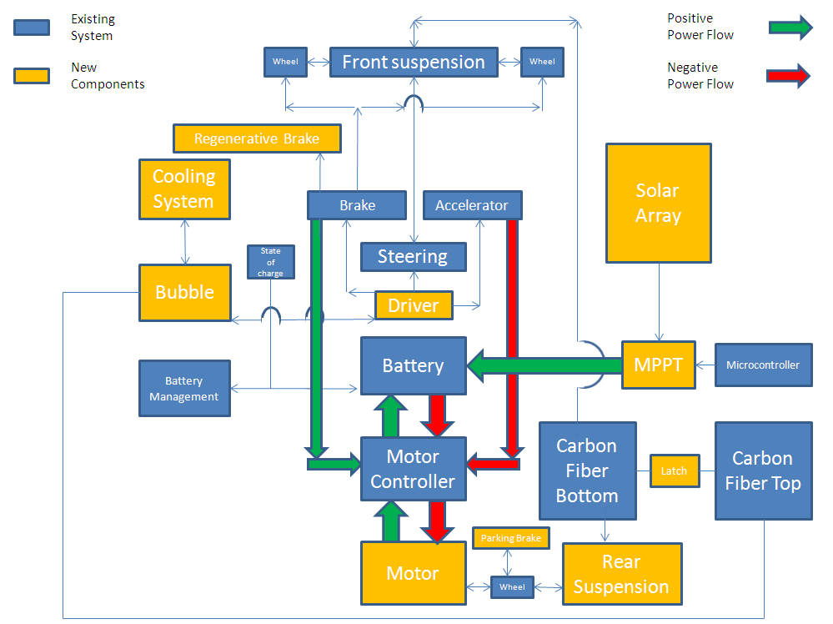

Figure 2.2 - Top Level Design

Motor and Suspension Design

Motor
Wheel
Rear Suspension
Carbon Fiber Bottom
Rear Suspension Arm
Suspension Bracket

Figure 2.2.1 – Motor and Rear Suspension

Due to recent complications involving the motor that was to be used, the main design ideas behind the rear suspension and arm will need to be redesigned once the new motor is order. The new motor is a major component that we will have to design around due to lack of funds to purchase a new motor. This drastically changes what was originally planned for the rear suspension, in that only the rear suspension bracket needed to be redesigned.

In redesigning the rear arm, a new single bracket will replace the two U-shaped brackets holding the arm to the body. This will help eliminate the change in alignment that occurred for last years’ team. The design of the new arm has not been decided on as the new motor must be inspected first to determine possible mounting options.

Latch and Hinge

Driver
Carbon Fiber Bottom
Carbon Fiber Top
Latch
Hinge

Figure 2.2.2 – Latch and Hinge

The latching system will allow for a single person to open and close the lid of the car. The latch will be accessible from the inside and outside of the car. Two hinges will be attached to the left side of the car, while the latches are attached to the right side. Therefore, if the driver needs to get out during operation, he/she will exit the vehicle to the right side and away from traffic. This allows for much higher operational safety as it will keep the body of the car secure and stable under operation. The aerodynamics will also be improved as the top part of the body will be more secure and allow airflow to pass over the nose of the car with minimal flow separation. The lid will be set at certain angles to be orthogonal to the sun while charging. Much like propping open a car hood, it will have multiple notches allowing for incremental degree changes. This will be useful if the driver has to pull over to the side of the road to recharge the batteries in the fastest time possible.

Bubble
Bubble
Carbon Fiber Top
Bubble Mounting Bracket

Figure 2.2.3 - Bubble

Several simulations will be performed on proposed design shapes to see which will provide the highest performance while remaining economical. The geometries used for the simulations will range from spherical to airfoil shape. This is due to the fact that a spherical shape is the most simplified form and easiest to calculate as well as being easier to manufacture, while an air foil shape is the most ideal aerodynamic geometry but may be hard to implement as a bubble in the required parameters. The final design will most likely be in the middle at a point where the form and function are both at local maximums. Material selection has yet to be determined but it will be similar to the polycarbonate beads used in motorcycle visors so as to be shatter resistant while maintaining a high level of clarity.

Air Ventilation

Fan Mounting Bracket
Carbon Fiber Bottom
Fan
Air Ducts

Figure 2.2.4 – Air Ventilation System

An onboard air circulation system will be implemented to keep both the driver and electronics cool. Circulation ducts will be made using lightweight tubing to direct airflow to certain areas of the car that most require cooling. This will be mainly to all electronics and to the driver in order to keep them within a safe operating temperature of 40˚F – 95˚F. The system will possibly use disposable batteries so that it does not drain energy from the solar cells and decrease their efficiency. While the extra fan and batteries will add weight, the need to keep the electronics and the driver cool is extremely important.

Parking Brake

Motor
Wheel
Rear Suspension
Carbon Fiber Bottom
Parking Brake

Figure 2.2.5 – parking brake

A braking system, independent of the regenerative and disc brakes, will be implemented on the rear wheel. This will be used for parking and emergency situations where the two primary brakes need to be bypassed in the case of brake failure. Due to the lack of room on the front two wheels to put a parking brake, it may need to be fitted to the rear wheel. Once installed, the parking brake needs to hold the weight of the car and driver up to a 15° incline.

Regenerative Brakes

Driver
Steering
Brake
Accelerator
Regenerative Brake

Figure 2.2.6 Regenerative braking

The solar car will be equipped with three different braking systems. While disc brakes are already on the car, regenerative brakes will be added to further increase the systems overall efficiency. This will be done in a two-step system, where the regenerative brakes can be used on their own or in conjunction with the disc brakes. The idea is that if only a little braking is required under certain circumstances, the driver can use solely regenerative brakes, recapturing as much energy as possible. This allows for disc brakes to be used only if necessary when the regenerative brakes do not supply enough stopping power.

For this design, an integration and control of the regenerative braking with mechanical braking will need to be performed by both mechanical and electrical engineers. The regenerative braking will be allowed up to a certain point after which mechanical braking will be applied. It is possible that a control system can be used to transitions from one to the other, as well as extending the brake pedal or shortening brake fluid line up to a certain point at which a sensor will detect where then regenerative braking stops and brake line begins.

Proposed Solar Array Topology

In order to build a more efficient MPPT, we have chosen to operate the PV array at a voltage lower than the input voltage of the motor and boost the voltage up. Because losses in converters are increased with higher currents, it is best to boost the voltage up and lower the current. Space constraints will restrict the number of solar panels to approximately 70 units, which allows for 35 parallel arrays of two series panels. The total nominal power of the array will be approximately 215 Watts.

Statement of Work (SOW)

Task 1: Project Management

Objectives
The solar car team’s objective this year is to complete the third phase of the solar car project with the intention of moving the solar car project to a renewable energy club and to participate in future competitions. To meet this objective the team needs to fix multiple components of the vehicle as well as integrating additional electrical components, i.e. Solar panels, MPPT, motor while managing the budget The mechanical tasks that are required in order to consider the car complete are a driver encasement (bubble), new motor, redesigned rear arm/suspension, latching system, parking brake, and an air circulation system. While the Electrical tasks include integrating the PV array, building a Max power point tracker system, and implementing the motor and controller subsystems

Approach
The solar car project consists of two separate but cohesive systems, mechanical and electrical. The team will work in two groups, mechanical engineers and electrical engineers, in order to properly address and solve the various problems and needs for the car. The mechanical engineers will analyze and solve each problem as a team in order to be cohesively informed and be able to discuss different ideas and issues for each task.

Managerial duties

In order to meet the goals of the final phase of the solar car project, the team must use what was given to them from the previous two phases of the project to complete the solar car. To manage this project the group will have two team leaders, one for mechanical and one for electrical. They will divide up tasks weekly in order to make sure that the projects goals are being completed according to the team schedule. The team manager as well as having these responsibilities will also have the duty of assigning each engineer to a task. The manager will then need to assign engineers to test the implementation of each design component.

Engineering responsibilities
Each engineer will be responsible for an aspect of the car that suits their particular skill set. Each engineer will then have the responsibly of researching and designing their part of the system and presenting their result to the team for evaluation. If approved, the engineer will be in charge of implementing his or her part of the design into the solar car.

Website
The team will also need an engineer to maintain the team’s website in order to keep good rapport with previous sponsors and gain new supporters for this year’s project.

Finance and Fundraising
The team treasurer will be responsible for keeping the team’s budget under consideration as the year progresses and expenditure are required. The treasurer will be handling donations as well as coordinating fundraising events throughout the year.

Task 2: Motor Replacement

Objectives
The previous year’s senior design team redesigned the body and other mechanical systems of the solar car, but reused several parts of the electrical system. The electric motor is more than 10 years old and has deteriorated to the point that it is highly unreliable. This year’s team must find an economical replacement for the motor and implement it. It is worth noting that if a different type of motor is chosen, a new motor controller must be chosen that fits within the parameters of the existing electrical system. Also, the rear suspension will have to be redesigned.

Approach
The approach the engineers will take to complete these objectives is to research and compare different types of electric motors, with careful consideration for budgetary constraints, as well as constraints within the electrical system. To replace the motor with a duplicate of the same model would cost over $16,000 dollars and, given the limited budget, this is not a feasible option. Steps include researching a new motor and, if applicable, a new motor controller and a new rear suspension. Also, if applicable, this step will include the design of a new rear suspension to replace the current design. Secondly, the team will order the motor and controller and test them upon delivery, in order to ensure proper operation. Next, the team will implement the motor and the redesigned rear suspension. Finally, the entire subsystem will be tested.

Subtask 2.1: Research and Design

Objectives
The overall objective of the research phase is to ensure that the final choice in replacement motor and controller meets all required parameters set forth by both last year’s senior design team, in regards to required torque/power, as well as compatibility with the existing electrical system. Steps include outlining available voltage levels that could be achieved by reconfiguring the battery system and determining the available space to mount the motor and possible drive systems to connect the motor to the wheel. Next, the rear suspension will be redesigned using all of this data.

Approach
Researching a new electric motor to be used as a replacement of the solar car’s propulsion consists of comparing several types of motors across multiple vendors in order to find the most economical solution that meets or exceeds the power and space requirements. The design of the rear suspension shall consist of the shock absorber from the previous design and a belt drive or axle drive system connecting the new motor to the rear wheel.

Outcomes of Task
The outcome of this task will be a choice of replacement motor and a design of the rear suspension, ready to be implemented.

Subtask 2.2: Implementation

Objectives
The overall objective of the implementation phase of the motor subtask is to realize the designed subsystem. Steps included in this phase are the machining of parts, the assembly of the rear suspension, and the attachment and connection of the new motor.

Approach
The parts for the rear suspension will be machined and assembled at the COE.

Test/Verification Plan
The motor and controller should be tested before connection to the rear suspension and drive by connecting them directly to the batteries and verifying proper operation. During assembly of the rear suspension, the drive belt or axle should be shown to maintain contact through the whole range of motion of the shock absorber.

Outcomes of Task
The outcome of this task is the completion of the motor/controller and rear suspension subsystem.

Subtask 2.3: Testing

Objectives
Aside from the testing of the individual components through subtask 2.1 and 2.2, testing of the overall subsystem must take place.

Approach
This testing will include a launch from standstill at the maximum incline, and a mild shock during normal driving conditions.

Outcomes of Task
The outcome of this task is the final, verified motor/controller and rear suspension subsystem, which, at this phase, will be ready to be integrated into the vehicle system congruently with the other subsystems.

Task 3: PV array

Objectives
The PV array must be integrated into the existing electrical system of the car. There must be ample PV cells to cover 6m² of the solar vehicle. The engineers must test and determine the solar modules efficiency to collect solar irradiation, in order to determine the solar modules output parameters. The engineers need to determine the most appropriate design of the solar arrays to meet the needs of the cars electrical systems, including the motor. How the solar array is mounted on the vehicle is pertinent to its performance and protection. As such, the engineers need to devise a system for the attachment and protection of the solar array.

Approach
The approach the engineers will take to complete these objectives is to research, design, implement, and test each objective. This process will ensure that the objectives are met in a timely manner while considering efficiency and aptness.

Subtask 3.1: Research and Design

Objectives
The overall objective of the research and design phase is to ensure that the final, completed PV system meets the requirements set forth in the needs and analysis document. Steps include, determining the mean solar irradiation levels in the Tallahassee area over the course of a year. This will help the team determine the array’s total output parameters, which will be used when designing the panel layout. Once the array parameters are determined, the team will be able to choose a method of wiring the panels in the proper configuration. Research will need to be conducted for the proper methods of securing the solar panels to the body of the vehicle, as well as protecting the solar panels once they are installed on the vehicle and exposed to the elements.

Approach
Ample time will be given to the engineers to research contemporary issues in photovoltaic system design in order to ensure that a proper method of design is chosen. Upon concluding the research phase each method of design will be voted upon by the team. The majority vote will decide on a final method of design.

Test/Verification Plan
No testing or verification is required for the research portion of this subtask. However, for the design portion, the team will use software to simulate the chosen design. This step will mitigate or eliminate unexpected delays in delivery and budget overages by ensuring that the design meets all parameters before any parts are ordered.

Outcomes of Task
One end product of this task will be the chosen method of design, agreed upon by the engineers. This research will give the engineers direction in the design of the P.V. array. Secondly, the design, including software modeling, shall be completed by the end of this task.

Subtask 3.2: Implementation

Objectives
The overall objective of the implementation phase of the PV subtask is to realize the designed, and modeled in software, PV subsystem. Steps included in this phase are, choosing individual components that make up the subsystem, ordering the components, and assembling the components into the final subsystem.

Approach
First, parts must be found whose specifications meet the parameters set forth in the research and design phase. e.g. a diode must be rated for a current found in the region of the subsystem in which it is located. Secondly, said parts must be ordered, allowing for shipping time and backorder delays. Next, individual parts must be tested to ensure that they meet their factory specifications. Finally, the parts shall be assembled into their final arrangements.

Test/Verification Plan
Each ordered part shall be tested and compared to factory specs using a digital multimeter to ensure no faulty parts have the opportunity to cause permanent damage to the subsystem.

Outcomes of Task
The outcome of this task is the completion of the PV subsystem.

Subtask 3.3: Testing

Objectives
Aside from the testing of the individual components through subtask 2.1 and 2.2, testing of the overall subsystem must take place. This testing will include verification of the overall power output of the PV array, verification of the nominal operating voltage, and the strength of the mounting of the solar panels to the vehicle body.

Approach
The overall power output shall be verified by exposing the array to multiple irradiation conditions by connecting the PV array to a resistive load and measuring the current and voltage. Irradiation conditions to be included are early morning sunlight, strong, mid-day sunlight, and late afternoon sunlight. Also, the strength of the solar panel mounts shall be tested by first using a leaf blower to simulate heavy wind speed in a small area. This approach avoids a scenario where a strong enough wind suddenly dismounts a large number of solar panels at the same time. Secondly, the strength of the entire layout will be verified by slowly incrementing driving speed until a safe maximum operating speed of the vehicle is reached, and visually verifying that the solar panels remain secured.

Outcomes of Task
The outcome of this task is the final, verified subsystem, which, at this phase, will be ready to be integrated into the vehicle system congruently with the other subsystems.

Task 4: Maximum Power Point Tracker

Objectives
The objective of this task is to design a MPPT to increase the power delivered from the PV array to the battery system. An MPPT is a converter that is controlled by altering the duty cycle of the converter’s switch. In very bright sunlight, a MPPT can be shown to increase the power delivered by 10%, but in less direct sunlight it can increase power by 50% or more.

Approach
There are several options for off the shelf maximum power point tracking converters, but they are cost prohibitive. The approach to this solution will be for the team to design an MPPT that only offers the features required by the solar car’s and to use the existing dragon board microcontroller to control the duty cycle. This should ultimately only cost a fraction of the price.

Subtask 4.1: Research and Design

Objectives
The overall objective of the research phase is to ensure that the final MPPT design meets all required parameters set forth by the needs analysis document. Steps include defining operating parameters, such as input and output voltage ranges, using mathematical formulas to determine the value of individual components, and simulating the design using software.

Approach
The operating parameters are determined by the configuration of the PV array and the operating voltage of the battery system. Using these values, the current and voltage ratings of the switches, the inductor, the diodes, and the capacitor can be determined, as well as the capacitance and inductance values. The capacitance and inductance values will be determined by mathematical methods found in the fundamentals of power electronics textbook.

Test/Verification Plan
Before any parts are ordered, the MPPT will be simulated in either Simulink or PSPICE. This will decrease the risk of damage to all of the different subsystems by verifying that the design will operate correctly before testing the actual MPPT in the solar car.

Outcomes of Task
The outcome of this task will be the design of the MPPT, ready to be implemented.

Subtask 4.2: Implementation

Objectives
The overall objective of the implementation phase of the MPPT subtask is to realize the designed subsystem. Steps included in this phase are the machining of parts, the choosing of components, and the actual construction of the MPPT. Also, the MPPT should be tested to ensure that it performs correctly before it is finally connected into the solar vehicle between the PV array and the batteries.

Approach
First, the parts must be assembled into the boost converter topology. Next, the microcontroller must be programmed to alter the duty cycle of the converter up or down in order to track the voltage of the batteries/motor controller. This step also includes any signal conditioning and/or level shifting.

Test/Verification Plan
The MPPT should be tested before connection to the batteries by connecting it a variable power supply and verifying proper operation.

Outcomes of Task
The outcome of this task is the completion of the MPPT subsystem.

Subtask 4.3: Testing

Objectives
Aside from the testing of the individual components through subtask 2.1 and 2.2, testing of the overall subsystem must take place.

Approach
This testing will include monitoring of the voltage output of the MPPT and the current passing through the MPPT in order to calculate and compare the output power of the array to the manufacturer’s specifications.

Outcomes of Task
The outcome of this task is the final MPPT subsystem, which, at this phase, will be ready to be integrated into the vehicle system congruently with the other subsystems.

Task 5: Latch/Hinge

Objectives
The latch will securely attach the top of the car to the bottom while the car is in motion and the hinge will allow the top of the car to tilt to one side to let the driver exit.

Approach
The latch will be designed to be accessed from both inside and outside of the car from each point. The hinge will keep the top of the car attached to the bottom and allow it to be lifted and tilted.

Subtask 5.1: Hinge

Objectives
To attach the lid to the bottom of the car and allow it to be lifted from one side so the driver can exit.

Approach
The approach will be to apply the hinges without affecting the integrity of the material that the body is made of, which can cause it to bend or crack.

Research and design
Our team will research hinge sizes and the materials of which the hinges are made. Also, we will research where and how many hinges we will need to maintain the strength of the material of the car body.

Implementation and testing
Once the ordered or machined hinges are received and ready to install on the car we will attach them to each part of the car. While the hinges are attached we will observe the side that is hinged and make sure that both the top and bottom of the car do not begin to bend or crack due to its weight.

Outcomes of Task
The completion of this task will ensure that the top of the car will be attached to the bottom and will be able to be lifted from one side to allow the driver to enter and exit the car. Also, the completion of this task will allow our team to begin trying to latch the other sides of the lid.

Subtask 5.2: Latch

Objectives
To keep the lid of the car attached to the body, especially while in motion. Also, we need to be able to unlock and lock the car from the inside and outside.

Approach
To use a latching system that can keep the car together and is easy to engage and disengage to allow the driver to exit the vehicle as quickly as possible.

Research and design
The team will research different types of latching systems and methods in order to determine which one will best fit the car. Also, we will design where the latches need to be placed and how many latches we need. For the latches for the front and back of the car, we will need to design an extension rod to allow the driver to unlock each latch from inside the car.

Implementation and Testing
Once the latches are installed our team will test each latch from the inside and outside of the car, making sure that they can be locked and unlock from each side. A driving test will be performed to make sure that the latches hold the car together while it is in motion.

Outcomes of Task
Once this task is completed the lid will be able to be locked and unlocked by the driver and a team member from outside the vehicle. Also, while the car is in motion the top will stay attached to the bottom without the aid of the driver.

Task 6: Driver Encasement (Bubble)

Objectives
The driver bubble will complete the top of the car and shield the driver from the outside environment. Also it will protect the electrical components inside of the car from the elements.

Approach
Our team needs to make the encasement as aerodynamic as possible without using too much space on the top of the car which would take away from the amount of solar panels that can be placed on it.

Research and Design
First our team will research the types of materials that the bubble can be made of. The material must be shatter resistant and transparent. Also, using computer programs we will simulate and calculate the amount of drag that different shaped bubbles will experience. We also, will research companies to construct and ship the bubble to us. The cost of the total process will be calculated in the budget. Finally, our team will have to design a way to attach the bubble to the top of the car.

Implementation and Testing
Most of our testing for the bubble will be through simulations because it is easier and cheaper to change the parameters through a model than through prototyping. Once the bubble is made and shipped, we will not have the money in our budget to have another one made if changes are made. Once we receive the bubble, we will attach it to the top of the car. A test drive will guarantee that the attachment of the bubble is sufficient and it will not detach while at high speeds.

Outcomes of Task
Once this task is completed, the top of the car will be complete. Also, the driver and electrical components inside the car will be safe from the outside environment.

Task 7: Parking Brake

Objectives
The parking brake will be used to keep the car stationary when it is not in use, especially when parked on an inclined surface. Also, it will be used as an emergency stopping mechanism when the driver needs to stop the car quickly.

Approach
The approach that the team will take in designing the parking brake will be to choose a brake type that will allow usage on one wheel to be able to keep the car stable while stopping. The brake must be able to do this with a driver in the car. This means that the brake will have to provide enough friction to oppose the weight of the vehicle and driver combined.

Research and Design
Our team will research types of parking brakes and how they are used on cars. The previous solar car team began to design a place where the parking brake can be installed on the car. Depending upon the type of brake we choose we may complete their design and place it in the same position.

Implementation and Testing
The parking brake will be installed on or near the rotor on one or more wheels. Also, if the parking brake uses a lever to engage it, the lever will be placed in a convenient position for the driver to use. Testing of the brake will include placing the vehicle, with a driver inside, on an inclined surface and making sure that it remains stationary long enough to allow the driver to exit the car. Another test will be an emergency stopping test that will test the effectiveness of the brake during a quick stopping action at different speeds.

Outcomes of Task
Once this task is completed the car will be able to be parked on inclined surfaces and remain stationary for a driver to enter and exit the car. Also, the brake will improve the stopping distance required for the car in an emergency while also using the mechanical and regenerative brakes.

Task 8: Regenerative Braking

Objectives
The objective for regenerative braking is to maximize the use of the regenerative brake of the motor so that the energy produced can be put back into the system.

Approach
The approach for regenerative braking is to make the braking process a two step process which will allow the regenerative brake to be used initially once the brake pedal is pressed, and then use the mechanical brake after the pedal has been pressed a certain distance.

Research and Design
The research of the regenerative brake will consist of checking the specifications of the motor which will be used to see how much energy can be generated. Also, we will measure the travelling distance of the brake pedal to possibly extend the travel distance to allow time before the mechanical brake is used.

Implementation and Testing
The regenerative brake is a part of the motor, and so the implementation of it will be to engage it before using the mechanical brakes to slow or stop the car. A way to test the braking process is to press on the pedal and monitor when the mechanical brakes become compressed. Also, using this test we will see how long the regenerative brake will be used. Another test that will be performed is a measurement of how much energy is produced by the regenerative brake while the car is in motion and the brake pedal is pressed.

Outcomes of Task
The outcome of this task will be a more effective braking system that can generate more energy and use less of the mechanical brakes.

Task 9: Rear Suspension and Rear Arm

Objectives
The rear arm and rear suspension will stabilize the entire vehicle and will be where the car is propelled. The rear arm and suspension will be part of the rear wheel which will be attached to the motor.

Approach
Our team will have to redesign the connections used to attach the arm and suspension to make it a more secure connection. There should be no rotation of any part of the arm or suspension, which occurs in the current design.

Subtask 9.1: Rear Arm

Objective
To design a rear connection that will attach to the back of the car and allow for a place for the tire and suspension to be attached.

Approach
The rear arm will have to be a light, rigid connection that will attach to the car and include a connection for the suspension. It must also have a location for the tire to attach to it and be able to rotate freely.

Research and Design
Our team will research different suspension arm designs used in vehicles. Also, we will research suitable bearings and rods that will allow the tire to rotate with as little as friction as possible and that will be able to withstand the forces acting on them due to the weight of the car and driver.

Implementation and Testing
The rear arm will be connected to the vehicle just behind the driver seat. The arm will be tested for its strength and ability to endure the weight of the vehicle and driver and must allow for smooth rotation of the wheel.

Outcomes of Task
The outcome of this task will be that the rear wheel will be able to be rotate orthogonal to the ground and that there will be no rotation of any connection on the back of the car while in motion. Also, the arm will have a place for the strut and spring to be attached.

Subtask 9.2: Rear Suspension

Objective
The objective of the suspension is to maintain the balance of the back of the car. Also, allow the rear wheel to adjust to changes in the terrain without affecting the driver’s ability to operate the car.

Approach
The suspension will have to provide enough stiffness at the back of the car to keep the car balanced. Also, it should be compliant such that the tire will be able to adjust to the changes in the ground as it passes over any bumps or potholes.

Research and Design
Our team will research how we can attach the current strut that is on the car now to the new design of the rear arm. We will also research new struts and springs if we have to change them to the design of the new arm.

Implementation and Testing
The suspension will be attached at two positions, one at the back of the car and the other on the rear arm. Testing of the suspension will be to make sure that it can hold the weight of the car and a driver. Further testing of the suspension will be performed once the arm and suspension is attached to the back of the car.

Outcomes of Task
Once the rear suspension is completed the entire connection can be tested for its strength and stability during operation.

Implementation and Testing
The rear arm and suspension will be tested for its ability to withstand the weight of the car alone and the weight of the car with a driver inside. The car should be at least nine inches above the ground with a driver inside. Also, there should be less than one degree offset of the tire to the ground in either direction, keeping the tire nearly orthogonal to the ground at all times.

Outcomes of Task
Once this task is complete, the car will be balanced and able to be driven effectively without experiencing any axial forces due to the rotation of the arm from the back of the car. Also, the suspension will maintain the balance of the vehicle while it is being operated.

Task 10: Air circulation system

Objectives
The objective of the air circulation system is to cool and maintain a comfortable temperature range for both the driver and the electrical components in the car.

Approach
Our team would like to use the least amount of electrical energy as possible to have air circulated throughout the car. The use of a small motorized fan may be used. We will mainly be using the air around the car by channeling it throughout the car, especially while it is in motion.

Research and Design
The current design of the body is separated into sections so we will have to brainstorm on different channel and flow configurations to efficiently move the air throughout the entire car. More important than moving the air through the vehicle is how to get it into the car. Our team will research possible ways to channel air into a closed area. Finally, we will search for a small low energy fan system and compressor to circulate cooled air.

Implementation and Testing
The installation of the circulation system will be a process that requires parts to be added to the car such as piping or tubing to get the air to the most important areas of the car. Also, parts may be added or the vehicle may be cut to allow the air to enter the vehicle at places where air flow around the car would be easier to channel inside. If we do require the need the need of a compressor and fan system the components for each part will be placed inside the car within reaching distance to the driver so that it can be used as needed. To test the air circulation within the car we will monitor the temperature of the interior of the car while it is exposed to the sun and make sure that the temperature stays within the range of 40 degrees to 90 degrees Fahrenheit.

Outcomes of task
The outcome of this task will be to make the interior of the car a more comfortable environment for the driver and will maintain a temperature range that will allow the electrical components to continue to operate efficiently.

Risk Assessment

The greatest risk the team has faced is the motor. Recently the motor that has been used by prior teams was found to be defective and can no longer function. Due to lack of funding to buy a new motor of the same model, an alternative has been presented by Dr. Edrington to use a less expensive DC motor. Our project team was informed of this within the last 24 hours and has not been able to examine the new motor and come up with new design ideas for its connection in the vehicle. Therefore, the suspension arm/motor attachment is also a risk due to the fact that the new motor may not be attached in the same way as the previous motor. There may be a need for an entirely new suspension design that will incorporate the new motor if the dimensions are different.

The regenerative braking integration is a risk for the team because the operation and implementation with the disc brakes and the new motor is not yet fully understood and will not be able to be resolved until the new motor is purchased. The latching system for the lid is a risk because the design must be able to be secure at high speed operations. If the latch is not secure, the lid could come loose and cause injury to the driver and other bystanders. If the latch is not able to open and close easily, the driver could become trapped inside the vehicle. The bubble material must be shatter resistant to prevent injuries to the driver if a collision were to occur. Therefore, this is a risk the team must face in designing the bubble to be safe and reliable. A risk in designing the parking brake is that it could fail if every detail in the design is not considered. If the parking brake is not installed correctly or if the correct parking brake is not chosen for the type of primary braking system currently present in the car, the parking brake could fail and the car would not be able to stop in an emergency situation.

Qualifications and Responsibilities of Project Team
This section is where the qualifications and organization of the project team is highlighted. It typically starts with a paragraph briefly stating the overall expertise of the design team with a positive message that this is more than adequate to complete the project.

Task Assignments (example)
Team Member | Skills and Knowledge
Jordan Eldridge | Photovoltaics, Programming, control systems, Electronics, and Testing
Patrick Breslend | Electrical simulations, Photovoltaics, and Power
Valerie Pezzullo | Dynamic systems, control systems, vehicle design, fluid dynamics
Greg Proctor | Photovoltaics, Power, Electronics, and Electrical Simulations
Shawn Ryster | Computer programming, Electrical simulations and Power systems
Bradford Burke | Mechanical system, materials, vehicle design and model construction
Tyler Holes | Mechanical system, vehicle design, thermo/fluid dynamics

Finally, you need to back this section up with some form of resume for each team member. In actual proposals, these can include one or more of the following: 1-paragraph description of expertise, 1- or 2-page biosketch, or full resume. Biosketches and resumes are typically included in the appendices for the proposal. For this proposal, include a 1-paragraph description of each team member including the student’s degree program, related classes, experience, etc. that make the student qualified for the tasks to which the student has been assigned.

The engineers on the design team are well-rounded students that are experienced in various disciplines in engineering. The amalgam of skills in different specializations will be beneficial to the design of the project and will expose each student to new skills as well as enhance the skills they’ve already acquired.
Brad Burke is a mechanical engineering major interested in mechanics and materials. He has taken classes in materials selection as well as classes this fall semester in machine design and finite element method (FEM). Brad’s expertise in these areas will help in the design of the linkages needed for the rear suspension redesign and the latch/hinge, as well as the ability to use FEM in designing an aerodynamic driver bubble.
Tyler Holes is a mechanical engineering major interested in thermal fluids and has knowledge in gas dynamics from his class this semester, as well as other areas in thermodynamics. His expertise will help in the design of the driver bubble, the air circulation system, and any other components that may need thermodynamic consideration.
Valerie Pezzullo is a mechanical engineering major interested in dynamics systems and control systems. She is currently taking a vehicle design class which aid in redesigning the rear suspension as well as other aspects of the overall design of the car. She also has experience in computational fluid dynamics from a summer research program which will be utilized in designing the aerodynamics of the driver bubble.
Patrick Breslend is an electrical engineering major interested in power and renewable energy. He has taken Fundamentals of Power and Electro-Mechanical Dynamics which will serve the team well for numerous applications on this project.
Greg Proctor is an electrical engineering major interested in Power and Photovoltaics. He has taken classes in Photovoltaics and Solid State, Two courses that will be useful in the completion of the Solar Car.
Jordan Eldridge is an electrical engineering major interested in Power system, linear control systems, and communications. He has taken courses in solid state electronics, Photovoltaics, Control system, Microprocessors which will be useful for the completion of the solar car.
Shawn Ryster is an electrical engineering undergrad interested in power systems and renewable energy. He is an undergraduate research assistant at the Center for Advanced Power Systems and has some experience with power converters which will be useful in designing and building the solar array and MPPT. He is also enrolled in the electromechanical dynamics course taught by Dr. Edrington.

Mechanical Task Assignments:
Task | Assignment | Skills and Knowledge Needed
3.1: Project Management | Team Lead | Basic managerial skills, organization skills, and communications abilities
3.2:Motor | EE | Power systems, Simulink simulations, control systems, mechanical devices theory, and circuit theory
3.3: PV Array | EE | Photovoltaics, Simulink simulations and circuit theory
3.4:Maximum Power Point Tracker | EE | Controls, photovoltaics, circuit theory, and Simulink simulations
3.5: Latch/Hinge | ME | Basic linkages & materials selection, decision matrix
3.6: Driver Encasement (Bubble) | ME | CFD and FEM modeling, fluid dynamics equations, materials selection & design
3.7: Parking Brake | ME | Vehicle design, brake installation, brake testing knowledge
3.8: Rear Suspension and Arm | ME | Vehicle design, suspension analysis
3.9: Regenerative Braking | ME | Basic mechanical & vehicle design
3.10: Air circulation | ME | Thermodynamics

Schedule

Task Name | Duration | Start | Finish
Senior Design Team 2 - Solar Car | 150 days? | Wed 10/5/11 | Fri 4/20/12
FUND RAISING | 141 days | Mon 10/10/11 | Thu 4/12/12
Sponsorships | 141 days | Mon 10/10/11 | Thu 4/12/12
EVENTS | 26 days | Sat 10/22/11 | Sat 11/19/11
Florida State | 26 days | Sat 10/22/11 | Sat 11/19/11
Games | 26 days | Sat 10/22/11 | Sat 11/19/11
Football | 26 days | Sat 10/22/11 | Sat 11/19/11
Maryland | 1 day | Sat 10/22/11 | Sat 10/22/11
NC State | 1 day | Sat 10/29/11 | Sat 10/29/11
Miami | 1 day | Sat 11/12/11 | Sat 11/12/11
Virginia | 1 day | Sat 11/19/11 | Sat 11/19/11
Pow-Wow | 1 day | Fri 11/18/11 | Fri 11/18/11
Florida A&M | 1 day | Sat 11/5/11 | Sat 11/5/11
Games | 1 day | Sat 11/5/11 | Sat 11/5/11
North Carolina A&T | 1 day | Sat 11/5/11 | Sat 11/5/11
ELECTRICAL | 145 days? | Wed 10/5/11 | Fri 4/13/12
PAPERS | 128 days | Thu 10/20/11 | Thu 4/5/12
Project Proposal | 1 day | Thu 10/20/11 | Thu 10/20/11
System Level Design Review | 11 days | Thu 12/1/11 | Thu 12/15/11
Detailed Design Review and Test Plan | 1 day | Thu 1/19/12 | Thu 1/19/12
Midterm Hardware Review | 11 days | Thu 3/22/12 | Thu 4/5/12
Design Fair/ Hardware Demo/Final Report | 11 days | Thu 3/22/12 | Thu 4/5/12
PV | 144 days | Wed 10/5/11 | Thu 4/12/12
Research & Design | 49 days | Wed 10/5/11 | Thu 12/1/11
Determine Irradiation | 39 days | Wed 10/5/11 | Sat 11/19/11
Determine Array Parameters | 39 days | Wed 10/5/11 | Sat 11/19/11
Test Existing Cells | 8 days | Mon 10/10/11 | Wed 10/19/11
Determine Layout of cells | 15 days | Tue 10/18/11 | Thu 11/3/11
Research Method of Installation | 16 days | Mon 11/14/11 | Thu 12/1/11
Simulation of Array | 5 days | Thu 10/27/11 | Tue 11/1/11
Implementation | 72 days | Tue 11/1/11 | Wed 2/1/12
Order remaining/ Replace Bad Cells | 15 days | Tue 11/1/11 | Wed 11/16/11
Mount Solar Cells | 25 days | Mon 12/5/11 | Fri 1/6/12
Plan Array Protection | 18 days | Mon 12/12/11 | Wed 1/4/12
Implement Protection | 20 days | Thu 1/5/12 | Wed 2/1/12
Testing | 52 days | Wed 2/1/12 | Thu 4/12/12
Test Protection | 14 days | Wed 2/1/12 | Mon 2/20/12
Verify Temp Parameters in Sun | 25 days | Thu 2/16/12 | Wed 3/21/12
Verify Power Output | 14 days | Wed 3/7/12 | Mon 3/26/12
Test Strength of PV Mount | 14 days | Mon 3/26/12 | Thu 4/12/12
MPPT | 135 days? | Tue 10/11/11 | Thu 4/5/12
Research MPPT system | 49 days | Tue 10/11/11 | Wed 12/7/11
Research Dragon Board(Current MC) | 15 days | Tue 10/11/11 | Fri 10/28/11
Determine MPPT Parameters | 10 days | Tue 10/25/11 | Fri 11/4/11
Simulate MPPT Design | 15 days | Tue 11/8/11 | Thu 11/24/11
Spec Out Parts | 10 days | Fri 11/25/11 | Wed 12/7/11
Implementation of MPPT | 57 days? | Wed 12/7/11 | Thu 2/23/12
Order Parts | 30 days? | Wed 12/7/11 | Tue 1/17/12
Test Parts | 10 days? | Tue 1/10/12 | Mon 1/23/12
Assemble Parts | 15 days? | Mon 1/23/12 | Fri 2/10/12
Implement MPPT with Dragon Board | 10 days? | Fri 2/10/12 | Thu 2/23/12
Test MPPT with Dragon Board | 26 days? | Thu 3/1/12 | Thu 4/5/12
Verify Array & MPPT Charge Condition | 26 days? | Thu 3/1/12 | Thu 4/5/12
Verify Array & MPPT Dual Source Condition | 26 days? | Thu 3/1/12 | Thu 4/5/12
MOTOR | 145 days? | Wed 10/5/11 | Fri 4/13/12
Research & Design | 114 days? | Wed 10/5/11 | Thu 3/1/12
Assessing Vehicle Needs | 4 days? | Wed 10/5/11 | Mon 10/10/11
Get Quote for Refurb/new Motor | 30 days? | Mon 10/10/11 | Sat 11/12/11
Ship motor for Refurb/ Order new Motor | 9 days? | Wed 11/2/11 | Thu 11/10/11
Wait time for motor repair/order | 81 days? | Mon 11/14/11 | Thu 3/1/12
Implementation | 23 days? | Thu 3/1/12 | Mon 4/2/12
Receive motor | 10 days? | Thu 3/1/12 | Wed 3/14/12
Mount Motor | 5 days? | Tue 3/27/12 | Mon 4/2/12
Testing | 23 days? | Wed 3/14/12 | Fri 4/13/12
Test New/Refurb motor | 10 days? | Wed 3/14/12 | Tue 3/27/12
Test with load | 10 days? | Mon 4/2/12 | Fri 4/13/12
MECHANICAL | 150 days? | Wed 10/5/11 | Fri 4/20/12
REGENERATIVE BRAKING | 150 days? | Wed 10/5/11 | Fri 4/20/12
Mechanical Components | 9 days | Wed 10/5/11 | Sat 10/15/11
Measurements | 1 day? | Fri 10/14/11 | Sat 10/15/11
Determine Pedal Travel Distance | 6 days? | Fri 10/7/11 | Sat 10/15/11
Implement Regen Braking | 14 days? | Tue 3/27/12 | Sun 4/15/12
Install new/Refurb Motor | 5 days? | Tue 3/27/12 | Mon 4/2/12
Determine start/end point in Regen/Mech Braking | 13 days? | Wed 3/28/12 | Sun 4/15/12
Driving Test | 15 days? | Mon 4/2/12 | Fri 4/20/12
Determine Energy Produced from Regen Braking | 15 days? | Mon 4/2/12 | Fri 4/20/12
Final Brake Test | 9 days? | Tue 4/10/12 | Fri 4/20/12
DRIVER ENCASEMENT(BUBBLE) | 80 days? | Wed 10/5/11 | Sun 1/15/12
Rough Sketches | 26 days? | Wed 10/5/11 | Sat 11/5/11
General Shape and Dimensions | 18 days? | Wed 10/5/11 | Thu 10/27/11
Design Attachment Method | 9 days? | Thu 10/27/11 | Sat 11/5/11
Materials Selection | 1 day? | Tue 10/18/11 | Tue 10/18/11
CAD Design | 18 days? | Tue 11/1/11 | Sun 11/20/11
Specific 3D Models with Accurate Dimensions | 14 days? | Tue 11/1/11 | Tue 11/15/11
Calculations Based on Dimensions from Model | 5 days? | Tue 11/15/11 | Sun 11/20/11
Simulations | 9 days? | Fri 11/18/11 | Mon 11/28/11
Visual Airflow and Drag Calculations | 9 days? | Fri 11/18/11 | Mon 11/28/11
Fabricate and Install | 32 days? | Thu 12/1/11 | Sun 1/15/12
Research Manufacturers & Pricing | 11 days? | Thu 12/1/11 | Thu 12/15/11
Send CAD and Order Parts | 9 days? | Tue 12/20/11 | Sun 1/1/12
Install Bubble | 10 days? | Mon 1/2/12 | Sun 1/15/12
LATCH/HINGE | 23 days | Mon 10/24/11 | Thu 11/17/11
Research Manufacturers & Pricing | 17 days | Mon 10/24/11 | Thu 11/10/11
Materials Selection | 3 days? | Mon 10/24/11 | Wed 10/26/11
Ordering and Delivery of Parts | 14 days? | Thu 10/27/11 | Thu 11/10/11
Placement and Installation | 7 days? | Thu 11/10/11 | Thu 11/17/11
AIR CIRCULATION | 44 days | Wed 11/23/11 | Fri 1/20/12
Brainstorm Design Ideas | 17 days? | Thu 11/24/11 | Thu 12/15/11
Rough Sketches of System | 3 days? | Thu 11/24/11 | Sat 11/26/11
Materials Selection | 11 days? | Thu 12/1/11 | Thu 12/15/11
CAD Design | 5 days? | Sat 11/26/11 | Thu 12/1/11
Research Manufacturers & Pricing | 12 days? | Thu 12/15/11 | Fri 12/30/11
Ordering and Delivery of Parts | 12 days? | Thu 12/15/11 | Fri 12/30/11
Installation | 5 days | Mon 1/9/12 | Sun 1/15/12
Temperature Testing | 5 days? | Mon 1/16/12 | Fri 1/20/12
PARKING BRAKE | 81 days? | Thu 10/20/11 | Tue 1/31/12
Research Different Types of parking Brakes | 13 days | Thu 10/20/11 | Thu 11/3/11
Choose Best Design | 3 days? | Tue 11/1/11 | Thu 11/3/11
Research Manufacturers & Pricing | 11 days? | Mon 11/7/11 | Fri 11/18/11
Order and Delivery of Parts | 11 days? | Mon 11/7/11 | Fri 11/18/11
Installation | 1 day? | Fri 11/25/11 | Fri 11/25/11
Brake Testing | 3 days? | Fri 1/27/12 | Tue 1/31/12

Budget Estimate

Personnel
Name | Effort (hr/week) | Base Pay (per hour) | Total (per week) | Total (per semester) | Entire Project Cost
Patrick Breslend | 12 | $30.00 | $360.00 | $5,760.00 | $11,520.00
Bradford Burke | 12 | $30.00 | $360.00 | $5,760.00 | $11,520.00
Jordan Eldridge | 12 | $30.00 | $360.00 | $5,760.00 | $11,520.00
Tyler Holes | 12 | $30.00 | $360.00 | $5,760.00 | $11,520.00
Valerie Pezzullo | 12 | $30.00 | $360.00 | $5,760.00 | $11,520.00
Greg Proctor | 12 | $30.00 | $360.00 | $5,760.00 | $11,520.00
Shawn Ryster | 12 | $30.00 | $360.00 | $5,760.00 | $11,520.00
Team Total | 84 | $210.00 | $2,520.00 | $40,320.00 | $80,640.00

Overhead (45%)
Personnel + Expenses | $86,635.00
Expenses
Mechanical Expenses |  | Amount
Bearings |  | $500.00
Chain/Belt |  | $200.00
Labor to machine parts |  | $2,000.00
Nuts, Bolts, Screws, Washers |  | $300.00
Hinges/latches |  | $600.00
Rods |  | $300.00
Extra/Spare Parts |  | $600.00
Sub Total |  | $4,500.00
Electrical Expenses |  | Amount
Ribbon Wire |  | $100.00
Solar cell Solder |  | $90.00
Solder Irons x2 |  | $120.00
Solder Iron Tips x 4 |  | $40.00
Mounting Tape |  | $100.00
Wire |  | $125.00
Connectors |  | $20.00
PV cell protection |  | $800.00
Sub Total |  | $1,495.00
Total |  | $5,995.00

Equipment
 | Amount
Materials | $2,500.00
Electric Motor | $2,000.00
Bubble fabrication and delivery | $2,000.00
Rear suspension/Motor Mount | $1,500.00
MPPT | $1,500.00
Motor Controller | $1,500.00
Total | $9,500.00
Total Parts/Equipment | $15,495.00
Total Personnel With Overhead | $190,660.60

Total Estimated Cost
Parts, Labor, and Overhead | $206,155.60
Budget Estimate

Deliverables
The following deliverables and their deadlines for the Fall 2011 semester are shown in the table below:

Deliverable Type | Deadline
Needs and Requirements Specification Presentation | 9/27/11
Needs and Requirements Specification Paper | 9/29/11
Project Proposal Paper | 10/20/11
Project Proposal Presentation | 10/25/11
System Level Design Review Presentation | 11/29/11
System Level Design Review Paper | 12/1/11 – 12/15/11
Detailed Design Review and Test Plan | 1/19/12
Midterm Hardware Review | 3/22/12 – 4/5/12
Design Fair/Hardware Demo/Final Report | 3/22/12 – 4/5/12

Appendices

Motor
Motor Options
- Replace Current Motor with same model [1]

SCM150 is an ultra-efficient, 7.5 kW peak power motor especially designed for solar car applications where efficiency is key. An in-wheel motor having a variable gap mechanism that allows for the torque-speed characteristics to be changed on the fly. Used by more than 90% of solar car teams in the US.

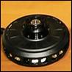
Figure 9.1.1 SCM150 Motor

EVC402-042/092 series controllers are 48/96 V controllers that are “plug & play” with SCM150 motors used in solar cars. They are ultra high efficiency sine wave controllers that provide regenerative braking. Capable of serial or discrete communication.

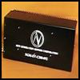
Figure 9.1.3 EVC402 Motor Controller

Current quote is 16,000 USD with some discount for possible salvage.

Pros:
- Effortless integration into existing system. i.e. compatible with current motor controller, battery configuration, current suspension and wheels/tires, regenerative braking, and accelerator.
- Saves design time.

Cons:
- More than doubles our initial budget.
- 16 week lead time.
2. Buy a different type of motor. (permanent magnet, dc brushed)
Some examples.
http://www.cloudelectric.com/product_p/mo-lem200-126.htm

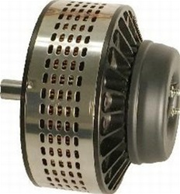
Figure 9.1.4 Lynch Style dc Brush Motor

Photovoltaic Array

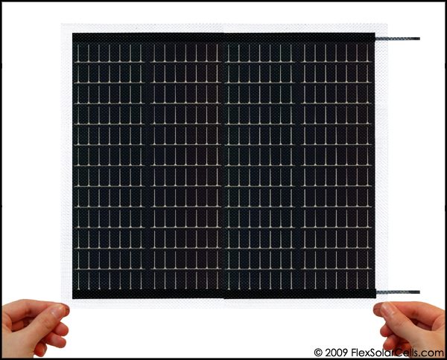
Figure 9.2.1 Powerfilm PT15-300 Solar Module

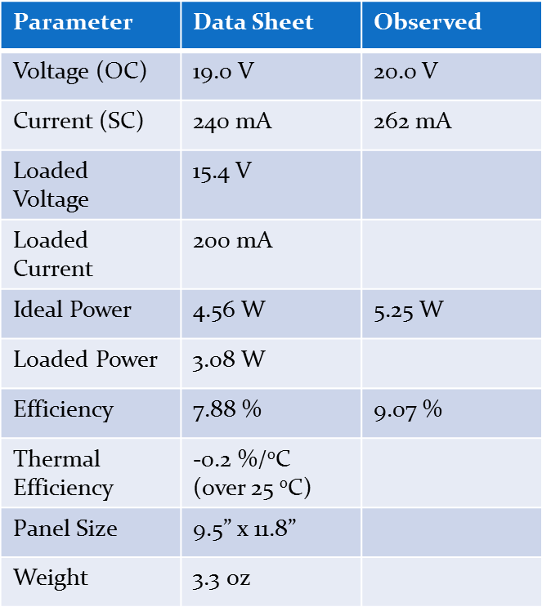
Table 9.2.1 PV module Parameters

Max power point tracking

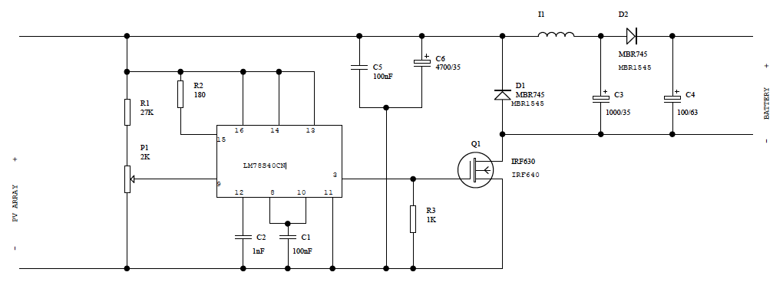
Figure 9.3.1 MPPT schematic using the LM78S40

LM78S40 Data sheet is in the file exchange labeled as LM78S40.pdf

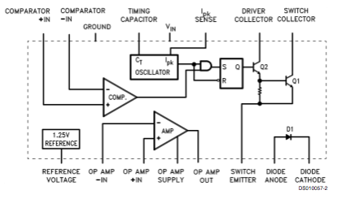
Figure 9.3.2 LM78S40 Internal Schematic

Latch/ Hinge and Driver Encasement
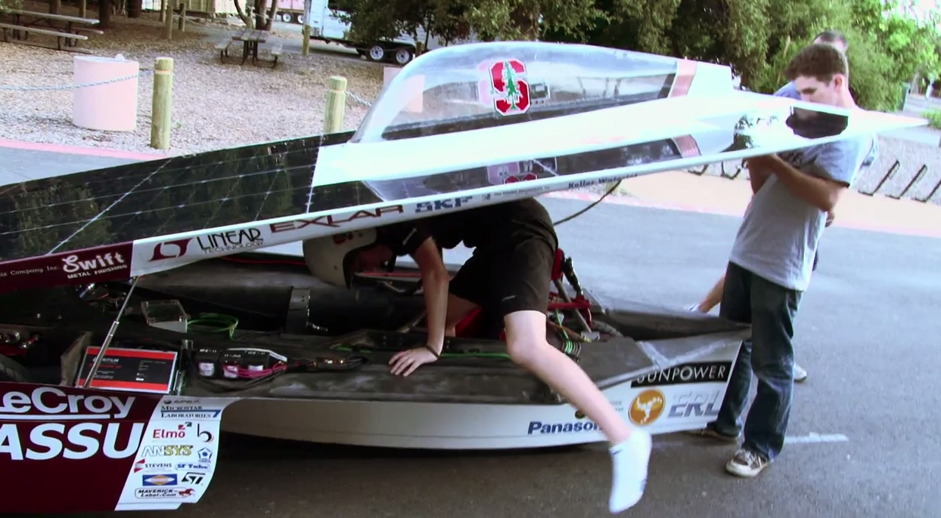
Figure 9.4.1 Example of latch and hinging system for driver encasement.

Parking brake
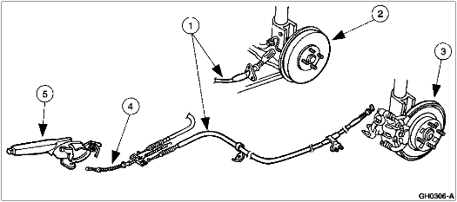
Figure 3.7

Rear arm and suspension
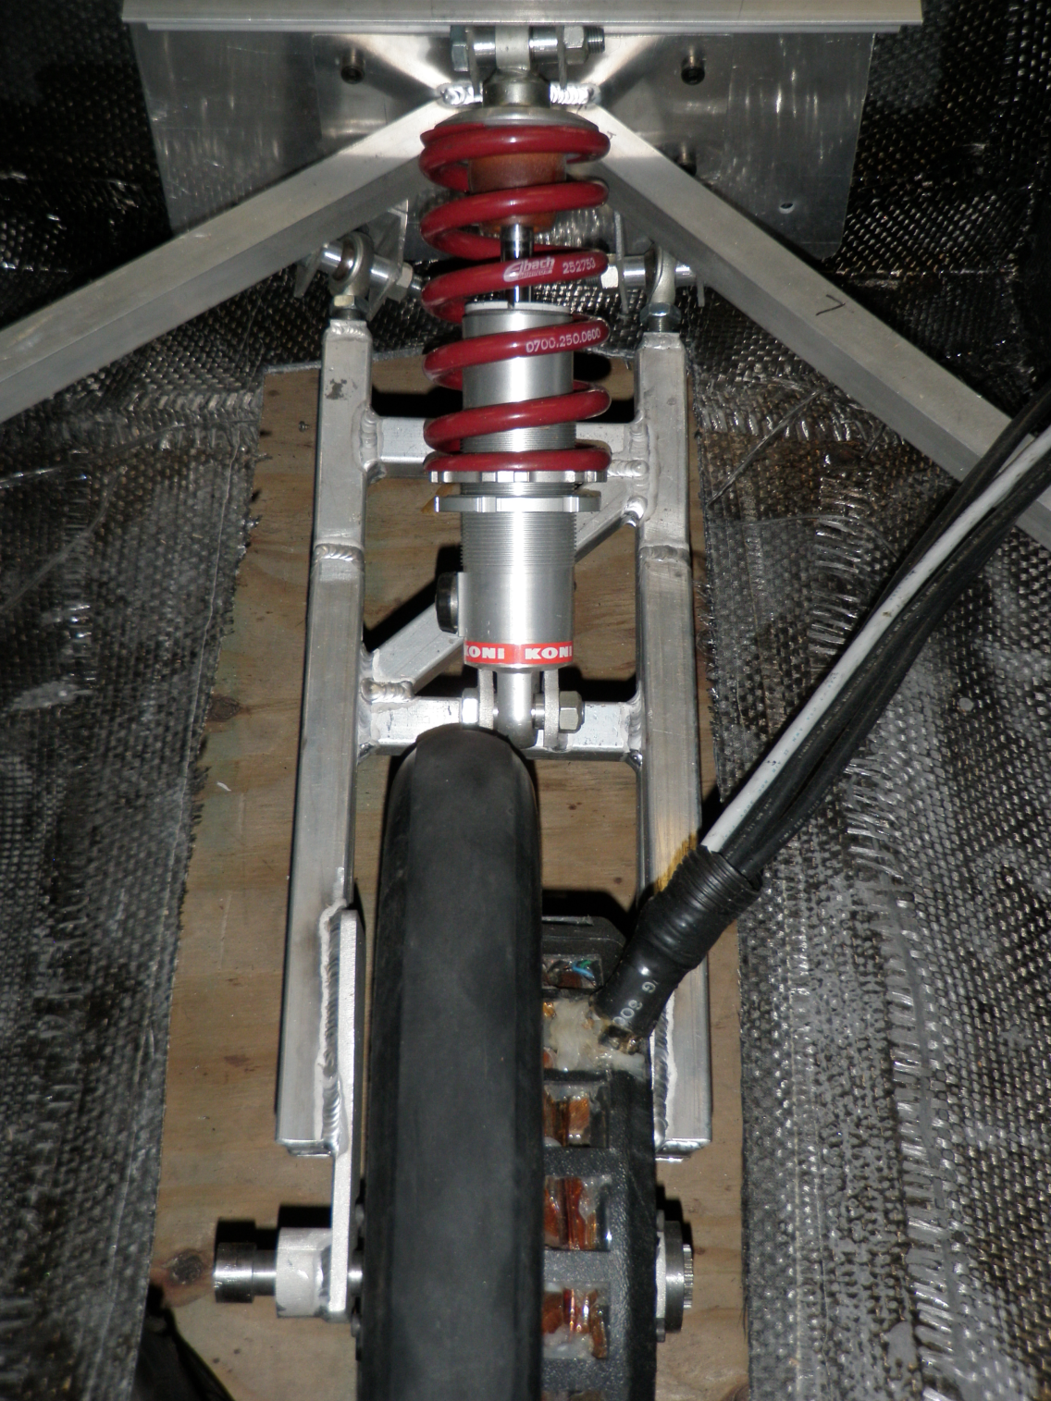
Figure 3.8

Regenerative brakes
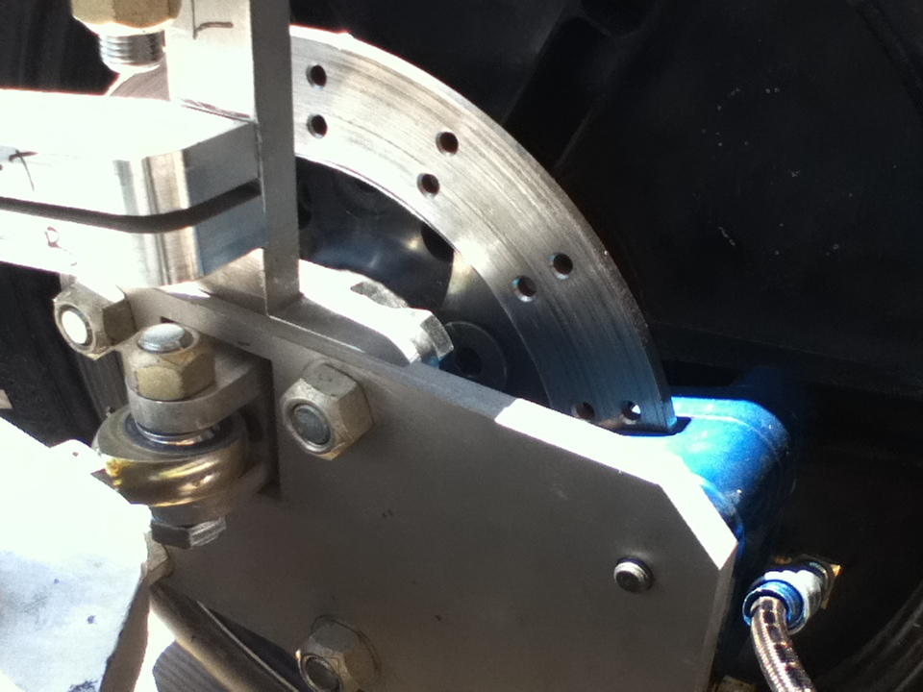
Figure 3.9

Air circulation
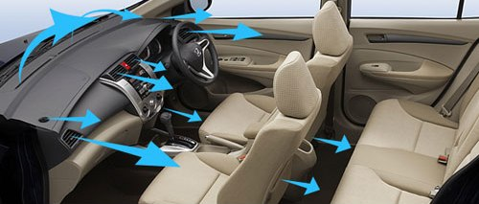
Figure 3.10

Broken Motor
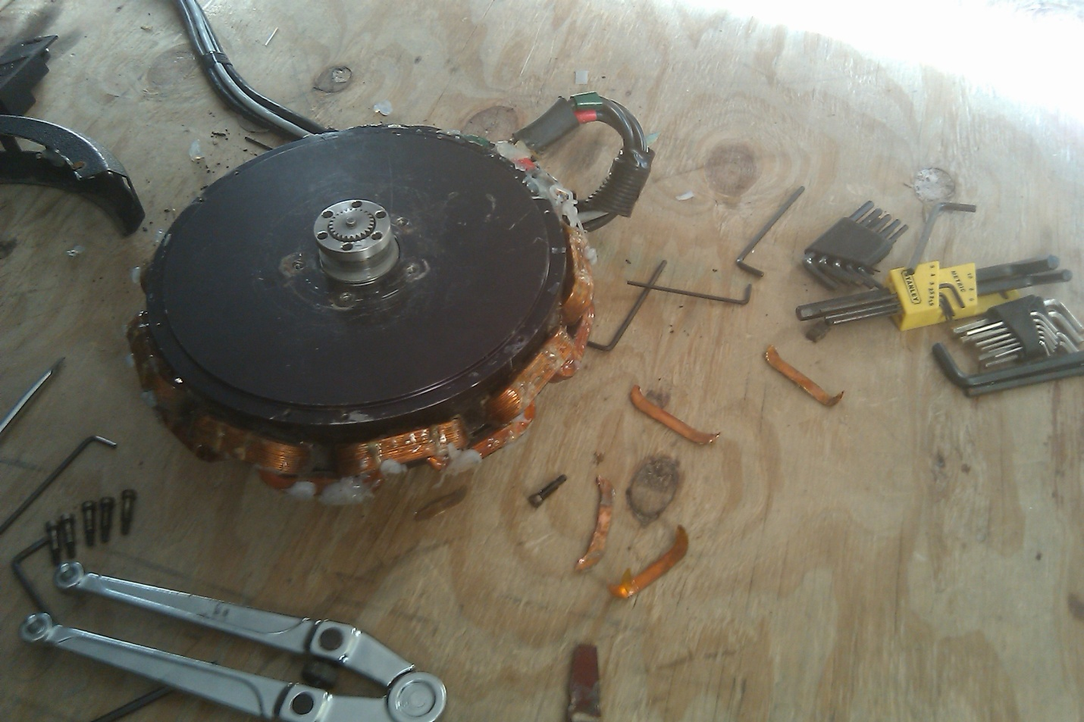
Broken pieces of coil
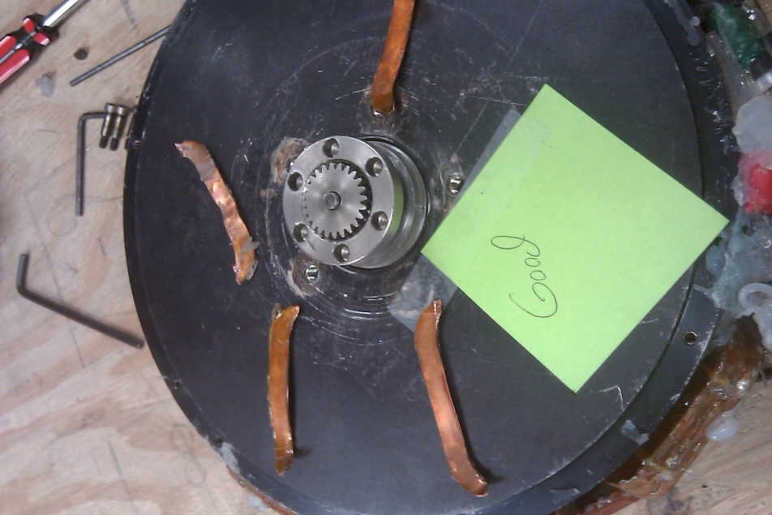

Rear Suspension Arm & Suspension

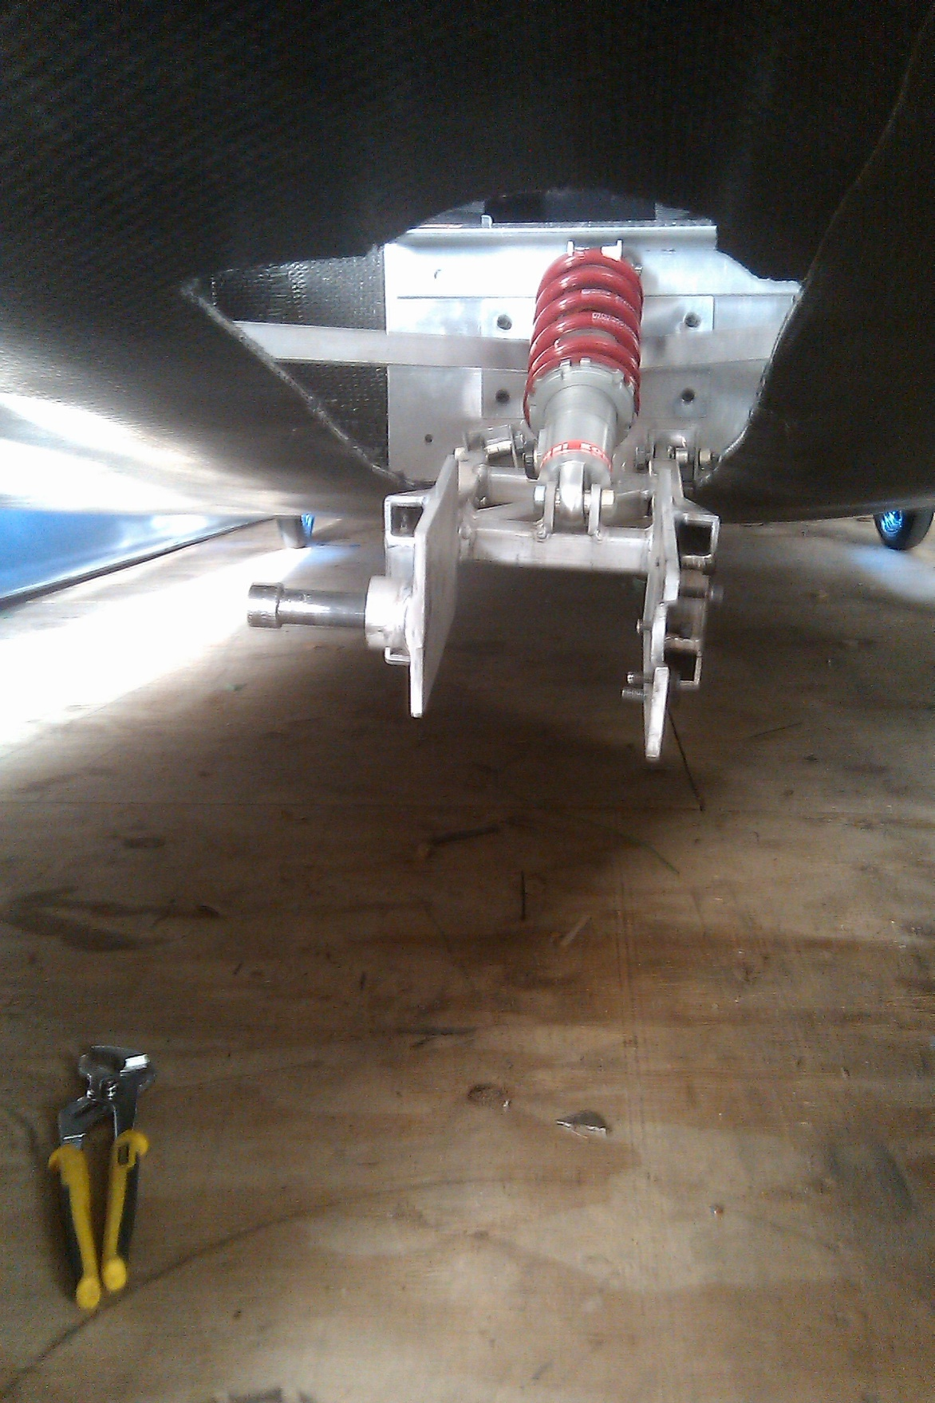
U-shaped bracket twisted, causing entire rear wheel arm to be rotated
