|  |
| --- |
| https://si0.twimg.com/profile_images/1449204998/COE_color_seal.jpg |
| Deliverable #7 |
| Operational Manual |
|  |
|  |
| **3/28/2014** |

**Team 19: Self-Stabilizing Pool Table**

**Norman Gross**

**Alexander York**

|  |
| --- |
|  |

Table of Contents

1.0 Project Overview 3

2.0 Functional Diagram 4

3.0 Product Specification 5

4.0 Operation Instructions 7

5.0 Troubleshooting 8

6.0 Repair and Maintenance 8

7.0 Bill of Materials 9

# Project Overview

This Project is sponsored by Beyond Innovation LLC. Founded by inventors and engineers who have a passion for life and love to build, create, invent, and innovate. Either it be a new revolutionary idea needed to be produced or a product which needs improvement or upgrades for commercialization, Beyond Innovation LLC provides sophisticated solutions to the challenges that human kind may face during the ever changing fast-pace and highly technological environment.

For this project Beyond Innovations has decided to create a billiards table. The design for this billiards table is a new venture with amazing feats. The table will be capable of vertically stowing itself in a discrete housing whenever additional space is needed in the area the table is kept. Along with its amazing storage ability this table will also be capable of self-stabilization. After it has been removed from its housing, the table will level the surface to be perfectly horizontal to its respective location.

# Functional Diagram

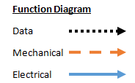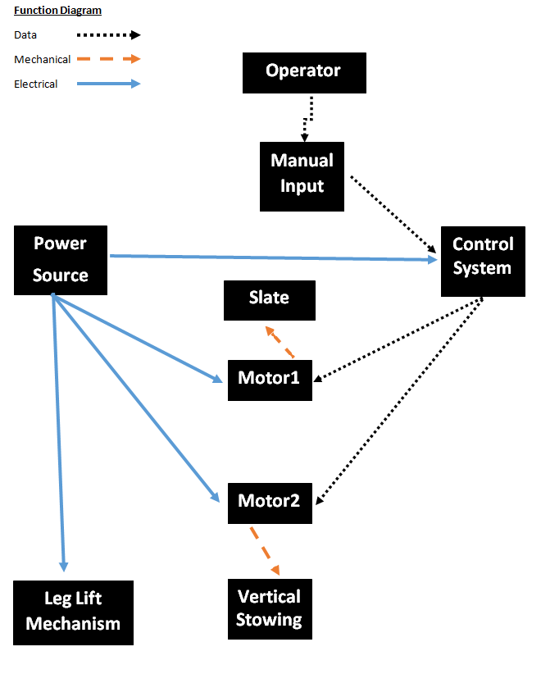

**Detailed Description**

Operator: This device begins with the player. The user must decide perform the following options: release the table from its housing, stow it back into the housing, or stabilize the surface again.

Manual Input: After the user has decided to either release the table from its housing, stow it back into the housing, or stabilize the surface again. He or she will input one of the commands with either a push button or GUI interface.

Power Source: Will come from a standard 120v AC wall outlet. An electrical circuit will be set up to dedicate the distribution of power.

Control System: The control system will be a carefully selected microcontroller which will have the capabilities to control the mechatronic system used to stabilize the surface, the vertical stowing process, and the leg extending and retracting process

Leg Lift Mechanism: Since the table will be stowed in a housing that is smaller in width than the actual table height, the legs must be retracted on and extended by some leg lift mechanism.

Motor 1: Receives information from the control system and is used to stabilize the surface on which the game is to be played.

Surface: Is a single piece surface which is to be leveled and locked to a secure and accurate playing position.

Motor 2: Receives information from the control system and is used to vertically stow the table into its respective housing.

Vertical Stowing: Is the process of hiding the table into its housing with the use of a motor, a control system, and a combination of mechanical linkages.

# Product Specification

**Customer Needs**

By focusing on the needs of the customer we are able to tailor design requirements that fit the customer’s desires. The following is a list of specific needs that the customer desires, based upon customer and market research:

1. Easy to move
2. Must be able to stow away to save space
3. The operation of the system should create minimal noise
4. Needs to be a regulation sized table
5. Easy to use by the average person
6. Must feel no different than a regular pool table
7. System needs to be aesthetically appealing
8. System needs to be durable (long-lasting)

From the previous list of customer expectations, the following design requirements have been created:

**Mechanical Design Requirements**

**System housing**

The system housing will contain the pool table when it is in its stowed position. The Dimensions of the Stowed System will be: 2ft x 4.5ft x 8ft (LWH) This is to provide enough space for the pool table as well as the lifting mechanism that will be contained in the housing as well. The lifting mechanism within the housing is required to have a form of safety redundancy in the event of catastrophic failure.

**Pool Table**

As per regulation the table dimensions must follow these requirements:

* + 1. Must have a length to width ratio of 2:1
    2. Outside dimensions: 86 inches x 48 inches
    3. Playing Field: 78 inches x 39 inches
    4. Height Restriction: Between the range of 29 inches to 31 inches

A goal of this project is to make this system as portable as possible. The Maximum table weight is restricted to 750lbs. This is the average weight of existing tables, so the desired outcome is to be below this limit.

The leveling requirements are as followed: A tolerance of +/- 0.25 degrees from the horizontal. This value was determined from the lowest average coefficient of kinetic friction between a pool ball and a felt table top. This tolerance ensures that the tilt of the table will not affect game play. Another feature built into the table will be its ability to absorb shock and vibration experienced during an average game of billiards.

**Electronics and Controls Requirements**

Since this system must be built to last more than 3 years the power supply will not be a battery source due to its degradation over time. The supplied power will come from a standard 120v grounded outlet, which means that the pool table must be tethered through some means.

This project will contain a certain degree of programming in order to meet the customer expectations. The needed control algorithms will be created primarily for the leveling controls. Subsequent controls will be derived from the height adjustment of the table. As far as the vertical stowing is concerned, simple bumper switched could delegate the on and off controls for the lifting mechanism.

The operation of this system must be user friendly which means that any input needed from the user must be as simple and clear as possible. The simplest of systems may use a push-button control, more advanced possibilities may incorporate a easy to use touch screen Graphical User Interface.

# Operation Instructions

Instructions on standard procedure for operation:

Start and warm up- Assuming the table is at rest in its housing and has not yet been deployed. There is a tethered connection within the housing which powers the winch system used to lift and deploy the table. Once this connection has been plugged into the wall the played by choose to deploy their table on command.

After the table has been deployed and oriented into a desired position by the player the table is ready to level and stabilize itself. A single power switch is used to regulate the power for the actuation, control, and sensing attributes of the system. A keypad and LCD screen will then be used as an interface with the player allowing them to choose between the options of "stow away" or "stabilize".

Data acquisition- After the player has deployed the system from its housing and is turned on, a microcontroller and leveling system will begin a user friendly interface composed of a liquid crystal display and a 4x4 keypad. The combination of these two components and actual user interface will determine which operation mode the table should be running while it is powered.

Mode of running- Since the table is not an active system it is not constantly running and therefore allows for there to be a run mode for each separate task, stowing and stabilizing. The stowing mode of operation is used to hide away the table into its respective housing and reduce the footprint of the table by 75%. the Stabilizing mode of operation is used in order to raise the table to a respective height and automatically level itself with respect to the horizontal plane it rests on,

The Stowing operation is a simple mode in which all legs will descend to their lowest point allowing then for the table to be maneuvered on its set of caster wheels. As for the stabilizing mode, four sensors values will be taken and manipulated through a preprogrammed control algorithm, in order to level the table with the horizontal. After each of these modes has been completed the power should be set to off and the mechanical structure will lock in place.

Key parameters to demonstrate or monitor- Safety is always a concern when operating heavy machinery, therefore small children and animals must be out of harms way when operating the system in "stow" or "stabilize" mode.

Steps for shutdown- The system will be equip with and exit feature with the user interface, but the operator at anytime can switch the main power button to off and it will act as an instant kill switch.

Calibration if needed- calibration is needed but as previously explained is only used during the leveling process of the system.

# Troubleshooting

**Self-leveling**

Burnout- In the stabilizing process the user will have the option to stabilize or stabilize. If they choose to stabilize when then should re-stabilize the can risk causing the motors to drive further than recommended and may cause a motor to actually burn out.

**Vertical stowing**

Trap zone- The "trap zone" is considered to be the area between the table and housing as it is being stowed away; it is referred to as the trap zone because that is essentially what can happen a child or small animal could find themselves trapped and injured if not careful.

**Recommended solution procedure**

In order to avoid these mistakes one should carefully read over the operations manual before attempting to control the system unsupervised.

Also the kill switch can be used at any time to stop all actuation to avoid burnouts.

# Repair and Maintenance

This system has been design to be modular where in the event that a moving part begins to wear or breaks down, it can be easily replaced. For this system, there are five electrical motors that have a potential cause of failure. The lifespan of this pool table is three years.

**Self-leveling**

The self-leveling motors are accessed by removing four bolts attached to each motor. These are a fully self contained unit where the life of these motors is expected to outlast the life of the table. The component of the table that will experience the most potential cause of failure is the playing surface. To prevent failure, all forms of liquid are recommended to be away from this surface. If water happened to be spilt onto the material, it will cause the medium density fiberboard to expand and deform.

**Vertical stowing**

Maintenance of the vertically stowing mechanism is only necessary if wear of the linear guides can be visually seen. It is recommend that a thorough inspection is performed every 4 months.

# Bill of Materials

