**[Direct Drive Solar-Powered Arcjet Thruster](index.htm)**

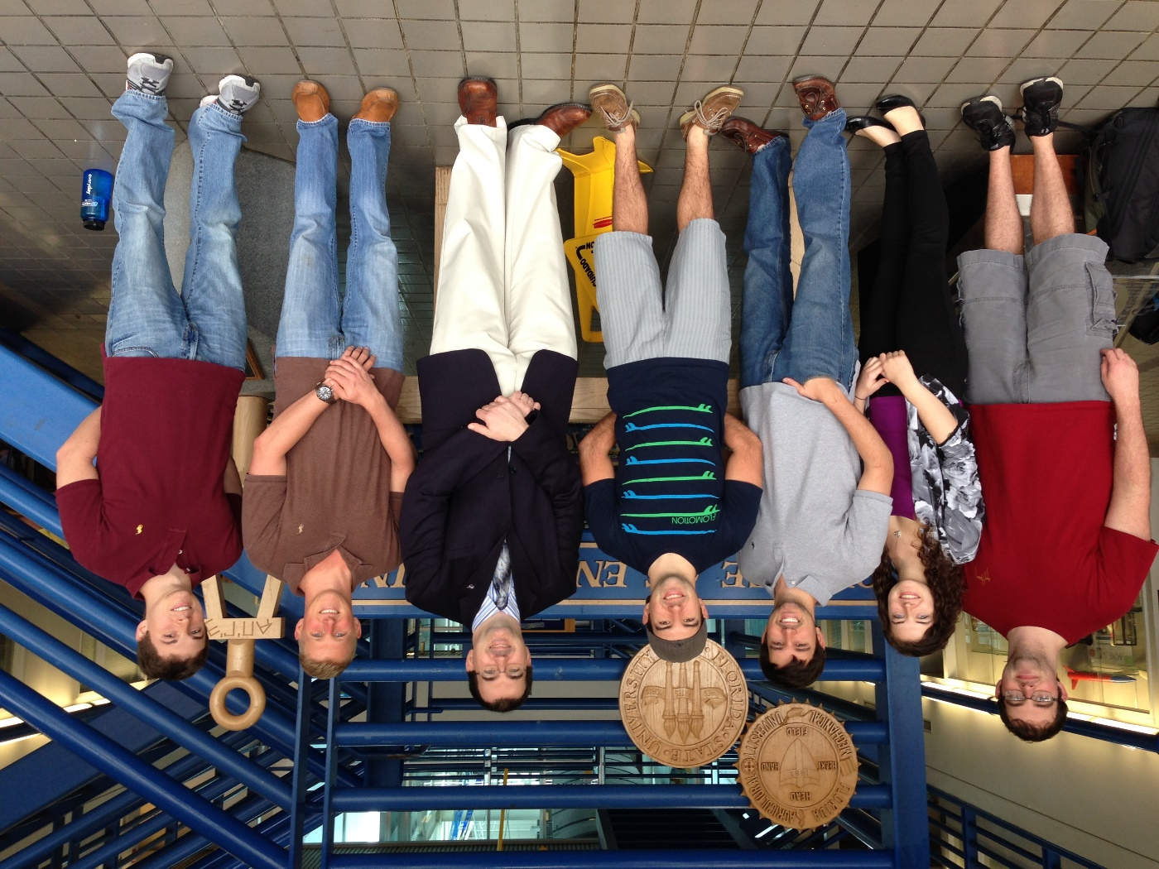

[**Meetings**](meeting%20minutes.pdf)

**[Deliverables](Deliverables.htm)**

[**Presentations**](Presentations.htm)

[**Biweekly Reports**](Biweekly%20Reports.htm)

[**Gantt Chart**](Gantt%20Chart.pdf)

[**Helpful Resources**](Helpful%20Resources.htm)

**Group Members**

**Christopher Brolin (ME)**

**Cory Gainus (ME)**

**Gerard Melanson (ECE)**

**Tara Newton (ME)**

**Griffin Valentich (ME)**

**Shane Warner (ECE)**

**Sponsor: Kurt Polzin (NASA)**

**Faculty Advisor: Wei Guo, Kwan Bing, Petru Andrei**