**Deliverable #6: Operations Manual**

EML4552C-Senior Design Spring 2014

**Team 20- Direct Drive Solar-Powered Arcjet Thruster**

**Sponsor:** Kurt Polzin (NASA)

**Faculty Advisor:** Wei Guo, Kwan Bing, Petru Andrei



**Group Members**

Christopher Brolin

Cory Gainus

Gerard Melanson

Tara Newton

Griffin Valentich

Shane Warner

Table of Contents

Functional Analysis 1

Function Diagram 1

CAD Models 1

Electrical Components 4

Expected Performance 4

Operational range 5

Safety 5

Procedure for operation 5

Operation 5

Shutdown 6

Assembly 6

Troubleshooting 6

Maintenance 6

Spare Parts 6

# Functional Analysis

## Function Diagram

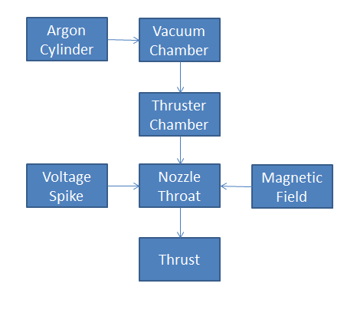Figure 1 below represents a schematic of the operation of the Solar Powered Arc Jet Thruster as designed by Senior Design Team 20 at the FAMU-FSU College of Engineering. The propellant supplied to the thruster in this case is Argon gas. The Argon is injected through the vacuum baseplate and into the thruster chamber. Here the flow is accelerated to sonic velocity at the throat of the nozzle due to the pressure difference inherent in the vacuum chamber. When the gas passes through the nozzle throat, energy is applied to the fluid in the form of a voltage spike. This voltage spike initiates a breakdown of the gas creating plasma that is then contained by the annular magnet surrounding the throat. The charged particles in the plasma react with the magnetic field and are accelerated out of the nozzle producing thrust. The goal of this project is to perform this operation without the use of a power processing unit. Using power from solar panels, the circuit must be able to create the voltage spike needed for breakdown.

Figure 1. Functional Analysis

## CAD Models

Figure 2 represents the overall testing apparatus setup. As seen in the figure, a large bell jar is to be placed over the thruster and test stand, on top of a baseplate.

Figure 3 shows the thruster positioned inside of the test stand. The test stand utilizes the existing bolt hole pattern in the thruster to mount itself vertically. This was designed as such to give maximum clearance between the nozzle exit and the glass bell jar. Exit temperatures have the potential to be very hot and could damage the bell jar if placed in close enough proximity.

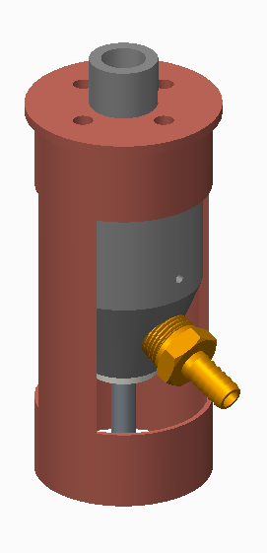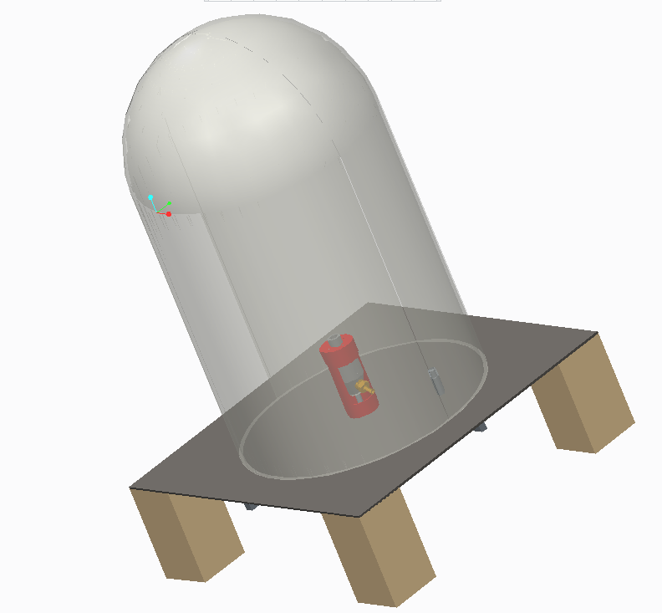

Figure 3. Thruster Test Stand

Figure 2. Testing Set Up

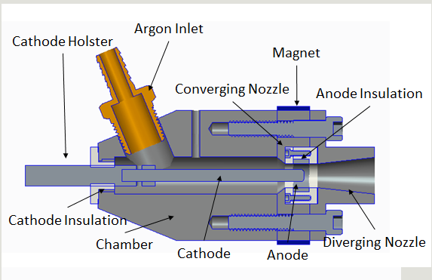

Figure 4. Cross Section View of Thruster

Figure 4 shows the cross section of the thruster. An exploded view of the thruster can be seen in Fig. 5 for assembly purposes. The components called out in the exploded view correspond to the bill of materials seen in Table 1.

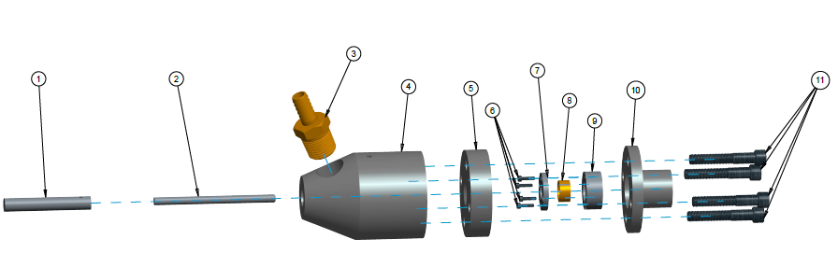

Figure 5. Exploded view of thruster

Table 1. Bill of Materials

|  |  |
| --- | --- |
| **Bill of Materials** | |
| Balloon Number | Name |
| 1 | Cathode Holster |
| 2 | Cathode |
| 3 | Argon Fitting |
| 4 | Chamber |
| 5 | Converging Nozzle |
| 6 | Anode Insulation Screws |
| 7 | Anode Insulation Cap |
| 8 | Anode |
| 9 | Anode Insulation |
| 10 | Diverging Nozzle |
| 11 | 1/4-20 Screws |

## Electrical Components

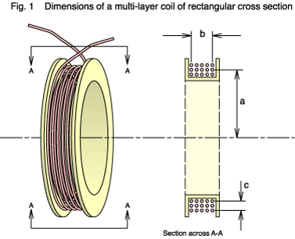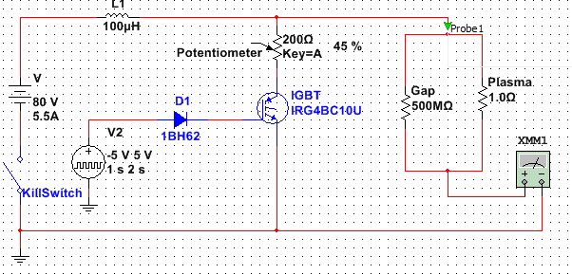

Figure 7. Magnet Design 1

Figure 6. Circuit Schematic

Figure 6 shows a schematic of the circuit that will be used to generate and sustain the plasma field. The circuit is run using four solar panels that act as an approximately 80V source that can sustain approximately 5.5A, as well as a pulse width modulator that opens and closes the IGBT in order to generate a large voltage spike through the use of the inductor.

Figure 7 shows the design of the electromagnet. The electromagnet will be a multilayered solenoid that will wrap around the test stand and generate a magnetic field through the thruster chamber.

# Expected Performance

The expected thrust produced from the apparatus is a few milinewtons. This is due to the low mass flow rate experienced through the thruster. The thrust value will increase when scaled to a larger thruster for use on actual satellites. The value of thrust for our thruster will be low; however the specific impulse from this type of propulsion system is very high. The specific impulse of a rocket or propulsion system is what is of concern when dealing with efficiency of propulsion.

The expected voltage spike from the circuit is 137 V. This is obtained with an input of 80 V and an IGBT flip time of 130 ns. This range of voltage spike will theoretically allow a breakdown of argon at 267 Pa (assuming an electrode spacing of 0.15”). The circuit is capable of producing a higher voltage spike (up to 2 kV), therefore the pressure at the throat can be varied to determine the range of operating conditions.

Vacuum level is extremely important in the testing of the thruster. Ideally it is preferable to obtain the highest level of vacuum to simulate the space environment as best as possible. We have access to a Welch 1400 vacuum pump which will pump our chamber to about 1E-4 torr (0.0133 Pa). This is characteristic of a medium vacuum rating; sufficient for our experiment.

The magnetic field strength that is to be applied around the throat of the nozzle is 50 mT. This is done by wrapping 150 turns around a spool and running 5 amps through the wire. This magnetic field will make breakdown more difficult, requiring a hirer voltage spike, but it will help direct the ions out of the nozzle and thus produce a higher thrust for a given input. This minimal increase in voltage necessary is not an issue because the circuit is capable of producing a spike of 2 kV.

Due to the high temperatures that are being dealt with in this plasma thruster, the operational time must be limited. This must be done not only for the well-being of the thruster and its components but for the safety of the bell jar.

# Operational range

Use max expected voltage spike in combination with electrode spacing to determine range of pressures to be supplied. The range of pressure to be supplied theoretically will be from 52 pa to 17.5kPa. This is an ideal case, in reality the pressure range will likely need to be around 250 Pa.

A short run time should be used to avoid melting cathode/anode and nozzle as well as maintaining integrity of the bell jar. A run time of 2 seconds maximum should be used to avoid damage to components.

# Safety

* High voltages and temperatures during operation
* Wear proper eye protection when looking at arc
* Proper handling and operation of pressurized argon cylinders

# Procedure for operation

## Operation

* Insert thruster and stand onto baseplate, place bell jar on top
* Attach wire leads to anode and cathode respectively
* Seal bell jar ring with vacuum grease
* Attach all fittings to baseplate
  + Hose clamp vacuum fittings
* Turn on vacuum pump
  + Ensure vacuum level with vacuum gauge
* Initialize DAQ – Pressure, force
* When absolute vacuum is reached supply argon to chamber until a pressure of 550 Pa is reached
* Take data with DAQ
* Initiate pulse width modulator to charge and discharge inductor and generate spike

## Shutdown

* Open kill-switch
* Cut off argon supply to chamber
* Turn off vacuum pump
* Release pressure in vacuum chamber by loosening hose clamps on to port connected to the vacuum pump
  + Slowly allow air to leak through hose into bell jar

# Assembly

See exploded view and BOM in the CAD Models section.

# Troubleshooting

* Vacuum leak
  + Check around the base of the bell jar
  + Check all fittings going through the baseplate
* Over heating/melting
  + Operate in short bursts (2 second maximum)
* Voltage spike
  + Make sure all electrical connections are sound
* No arc produced
  + Vary the pressure in the thruster chamber from 106 Pa to 78 kPa
  + If changing stagnation pressure does not induce spike, lower the resistance on the circuit or increase source voltage, this should increase the potential voltage spike

# Maintenance

* Routine
  + Replacement of anode and cathode when eroded beyond functional use.
  + Changing of argon cylinders once the supply has been exhausted.
* Major
  + Replacement of divergent portion of nozzle.
  + Replacement of macor insulation.

# Spare Parts

* + - * Spare macor insulation cap – 1
      * Spare cathodes – 4
      * Spare anodes – 3
      * Spare tubing – 8”