**Direct Drive Solar-Powered Arcjet Thruster**

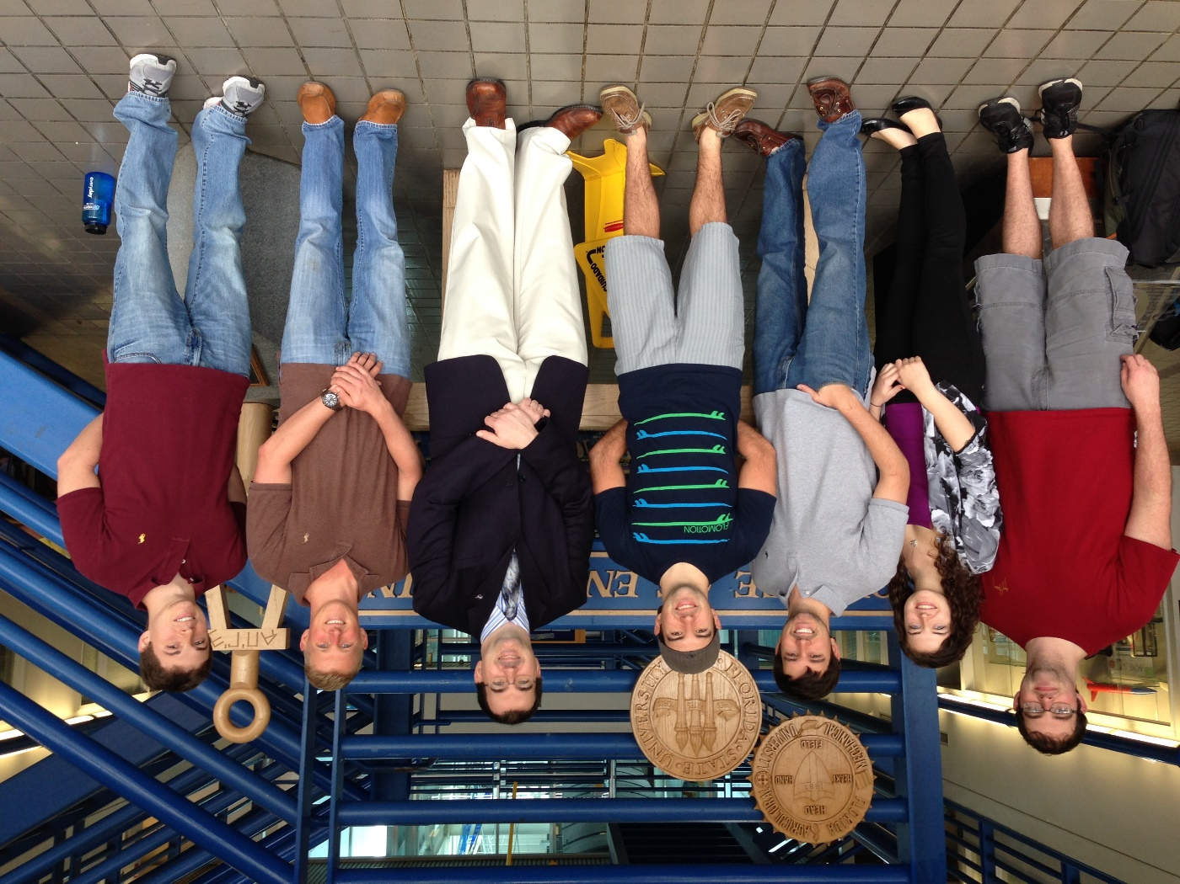

**[Meetings](\\\\codex2\\warnesh\\TEAM20\\meeting minutes.pdf)**

**Deliverables**

**Presentations**

**Biweekly Reports**

**[Gantt Chart](\\\\codex2\\warnesh\\TEAM20\\gantt final.pdf)**

**Helpful Resources**

[](http://www.nasa.gov) **[](http://www.eng.fsu.edu)**

**Group Members**

**Christopher Brolin (ME)**

**Cory Gainus (ME)**

**Gerard Melanson (ECE)**

**Tara Newton (ME)**

**Griffin Valentich (ME)**

**Shane Warner (ECE)**

**Sponsor: Kurt Polzin (NASA)**

**Faculty Advisor: Wei Guo, Kwan Bing, Petru Andrei**