## **Project Title: Helmet/Vest Design to Reduce Impact**

**Sponsor**

Gavin Boone

Executive Sales Professional

Sanofi Inc.

**Faculty Advisors**

Dr. Kamal Amin (ME)

Dr. David Olawale (IE)

Project Plans and Product Specs

Due:

October 11, 2013

Team 2

Ryne Wickery ME Team Lead

Kyler Hast ME Team Member

Kyle Meredith ME Team Member

Cecilia Wong IE Team Lead

Maria Miro IE Team Member

Garth Fletcher IE Team Member

**Problem Statement:**

There is a need in the baseball community for a protective vest for a batter that extends to cover the back of the neck and the entire spinal region so that when a baseball makes contact with it, there is no immediate injury to the wearer.

**Project Scope**

Protective gear designers have not come up with a batting protection vest that offers adequate protection, and is aesthetically pleasing enough to get athletes to wear it.

**Justification/Background:**

The inspiration for this design arose from Mr. Boone seeing a Lincoln High School (Tallahassee, FL) player being struck in the back of the neck during a game. After witnessing the fear on the players’ faces as well as the parents in the stands, Mr. Boone recognized there existed a need for a protective garment that would protect the neck as well as other vital areas such as the spinal region. This protective concept has the ability to be used extensively throughout the baseball community, from young children in Little League all the way through the college and Major Leagues. The protective vest will incorporate all the necessary elements for a sports garment; safe, lightweight, comfortable, stylish. Multiple designs are being considered, as well as placement of the garment in the uniform protocol.

**Objectives:**

There are multiple goals we hope to achieve by the end of our senior design period (end of spring 2014). These include:

1. Determine the ideal material for our vest, and verity it’s suitable for prototyping.
2. Choose design for the protective vest with detailed description.
3. Analyze materials to determine the best choice for protective vest.
4. Analyze designs to determine best choice for protective vest.
5. Construct / Test / Analyze a prototype.
6. Determine manufacturing characteristics of production.

**Methodology:**

1. Theoretical Analysis:
2. Determine constraints such as impact energy of a baseball, addition of material/components to uniform, size/weight of vest, etc.
3. Choose all materials the team feels may be suitable for protective vest
4. Compare properties of chosen materials that are relevant to the constraints of the vest. These might include impact resistance, flexibility, transparency, weight, durability, etc.
5. Design multiple variations of the vest.
6. Compare vest designs to determine which would be most suitable when worn by a player.
7. Determine desired manufacturing characteristics.
8. Experimental Analysis:
9. Use impact tests to determine if material samples meet desired characteristics.
10. Construct a prototype.
11. Have team/players test prototype to determine comfort, usability, aesthetics, and wear-ability.
12. Organize mock manufacturing methods to test desired manufacturing characteristics.

**Constraints:**

* Must withstand an impact from a pitch up to 100 mph
* Thermodynamically suitable to be worn in temperature exceeding 100 degrees, and worn for 30 minutes
* Must be light weight
* Vest be transparent on the back do that the name and number can be seen
* Must be easy to take on and off
* Swinging motion of the player must not be impaired by the vest
* Vest must last a minimum of 3-5 years

**Task List / WBS:**



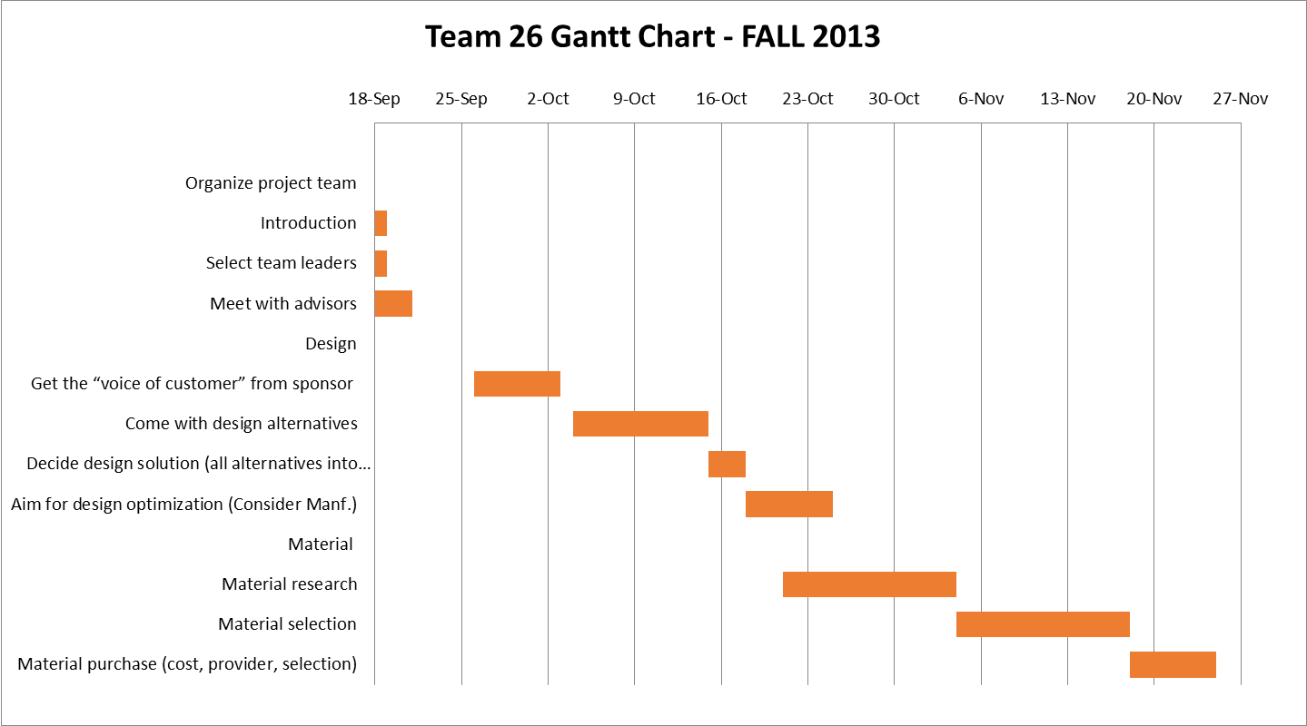

**Product Specifications**

**Design Specifications:**

1. The vest should fit the torso snugly, and also fits tight to the body.
2. Vest should be scaled to multiple different sizes, so it can be offered to players of all sizes.
3. Vest should weigh no more than 2 pounds so as not so significantly restrict runner’s speed.
4. Vest should cover entire spinal region, preferably the rib region, and any parts surrounding the neck that are not covered by the batters helmet.
5. Vest should be able to integrate with the helmet without interference.
6. Vest Material should be “breathable” so the vest can be warm in hot weather.

**Performance Specifications:**

1. Must withstand the force of a 110 MPH baseball.
2. Must absorb the impact of a baseball so that protected regions will not be damaged.
3. Must be transparent in the region where a player’s name and number are located.
4. Needs to be affordable to the point where the average middle class family can afford a vest for a child, or that a smaller organization can have vests available for player’s to wear.
5. Vest must not cause potential danger to the player, or opponent, when the player is approaching or sliding into a base.
6. Vest must be able to be worn the entire time the batter is on the bases, without causing restriction, but also able to be removed when the batter is not batting.
7. The vest should be flexible enough that the batter retains complete range of motion.