

**Team 5 - Magnet Insertion Process**

**Deliverable #1 – Needs Assessment**

**9/27/13**

**EML 4551 Senior Design Fall 2013**

**Turbocor Director of Technical Operation: Paul Lugjuraj**

**Faculty Advisor: Dr. Simone Peterson Hruda**

Group Members:

Jaro Volny

Henry Ferree

Timothy Blum

**Index: Page:**

1. Needs Assessment 1
2. Project Scope 1
   1. Problem Statement 1
   2. Justification/Background 1
   3. Objectives 2
   4. Methodology 2
   5. Constraints 3
   6. Expected Results 3

**Needs Assessment:**

There is a need for an ergonomic and efficient magnet insertion process for properly placing magnets on axial bearings.

**Project Scope:**

**Problem Statement:**

Magnets need to be properly placed on the axial bearing.  Location and orientation are critical to the assembly and operation of the compressor.

**Justification/Background:**

Turbocor is a leading manufacturer of magnetic bearing centrifugal compressors. Using magnet technology allows for the benefit of having a levitating shaft within the compressor. This innovative design eliminates the need to use oil for shaft components. The ability to remove oil from the compressor design adds a multitude of benefits. The levitating shaft experiences less resistance to rotation by being immersed in air instead of a more viscous oil, which increases the efficiency of the compressor. Additionally, no maintenance is needed to change oil or re-lubricate components, which saves on cost of the machine. Finally, magnetic bearing compressors draw less current than standard compressors, resulting in savings in energy consumption. These positive aspects of oil free compressors have been noticed by consumers who need a powerful compressor for their cooling devices or pneumatic needs. Over the past two decades, Turbocor has grown in the market of sustainable, energy efficient compressors and presently has over 30,000 compressors in service.

With the implement of inserting magnets in a shaft and its bearings, the compressors are able to have a highly efficient levitating shaft. Handling the magnets is a primary concern due to their strength; the magnets are strong enough to latch to metal far away and may break into many pieces because of its brittleness, thus destroying the magnets. Proper placement is necessary to ensure that the magnets have their correct polarity and no magnets are misaligned; if these errors were to occur then the bearings are wasted, the compressors will not work properly, and time with money is lost.

Turbocor has experimented with different processes for mounting the magnets on the bearing. The current process requires a technician to place the magnets by hand. The process involves removing the magnets from the magnet stack and placing them on the plate and then checking the polarity. This accounts for the majority of the worker’s time that could be spent performing other tasks. Turbocor has looked into automating this process. They purchased an automated magnet insertion machine custom made for them by Industrial Automation. The machine is pneumatically driven and loads the magnets onto the bearing and also checks for polarity. The machine is designed to work for different bearing sizes. However, roughly a year ago the machine began experiencing many faults and control issues. It currently can only load magnets for one bearing size. Attempting to load magnets for other size bearings results in machine faults. The machine is presently idle and has not been in the product line for the past eight months. The challenge for the design team is to understand the current processes and develop the optimal process for placing the magnets on the bearing.

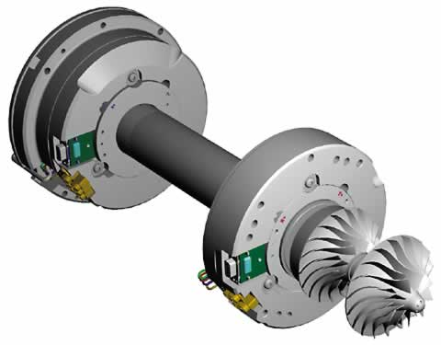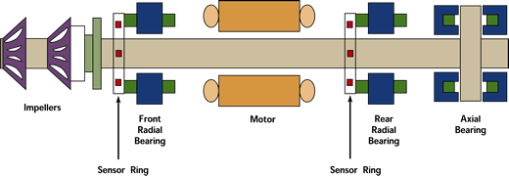

**Objectives:**

* Devise an ergonomically friendly process that properly inserts magnets into an

axial bearing

* Magnet polarity orientation should match design specifications
* Magnets are inserted without any misalignment
* Operating Technician can perform the process without risk of bodily harm or

injury.

**Methodology:**

* Gain a better understanding of existing automated mechanism
* Decide on best process for magnet insertion
  + New tools for technician
  + Repair/improve existing automation mechanism
  + Create a new manually operated mechanism
* Review Mechanical systems & research existing mechanisms
* Break down manufacturing process steps

Once an insertion process has been chosen:

* Brainstorm for possible design solutions
* Create individual designs
* Create a Decision matrix
* Decide on a design

Once a specific design is chosen:

* Construct in CAD
* Simulate functionality
* Theoretical force analysis
* Evaluate materials needed
* Purchase relevant materials
* Build prototype
* Test physical product
* Analyze & compare to existing mechanism
* Make changes or adjustments if needed
* Test for reliability’

**Constraints:**

* Must develop process that works for the different compressor bearing sizes and magnet sizes.
* Process/design must be simple, ergonomic and safe for technician.
* Process must insert, check for and verify the proper magnet orientation and polarity.
* Design must insert the brittle magnets without damaging them.
* Design must be within a reasonable budget for company.

**Expected Results:**

When completed, the machine will produce an ergonomically friendly simple process that implements various magnet sizes into different types of radial bearings in a safe and timely fashion.