**Design for Manufacturing and Reliability**

Mass Flow Sensor Integration

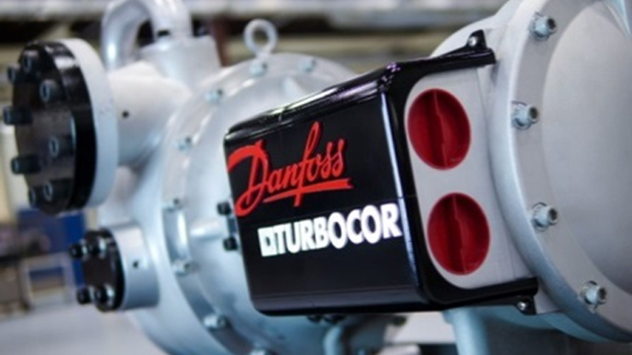

Team Number: 5

Submission Date: Friday, October 25th

Submitted To: Dr. Gupta

Team Members: Luis Mendez (lm13r@my.fsu.edu), Beau Rodgers (ber13@my.fsu.edu), Keenan Cheeks (kmc11j@my.fsu.edu), Brian Roberts (bpr13b@my.fsu.edu).

Faculty Advisor: Dr. Chiang Shih

Table of Contents

**Table of Figures……………………………………………………………………………....….iii**

1 Introduction 4

2 Design for Manufacturing 5

2.1 Product Parts and Assembly 5

2.2 Manufacturing Timeline and Design 8

3 Design for Reliability 10

3.1 Mechanical Systems 10

3.2 Background Information 11

3.3 Customer Needs and Product Specifications 11

4 Design for Economics 12

4.1 Budget 12

4.2 Existing Systems 13

5 Conclusion 14

References 15

**Table of Figures**

Figure 1: Quick release bracket system 6

Figure 2: Steering wheel quick release 6

Figure 3: This photo shows the sensor mount (left) and the pipe mount (right) 7

Figure 4: CAD Assembly of Mounting System 8

Figure 6: Signal Conditioning Circuit 10

Figure 5: Circuit Diagram 10

Figure 7: Pie chart of budget expenditures. 12

# Introduction

Danfoss Turbocor has sponsored senior design Team 5 to develop a method of determining real time efficiency of their centrifugal compressors at application sites.

In order to accomplish this goal, the team has decided to use a non-intrusive, ultrasonic flow sensor to collect necessary data for calculations. This ultrasonic sensor will be used in conjunction with operating parameters from the system in operation and the developed thermodynamic correlations to determine the real time coefficient of performance (COP) that will be measured in kW/ Ton.

To maintain a compact package, the team designed a mounting system that will keep the sensor control module from having to be mounted to a wall.

# Design for Manufacturing

## Product Parts and Assembly

The package developed to determine real time efficiency or COP, requires the use of the selected ultrasonic flow meter, resistive temperature sensors, and existing operating hardware. In order to keep the sensor package relatively compact, a mounting bracket was designed.

The flow sensor being used in this project is a Dalian High Peak TDS-100M. This unit uses a wall mounted control module and wired, clamp on ultrasonic sensors to read a volume flow rate.

In order to avoid difficulty in set up of the sensor system, it is important to follow a set up procedure. First, a proper mounting location should be determined for the ultrasonic sensors using information that can be found in the Operations Manual. Next, all of the wiring to and from the sensor control module must be completed. It is important to note that the TDS-100M will require a 120V plug to operate. Finally, once all of the wiring is completed and the system initial setup (per the operation manual) is done, a location for the mounting bracket can be chosen to best suit the operator.

To keep the sensor off the wall and avoid running extra wiring, we developed the quick release bracket system in Figure 1.

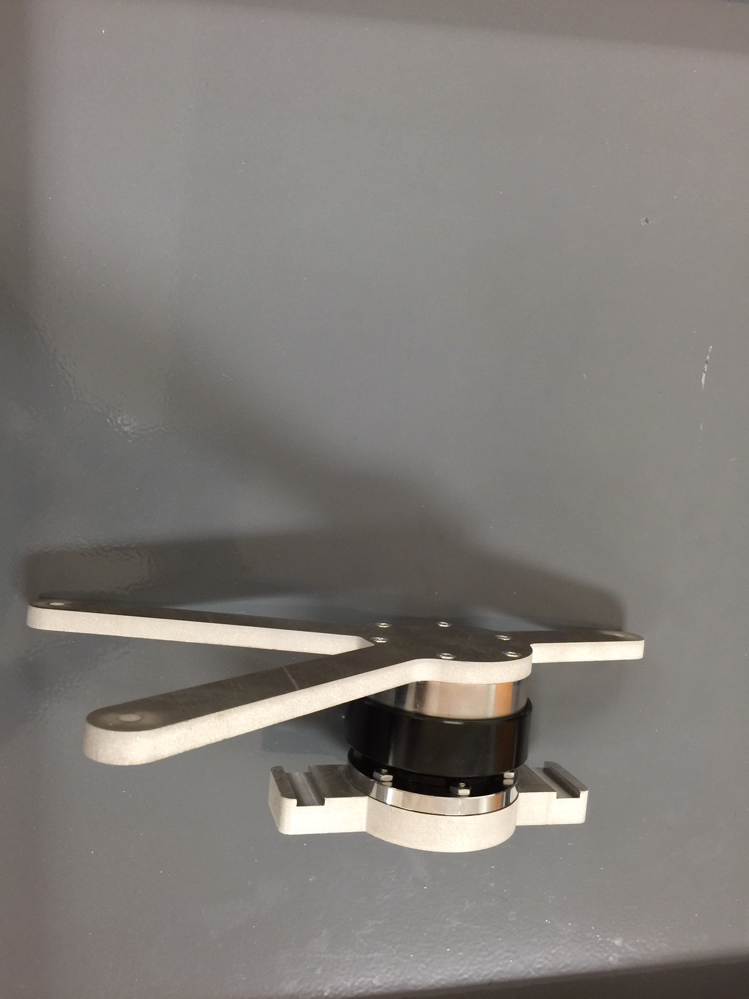

Figure 1: Quick release bracket system

The bracket system consists of three main components. They include the pipe support, quick release, and sensor bracket. The quick release shown in Figure 2 is a premanufactured part that is designed to quickly release steering wheels in custom vehicles.

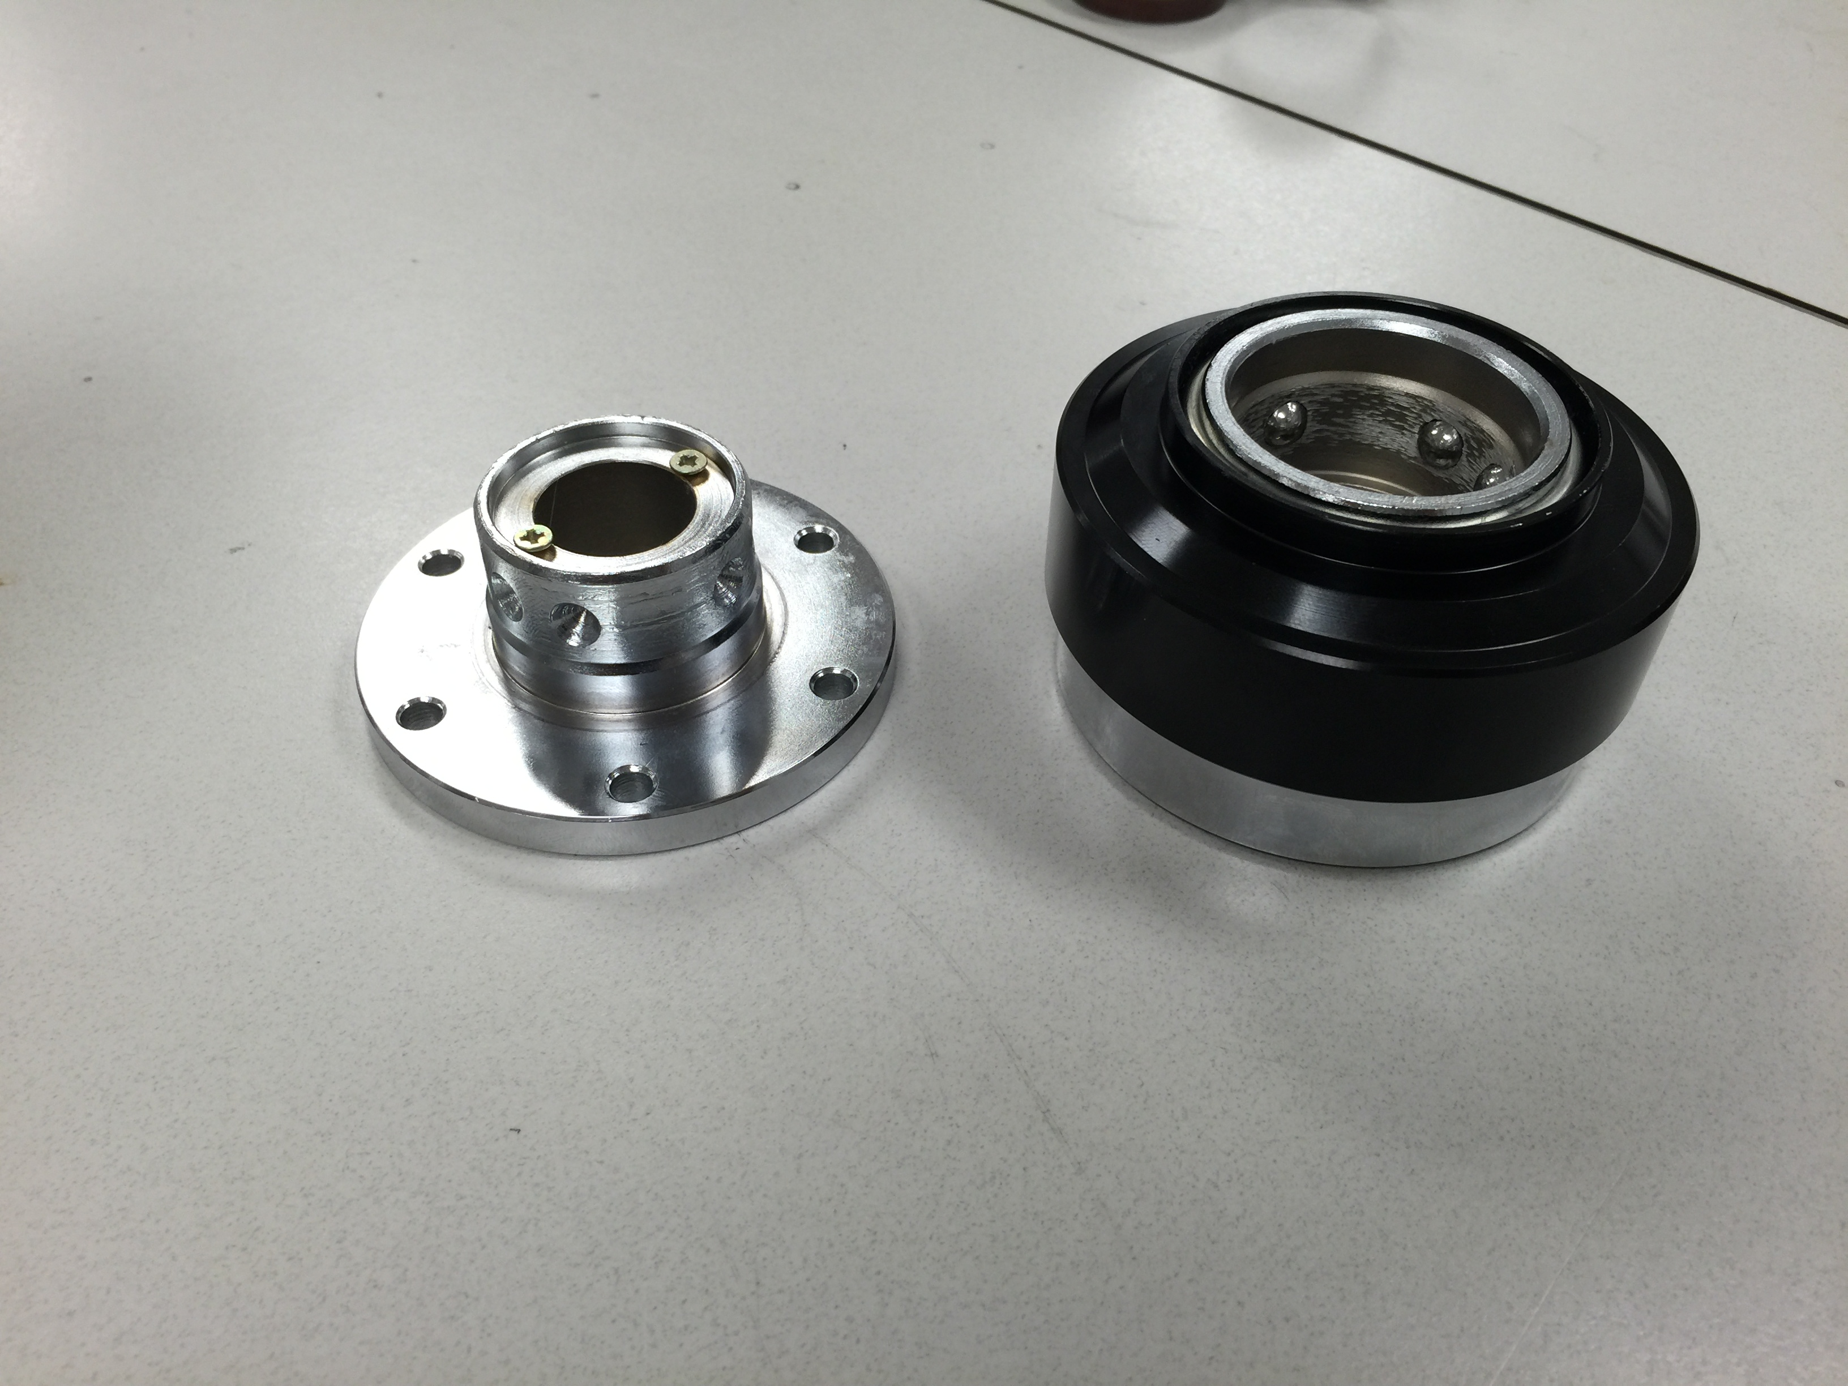

Figure 2: Steering wheel quick release

The quick release is designed to lock in a fixed position when engaged, not allowing any rotation between its two components. In order for this system to work for the team’s purpose, it was modified on a lathe to create a channel where the locking ball bearings can move freely and allow for the two components to rotate independent from each other. The grove can be seen in Figure 3.

The remaining two parts for the mount were designed based on the sensor and the quick release mounting holes.

The sensor bracket and pipe mount can be seen independent of each-other in Figure 3. The sensor bracket uses a simple design in the shape of a “Y” to attach to the sensor module. The sensor mount is attached using the hardware provided with the quick release to the spring loaded female side of the quick release for ergonomic purposes. The hardware included is 6 machine screws with allen drive.

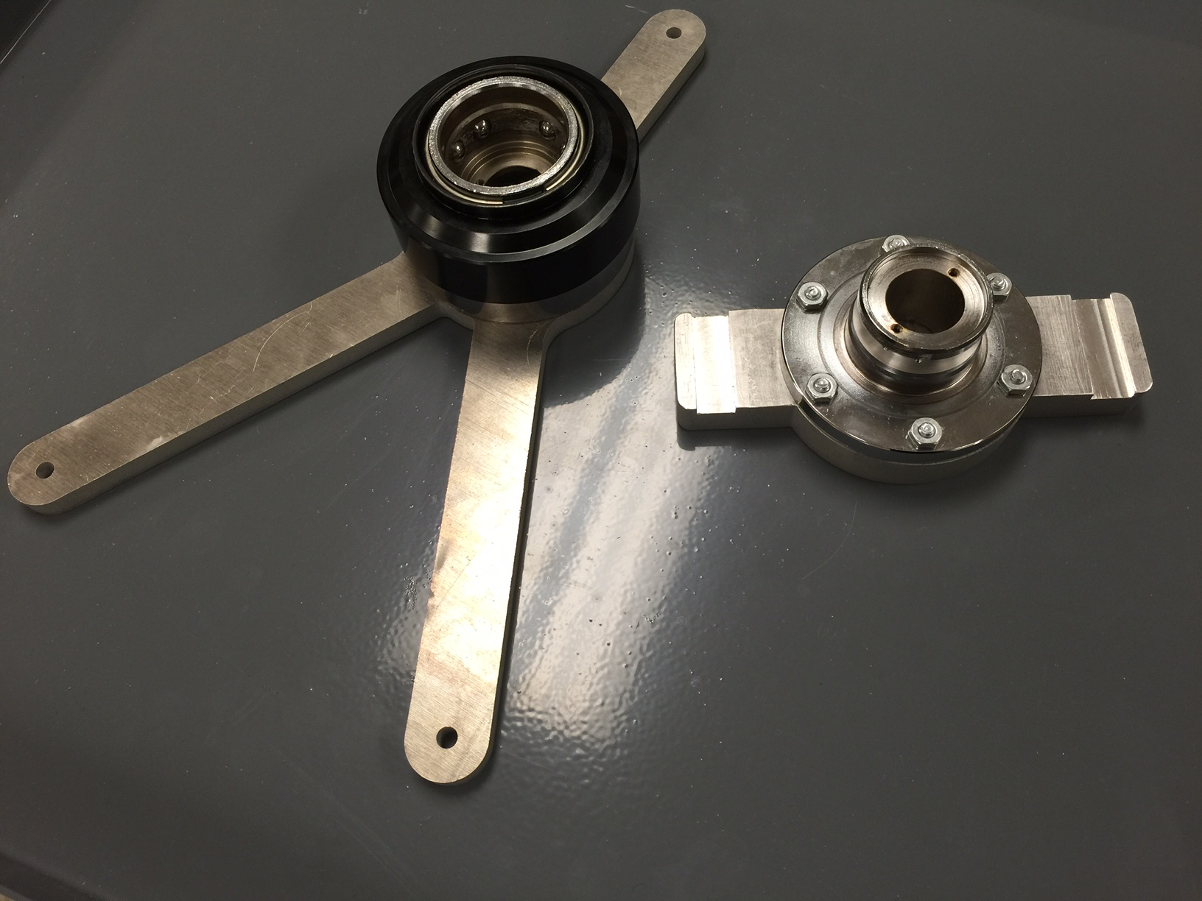

Figure 3: This photo shows the sensor mount (left) and the pipe mount (right)

The pipe mount portion was designed to have two slots on either end of it that can be seen in Figure 3 so that it can be mounted using either heavy duty zip ties or metal band clamps to existing pipes. It is bolted onto the male side of our quick release using machine screws that were not provided with the quick release. This part of the mounting system will be permanently mounted onto the piping where flow measurements will be taken. The overall assembly of the mounting system can be seen in Figure 4.

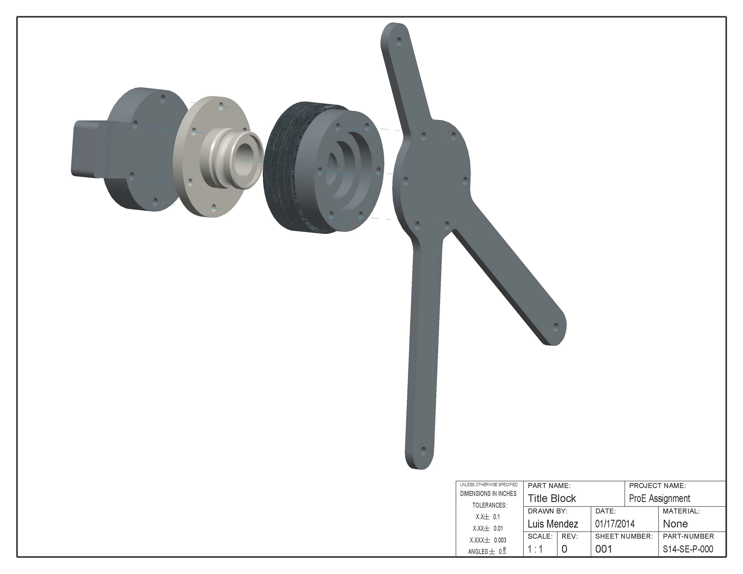

Figure : CAD Assembly of Mounting System

The optimal location to mount the bracket and sensor will be at eye level (if possible) as close to the sensors as necessary. The distance from the sensors is only bound by the maximum length of the connecting cables to the ultrasonic sensors, and compressor input ports.

## Manufacturing Timeline and Design

The design for the overall sensor package was kept as complicated as necessary. From combined experience, the design team decided to uses as much existing hardware as we could while still keeping the package cost effective and below budget.

The only parts that required manufacturing/machining in Team 5’s sensor package was the male side of the quick release, the sensor bracket and the pipe mount used in the mounting system for the sensor. Knowing the sizes of the hardware that needed to be used, the design for the sensor bracket and pipe mount parts was kept simple.

The parts shown in Figure 3 were designed in a way where they could be easily cut with most of the required features using a water-jet. The goal was to keep the finishing work to a minimum. After initial cutting on the waterjet the only necessary features to finish were the channels seen on the pipe mount and the counter bore of the holes in both the sensor bracket and the pipe mount. These finishing are done in order to ensure proper attachment to the sensor and the pipe.

The machining of the male side of the quick release only involves using a lathe to machine a trough where the existing spring loaded ball bearings can sit and allow for rotation of the pieces individually yet still lock the two parts together.

Our careful consideration on the design of the mount ensured that the time required to machine would be minimal. During the process of getting our parts machined, we realized that due to the simplicity of our design the time required was less than anticipated. Our product took approximately 2 days to machine. It’s important to note that the Machine shop at the FAMU/FSU college of engineering was also working on manufacturing parts for many other senor design projects. Based on that information, we estimate that the total machining time would be closer to about 3 hours at maximum.

# Design for Reliability

## Mechanical Systems

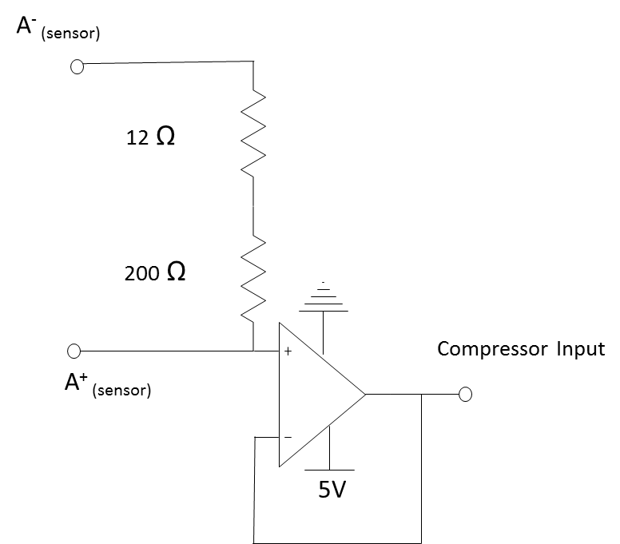The mechanical systems in the design project are limited to the mass flow sensors and their mounting bracket. Research on external mass flow sensors shows that the actual sensors are mounted separately from the control/data module supplied with them. Sensors are mounted directly to the piping and cables are run to the wall mounted control/data modules. In order to maintain a compact footprint, the team has decided to either modify or design a new mount for the sensor to be selected. This mount will keep the control unit mounted at the pipe where the sensors are to be mounted in order to avoid having to run excessive wiring and thus maintaining a compact footprint when installed in existing systems.

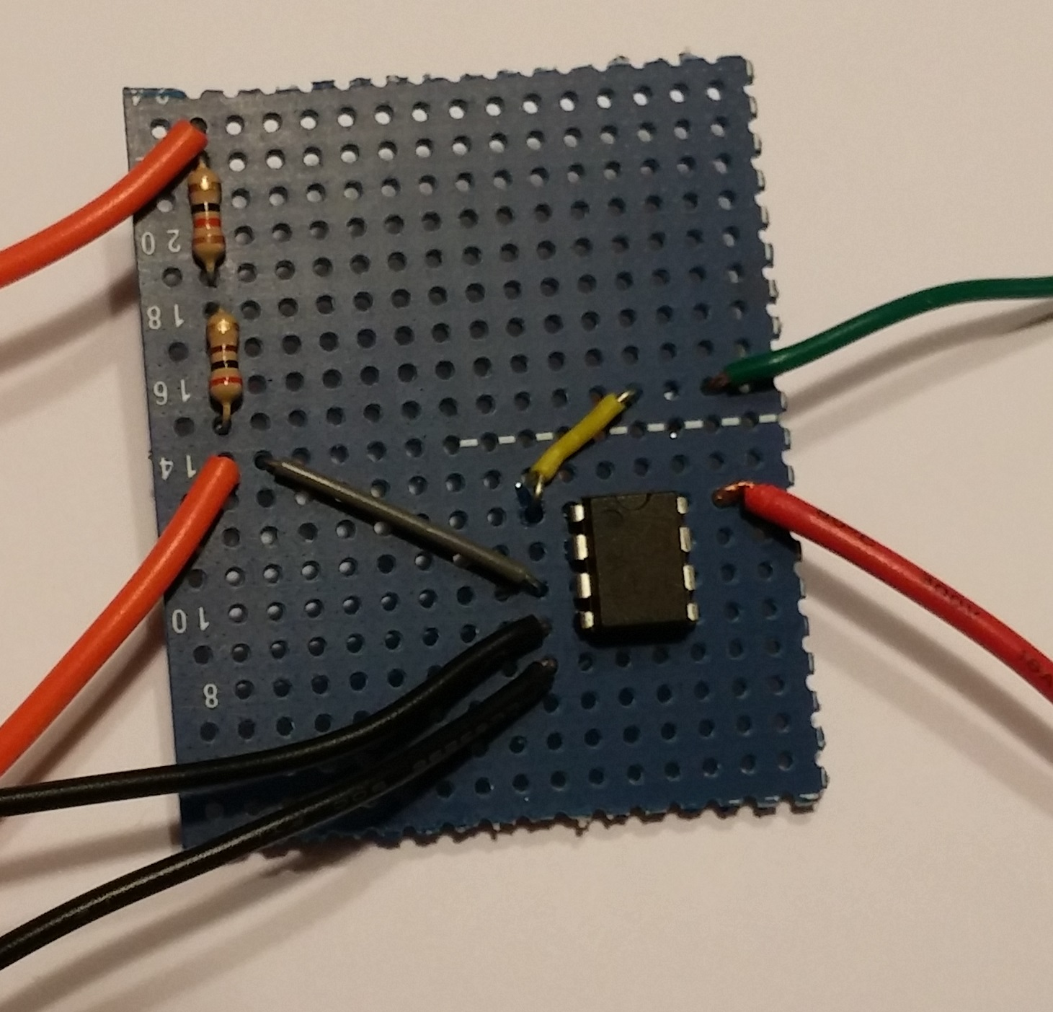In addition the signal output of the sensor needed to be conditioned in order to properly interface with the Turbocor equipment. A simple transresistive circuit with a unity gain buffer was implemented to meet these needs. The circuit created a voltage signal from the analog current output of the sensor. In addition, the buffer allows electronic separation between the sensor package and the compressor. This was done in order to reduce the likelihood of interference or feedback from one system affecting the other. Figure 5 shows the circuit diagram. Figure 6 is an image of the actual circuit built. A simple housing goes around the circuit to protect it from the environment.

Figure : Signal Conditioning Circuit

Figure : Circuit Diagram

## Background Information

Knowing the typical Turbocor compressor application and its basic function is essential to understanding the application of the team’s project. Their compressors are typically used in commercial HVAC systems that use a chiller, cooling tower, and condenser in order to remove heat. These systems essentially run on three loops. In the first loop of the system, the Turbocor compressor circulates R34A refrigerant. The Turbocor compressors use impellers to increase the pressure and in turn the temperature of the recirculating R134A refrigerant. The heated refrigerant then runs through a chiller, which is essentially a counter flow heat exchanger, in which heat is removed by a second loop of flowing water. This cooler refrigerant then makes its way to an expansion valve which further chills the refrigerant by decompressing the gas. This chilled refrigerant then flows through the condenser. This condenser is a second heat exchanger that removes heat from flowing water in the 3rd loop and chills it. The chilled water being pumped through the 3rd loop is then used to cool air by removing heat via a final heat exchanger. The importance of this information will become evident in subsequent sections.

## Customer Needs and Product Specifications

Turbocor has suggested a compact system that will measure the real-time efficiency of their compressor within 1% error. The specifications or constraints given to the team include; any mass flow sensing device must be external and not interfere with flow, the temperature differential and mass flow are to be measured at the evaporator in an HVAC system, the sensor signals must use common language to communicate with current platforms, the efficiency calculations should maintain an error less than or equal to 1%.

# Design for Economics

## Budget

The team was first given an undefined budget to initialize the design. The initial stages of the project were focused on project definition and scope development. As the project scope was solidified, the team was given a budget of $1000 to complete the sensor package.

Maintaining our budget was a major challenge of our design project. Our data collection requires an accurate ultrasonic sensor to determine the mass flow of water through a pipe.

Initial research into sourcing a sensor with the accuracy we require and compatible with the pipes used in the chiller systems presented us with a budget issue. Many of the sensors that performed within our parameters were significantly over budget. After extensive research we were able to source the Dalian High Peak TDS-100M within our budget. The budget allocation can be seen in the pie chart in Figure 4.

Figure : Pie chart of budget expenditures.

As shown in Figure 4, the mass flow senor consumed the majority of the allotted funds. The funds shown to be used for the quick connect was used for two quick release mounts. Each mount was $29.43. The team decided to order two quick connects for the purpose of modifications. The mount needed to have a trough cut into it to function as required. Since we did not know how the modification would affect the function of the mount, we ordered an extra unit in case we, for lack of a better description, ruined the mount during modifications.

Although the total budget of $1000 dollars was thought to be small, the teams careful planning and research has allowed us to stay within budget and as of now have an approximately $320 surplus. This is in part due to the hardware and raw materials supplied by Turbocor to manufacture our mount. Another factor includes the free machining labor that we were able to take advantage of.

Despite the free labor and raw materials for the mount, it was the teams goal to ensure that the entire project could be replicated for the $1000 budget. The simplicity of the design of our mount and the use of materials and hardware that Turbocor stocks in house will ensure that the package can be replicated within budget.

## Existing Systems

The sensor package put together by our team is a completely new system. Extensive research shows that there are no existing systems that functions as ours does. Real time efficiency is something that is usually monitored at test facilities and not at application sites. This is usually because in order to determine real time efficiency, parameters that are necessary are expensive and or difficult to read off of the systems in operation. The mass flow rate of refrigerant specifically requires an inline mass flow sensor to accurately detect and measure.

Our team has decided to use the mass flow of water through the evaporator as well as temperature differentials using data from existing sensors to determine real time efficiency. With our ultrasonic meter and our thermodynamic correlations, we are able to determine efficiency at application sites without major mechanical modifications to the existing systems.

Because the system developed by our team is all new, there is nothing to compare the performance and cost of our system to other than the existing bulky, and expensive test facility equipment. Our compact sensor package and equation model is an extremely cost effective way for Turbocor to collect operating data from the compressors that are used in different applications. This ability to monitor the operation of their system in real time results in added value to their product. Adding value to their product will benefit both existing and future customers.

# Conclusion

Turbocor seeks a real time efficiency readout to monitor equipment health in the first step to determining future failure modes. Team 5 has proposed a plan to incorporate a non-intrusive mass flow clamp on device coupled with sensors in pre-existing ports to accomplish this task. Thermodynamic laws and algorithms will transform this data into a usable form for Turbocor that will add value to their product as well as their customer. The team seeks to get approval and order the necessary equipment in the following weeks to stay on schedule. Effectively executing project plans are of importance but safety of all team members are held to the highest regard. It is necessary to follow all protocols while working in the machine shop as well as the Turbocor facility. In case of an incident the proper personnel should be notified immediately

# References

|  |  |
| --- | --- |
| [1] | "Power Generation," [Online]. Available: https://powergen.gepower.com/service-optimize/services/gas-turbines/software-analytics/monitoring-and-diagnostics.html. [Accessed 24 9 2015]. |
| [2] | Danfoss. [Online]. Available: http://industrialrefrigeration.danfoss.com/assets/0/114/137/138/17179871081/17179873132/42913673-264d-4750-8c9b-484debe90f4f.jpg?n=1124. [Accessed 24 9 2015]. |
| [3] | C. G. Lomas, Fundamentals of Hot Wire Anemometry, Cambridgeshire: Cambridge University Press, 1985. |