Midterm II: Detailed Design

Mass Flow Sensor Integration

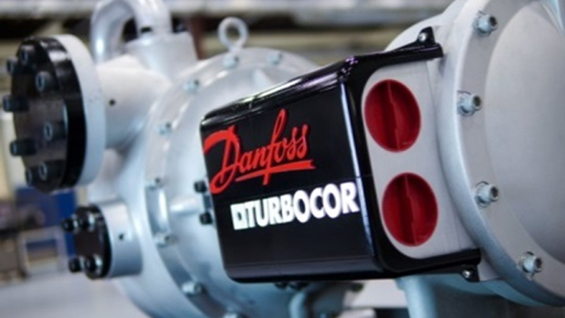

Team Number: 5

Submission Date: Friday, April 8th

Submitted To: Dr. Gupta

Team Members: Luis Mendez (lm13r@my.fsu.edu), Beau Rodgers (ber13@my.fsu.edu), Keenan Cheeks (kmc11j@my.fsu.edu), Brian Roberts (bpr13b@my.fsu.edu).

Faculty Advisor: Dr. Chiang Shih

Table of Contents

**Table of Figures……………………………………………………………………………....….iii**

Acknowledgements v

Abstract vi

1 Introduction 7

2 Problem Statement and Project Purpose 8

2.1 Design Requirements 8

2.2 Objective 9

3 Design and Analysis 10

3.1 Background Information 10

3.2 Methodology 10

3.3 Mechanical Systems 11

3.4 Data Collection 12

3.5 Data Analysis 13

3.6 Relevant Thermodynamic Correlations 13

3.6.1 Acquiring Known and Unknown Parameters 15

3.6.2 Uncertainty in Calculations 16

4 Concept Generation and Sensor Selection 19

4.1 Temperature Sensors 21

5 Final Design 22

5.1 DFM/ Reliability/ Economics 22

5.1.1 Products Parts and Assembly 22

5.1.2 Manufacturing Timeline 25

5.1.3 Mechanical Systems 26

5.1.4 Budget 27

6 Project Specification 29

6.1 Sensor Properties 29

6.2 Compressor Control Input 29

6.3 Trans-resistive Circuit 30

6.4 Mass flow rate vs. Voltage 30

6.5 Bracket Mounting System 30

7 Project Set up Procedure 33

7.1 Operations Instructions 34

7.2 Trouble Shooting 34

7.2.1 Incorrect Mass Flow Rate 34

7.2.2 Transducer Piping Contact 34

7.2.3 Transducer Spacing 35

7.2.4 Transducer Wiring 35

7.2.5 Pipe Specifications 35

7.2.6 Transducer Mounting 36

7.2.7 Set Sensor Zero 36

8 Regular Maintenance 37

8.1 Minor maintenance 37

8.2 Spare Parts 37

9 Results 38

10 Safety 42

10.1 Environmental Impact 42

10.2 Ethics 43

11 Schedule 44

12 Resources 45

12.1 Turbocor Facility 45

12.2 FAMU FSU College of Engineering Machine Shop 45

13 Procurement 46

13.1 Budget & Allocation 46

13.2 Materials 47

14 Communications 48

14.1 Team Communications 48

14.2 Sponsor Communications 48

14.3 Faculty Communications 49

15 Conclusion 50

16 References 51

**Table of Figures**

Figure 1 NI myRIO A and B ports where the data will be collected 13

Figure 2 A simplified diagram of the refrigerant cycle and the water through the evaporator 14

Figure 3: Quick release bracket system 24

Figure 4: Steering wheel quick release 24

Figure 5: This photo shows the sensor mount (left) and the pipe mount (right) 25

Figure 6: CAD Assembly of Mounting System 26

Figure 7 circuit diagram 27

Figure 8: Signal Conditioning Circuit 28

Figure 9: Trans-resistive Circuit 30

Figure 10: Pipe clamp; Allows the mass flow meter to be placed directly onto the pipe. 31

Figure 11: Quick release mechanism use to connect the entire system together while allowing for easy removal. 32

Figure 12: Mass Flow Sensor clamp; used to secure the sensor to the quick release. 32

Figure 13 The complete bracket assembly with sensor attached. 1 shows the quick release system that allows for quick removal of the sensor from the pipe. 2 shows the slotted groves that allow band clamps to attach the bottom portion of the bracket to the pipe. Finally, 3 shows the front of the bracket where the hardware attaches the sensor to the bracket system. 33

Figure 14 Silicone paste used to provide good contact between the pipe and the transducers. 35

Figure 15 Wired Sensor Module 36

Figure 16 Transducer mounting 37

Figure 17 This is the calibration curve for the TDS 100m mass flow sensor that correlates current output to mass flow rate in L/s. 39

Figure 18 This plot shows the steady difference in water flow rates between out sensor and Turbocor’s sensor 40

Figure 19 R134a refrigerant mass flow rate trended over time 41

Figure 20 This plot shows the coefficient of performance of the evaporator over the test run indicating that as the mass flow rate of the refrigerant decreased the performance of the heat exchanger increased. 41

Figure 21 This plot shows that the compressors efficiency decreased as the refrigerant mass flow rate was decreased. 42

Figure 22 This plot gives a look at how close the compressor is to moving the refrigerant isentropically. 43

Figure 23 Pie chart of the Budget allocation 48

# **Acknowledgements**

We would like to acknowledge and thank Dr. Gupta, Dr. Shih and the many engineers at Turbocor thus far for helping to define the scope of this design project. We are grateful for Turbocor engineers that have taken time away from their projects in order to guide this design team in a productive direction and for the opportunity provided to us through both or faculty advisor and the Danfoss Turbocor company. Furthermore, we are extremely excited and thankful for Turbocors willingness to grant the entire design team access to their on-site testing facilities and resources.

# **Abstract**

Senior design Team 5 was tasked with working with Danfoss Turbocor on developing new systems that will assist the teams learning process. The design process will use general and specific concepts that the team will have learned in their coursework. The team’s initial meetings with Danfoss Turbocor staff helped to mold the project scope into the development of a mass flow sensor package that can be integrated into existing systems with the goal of determining real time efficiency of their compressors at application sites. This project is to be used as a stepping-stone to the ultimate goal of development of a failure modes prediction system. The system was developed to function as a non-intrusive method that can be implemented into existing customer platforms as well as future applications. It uses an ultrasonic flow meter used to read the volume flow rate through the water pipes of an evaporator. Collected flow data showed a constant -5% error in the value of the flow. Thermodynamic correlations between this flow rate, and various measured temperatures result in a coefficient of performance (COP) value that is used currently by Turbocor. This COP value is the efficiency that we require in order to develop long term trends that can be modified to account for the error involved. This system was primarily developed to be integrated to the Variable Twin Turbo Compressor (VTT) as it is the newer system being developed by Turbocor and as such the programing in the platform is still under development. Although the system was not integrated into Turbocor’s existing system by the conclusion of the project, all the necessary information and processes are included in the following text.

# Introduction

Turbocor is a Tallahassee, FL based company that designs, develops, and manufactures high efficiency compressors to be used in HVAC chiller systems using innovative proprietary “mag-lev” technology. The company started in Australia in 1993 then moving to Montreal Canada in 1999. Turbocor brought their high efficiency compressors to market in 2002. Eventually being acquired by their now parent company, Danfoss in 2006, they moved to the purpose built facility in Tallahassee to cope with growing demand for their product.

Although the Turbocor compressors are known to be very reliable, to provide long-term customer satisfaction Turbocor hopes to develop methods of failure modes predictions. As emerging technologies from other companies become more and more competitive, Turbocor is turning its attention to the end user’s satisfaction to create a strong and loyal customer base. Turbocor is already competitive in customer service through their proactive efforts in assuring the highest manufacturing quality. However, the company desires to add another level of service through remote monitoring and diagnostics of their compressors as a means by which to increase product uniqueness and value. Many companies like General Electric and Siemens have already taken this step and integrated the necessary mechanical components into their compressors. Thus, to provide stepping stones toward achieving this end goal, our team is to use temperature sensors and a mass flow sensor to determine real time efficiency of the compressors under load.

# Problem Statement and Project Purpose

The Turbocor compressors are premium products in their market. As such, it is important for Turbocor to maintain a high level of customer satisfaction. Developing technologies within their market are becoming more competitive. Due to this developing increase in competition, Tubocor wishes to add value to their product for existing and future customers through the incorporation of a method for product failure prediction.

Currently, Turbocor’s compressors are only serviced post failure. Downtime is a major concern in situations where a compressor has failed. This downtime can be directly correlated to capital loss and customer dissatisfaction. For example, data centers rely heavily on their cooling systems. A compressor driven chiller system being down for merely a day can cause major issues to the extent of revenue loss and possible loss of assets. Another example would be a major hospital cooling system. A catastrophic failure of the compressor could potentially cause bodily harm to patients.

By designing a method to collecting real-time efficiency of the compressors, Turbocor can monitor their system and correlate a decrease in efficiency to a possible failure. By being able to predict failures, downtime of a major HVAC can be scheduled and the consumer and Turbocor can plan accordingly in order to maintain the consumer’s satisfaction.

## Design Requirements

Turbocor has suggested a compact system that will measure the real-time efficiency of their compressor within 1% error. The specifications or constraints given to the team include;

* Mass flow sensing device must be external and not interfere with the flow.
* The temperature differential and mass flow are to be measured at the evaporator in a chiller system.
* The sensor package output signals must be compatible with compressor input ports.
* The efficiency calculations should maintain at error less than or equal to 1%.
* Easy setup and installation at application sites.

## Objective

The collection of data from Turbocors existing systems and from our sensor package is relevant to the determination of the efficiency of the compressor. The ultimate goal of this project is the integration of our data collection into the exiting program platform of the Turbocor compressor to determine real- time efficiency in an effort to help in the prediction of compressor failure.

Real time efficiency is a vital step towards the future goal of failure modes prediction. By monitoring efficiency real time and comparing it to collected efficiency data, the performance of the compressors can be monitored and analyzed to help determine these modes.

# Design and Analysis

## Background Information

Knowing the typical Turbocor compressor application and its basic function is essential to understanding the application of the team’s project. Their compressors are typically used in commercial HVAC systems that use an evaporator, cooling tower, and condenser in order to remove heat. These systems essentially run on three loops. In the first loop of the system, the Turbocor compressor circulates R34A refrigerant. The Turbocor compressors use impellers to increase the pressure and in turn the temperature of the recirculating R134A refrigerant. The heated refrigerant then runs through a chiller, which is essentially a counter flow heat exchanger, in which heat is removed by a second loop of flowing water. This cooler refrigerant then makes its way to an expansion valve which further chills the refrigerant by decompressing the gas. This chilled refrigerant then flows through the condenser. This condenser is a second heat exchanger that removes heat from flowing water in the 3rd loop and chills it. The chilled water being pumped through the 3rd loop is then used to cool air by removing heat via a final heat exchanger. The importance of this information will become evident in subsequent sections.

## Methodology

In order for the team to achieve the goal of reading real time efficiency to aid in failure mode predictions, several key tasks must be addressed.

First, the team researched and determined the valuable parameters needed in the determination of compressor efficiency. Research shows that in order to calculate the efficiency, values for the work, the compressor outputs, and the draw of power by the compressor are necessary. Per Turbocor, the compressor’s power draw can be currently monitored by existing systems. However, the output work of a compressor in application can only be estimated based on data from product testing at the Turbocor facility. Because of this, the team must identify a method to calculating the work output by the compressor.

Using previous experience, the team determined that the work output of the compressor would correlate directly to heat transfer at various stages of the system. The team members sought out the assistance of a FAMU & FSU College of Engineering faculty members versed in heat transfer and other thermodynamic fields. Dr. Kumar and Dr. Vansciver aided us in development of our thermodynamic correlations. This meeting also helped determine that values for heat transfer for the compressor loop and the evaporator loop would be necessary. In order to determine said values, the mass flow rate through the condenser loop must be determined and used in conjunction with a temperature differential between the input and output of the compressor. However, determining mass flow proved to be a difficult task in application due to the phase of the fluid in this loop. The team decided to determine mass flow through the evaporator loop as it is simpler because the fluid through it is in liquid form.

Investigation into HVAC systems revealed that there are no existing measuring devices for the mass flow through any point in the system. Thus, the team must select un-intrusive sensors to determine mass flow through the evaporator.

Next, the temperature differential is needed through the evaporator. Sensors already exist on the inlet and outlet sides of the evaporator. The team has decided to collect this data from existing sensors and use it to determine the temperature differential.

An additional desired feature for the system is that it be compact in footprint. To achieve this, the team will design a mounting system to keep all components of selected sensors condensed.

The Final step in the project will be to analyze collected data and use the concepts and correlations described a subsequent section, to work in conjunction with CS Engineers in order to integrate the data into existing platforms. The data collected must determine an accurate value for real-time efficiency of the Turbocor compressor so that it may aid in the prediction of failure modes.

## Mechanical Systems

The mechanical systems in the design project are limited to the mass flow sensors and their mounting bracket. Research on external mass flow sensors shows that the actual sensors are mounted separately from the control/data module supplied with them. Sensors are mounted directly to the piping and cables are run to the wall mounted control/data modules. In order to maintain a compact footprint, the team has designed a new mount for the sensor to be selected. This mount will keep the control unit mounted at the pipe where the sensors are to be mounted in order to avoid having to run excessive wiring and thus maintaining a compact footprint when installed in existing systems.

## Data Collection

The TDS-100 reads a mass flow rate of the water in the evaporator. For this data to be useful it must be collected and manipulated. The TDS-100 outputs a current that is not compatible with the free inputs on the compressor board. Therefore, a trans resistive circuit was needed to create a voltage difference that could be measured. The 212-ohm nominal resistor was chosen to scale the voltage output to the 0-5-volt range that is compatible to the compressor. Although this circuit is necessary to be in line for the final design, it was also necessary to develop a calibration curve for the TDS-100.The NI-myRIO from the mechatronics lab was employed for this task. The myRIO is a programmable I/O board used for data collection. Coupled with LabVIEW, this board collects the voltage output from the sensor and is correlated to the timestamped video mass flow rates from the sensor. After graphing the data is was found that the mass flow rate is perfectly linear with increasing voltage. This relation is the necessary parameter for compressor board signal processing.

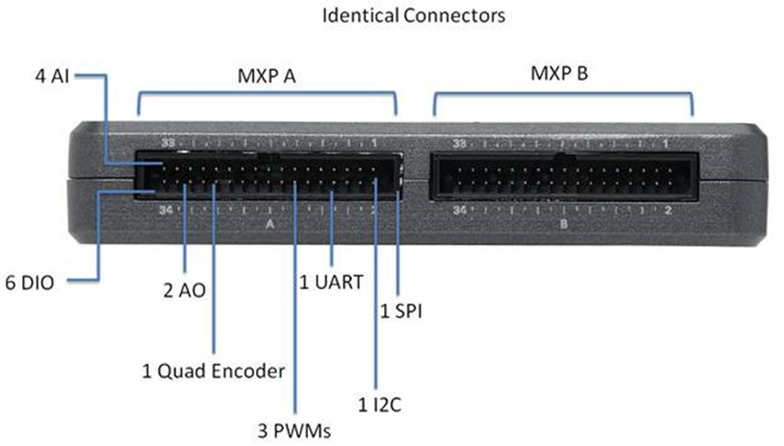

Figure 1 NI myRIO A and B ports where the data will be collected

## Data Analysis

In order to determine efficiency of the Turbocor compressor, data needs to be collected at other locations in the HVAC system. Determining the heat transfer at the condenser, will allow the calculation of other parameters needed.

The evaporator is the heat exchanger of interest for this project which cools water using R134-a refrigerant by means of counter flow heat transfer. This is essentially where the cooling load is applied. Figure 1 below shows how the basic HVAC system is set up. The task given for this project is to find the efficiency of the compressor without creating an inline or intrusive design. Finding the efficiency will require two main processes. First, the heat transfer correlations must be made to link the properties of the water and the refrigerant. Second, the unknown parameters of the correlations must be accounted for with onboard compressor sensors.

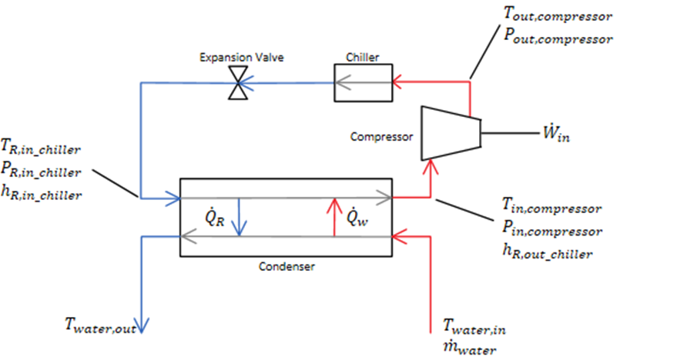

Figure 2 A simplified diagram of the refrigerant cycle and the water through the evaporator

## Relevant Thermodynamic Correlations

Heat exchanger calculations require a value for the heat transfer rate, $\dot{Q}$, which can be calculated from the known flow rate of one of the fluids, its heat capacity, and the temperature change at the inlet and exit of the condenser. We have decided to evaluate $\dot{Q}$ of the water because it eliminates the difficulties of dealing with the superheated gas state of the R134-a refrigerant. Equation 1 will be used to determine the rate of heat exchange the water experiences through the evaporator.

$\dot{Q_{w}}=\dot{m_{water}}c_{p,w}(T_{w,in}-T_{w,out})$ [kW] Eq.1

Where $\dot{m_{w}}$ is the mass flow rate of the water, $c_{p,w}$ is the heat capacity of the water, and $T_{w,in} and T_{w,out}$ are the inlet and exit temperatures of the water in the evaporator. After finding the heat transfer rate of the water the mass flow rate of the refrigerant can be found using equation 2 noting that the amount of heat transferred to the refrigerant is equal to the amount of heat taken from the water.

$\dot{Q_{R}}=\dot{m_{R}}(h_{R,in_compressor}-h_{R,out_condenser})$ [kW] Eq.2

Where $\dot{Q_{R}}$ is the heat transfer rate of the refrigerant, $\dot{m_{R}}$ is the mass flow rate of the refrigerant, and $h_{R,in_compressor }and h_{R,out_condenser}$ are the enthalpies at the inlet and exit of the compressor and condenser with respect to the refrigerant cycle. The last parameter needed to calculate compressor performance is the isentropic enthalpy change from state one at the suction side of the compressor to state two at the discharge side of the compressor. This enthalpy change can simply be interpolated from the R134-a refrigerant tables provided in any thermal fluid sciences textbook. With all the parameters defined above the compressor and evaporator performance will now be defined starting with the cooling capacity of the evaporator using equation 3, which is an industry standard calculation. The cooling capacity gives the total heat exchange of the evaporator versus how much power it takes the compressor to provide it.

$Cooling Capacity= \frac{P_{in.compressor}}{\dot{Q_{w}}*0.284}$ [kW/Ton] Eq.3

Where, in equation 3 $P_{in.compressor}$ is the power consumption of the compressor in kW and 0.284 is simply a conversion factor that converts the rate of heat exchange from kW to Ton of refrigeration. A ton of refrigeration is a unit of power used to describe the heat extraction capacity of HVAC equipment. Next, with the mass flow rate of the refrigerant calculated, we can use it to find the coefficient of performance of the compressor with equation 4.

$COP= \frac{\dot{m_{R}}*{∆h}_{isentropic}}{P_{in,compressor}}$ Eq.4

Where, in equation 4 COP is the coefficient of performance of the compressor, $\dot{m_{R}}$ is the mass flow rate of the refrigerant, and ${∆h}_{isentropic}$ is the isentropic difference in enthalpy of the refrigerant at the discharge side of the compressor and the inlet to the evaporator. In addition to these definitions of efficiency, Turbocor also defined another metric that they use to define how well the compressor is working. This final definition is the known as the compressor aero efficiency and is shown in equation 5.

$Aero Eff=\frac{{∆h}_{isentropic}}{{∆h}_{actual}}$ Eq.5

Where ${∆h}_{isentropic}$ and ${∆h}_{actual}$ are the isentropic and actual differences in enthalpies at the compressor discharge and inlet to the evaporator of the refrigerant line. Using all of these correlations Turbocor will now be able to find and trend the efficiency of their compressors on customer sites without having to go into the refrigerant line to measure refrigerant mass flow rate.

### Acquiring Known and Unknown Parameters

Some of the parameters, used in the correlations laid out in section 1, are currently available without modifications to the Turbocor compressor system, however, other parameters need to be accounted for by external sensors. From equation 1 all of the parameters will be known via sensors. The mass flow rate of the water, $\dot{m_{w}}$, will be determined using an ultrasonic mass flow rate sensor that is externally mounted onto the water pipe. This sensor will provide the flow velocity of the fluid and knowing the diameter of the pipe will ultimately give us the mass flow rate via equation 6.

$\dot{m_{w}=}ρ_{w}V_{w}A_{c}$ [kg/s] ; Eq.6

Where $ρ_{w}$ is the density of the water, $V_{w}$ is the flow velocity of the water given by the ultrasonic sensor, and $A_{c}$ is the cross sectional area of the pipe found using the known diameter. Next, the refrigerant temperature at the exit of the condenser will also need to be found using an external temperature sensor. Then, from equation 2 the known parameters will be the enthalpy at the suction side of the compressor due to the onboard temperature and pressure sensor at the inlet of the compressor and the enthalpy at the exit of the condenser of the refrigerant. Then as stated before, since the heat exchange rate in the evaporator between the refrigerant and the water are equal, the mass flow rate of the refrigerant can then be found in equation 2. The rest of the equations will have all known parameters because Turbocor currently monitors them in the test facility and are a standard measurement for most of the industry including their customers. This means that Turbocors customers can use this sensor package to measure compressor efficiency without having to install any extra sensors in addition to the ultrasonic sensor.

### Uncertainty in Calculations

At this point in the real time efficiency via mass flow integration project both mass flow rate and temperature sensors are being researched and purchased. Thus, there aren’t any experimental results to date. Once the sensors and proper supporting electronics arrive they will be installed and start pulling data as soon as possible. The theoretical uncertainties of the correlations previously discussed as well as possible risk that could arise follow.

The uncertainties of this project lay directly in the measurement tools being purchased for the measurement of mass flow rate, temperatures, and pressures at various locations of the HVAC system. To begin, the uncertainty in the mass flow rate of the water will be shown. The uncertainty here stems from the ultrasonic mass flow rate sensor which simply measures the velocity of the fluid flow through the pipe. The uncertainty in the mass flow rate is given by equation 7.

${δ{\dot{m}}_{w}}^{2}= {\left[\frac{∂{\dot{m}}_{w}}{∂ρ_{w}}δρ_{w}\right]}^{2}+{\left[\frac{∂{\dot{m}}_{w}}{∂V_{w}}δV_{w}\right]}^{2}+{\left[\frac{∂{\dot{m}}_{w}}{∂A_{c}}δA_{C}\right]}^{2}$; Eq.7

where ${\dot{m}}_{w}$, $δρ_{w}$, $δV_{w}$, and $δA_{C}$ are the uncertainties in water mass flow rate, density, velocity, and cross sectional area respectively. $\frac{∂{\dot{m}}_{R}}{∂ρ_{w}}$, $\frac{∂{\dot{m}}_{w}}{∂V_{w}}$, and $\frac{∂{\dot{m}}_{w}}{∂A_{c}}$ are the partial derivatives of water mass flow rate with respect to each parameter. This equation reduces further after simplification to equation 8

${δ{\dot{m}}_{w}}^{2}={\left[ρ_{w}A_{c}δV_{w}\right]}^{2}$; Eq. 8

The next major uncertainty that will be introduced into the calculations will be in the mass flow rate of the refrigerant shown in equation 9

$\dot{m_{R}}=\frac{\dot{m_{water}}c_{p,w}(T_{w,in}-T_{w,out})}{(h_{R,in_compressor}-h_{R,out_condenser})}$ [kg/s] ; Eq.9

where $c_{p,w}$, $T_{w,in} ,$ and $T_{w,out}$ are the specific heat capacity and temperature at the inlet and exit of the condenser respectively. $h_{R,in_compressor}$ and $h_{R,out_condenser}$ are the enthalpies of refrigerant at the inlet and exit of the compressor and condenser respectively. For equation 9 the uncertainty comes from propagation of the error in $\dot{m_{water}}$, and the uncertainties in the temperature and pressure sensors. Equation 10 gives the error in this correlation.

${δ{\dot{m}}_{R}}^{2}= {\left[\frac{∂{\dot{m}}_{R}}{∂\dot{m_{water}}}δ{\dot{m}}_{w}\right]}^{2}+{\left[\frac{∂{\dot{m}}_{R}}{∂c_{p,w}}δc_{p,w}\right]}^{2}+{\left[\frac{∂{\dot{m}}_{R}}{∂T_{w,in}}δT_{w,in}\right]}^{2}+{\left[\frac{∂{\dot{m}}_{R}}{∂T_{w,out}}δT_{w,out}\right]}^{2}+{\left[\frac{∂{\dot{m}}_{R}}{∂h_{R,in_{chiller}}}δh_{R,in_{compressor}}\right]}^{2}+{\left[\frac{∂{\dot{m}}_{R}}{∂h_{R,out_{chiller}}}δh_{R,out_{condenser}}\right]}^{2}$; Eq.10

Where ${δ{\dot{m}}_{R}}^{2}$, $δ{\dot{m}}_{w}$, $δc_{p,w}$, $δT_{w,in}$, $δT_{w,out}$, $δh_{R,in_{ccompressor}}$, and $δh_{R,out_{condenser}}$ are the uncertainties in mass flow rate of refrigerant, mass flow rate of water, specific heat capacity of water, temperature of water into the condenser, temperature of water out of the condenser, enthalpy of refrigerant into the condenser and enthalpy of the refrigerant out of the condenser. Noting that the error due to the enthalpies of refrigerant in and out of the condenser stem from the interpolation process of temperature and pressure tables it is seen that their error like the temperature of water in and out of the condenser also comes from the accuracy of the temperature and pressure sensors available. Finally, the uncertainty in the work out of the compressor is purely based on error propagation of all the sensors and previous calculations.

# Concept Generation and Sensor Selection

Based upon the criteria identified through research and discussion with the sponsor, various brands and models of external mass flow sensors were compared in order to determine the best option for this application. A selection matrix was constructed by assigning a weight from 1-5 for each criteria and then rating them for each system with a scale of 0-3 where 0 indicates that the criteria is not met at all. The models were then given an overall rating that was the sum of each individual rating multiplied by the weight of the corresponding attribute.

The most important criteria identified was the accuracy of the measurement. Any deviation in the mass flow measurement will propagate through the rest of the calculations as shown previously. If this value is not within the acceptable range the rest of the features of the system are irrelevant.

Next in importance were three criteria involving the physical nature of the system itself. It is imperative that the sensors be able to operate over a variety of different diameter pipes. Depending on the volumetric flow and environment the chillers are operating in there could be several different pipe configurations. In addition, we know that the cooling water will be fluid but not the precise temperature as this varies, an operating range from 0°C to 100°C is preferable. The third property is the range of measurable fluid velocities. This can vary widely based upon the diameter of the pipe and the necessary flow rates. A wider range was considered better. Some systems are bidirectional and report velocities as positive or negative based upon the orientation of the system. The chillers only operate in one direction so this feature was irrelevant for our purposes.

Cost was considered of moderate importance. Staying within the budget is of course mandatory, but other than the sensors themselves there is little of large value that must be acquired for this project. Other components like the mounting system are were fabricated with left over materials at the Turbocor facility for no cost.

Some systems include the feature to calculate heat transfer in the system. They require temperature sensors to be mounted in the flow and fed back to the control box of the flow meter. This is imperative at some point for our final goal and temperature sensors have to be integrated into the design regardless. This feature could prove helpful for the final goal of calculating efficiency and facilitate a less complex interaction between the mass flow sensor and the compressor control board by reducing the number of inputs necessary to get the desired information.

The last criteria considered was the type of outputs. It is important that the system have an output that can be read by the compressor control board and not just a display that can only be read manually. Variety of outputs available was considered a bonus because it would keep options open when attempting to process the signal. Table (1) below shows the selection matrix for the top four ultrasonic mass flow sensors within error tolerance.

Table 1 Selection Matrix

|  |  |  |  |  |  |  |  |  |
| --- | --- | --- | --- | --- | --- | --- | --- | --- |
| Characteristics  Weighted 1-5 | Accuracy | Cost | Pipe ᴓ (m) | Fluid Temp(°C) | Fluid Velocity(m/s) | Calculate Q̇ ? | Output (Analog or Digital) | Total |
|  | 5 | 3 | 4 | 4 | 4 | 3 | 2 |  |
|  | Actual Values rated from 0-3 | | | | | | |  |
| Sierra InnovaSonic 210i | ±0.5%  **3** | $3,170  **1** | 0.15 to 6  **3** | -40 to 80  **2** | 0.05 to 12  **1** | No  **0** | A  **2** | 46 |
| Dalian Hipeak TDS-100F | > ±1%  **2** | $500-700  **3** | 0.15 to 7  **3** | 0 to 90  **2** | -30 to 30  **3** | Yes  **3** | A/D  **3** | 66 |
| GE Panametrics PT878 | ±1%  **1** | $10,035  **0** | .13 to 7.6  **3** | -10 to 50  **1** | -40 to 40  **3** | No  **0** | A/D  **3** | 39 |
| Greyline TTFM 1.0 | ±1%  **1** | $2,600  **2** | 0.12 to 1.2  **2** | -40 to 150  **3** | 0.02 to 12  **2** | No  **0** | A  **2** | 43 |

Many systems were looked at and rejected as unacceptable based on budget. It was decided that the Dalian Hipeak TDS-100F would be the best choice. It operates within all of our specified ranges and has a cost that is significantly better than any comparable systems. In addition it has the capability of calculating Q̇ which can then be directly output to the system. Also it has a large variety of output types which will make processing the data easier.

## Temperature Sensors

For the integrated design it is necessary to utilize a temperature sensor in existing ports on the inlet and outlet of the evaporator. This enables real time temperature readings of the water for a more accurate compressor efficiency. Turbocor currently uses the Texas Instruments 112CP3-4 pressure and temperature sensor in their compressors. This temperature sensor has an accuracy of 0.6% and will be compatible with Dalian Hipeak mass flow sensor. Therefore to reduce costs the team will repurpose this sensor into the design.

# Final Design

The Final design includes the Dalian Hipeak TDS-100 ultrasonic mass flow sensor, sensor mounting bracket and trans-resistive buffer circuit to effectively be integrated into the Turbocor platform. This system coupled with the pseudo-code will allow the engineers at Turbocor to integrate it with no modification to any other system on the chiller. This will effectively be able to record and trend efficiency of the compressor over short and extended periods of time.

## DFM/ Reliability/ Economics

### Products Parts and Assembly

The package developed to determine real time efficiency or COP, requires the use of the selected ultrasonic flow meter, resistive temperature sensors, and existing operating hardware. In order to keep the sensor package relatively compact, a mounting bracket was designed.

The flow sensor being used in this project is a Dalian High Peak TDS-100M. This unit uses a wall mounted control module and wired, clamp on ultrasonic sensors to read a volume flow rate.

In order to avoid difficulty in set up of the sensor system, it is important to follow a set up procedure. First, a proper mounting location should be determined for the ultrasonic sensors using information that can be found in the Operations Manual. Next, all of the wiring to and from the sensor control module must be completed. It is important to note that the TDS-100M will require a 120V plug to operate. Finally, once all of the wiring is completed and the system initial setup (per the operation manual) is done, a location for the mounting bracket can be chosen to best suit the operator.

To keep the sensor off the wall and avoid running extra wiring, we developed the quick release bracket system in Figure 1.

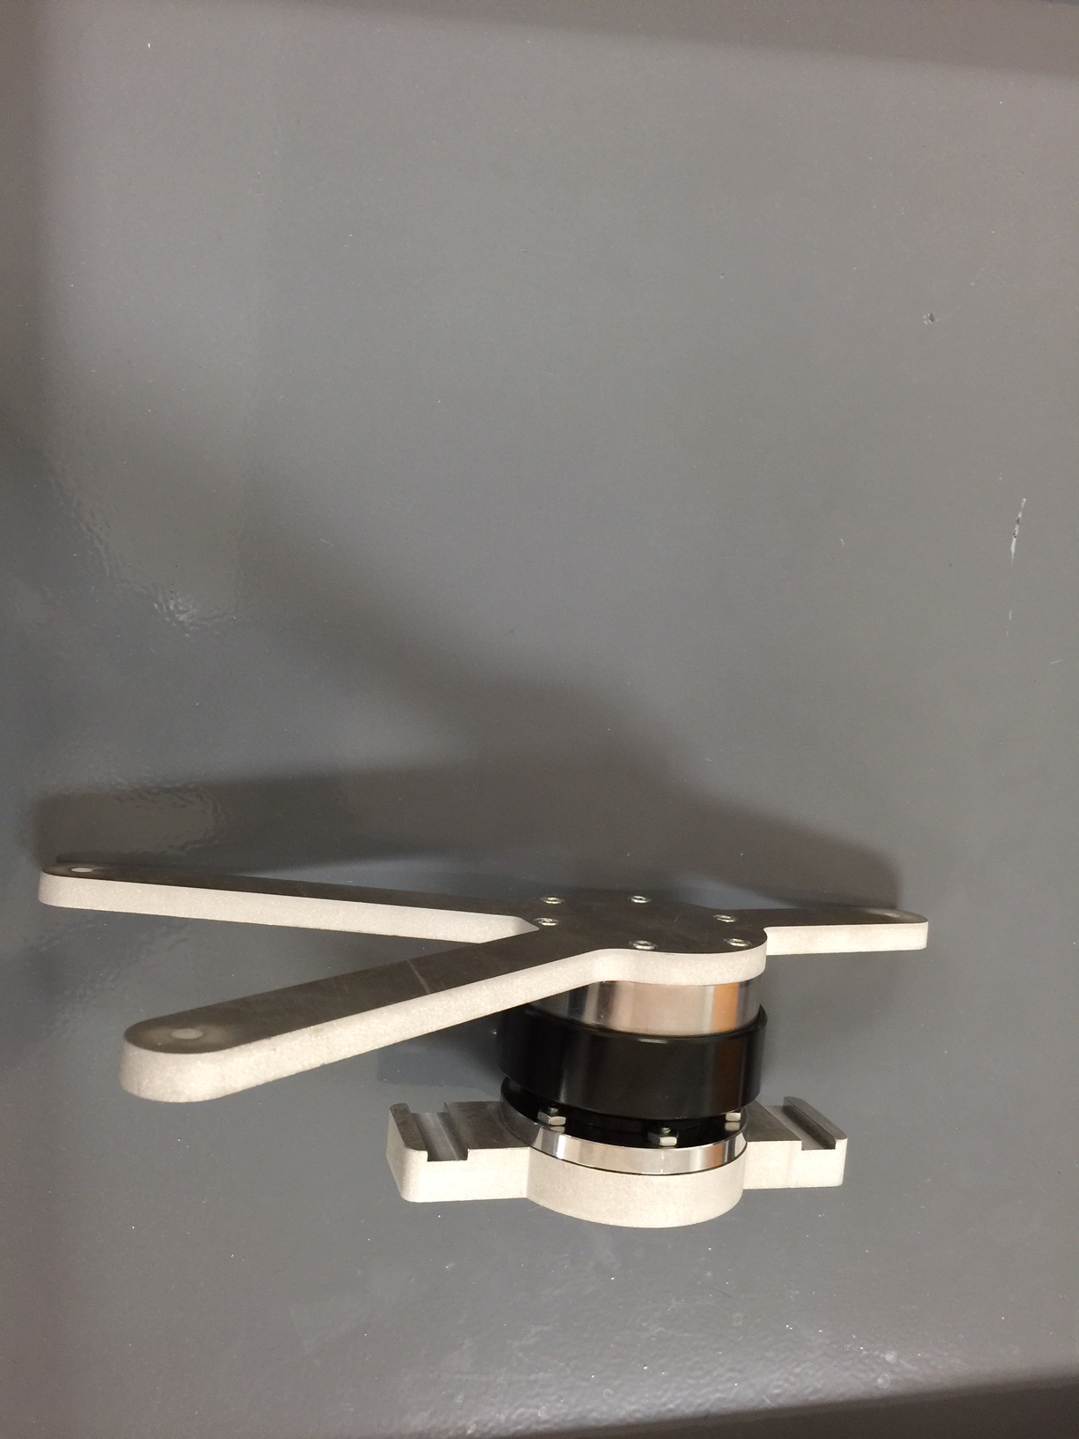

Figure 3: Quick release bracket system

The bracket system consists of three main components. They include the pipe support, quick release, and sensor bracket. The quick release shown in Figure 2 is a premanufactured part that is designed to quickly release steering wheels in custom vehicles.

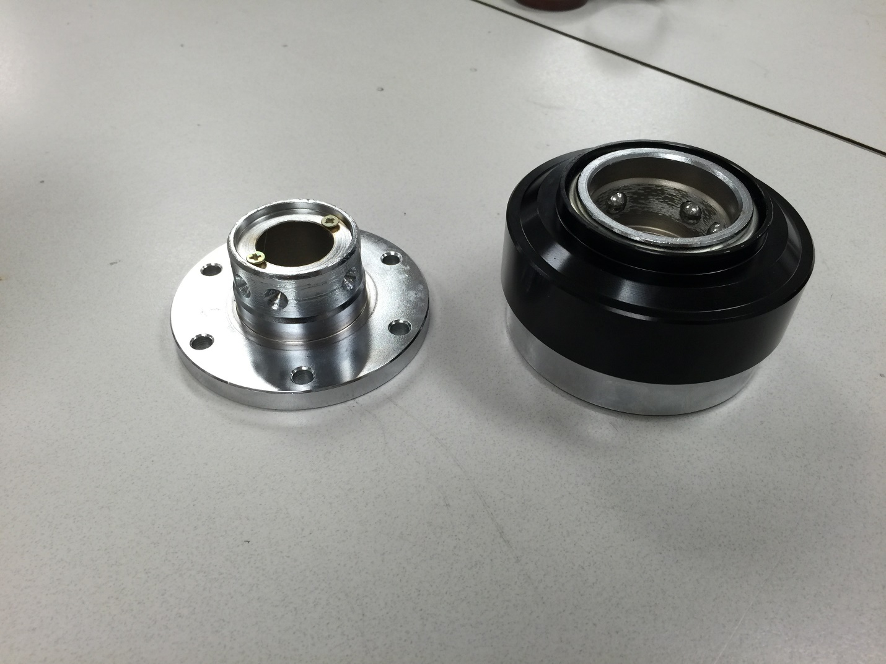

Figure 4: Steering wheel quick release

The quick release is designed to lock in a fixed position when engaged, not allowing any rotation between its two components. In order for this system to work for the team’s purpose, it was modified on a lathe to create a channel where the locking ball bearings can move freely and allow for the two components to rotate independent from each other. The grove can be seen in Figure 3.

The remaining two parts for the mount were designed based on the sensor and the quick release mounting holes.

The sensor bracket and pipe mount can be seen independent of each-other in Figure 3. The sensor bracket uses a simple design in the shape of a “Y” to attach to the sensor module. The sensor mount is attached using the hardware provided with the quick release to the spring loaded female side of the quick release for ergonomic purposes. The hardware included is 6 machine screws with Allen drive.

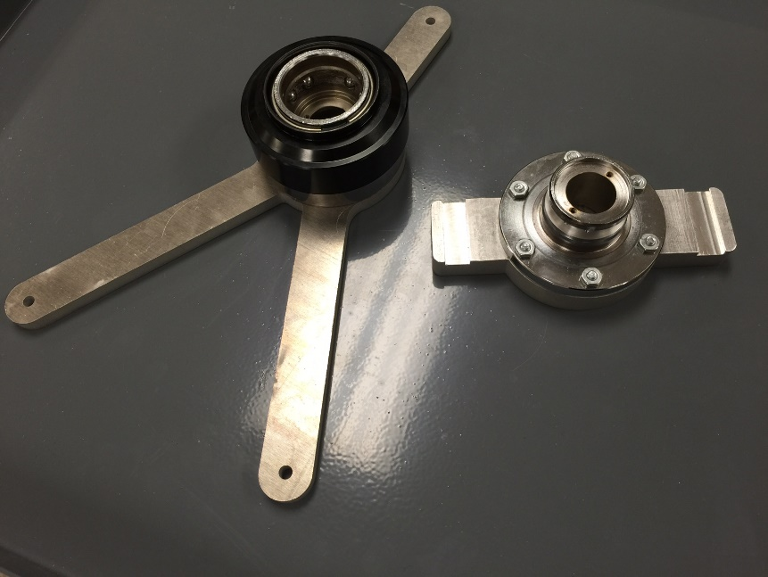

Figure 5: This photo shows the sensor mount (left) and the pipe mount (right)

The pipe mount portion was designed to have two slots on either end of it that can be seen in Figure 3 so that it can be mounted using either heavy duty zip ties or metal band clamps to existing pipes. It is bolted onto the male side of our quick release using machine screws that were not provided with the quick release. This part of the mounting system will be permanently mounted onto the piping where flow measurements will be taken. The overall assembly of the mounting system can be seen in Figure 4.

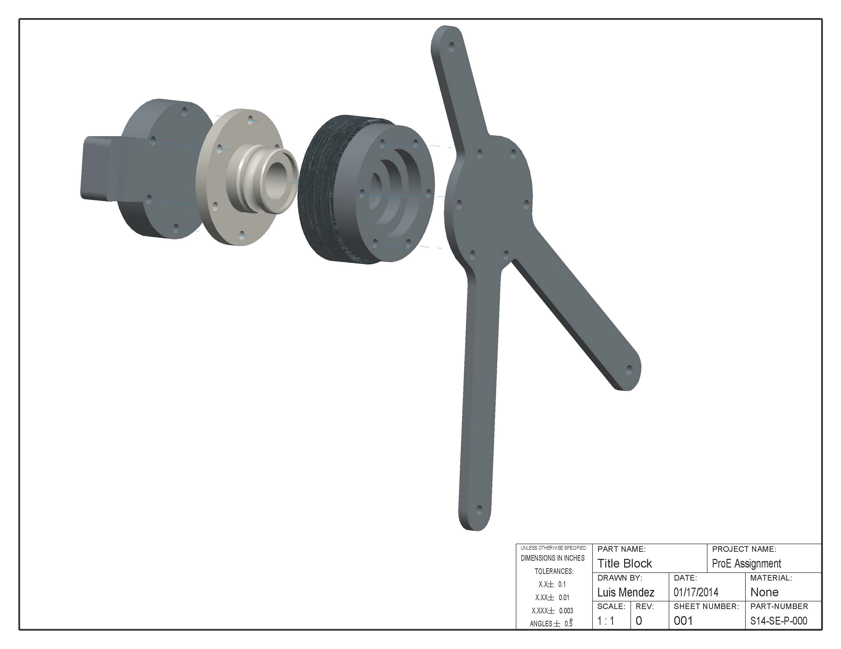

Figure 6: CAD Assembly of Mounting System

The optimal location to mount the bracket and sensor will be at eye level (if possible) as close to the sensors as necessary. The distance from the sensors is only bound by the maximum length of the connecting cables to the ultrasonic sensors, and compressor input ports.

### Manufacturing Timeline

The design for the overall sensor package was kept as complicated as necessary. From combined experience, the design team decided to uses as much existing hardware as we could while still keeping the package cost effective and below budget.

The only parts that required manufacturing/machining in Team 5’s sensor package was the male side of the quick release, the sensor bracket and the pipe mount used in the mounting system for the sensor. Knowing the sizes of the hardware that needed to be used, the design for the sensor bracket and pipe mount parts was kept simple.

The parts shown in Figure 3 were designed in a way where they could be easily cut with most of the required features using a water-jet. The goal was to keep the finishing work to a minimum. After initial cutting on the waterjet the only necessary features to finish were the channels seen on the pipe mount and the counter bore of the holes in both the sensor bracket and the pipe mount. These finishing are done in order to ensure proper attachment to the sensor and the pipe.

The machining of the male side of the quick release only involves using a lathe to machine a trough where the existing spring loaded ball bearings can sit and allow for rotation of the pieces individually yet still lock the two parts together.

Our careful consideration on the design of the mount ensured that the time required to machine would be minimal. During the process of getting our parts machined, we realized that due to the simplicity of our design the time required was less than anticipated. Our product took approximately 2 days to machine. It’s important to note that the Machine shop at the FAMU/FSU college of engineering was also working on manufacturing parts for many other senor design projects. Based on that information, we estimate that the total machining time would be closer to about 3 hours at maximum.

### Mechanical Systems

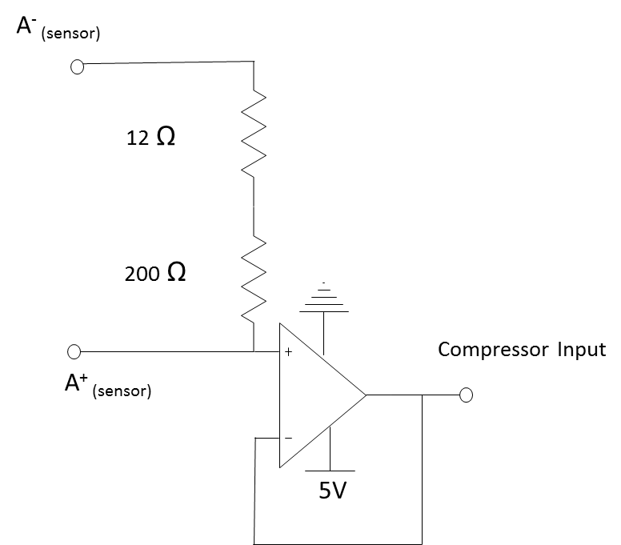The mechanical systems in the design project are limited to the mass flow sensors and their mounting bracket. Research on external mass flow sensors shows that the actual sensors are mounted separately from the control/data module supplied with them. Sensors are mounted directly to the piping and cables are run to the wall mounted control/data modules. In order to maintain a compact footprint, the team has decided to either modify or design a new mount for the sensor to be selected. This mount will keep the control unit mounted at the pipe where the sensors are to be mounted in order to avoid having to run excessive wiring and thus maintaining a compact footprint when installed in existing systems.

Figure circuit diagram

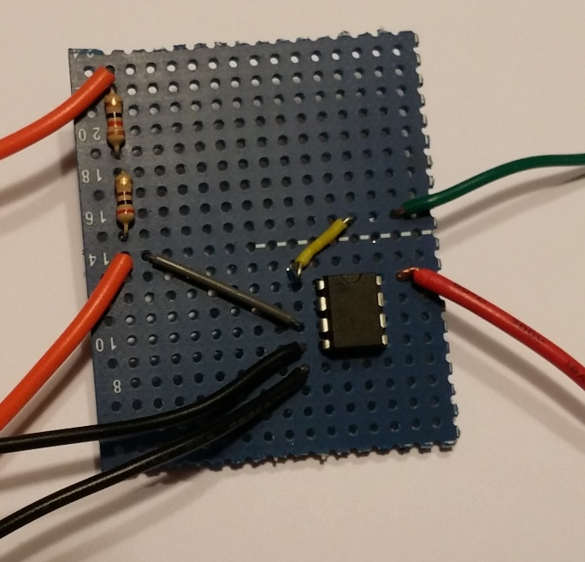In addition, the signal output of the sensor needed to be conditioned in order to properly interface with the Turbocor equipment. A simple trans-resistive circuit with a unity gain buffer was implemented to meet these needs. The circuit created a voltage signal from the analog current output of the sensor. In addition, the buffer allows electronic separation between the sensor package and the compressor. This was done in order to reduce the likelihood of interference or feedback from one system affecting the other. Figure 5 shows the circuit diagram. Figure 6 is an image of the actual circuit built. A simple housing goes around the circuit to protect it from the environment.

Figure : Signal Conditioning Circuit

As shown in Figure 4, the mass flow senor consumed the majority of the allotted funds. The funds shown to be used for the quick connect was used for two quick release mounts. Each mount was $29.43. The team decided to order two quick connects for the purpose of modifications. The mount needed to have a trough cut into it to function as required. Since we did not know how the modification would affect the function of the mount, we ordered an extra unit in case we, for lack of a better description, ruined the mount during modifications.

Although the total budget of $1000 dollars was thought to be small, the teams careful planning and research has allowed us to stay within budget and as of now have an approximately $320 surplus. This is in part due to the hardware and raw materials supplied by Turbocor to manufacture our mount. Another factor includes the free machining labor that we were able to take advantage of.

Despite the free labor and raw materials for the mount, it was the teams goal to ensure that the entire project could be replicated for the $1000 budget. The simplicity of the design of our mount and the use of materials and hardware that Turbocor stocks in house will ensure that the package can be replicated within budget.

# Project Specification

The two main components of the system are the sensor itself and the mounting bracket. The sensor was chosen to meet the requirements of the compressor, pipes commonly used and environment.

## Sensor Properties

The Dalian Hipeak TDS-100F mass flow sensor package was chosen after research and analysis of requirements. In addition the type M1 and type L1 transducer were chosen. It has the following relevant properties:

Table 2: Sensor Properties

|  |  |
| --- | --- |
| **Operating Power** | Ac 85-264 V or DC 8-36 V |
| **Accuracy** | Better than 1% |
| **Output** | Analog 0-24 mA |
| **Acceptable Pipe Diameters** | 15-6000 mm |
| **Keypad Menu** | Allows:  Monitoring of equipment  Manual input of parameters  View of data log |
| **Measureable Flow** | 0-2777.77 L/s |

## Compressor Control Input

In order to interface with the compressor control board one of the unused temperature and pressure sensor inputs was repurposed. Normally a resistive type sensor is used in this location. The connection on the board consists of a +5V supply, ground and two voltage inputs for the pressure and temperature. Our design required converting the analog current signal to a voltage in order to allow the control board to use the value.

## Trans-resistive Circuit

A simple trans-resistive circuit was designed. It includes a unity gain buffer to help isolate the sensor from the compressor. This was done in order to prevent electromechanical interference from affecting the sensor package or feedback to damage the control board. Figure # shows the circuit diagram. This package also allows the grounds for the devices to be tied together so that the voltage provided has the same reference point. The actual circuit built had a total resistance of 208.33 Ω.

Figure : Trans-resistive Circuit

## Mass flow rate vs. Voltage

After collecting data and combing through the sensor documentation it was determined that the sensor output is linear. At a flow rate of 0 L/s the output is 4 mA. At the maximum flow rate of 2777.77 L/s the output is 24 mA. The circuit devised converts this to a 0-5 V scale so that the calibration function can be described through Eq. 1 where *x* is the voltage input:

$\dot{V}=(666.64 \frac{(\frac{L}{s})}{V}) (x-0.8332 V)$ Eq.7

## Bracket Mounting System

The bracket system consists of 3 main components made from aluminum. The first component of the bracket will attach to the pipe via band clamps that fit easily through designed grooves as shown in Figure 2. The second piece of the system shown in Figure 3 is a quick release mechanism typically used for easy removal of steering wheels in cars and trucks. This piece has been modified to allow the sensor to be positioned at any angle on the pipe meaning that it can always be easily read and worked on. In addition to angle adjustment, the quick release system will allow for the sensor to be completely removed from the pipe without the need for any tools. The final piece to the bracket is responsible for securing the sensor tightly with screws, washers and nuts as shown in Figure 4. The complete assembly is shown in Figure 5.

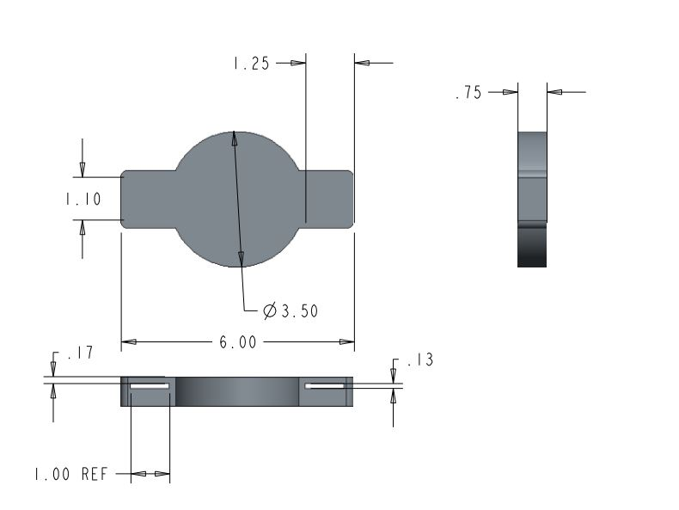

Figure 10: Pipe clamp; Allows the mass flow meter to be placed directly onto the pipe.

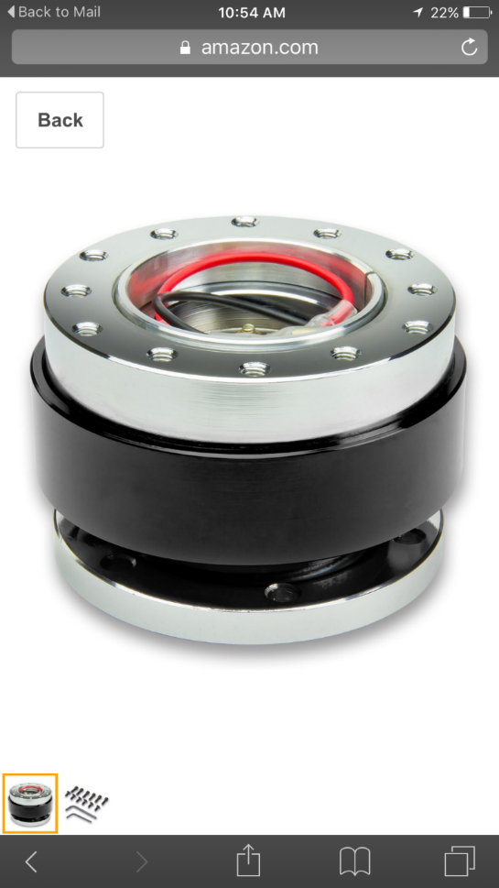

Figure 11: Quick release mechanism use to connect the entire system together while allowing for easy removal.

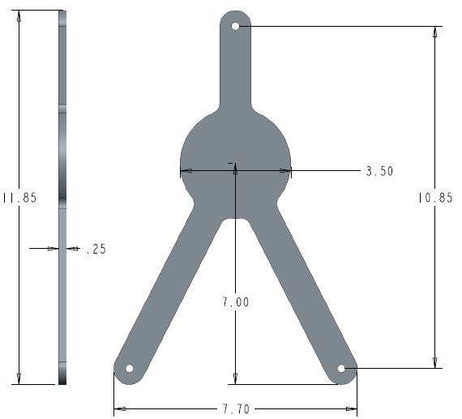

Figure 12: Mass Flow Sensor clamp; used to secure the sensor to the quick release.



Figure 13 The complete bracket assembly with sensor attached. 1 shows the quick release system that allows for quick removal of the sensor from the pipe. 2 shows the slotted groves that allow band clamps to attach the bottom portion of the bracket to the pipe. Finally, 3 shows the front of the bracket where the hardware attaches the sensor to the bracket system.

# Project Set up Procedure

To begin installation of the sensor package (although it is not necessary for operation of the sensor) it is advised that the system be shut down so that the sensor may be zeroed to the new HVAC system for increased accuracy. The next step in the installation is to attach the base of the bracket to the pipe where desired via band clamps. Next, the sensor must be securely attached to the front of the bracket and snapped onto the base using the quick release system. After the sensor has been attached to the pipe it can now be wired and turned on using a standard 120 Volt outlet. On startup of the sensor the user will be prompted to insert the physical properties of the pipe including its inner and outer diameters and its material. It is important to know the schedule pipe on which the sensors are being mounted for accurate dimensions of the pipe. After the pipe parameters are input into the sensor, it will automatically calculate the distance that the transducers must be spaced apart to get the correct time differential between pulses. It is extremely important to note that the distance is measured from the inner edges of each transducer and they must be mounted on the same axis. Care must be taken when placing them so that accuracy is upheld. For better understanding this topic, refer to the trouble shooting section of this manual

Also important to note, the sensor takes into account whether a transducer is located up stream or downstream of the pipe and must be wired into the sensor accordingly. The Mass flow sensor will now read the velocity of the fluid flowing through it and output numerous statistics and measurements that aid in monitoring the system. This will complete the installation of the sensor package and will provide the efficiency of the compressor in addition to Turbocors current compressor monitoring processes.

The sensor module can display data in different units. The current output of the data is not affected by the units used in the sensor set-up and will function regardless. However, if the user would like to change the units displayed on the LCD build into the module, refer to the sensor instruction manual to do so.

## Operations Instructions

The sensor package requires little to no hands on operation. After the sensor has been set up and put in place it will be able to read every metric that is necessary to calculate the compressor efficiency.

## Trouble Shooting

During the initial set up and installation of the mass flow sensor there are important parameters that need to be taken into account. Ignoring or overlooking these parameters could lead to inaccurate data flow and cause unnecessary red flags. Common problems that can arise and troubleshooting solutions follow.

### Incorrect Mass Flow Rate

### Transducer Piping Contact

To ensure an accurate flow rate the transducer and pipe must be in direct contact with no obstructions. It is necessary to clean the pipe and apply a dielectric grease/silicone compound to the side of the transducer that is in contact with the pipe. 3M silicone paste was provided by Turbocor for our application.

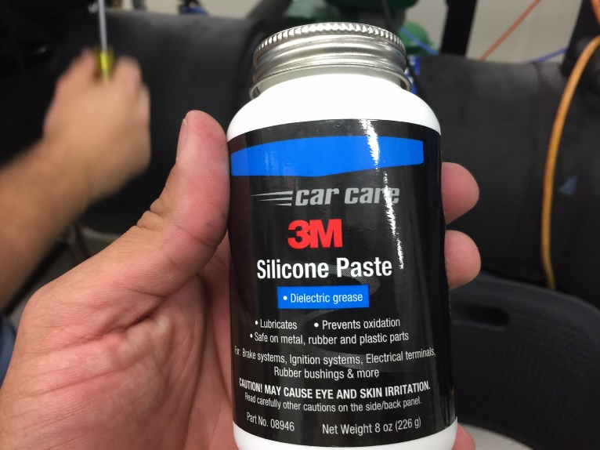

Figure 14 Silicone paste used to provide good contact between the pipe and the transducers.

### Transducer Spacing

Transducer spacing on the piping system depends solely on the input pipe dimensions. Once the parameters are input, the system will specify the distance apart the transducers should be. This distance is measured between the front faces of the transducers. It should be noted that if the transducers are not within ±3 inches of the specified measurement the flow meter will not display a reading. While calibrating the sensor, the transducer distance was varied slightly and revealed a 2% error in the mass flow rate per half inch of distance error between the transducers. A caliper should be used to measure this distance.

### Transducer Wiring

Once the transducers are mounted on the pipe, it is necessary to wire them into the TDS-100 board. The orientation of the transducers upstream or downstream in the flow determines which port to wire them into. The power supply 120V cord must also be wired into the board. The figure below shows how the three cords were connected.

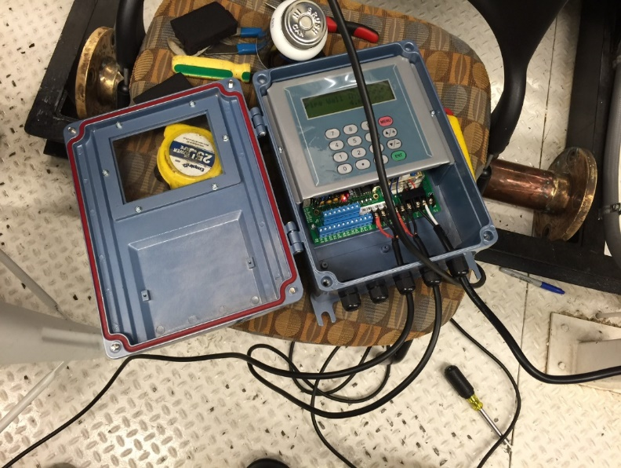

Figure 15 Wired Sensor Module

### Pipe Specifications

After the board is powered and the transducers are mocked up to the pipe, it is necessary to input certain parameters about the system. Material of the pipe, inner and outer diameter of the pipe, and liquid in the pipe. It is imperative that the pipe parameters be accurate and be input correctly. If the pipe has an interior liner, the sensor takes this into account and this parameter must also be input. Erroneous pipe dimensions will have a drastic effect on the flow that the sensor is reading.

### Transducer Mounting

It is necessary to mount the transducers on a section of pipe that is straight and free of sharp bends or valves within 5 diameters upstream or 10 diameters downstream. These obstructions cause turbulence in the flow and will give inaccurate readings. It should be noted that the pipe orientation is negligible. The figure below shows a team member mounting the transducers on a stainless steel pipe at a 45 degree angle.

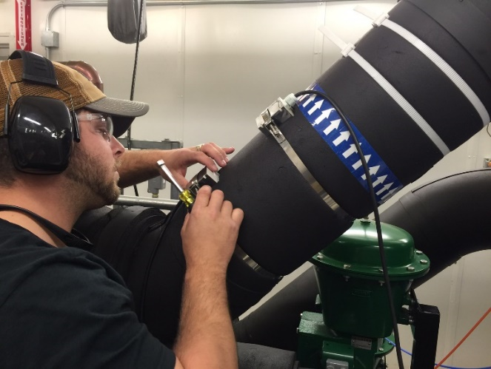

Figure 16 Transducer mounting

### Set Sensor Zero

Although not necessary, zero the sensor in place when the system is off and no mass flow is detected. This is step can (in some cases) improve sensor accuracy for the particular application.

# Regular Maintenance

## Minor maintenance

Once the transducers are in place the system requires little to no maintenance throughout the life of the system. If vibrations in the piping system are evident the sensor spacing should be checked on a yearly basis, and tightened accordingly. This could cause error in the mass flow rate readings. The gasket that seals the TSD-100 board should be checked every 5 years and replaced if it becomes non-resilient. This ensures no debris get inside the system.

## Spare Parts

With the rugged design of both the mass flow sensor and the bracket system, the sensor package will rarely need to have parts replaced. As outlined in the maintenance section, a spare housing gasket should be kept to be replaced every 5 years per the maintenance schedule. Dielectric grease should be kept in stock as well. If the sensors have to be adjusted, the previous residue should be cleaned off and a fresh coat re-applied to the bottom surface of the transducers before mounting them back to the pipe surface.

# Results

All results were calculated using Microsoft Excel. The NI myRIO was used to first find the correlation between the current output and the mass flow rate that the ultrasonic flow meter is reading. Then with this calibration curve the voltages recorded over multiple test were converted into refrigerant mass flow rates. After converting these voltages into mass flow rates the data was able to be trended and monitored as intended by Turbocor. The calibration curve for the TDS 100m ultrasonic mass flow sensor is shown in figure #. As expected the correlation is a simple straight line meaning the current linearly changes with the mass flow through the pipe which is also depicted in the equation provided.

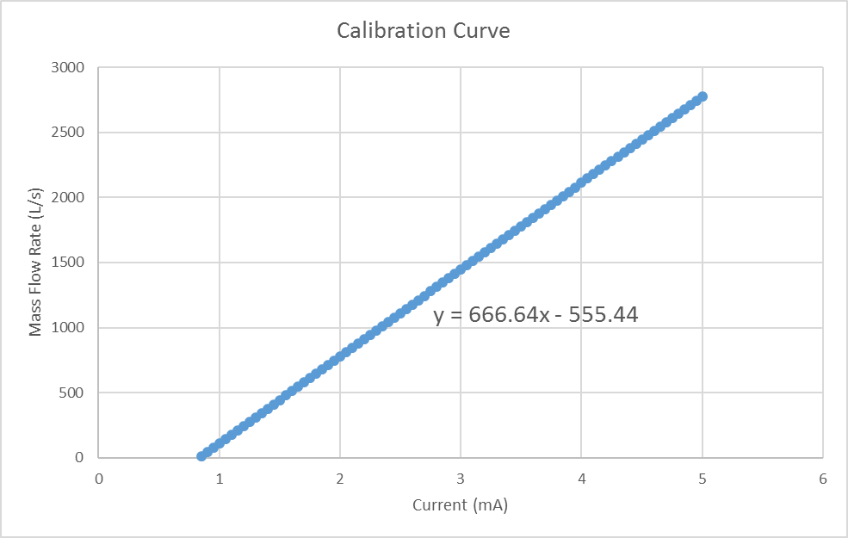

Figure 17 This is the calibration curve for the TDS 100m mass flow sensor that correlates current output to mass flow rate in L/s.

Figure # shows the mass flow rate of the water that was picked up from our mass flow sensor against the mass flow rate that Turbocor read during the same test. From this data trend it can be seen that the mass flow rate is not as accurate as expected but is offset by approximately 5 percent across the entire range. Even with this inaccuracy, since the difference is steady, a simple factor can be used to obtain the correct flow rate. The cause of this discrepancy may be due to multiple factors including incorrect thickness of the pipe, incorrect spacing of the ultrasonic sensors, as well as less than ideal contact with the pipe.

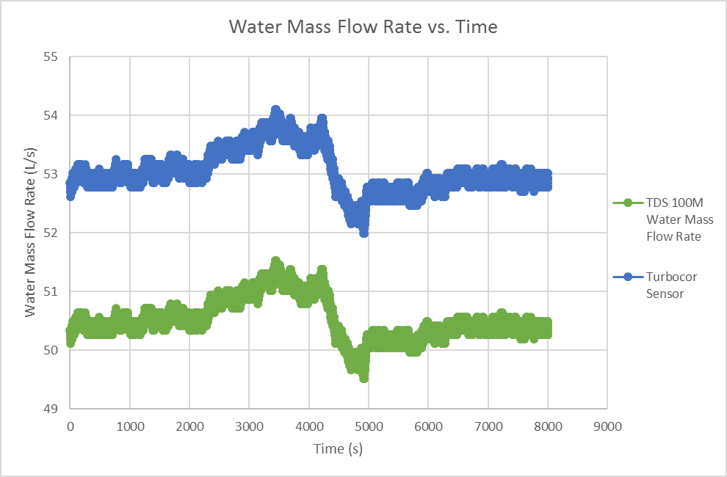

Figure 18 This plot shows the steady difference in water flow rates between out sensor and Turbocor’s sensor

Figure # shows the plot of the refrigerant mass flow rate during one of the test that was run at Turbocor. The spikes in the plot can be attributed to Turbocors test facility manipulating the mass flow rate which affects all of the data similarly. Using this mass flow rate as well as the temperatures and pressures measured by Turbocors built in sensors we were able to trend all of the data needed including the cooling capacity/load, the system coefficient of performance, as well as both the compressor efficiency and aero efficiency as desired by Turbocor.

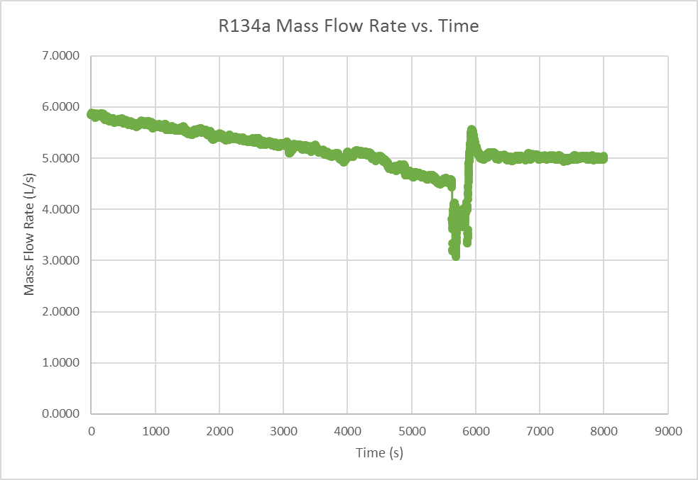

Figure 19 R134a refrigerant mass flow rate trended over time

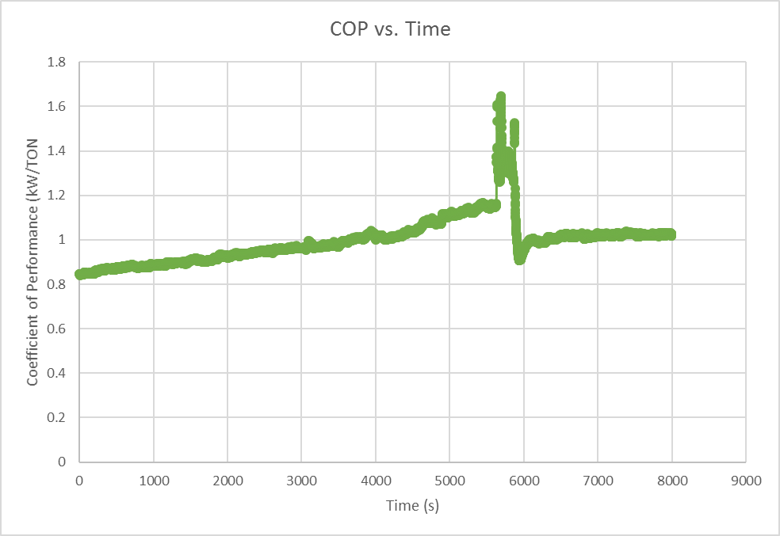

Figure 20 This plot shows the coefficient of performance of the evaporator over the test run indicating that as the mass flow rate of the refrigerant decreased the performance of the heat exchanger increased.

The coefficient of performance shown in figure # shows that the evaporator does not exchange heat as efficiently as desired but is to be expected from any heat exchanger. The spike in the plot is again due to the changing of the mass flow rate of the refrigerant.

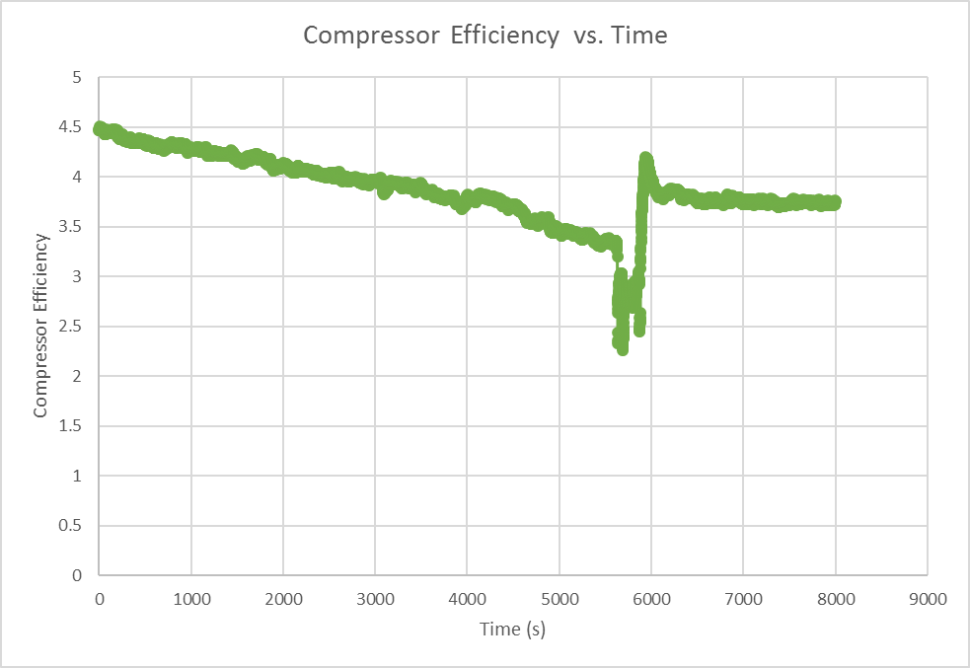

Figure 21 This plot shows that the compressors efficiency decreased as the refrigerant mass flow rate was decreased.

As this test was being run the refrigerant mass flow rate was dropped from roughly 6 L/s to 3 L/s. From figure # the compressor efficiency shows that as the refrigerant flow rate is dropped the efficiency of the compressor also drops meaning the compressor functions at a much better efficiency at high rpms.

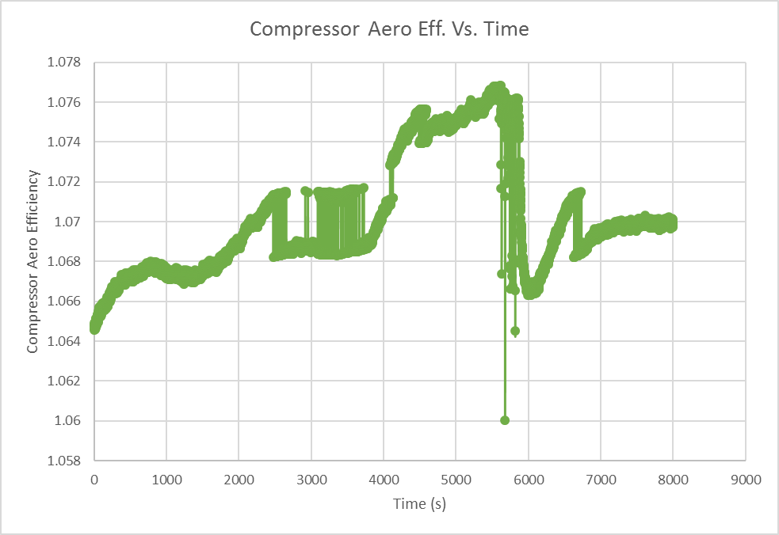

Figure 22 This plot gives a look at how close the compressor is to moving the refrigerant isentropically.

Finally, the compressor Aero efficiency was trended over the same test shown in figure #. This is a plot of how well the compressor is moving the refrigerant from suction to discharge as compared to the isentropic ideal case. The goal for the compressor here is to be as close to unity as possible. The dramatic spikes here can be due to the frequency at which the data was taken, as well as the change in the refrigerant mass flow rate over time.

# Safety

While engaging in senior design projects all team members should be mindful of their surroundings and always take safety precautions when working with machinery. The team has developed a list of possible hazards that could be encountered while completing the project as well as precautions in case of such an event.

A mounting system for the interface of the mass flow sensor device is proposed as a part that must be made in the machine shop. When working with an end mill or cutting device safety glasses must be worn at all times. It is also necessary to remove all jewelry, wearing long pants and closed toe shoes. Possible dangers that could arise while end milling include workpiece dislodgement, bit binding, or possible cuts from metal chips being produced. A dislodged workpiece could be sent flying and could be a source of serious injury. Bit binding could possibly cause machine damage.

In future testing and configuration of the proposed mass flow system the team will be working at the Turbocor facility as well. It is necessary to follow all policies that Turbocor has in place as well as be familiar with the facility in case an accident arises. Turbocor requires long pants, safety glasses and safety toe shoes when entering their testing and manufacturing facility. Knowledge of where the nearest emergency exits and fire extinguishers are necessary as well.

The team has devised a list of steps necessary in the event an accident arises. First aid should be administered immediately in case of a minor cut or burn. In the case of fluid entering the eyes they should immediately be flushed with water. The team advisor Dr. Shih and the professor Dr. Gupta should then be notified of the event. The shop manager should then be notified as well as the head of the mechanical engineering department. In the case of a serious injury, emergency medical services should be contacted.

## Environmental Impact

Environmental impact for this particular project is limited to disposal of used components. Since the design is a self-contained sensor package, its application into existing system possess little significant environmental concern beyond that of the HVAC system to which it is connected to. However, as with any electronic component, disposal of a unit that has failed or no longer functions is of concern. Electronics components can be recycled and reused in different applications. Recycling of electronics will reduce impact on the environment.

The components in this design are expected to have a high longevity. Since we expect each sensor package to last no less than 10-15 years, the impact on the environment will be minimal at best. With proper disposal and recycling of failed parts, this impact will be further reduced.

## Ethics

As engineering students, the team must abide by a high ethical standard during our project. To maintain a high level of integrity and honesty, the team has been following the standards set forth by the National Society of Professional Engineers. We will continue to follow the Code of Ethics through the remainder of our project. In addition, the team will also abide by the Code of Conduct set forth at the beginning of the semester.

# Schedule

Once the scope of the project was defined, the necessary tasks to achieve completion were determined. The scheduling of the project was tracked through the use of a Gantt chart. The various phases were defined and ordered based upon reliance on completion of previous tasks. The two semesters were broken into larger project stages, planning and research during the Fall then construction, prototyping and implementation during the Spring. Certain tasks were ongoing, such as continued refining of the thermodynamic model and analysis of data.

Overall the project followed the Gantt chart very closely. Each task was completed close to the desired deadlines. Time was scheduled for project overflow and has been used to refine our documentation and coordinate future uses of the sensor package with Danfoss.

# Resources

## Turbocor Facility

During the initial stages of the design project, discussions between Turbocor staff and the team revealed that we would be spending much time at the facility for testing. Turbocor advisors decided to provide the team members with full access to their facility.

In order to receive access, the team was required to sign Non-Disclosure Agreements and provide personal information, so that we could receive access cards.

The access cards afforded the team the freedom to move about the facility without restriction so that we could have access to any resource needed to complete our project. This was of great benefit, specifically during testing when the team was in and out of the facility several times.

## FAMU FSU College of Engineering Machine Shop

At the college of engineering, the team has access to several machine shops. Although our particular project did not require much in terms of machining, they were very useful when developing our mounting system.

In order to keep machine shop time to a minimum, our design was kept very simple. To aid in simplifying the design, the team consulted Mr. Larson. He was also able to perform some of the simple milling procedures needed for our mounting system at his shop. The benefit to this was the fact that we had minimal need of the larger and better equipped machine shop being used by the majority of the senior design teams. The only need we had was of their water jetting machine.

# Procurement

## Budget & Allocation

During the project scope development stage, the team was not provided with a hard number budget. This was primarily due to not having a specific project definition or goal in mind.

As the scope and goal of the project were developed, the team was given a budget of $1000.00 to complete the project. Initial assessment of the funds allotted seemed to be insufficient for our project. Reasoning behind this lies with the fact that the ultrasonic sensors that would perform within our specifications are routinely in the range of $2000 - $10000.

Extensive research and downright resourcefulness by a team member did however result in the sourcing of an ultrasonic mass flow sensor that would work for our application for a total cost of $620.89.



Figure 23 Pie chart of the Budget allocation

Although the sensor consumed about 62% of our total budget, the team was still successful in completing the project under budget. Observing figure 23, we can see the how the remaining funds were used.

## Materials

The materials used in our design were very limited. The mounting system was constructed from scrap aluminum provided to us by Turbocor. Some of the hardware used was provided by Turbocor while the rest was sourced at local hardware retail stores.

Materials included 6 nuts and bolts, quick connect with included hardware, ¾ in

# Communications

Overall, the team did not experience many issues with communications. During the initial stages of the project, the team met to determine what the best way of communication between team members and sponsors would be. Communications was an area in which we did not experience any difficulty.

## Team Communications

Communication between team members was done primarily via text message. The team leader opened a group text where all information that pertained to the project was discussed. This medium was used as a team announcement board as well. Our code of conduct specified that team text messages were to be replied to in a timely manner. Individual team members were contacted by text message directly when work was being delegated.

For sharing of important documents, each team member was required to make a Dropbox account. The Dropbox accounts allow all team documentation to be saved using a cloud based system, making any document available to all team members at any time. This type of document sharing was used as opposed to a medium such as Google Docs because it allows the user to use all of the features available on Microsoft Office programs. This made the editing of details in our documents significantly more user friendly and simple.

## Sponsor Communications

Communication with Turbocor sponsors was carried out primarily through email. Conveying major announcements pertaining to required data and scheduling was the responsibility of the team leader. When corresponding with Turbocor, all of our advisors and team members are provided carbon copies (or CC’d) in the emails. This ensures that all team members and advisors are kept up to date on any changes throughout the course of the project.

As a secondary method of contact, Turbocor advisors provided team members with cell phone and office contact numbers so that we could contact them with any last minute requests and information updates. Communication via phone was used sparingly and only when immediate responses were necessary.

Another method that team members kept in contact with sponsors from Turbocor, was the use of a prescheduled weekly meeting at their facility. Each week on Tuesdays at 2pm, the team met with all available Turbocor advisors to discuss project issues and progress.

## Faculty Communications

Communication with our faculty advisors and class professor was primarily through email and Blackboard announcements. When possible, faculty and TA’s were visited in person during pre-determined office hours.

Scheduled bi weekly meetings were held with faculty members as a way of keeping them up to date on progress and receiving advisement and suggestions on solving problems or on how to proceed with our design project.

# Conclusion

Turbocor seeks a real time efficiency readout to monitor equipment health in the first step to determining future failure modes analysis software. Team 5 has proposed, designed and implemented a non-intrusive mass flow clamp on device coupled with sensors in pre-existing ports to accomplish this task. Thermodynamic laws and algorithms wrote in pseudocode for integration, transform this data into a usable form for Turbocor that will add value to their product as well as their customer. This system is ready for integration into the compressor’s board and is essentially plug and play at any application site. Future plans for Turbocor is to implement this in all chiller systems outfitted with their compressor to prevent catastrophic failures and capital loss. Turbocor engineers are pleased with the team’s performance and the product that was delivered.

# References

|  |  |
| --- | --- |
| [1] | "Power Generation," [Online]. Available: https://powergen.gepower.com/service-optimize/services/gas-turbines/software-analytics/monitoring-and-diagnostics.html. [Accessed 24 9 2015]. |
| [2] | Danfoss. [Online]. Available: http://industrialrefrigeration.danfoss.com/assets/0/114/137/138/17179871081/17179873132/42913673-264d-4750-8c9b-484debe90f4f.jpg?n=1124. [Accessed 24 9 2015]. |
| [3] | C. G. Lomas, Fundamentals of Hot Wire Anemometry, Cambridgeshire: Cambridge University Press, 1985. |