Project Scope and Plan

Mass Flow Sensor Integration

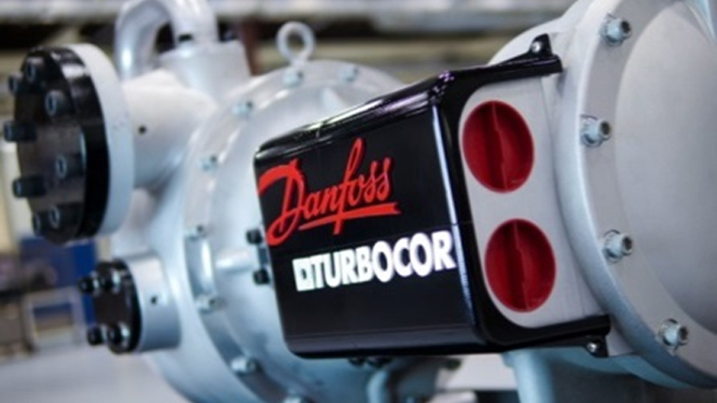

Team Number: 5

Submission Date: Friday, January 15

Submitted To: Dr. Gupta

Team Members: Luis Mendez (lm13r@my.fsu.edu), Beau Rodgers (ber13@my.fsu.edu), Keenan Cheeks (kmc11j@my.fsu.edu), Brian Roberts (bpr13b@my.fsu.edu).

Faculty Advisor: Dr. Chiang Shih

Table of Contents

**Table of Figures……………………………………………………………………………....….iii**

Acknowledgements iv

Abstract v

1 Introduction 6

2 Problem Statement and Project Scope 7

2.1 Project Purpose 7

2.2 Key Technical Questions 7

2.3 Goal 8

3 Project Plan and Schedule 9

3.1 Update on Recent and Future Project Plans 9

3.2 Schedule 9

Conclusion 11

**Table of Figures**

Figure 1 10

# **Acknowledgements**

We would like to acknowledge and thank Dr. Gupta, Dr. Shih and the many engineers at Turbocor thus far for helping to define the scope of this design project. We are grateful for Turbocor engineers that have taken time away from their projects in order to guide this design team in a productive direction and for the opportunity provided to us through both or faculty advisor and the Danfoss Turbocor company. Furthermore, we are extremely excited and thankful for Turbocor’s willingness to grant the entire design team access to their on-site testing facilities and resources.

# **Abstract**

Senior design Team 5 has been given the task of working with Turbocor on developing new systems that will assist the teams learning process and use general and specific concepts that the students will have learned in their coursework. The team’s initial meeting with Turbocor dictated that the team was to work on a data analysis in order to predict failure modes of the Turbocor compressors. Bi-weekly meetings are held in which the team and their advisor, Dr. Shih, and their instructor, Dr. Gupta, discuss the merits and progress of the project. The first bi-weekly meeting proposed a testing platform to be developed instead of the data analysis. This proposal was brought to Turbocor by the team and was deemed unnecessary. The team and Turbocor discussed possible project scopes ultimately leading to our current work. The team is to design and integrate a system for determining real time efficiency of the compressor in application as a stepping stone to reach Turbocor’s initial goal of predicting failure modes. The system to be integrated will consist of temperature sensors through the condenser units of existing HVAC systems and an external mass flow meter to determine the mass flow of water through the condenser unit. The integration of this system will require several steps to calculate the temperature differential from existing sensors and use collected mass flow data to determine efficiency. Once real-time efficiency can be determined accurately, the team can then use this information in conjunction with operating data to help predict failure modes for their compressors. This design was proposed to be integrated to the Variable Twin Turbo Compressor (VTT) as it is the newer system being developed by Turbocor and as such the programing in the platform is still under development.

# Introduction

Turbocor is a Tallahassee, FL based company that designs, develops, and manufactures high efficiency compressors to be used in HVAC chiller systems using innovative proprietary “mag-lev” technology. The company started in Australia in 1993 then moving to Montreal Canada in 1999. Turbocor brought their high efficiency compressors to market in 2002. Eventually being acquired by their now parent company, Danfoss in 2006, they moved to the purpose built facility in Tallahassee to cope with growing demand for their product.

Although the Turbocor compressors are known to be very reliable, to provide long-term customer satisfaction Turbocor hopes to develop methods of failure modes predictions. As emerging technologies from other companies become more and more competitive, Turbocor is turning its attention to the end users satisfaction to create a strong and loyal customer base. Turbocor is already competitive in customer service through their proactive efforts in assuring the highest manufacturing quality. However, the company desires to add another level of service through remote monitoring and diagnostics of their compressors as a means by which to increase product uniqueness and value. Many companies like General Electric and Siemens have already taken this step and integrated the necessary mechanical components into their turbines. Thus, to provide stepping stones toward achieving this end goal, our team is to use temperature sensors and a mass flow sensor to determine real time efficiency of the compressors under load.

# Problem Statement and Project Scope

## Project Purpose

Danfoss’ Turbocor compressors are premium products in their market. As such, it is important for them to maintain a high level of customer satisfaction. Developing technologies within their market are becoming more competitive. Due to this developing increase in competition, Danfoss wishes to add value to their Turbocor product for existing and future customers through the incorporation of a method for product failure prediction.

Currently, Turbocor compressors are only serviced post failure. Downtime is a major concern in situations where a compressor has failed. This downtime can be directly correlated to capital loss and customer dissatisfaction. For example, data centers rely heavily on their cooling systems. A compressor being down for merely a day can cause major issues to the extent of revenue loss and possible loss of assets. Another example would be a major hospital cooling system. A catastrophic failure of the compressor could potentially cause bodily harm to patients.

By designing a method to collecting real-time efficiency of the compressors, Danfoss can monitor their system and make correlations between failure data and efficiency data to develop a method of failure prediction. By being able to predict failures, downtime of a major HVAC can be scheduled and the consumer and Danfoss can plan accordingly in order to maintain the consumer’s satisfaction.

## Key Technical Questions

Key technical information is required in order to proceed with this design project. The following questions are set forth in order to assist the team in determining parameters and concepts needed to move forward:

* What concepts are necessary to aid in the determination of Efficiency?
* Based on the concepts necessary, what empirical data can the group collect from existing systems, and what other information needs to be collected?
* After the determination of missing parameters, how will these values be collected?
* Once collected, how will the signal be transmitted in a format the team can use?
* Most importantly, how will all the collected data and signals be integrated into the system, and how is this helpful in prediction of failure modes?

## Goal

The design team is currently working on the collection of data that will be relevant to the determination of the efficiency of the compressor. The ultimate goal of this project is the integration of our data collection into the exiting program platform of Danfoss’ Turbocor compressor to determine real-real time efficiency in an effort to help in the prediction of compressor failure.

Real time efficiency is a vital step towards the future goal of failure modes prediction. By monitoring efficiency real time and comparing its data with failure data history, the performance of the compressors can be monitored and analyzed to help determine failure modes.

# Project Plan and Schedule

## Update on Recent and Future Project Plans

Over the Christmas Break the TDS-100 Ultrasonic Flow meter was delivered to the Danfoss facility for pickup by the design team. The team has since familiarized itself with the apparatus and has scheduled time in the test facility for initial setup and calibration of the Flow meter and Sensors. This will provide actual data to test algorithms derived to calculate real time efficiency of the compressor. The team has also borrowed the MyRio interface to couple with the mass flow sensor to output the data into an excel file. This will be essential for data analysis.

## Schedule

The team has updated their schedule with the projected goals for this second semester of the Senior Design project. The main tasks left to complete involve learning to use the sensors obtained and integrating them into the system. The necessary tasks have been divided into 5 main stages: planning, initial setup, physical construction, data collection and processing, and integration.

Our planning phase consisted of coordinating spring schedules to ensure adequate time is dedicated to the project. The initial setup phase involves becoming familiar with the system and acquiring any remaining materials. During the physical construction phase the mounting system will be designed and fabricated. The data collection and processing time will be spent collecting data on the test rig and determining any necessary signal processing. This phase will also include refinement of the derived algorithms for determining efficiency. The fifth phase is for integration into the Danfoss’ Turbocor compressors. At this point we will transmit our calibrated signals to the main control board of the system and coordinate the inclusion of our formulas into their firmware. The system then should be able to calculate and display efficiency in real time.

The plan we have chosen also includes extra time at the end of the semester for unforeseen setbacks. If the project proceeds according to our time line, then this time can be spent adding more features or creating thorough documentation for the added flow meter subsystem.

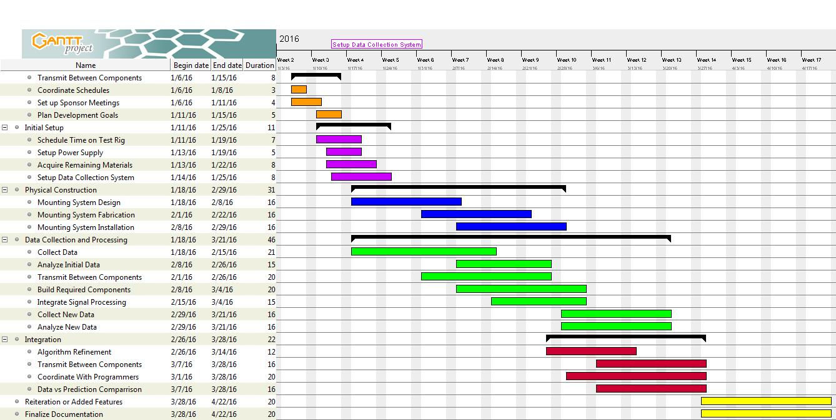

Figure

# Conclusion

Turbocor seeks a real time efficiency readout to monitor equipment health in the first step to determining future failure modes. Team 5 has proposed a plan to incorporate a non-intrusive mass flow clamp on device coupled with sensors in pre-existing ports to accomplish this task. Thermodynamic laws and algorithms will transform this data into a usable form for Turbocor that will add value to their product as well as their customer. The team seeks to test and calibrate the acquired equipment in order to proceed to the integrate the system into the Turbocor compressors firmware. Effectively executing project plans are of importance but safety of all team members are held to the highest regard.