Alexander M. McKinlay;First M. Last

FAMU-FSU College of Engineering  2525 Pottsdamer St. Tallahassee, FL. 32310

Team 08: SAE Formula Hybrid

10/6/2017



# Abstract

Recently the world has moved towards using electric energy instead of fuel to power cars. It is the responsibility of future engineers to continue this trend and make electric cars as efficient as possible. Our senior design project involves adapting electric energy technology into a formula hybrid car and taking it to race in a competition. A formula hybrid car is a type of race car that has an open cockpit and uses batteries and motors along with a standard engine. The race is held by the Society of Automotive Engineers and it allows students from different engineering disciplines to work together for the first time as a team.

Our team is the start of a five-year project which involves building a hybrid car that can race in the competition in the year 2023. We are the first year of senior design teams at Florida State University working on this project. We aim to design the most efficient hybrid car possible while making our work easy to understand for future teams. As a first year team our main goals include finishing the designs of the architecture, the hybrid drivetrain, and suspension of the car. We also plan on having a physical demonstration to show for our work.

So far our team has almost finished each of the designs for the car. We are now focusing on building a model for demonstration. By the end of this year we plan to have a quarter car model setup. The setup includes combining the chosen motor and batteries with a model of the suspension and steering. We also intend to test the motor using the batteries that were chosen for the design.

*Keywords*: list 3 to 5 keywords that describe your project.

# Disclaimer

(Not yet created/discussed)

# Acknowledgement

(Not yet created)

Table of Contents

Abstract ii

Disclaimer iii

Acknowledgement iv

List of Tables viii

List of Figures ix

Notation x

Chapter One: Conceptual Design 10

1.1 Project Scope 10

Project Description. 10

Key Goals. 10

Markets. 10

Assumptions. 2

Stake Holders. 2

1.2 Customer Needs 2

Sponsor Statements 2

Formula Hybrid SAE Rulebook 4

1.3 Functional Decomposition 5

1.4 Target Summary 5

1.5 Concept Generation 6

Concept 1. 6

Concept 2. 6

Concept 3. 6

Concept 4. 6

Concept n+1. 6

1.6 Concept Selection 6

1.8 Spring Project Plan 6

Chapter Two: EML 4552C 7

2.1 Spring Plan 7

Project Plan. 7

Build Plan. 7

Appendices 8

Appendix A: Code of Conduct 10

Appendix B: Functional Decomposition 11

Appendix C: Target Catalog 12

Appendix A: APA Headings (delete) 12

Heading 1 is Centered, Boldface, Uppercase and Lowercase Heading 12

Heading 2 is Flush Left, Boldface, Uppercase and Lowercase Heading 12

Heading 3 is indented, boldface lowercase paragraph heading ending with a period. 12

Appendix B Figures and Tables (delete) 13

Flush Left, Boldface, Uppercase and Lowercase 14

References 15

# List of Tables

Table 1: Comparison of Statements Made by the Sponsor 4

Table 2: Functional Decomposition 6

Table 3: Concept Generation 12

Table 4: The Word Table and the Table Number are Normal Font and Flush Left. The Caption is Flush Left, Italicized, Uppercase and Lowercase 47

# List of Figures

Figure 1: Series All Wheel Drive Hub Motor 32

Figure 2: Series Single Rear Motor (RWD) 33

Figure 3: Series Dual Rear Motor (RWD), Batteries Underneath Driver 34

Figure 4: Series Dual Rear Motor (RWD), Batteries at Drivers Side 35

Figure 5: Through the Road Front Motor, Rear Engine 36

Figure 6: Example of Motor Power/Torque Curve Provided by Manufacturer. 39

Figure 7. Flush left, normal font settings, sentence case, and ends with a period. 46

# Notation

(Not yet defined)

# Chapter One: Conceptual Design

## Project Scope

### Project Description.

The senior design SAE Formula Hybrid competition is a five year multidisciplinary project which requires senior design teams to observe SAE trends, establish a vehicle architecture that will be viable by the year 2023, and build scalable systems for demonstration. This project will involve using a systematic design approach to define vehicle functions and achieve competition targets. The 2017-2018 senior design team will be compartmentalized to design and model a quarter car setup.

### Key Goals.

The primary goal for this project is to define and implement a vehicle architecture that will compete in an SAE Collegiate Design competition in 2023. The 2017-2018 senior design team will focus on designing, integrating, manufacturing, and demonstrating a scalable quarter car setup by engineering design day (April 10th, 2018). The quarter car model should include one motor with enough batteries to sufficiently power it, a plan for the control system, and a suspension. The suspension can be modeled using non-load bearing materials but should be designed to withstand real load bearing situations. The overall vehicle architecture and a transition plan also need to be designed and optimized based on the components chosen for the vehicle. Simultaneously, knowledge transfer will be practiced for the long-term and short-term goals of the project which should effectively result in a reproducible design and design process.

### Markets.

#### Primary Market

The vehicle will be produced for the 2023 Formula Hybrid SAE Competition.

#### Secondary Market

The results of the project will contribute to the innovation and application of current hybrid vehicle technologies.

### Assumptions.

Chassis schematics will be sent to a company for professional manufacture. The engine and motors will be chosen as complete units and the rest of the drivetrain will be designed in-house. The manufacturing of the steering and suspension components will be done in-house. All funds will be supplied by the team sponsors and purchases will be executed through the FAMU-FSU College of Engineering.

### Stake Holders.

Parties that hold interest in the project include General Motors, FAMU-FSU College of Engineering, and SAE International.

## Customer Needs

### Sponsor Statements

To better understand the requirements of the project, information was gathered from the sponsor regarding the specificities of the product. This information was then interpreted into a list of needs that the product must satisfy. The sponsor statements and their interpreted needs are listed in table 1.

The sponsor first stated that they want a formula hybrid SAE vehicle. To identify what is meant by this, the basic function of a vehicle must be considered. At the most fundamental level, a vehicle must be able to move; and what is necessary for movement is acceleration, deceleration, and the ability to negotiate turns. The sponsor also intends for the vehicle to eventually compete in the Formula Hybrid SAE competition. The actions that need to be taken to achieve this are that the vehicle must first get to the competition, and that it must submit and pass a technical inspection to ensure compliance with the rules and regulations of the competition.

It was then stated that a front engine, rear motor driven vehicle would be ideal. Why this would be ideal for the sponsor had to be analyzed to obtain the characteristics of the vehicle that are desired.The desire to locate the engine and motor at opposite ends of the vehicle was determined, in part, to be due to the need for even weight distribution. This setup also allows the vehicle to be all wheel drive, and having the motor specifically in the rear provides the rear wheels with the most torque. Another aspect of this setup is that it simplifies the control system between the engine and motor since the wheels they drive are independent of one another.

It was made clear by the sponsor that winning is not of the utmost importance. To interpret this as a need, the definition of success at the competition had to be defined. The competition is made up of different events, and if being the top team for each event is not what is desired, then completing each event would be the next marker of success. While winning is not a priority, maximizing event scores are still important. Considering only the events that involve the physical performance of the vehicle, meaning the dynamic events, the minimization of weight is the biggest factor in the overall performance of the vehicle (i.e. handling, acceleration). Thus, if the sponsor desires to maximize the scores received in these events, the primary need is to minimize the weight.

Table 1: Comparison of Statements Made by the Sponsor

|  |  |
| --- | --- |
| **Sponsor Statement** | **Interpreted Need(s)** |
| It should have the basic functions of a vehicle. | The vehicle accelerates, decelerates, and navigates corners. |
| Compete in the Formula Hybrid SAE competition. | The vehicle gets to the competition and passes tech inspection. |
| Why not have a front mounted engine and rear mounted motor? | The vehicle has a 50/50 weight distribution. |
| The vehicle is all wheel drive. |
| Most of the output torque is applied to the rear wheels. |
| The ICE and motor work together with a simplified control strategy. |
| Winning is not the goal. | The vehicle completes all competition events. |
| The dynamic event scores should be maximized. | Minimize weight. |
| The vehicle should be able to exceed 60 mph. | The vehicle has sufficient power to reach at least 60 mph. |

The only other statement made by the sponsor regarding how the vehicle should perform is that it should be able to exceed 60 mph. This constraint was looked at as requiring a performance metric. In its most basic form, this metric is that the vehicle has enough power to reach this speed, however much that may be.

### Formula Hybrid SAE Rulebook

In addition to the needs as determined by sponsor statements, the necessity to satisfy the rules of the competition create more needs for the vehicle. Because the rules lay out design requirements in such a technical manner, no analysis or interpretation is necessary.

SAE International lays out requirements for the vehicle to compete which guides the design of an open-wheeled and open-cockpit vehicle (SAE, 2017, T2.1). The suspension is bounded by how small geometric constraints can be (SAE, 2017, T2.3-2.4 & T6) while braking is limited in location and implementation (SAE, 2017, T7). The visibility from the driver’s perspective and their ability to quickly egress is crucial when designing the passenger compartment (SAE, 2017, T4.1-4.2 & T4.7-4.8)**.** The chassis’ structure is strictly limited to ensure a consistent passenger compartment between competing vehicles (SAE, 2017, T3). Safety is regulated with rules defining required safety features and their implementation (SAE, 2017, T5.1-5.8 & T14-15).  Safety is additionally stressed with emphasis on passenger isolation from heat, electrical components, foreign objects, and specifically defined components (SAE, 2017, T4.3-4.6 & T8.4 & T10). Body and aerodynamics are limited by their mounting and activation (SAE, 2017, T3.22-3.23 & T9.1). Internal combustion engine systems and components are limited in specifications and implementation (SAE, 2017, IC1-3)**.** Finally, electric power storage is strictly regulated and closely monitored during the event with specific testing and handling methods required (SAE, 2017, EV1-12)**.**

## 1.3 Functional Decomposition

Table 2: Functional Decomposition

|  |  |  |  |
| --- | --- | --- | --- |
| **System** | **Subsystem** | **Subsystem** | **Function** |
| Vehicle | Body | Aero | Regulates air flow |
| Stabilizes the body |
| Safety | Regulates separation from environment |
| Chassis | Frame | Secures and positions vehicle components |
| Suspension | Transfers weight through the frame |
| Guides vehicle motion |
| Stabilizes the vehicle relative to the ground |
| Drivetrain | Motor | Transfers electric potential energy to rotational kinetic energy |
| Engine | Transfers chemical potential energy to kinetic energy |
| Transmission | Translates power to the ground |
| Energy Storage | Regulates electric power storage |
| Regulates chemical fuel storage |

## 1.4 Target Summary

The targets for the car were selected starting with the basic geometry of the suspension and the driver’s location.

### Suspension Target Summary

The wheelbase is based around the smallest allowed wheelbase, according to SAE Formula Hybrid standards, to optimize a low speed track that contains corners that Formula SAE competitions mostly commonly have. To find a track width for the front and rear benchmarking was done for the top placing teams with the focus of having a large front wheelbase to help with the turn-in behavior of the car. This led to a front and rear trackwidth of around 80% of the wheelbase (~48.75 inches) for the front and 75% (~46.5 inches) for the rear. The ride height of the car will need to keep a balance of preventing the car from contacting the ground under all circumstances in the race and keeping it as low as possible. After researching the location of the track and the likely large overhang accompanying the large short wheelbase, a ride height of 2 to 3 inches was found to be sufficient. Tires can be compared with the pros and cons of different sizes, tire data, and size of the rims needed. One of the options was a small and lightweight tire and rim package of around 19 inch/10 inch tire and wheel diameters respectively, however this general size limits possible geometries and often suffers from poor wheel stiffness and exaggerated tire deformation with sidewall flex as it is generally the highest of the possible tire/rim options. Many teams experience catastrophic wheel deflection due to limited options and relatively low stiffness compared to larger options. Alternatively, a larger slightly heavier tire/rim combination at around 21 inches/13 inches for the tire and wheel diameters respectively can help solve some of the problems with a smaller option at the cost of increased weight and diameter. An increase in weight here is particularly poor for performance as the wheels rotate increasing the rotational inertia of the wheel assembly to the squared power with an increase in radius. Additionally the added weight is unsprung mass of the suspension suffering from a similar increase in inertia causing poor handling characteristics. With more room for adjustment within the wheel however this option can help to ensure the least restrictions on geometry to allow for a dialed in and cohesive suspension package. Additionally these sizes have more options in both tire and rim selection, more easily attainable tire data, less sidewall flex, and stiffer rim options. This lead us to develop an overall target utilizing the larger tire/wheel combination at around 21 inches with a mid-sized tire width of about 7-8 inches to accommodate common tire choices and to not limit the geometry’s possibilities.

The final targets for the geometry were based around the car’s behavior to ensure the best possible contact patch throughout the race. The tires available are well documented by teams as having large amounts of sidewall flex, leading to lost camber with roll and large loading conditions. Our target here is to account for this lost camber due to rolling with at least 1:1+ degree camber angle gain over change in roll angle. Finally, low roll centers close to the ground, high enough to remain positive under all squat conditions and symmetric front and rear are going to be designed with a focus on minimizing change in roll center over suspension travel and controlling roll all together with the addition of anti-roll features such as anti-roll bars.

### Chassis Target Summary

The targets for the chassis are centered on weight distribution and maximizing the effectiveness of the suspension. A 50:50 distribution was set as our target to ensure a predictable and well handling car for the tight corners of an autocross track. Additionally, a low center of gravity of about 8 inches at the most is our goal to help ensure the best cornering characteristics. Additionally, to pass technical inspection the car must not tip over at 60 degrees on inclination which simulates around 1.7G and a simple calculation was made considering desired suspension targets to check the location of the center of gravity from the instant center to ensure the car will not tip over.

The original target was a of 50:50 weight distribution for a target weight of 450lb or less, as selected through benchmarking the top placing teams. The location and packaging of the components in respect to the driver plays the largest role and starts with picking the location of the driver and how the components then relate around them. Formula SAE, however, has unique regulations on the frame and driver locations and hardpoints meaning both were considered when finding targets for the driver location. The hip location was found with the hardpoint H30 relating the hip height from the vehicle floor. With the hip length from the vehicle's front axle L114 being selected next. The H30 was selected to be as low as possible in the car without the seat dipping below the bottom of the frame as restricted by the rules. The secondary goal was then to have the car rotate around the driver’s hip and to minimize the distance from the hip to the center of the wheelbase by adjusting the L114. The addition of the steering wheel location L10 and various angles of the driver’s body L42, L44, and L34 help to drive the overall position of the driver with the target of keeping them as low as possible with their center of mass as close as possible to the center of the wheelbase to maximize the 50:50 distribution. Lastly these target criteria are aimed to work with the smallest and largest driver on the team making sure to pass all rules appointed by SAE and focusing on an ideal position for the smallest driver.

With the driver position selected, the rest of the components from the tractive system and engine/drivetrain can be added to a CAD model or free body diagram and a center of gravity can be calculated for the different locations to find the overall car’s center of gravity to dial in the target 50:50 distribution for the smallest driver.

### Tractive Target Summary

The basis of the tractive system revolves around the selection of the motor, accumulator, ideal power/weight ratio, and the required energy to complete the endurance race. The combination of these components to achieve a high enough capacity to successfully endure a long continuous run time and to travel up to 44 kilometers is essential. Based on benchmarking winning teams in the past, the target lap time for our vehicle is set at approximately 85 seconds per kilometer with an average speed of 11.75 meters per second (about 25 mph).

The first component to be selected will be the motors, along with the setup in which they will be implemented. With a series drive type selected, the only method that allows for a reasonable power/weight ratio is that of a single or dual rear wheel Emrax brushless DC motor. There multiple options to choose from for this type of motor which are all based on low, medium, or high operating voltages. The target voltage which the motors are to be run at is 60 volts. This target depends mainly on the RPM range that the motor can be run with. It should also be noted that that maximum voltage that is allowed is 300 volts. It is crucial to minimize the voltage while keeping it high enough to draw substantial power. Some motors are not rated to run at certain voltages, because overcurrent protection may not be existent outside of a low, medium, or high voltage range. Motors that have lower voltages will increase the total weight of the tractive system because the required amperage that the motor pulls from the battery pack will increase, along with more cooling, thicker wires, and potentially thicker/heavier conduit. If the motors are to be run at a medium-high voltage, then the team is required to use the proper tools and work space to satisfy all the required safety regulations. Medium-high voltage does allow for a lighter battery module, smaller wires, less conduit and a decrease in cooling equipment which further optimizes the power/weight ratio. All of these factors will affect the power to weight ratio of the tractive system which is currently targeted at 0.125, while the target weight for the motor setup is dependent on the actual motor that is chosen. This target power to weight ratio leads to a power target of about 25-30 kilowatts. The chosen power to weight ratio target is based on using the smallest motor of the potential motor options available. The smallest motor was chosen based on being the only viable option to satisfy the total car weight target of 204 kilograms (450 lbs).

Once the motor(s) have been chosen, the accumulator is able to be designed. The development of the target catalog revealed that most energy storage technologies are adaptable to each of the motor types/configurations outlined.  The main attributes in question when choosing an accumulator includes reliability of the technology, weight, space that the required accumulator configuration will consume, and its ability to accommodate the energy requirements of the motor endurance. In order to provide enough energy to the motors the accumulator need to be large enough while still minimizing the weight, as they will take up the bulk of the weight of the entire tractive system. The target specific energy of the accumulator is about 875 kJ/kg which is based off the type of motor that was chosen. The target weight of the accumulator (not including its packaging) is approximately 46 kilograms (100 lbs) which is based on the number of cells needed to deliver the optimum amount of energy to the dual motor configuration. The target volume of the accumulator has not been chosen yet because it will be based off the final design and placement of the other major components. The accumulator packaging also needs to be taken into account. The target weight for the accumulator packaging is about 12 kilograms, setting the net weight goal for the accumulator at 58 kilograms (128 lbs).

### Drive Train Target Summary

The engine and gearbox were considered part of the drivetrain subsystem. There are 9 engine sizes, in cubic centimeters, that are considered and various engine/motor/battery combinations to optimize weight and power. The combinations are displayed in the target catalog (Appendix C). Engine sizes range from 125-525 cc and weigh between 10-20 kg. They can produce power anywhere from 50-150 kW. This, in conjunction with tractive systems, allows selection of optimal power to weight ratio.

## 1.5 Concept Generation

Table 3: Concept Generation

|  |  |
| --- | --- |
| System | Concept |
| 1A: Tractive - Motors | Concept 1: Hub Motors at Each Wheel  Concept 2: Single Rear Brushless DC Motor  Concept 3: Dual Rear Brushless DC Motors |
| 1B: Tractive – Energy Storage Systems | Concept 1: Lithium Iron Phosphate Battery Concept 2: Lithium Nickle Manganese Cobalt Oxide Batteries  Concept 3: Lithium Nickle Cobalt Aluminum Oxide Batteries |
| 2A: Engine | Concept 1: Small displacementConcept 2: Mid Displacement Concept 3: Large Displacement |
| 2B: Drivetrain | Concept 1: Hubcentric Gearing Concept 2: Output Gearing  Concept 3: Direct Drive |
| 3A: Suspension | Concept 1: Front and Rear Beam Type Suspension Concept 2: Front and Rear Double A-Arm |
| 3B: Architecture | Concept 1: Series All Wheel Hub Motor Concept 2: Series Single Rear Motor  Concept 3: Series Dual Rear Motor, Batteries Underneath  Concept 4: Series Dual Rear Motor, Batteries at Drivers Side  Concept 5: Through the Road Front Motor, Rear Engine |

### System 1A: Tractive - Motors.

Electrical machine that converts electrical energy into mechanical energy. Provide sufficient mechanical power based on total vehicle weight for propulsion of vehicle.

#### Concept 1: Hub motors at each Wheel

##### Overview

Electric motor that sits inside the hub of the wheel and drives the vehicle.  This motor type utilizes electromagnetic fields that are supplied to the stationary windings of the motor. This method of motor use has become standard in uses like bicycle hubs, however is far from mainstream in vehicular use. This system can be implemented into a design if it is an AWD system with the benefit of adding drive to any wheel desired.

##### Power-To-Weight

The ratio is low due to the limited space in the wheels, the size of the motor is reduced dramatically compared to the other concept options. The power output of each is low, and while redundancy plays a factor in increasing the overall power output value, the output may be too low for power needs due to wheel diameter constraints. The weight of the motors (i.e. the Kelly Hub Motor 72V 6 kW(13-inch)) would play a factor in 50:50 weight distribution as they would be equally distributed between the four, however these motors would add 200 lbs to the overall design for an AWD setup, which is in itself almost half of the 450 lb weight goal and undo any weight saving benefits from a dual hub motor setup, especially with the addition of the hubcentric gearing.  Lastly, a major challenge in the use of hub motors is the factor of unsprung weight that is not supported by the vehicle suspension.  Decreasing unsprung weight improves handling, steering, and overall performance of the vehicle so the addition of hub motors would increase unsprung weight vastly and influence performance negatively.

##### Rated Voltage

The voltage for each hub motor is low.  The factors that play into distinguishing this are the actual motor diameter/size, the number of motors used/the power required by each, and the analysis of the motor options via benchmarking.

##### Speed (RPM)

In order to reach the optimal RPM range that is desired for high performance,  each motor needs to be geared down quite a bit for an ideally performing vehicle.  The wheel speeds would also encounter an issue when the complexity of controls comes into play.  The control and tuning that goes into a single motor for each wheel separately is far more extensive than that of a rear wheel drive system covered by concept one and two.

##### Size

An in wheel hubcentric motor setup incorporates small motors for volumetric efficiency, however the complexity /density of the motors plays a factor in an increase in weight inefficiency.  Of all of the concepts, this option is the most favorable volumetrically, however this is off put by the weight and limited power output and peak speed (with gearing) contribution that it makes to the overall design.

#### Concept 2: Single Rear Brushless DC Motor

##### Overview

The single motor will drive both wheels simple two wheel drive setup and a simple control setup as the power vectoring between the wheels would be taken care of by a standard differential.

##### Power-to-Weight

The power-to-weight ratio of a single rear motor would be larger than hub motors at all four corners, as the motor can be much larger easily out performing the limited power of the hubcentric motors combined. With increased reduction from the motor to the wheels, more power is made at the cost of more batteries needed, but the overall power-to-weight of the car decreases.

##### Rated Voltage

The single rear motor benefits from a freedom of voltage, allowing for a powerful motor at an ideal voltage with less cooling required at higher voltages. However, the the larger power means more energy is needed meaning a larger battery size.

##### Speed (RPM)

While the single rear motor would not need to be geared down, doing so would help reach a more ideal RPM range leading to a higher power output at a higher efficiency. However, the larger the power, the larger the resulting batteries and increase in weight. This allows for a large amount of adjustability for an ideal setup to find the best power-to-weight setup with motor size, gearing, and batteries needed.

##### Size

While the motors would be larger than the hubcentric option, the motors would be packaged inside the frame of the car meaning there would be a large amount of space to work with adjustability to reach an ideal weight distribution.

#### Concept 3: Dual Rear Brushless DC Motors

##### Overview

A dual motor setup would allow for extra control and power to the driven wheels without the need for a standard mechanical differential. This greatly reduces the complexity to design and remains about the same in overall cost as not costly differentials are needed.

##### Power-to-Weight

The power to weight of this option is highest as it benefits from the same relationship found with the single rear motor. The relationship found showed although battery size increases with power output, the overall power counteracts the weight of the rest of the car leading to a lower overall power-to-weight ratio.

##### Rated Voltage

This option generally requires the highest voltage as the lower voltage setups would require a large amount of thick wiring and even further cooling. However, there is still the option to run it at a medium or low voltage, though the increase in weight can outweigh the benefits from using two motors as it will negatively affect the overall power-to-weight.

##### Speed (RPM)

Like concept 2, this option would not need to be geared down, though a reduction would increase the power-to-weight of the car overall giving the option to ideally tune the car’s power-to-weight while remaining within the 450lb target weight.

##### Size

Like the second concept, the packaging would have a lot of adjustability in the frame and without the need for a differential, would likely be easier to work around than the single option.

### System 1B: Tractive – Energy Storage Systems

#### Overview

The energy storage system delivers the amount of energy needed and transmits enough power to the motors in order to run the vehicle efficiently. These devices will be supplemented by the internal combustion engine to match the required capacity in order to finish the endurance race.

##### Specific Energy

This is the energy that is able to be stored and then used to power the vehicle and complete the endurance race. Each concept below has a setup that will allow this specific energy to be reached.

##### Power Output

The power output is crucial; the acceleration of the vehicle will depend on the amount of power being supplied by the energy storage system. Without sufficient power, the vehicle’s performance capabilities will suffer, along with the lifetime of the energy storage devices.

##### Operating “Nominal” Voltage

The operating voltage is the electrical property of the energy storage device that aligns with the motor. If it is too low, the energy storage system will not supply the motor with enough current to get the maximum power output and the vehicle will run less efficiently.

##### Packaging

The Packaging of the batteries is based on the casing required in order to safely operate the battery. The casing will add a significant amount of weight to the system no matter which concept is chosen. Depending on the type of battery cells chosen (module, pouch cell, prismatic cell, etc.) the packaging may require a variation of components. The benefit of using pouch/prismatic cells is the flexibility in the shape and volume of the energy storage setup. The downside to pouch/prismatic cells is that they will have to be connected and properly controlled in order to ensure safe operation. By using an already assembled module, certain components such as a BMS system will already be in place, but the shape and size will be unchangeable.

#### Concept 1: Lithium Iron Phosphate Battery

Overview: Generally the safest option available with sufficient power density but requires more cells to meet energy standard.

Specific Energy: Low 90-120 Wh/kg will be heavy for the amount of energy required

Nominal Voltage: 3.2 - 3.3 volts

Power output available: Very high and safe compared to other options

Packaging: Expensive will be heavy due to around 94 cells required

#### Concept 2: Lithium Nickel Manganese Cobalt Oxide Battery

Overview: Sufficient power and energy capability.

   Specific Energy: Medium 150-220 Wh/kg will be heavy for the amount of energy required

    Nominal Voltage: 3.6 - 3.7 volts

    Power output available: High power to easily supply the motors

    Packaging: Expensive will be heavy due to around 82 cells required

#### Concept 3: Lithium Nickel Cobalt Aluminum Oxide Battery

Overview: Sufficient power and energy, but difficult to find a supplier (used by Tesla).

 Specific Energy: High 200-260 Wh/kg will be lighter for the amount of energy required

 Nominal Voltage: 3.6 volts

 Power output available: High power to easily supply the motors

    Packaging: Expensive will be lighter with only 5 cells required

#### Concept 4: Lithium-ion Supercapacitors in parallel with battery concepts 1, 2, or 3

Capacitance: High Power 3000 Farad Cells

Specific Energy: 18-25 Wh/kg is relatively high for capacitors

Power output available: Very high power to help support batteries during acceleration

### System 2A: Engine.

When coming up with concepts for the engine, in addition to the rulebook, whether the vehicle was going to be a series or parallel hybrid was considered first. If series, the engine would preferably be the lightest weight with the highest power-to-weight ratio, while also having the power necessary to charge the batteries. If parallel or a through the road setup was desired, we would be less focused on weight and more focused on maximizing the power output so that as much power as possible is transferred to the wheels.

#### Concept 1: Small Displacement (50cc-125cc)

##### Overview

Since there is only a maximum allowable displacement and no minimum, we looked at various engines and compared their relative power-to-weight. The largest power-to-weight was ideal at the cost of more complex setups and more expensive components. Most small engines lack too much power to justify using one in a parallel setup while large engines generally come with transmissions that add quite a bit of weight. We limited our search to no less than 50cc as that is the smallest size engine that is commonly used for full size vehicles, and anything smaller would struggle to provide the necessary power with the largest being limited by fuel type. As engine size decreases, 2 stroke engines tend to outperform 4 strokes when considering power output and weight, but they are not allowed in the competition per the rulebook as they require oil to mix in the combustion chamber so are ruled out as an option.

##### Fuel

Since fuel is limited to that which is provided by the competition, we are somewhat limited as to what engine we can select. The rulebook lists only two fuels as what will be provided, regular gasoline and e85. Regular gasoline provides a wide range of engine options, but there are few, if any, small engines that can run on e85. We could convert a small engine to run e85 but this would add expense and complexity to the build process, but would greatly increase efficiency when adopted in a parallel setup running the engine at a consistent RPM range.

##### Power-to-Weight Ratio

Through the research conducted, it was revealed that small engines generally have the worst power-to-weight ratios as the engine block still has to be strong (i.e. heavy) with common off-the-shelf components that are built for triple the power engines while the smaller displacement produces less power.

#### Concept 2: Mid Displacement (125cc-200cc)

##### Overview

As engines increase in size, their adjustability and ability to be tuned become easier. These engines offer good compromises for power output and weight. They are not as heavy as their large displacement counterparts usually lacking an entire transmission, but produce more power than the small engines. Mid displacement engines are viable in series, parallel, and through the road setups. They generally are more viable for series than small engines, as they do not weigh much more than a 50cc engine but can produce almost twice the power. But in a parallel and through the road hybrid setups power is essential, so a larger displacement engine would still be more desirable.

##### Fuel

As with all other engine choice, this range of engine displacements offers a wide variety of regular gasoline options. E85 is more viable for this range, but a conversion would most likely still be necessary and thus add to the cost and complexity of the build process just as with small engines. Again, E85 would benefit from a series setup maximizing possible efficiency. In this segment bio-diesel engines are more viable, though their heavy blocks causing substantially low power to weight ratios and the difficulty in finding optimal fuel generally outweigh the lack in restrictions in the rules.

##### Power-to-Weight Ratio

Power-to-weight ratio is where this mid-range of engines have an advantage. A stock engine will provide ample power relative to its weight, but this can be improved with modification. The most popular engines within this range have kits available to “stroke” the engine for generally low cost. This increases the travel of the piston’s stroke effectively increasing the compression ratio and thus power output of the engine. While stroking an engine technically would increase its displacement, and thus move it into the large displacement bracket, we still considered it to fall within the mid range bracket for our purposes of comparison. One possible disadvantage is that most of these engines are air cooled and would possibly require the addition of a liquid cooling system to prevent overheating in race conditions.

#### Concept 3: Large Displacement (200cc-250cc)

##### Overview

With the major popularity of 250cc motorcycles, this range of displacements provides the most options for engine selection with high power without modification. These engines are also popular in the non-hybrid Formula SAE competition, meaning important background information on their implementation would be more widely available. Being used for production vehicles, these engines are inherently more restricted relative to tuning and adjustability.

##### Fuel

This range of engines is more viable for use with e85 as they are more durable and can withstand more variability in combustion. Additionally, at this range plug and play ‘industrial’ diesel options are available, exempting restrictions from the rules.

##### Power-to-Weight Ratio

The most common engine in this size category would be the gasoline powered motorcycle engines which make by far the most power of all of the options. However, these engines are by far the heaviest option with the addition of full transmissions with up to 6 forward gears causing their overall power-to-weight to suffer greatly. These transmissions are essential for parallel and through the road setups, but only add unnecessary weight to a series setup which only needs the optimal gearing for producing power, meaning the rest of the drivetrain would need removing. Industrial diesel engines, as touched on earlier can be bought instead to reduce the overall weight compared to motorcycle engines, but suffer greatly from low relative power output at the same low power-to-weight ratio suffered by most diesel options. Finally, in general higher displacement engines are more viable in a parallel setup where their increased power output can be utilized to power the wheels, as they produce more power than is necessary to charge the batteries.

### System 2B: Drivetrain.

The drivetrain is the system that supplies the power to the wheels. Several gearing options are available for the drivetrain including hub centric gearing, chain sprocket system, and direct drive. A configuration can be confidently decided upon once a proper power-to-weight ratio is selected between the engine and tractive system and parallel or series setup is determined (see engine and chassis/suspension systems). Weight and complexity of design will also aid in determining the most efficient and practical setup.

#### Concept 1: Hubcentric gearing

##### Overview

Hub centric gearing will allow the gearbox to be located inside the hubs out by the wheels with small motors attached. This option, while small in packaging and lighter than a traditional gearbox, puts the weight at the corners of the car, far from the center of the vehicle and on the suspension itself as unsprung mass.

##### Complexity

The main issue with hubcentric gearboxes is their complexity to design, build, and properly implement. With each wheel requiring a small planetary gearbox and motor combination, the cost is extraordinarily high with small room for error in manufacturing or tolerancing as a large amount of force will be experienced by the unit. This is a common failure point for many teams, leading to a common did-not-finish (DNF) scoring for many of the dynamic events.

##### Weight

It would be beneficial to use this setup in terms of overall weight reduction as hubcentric gearing is fairly low weight compared to a traditional gearbox. In terms of inertial forces on the car, however, the gearbox being located out by the wheels causes poor rotational inertia which is not ideal when cornering. Additionally, as the unsprung mass in the suspension of the hubcentric wheels is increased, especially with the front wheels, the suspension’s behavior will greatly suffer with higher forces and more inertia to overcome when trying to change direction.  Finally with the need for a hubcentric gearbox/motor at each of the drive wheels, the weight benefit can quickly be lost when more drive wheels are added, even further negatively impacting the unsprung mass and overall behavior of the vehicles suspension.

#### Concept 2: Output gearing

##### Overview

A few options for output gearing include chain sprocket, belt reduction, and gearbox setups. One of the most popular options for formula cars, a chain sprocket setup would reduce the output of the engine and put the motors and engine in an optimal RPM range. Considering need for lubrication, chains are generally efficient, though they can get expensive when needing to run uncommon setups. Running a belt instead of chain gives the freedom to have the guard be aluminum instead of steel and is therefore lighter in weight with the additional benefits of effectively no backlash and higher efficiency. However, belts hold much less power than a traditional chain setup with the addition of extra belts or more expensive belts to hold the same amount of power as a chain setup likely being much more expensive to run overall. A gearbox gives the option of smaller packaging for the same reduction with a much stronger package that is less likely to fail. Gearboxes are also lower maintenance and don’t require a chain guard, though their price and complexity can make them more trouble than they are worth.

##### Complexity

Mounting a chain sprocket and belt would be fairly straight forward but would require more room for packaging than a gearbox, especially with ratios larger than 4 :1. In addition, chains allow for a wide range of adjustment and operate under various tension conditions. The chain is adjustable in length, the links are removable and therefore simple to work with. Belts have less freedom in the range of tension they operate in. They also aren’t adjustable and, depending on the setup, this may mean a belt would have to be outsourced and customized which would end up raising the price. Gearing is also not adjustable and overall the most complex to design and source while also being generally the most expensive.

##### Weight

Chains are the heaviest compared to belt and gearbox setup. A gearbox would give the freedom of requiring less space for packaging and, when optimized, can be fairly lightweight comparatively; however, overall any output gearing will be heavier compared to direct drive and hub centric gearing.

#### Concept 3: Direct Drive

##### Overview

Direct drive is the direct transmission of power to the wheels and does not require reduction or gear pairs. The tradeoff in this concept is the low RPM output, which is not within the ideal range of operation and therefore will produces less power and torque. Direct drive is more efficient than a reduction and provides greater torque at higher speeds and generally lower cost. However, the lower power and torque when compared to a reduced output setup are not practical for low speed, high maneuverability, race tracks.

##### Complexity

Driving the wheels directly via axles and a drive shaft is fairly simple and doesn’t require serious gear reduction calculations. This design is also simple to maintain and easy to design, build, and implement.

##### Weight

The weight additionally is the lowest of all the options without the need for any reductions and less overall packaging. However, with the decrease in RPM and following decrease in power output, the overall power to weight of the car suffers greatly.

### System 3A: Suspension

#### Concept 1: Front and Rear beam type suspension.

##### Overview

This would implement a solid front and rear axle setup to allow for consistent behavior between the front and rear and a simplified rear drivetrain setup.

##### Geometry

The geometry would allow for a consistent camber angles for the tires along the suspensions roll and parallel wheel travel cases. However, it does not allow for much adjustment in the geometry outside of scrub radius, kingpin, and caster as the roll center and instant centers are difficult to ideally locate. Additionally this setup suffers from opposite wheel travel introducing unwanted motions into the suspension upsetting the car’s stability when the right/left side bumps separate to the opposite wheel. Finally, this setup usually requires a quad link or similar style swing arm setup leading to a front to rear instant center and possible unwanted anti-characteristics that can be difficult to account for.

##### Actuation

The actuation of this setup is limited to strut to frame style actuation and material property driven actuation such as leaf spring/torsion bar. This limits the overall travel of the suspension over bump and rebound in regards to the actuation itself. This means finding a geometry that actuates the strut or spring equally between bump and rebound can be difficult and even harder to tune in practice. These actuation methods also limit the location of the hard points of the vehicle leading to more complex frame setups to meet the required locations.

##### Weight

This setup suffers greatest in weight as the solid axle requires a large component to stretch from one side of the car to the other, generally needing to be both strong and stiff. This can be reached, but at the cost of heavy metal component or costly composite one and do not allow for much in the way of adjustability. Additionally, the extra links needed to complete a quad link setup add additional weight, rivalling a standard A-arm setup alone.

#### Concept 2: Front and Rear Double A-arm suspension

##### Geometry

This setup allows for great adjustment and placement of the suspension’s geometry in regards to the roll center, instant centers, various view swing arm lengths, and anti-features.  While this setup allows for optimal placement of the geometry, it can suffer from unfavorable movement of the roll center and scrub over the suspensions travel. This can be countered with things such as increased kingpin inclination and caster angle with an adjusted scrub radius. Additionally, the geometry is much easier to realize in practice with adjustable setups that can be changed out on the track with feedback from the driver and recorded tire data. Additionally, this setup allows for idealized camber curves to match the deflection of the large sidewall tires to allow for optimal tire contact with the ground under various conditions.

##### Actuation

This setup allows for the largest freedom of actuation with anything from strut to frame style actuation, push/pullrod-rod actuation, and even material based actuation such as composite leaf spring style components. This allows for optimal packaging with idealized geometries and weight savings.

##### Weight

Because this setup is highly adjustable, there is a large amount of room for lightening components. Additionally, most FSAE teams run this setup meaning a large amount of resources are available to reference when designing the components to be as light as possible.

#### Concept 3: Front double A-arm and Rear multi-link type suspension.

Geometry: Like concept 2, the geometry would benefit from a large amount of adjustability with the double A-arm setup while the rear multi-link suspension would solve some of the scrub over travel issues of the double A-arm setup.  This extra adjustability come as the cost of a slightly harder to package setup with possibly less adjustability than the double A-arm setup when working in the constraints of a 10-13 inch wheel. These benefits of the multilink suspension are mainly with the camber curve of the wheels over travel, with the wheels gaining a controllable amount of camber over their travel with the option of holding a consistent degree of camber if desired. However, with the large deflection of the tire’s sidewall, camber gain will be desired meaning any benefits over the double A-arm setup may be undone in the pursuit of higher camber gains over roll/travel.

Actuation: Both methods allow for strut and push/pull-rod actuation, though the multi-link style makes anything other than strut to frame actuation difficult in regards to packaging.

Weight: With the addition of the multilink rear suspension the weight is likely to increase as the more complex linkages and packaging will likely need novel solutions that increase weight over a traditional double A-arm suspension.

### System 3B: Architecture - Overall placement of all components.

The second system is the overall architecture of the car with the placement of the components and how they overall affect the behavior of the car and location of the car’s weight distributions.

#### Concept 1: Series All Wheel Hub Motor (AWD)

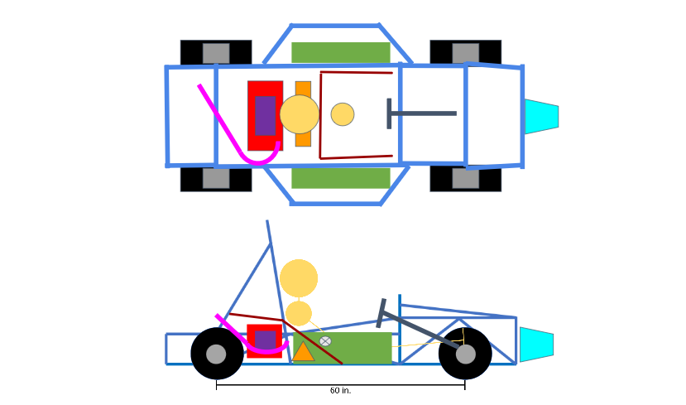

Figure 1: Series All Wheel Drive Hub Motor

This concept includes a motor placed at each of the four wheels. The internal combustion engine is located directly behind the driver with the batteries positioned on each side of the driver. This concept benefits from being all wheel drive, which gives more control to the driver, as well as the lack of a transmission from the frame to the wheels. This concept’s drawback is that significant weight is at a distance out from the center, negatively impacting the rotational inertia of the car as it turns. Additionally, the inclusion of motors at the hubs of the wheels increases the unsprung weight by a large margin, negatively affecting the response of the suspension.

#### Concept 2: Series Single Rear Motor (RWD)

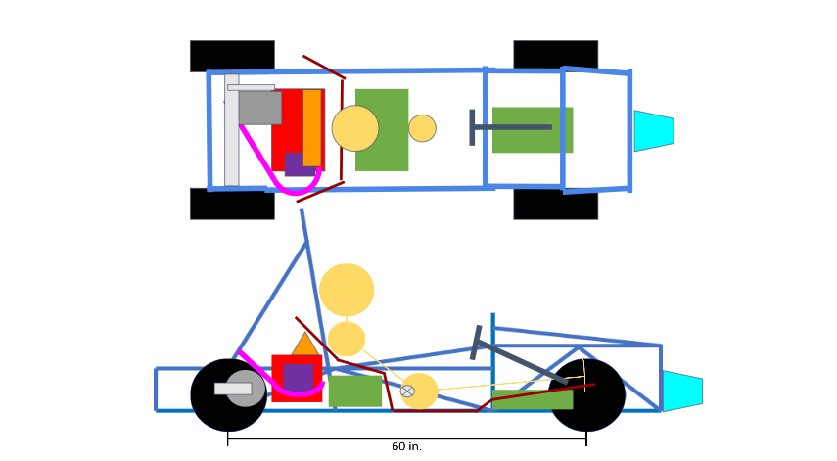

Figure 2: Series Single Rear Motor (RWD)

This concept consists of a single motor powering the rear wheels while the internal combustion engine directly behind the driver charges the batteries. CAD testing determined that the batteries would be located below the hip and feet of the driver. This provides for an optimal, 50:50 distribution of weight. This concept is much simpler in design and in its control systems, not allowing power delivery between the rear wheels without the addition of a controllable differential. The differential needed with the additional gearing reduction would cost likely around the price of a second motor without benefitting from extra power. However the lower power would relate to a lower weight, helping maintain an ideal power to weight ratio.

#### Concept 3: Series Dual Rear Motor (RWD), Batteries Underneath Driver https://lh4.googleusercontent.com/8F38OfunUujjrzgk_xxWsthAf_qrvZyzUDoXwFiv2IXYLhs56xHCFUIYva3X0O9r1Lf7WQZqw9wU40h5lsCUu_BSxtkOnO2qHPP-M-2l-CBrhvl8mj9F09d9-oXeAMFHR4IUpO7n

Figure 3: Series Dual Rear Motor (RWD), Batteries Underneath Driver

Concept 3 positions the engine behind the driver with the batteries underneath the hip and legs of the driver. This concepts implements two rear mounted motors that powers the rear wheels through a reduction. The architecture of this concept is still very simple, but the design is slightly more complicated since the power of both motors must be controlled to simulate a differential. This concept has many benefits such as not needing a differential to connect the rear wheels, having a large amount of precision control over the rear wheels, and increased power output. However, increasing the amount of power increases the energy needed and changes critical battery specifications. The necessary accommodations would result in less packaging space and an increase in total weight.

#### Concept 4: Series Dual Rear Motor (RWD), Batteries at Drivers Side

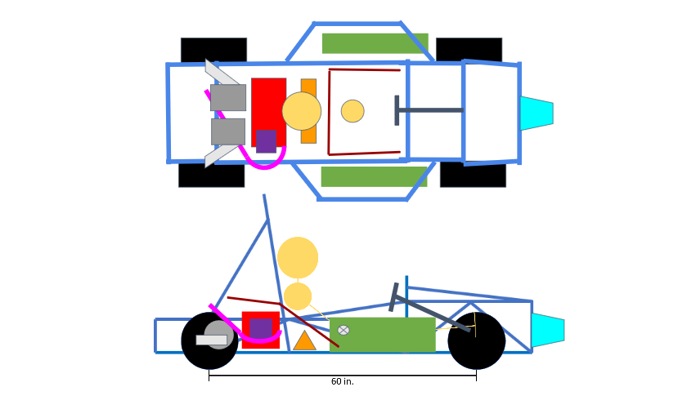

Figure 4: Series Dual Rear Motor (RWD), Batteries at Drivers Side

The fourth concept is very similar to the third concept with the exception of the battery placement. The batteries are located to the side of the driver rather than under them. Such positioning helps achieve the targeted 50/50 weight distribution and allows more adjustability, but also moves more mass away from the center of the vehicle, reducing the rotational inertia of the car as it turns. This setup allows for larger battery accumulators without being constrained by shape or size being mounted in different parts of the vehicle.

#### Concept 5: Through the Road Front Motor, Rear Engine

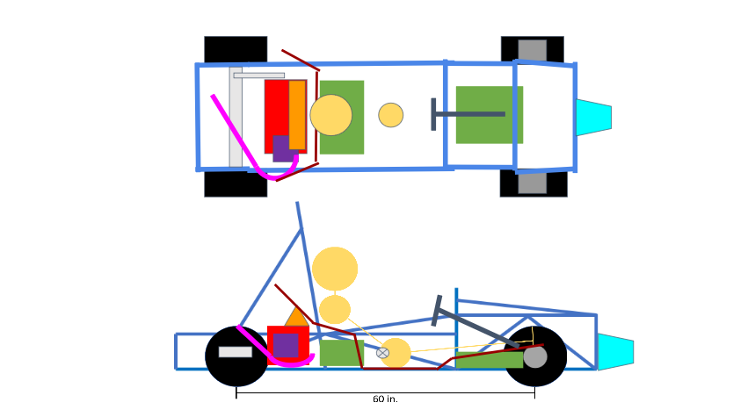

Figure 5: Through the Road Front Motor, Rear Engine

This concept is an all-wheel-drive system, just like the first concept, but instead of having a hub motor power each wheel, it uses two hub motors, one to power each of the front wheels, and the singular engine to power the rear wheels. The batteries are placed under the driver to aid in achieving the 50:50 weight distribution while remaining close to the center of the vehicle. This setup relies on the engine powering the wheels along with the motors, meaning smaller batteries would be needed. However, a powerful enough engine would require a heavy transmission, resulting in a dramatic increase in total weight. Additionally a complicated control setup to effectively and smoothly transmit power to the wheels between the engine’s power curve, motor’s power curve, and changes in reduction/gear-pairs of both the engine and motors’ transmissions to wheels.

## 1.6 Concept Selection

### System 1A: Tractive - Motors.

Tractive system converts electrical energy into mechanical energy.

#### Motor Type:

To Begin, it was determined that the advantages of a brushless DC motor as well as the AC induction motor far outweighed those of a Brushed DC Motor.  Brushed DC Motors are less efficient, have a higher rate of wear and tear requiring potential fixing of parts over the time period prior to competition, and requires a complex speed controller to achieve regenerative braking.  These factors determined that the Brushed DC Motor was the least viable option of the three.

#### Motor Configuration:

Three motor concepts were originally looked at:  hubcentric motors (electric hub motor at each wheel attached to the suspension), single rear brushless DC motor and dual rear brushless DC motor. Although the hubcentric method offers four wheel drive and helps in weight distribution this method was not chosen for simple reasons. The first being that the 13” limited size of the rim to fit standard 21 inch tires constrained the size of the motor that could fit within the wheel and with such a small motor the total power output from all wheels did not compare to the other methods. Additionally the added unsprung weight out at the corners of the car and much higher complexity and cost further took away from the option. The next method that was eliminated is the single rear brushless DC motor. This design offers an easy implementation and requires the least amount of energy which means less batteries.  Although this design was a close second the eliminating factors was the need for a differential which added weight to the car and that after calculations were made this concept had a lower power to weight ratio compared to the dual rear brushless DC motor.

The method of dual rear brushless DC motors was selected in the light of redundancy and the ease of capability to reach the desired power/weight, overall vehicle weight, energy requirements, and the adaptability to 50:50 weight distribution that this method offered. The dual rear motor configuration allowed for power control to individual wheels comparable to the hubcentric motor design, but with much less weight as only two motors would be used for the rear. Additionally, the lack of differential overcame the added weight of the second motor. The configuration was finally determined using a simplified HOQ and a dual rear setup was found to be the most ideal for the above stated reasons.

Table 4: Configuration House of Quality

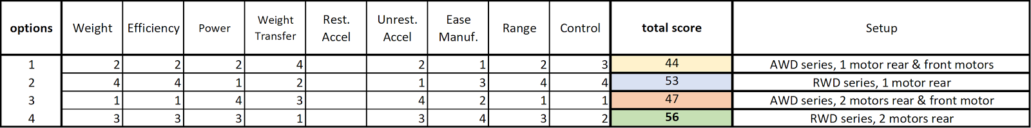

#### Motor Selection:

With brushless DC motors selected for a dual motor configuration, the manufacturer Emrax was chosen for their support for FSAE teams and high specs relative to most motors on the market. Deciding between supplied sizes was then done through a large spreadsheet taking all variables into account to calculate the overall power-to-weight and overall weight of the vehicle given various engine, motor, battery combinations. Below is a sample from the spreadsheet implementing all calculations used to find the overall power-to-weight. It was found with the limited battery options, the best choice would be the Emrax 188 motors with a reduction of 3.25:1 to the wheels to top the motor out at 70 mph, the fastest needed for the competition. 

This would allot the best power-to-weight of 0.078 kW/kg given the 204 kg (450 lb) weight limit with an average power output of 19 kW (25.9 hp) with a peak output likely to reach around 130 kW (174.3 hp) at 70 mph. This additional reduction would require some added weight but would make the most out of the motor’s power curve while remaining under the weight target of 204 kg at an estimated 188 kg (414 lb) with more room for additional batteries without exceeding the weight target.

As previously discussed in the concept target summary, the total energy was calculated based off of the average effective power of the vehicle over the total time of the race. This total time was based off a target average lap time of 85 seconds per 1 km lap with a total time of 4,114 seconds over the 44 km after a 10 percent safety factor was included.

Equation 1: Time Endurance

$$Time Endurance \left[s\right]=85\left[\frac{s}{km(lap)}\right]×44\left[km(laps)\right]×\left(\frac{110\%}{100\%}\right)=4,114[s]$$

The effective power would then be the average continuous power drawn by the motor, calculated by the average motor speed and motor selected with the power supplied by the engine subtracted.

Equation 2: Effective Power

$$Effecvtive Power \left[kW\right]=Power Cont. \left[kW\right]-Power Generated[kW]$$

The average motor speed is calculated by taking the average speed over the race of about 11.75 m/s and using the diameter of the wheels with the chosen reduction from the motor to the wheels to find the average motor speed.

Equation 3: Motor Speed Requirement

$$Motor Speed \left[RPM\right]=\frac{Road Speed\left[\frac{m}{s}\right]×\left(1000\left[\frac{mm}{m}\right]×60\left[\frac{min}{s}\right] \right)}{2×π×Radius Wheel\left[inch\right]×25.4\left[\frac{mm}{inch}\right]}×motor reduction\left[\frac{RPM}{RPM}\right]$$

This speed was then related to the motor speed curve provided by the manufacturer to find the power output with a linear relation being fit to estimate power draw under different speeds for the spread sheet.

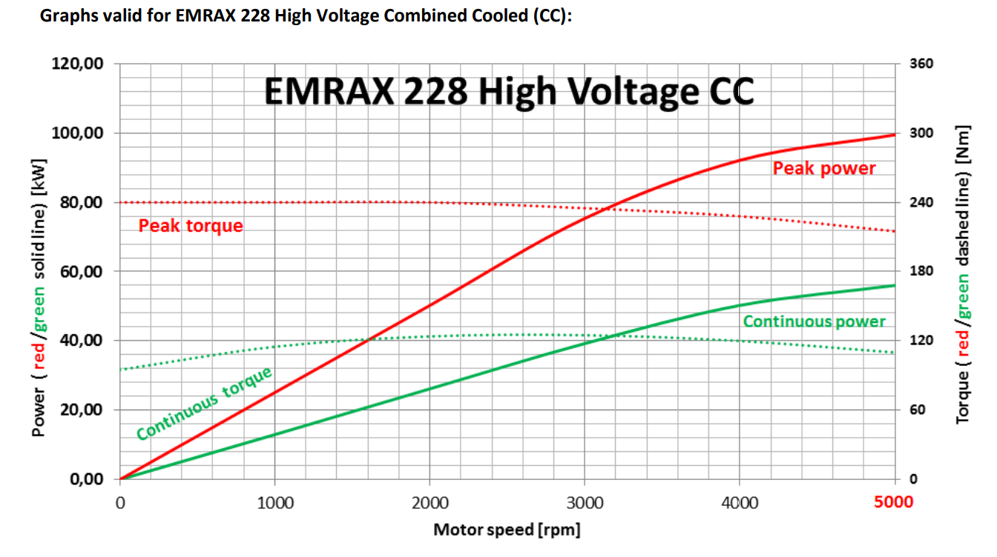

Figure 6: Example of Motor Power/Torque Curve Provided by Manufacturer.

### System 1B: Tractive – Energy Storage Systems.

Tractive system converts electrical energy into mechanical energy.

#### Overview:

The final selection of dual rear Emrax 208 motors with 3.25:1 reductions for each related to a required energy of 14,500 kJ which when compared to the target specific energy of about 720 kJ/kg (200 Wh/kg) related to about 20 kg of added batteries. This energy required by the batteries is additionally well under the max allotted of 35,500 kJ with an estimated weight under 450 lb meaning extra batteries would not put the vehicle over the limit if they are needed. This requirement for as high of a specific energy as possible along with the need for batteries that can output at the rate required for two motors lead the decision of the batteries.

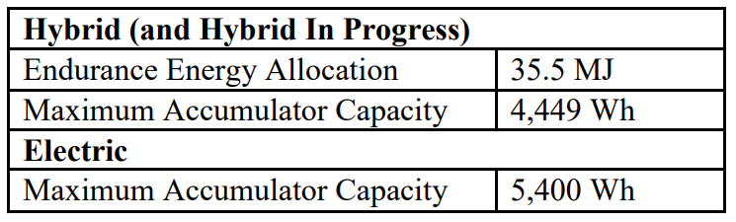

The main goal for the energy storage system is to supply enough energy to power the formula hybrid vehicle so that it can successfully complete an entire endurance race which is 44 kilometers in length. At the same time it needs to be capable of supplying enough power to the motors to be able to reach an average speed of 11.75 m/s (25 mph). The placement of the energy storage systems plays a large part in designing the vehicle as well, which depends mainly on how it is packaged and how safe it is.

    Lithium-ion batteries were chosen to be the type of energy storage device used for the purpose of supplying power to the formula hybrid vehicle. These advanced batteries are currently one of the best choices for energy storage applications in the market today, especially for electrically powered vehicles. They are known for their high specific energy and efficiency, and are able to maintain a relatively high power output. The only drawback of these batteries is that they are costly to buy and can be considered to be unsafe if not handled properly.

#### Lithium-ion Battery Options:

There are many types of lithium-ion batteries and each of them differ in their chemistry which allows them to work more efficiently in different applications. Many of these chemistries are capable of powering an electric vehicle, therefore through concept generation a variety of options were narrowed down to only three choices: lithium iron phosphate, lithium nickel manganese cobalt oxide, and lithium nickel cobalt aluminum oxide. Each of these choices will be reviewed and compared in order to justify the best battery to be used for the formula hybrid vehicle.

#### Lithium Iron Phosphate Battery:

Overview: The lithium iron phosphate battery is one of the most commonly used lithium-ion batteries in the market today. It is known for being one of the safest types of lithium-ion batteries; as well as being one of the cheapest and easiest to purchase from a commercial vendor. The only drawback for this chemistry is that is has the lowest specific energy of all three choices.

Specific Energy: 90-120 Wh/kg

Nominal Voltage (per cell): 3.3 V

#### Lithium Nickel Manganese Cobalt Oxide Battery:

Overview: The lithium nickel manganese cobalt oxide battery has excellent performance capabilities and is considered a preferred candidate to be used in electric powertrains for electric powered vehicles. One of its unique capabilities is that it can be tailored to serve as an energy cell or a power cell depending on the application it will be used in, meaning it can be optimized for specific energy or a preferred power output.

Specific Energy: 150-220 Wh/kg

Nominal Voltage (per cell): 3.7 V

#### Lithium Nickel Aluminum Cobalt Oxide Battery:

Overview: The lithium nickel aluminum cobalt oxide battery has very good specific energy and its power output is reasonable. It is considered a great candidate for electric powertrains mainly because of its long cycle life. The drawbacks of this battery are that they are known to be more unsafe and are very expensive.

Specific Energy: 200-260 Wh/kg

Nominal Voltage (per cell): 3.6 V

#### Significant Parameters:

The decision on which type of lithium-ion battery to choose will depend on a few major parameters that are important to the formula hybrid vehicle, and more specifically to the events in the SAE formula hybrid competition. As was stated before, the most important parameter is the specific energy. The specific energy needs to be as high as possible to be able to supply enough energy to finish the entire endurance race. By having a high specific energy, it also means that the cell has a good energy to weight ratio which allows the battery to supply a lot of energy while minimizing the weight of the battery pack and the total weight of the car. Another important parameter to take into account is the cost of the battery cells. There is a budget that needs to be adhered to, and lithium-ion battery cells can get very expensive depending on the chemistry. The ease of purchase from a vendor needs to be considered as well. Some vendors are not viable because they will not supply a number of battery cells under a certain threshold. Also, most notable lithium-ion battery vendors come out of China, and it can take a very long time for the cells to ship all the way to the United States, along with potential border/customs problems. Finally, the way the cells are packaged is a large factor that needs to be decided. In order to work with the chosen architecture of the car and the planned placement of the energy storage system while also complying with the SAE formula hybrid competition rules, the packaging of the battery cells is very important.

#### Non-Viable Options:

After doing some research and making comparisons, one of the three chosen types of lithium-ion batteries were ruled out. The lithium nickel aluminum cobalt oxide batteries were considered non-viable due to their unsafe nature and high costs. They have a very similar performance to the lithium nickel manganese cobalt oxide batteries, just with more negatives attached. It is also very hard to find a vendor in the United States that is willing to manufacture these type of cells for this project. Therefore, when searching for possible batteries to purchase, only the lithium iron phosphate and lithium nickel manganese cobalt oxide batteries will be compared.

The fourth option from the concept generation where capacitors would be used in parallel with the batteries was ruled out. This is mainly because of the weight the capacitors would add to the total weight of the car. By adding extra capacitor cells, the target for the total weight of the car could not be met. This option would also create a more complex energy storage system that would need to be implemented and calibrated which would take up a lot of time.

#### Detailed Comparison:

The table below compares the number actual batteries that can be used for the formula hybrid vehicle. It shows different types of potential lithium-ion batteries along with some detailed properties which include things like: vendor names, types of lithium-ion batteries, battery specifications, and costs. Notice there may be some missing information for certain batteries (TBA); this is because the vendor that supplies those specific batteries is currently being talked with and that information has not been presented yet.

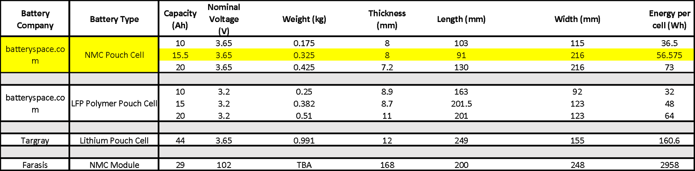

The yellow highlighted battery type represents the best choice based on the most important parameters that were discussed earlier. The lithium nickel manganese cobalt oxide (NMC) single pouch cell that was chosen from batteryspace.com had three different capacities to choose from. As can be seen the 15.5 Ah capacity NMC pouch cell proves to have the highest specific energy out of all the options available. The NMC cells also have a higher nominal voltage than the rest of the cells which will allow for more power output. Between the specific energy and power output values it is obvious that the NMC battery from batteryspace.com will have the best performance to use for the formula hybrid vehicle.

As was stated before the cost and packaging also need to be taken into account before making a decision on a battery. Although the NMC cells from batteryspace.com have the best performance, they do cost a little more than the LFP cells. It will be shown, however, that even though each NMC single cell costs more, there will be less cells to buy due to their high energy density. So the total cost of all the cells needed may actually be about the same if only a little different. Another important note is that all cells purchased from batterspace.com are shipped from California. The table below shows the calculated numbers for how many cells need to be purchased in order to meet the voltage and energy requirements for the electric hybrid vehicle based on the motor that was chosen. That motor that will be used is the EMRAX 228 series without reduction.

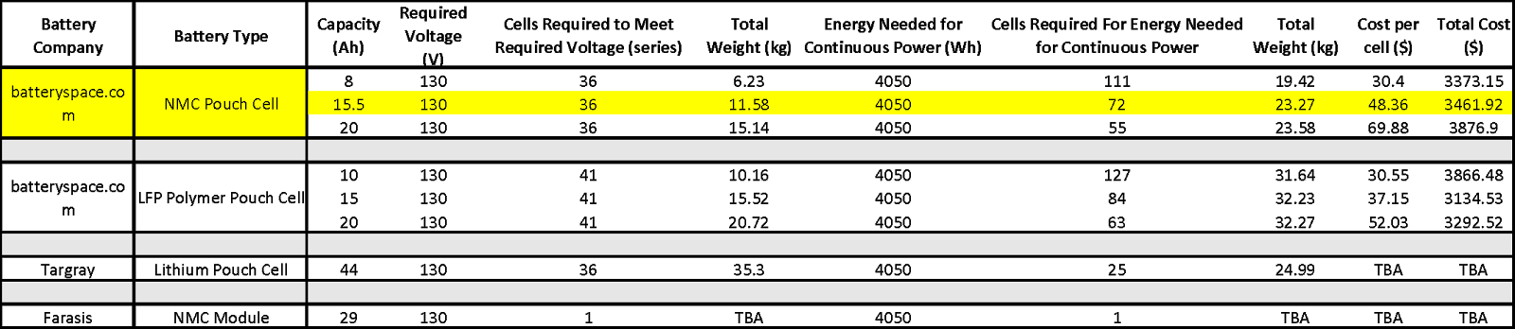

The 15.5 Ah NMC pouch cell battery from batteryspace.com is still the top contender of all the possible batteries based on the table above. There needs to be enough cells to satisfy both the required voltage and energy needed for continuous power. Even though the 8 Ah NMC cells are much cheaper, they also need about 111 cells to meet the energy requirement, whereas the 15.5 Ah needs only 72 cells to meet the energy and voltage requirement. It can be seen that the total cost of the NMC batteries based on the amount of cells needed is relatively close to the total cost of the LFP cells. The cost comparison along with the better performance makes the NMC pouch cells from batteryspace.com the ideal candidate to power the formula hybrid vehicle.

Notice most of the batteries that were selected for comparison are in pouch cell form; this is because pouch cells were decidedly better than buying a prepackaged module due to their flexibility in the shape and size of how they are packaged. In order to get pouch cells to work, however, a protection circuit module (PCM) and a battery management system (BMS) must also needs to be purchased. Both of these systems can be purchased from the respective websites of each vendors cells.

#### Final Selection:

After doing the comparisons it became clear that the lithium nickel manganese cobalt oxide (NMC) batteries are a much better option than the lithium iron phosphate (LFP) batteries. With everything from their performance qualities to their cost, the NMC cells proved to be the best. As of now these cells are planned to be bought from the vendor batteryspace.com. However, there is still being talks with the vendor Farasis who also manufactures NMC cells. Not only do they make NMC cells, but they also make thin, optimized modules made up of NMC cells that can potentially be implemented in the formula hybrid vehicle. Even though pouch cells were chosen as the best form to purchase the batteries in due to their flexibility, a good enough module should not be completely ruled out before all of the details are known. Modules already have implanted protection circuit modules and in some cases come with good battery management systems. Until the talks with Farasis are complete, however, the 15.5 Ah NMC pouch cells from batteryspace.com are the chosen batteries to be used for the formula hybrid vehicle.

### System 2A: Engine.

           The engine selection is determined by the type of motor being used as well as whether or not there is an output gear reduction on the motor. To reduce as much weight as possible, the smallest motor will be used. Because of the motors power band, as discussed in the motor section, gear reduction will be included. With this combination, there are three engines that were considered: a 50cc, a 125cc, and a 205cc. To determine the best option, the power-to-weight ratios were calculated as well as the amount of energy they will theoretically produce over the course of the race, as seen in Equations 1 and 2. Engine specs and comparison between different engines can be found in Table 5.

Table 5: Engine Specs and Comparison: NOTE: In order to view full table, download document and double click on the table.



           Using the total energy production, the number of batteries needed and their combined weight were found. From this we calculated the total weight of the vehicle and then used to power of the motor to find the total power-to-weight ratio of the whole vehicle. Thus, the lowest weight combination of engine and batteries will produce the best power-to-weight ratio. After this analysis, the best engine was determined to be the 205cc, which will be a stroked Grom engine. Small and midsized engines were taken out of consideration because of the lack of power they could produce.

### System 2B: Drivetrain.

With the selection of a reduction to aid each of the motors, the type of reduction was next to choose. A simple chain and sprocket setup was chosen as with a 3.25:1 reduction. Fairly common sizes can be implemented, therefore greatly reducing the cost and complexity relative to a gearbox or belt, with many resources available for proper implementation. The drive shafts were additionally chosen to be RCV Performance hollow half shafts as they provide the best value for performance and mate with the RCV components chosen for the suspension. The shafts use standard 1 inch splines in tandem with Taylor Race tripod style joints and tripod housings, pre-machined into the rear hubs with resources to machine the inner housings provided by Taylor Race.

### System 3A: Suspension.

#### Wheel Assembly:

The actual components decided on were OZ racing H4 Formula Student series 13 inch rims with Hoosier R25B 20.5x7x13 racing slicks as these are currently being run by the FAMU-FSU SAE team and overall present great specifications for the price with available tire data and relatively light rims for the size. With an outer diameter of 20.5 inches and prior experience finding an ideal geometry will be less difficult than with a smaller sized wheel and tire combination. Finally because the FAMU FSU SAE team currently runs this setup, the hubs, brakes, and bearings chosen from RCV Performance are being used on 2017 to 2018 Formula Nebraska competition vehicle. With these components selected along with the rims, the suspension geometry can start getting modeled more accurately in CAD.

#### Suspension Selection:

The front and rear double wishbone suspensions were selected as they presented the same benefits as a multilink suspension with both being an independent 5-link design through slightly different methods. Both methods allowed the freedom for idealized aggressive camber gain curves that a beam type would not allow with more freedom to add anti-features and lighter weight overall components. The front and rear double wishbone however presented an easier to implement setup for the rear without the need for a separate rear subframe style assembly holding the drivetrain and suspension together and instead promoting the mounting of control arms closely together with the rear engine and drivetrain components directly to the frame. The double wishbone rear suspension when configured right can behave nearly identical to multi-link style geometries with far more resources available. Finally the addition of anti-roll bars will take the place of anti-roll characteristics designed into the geometry to allow for further control with the option of complete removal if needed.

#### Suspension Geometry Values:

Roll centers, the point at which the car rotates while cornering, of 1.5 inches front and rear are selected to leave room for change over suspension travel to ensure they remain positive. This along with a camber change value of 1.5 degrees per inch of travel would allow the vehicle to gain negative camber as the car rolls in cornering and loads the tires, accounting for the deformation of the tires and loss in camber due to roll. This along with a slightly positive Ackermann steering geometry will allow for optimal low speed, tight cornering performance.

### System 3B: Architecture - Overall placement of all components.

The architecture defines the location of all the components of the car

#### Architecture Options:

The architectures taken into consideration were through the road, parallel, and series. A through the road setup implementing the engine and motors separate from each other on separate ends of the car (front or rear). Parallel would mean driving one pair of wheels with the engine and motors together while Series would only use the motors to drive the wheels while the engine generates energy to charge the batteries.

Research into each of the setups focused on power delivery, ease of design and manufacturing, control, and most importantly the impact they would have on the performance in the competition. The research was then compiled into a House of Quality (HOQ) and compared to find the best option based off the criteria supplied. Below is the HOQ used with the top ranked options highlighted.

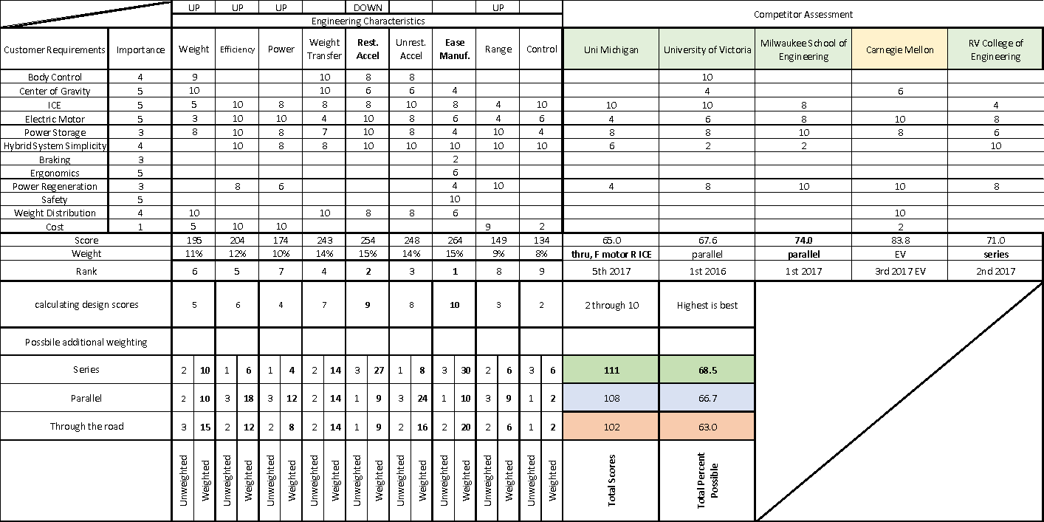

Figure 7 - House of Quality (HOQ)

Through the road saw many major disadvantages namely being the need to run a rear engine front motor system as a front engine setup would conflict too much with the rules given the target wheelbase of 60 inches. Front motors would therefore most easily be done with hub motors as it would circumvent the necessary additional safety features required for frame mounted front motors, though would add a large amount of complexity, cost, and poor weight characteristics with increased unsprung mass far from the center of the vehicle. Finally, after benchmarking other teams it was found the implementation of a motor and engine required a large amount of tuning to smoothly and controllably deliver power to the ground, especially given the required transmission for the engine to optimally supply power to the wheels. These negative characteristics showed themselves in the HOQ and ultimately lead to a lower overall ranking.

Parallel as of the 2016 competition year was the most popular setup by far benefiting from direct power output to the wheels from both the engine and motors with less reliance on batteries. However, this setup proved to be the most complicated setup with the highest level of relative failure for teams with many teams not able to even store enough energy to last the entire 44km of the race. This is from the limits on allotted energy at the beginning of the race and with a reliance on the strictly limited fuel storage as soon as the engine would run out of gas, the electric motors would have to drive the vehicle on the remaining battery power alone. The complexity and overall limitation lead to the lower ranking of this setup when compared to the parallel setup.

Finally, the Series setup suffers generally from low relative power to weight when compared to series setups but benefits from higher relative range as the fuel is used to supplement the batteries with much higher efficiency than the series engine setup as it lacks the transmission to the ground and simply drives an inverter to charge the batteries, making the most out of the allotted fuel. This aspect along with the ease of design and implementation helped drive the highest ranking in the HOQ.

#### Optimizing Placement of Components:

The architecture of the Series setup was then determined using CAD to find which general setups yielded the best center of gravity along with the previously determined dual rear motor setup. This allowed the driver location to be determined within the locations of the batteries, engine, motors, and suspensions components to best maintain a 50:50 weight distribution as low to the ground as possible.

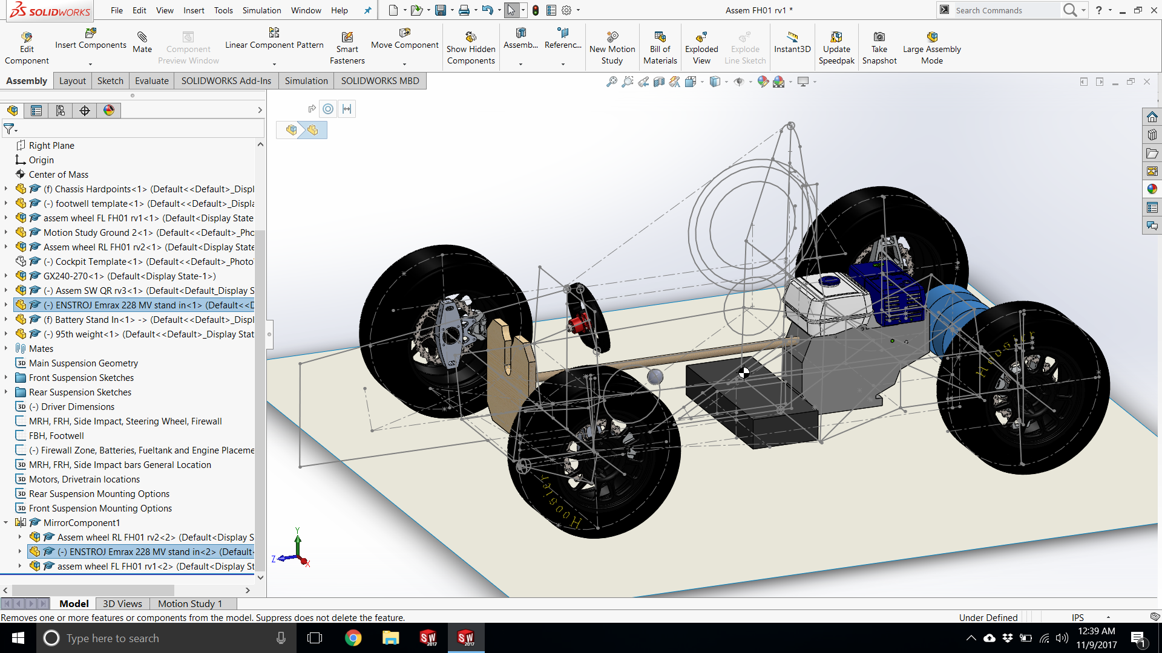

Figure 8 - Solidworks Rendering of Prototyped Vehicle

# Chapter Two: EML4552C

## 2.1 Spring Plan

### Project Plan.

Table 7 - Gantt Chart for Spring Project Plan. NOTE: To view full table please download electronic word document and double click on the table.



The plan for this semester includes purchasing and prototyping each subsection within the scope of this year’s project and running failure analysis in Solidworks and Adams software. All milestones are marked with the symbol “🞚” as seen in table 7. All milestones consist of physical implementation of the systems and are not advised to be performed until proper online testing and analyses are complete.

### Quarter Car Model Build Plan

The list below details a specific plan of implementation of the model demonstration that should be completed by engineering design day (April 10, 2018).

Needs –

* One of the two EMRAX 188 motors needs to be purchased and setup for safe testing.
* A sufficient amount of the chosen batteries need to be purchased in order to power one of the EMRAX 188 motors that will be purchased.
* The accumulator setup (module and BMS control system) needs to be designed and implemented to demonstrate power and control to the motor, as well as ensuring it is designed to properly fit into the vehicle architecture that was chosen.
* A fully functional (load bearing) suspension and steering system need to be designed to meet project targets and to fit the vehicle architecture.
* A model of the suspension and steering system will be built using non load bearing materials to physically demonstrate the vehicle architecture integrated with the motor and batteries.
* A video demonstration of the motor being safely powered and tested should be acquired by engineering design day.
* A transition plan needs to be designed in order to transfer the quarter car setup between locations.

### Control System

The list below details a more specific plan of implementation for the control system required to operate the system.

Needs –

* Drive Control System enabling driver to race competitively in the aspects of both speed and efficiency.
* Obedience to the SAE Formula Hybrid Rules ensuring that the vehicle is safe, essential to promote reasonable competition.

Objective –

* Design an intelligent Drive Control System
* Implement torque vectoring
* Implement traction control
* Deliver as much power as possible from batteries
* Follow all guidelines provided by Society of Automotive Engineers (SAE)
* Create a safe and successful vehicle

Process of development –

* Drive control Printed Circuit Board (PCB)
  + Inputs:
    - Sensors:
      * Brake Potentiometer
      * Wheel Sensors
      * Steering Potentiometer
      * Throttle Potentiometers
    - Pulse Width Modulation (PWM) Signal output from Drive Control Microcontroller/Electronic Speed Controller (ESC)
  + Outputs:
    - Steering Output/Brake Output/Throttle Output to Drive Control Microcontroller/Electronic Speed Controller (ESC)
    - Wheel Sensor output to Protoboard
    - Pulse Width Modulation to Protoboard
* Protoboard
  + Inputs:
    - Wheel Sensor output from PCB
    - PWM from PCB
  + Outputs:
    - Wheel Sensor output to ESC
    - Filtered torque and brake output to Left Motor Controller (Node)
    - Filtered torque and brake output to Right Motor Controller (Node)
* Right/Left Motor Controller (2 separate nodes) (NOTE: only one motor will be implemented here)
  + Inputs:
    - Filtered torque and brake output from Protoboard
  + Outputs:
    - Left Motor
    - Right Motor (not within project scope for 2018)

### Timeline

The timeline below will layout the plan to meet the project plan goals stated previously.

Purchasing –

* One EMRAX 188 motor should be purchased by February 9th. (2/9/2018).
* If it is decided to purchase a pre-designed control system, it should be purchased no later than February 23rd (2/23/2018).
* The batteries should be purchased ASAP, but no later than March 2nd. (3/2/2018).
* Any materials required for the suspension and steering should be purchased no later than March 2nd (3/2/2018).
* Any other materials required for the demonstration frame, transition design, or any other component needed to meet the 2017-2018 project goals need to be purchased no later than March 2nd (3/2/2018).

Design and Construction –

* The accumulator system (battery cells, BMS, packaging) should be completely designed and ready for construction by March 2nd (3/2/2018).
* The load bearing suspension and steering system needs to be fully designed by March 2nd (3/2/2018).
* The EMRAX 188 motor and accumulator system needs to be integrated and calibrated by March 16th (3/16/2018).
* The control system plan needs to be ready by March 30th (3/30.2018).
* The suspension and steering model needs to be fully constructed by March 30th (3/30/2018).

Testing and Wrap up –

* The batteries need to be tested and analyzed by March 23rd (3/23/2018).
* The EMRAX 188 motor needs to be powered and tested by March 30th (3/30/2018).
* The quarter car model (suspension/steering, accumulator, motor) needs to have a test setup by April 3rd (4/3/2018).

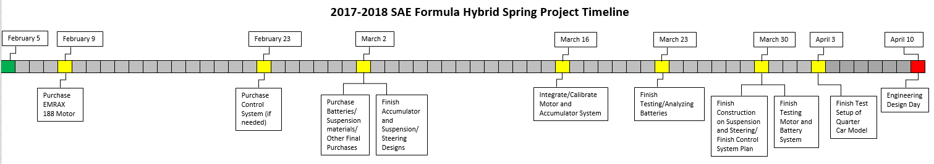

The timeline above may be hard to read as it is, therefore on the next page the timeline has been rotated length wise along the page which should make it more eligible, especially when printed.



### Task Ownership

Once each part of the project is designed and purchased, the whole team will work together to test and integrate them into the quarter car model.

Motor and Batteries –

* Daniel Adams
* Lee Joiner
* Donghao Ye
* Joey Chrabot

Suspension and Steering –

* Jonathan Mendez
* Will McCormack
* Alex McKinlay

Controls Plan –

* Rachael Rosko
* Matthew Adams

### Budget

For the 2017-2018 year the budget is estimated to be about $6000. The table below shows a simple breakdown of how the budget will be used.

|  |  |
| --- | --- |
| **Budget Breakdown** | |
| **Components** | **Cost** |
| EMRAX 188 Motor | 3500 |
| Batteries | 1500 |
| Suspension and Materials | 1000 |

# Appendices

# Appendix A: Code of Conduct

# Appendix B: Functional Decomposition

# Appendix C: Target Catalog



To view entire Target Catalog, download word document and double click on table.

# Appendix A: APA Headings (delete)

# Heading 1 is Centered, Boldface, Uppercase and Lowercase Heading

## Heading 2 is Flush Left, Boldface, Uppercase and Lowercase Heading

### Heading 3 is indented, boldface lowercase paragraph heading ending with a period.

#### Heading 4 is indented, boldface, italicized, lowercase paragraph heading ending with a period.

##### Heading 5 is indented, italicized, lowercase paragraph heading ending with a period.

See publication manual of the American Psychological Association page 62

# Appendix B Figures and Tables (delete)

The text above the cation always introduces the reference material such as a figure or table. You should never show reference material then present the discussion. You can split the discussion around the reference material, but you should always introduce the reference material in your text first then show the information. If you look at the Figure 1 below the caption has a period after the figure number and is left justified whereas the figure itself is centered.

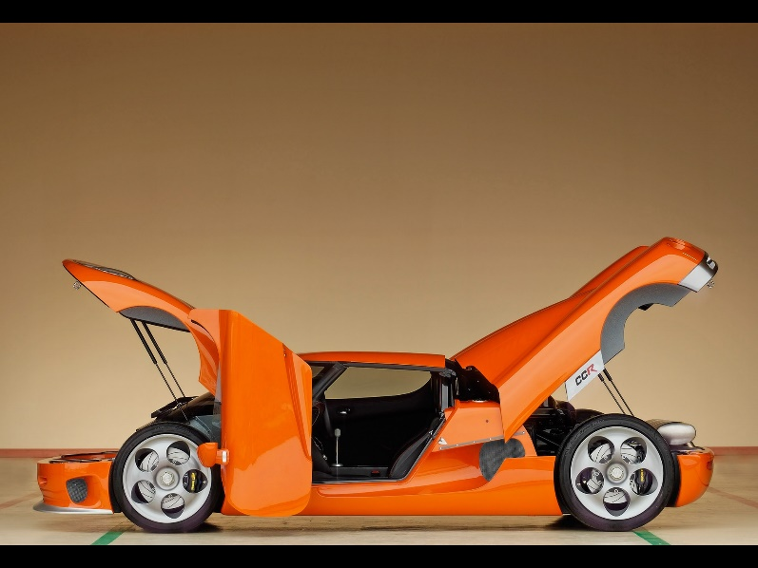

Figure 9. Flush left, normal font settings, sentence case, and ends with a period.

In addition, table captions are placed above the table and have a return after the table number. The second line of the caption provided the description. Note, there is a difference between a return and enter. A return is accomplished with the shortcut key shift + enter. Last, unlike the caption for a figure, a table caption does not end with a period, nor is there a period after the table number.

Table 8  
The Word Table and the Table Number are Normal Font and Flush Left. The Caption is Flush Left, Italicized, Uppercase and Lowercase

|  |  |
| --- | --- |
| Level of heading | Format |
| 1 | **Centered, Boldface, Uppercase and Lowercase Heading** |
| 2 | Flush Left, Boldface, Uppercase and Lowercase |
| 3 | Indented, boldface lowercase paragraph heading ending with a period |
| 4 | Indented, boldface, italicized, lowercase paragraph heading ending with a period. |
| 5 | Indented, italicized, lowercase paragraph heading ending with a period. |

# References

**There are no sources in the current document.**