Functional Decomposition
T522: Nicolas Garcia, Madison Jaffe, David Alicea, Ethan Saffer
FAMU-FSU College of Engineering
October 2, 2020

Introduction
The functional decomposition is used to break down the general components our product will offer. Without specifying what the product will be, our team has coordinated a plan on the focus of the project. Being involved in a demographic that is comprised of the visually disabled, our primary goal is to offer a product that helps ease everyday activities in a safe and efficient manner. In doing so, our functional decomposition is gathered around the central idea of having a product that allows for the individual to navigate freely and safely, as well as provide the customer with an easy to use and intuitive interface. This functional decomposition will continue to aid us in the succeeding assignments as we will use it as a guide when specifying the product design.
Data Generation
In order to generate the concepts and data required to perform functional decomposition, various experts on the teaching and rehabilitation of visually impaired people were contacted. Dr. Eileen Bischof, an Orientation and Mobility expert, was of great help in the development of our design requirements. Dr. Bischof helped us deconstruct the functions of the classical white walking cane most severely visually impaired people use. The white cane is primarily used to detect changes in their path, be them in terms of terrain, elevation, or objects potentially blocking their path. The team then analyzed various products/gadgets sold to aid the visually impaired. Many of these are sensors mounted onto glasses or arms in order to provide haptic feedback regarding the distance between the person and their surroundings. All of these included a relatively slick and simple design with minimal usage of buttons for ease of use. Dr. Bischof also made it clear that most visually impaired people depend solely on their Orientation & Mobility training, which means whichever device they might want must synergize with those skills. The team also contacted Jeff Whitehead of the Rehabilitation council of the Florida Division of Blind Services, who emphasized to the group that whatever design they came up with, it had to be compatible with skills they develop through the O&M training, but it should also interface with known technology for a sense of familiarity.
The following graphics are here to display our team’s analysis of the what our design needs to do. The information within these graphics are based on our interpretation of our customers’ feedback. We are showing what are design should look like by breaking it down into systems and then showing the functions each system needs to achieve. The three systems we defined for our design are orientation, mobility, and utility. These systems can also be the major functions of our design while the functions can also be described as minor functions compared to the systems. These graphics make our objectives for our design clear and give us a bit of a plan of how to check and ensure we fulfill all the required functions.
Discussion of Results
Our functional decomposition was gathered by defining what we wanted our final product to do. As a group, we decided that the most important product specification was to give individuals with vision impairment a way of navigating the world around them. From there, we decomposed exactly what navigation was, and the substance our product will need to complete that task in a safe, efficient and intuitive manner. We broke down our vision impairment device into three primary functions: Mobility, Orientation, and Utility. In order to navigate the world, we need to first make the individual comfortable with moving. This includes moving around static and dynamic objects, as well as identifying dangerous obstacles such as low hanging signs or steps. The orientation function will be used to allow the user to understand where exactly he/she is as well as alert the user of a change in elevation grade. The utility function is mainly to supply the user with an intuitive and safe interface.
The functions our product will be comprised of are similarly related. The mobility and orientation functions are completely dependent on each other, as you can’t navigate the world without the ability to walk safely as well as know where you are. The utility function feeds off these both. Ideally, the utility function will be able to assist in both the mobility and orientation of the user. This can be accomplished by keeping track of commonly used paths to assist the user in the safest way to their desired location, as well as interacting with emergency contacts in the case of an emergency. In all, these three functions will provide for a seamless design as well as overall user satisfaction.
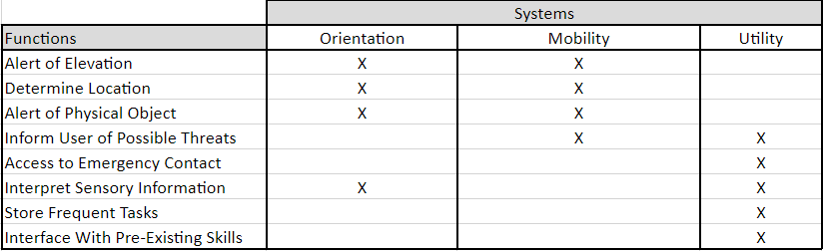
The hierarchy of the system begins with creating a theoretical vision technology product. It is then broken down into three main categories that Team 522 wants to encompass in the project. These three sections are mobility, orientation, and utility. These were all based on the previously mentioned O&M techniques for the visually impaired. Orientation and mobility had to be separated for the distinction of the user knowing where they are compared to the user being able to move in said surroundings. Utility goes on to encompass all extra features which were strongly encouraged by the people kind enough to provide their input in the matter.
The priority ranks are best shown in the functional decomposition cross reference table. This is because functions that are encompassed by more than one system will be given a higher priority. Many functions overlap with the systems of orientation and mobility. This is reiterated in the teachings taught at secondary schools for people who are visually impaired. Often times people who are visually impaired are taught orientation and mobility hand in hand as it lets people use their senses to know where they are positioned in their environment. These teachings are used for the rest of their lives to help navigate around areas they are not familiar with. Informing the user of possible threats has a cross sub-system relationship with mobility and utility, while interpreting sensory information is overlapped with orientation and utility. These two functions will also be a high priority in the product as it helps in two different areas of focus.
Since orientation and mobility are so closing related for the visually impaired, many functions will have cross sub-system relationships. Alerting the user of changes in elevation allows them to both gauge their walking path and obtain a sense of orientation (be it through memory or relative to surroundings) while also ensuring they can properly navigate through said terrain. Similarly, being alerted to physical objects in their path is tied to the ability to move around said objects, as well as using them to orient themselves across a path. The design should be able to determine the user’s location; however, much of this can be tied to the user’s skill and training since informing the user of a distance is irrelevant if they are unable to process what it means. Informing the user of threats relates to any imminent risk they should be aware of and try to avoid, but unlike a physical object that might be stationary, this might wound or hurt the user (such as fast-moving objects). Interpreting sensory information mainly focuses on detecting information unavailable to the visually impaired, such as text or signs. This can be a very useful feature to the design so the user “read” what they couldn’t previously, but it can also allow them to read street signs and orient themselves in their town/community.
Action and Outcome
Overall, the product must give access technology to people who are visually impaired. The product must help them navigate around areas they are not familiar with and provide sensory information that they would not be receiving otherwise. The white cane is the most widely used physical tool for people who are visually impaired. This is because the white cane is cheap and typically taught in Orientation & Mobility School. For our product, we want the learning to be intuitive with the knowledge they have already obtained. This will allow confidence when taking on tasks that should be accessible to everyone with ease.

References
McConomy, Shane (2019). Chars Functions Targets and Metrics 180919, EDM

