Team 502 Operation Manual
Makada Browne, Erich Noack, Charles Stubbs, Amelia Veith
FAMU-FSU College of Engineering

Contents
Overview 5
Project Objective 5
Key Goals 6
Assumptions 6
Component/Module Description 8
Electrical Module 8
Arduino 8
Teensy 8
Chassis Module 8
Gripper Module 9
Operation 10
Troubleshooting 11
CAD Model and Assembly 12
Bill of Materials 13
Appendix A- Wiring Diagrams 14
Appendix B- CAD Drawings and Assembly 16

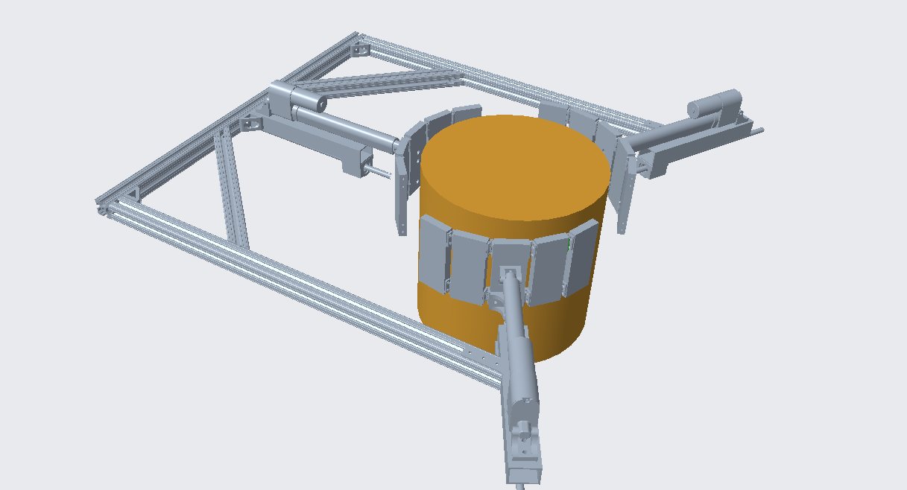
Overview
Figure 1: Ceramic Handler

In order to keep up with advancing standards and manufacturing processes for ceramic materials, Corning is seeking alternative systems for handling fragile ceramic substrates. To achieve this, the team must design an end effector to be incorporated in the manufacturing process. This implementation does not damage parts while they are moving from the end of the firing stage to the finishing stage.

Project Objective
The team will propose and develop solutions for successful manipulation of ceramic parts without observed damage.

Key Goals
The project placed emphasis on producing innovative ideas to service the automatic handling process. One of the key goals of the project is that the final system should reduce damage to the ceramic parts. The current process Corning is using is causing damage to ceramic parts and may not be sufficient for production; the ceramic parts exhibit reduced strength, due to the mixing of high prosperous materials and introduction of high temperature. Damage to parts must be avoided to remain in compliance with part specifications.
Another key goal is to produce a design that accommodates a lean manufacturing process. This is important as any extra steps in manufacturing will cause additional unwanted manufacturing time. Corning currently produces 120 parts per hour, because of this the Handler must be able to carry out the process within 30 seconds so it’s not the bottle neck station. The next key goal is to test with part samples. By testing with ceramic blanks that Corning has provided, then the design can be validated. The validations will correspond with the team’s targets and metrics.
The last key goal is pick and place capability. The Handler must be able to lift the ceramic and place it down without causing any damage.

Assumptions
The material will have characteristics of solid ceramics: brittle, high melting point, high wear resistance, low impact strength. The materials being maneuvered are cylindrical extrusions with parallel channels. These assumptions are based on the samples provided by Corning.
The current manufacturing process is automated. The manufacturing environment is under ambient conditions. This project cannot leverage any existing handling processes used by Corning, so the developed product must not rely on these processes.

Component/Module Description
To break down the components of the Handler, the overall design can be separated into three modules. The modules are: The electrical module, the chassis module, the gripper module.

Electrical Module
The electrical portion of this design can be separated into 5 primary systems: Arduino, Teensy, linear actuators, force sensors (FSRs), proximity sensor. The circuit diagrams are included in Appendix A.

Arduino
The Arduino’s functions include processing sensor information, communicating commands to the Teensy and controlling console input and output to an external display. The external console will communicate over the Arduino’s Serial 0 port while the Teensy will communicate over the Serial 2 port, they will all share a common ground source. The FSRs will provide sensor output to Analog pins A0, A1 and A2.

Teensy
The Teensy will communicate with the linear actuator controllers over the Serial 2, Serial 3, and Serial 4 ports. The Teensy will convey the linear actuator position to the Arduino for processing and the Arduino will provide desired position information. This communication will take place over the Serial 1 port at a 9600 baud rate.

Linear Actuators
The linear actuators will be controlled by the Jrk G2 motion controllers. These can be tuned for preferred controller gains by connecting to a device with the configuration utility. This can then be setup for position control over Serial communication. The Arduino should be setup to direct the linear actuators to extend until the force sensor feedback is in a desired range.

FSRs
The force sensors should be configured with the signal transducer circuit as depicted in Appendix A. The feedback potentiometer should be adjusted for the intended range of forces applied. This will directly change the sensitivity of the sensor output. Calibration of this sensor should involve checking for reliable readings on the force sensors with a linear output with respect to increasing forces applied.

Proximity Sensor
The proximity sensor will provide feedback to the Arduino on whether the handler is in range with the ceramic. There will also be an LED indicator for immediate indication to the user.

Chassis Module
The chassis is a rectangular structure made of two 34.5-inch 8020 bars connected by one 36-inch 8020 bar. To support the right angle of the chassis, an 8020 diagonal brace of 18 inches was added. Additionally, gussets were added at each corner to reinforce the 90-degree angles. At the center of the top bar, there is a mounting bar created out of rectangular tubing to mount the linear actuator. Additionally, two mounting bars are connected at 120-degree angles. This rectangular tubing is connected by 120-degree brackets on the top and bottom of the mounting bar. On the top of this bar there is an aluminum mounting bracket to hold the linear actuator in place. On the bottom of these mounting bars are steel linear bearings with steel linear motion shafts going through to connect to the flaps. Because these bars are T-Slot frames, these connections were made using T-Slotted framing end-feed single nuts with button heads.

Gripper Module
The gripper module is the portion of the design that will actually come in contact with the ceramic. To accommodate various diameters, the gripper consists of three points of contact 120 degrees about the central axis of the ceramic. Extending outward from the central contact point are additional flaps, which are by 2.5 inches wide, 6 inches tall and 5/8 inches thick. These flaps are connected to one another by fiberglass friction hinges. The hinges are by 1.2 inches by 1 inch, with a rotating pin in the center. These hinges have adjustable resistance to allow for the varying diameters. Additionally, the aluminum flaps may be added or taken away based on the diameter of the ceramic substrate being tested. On the face of each of these flaps, super-cushioning polyurethane foam sheets are connected by Velcro strips for easy replacement. On top of the polyurethane, fabric-faced wear-resistant natural gum foam sheets are connected using E6000 clear adhesive. Both these materials are cut to the size of the flaps.

Operation
Once the project is properly assembled, the handler can be placed on the ground for testing. After pressing the red “On” button, the proximity sensor will begin reading in distance values. Once the sensor detects that the handler is within 0.5 inches of the ceramic substrate, the linear actuators will begin pushing the grippers in. Upon contact with the ceramic, the force sensing resistors will begin reading the force applied by the linear actuators. Once the sensors read a force that is too high, the gripper will stop closing in. At this point, a test fixture can be used to lift the part 18 inches vertically and 18 inches horizontally. The test fixture can now be used to lower the ceramic back down to ground position. Once safely on the ground, the “Off” button will return the linear actuators to their starting position and the electronics will turn off.

Troubleshooting
Ceramic cracking upon contact – lower the force at which the gripper stops closing in by altering the code for the FSR.
Chassis becomes warped – use a hammer to adjust placement and angles. Ensure that each gusset and bracket are properly placed.
Gripper too large for desired ceramic – remove flaps by unscrewing hinges.
Gripper too small for desired ceramic – additional flaps may be added using the friction hinges.
Gripper begins closing in on ceramic at wrong time – ensure that the proximity sensor is working properly by placing an object exactly 10 inches away from the sensor. Make sure the lighting in the room is moderate. If problem persists, adjust code by altering the distance to be more desirable.
Mounting hardware comes loose – add Loctite to hardware to add stability to connections.

Bill of Materials
Below is a compiled list of the necessary materials for this design. The list is color coated based on module, with a separate module for additional hardware.
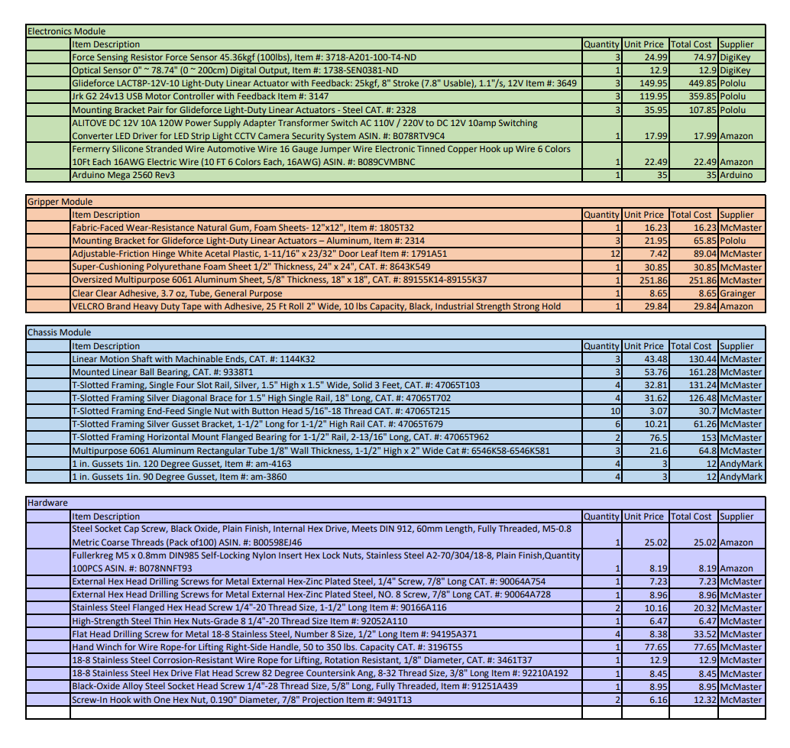
Figure 1: Bill of Materials

Appendix A- Wiring Diagrams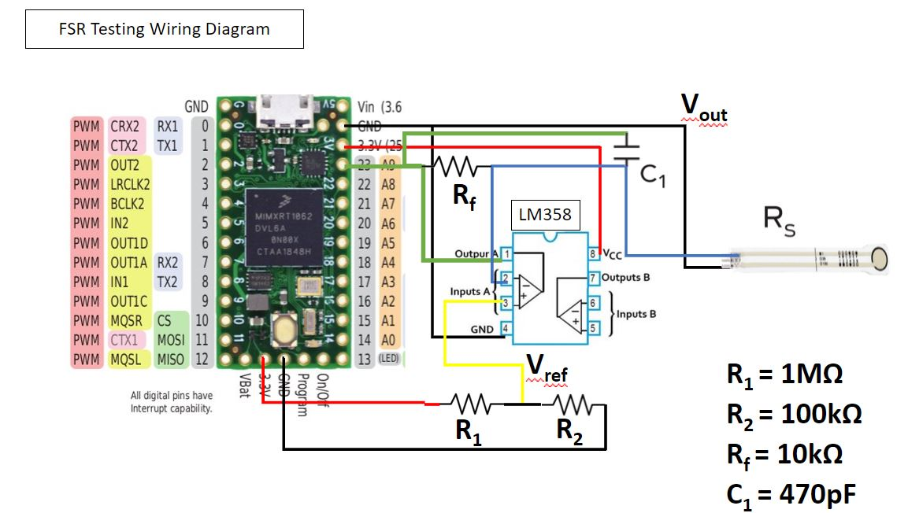
Figure 2: General FSR Wiring Diagram

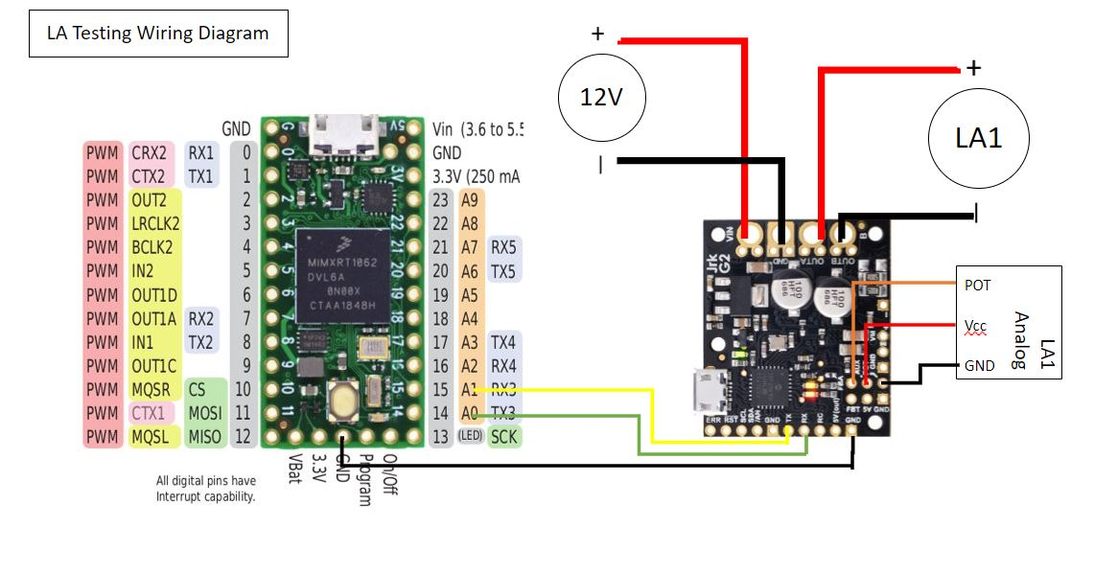
Figure 3: General Linear Actuator Wiring Diagram

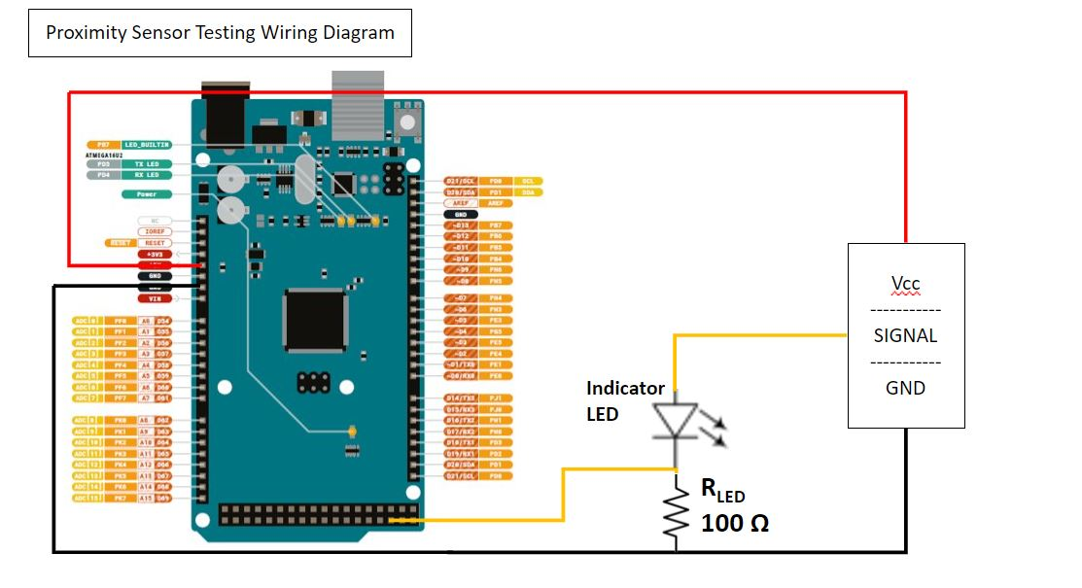
Figure 4: Proximity Sensor Wiring Diagram

Appendix B- CAD Drawings and Assembly

