Nicholas Blenker, Tucker Hall, David Wilson
FAMU-FSU College of Engineering 2525 Pottsdamer St. Tallahassee, FL. 32310

Team 503: Danfoss - Environment - Controlled Compressor Test Stand Chamber
4/12/2022

Abstract
Our project goal is to design an air control system that attaches to a plastic chamber to test compressors at different temperatures and humidity levels. Compressors are parts of air-conditioners that compress a liquid to cool down and draw moisture from the air. Each one must work in the weather where it will be used. The main issues when testing them are air leaks and heat loss through the testing cell. Our design addresses this problem by putting the air control unit right next to the chamber. This reduces the needed amount of duct, which lessens air leaks and heat transfer. All cracks and holes seal tightly to create a closed volume of air, as well. These choices allow for accurate control of inner conditions within 15 minutes. The design also stops condensed water from building up by collecting and returning it to the humidifier. Our design improves an existing design by increasing the range of cooling, humidity, and mobility, and by lowering the heat lost to the surrounding air. It features a more powerful air chiller, humidifier, and two more heaters. Ducts from these pieces attach to the chamber’s sidewalls and are easily removable. Putting the unit on the floor rather than a wall simplifies the previous design greatly. Sensors check the inner temperature and humidity levels to adjust to the user’s wanted values. This achieves hands-free testing in harsh and mild settings. Testing the compressor’s performance in each condition allows the user to find out its abilities before selling or using it. Since the system is mobile, it can attach to any large box for testing devices in common weather. In this way, our project has wide application and can help many industries.

Keywords: Environmental, Control, Testing, Chamber, Compressors.

Acknowledgment
We would like to recognize our sponsor for this project, William Bilbow of Danfoss Turbocor. Thank you for providing us with this opportunity and meeting weekly with us to keep the project on track.
We would also like to recognize our academic advisor, Keith Larson. Thank you for sharing your expertise and allowing us to use some of your materials.
Next, we want to thank Danfoss Turbocor for providing us with their materials and resources. This project would not have been possible without you.
Finally, a huge thanks to our senior design professor, Dr. Shayne McConomy. We cannot thank you enough for everything you do for the FAMU-FSU College of Engineering and your guidance with our project. Your hard work, dedication, and knowledge are an inspiration to us all and has given us the best opportunity to learn and grow.
Table of Contents
Abstract ii
Acknowledgment iii
List of Tables vi
List of Figures vii
Notation ix
Chapter One: EML 4551C 1
1.1 Project Scope 1
1.2 Customer Needs 3
1.3 Functional Decomposition 5
1.4 Target Summary 9
1.5 Concept Generation 13
1.6 Concept Selection 26
1.8 Spring Project Plan 1
Chapter Two: EML 4552C 37
2.1 Restated Project Definition and Scope 37
2.2 Results 38
2.3 Discussion 40
2.4 Conclusions 40
2.4.1 Errors 41
2.5 Future Work 41
Appendices 43
Appendix A: Code of Conduct 44
Appendix B: Functional Decomposition 52
Appendix C: Target Catalog 53
Appendix D: Operation Manual 54
Project Overview 54
Component/Module Description 54
1. Koldwave Portable Air Conditioner 54
Controls 56
2. Industrial Humidifier 57
General Safety Guidelines 57
Controls 59
3. Electric Space Heater 60
General Safety Guidelines 60
Integration of Components 61
Assembly Process 61
Other Components 61
Operation 62
Related Documents 65
Team 503: Contact Information 65
Pseudocode 66
Troubleshooting 68
Appendix A-1: Connections and Wiring Diagrams 70
Appendix B-1: Pictures 72
Appendix E: Engineering Drawings 74
Appendix F: Calculations 79
Appendix G: Risk Assessment 83
Project Control 83
Project Hazard Assessment 85
Appendix H: Arduino Code 94
References 94

List of Tables
Table 1: Customer Responses and Interpreted Needs 3
Table 2: Functional Decomposition Cross Reference Chart 7
Table 3: Critical Targets and Metrics 9
Table 4: Anti-Problem 14
Table 5: Morphological Chart 15
Table 6: Customer Requirements and Engineering Characteristics 26
Table 7: Binary Pairwise Comparison 27
Table 8: House of Quality 27
Table 9: Top Design Concepts 29
Table 10: Pugh Chart Iteration 1 29
Table 11: Pugh Chart Iteration 3 31
Table 12: Criteria Comparison Matrix 32
Table 13: Normalized Comparison Matrix 32
Table 14: Consistency Check 33
Table 15: Final Rating Matrix Transpose 34
Table 16: Alternate Value Chart 34
Table 17: Troubleshooting 69

List of Figures
Figure 1: Functional Decomposition Hierarchy Chart 6
Figure 2: Originally approved design 16
Figure 3: Duct Insulation 17
Figure 4: Increased Wall Panel Thickness 18
Figure 5: Heater Inside Duct 19
Figure 6: Hotplate with Water Dropper Humidifier 20
Figure 7: U-tube Bottom Surface 21
Figure 8: Wall-mounted AHU with detachable overhead ducts 23
Figure 9: Floor-mounted AHU with fixed side ducts 24
Figure 10: Floor-mounted AHU with detachable overhead ducts 25
Figure 11: Final Design Selection 35
Figure 12: Fall Schedule of Availability 45
Figure 13: Spring Schedule of Availability 46
Figure 14: Signed Statement of Understanding 52
Figure 15: Koldwave AC Unit (Front) 55
Figure 16: KOLDWAVE AC Unit (Back) 56
Figure 17: KOLDWAVE AC Unit (Control Panel) 57
Figure 18: KOLDWAVE AC Unit (Ambient Air Adapter) 58
Figure 19: Industrial Humidifier (Part Breakdown) 58
Figure 20: Industrial Humidifier 58
Figure 21: Industrial Humidifier (Control Panel) 60
Figure 22: Electric Space Heater 61
Figure 23: Electric Space Heater (Control Module) 61
Figure 24: LED Display 63
Figure 25: 3D Printed (Control Panel) 64
Figure 26: Basecamp (Form Invitation) 66
Figure 27: Solenoid (Button Pusher) Connections 71
Figure 28: Waterproof Heater Connections 71
Figure 29: Temperature/Humidity Sensor Connections 72
Figure 30: Stepper Motor Connections 72
Figure 32: Duct Connections (Front View) 73
Figure 33: Duct Connections (Side View) 73
Figure 34: Overall System (Side View) 74

Notation
A/C | Air Conditioning
AHU | Air Handling Unit
C | Celsius
COE | College of Engineering
F | Fahrenheit
FAMU | Florida Agricultural & Mechanical University
FSU | Florida State University
HVAC | Heating, Ventilation, and Air Conditioning
LCD | Liquid Crystal Display
RGB | Red Green Blue
RH | Relative Humidity

Chapter One: EML 4551C

1.1 Project Scope
Project Description
This project aims to validate the existing design of an environmental testing chamber and deliver an assembly that monitors and regulates its internal temperature and humidity for use in a laboratory environment.
Key Goals
The goals of this project are to complete, validate, and implement the chamber design. These include conducting a thorough heat balance analysis, modifying and finalizing the hardware and software, and overseeing the construction of the final product. The chamber is desired to be capable of fluctuating from conditions ranging from 10°C to 50°C and 0-95% relative humidity within 15 minutes. Other goals are that the compressor can be seen during testing and can be easily accessed. The final goal is to deliver a system capable of long-term testing of Danfoss Turbocor compressors.
Markets
The primary market of this project is the end-users of the environmentally controlled test chamber, Danfoss Turbocor Compressors, Inc. They will use it to test the performance of their products. Secondary markets include any individual or company which requires the chamber for testing of their own. This would consist of other compressor manufacturers, companies that provide air-conditioned storage, ecology companies, and laboratories storing sensitive substances.
Assumptions
Some assumptions were made about this project to limit its scope and maintain focus on achieving the key goals. It is assumed that the design will rest on a flat test rig that rests on a level surface. There will be access to machining services and multiple power sources including a 110V power outlet. Another presumption is that the compressor’s conductive heat is small enough to be considered negligible and hence unaccounted for. It is also assumed that the user has access to a crane capable of lifting and lowering the compressor into the test chamber. The existing support for the test chamber is assumed to have sufficient load capacity for the compressor, and the compressor’s size remains the same. These assumptions allow for concentration on the content and challenges of this project’s scope.
Stakeholders
The main stakeholders of this project are Danfoss Turbocor Compressors, Inc., William M. Bilbow, Mr. Larson, and Dr. McConomy. Each will contribute to the project in some capacity and benefit from the design. Another stakeholder would be an original equipment manufacturer (OEM) of compressors.

1.2 Customer Needs
Danfoss Turbocor, Inc. is developing an environmentally controlled test chamber to simulate the environments in which their compressors will be used. William Bilbow is the project sponsor and has provided the responses shown in Table 1 below.
Table 1: Customer Responses and Interpreted Needs
Question Asked | Customer Statements | Interpreted Needs
1. What problem(s) need to be solved? | “Build upon the previous team’s design and assemble the test chamber at the Danfoss Turbocor R&D Lab Facility.” | Adapt and tune a chamber design and build it to provide environmental control.
2. What are the expectations by the end of the project? | “Finalize the specification and sourcing of all hardware and controls.” | Ensure all hardware can reach the specified conditions.
 | “Review and confirm the heat balance analysis conducted by the previous team.” | Perform and validate the heat balance calculations done by the previous team.
 | “Tune the environmental chamber system controls to achieve stable and specified test conditions.” | Tune the controls to achieve stable and specified conditions quickly and accurately.
 | “Demonstrate fundamental 6-sigma methods of problem-solving in 1+ project challenges.” | Use fundamental 6-sigma problem-solving practices for 1 or more project challenges.
 | “Use the numbers that the previous project group used for assumptions and target values.” | The chamber must go from 10 to 55 degrees Celsius and from 10% to 95% relative humidity.
3. What is the volume of air that needs to be controlled? | “The environment of the entire chamber does not need to be controlled, just the air surrounding the compressor.” | Focus on regulating the temperature and humidity of the air surrounding the compressor.
4. What components are already in place? | “The main test rig (base and large chamber) is already in place.” | The design fits in and around the test rig and its surroundings.
 | “The supports for the compressor have already been installed.” | The design is supported by previously installed parts.
5. What are some other design considerations? | “The compressor will be installed using a crane.” | Accommodate space for the crane to install the compressor from above.
 | “The compressor should be visible from all sides during the test.” | The compressor and components are in view and the panels provide internal visibility.
The team was provided with an overview of the project background, the work completed by previous teams, and a list of the project objectives. After brainstorming the questions displayed in Table 1, responses were gathered and interpreted into the true project needs over three meetings with the sponsor. The questions were presented via Microsoft Teams meetings and responses were recorded and evaluated into interpreted needs, also shown in Table 1. The primary project needs are to ensure all hardware can regulate air from 10°C to 55°C and 10% to 95% relative humidity for the Danfoss Turbocor R&D Lab Facility. The design will need to fit within the existing test rig and allow room for installation of the compressor by crane (from above).
Based on these interpreted needs, the team will continue moving forward in validating the previous design and begin formulating ways to address any issues and necessary improvements.

1.3 Functional Decomposition
Introduction
The process of functional decomposition was used to break down the broad project scope into specific tasks that the final product needs to achieve. Establishing these basic level functions of the environmentally controlled test chamber allows the group to easily identify the targets and metrics of the project.
Data Generation
The functions displayed in the hierarch chart (Figure 1) below were a result of asking what the tasks are that the chamber needs to perform. Answers to this question were found by conducting a thorough analysis of the project description, assumptions, key goals, and customer needs. Once all functions were determined, they were classified into major and minor functions based on their importance in delivering a test chamber capable of simulating the necessary conditions.
Flow Chart Reasoning
The three main systems which the testing chamber comprises of are: support, control, and accessibility. Support includes the tasks pertaining to the structural stability and keeping the compressor secure. The control system entails the functions relating to the monitoring and manipulation of the heating, cooling, humidifying, and dehumidifying components. Accessibility covers the visibility and access to the compressor, clearance for the overhead crane, and display and adjustment of the chamber’s temperature and humidity. Breaking down the test chamber into these three systems ensures that the goals and interpreted needs from the sponsor will be met.
These include:
- Building a testing chamber to be used in a lab to simulate environmental conditions.
- Providing access to the test chamber from any angle depending on the lab environment.
- Raising and lowering temperature and relative humidity around a compressor to specified values within the specified time period (15 minutes)
The control of the system is separated into control of the temperature, humidity, and airflow in order to maintain the desired climate conditions. For each of these subsystems, the chamber will monitor and manipulate each condition as necessary. Accessibility is divided into two subsystems, chamber accessibility and climate control.

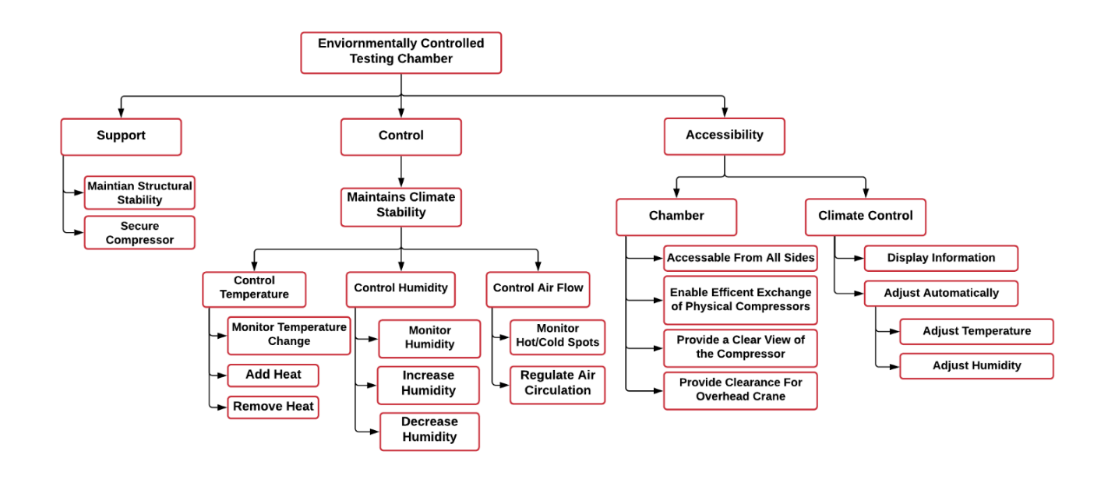
Figure 1: Functional Decomposition Hierarchy Chart

Connection to Systems
A visual comparison of the functions and their relation to each system is shown in the functional decomposition cross reference chart in Table 2 below. The X’s indicate which system(s) each function influences, which can be more than one.

Table 2: Functional Decomposition Cross Reference Chart
System Functional Decomposition
Function | Support | Control | Accessibility
Maintain Structural Stability | X
Secure Compressor | X
Add Heat |  | X
Remove Heat |  | X
Increase Humidity |  | X
Decrease Humidity |  | X
Regulate Air Circulation |  | X
Accessible From All Sides |  |  | X
Enable Efficient Exchange of Physical Compressors |  |  | X
Provide a Clear View of the Compressor |  |  | X
Provide Clearance for Overhead Crane |  |  | X
Adjust Temperature |  | X | X
Adjust Humidity |  | X | X
Integration
The functions of the chart were made to be interrelated to each other on a row-by-row basis. The stability of the climate and the structure itself both describe the need for the chamber to be secure and stable. Within the control branch, each row describes the same needs but for different portions of the project that need to be monitored and controlled. Also, when adjusting the temperature, the relative humidity will be adjusted as described in a psychrometric chart. To control the humidity or temperature, the airflow must also be controlled appropriately to add or remove air with the desired conditions. The adjustment of temperature and humidity from the accessibility branch is also related to the control since it describes that accessibility to the controls must be provided in order to control the system.
Action and Outcome
The outcome of this project is to assemble and implement a working environmental control system that adjusts temperature and relative humidity for testing compressors. The control system will be able to control to and from a range of desired temperatures and humidity. This chamber is to allow for installation, access, and visibility of the tested compressor at all times.

1.4 Target Summary
Development of the critical targets and metrics is necessary for all designs to determine their success once the design is completed. Targets are specific values used to design for, which are found by analyzing the required functions of the system, and metrics are the means of measuring or validating that a target is met (size, weight, temperature, etc.). The critical targets and metrics for the Environmentally Controlled Test Chamber are listed in Table 3 below. Other targets and metrics not relating to a function, but were customer requirements, are noted in Appendix C. The entire functional decomposition chart relating to each target and metric can be found in Appendix B.
Table 3: Critical Targets and Metrics
Functions | Metric | Target | Description
Increase and Decrease Humidity | Relative Humidity | 0-95% RH | Relative humidity is desired to reach any value in this range
Add and Remove Heat | Temperature | 10°C ≤ T ≤ 55°C | Temperature is desired to reach any value in this range
Regulate Air Circulation | Volumetric Flow Rate | 1 m³/min | Air handling unit should be capable of providing this flow rate
Maintain Structural Stability | Deformation | ~ 5% | Chamber should not move or deform
Provide Clearance for Overhead Crane | Area | OSHA requires only 2” of clearance on the side and 3” above. | There should be no obstructions in the way of the crane
Display Information | Display Temperature and Humidity | Yes, they are always displayed during testing | Temperature and humidity will be always shown
Adjust Temperature and Humidity Automatically | Automatic Adjustment | No human action required to reach the desired conditions | Desired temperature and humidity are reached automatically by the system

Determination of Critical Targets and Metrics
The critical functions for the success of this project are summarized in Table 3 above. The critical targets and metrics were chosen because they relate directly to the key functions of the test chamber. The first critical target is for the air surrounding the compressor to be controlled in a range of 0% to 95% relative humidity. The metric (relative humidity) will be manipulated and maintained by implementing feedback control. In addition to humidity, the chamber’s temperature must be manipulated and maintained within a range of 10°C to 55°C. Feedback control will also be used to control the temperature metric recorded by a sensor within the control volume. To provide adequate heat and humidity to the control volume, the air-flow must be able to reach 1 m³/min. This target was determined by performing a heat balance analysis of the system, including the control volume, ductwork, and infiltration.
Another critical function of the design is to provide sufficient structural stability. Since the system must be stable and sturdy, its structure needs to be strong and rigid. In other words, the chamber cannot move or deform during testing and will be able to support its own weight. The metric was chosen to be deformation, the standard method of measuring structural stability, and its target is 0%. This applies not only to the base and frame of the chamber, but also the doors, which need to seal the chamber from the outside air to prevent infiltration.
It is also important to provide sufficient space for the compressor to be loaded into the chamber by an overhead crane. Based on regulations by OSHA, the target clearance is 2 inches on the sides and 3 inches above. This means that there should be an opening with at least this clearance compared to the crane on top of the control volume, and the ductwork should not be in the way of the crane during the exchange. The climate conditions of the control volume should also be displayed to the user, so the target is that the temperature and humidity values are indeed always displayed to the user during the testing process. Finally, it is key that the temperature and humidity are adjusted automatically. As a result, the design aims to require zero human interaction in order to reach the desired conditions once the temperature and humidity are chosen.
Methods of Validation
The means of validating each target includes the tools used as well as the methods of testing which will be conducted. The first method of validation will be a small-scale test of the controls and display of the system to make sure that all components can be easily controlled and that the temperature and relative humidity is accurately measured and displayed. The final system will then be tested once it is installed at the Danfoss Turbocor R&D Lab Facility to validate each target. An extensive test will be run to ensure that the control volume can reach any condition within 10°C to 50°C and 0% to 95% relative humidity. The flow rate will be determined by measuring the air velocity through the ductwork with a pitot-static tube and multiplying this value by the cross-sectional area of the duct.
To validate the structural stability of the design, the chamber will be bumped and pushed to observe if the components break apart or deform. When the compressor is loaded into the chamber by the overhead crane, it will be clear whether there is adequate space for installing the compressor from above. Finally, the full-scale test will indicate if the display system properly displays the climate conditions to the user and if the system automatically adjusts the temperature and relative humidity to the desired values. The control system will require tuning, which will consist of modifying the controller gains to meet the desired time limit of 15 minutes. Separate temperature and humidity sensors will be used to compare results and ensure that the control volume’s conditions are accurately measured. All measurements will be taken in SI units during testing and validation.

1.5 Concept Generation
In order to come up with a good design for our project, 100 design concepts of varying fidelities were made by incorporating multiple ideation processes. Our team used biomimicry, antiproblem, crapshoot, morphological analysis as tools to generate the concept ideas. The best eight concepts were chosen and are described in detail below as medium and high-fidelity concepts. All 100 concepts are tabulated and displayed in Appendix D. Reaching 100 ideas was challenging since this was completed once before for this project but was made possible by imagination and concept generation tools.
Biomimicry
Our team used biomimicry the practice of using inspiration from animals and natural phenomena and adapting this into engineering solutions. Multiple biological systems were analyzed to result in innovative designs to control temperature and humidity within the chamber.
By designing an intricate system of porous walls, termites create their own natural air conditioning system which uses the increase surface area to heat and cool their mounds. The mound’s shape allows for warmer air to move upwards, leaving cooler air at the bottom, similar to how a chimney works. This concept has employed by engineers into building design for more efficient energy usage. For our application, this design can be scaled down by adding extrusions into the vertical portion of the ductwork above the test chamber.
Tropical dog tics can absorb moisture from the air around them using a fluid which they secrete. This concept has been used by engineers in the past to make liquid desiccant dehumidifiers which use salt solutions to pull humidity from the air in buildings. This could be used in our case to more rapidly remove the water from the air inside of the chamber by attaching it to our vent system.
Clams have grooved backs which allow them to more easily glide through the water without being caught by waves or currents. This may be used in order to modify the shapes of fan fins or the ventilation to improve the air flow of the ventilation system.
Another practice our team used was our own version of biomimicry, “baby mimicry” which looks at baby incubators which are relatively like a control chamber. Baby incubators are used to provide a safe controlled space for infants to develop their vital organs, which is an excellent to look for inspiration on ways the chamber can be improved to provide a consistent desired environment.
Anti-Problem
Another concept generation technique is anti-problem, where designers analyze the desired goals of a product and all of the challenges or issues that could arise in trying to achieve these goals. This technique can be helpful in shifting the perspective from how to optimize a design towards the possible failures that may occur which could otherwise be overlooked. Table 4, shown below, displays the challenge, anti-problem, reverse solution, and a possible solution to this challenge.
Table 4: Anti-Problem
Challenge | Anti-Problem | Reverse Solution | Possible Solution
How do we make the interior chamber accessible? | What can we do to make the chamber inaccessible? | - Make walls completely opaque and sealed  - Make chamber dangerous  - No openings or doors  - Make chamber too big to fit into the lab | - Keep the chamber walls see-through  - Make sure the chamber is safe for use  - Allow the chamber to be opened  - Make the chamber compact
How do we control the temperature and humidity? | How do we make the temperature and humidity uncontrolled? | - No feedback or sensors  - Make inputs random  - Make everything run randomly  - No off switch | - Make sure sensors are placed and working  - Allow outside inputs  - Use a feedback controller
How do we maintain the stability of our additional parts? | How do we make the ventilation and equipment unstable? | - Place the equipment on unstable surfaces  - Have the equipment freely standing or hanging  - Place equipment in the way of other moving parts | - Make sure the equipment is securely fastened  - Keep ventilation and parts clear from other lab equipment  - Attach the equipment to nonobtrusive surfaces like the walls or ceiling
How do we keep the chamber insulated? | How do we make the chamber have high heat transfer? | - Add in holes for leakage.  - Remove walls  - Make walls have their own heat generation  - Add a thin layer of highly conductive material around the chamber | - Keep walls secure and sealed during testing  - Have leak detection and ways to seal them
Morphological Chart
We also used a morphological chart as a generation tool. To do this, we created a chart using various requirements of the design and then connected an idea from each column to each other to make a full idea using them. This technique was used to make 50 concepts. The morphological chart is shown below in Table 5.
Table 5: Morphological Chart
Mount AHU | Route Ductwork to Chamber | Ductwork | Increase Humidity | Decrease Humidity | Provide Cooling | Connect Ducts | Insulate Ducts
Wall-mounted | Ductwork attached to roof | Flexible ductwork | Boiler humidifier | No dehumidifier | Air-cooled chiller | Duct tape | Fiberglass  insulation
Floor-mounted | Ductwork attached to floor | Rigid ductwork | Ultrasonic humidifier | Heat pump dehumidifier | Water-cooled chiller | Screws/nails | Polyethylene  insulation
Brainstorming
Brainstorming, the most basic and classic method of concept generation, was also used to come up with a portion of the 100 concepts. The individual and collective creativity of the group was utilized to develop as many ideas as possible, with no restrictions on feasibility or practicality. These ideas were then narrowed down into the 100 concepts, shown in Appendix D.
Medium Fidelity Concepts
Since the previous team has created an approved design from Danfoss our medium fidelity concepts are designs that would improve or make the existing design more efficient.
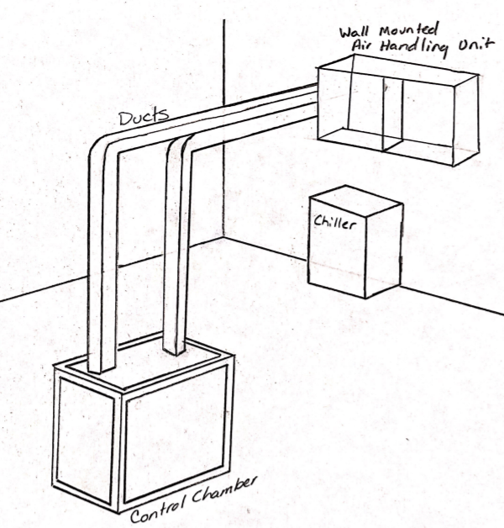
Figure 2: Originally approved design

Concept 1. Duct Insulation
This concept is adding insulation to the ductwork in order to increase the fractional increase in thermal resistance.
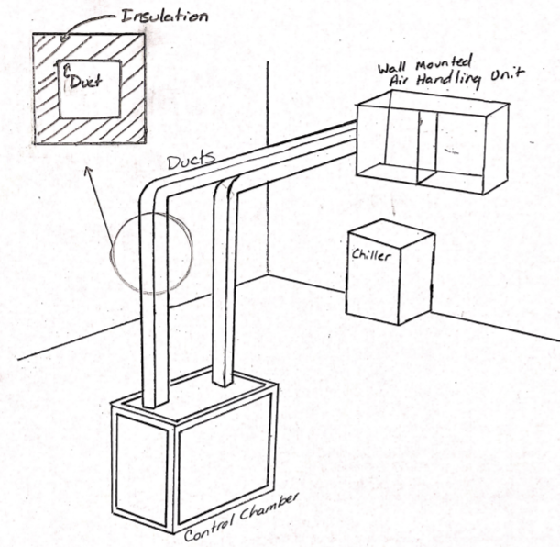
Figure 3: Duct Insulation

Concept 2: Increased Wall Thickness
This concept increases the wall thickness of the material used for the walls of the control chamber.
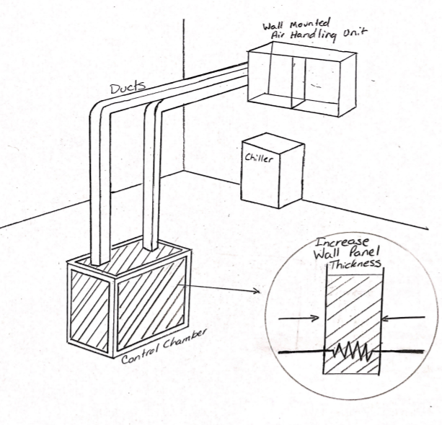
Figure 4: Increased Wall Panel Thickness

Concept 3: Heater Inside Duct
This concept places a heater inside the duct in order to increase the heat of the air entering the chamber. This duct heater is a way to increase the heat of the surrounding air used to help control the environment of the chamber. Duct heaters allow increased humidity control, and machinery pre-heating.
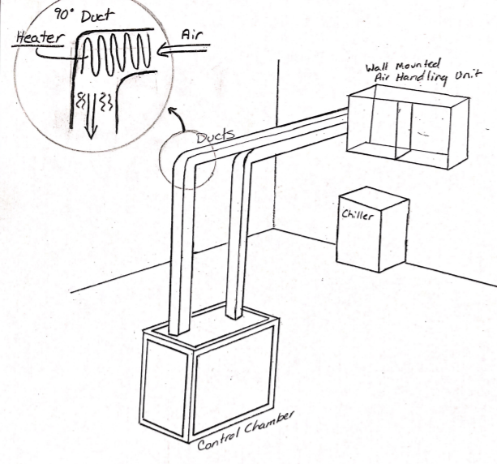
Figure 5: Heater Inside Duct

Concept 4: Hotplate with Water Dropper Humidifier
A hotplate placed in the chamber as a heating element to increase the overall temperature and heat of the chamber. The water droplet controller is positioned and secured over the hotplate where it would release water droplets onto the hotplate increasing the overall humidity of the chamber.
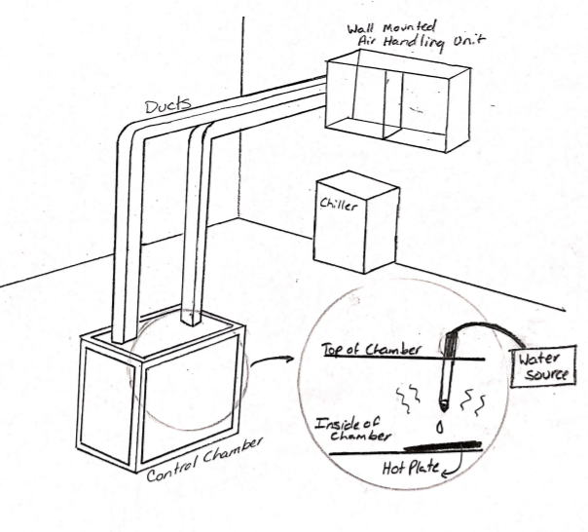
Figure 6: Hotplate with Water Dropper Humidifier

Concept 5: U-tube Bottom Surface
This concept uses an extra bit of fluid tubing connected to its own fluid conditioning cycle which goes through the chamber to heat or cool the surrounding volume during while the humidity is controlled via a separate boiler system. These are attached to the chamber via tubes of their own, which pump the fluid through. The fluid tubing will be set up similarly to a u-tube, which can be used as a primary source of heat transfer within systems. The tubing could minimize hot and cold spots within the chamber by being placed nominally.
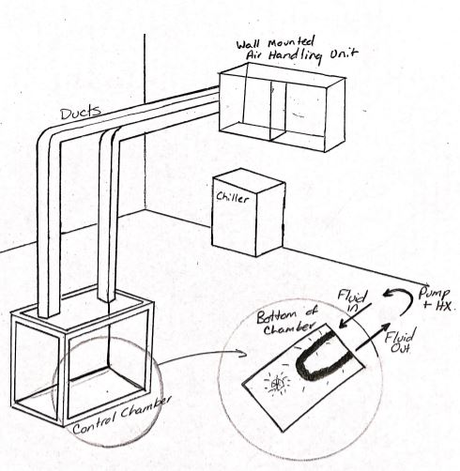
Figure 7: U-tube Bottom Surface

High Fidelity Concepts
Wall-Mounted AHU with Detachable Overhead Ducts
In this design, ducts are detachable using screw on connections, which allows the crane to insert and remove the compressor from above without issue. This also means that the system could be moved to a different location and the ductwork could simply be extended to the new location. The ducts will be made of a rigid material and covered by insulation to prevent as much condensation and heat transfer out of the system as possible. By placing the AHU on the wall, more floor area is available for other lab equipment in the facility. The chamber also has putty infiltration seals placed inside due to holes in the bottom of the chamber which normally allow wires through but also cause extra convection transfer. The putty would be placed in these holes to minimize the convection that occurs. The design also proposes to have rubber inserts seal the edges of the chamber where the plexiglass walls meet the aluminum frame and would otherwise allow for significant infiltration. These inserts will not affect the accessibility of the compressor. To account for condensation pooling within the ducts, several dips will be added into the horizontal portion of ductwork, which should be drained following each test cycle or once significant condensation accumulates.
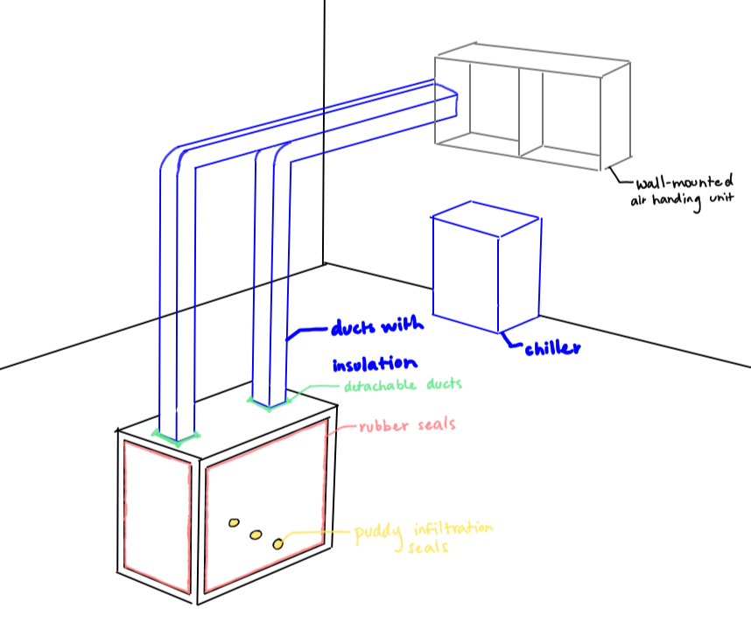
Figure 8: Wall-mounted AHU with detachable overhead ducts
Floor-Mounted AHU with Fixed Side Ducts
In this design, ducts are fixed to their positions with nuts and bolts, which keep them more stable in their positions and lowers the chance that they will be knocked over or broken. Since they are rigidly attached, they will need to be placed around the other equipment in the room and so that they do not obstruct the overhead crane which moves the compressor. The ducts will be made of a flexible material so that they can be bent around obstacles and covered with insulation to prevent significant condensation and heat transfer with the surrounding lab environment. The floor-mounted air handling unit heats and humidifies the air while the chiller cools it down and dehumidifies it. Placing the AHU on the floor allows for easier installation and eliminates the issue of making sure that the wall and supporting brackets provide sufficient support for the heavy components. The chamber also has putty infiltration seals placed inside due to holes in the bottom of the chamber which normally allow wires through but also cause extra convection transfer. The putty would be placed in these holes to minimize the convection that occurs. The design also proposes to have double-layered plexiglass walls and rubber seals around the edges of the plexiglass to minimize heat transfer and infiltration. By using double-layered walls, heat transfer is reduced significantly, and less condensation will accumulate on the walls to allow for more visibility of the compressor. To account for condensation pooling within the ducts, several sponges will be placed inside, and the ductwork will have several connections in order to drain any excess condensation after testing.
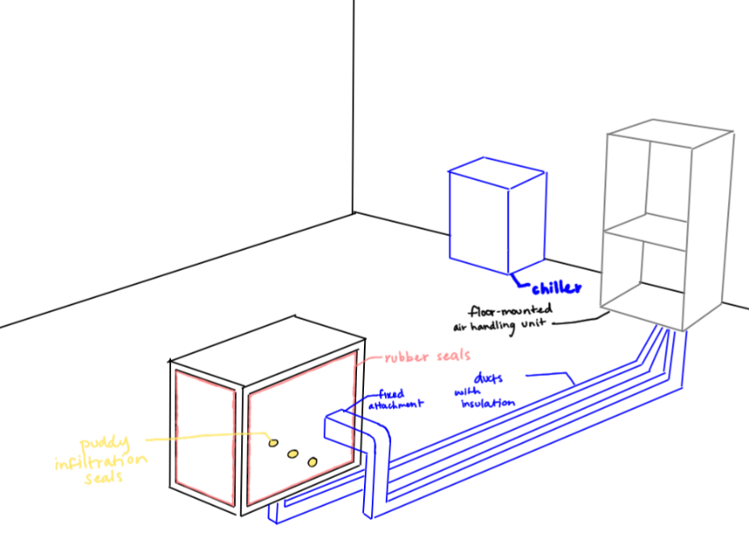
Figure 9: Floor-mounted AHU with fixed side ducts
Floor-Mounted AHU with Detachable Overhead Ducts
In this design, ducts are detachable using a snap-on connection, which allows for quick attachment and removal of the ducts to insert and remove the compressor with a crane from above. This also means that the system could be moved to a different location and the ductwork could simply be extended to the new location. The ducts will be made of a rigid material and covered with insulation to prevent as much condensation and heat transfer out of the system as possible. The floor-mounted air handling unit heats and humidifies the air while the chiller cools it down and dehumidifies it. Placing the AHU on the floor allows for easier installation and relocation and eliminates the issue of ensuring that the wall and supporting brackets provide sufficient load capacity for the heavy system. The chamber also has putty infiltration seals placed inside due to holes in the bottom of the chamber which normally allow wires through but also cause extra convection transfer. The putty would be placed in these holes to minimize the convection that occurs. The design also proposes to have the outside of the chamber sealed with an extra layer of rubber to prevent as much leakage as possible while not sacrificing the user’s access to the chamber itself. With a duct close off or open the airway to further control the airflow from the air handling unit to the chamber.
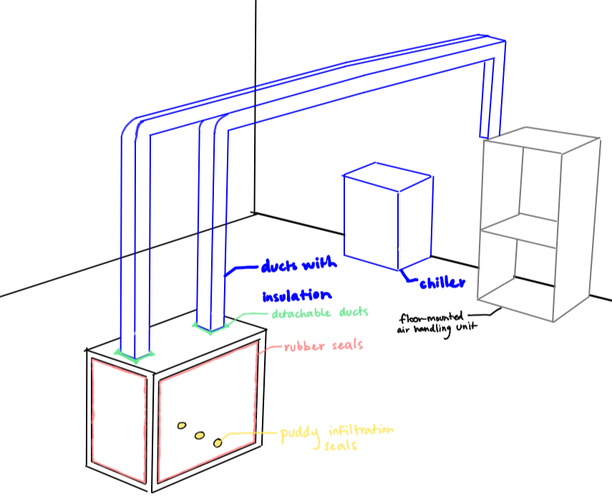
Figure 10: Floor-mounted AHU with detachable overhead ducts

1.6 Concept Selection
Once the concept generation process was completed, the concept selection process began by using standard design selection methods including binary pairwise comparison of design criteria, House of Quality, Pugh charts, and the Analytical Hierarchy Process. These tools were used to minimize bias during the selection phase and improve the feasibility of the final design.
Binary Pairwise
The binary pairwise comparison chart, shown below in Table 7, was used to analyze the customer needs obtained from the project sponsor. A more detailed list of customer needs can be found in Table 6.
Table 6: Customer Requirements and Engineering Characteristics
# | Customer Requirements | Engineering Characteristics
1 | The compressor and all ductwork will be adequately supported | Provide support
2 | The control volume will reach 10-50C and 0-95% relative humidity | Manipulate temperature and humidity
3 | The air flow will be controlled | Regulate air circulation
4 | The compressor will be accessible within a reasonable amount of time | Provide access
5 | Clearance will be provided for the overhead crane | Provide clearance
6 | The temperature and humidity of the control volume will be displayed | Display conditions
7 | The temperature and humidity of the control volume will be measured | Monitor conditions
8 | The compressor will be visible at all times during testing | Provide visibility
9 | The conditions of the chamber will be automatically adjusted | Automate control
This comparison chart works by judging if the row is more important than the column (1) or vice versa (0). These results provided an importance weight factor for each criterion, showing that manipulating temperature and humidity is the highest priority of the design. This importance weight factor was then utilized in the house of quality chart, shown in Table 8, to rank the outcomes of the environmentally controlled test chamber. Further detail of the engineering characteristics can be found in Table 6.
Table 7: Binary Pairwise Comparison
Binary Pairwise Comparison
Customer Needs | #1 | #2 | #3 | #4 | #5 | #6 | #7 | #8 | #9 | Total
#1 | - | 0 | 0 | 0 | 0 | 1 | 0 | 0 | 0 | 1
#2 | 1 | - | 1 | 1 | 1 | 1 | 1 | 1 | 1 | 8
#3 | 1 | 0 | - | 0 | 0 | 1 | 0 | 1 | 0 | 3
#4 | 1 | 0 | 1 | - | 0 | 1 | 0 | 1 | 0 | 4
#5 | 1 | 0 | 1 | 1 | - | 1 | 0 | 1 | 0 | 5
#6 | 0 | 0 | 0 | 0 | 0 | - | 0 | 0 | 0 | 0
#7 | 1 | 0 | 1 | 1 | 13 | 1 | - | 1 | 0 | 6
#8 | 1 | 0 | 0 | 0 | 0 | 1 | 0 | - | 0 | 2
#9 | 1 | 0 | 1 | 1 | 1 | 1 | 1 | 1 | - | 7
Total | 7 | 0 | 5 | 4 | 3 | 8 | 2 | 6 | 1 | n-1=8

House of Quality
The House of Quality chart compares the engineering characteristics, or decomposed functions, against the requirements expressed by the customer. The importance weight factor of each requirement is used to rank how well each characteristic fit that need. The result is a complete ranking of engineering characteristics by importance of the final chamber design.
Table 8: House of Quality
House of Quality | Engineering Characteristics
Improvement Direction | ↓ | ↑ |  | ↑ | ↓ | ↑ |  |  | ↑
Units |  | m | °C % | cfm | t | m | - | - | % | -
Customer Requirements | IPF | #1 | #2 | #3 | #4 | #5 | #6 | #7 | #8 | #9
#1 | 1 | 9 |  |  | 1 | 1
#2 | 8 |  | 9 | 3 | 1 |  | 3 | 3 | 1 | 3
#3 | 3 |  | 9 | 9 | 3 |  |  | 1 | 3 | 3
#4 | 4 |  |  |  | 9 |  |  |  |  | 3
#5 | 5 | 1 |  |  |  | 9
#6 | 0 |  | 3 |  |  |  | 9 | 9 |  | 3
#7 | 6 |  | 3 | 1 | 3 |  | 9 | 9 | 1 | 3
#8 | 2 |  | 1 | 1 |  |  |  | 1 | 9
#9 | 7 |  | 3 | 3 | 3 |  | 3 | 3 |  | 9
Raw Score | 743 | 14 | 140 | 80 | 93 | 46 | 99 | 104 | 41 | 126
Relative Weight |  | 1.9 | 18.8 | 10.8 | 12.5 | 6.2 | 13.3 | 14.0 | 5.5 | 17.0
Rank Order |  | 9 | 1 | 6 | 5 | 7 | 4 | 3 | 8 | 2
From the results presented in the House of Quality chart, the most important functions are manipulating temperature and humidity, automatic control, monitoring the chamber conditions, and displaying those conditions. These top four functions were later used as criteria for AHP comparison charts and subsequently the alternative value chart. On the other hand, the least important functions are providing clearance, visibility, and support. This information helps to evaluate the viability of each concept objectively and quantitatively. By using this process, concepts that may seem favorable at first glance can be judged more accurately in comparison to other concepts.

Pugh Chart
A Pugh chart is a method of design selection which compares a set of medium and high-fidelity designs and compares each of them to a selected datum or reference. The chart indicates whether a concept is favorable by determining if each criterion is met better (+), worse (-), or satisfactorily (S) when compared to this reference.
The top concepts generated from the previous section are compared to the design functions of each. The to a visit eight concepts that were chosen from concept generation have been adjusted to represent a floor-mounted this is due to a visit that occurred over at the Danfoss lab facility, where the wall space did not seem suitable to mount an air-handling unit. The floor mounted unit was favored when discussing and visiting with Jerry Huang the paired engineer.
Table 9: Top Design Concepts
Top 8 Concepts
# | Description | Fidelity
1 | Floor-mounted AHU with duct insulation | Medium
2 | Floor-mounted AHU with increased wall thickness | Medium
3 | Floor-mounted AHU with heater inside duct | Medium
4 | Floor-mounted AHU with hotplate and water dropper humidifier | Medium
5 | Floor-mounted AHU with vein-like inner surface of chamber | Medium
6 | Wall-mounted AHU with detachable overhead ducts, putty infiltration seals, rubber inserts, and dips inside ductwork | High
7 | Floor-mounted AHU with fixed side ducts, putty infiltration seals, double-layered walls, and sponges inside ductwork | High
8 | Floor-mounted AHU with detachable overhead ducts, putty infiltration seals, rubber inserts, and a duct close off inside ductwork | High

In the first iteration of the Pugh chart, shown in Table 10, the datum was selected to be the existing design chosen by the previous team. The results from this chart clearly show that concepts 6, 7, and 8 were most favorable, which were chosen for the second iteration of the Pugh chart in Table 17. Concept 1 became the datum since it was the least polarizing design along with concept 3, and was the simpler of the two.
Table 10: Pugh Chart Iteration 1
Pugh Chart: Iteration 1
Function |  | Concepts
 |  | 1 | 2 | 3 | 4 | 5 | 6 | 7 | 8
Provide support | Datum | S | S | S | S | S | S | - | S
Manipulate conditions |  | + | + | + | + | + | + | + | +
Regulate circulation |  | S | S | S | S | S | + | + | +
Provide access |  | S | S | S | S | S | + | + | +
Provide clearance |  | S | S | S | S | S | S | S | S
Display conditions |  | S | S | S | S | S | S | S | S
Monitor conditions |  | S | S | S | S | S | S | S | S
Provide visibility |  | S | - | S | - | - | S | + | S
Automate control |  | S | S | S | S | S | S | S | S
Plus (+) |  | 1 | 1 | 1 | 1 | 1 | 3 | 4 | 3
Satisfactory (S) |  | 8 | 7 | 8 | 7 | 7 | 6 | 4 | 6
Minus (-) |  | 0 | 1 | 0 | 1 | 1 | 0 | 1 | 0
The second iteration of the Pugh chart consisted of the concepts which were at least satisfactory for the criteria that were deemed highly important. This was done in order to prevent criteria of low importance from causing a design to be overlooked.
A third iteration of the Pugh chart was also performed to do an analysis on two of the top 3 design concepts, using concept 8 as datum, as well as concept 1 to see how the less polarized concepts from chart 1 would fare in comparison to the others. It was determined that Concept 1 was insufficient for the final design. However, concept 3, which had a similar score to concept 1 in Pugh chart 1, is still used later in the AHP Design Alternatives charts.
Table 11: Pugh Chart Iteration 3
Pugh Chart: Iteration 3
Function | Concept 8 | Concept 1 | Concept 7
Provide Support | Datum | S | -
Manipulate conditions |  | S | S
Regulate circulation |  | - | -
Provide access |  | S | +
Provide clearance |  | + | +
Display conditions |  | S | S
Monitor conditions |  | S | S
Provide visibility |  | - | +
Automate control |  | S | S
Plus (+) |  | 1 | 3
Satisfactory (S) |  | 6 | 4
Minus (-) |  | 2 | 2
Analytical Hierarchy Process
Another method that was used for determining the importance of the chosen criteria was an analytical hierarchy process (AHP), which determines the importance of each of the criteria relative to its other. These criteria are compared on a scale of odd numbers from 1 to 9. When comparing two criteria, A and B, a 9 means criteria A is much more important than criteria B, while if the comparison is given a 1, the two criteria are equally important. The inverse value was then placed on the opposite side of the table, as seen in Table _. The columns represent criteria A, and the rows represent criteria B. After summing each column, the most important criteria were determined to be manipulating temperature and humidity, which corresponds to the lowest sum of the columns. The least important, on the other hand, was found to be providing visibility.
Table 12: Criteria Comparison Matrix
Criteria Comparison Matrix
Customer  Needs | #1 | #2 | #3 | #4 | #5 | #6 | #7 | #8 | #9
#1 | 1.00 | 0.11 | 0.33 | 1.00 | 1.00 | 3.00 | 0.33 | 1.00 | 0.33
#2 | 9.00 | 1.00 | 3.00 | 5.00 | 5.00 | 9.00 | 1.00 | 7.00 | 3.00
#3 | 3.00 | 0.33 | 1.00 | 3.00 | 3.00 | 5.00 | 1.00 | 7.00 | 1.00
#4 | 1.00 | 0.20 | 0.33 | 1.00 | 1.00 | 3.00 | 0.33 | 1.00 | 0.33
#5 | 1.00 | 0.20 | 0.33 | 1.00 | 1.00 | 1.00 | 0.20 | 0.33 | 0.14
#6 | 0.33 | 0.11 | 0.20 | 0.33 | 1.00 | 1.00 | 0.14 | 0.33 | 0.14
#7 | 3.00 | 1.00 | 1.00 | 3.00 | 5.00 | 7.00 | 1.00 | 5.00 | 0.33
#8 | 1.00 | 0.14 | 0.14 | 1.00 | 3.00 | 3.00 | 0.20 | 1.00 | 0.14
#9 | 3.00 | 0.33 | 1.00 | 3.00 | 7.00 | 7.00 | 3.00 | 7.00 | 1.00
Sum | 22.33 | 3.43 | 7.34 | 18.33 | 27.00 | 39.00 | 7.21 | 29.67 | 6.43

In order to ensure consistency, the table was normalized by dividing each cell in each column by the sum of that column. Then each row was averaged to get the criteria weight (W) for each row.
Table 13: Normalized Comparison Matrix
Normalized Criteria Comparison
Criteria | #1 | #2 | #3 | #4 | #5 | #6 | #7 | #8 | #9 | Criteria  Weight
#1 | 0.04 | 0.03 | 0.05 | 0.05 | 0.04 | 0.08 | 0.05 | 0.03 | 0.05 | 0.05
#2 | 0.40 | 0.29 | 0.41 | 0.27 | 0.19 | 0.23 | 0.14 | 0.24 | 0.47 | 0.29
#3 | 0.13 | 0.10 | 0.14 | 0.16 | 0.11 | 0.13 | 0.14 | 0.24 | 0.16 | 0.14
#4 | 0.04 | 0.06 | 0.05 | 0.05 | 0.04 | 0.08 | 0.05 | 0.03 | 0.05 | 0.05
#5 | 0.04 | 0.06 | 0.05 | 0.05 | 0.04 | 0.03 | 0.03 | 0.01 | 0.02 | 0.04
#6 | 0.01 | 0.03 | 0.03 | 0.02 | 0.04 | 0.03 | 0.02 | 0.01 | 0.02 | 0.02
#7 | 0.13 | 0.29 | 0.14 | 0.16 | 0.19 | 0.18 | 0.14 | 0.17 | 0.05 | 0.16
#8 | 0.04 | 0.04 | 0.02 | 0.05 | 0.11 | 0.08 | 0.03 | 0.03 | 0.02 | 0.05
#9 | 0.13 | 0.10 | 0.14 | 0.16 | 0.26 | 0.18 | 0.42 | 0.24 | 0.16 | 0.20
Sum | 1.00 | 1.00 | 1.00 | 1.00 | 1.00 | 1.00 | 1.00 | 1.00 | 1.00 | 1.00

A consistency vector was then created by dividing the weighted sum vector by the criteria weight as shown in the table below. Finally, a consistency ratio was calculated, which is ideally below 0.1. Since the consistency ratio was found to be 0.05, the results are acceptable.
Table 14: Consistency Check
Consistency Check
Customer  Needs | Weighted Sum  Vector (Ws) | Consistency  Vector (Cons)
#1 | 0.45 | 9.60
#2 | 2.88 | 9.84
#3 | 1.45 | 10.05
#4 | 0.48 | 9.57
#5 | 0.34 | 9.35
#6 | 0.22 | 9.51
#7 | 1.54 | 9.55
#8 | 0.45 | 9.29
#9 | 1.97 | 9.95
Lambda: |  | 9.63
Consistency Index: |  | 0.08
Random Index: |  | 1.45
Consistency Ratio: |  | 0.05
Is it consistent? |  | YES

The process described above was completed for each criterion and used to evaluate the final 4 concepts: Concept #3: Floor-mounted AHU with heater inside duct, Concept #6: Wall-mounted AHU with detachable overhead ducts, putty infiltration seals, rubber inserts, and dips inside ductwork, Concept #7: Floor-mounted AHU with fixed side ducts, putty infiltration seals, double-layered walls, and sponges inside ductwork, and Concept #8: Floor-mounted AHU with detachable overhead ducts, putty infiltration seals, rubber inserts, and a duct close off inside ductwork. The computed consistency ratios along with all the comparison charts are shown in Appendix E.
The final rating matrix, shown in Table 15, displayed the weight of criteria for each of the 4 concepts. These weights were calculated using the criteria comparison matrices, which are then used in the following chart to compute the alternate value.
Table 15: Final Rating Matrix Transpose
Final Rating Matrix Transpose
 | Criteria #1 | Criteria #2 | Criteria #3 | Criteria #4
Concept #3 | 0.250 | 0.100 | 0.100 | 0.129
Concept #6 | 0.250 | 0.300 | 0.300 | 0.388
Concept #7 | 0.250 | 0.300 | 0.300 | 0.304
Concept #8 | 0.250 | 0.300 | 0.300 | 0.179
Table 16: Alternate Value Chart
Concept | Alternative Value
Concept #3: Floor-mounted AHU with heater inside duct | 0.145
Concept #6: Wall-mounted AHU with detachable overhead ducts, putty infiltration seals, rubber inserts, and dips inside ductwork | 0.321
Concept #7: Floor-mounted AHU with fixed side ducts, putty infiltration seals, double-layered walls, and sponges inside ductwork | 0.296
Concept #8: Floor-mounted AHU with detachable overhead ducts, putty infiltration seals, rubber inserts, and a duct close off inside ductwork | 0.272
The alternate value chart compares each criterion weight with the score that each concept received in the final rating matrix. The results showed that concept 6 was the most viable concept to move forward with due to its high score.
Final Selection
Team 503’s final selection was chosen as concept 6, which was a wall-mounted AHU with detachable overhead ducts, putty infiltration seals, rubber inserts, and dips inside ductwork. However, due to a recent visit to Danfoss’s facility, having a wall-mounted unit has been determined to be undesirable. However, switching to a floor-mounted version of the same concept is a negligible change, as the primary aspects of the design are the attachments and additional equipment. The design is the best because the dipping ductwork provides an effective manner of releasing excess duct moisture while the detachable manner of the ducts allows it to be better at providing access to the chamber and slightly improving the ability to monitor the internal conditions of the chamber. 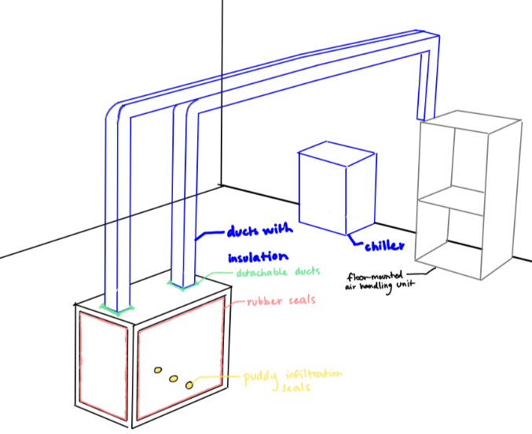
Figure 11: Final Design Selection

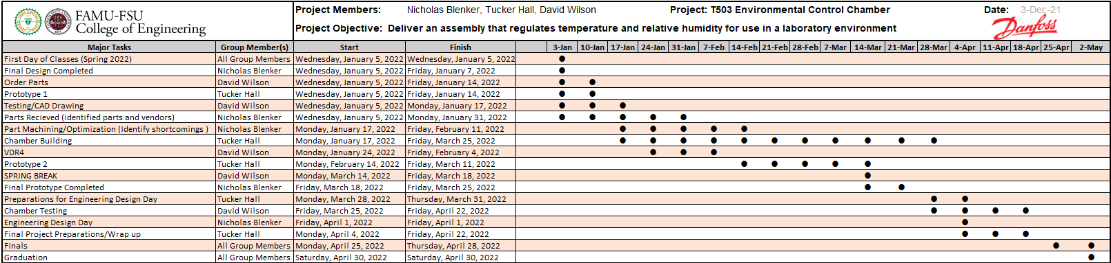
1.8 Spring Project Plan

Chapter Two: EML 4552C

2.1 Restated Project Definition and Scope
Project Description
This project aims to validate the existing design of an environmental testing chamber and deliver an assembly that monitors and regulates its internal temperature and humidity for use in a laboratory environment.
Key Goals
The goals of this project are to complete, validate, and implement the chamber design. These include conducting a thorough heat balance analysis, modifying and finalizing the hardware and software, and overseeing the construction of the final product. The chamber is desired to be capable of fluctuating from conditions ranging from 10°C to 50°C and 0-95% relative humidity within 15 minutes. Other goals are that the compressor can be seen during testing and can be easily accessed. The final goal is to deliver a system capable of long-term testing of Danfoss Turbocor compressors.
Markets
The primary market of this project is the end-users of the environmentally controlled test chamber, Danfoss Turbocor Compressors, Inc. They will use it to test the performance of their products. Secondary markets include any individual or company which requires the chamber for testing of their own. This would consist of other compressor manufacturers, companies that provide air-conditioned storage, ecology companies, and laboratories storing sensitive substances.
Assumptions
Some assumptions were made about this project to limit its scope and maintain focus on achieving the key goals. It is assumed that the design will rest on a flat test rig that rests on a level surface. There will be access to machining services and multiple power sources including a 110V power outlet. Another presumption is that the compressor’s conductive heat is small enough to be considered negligible and hence unaccounted for. It is also assumed that the user has access to a crane capable of lifting and lowering the compressor into the test chamber. The existing support for the test chamber is assumed to have sufficient load capacity for the compressor, and the compressor’s size remains the same. These assumptions allow for concentration on the content and challenges of this project’s scope.
Stakeholders
The main stakeholders of this project are Danfoss Turbocor Compressors, Inc., William M. Bilbow, Mr. Larson, and Dr. McConomy. Each will contribute to the project in some capacity and benefit from the design. Another stakeholder would be an original equipment manufacturer (OEM) of compressors.

2.2 Results
The following sections outline the targets and their respective methods of validation, results, along with percent error, for each system.
Support
Function | Target | Result
Support Equipment | 10 lbs | Success
Support Ducts | 5 lbs | Success

The sole targets for this system were for the walls to support all equipment (10 lbs) and air ducts (5 lbs). These targets were validated by attaching all duct flanges, screws, wing nuts, and ducts, and observing the short term and long term effects of the attachments.
Control
Function | Target | Result
Monitor Temperature | Within 1°C of true value | Success
Monitor Humidity | Within 1% of true value | Failure (Error: 1%)
Add Heat | 50°C | Success
Provide Cooling | 10°C | Failure (Error: 2%)
Increase Relative Humidity | 95% RH | Success
Decrease Relative Humidity | 0% RH | Failure (Error: 15%)
Regulate Air Circulation | 1 ft3/min | Success

The first control targets were to monitor the temperature and humidity within 1°C and 1% of the true values, validated using a thermometer and hygrometer, respectively. The system must also be capable of adding and removing heat from the control volume (to reach 10°C to 50°C) and increasing and decreasing humidity (to reach 0% to 95%). These were also validated using a thermometer and hygrometer. Another control target was to regulate the circulation of air in the chamber to ensure adequate air is provided to the control volume to produce desired conditions. The air flow needed to be at least 1 (ft³/m). To validate the flow rate, a pitot tube was placed at each outlet of the A/C unit, and the flow rate was calculated using this velocity reading and the known cross-sectional area of the ducts. The system also needed to be able to achieve its designated targets within 15 minutes. The time response target was validated using a stopwatch.
Accessibility
Function | Target | Result
Provide Clear View | 3 sides | Success
Adjust Conditions | No human interaction | Success
The first target for accessibility was to make sure that the inside of the chamber is visible at all times and from at least 3 sides, which was validated through observation of the system at all humidity settings. The other accessibility target was to achieve no direct human interaction with the system other than to input desired temperature and humidity values. The method of validation was observing the system in use. Additionally, the system could not be intrusive to the parts already in place. To achieve an unobtrusive system, another target is to allow the system to be fully install-able and removable within a 15 minute time frame. This target will be validated once the system is installed at the Danfoss lab facility.

2.3 Discussion
As shown by the results above, the system was mostly successful, with small errors in monitoring the humidity and providing cooling. The 1% error in monitoring humidity was due to the failure of one of the humidity sensors to work, while the other was limited to 2% accuracy. The cooling error was also due to component limitations, since the A/C unit only output air at 12°C, contradictory to its listed capability of 0°C. The largest error, decreasing humidity, was due to physical and budget limitations. In order to reach 0% relative humidity at 10°C, the refrigerant in the coils of the cooling unit must be cooled to extremely low temperatures to extract all moisture from the air, which a unit within our given budget is incapable of.

2.4 Conclusions
The targets of this project were within 2% of intended values overall. The environmental test chamber successfully met 8 out of the 11 total targets. While not all values were achieved, the system does still perform quickly while within the ranges that it is capable of, reaching its extremes in 15 minutes or less. Overall, the project delivered a system that can regulate the internal humidity and temperature of a chamber to a range of desired values. The simple control panel allows for straightforward operation with completely automated function.

2.4.1 Errors
The prototype created by the team is a model of part of the existing test rig at the Danfoss Turbocor lab facility where the system will be implemented. There are air leaks due to the nature of the plastic tote, differences in materials and structure from the test rig itself, and a lack of a condensation collection system that would be installed in the lab facility. Due to these variances, there are disparities in the demonstration and validation of the prototype. To decrease current errors further, more accurate temperature and humidity sensors should be installed and the control volume should be sealed as tightly as possible. Other error were due to discrepancies between the listed capabilities of the current A/C unit and sensors and their true capabilities.

2.5 Future Work
In the future, the system would ideally be moved over to the Danfoss Turbocor lab and implemented into test rig 12. It would then be tested to determine any further improvements to the design and tuned to account for the difference in volume and air leaks. In order to make the move as swift and easy as possible, a plexiglass wall the same size as the one at the lab will be drilled for use with our system. This includes three holes of 5" diameter each surrounded by six 1/4" holes, and one 3" hole for the humidifier. To do this, the dimensions for the plexiglass wall of the chamber have been requested from Danfoss and will be necessary to determine what size to cut the plexiglass down to. Additionally, the condensation collection system would need to be implemented by measuring the location of the compressor stand and creating a sloped funnel made from clear vinyl. At the bottom of the funnel, our tubing would attach and be routed to the humidifier tank.
In following stages of this project, sensors with higher accuracy should be implemented to optimize system performance. The control of the A/C unit could also be improved by adding a permanent solution to pressing and holding its power button which is more easily removable. The next design iteration should also aim to group all system components into one mobile system. This is essential in developing a system which can be applied to any test rig or control volume for purposes of testing a wide range of materials and equipment at the listed conditions.
To improve the system's scalability, other design aspects should also be modified. For instance, wireless communication between sensors, servos, and the microprocessor should be considered to improve portability and reduce obstruction with existing equipment. All 3D-printed parts could be switched to fabricated parts of higher quality. Other solutions could also be implemented to further decrease the cooling and dehumidifying capabilities. Such changes would allow for a more useful and versatile design.

Appendices

Appendix A: Code of Conduct
- Mission Statement
This team’s mission is to develop our professional skills in engineering, communication, and presentation while delivering test and measure support equipment for our sponsor, Danfoss. This will be achieved by working and communicating effectively with one another.
- Outside Obligations
This team has agreed that no one has outside obligations during the highlighted areas. Areas that are not highlighted indicate that there is at least one individual on the team who has an outside obligation such as class, work, etc.
  - Group Availability Fall 2021
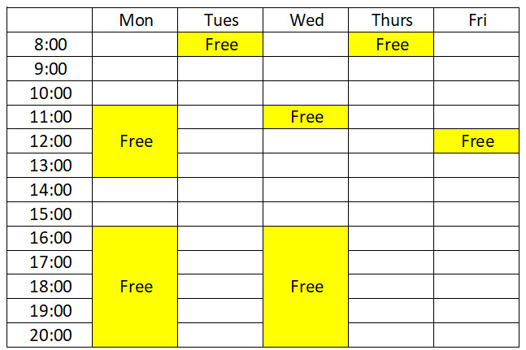
Figure 12: Fall Schedule of Availability

  - Group Availability Spring 2022
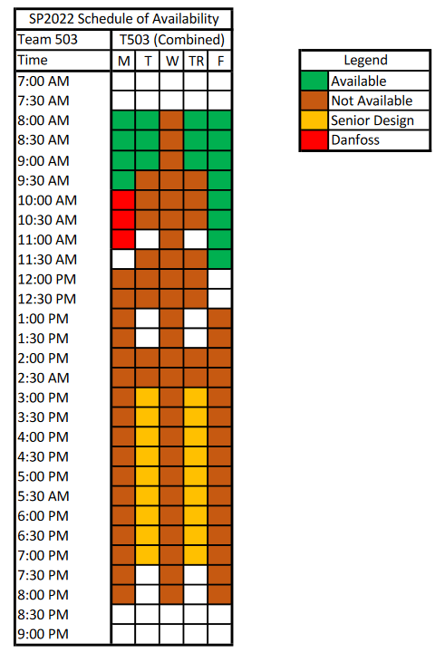
Figure 13: Spring Schedule of Availability
The work week for this group is from 8:00 am on Monday to 5:00 pm on Friday. Weekends are to be deemed personal days. However, if the group decides work needs to be done, that will take priority.
- Team Roles
The team roles for this project are relative on the tasks needed to complete the project. Every member is responsible for all aspects in the progression and advancements of this project.
- Nicholas Blenker – Mechanical/Design Engineer
Focuses on the mechanical aspects of the project and responsibilities include helping with necessary research, implementing innovative design ideas, and CAD modeling.
- David Wilson - Controls Engineer
Responsible for aspects of the project involving control systems as well as contributing to engineering calculations, CAD modeling, and simulations.
- Tucker Hall - Systems Engineer
Responsible for the timeline of events, integration of ideas, and improvements to the existing project. Keeps track of the project goals and makes sure the project meets sponsor needs.
- Decision Making
Our faculty advisor, Mr. Larson, should be consulted with for any major decisions about the direction of the project. In the case that there is not unanimous agreement between the group on a decision, Mr. Larson should be contacted. If he is unavailable, a TA or Dr. McConomy’s opinion should be considered. If none of these options are available, the decision should be made by the 2/3 majority.
- Communication
Communication will be incorporated through university email, group chat, Basecamp, Microsoft Teams, professional meetings and contacting Dr. McConomy/TAs further defined below in this section.
- University Email
University email will be the main formal mode of communication between group members, sponsor, faculty advisor, TAs, and Dr. McConomy. It will be used for documentation purposes and each group member should check their university email at least once per day.
Any group member who sends an email on behalf of the group one should CC the other group members. If a group member receives an email pertaining to the group and the rest of the group is not included, the receiving group member should then forward that email to the rest of the group.
For documents and emails within the group, the main form of contact will be the email group “Senior Design Group FSU”, which includes all members’ school emails:
seniordesigngroupfsu@admin.my.fsu.edu
This will be used so send links for editing project documents and providing any updates deemed necessary.
- Group Chat
The text message group chat will be the primary mode of general communication between group members; it will be an informal communication method. Group members are not required to respond in the group chat, but it is advised.
- Basecamp
Basecamp will be used to manage the group schedule, to-do lists, and discussions. Basecamp will be used as the foremost method for sharing documents and assignments with the rest of the group.
- To-Do lists
No one person will be solely responsible for creating to-do lists. Each assignment will receive its own to-do list which will include a list of tasks required to complete the assignment. The group should ensure that to-do lists are created when assignments are released so the group stays up to date. Each task should be specific, including the assignment name, due date, and submission date of the assignment.
- Schedule
No one person will be responsible for creating and updating the schedule. Group meetings should be added to the schedule, and if there is a change in meeting details, one should notify the team and update the schedule on Basecamp.
- Message Board
The message board is a formal communication method, a resource to keep track of important conversations and to have conversations written in a common, visible location. Teammates are expected to respond within 48 hours if addressed.
- Microsoft Teams
For this project Microsoft Teams will be the main meeting platform when meeting with advisors from Danfoss. Virtual meetings through Microsoft Teams will follow the dress code outlined in this document.
- Professional Meetings
All group members should interact in a professional manner when communicating with TAs, the project manager, the functional manager, and the project sponsor. This includes being respectful, listening to all input, and being prepared for questions they may pose.
- Contacting Dr. McConomy/TAs
Any problems between team members or regarding decision making should first be discussed amongst the group prior to contacting anyone else. If issues persist after having a group discussion, the TAs will be contacted for input. Dr. McConomy will then be contacted if the TA deems it necessary. All input from Dr. McConomy and the TAs should be respected by the group.
- Dress Code
Group members should dress synchronously for activities and follow the following dress code for specific events. Members will hold one another accountable by addressing violations directly, as soon as possible.
  - Team Meetings
Casual attire, or what is normally worn to class, is acceptable.
  - Meetings with Sponsors
Business casual, or a collared shirt with dress pants and a belt, at minimum.
  - Presentations
At a minimum: dress shirt and tie; formal.
- Attendance and Participation Policy
- Attendance
An attendance log will be maintained and updated through Microsoft excel. The log will be used to keep accountability and track team member attendance at any meeting in which the entire group is needed. No one person is specifically responsible for recording attendance; it is the responsibility of the group as a whole.
The document can be accessed through the following link: https://adminmyfsu-my.sharepoint.com/:x:/g/personal/njb17_my_fsu_edu/EYekHMKpCMBKsy7iv_K527kBGkUphQ-kh5EdDsxVo2joBw?e=fruppb
- Participation
All members are expected to contribute their fair share to the project. Participation and attendance should be desired by each group member, and no one should need to be forced to participate. It is the group’s responsibility to complete the required tasks throughout the semester; if a group member is not available to complete an assigned task, it is the group’s responsibility to complete it.
- Excused Absences
If a member notifies the members of the group 24 hours in advance, unless the meeting or assignment is an emergency, the absence will be marked excused in the attendance log. The group should be notified by either group text message or group email to ensure all members are aware. The member does not need to provide a reason for their absence and the group will not demand a reason.
- Privacy Clause
Group members will respect the privacy and personal information of all group members. Group members will never share personal information about other group members.
- Amending the Code of Conduct
When revisions to this document are necessary, a proposed draft of the updated section(s) will be shared with the group. To update the Code of Conduct, all three group members must approve and sign it. A PDF version will be saved and shared with all members for future reference.
- Statement of Understanding
Signing below indicates the group member is committed to the mission statement and accepts this Code of Conduct as a whole:
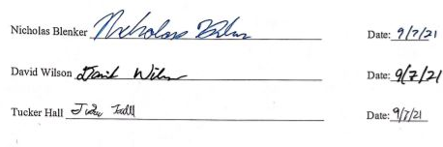
Figure 14: Signed Statement of Understanding

Appendix B: Functional Decomposition
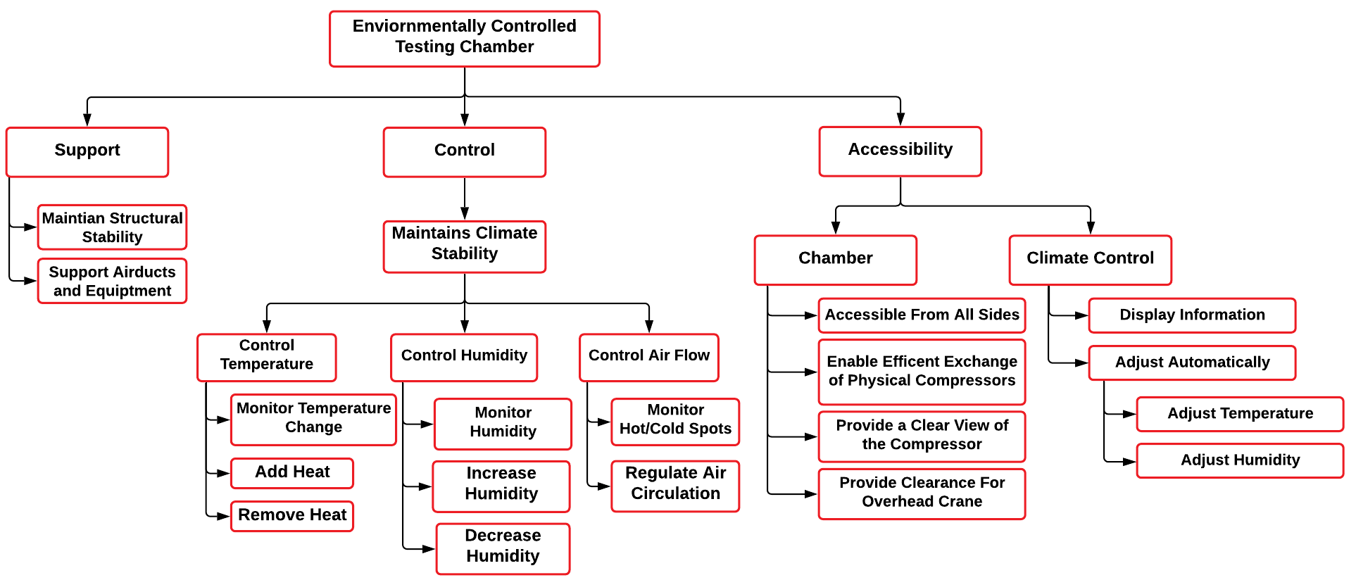

Appendix C: Target Catalog
Functions | Metric | Target | Description
Support Air Ducts and Equipment | Weight | 10 lbs | Equipment supports itself
Monitor Humidity | Relative Humidity | 1% | Measure relative humidity within 1% of its true value
Increase and Decrease Humidity | Relative Humidity | 0-95% RH | Relative humidity is desired to reach any value in this range
Monitor Temperature Change | Temperature | 1°C | Measure temperature within 1°C of its true value
Add and Remove Heat | Temperature | 10°C ≤ T ≤ 50°C | Temperature is desired to reach any value in this range
Regulate Air Circulation | Volumetric Flow Rate | 1 m3/min | Air handling unit should be capable of providing this flow rate
Monitor Hot and Cold Spots | Sensors | 3 sensors | Measure temperature from at least 3 places in the control volume
Maintain Structural Stability | Deformation | ~ 5% | Chamber should not move or deform
Provide Clearance for Overhead Crane | Area | OSHA requires only 2” of clearance on the side and 3” above. | There should be no obstructions in the way of the crane
Display Information | Display temperature and Humidity | Yes, they are always displayed during testing | Temperature and humidity will be always shown
Allow Access from All Sides | Number of accessible Sides | 4 sides | Allow access to the compressor from the front, back, left, and top sides
Enable Efficient Exchange of Compressors | Ease of compressor removal and installation | Yes, the compressors were exchanged successfully | Enable installation of other compressors
Provide Clear View of the Compressor | Visibility | 360° visibility | Compressor is fully visible from 360° during the entire testing process
Adjust Temperature and Humidity Automatically | Automatic adjustment | No human action required to reach the desired conditions | Desired temperature and humidity are reached automatically by the system
Reach Stable Conditions Quickly | Time | 15 minutes | Any condition can be reached within 15 minutes, starting from any other condition

Appendix D: Operation Manual

Project Overview
Our project goal is to design an air control system that attaches to a plastic chamber to test compressors at different temperatures and humidity levels. Compressors are parts of air-conditioners that compress a liquid to cool down and draw moisture from the air. Each one must work in the weather where it will be used. The main issues when testing them are air leaks and heat loss through the testing cell. Our design addresses this problem by putting the air control unit right next to the chamber. This reduces the needed amount of duct, which lessens air leaks and heat transfer. All cracks and holes seal tightly to create a closed volume of air, as well. These choices allow for accurate control of inner conditions within 15 minutes. The design also stops condensed water from building up by collecting and returning it to the humidifier.
Our design improves an existing design by increasing the range of cooling, humidity, and mobility, and by lowering the heat lost to the surrounding air. It features a more powerful air chiller, humidifier, and two more heaters. Ducts from these pieces attach to the chamber’s sidewalls and are easily removable. Putting the unit on the floor rather than a wall simplifies the previous design greatly. Sensors check the inner temperature and humidity levels to adjust to the user’s wanted values. This achieves hands-free testing in harsh and mild settings. Testing the compressor’s performance in each condition allows the user to find out its abilities before selling or using it. Since the system is mobile, it can attach to any large box for testing devices in common weather. In this way, our project has wide application and can help many industries.

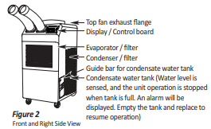
Component/Module Description
Figure 15: Koldwave AC Unit (Front)

Koldwave Portable Air Conditioner
Model No: KK17BGA2AA00
Power Supply: Single Phase 115V, 60Hz
Cooling Capacity: 16,800 BYU/h
Power Consumption: 1700 W

General Safety Guidelines
- Transport and store the unit in an upright position only. Leave the unit in an upright position for at least 3 hours before first use.
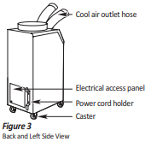
- Always place the unit on an even, level surface.
Figure 16: KOLDWAVE AC Unit (Back)
- Ensure the unit is connected to a grounded power supply of the correct rating/capacity.
- The unit will cool when the room temperature is between 18°C (64°F) ~ 45°C(113°F) depending on the thermostat setting.
- DO NOT use this unit for functions other than those described in this instruction manual.
- DO NOT tilt the unit.
- DO NOT cover or obstruct the unit's inlet and outlet grilles.
- DO NOT use the unit in areas where it will be exposed to rain or water.
- NEVER unplug the unit while it is operating.
- DO NOT use the unit in wet environments, such as a laundry room, to avoid the risk of electrical shock.10. DO NOT place any foreign objects on the unit.
- DO NOT operate the unit with wet or damp hands.
- DO NOT allow chemical substances to contact the unit.
- DO NOT operate the unit in the presence of flammable substances or vapors such as alcohols, pesticides, gasoline, etc.
- DO NOT operate the unit in explosive or flammable environments.
- DO NOT use the plug to start and to stop the unit. Always use the control panel to start and stop the unit.
- Always turn off the unit when it is not in use and unplug the power plug from the electrical outlet.
- Always turn the unit off and unplug the main power plug from the electrical outlet before cleaning, moving, or performing maintenance.
- AVOID the use of adapter plugs or extension cords. If it is necessary to use an extension cord or an adapter plug to operate the unit, ensure that they are correctly rated for the application. Consult a local qualified electrician and all local electrical codes to ensure proper setup. Any extension cord used with this device must be rated for a minimum of 15A.(120V)
- DO NOT unplug the unit by pulling on the electrical cord. Keep the electrical cord away from heat sources and always completely unroll the cord to avoid overheating. If the power cord becomes damaged, a qualified service agent, qualified electrician, or similarly qualified person must replace it, to avoid a hazard or shock. DO NOT operate a unit with a damaged power cord.
- The filters must be used with the product at all times. When the filters are removed for cleaning, always ensure that the unit has been turned off and unplugged from the electrical outlet.
- Regularly clean the filters to maintain efficiency. If the filters are not cleaned regularly, the unit’s output performance and efficiency will decline, and energy consumption will increase.
- DO NOT operate the unit with a damaged power cord or plug, after it malfunctions, has been dropped, or damaged.
- Only use in the upright position on an even, flat surface. The unit must be positioned at least 24inches (60 cm) from the nearest object in any direction.
- Stop operation immediately if abnormal noise or odor is noticed. Contact a local service center.
- Appliance is not to be used by children or persons with reduced physical, sensory, or mental capabilities, or lack of experience and knowledge unless they have been given supervision or instruction.
- Children being supervised not to play with appliances.
- That the appliance shall be installed in accordance with national wiring regulations.
- If the supply cord is damaged, it must be replaced by the manufacturer, its service agent, or similarly qualified persons to avoid a hazard.

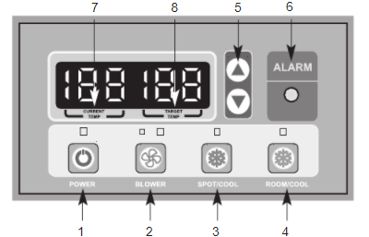
Controls
Figure 17: KOLDWAVE AC Unit (Control Panel)
- POWER BUTTON: Activates unit when POWER BUTTON is pressed. (Fan starts on low speed). If the power button is pressed during operation, the unit stops.
- BLOWER BUTTON: Changes fan speed from (Low) to (High) when pressed.
- SPOT/COOL BUTTON: Activates compressor and begins producing cool air 5 seconds after the button is pressed. Regulates temperature based on outlet cool air temperature.
- ROOM/COOL BUTTON: Activates compressor and produces cool air 5 seconds after button is pressed. Regulates temperature based on inlet ambient air temperature.
- SET TEMP BUTTONS: Change target temperature/data value by +/- 1. Change data value by +/-10 by pressing continually. Press the SET TEMP BUTTONS to set the temperature. The upper button is to heighten temperature and the Lower button is to lower temperature.
- ALARM: Alarm indicator lights (blinks) and indicates abnormal system operation. If Alarm occurs, the compressor stops. System operation stops when the ALARM light is activated (blinks) longer than 3 minutes.
- CURRENT TEMP: Displays current room temperature in display in Fahrenheit. (In RoomCool Mode only). SPOT/COOL Mode – Displays outlet (cool air) temperature during normal operations. To change °F to °C, press SPOT/COOL and ROOM/COOL buttons together for 2 seconds. C will blink 2 times and the Figure will change to °C. ALARM codes blink and are displayed when an abnormal operation occurs.
- TARGET TEMP: displays the unit set temperature for ROOM/COOL mode only. OFF-TIMER: Enter to Timer Setting Mode if you press the BLOWER Button and SPOT/COOL Button together for 1 second. Press the UP/DOWN button to set the timer until it shows the figure you want to set. After 5 seconds, the figure will be memorized, and the compressor will stop after the time set. AUTO RESTART: If the unit goes off due to an electrical interruption, the unit will automatically restart when the power resumes.

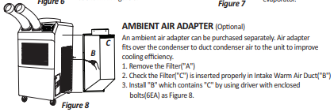
Ambient Air Adapter
This component attaches to the right side of the A/C unit using screws (provided) and allows for improved spot cooling capabilities when attached to a duct reducer and flex duct (also provided).
Figure 18: KOLDWAVE AC Unit (Ambient Air Adapter)

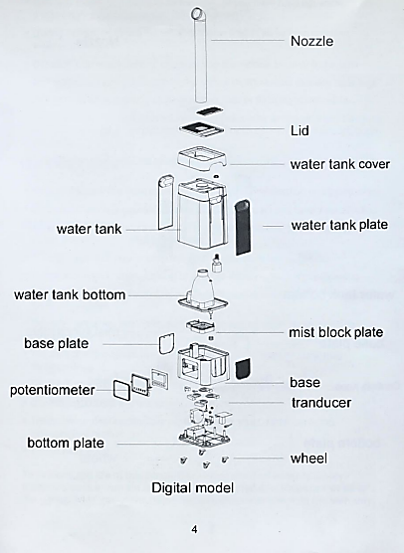
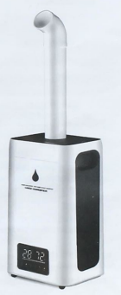
Industrial Humidifier
When using the humidifier, basic electrical safety precautions should always be followed.
WARNING: TO AVOID THE RISK OF ELECTRICAL SHOCK, FIRE, OR INJURY TO PERSON, ALWAYS MAKE SURE THE PRODUCT IS UNPLUGGED FROM THE ELECTRICAL OUTLET BEFORE RELOCATING, SERVICING OR CLEANING IT.
Figure 19: Industrial Humidifier (Part Breakdown)
Figure 20: Industrial Humidifier

General Safety Guidelines
Read all the instructions before using the humidifier:
- Use this humidifier only as described in this manual. Anything outside the
guidelines are not recommended, may cause fire, electric shock, or injury
to persons.
- Ensure all packaging is removed before use.
- Check the power cord and plug regularly for damage. If the power cord or the plug is damaged, DO NOT use it. It must be replaced by a manufacturer or a qualified person to avoid an electrical hazard.
- DO NOT pull the cord too hard as it could damage and fray. If it becomes damaged after prolonged use it should be repaired by a qualified technician
- Ensure that the voltage used corresponds to the voltage indicated on the rating plate
- DO NOT allow the power cord to touch hot surfaces and DO NOT place near a hot gas or electric burners
- Place the humidifier on a flat, level surface away from direct sunlight NEVER operate the unit without water
- Use only clean, cool water to fill the tank. (If you have hard tap water, it is strongly suggested to use distilled water)
- During operation, rotate the mist nozzle so it aims away from children, walls, and furniture.
- DO NOT add medication of any type into the nozzle, base, or water tank.
- DO NOT cover any openings on the unit or insert objects into any openings.
- DO NOT tilt or tip the unit or attempt to empty or fill while in operation.
- DO NOT leave the unit unattended in closed rooms as the air could become saturated and leave condensation on walls or furniture. Always ensure good ventilation.
- To protect against electric shock, do not immerse unit, plug, or cord in water or other liquids.
- Keep the cord away from areas where it could be walked on or tripped on.
- Close supervision is necessary when any appliance is used by or near children
- To disconnect, first turn the unit OFF, grip the plug and pull from the wall outlet. Never pull the plug by the cord
- Turn the unit OFF and unplug from the outlet when not in use
- Turn the unit OFF when moving to another location and before cleaning
- DO NOT operate the humidifier in the presence of explosive and/or flammable fumes
- DO NOT place the humidifier or any parts near an open flame, cooking, or other heating appliance
- The use of attachments not recommended by the manufacturer may be hazardous
- DO NOT place the humidifier on a wooden or polished surface
- DO NOT operate if the housing is damaged
- There are no user-serviceable parts in this product. Refer servicing to a qualified person
- This is NOT a toy
To prolong the life of this humidifier, using distilled water is highly recommended or run via an RO machine. Do not add fragrance or oil in the water, it will cause the machine to malfunction and void the warranty.

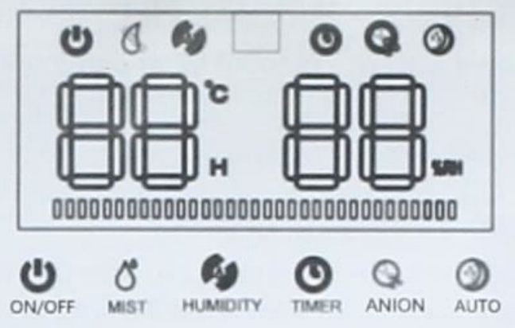
Controls
Figure 21: Industrial Humidifier (Control Panel)
- DEFAULT START: display indicate the room temperature, default mist level is “3" level, if not touch any function , display will turn dark after 5 seconds , fan working.
- MIST LEVEL SELECTION: press the “mist", it chooses between “1-5, 5 level is the biggest power working mode.
- SET HUMIDITY: Touch “humidity”, the humidity will increase 5%RH between 45%-95%RH, continue to touch max 95%RH then cancel humidity setting. if humidity %RH is twinkle, it's meant the room humidity still does not reach your set target humidity, it will work on the current mist level. when the %RH reaches your target humidity, it will stop making mist, the fan will stop after 10 seconds, anion stop too.
- TIMER (turn off): timer is between 1-12 hours, when you choose the hours after 3 seconds, it will turn to timer mode, if the time counts out, the machine will auto turn off. Touch the power can restart.
- ANION: turn on the machine, touch “ANION”, anion generator will work, touch one more time, it will turn on. if water shortage, the anion will auto turn off. If fill the water before auto-turn off (15 seconds), the anion will work again.
- AUTO function: Touch AUTO to start sleep mode, touch any button to wake up. Water shortage: working situation, if water shortage, the mist will stop making, the fan will stop after 10 seconds, water shortage signal twinkle per 0.5 seconds, beep sound 3 times then turn off after 15 seconds, water level light turn off too.

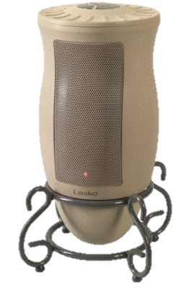
Electric Space Heater
Figure 22: Electric Space Heater

General Safety Guidelines
- Carefully remove the Heater from the plastic bag and the carton.
- Place the Heater on a firm and level surface. Plastic or rubber tabs, like the feet on this unit, may stick to furniture surfaces and/or hardwood floors. The unit may leave a residue that could darken, stain, or leave permanent blemishes on the finish of certain furniture surfaces, including wood surfaces, and/or hardwood floors.
- Plug the cord set into a 120-volt outlet. Be sure that the plug fits tightly into outlet. When plugs fit loosely into receptacles, they may slip partially or completely out of the receptacle with only the slight movement of the attached cord. Receptacles in this condition may overheat and pose a serious fire hazard; if covered by a curtain or drape, the fire hazard is even greater.
- When the Heater is initially plugged in, there will be a ‘beep’, indicating that there is power to the unit. The power light will remain lit until the Heater is unplugged from the outlet. 5. Turn the Heater ON by pressing the Power Button.
- When initially turned on, the Heater will be in High heat (1500 Watts) on Max. (The High light will be steady, and the Max light will be blinking).
- Press the Power Button once and the Heater will be in Low Heat, indicated by the steady light beside Low. The MAX light will be blinking.
- Pressing the Power Button a third time will turn the Heater OFF.

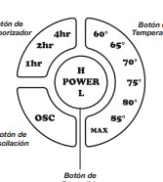
Controls
Figure 23: Electric Space Heater (Control Module)
- Oscillation Function: Pressing the Oscillation Button (OSC) will allow the Heater to oscillate back and forth. To stop the oscillation, press the Oscillation Button (OSC) once again. The oscillation function will stop when the temperature function is in use and the Heater has reached the desired temperature. The oscillation function will resume when the Heater turns back on.
- Temperature Function: To set the room at a specific temperature, press the Temperature Button to the desired setting. The light under the chosen temperature will continue to blink until the room reaches the desired temperature. For increased efficiency, the Temperature Function will only run on High heat. When set on MAX, the Heater will run continuously.
- Timer Function: The Timer Function may be activated when the Heater display is in any speed or temperature. This function allows you to set the length of time the Heater will run before turning itself off, from 1 hour to 7 hours. Pressing the Timer Button will increase the length of time, in combinations of 1, 2 and 4 hours. Continuously pressing the button will result in the timer being set for 7 hours. The Heater will turn off when the set time has elapsed.

Integration of Components
Material List: Link to final bill of materials: Updated Bill of Materials.xlsx
Wiring Diagrams: See Appendix A-1.

Assembly Process
- Three 4.5” diameter holes were drilled into the long side of the plastic tote using a Dremel circular saw. The pipe coming from the humidifier was traced with a marker on the bottom of the tote, and a circle of this size was drilled using the same hole.
- By holding a duct flange over each of the three side holes, the locations of six holes per flange were marked using a marker. A ¼” acrylic drill bit was used to drill all 6 holes surrounding each 4.5” hole.
- Three 6” duct flanges were fastened to the side holes of the tote using 6 ¼”-20 screws 6 ¼” washers, and 6 ¼”-20 wing nuts. The humidifier pipe was slid through the hole in the bottom of the tote and attached back to the humidifier.
- The blue covers on the end of each of the A/C unit ducts were removed, and the ducts were placed over two of the flanges. The other flange was attached to a 6” to 5” duct reducer, 6” flex duct, and 25” to 6” duct reducer. The large duct reducer attached to the ambient air adapter, which attached to the right side of the portable A/C unit via screws.
- A 9”x9.5” rectangle was drawn in the middle of the tote’s lid, and the Dremel circular saw was used to cut out this section. One of the 9” sides of this panel was pressed into the 3D-printed mechanical door shaft.
- The stepper motor shaft was placed into the hollow end of the mechanical door shaft, and the other end was placed into a 608 bearing inside the 3D-printed bearing holder.
- Solenoids and servos were placed into the A/C control panel and humidifier control panel, respectively. One solenoid was placed in the heater control panel. The solenoids, stepper, servo, sensors, and main control panel were all wired to the Arduino according to Table X. The Arduino code can be found in X.

Other Components
- SunFounder IIC I2C TWI 1602 Serial LCD Module Display
A LED display is used with the Arduino to display the internal settings of the chamber, the ambient air, user selection and the process values of the system working.
- Button #1
The first button is used to start up the system and initiate the priming cycle, or turn the system off and initiate the system shut down functions.
- Potentiometer #1
The first potentiometer will be connected to the main breadboard controlling the user-defined temperature.
- Potentiometer #2
The second potentiometer will be connected to the main breadboard controlling the user-defined temperature.
- Button #2
The second button is for the user to select the internal desired temperature and relative humidity values.
- RGB Light
The main control board will include a RGB light displaying the overall progress of the internal environment.
Red Error
Blue Human Interaction
Yellow In Progress
Green System Satisfied

Operation
A close-up of the liquid crystal display (LCD), which can be found in the top-right of the control panel shown in Figure X, is shown below.

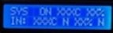
Figure 24: LED Display

The top row, labelled “SYS” (system), displays from left to right:
  - The system status (ON or OFF)
  - The current temperature inside the chamber in degrees Celsius
  - The current relative humidity inside the chamber in percent
The bottom row labelled “IN” (input), displays from left to right:
  - The current temperature inside the chamber in degrees Celsius
  - Whether or not the current temperature matches the input (Y or N)
  - The current relative humidity inside the chamber in percent
  - Whether or not the current humidity matches the input (Y or N)

The centralized control panel for monitoring and regulating the chamber’s temperature and humidity is shown in the image below.

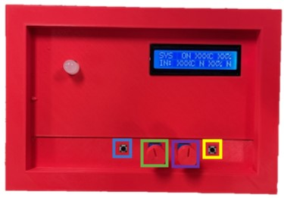
Figure 25: 3D Printed (Control Panel)

The system’s power is controlled by the button on the left (shown in blue). Once the button is pressed and the system is turned on, turn the temperature knob (shown in green) and the humidity knob (shown in purple) until the desired values for each are shown in the bottom row of the LCD screen. Once the desired values are set, press the “OK” button on the right side (shown in yellow). The system status is indicated by the color of the light in top left.

RGB Light Color Codes
Blue: User Input Required
- Occurs when the system detects a change in the desired temperature or humidity (when a knob is turned), but the user has not clicked the “OK” button. This status can be ignored if a knob is accidentally turned.
Green: Complete
- Occurs when the system achieves the desired temperature and humidity conditions previously input by the user, within 1%. The user can begin testing the compressor (or other equipment) when this light is on.
Yellow: In Progress
- Occurs when the user inputs desired values which differ from the current conditions. In this state, the components are manipulated automatically by the built-in controls to work towards the desired inner conditions.
Red: Error
- Occurs when one of the system components encounters an issue that cannot be resolved without human interaction. Turn off all components manually if the control system fails to do so on its own. Refer to the troubleshooting section of this manual to resolve the issue.

Related Documents
The important documents and files related to this project’s completion can be found in the basecamp provided by Shayne McConomy, the instructor for Senior Design at the FAMU-FSU College of Engineering. To be added to see important documents to the projects completion please contact one of the group members to complete the form from Basecamp shown below.
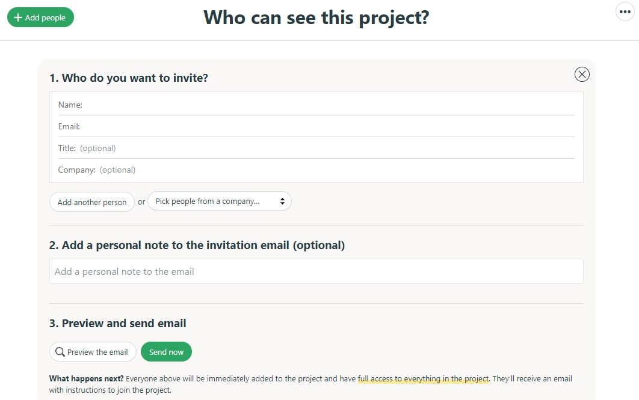
Figure 26: Basecamp (Form Invitation)

Team 503: Contact Information
The following is the group members’ contact information:

Nicholas Blenker
Phone Number: (954) 300-9764
Email: njb17@my.fsu.edu
Linkedin: https://www.linkedin.com/in/nicholas-blenker/

David Wilson
Phone Number: (904) 307-1125
Email: dhw18@my.fsu.edu
Linkedin: https://www.linkedin.com/in/david-h-wilson/

Tucker Hall
Phone Number: (850) 512-2718
Email: tdh16@my.fsu.edu
Linkedin: https://www.linkedin.com/in/tucker-hall-aa1b36191/

Pseudocode
Libraries
LCD variables
Stepper variables
RGB variables
General variables

void setup() {
Serial.begin(9600);
Sensor setup
LCD setup
RGB setup
}

void loop() {
Read sensor data
Display status on LCD
Check for user input
Adjust RGB based on input/status
Implement control logic
If current temperature = desired temperature & current humidity = desired humidity
Green RGB
End
If current temperature = desired temperature
If current temperature = room temperature
No action
Else if current temperature > room temperature + value
Keep heater running
Else if current temperature < room temperature - value
Keep A/C running
End
Else If current temperature > desired temperature & current temperature > 43C
Yellow RGB
Open vent door
Else If current temperature < desired temperature
Yellow RGB
Set heater to desired temperature
Else If current temperature > desired temperature
If vent door is open & current temperature < 43C
Close vent door
End
Yellow RGB
Set A/C to desired temperature
End
If current humidity = desired humidity
If current humidity = room humidity
No action
Else if current humidity > room humidity + value
Keep heater running
Else if current humidity < room humidity - value
Keep A/C running
End
Else If current humidity < desired humidity
Yellow RGB
Set humidifier to desired humidity
Else If current humidity > desired humidity
Yellow RGB
Set A/C to desired temperature
End
}

Troubleshooting
Table 17: Troubleshooting
Issue |  | Possible Cause(s) |  |  | Corrective Action(s)
- Koldwave Portable Air Conditioner
Water Leakage |  | High water level in condensate tank |  |  | 1. Remove blockage from drain hose  2. Remove any object stuck under the black panel under the water tank
The Unit Doesn’t Work |  | 1. Check the power supply  to verify that power is  available to the unit  2. Verify that the power  cord is connected |  |  | 1. Reset the circuit breaker and restart the unit  2. Connect the power cord
No cold air flows from the cold air outlet |  | 1. Ambient air cannot be  properly cooled if the filter is dirty and not regularly cleaned  2. Compressor will not work if the unit is turned off and on quickly  3. The ambient air temperature may be too high |  |  | 1. Clean the filter  2. Wait 2 minutes after the unit is turned off before turning the unit back on  3. The temperature of the compressor can be higher when the ambient temperature is too high. The compressor will not work unless the ambient air temperature is within the  acceptable operating range of the unit
Water flow can be heard after the compressor shuts off |  | 1. No cause |  |  | 1. Common to hear the coolant flowing after the unit shuts off
The alarm displays "FT" with less than half of condensate water in the tank Spring is possibly broken |  | 1. Spring is possibly broken |  |  | 1. Replace with a new spring
- Industrial Humidifier
Light off, fan not working, no mist |  |  | 1. Power not connected or has a problem |  |  | 1. Change to another new power socket
Light on, fan not working, no mist |  |  | 1. Too much base water |  |  | 1. Pour out a little water of the base and restart
Mist small |  |  | 1. Transducer covered by furring |  |  | 1. Clean the furring and change cleaner water
Water cannot reach base |  |  | 1. Valve stuck  2. Water higher than the full mark |  |  | 1. Clean valve and place the water tank in the right position  2. Pour out some water to be lower than the full mark
- Electric Space Heater
If your heater shuts off unexpectedly or fails to operate, the previously mentioned safety feature may have been activated to prevent overheating. | 1. Be sure the power cord is plugged into a working electrical outlet.  2. Check your Temperature setting. The Heater may be off because it has reached the desired temperature setting.  3. If your Heater runs for several minutes and shuts off repeatedly, your Heater may require cleaning. |  |  | If you have a problem that can not be resolved by the steps listed above, contact Technical Assistance at 1-800-233-0268, Monday through Friday, between the hours of 8 a.m. and 5 p.m. EST

Appendix A-1: Connections and Wiring Diagrams
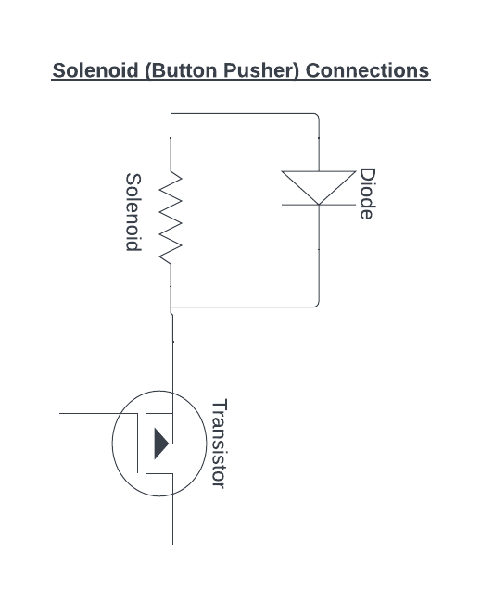
Figure 27: Solenoid (Button Pusher) Connections

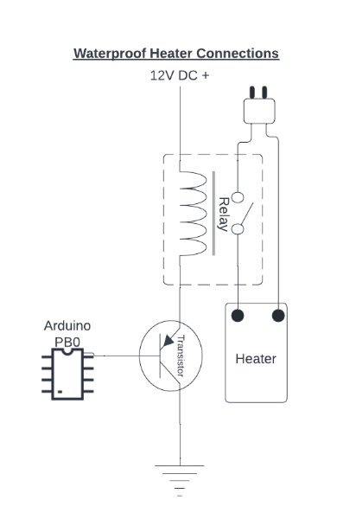
Figure 28: Waterproof Heater Connections
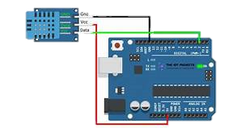
Figure 29: Temperature/Humidity Sensor Connections
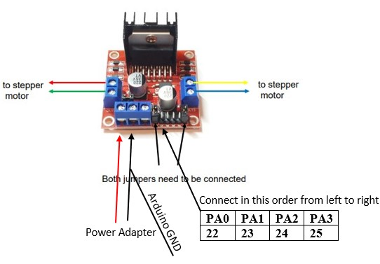
Figure 30: Stepper Motor Connections

Appendix B-1: Pictures
Figure 32: Duct Connections (Front View)
Figure 33: Duct Connections (Side View)
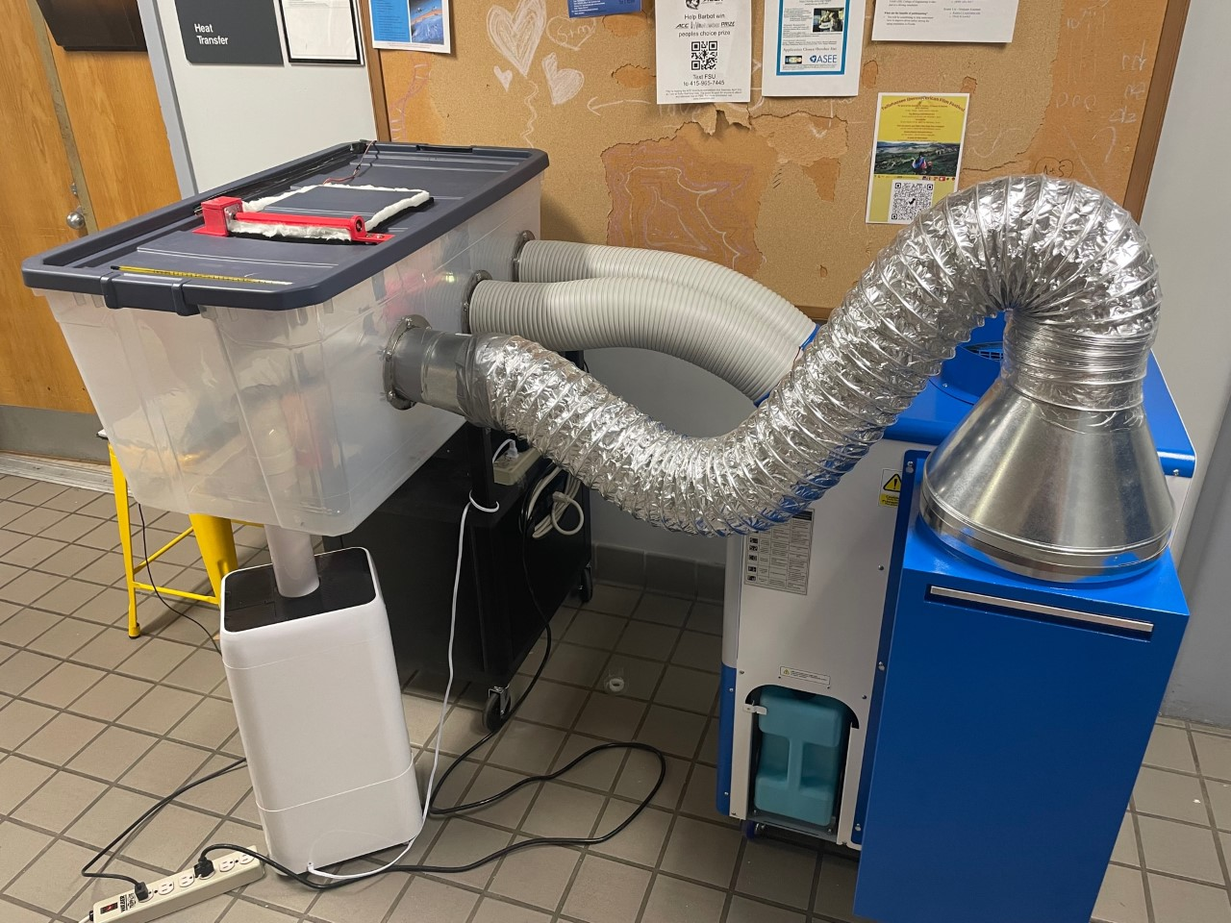
Figure 34: Overall System (Side View)

Appendix E: Engineering Drawings
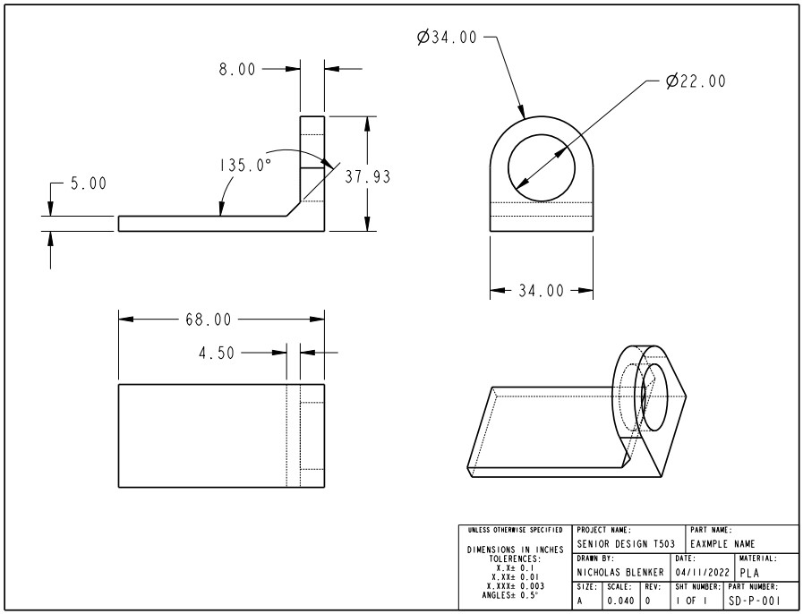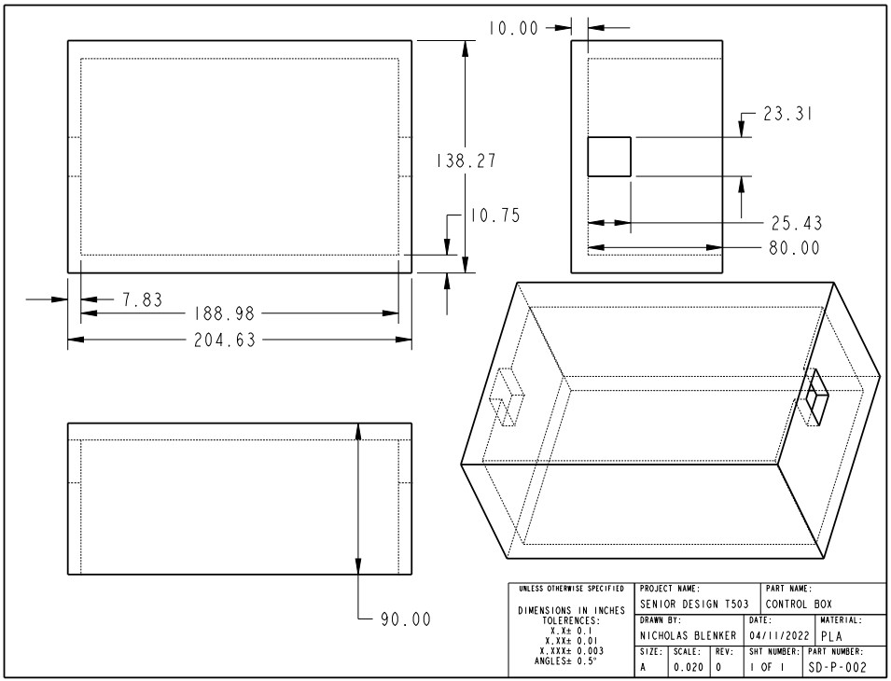
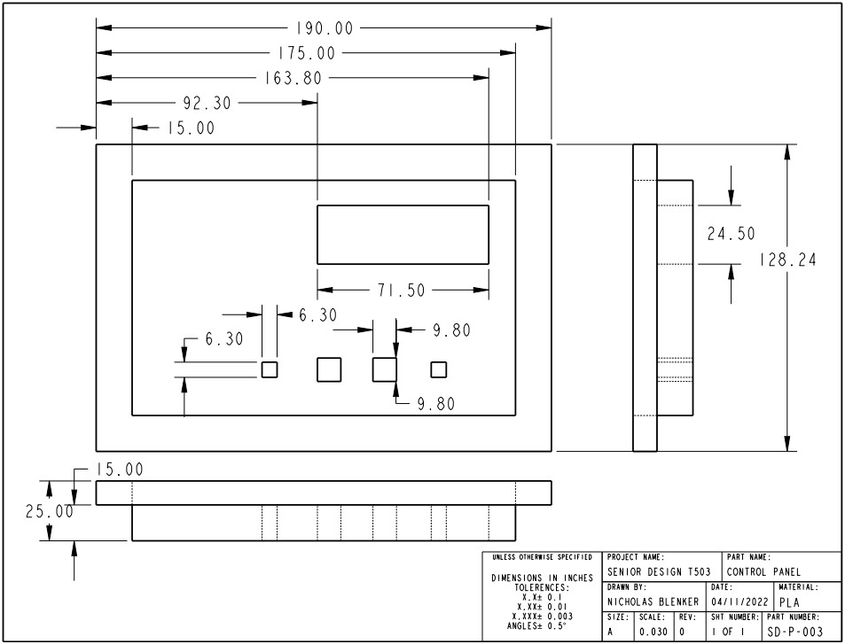
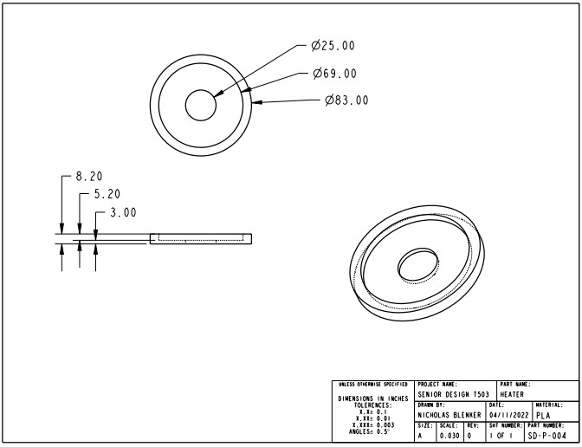
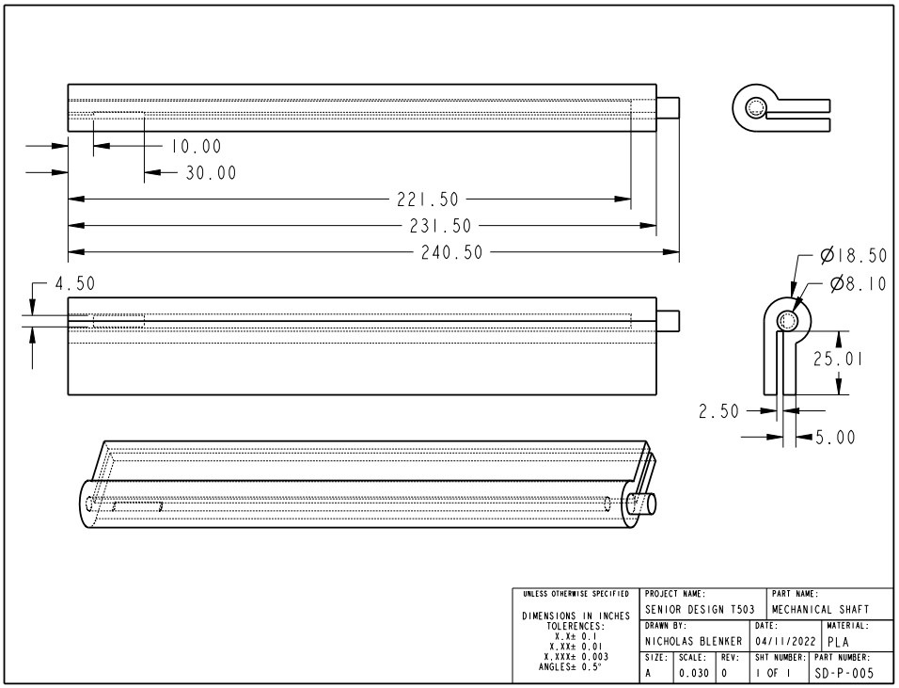

Appendix F: Calculations
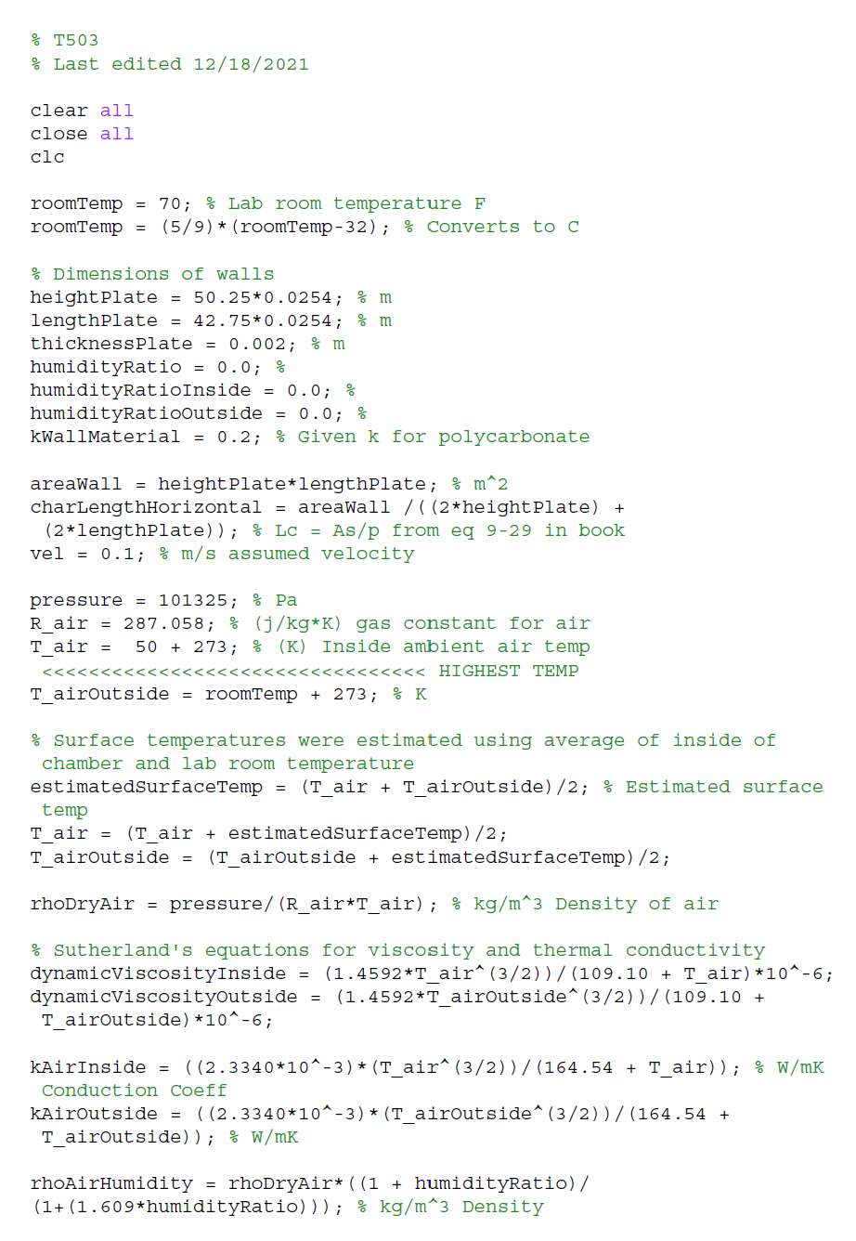
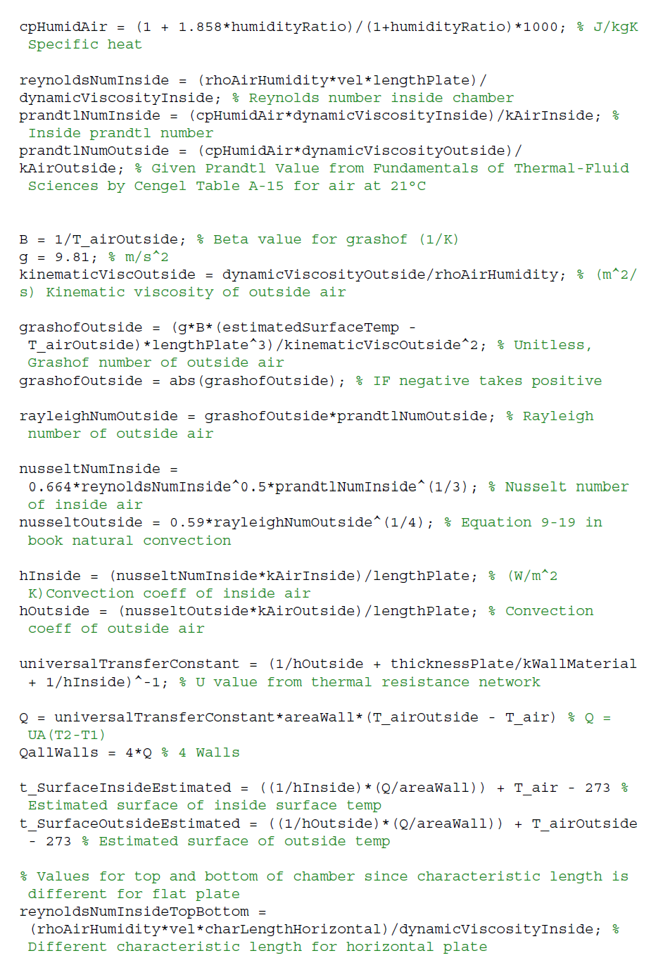
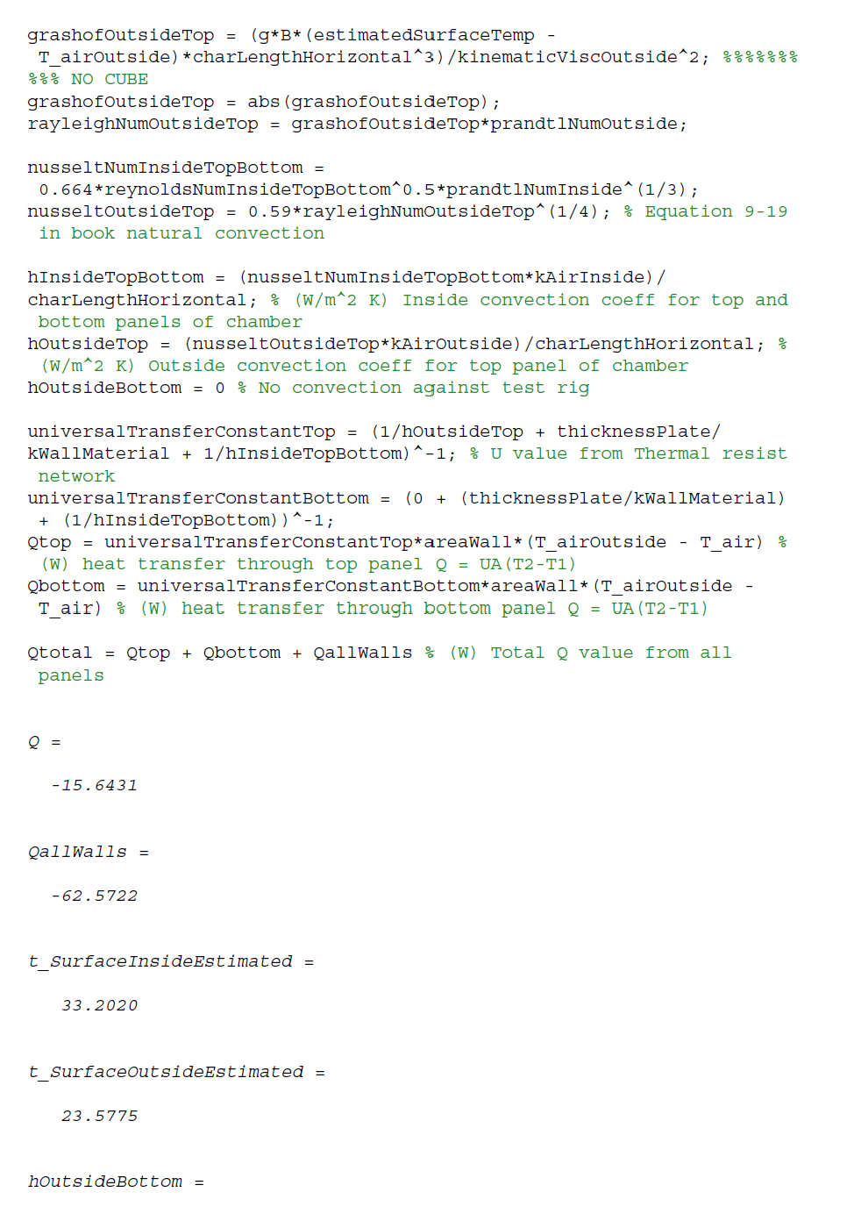
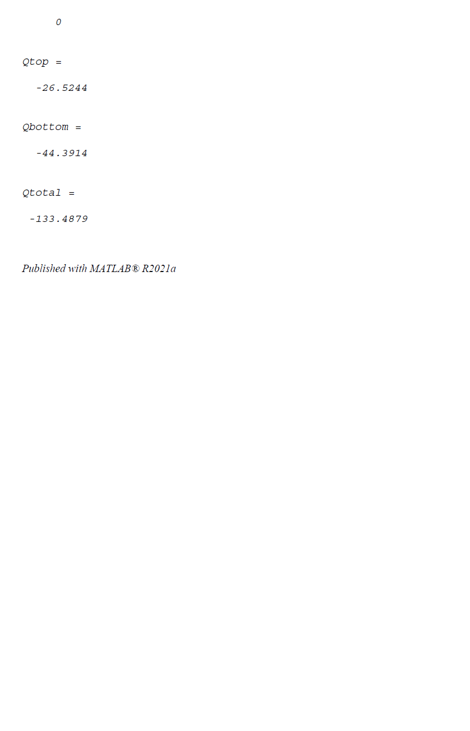

Appendix G: Risk Assessment

Project Control
Project Hazard Control- For Projects with Medium and Higher Risks
Name of Project: T503 Danfoss Environmental Control Chamber |  |  |  | Date of submission: 11/19/2021
Team member |  | Phone number |  | e-mail
Tucker Hall |  | 850-512-2718 |  | Tdh16c@my.fsu.edu
Nicholas Blenker |  | 954-300-9764 |  | Njb17@my.fsu.edu
David Wilson |  | 904-307-1125 |  | Dhw18@my.fsu.edu
Faculty mentor |  | Phone number |  | e-mail
Keith Larson |  | 850-410-6108 |  | Larson@eng.famu.fsu.edu
Shayne McConomy |  | 850-410-6624 |  | Smcconomy@eng.famu.fsu.edu
Rewrite the project steps to include all safety measures taken for each step or combination of steps. Be specific (don’t just state “be careful”).
Transportation of heavy equipment and assembly using equipment that is hot is necessary for this project. Some identified hazards involved are: electrocution, crushing due to the heavy equipment, coolant leaking from the dehumidifying unit, burns from high operating temperatures, and cuts caused by sharp edges. To prevent crushing during assembly, at least two people will be present when moving any equipment greater than 20 lbs and protective footwear (or toe guards) is required. Preventing leakage of coolant from the air-conditioning unit when it is moved is done by keeping it stable during movement and away from objects which could puncture the unit. To prevent any cuts, sharp edges will be rounded if possible, during the design process. Burns will be prevented by waiting for the strip heaters to cool before handling, and using protective gloves if necessary. Should the coolant leak from the equipment for any reason, the leakage will be reported, and an EPA type III certified technician will be notified to remove the coolant. During any transportation by car, the equipment is to be securely placed and fastened using belts or the geometry of the car to prevent movement. While at the Danfoss facility, the assembly and implementation of the project will mostly be done by on-site professionals directed by group members. During this process, at least two members should be present at any time.

Wiring will also need to be installed for the equipment to be used. Wiring errors can cause electrocution and cause people to trip over cords. Electrocution is especially at risk when in damp environments. To avoid the combination of wiring and water, a condensation collection system will remove water via a funnel and tube, and return it to the humidifier tank. A qualified electrician should perform all work, and the electrical power must be disconnected before performing all work. Verify that the wiring is dead before proceeding with electrical work. To prevent tripping, the wires will be placed as unobtrusively as possible and as far from sources of water as possible. OSHA standards for dealing with electrocution were used to create preventive measures to ensure safe operation. To further prevent electrocution, protective gloves and appropriate footwear (or toe guards) must be worn. In addition, any cords must be inspected for abrasions or wear prior to use and disconnected when not in use. The cords should also be pulled and strained as little as possible to prevent tearing.

The chamber will also be tested and operated once assembled. Potential hazards during this time are: slippage from condensation or wires, high temperature burns, sharp edges, electrocution, equipment failure and leakage of coolant. To prevent slippage, condensation will be funneled and drained away and in other cases may need to be removed from the floor. Wiring will be placed as unobtrusively as possible, away from sources of water. Prior to handling hot equipment, make sure the equipment is not hot enough to burn and use protective gloves. Edges will be rounded if possible, during the design process. Electrocution will be prevented by wearing appropriate protective equipment (rubber gloves), inspecting cords prior to use, disconnecting them when not in use, and placing as little strain on cords as possible. Equipment failure is prevented by an automatic cut-off of the air-conditioning unit above 110°F, will an automatic mechanical door to vent heat through the top of the chamber when the system needs to be cooled. Coolant leakages will be prevented by keeping the dehumidifier free from objects which could puncture it. If coolant leaks, it will be reported then removed by EPA type III certified technicians.
Thinking about the accidents that have occurred or that you have identified as a risk, describe emergency response procedures to use.
- Remove the injured person from the location of the accident if possible
- Call the necessary authorities depending on the severity (911, supervisor, FSU police)
- Call the emergency contacts and inform them of the accident
- Remove the source of injury if possible
- Cooperate with the authorities when they arrive
- Write an accident report with all team members after the incident is over
- Send the accident report to the Principal Investigator
List emergency response contact information:
- Call 911 for injuries, fires or other emergency situations
- Call your department representative to report a facility concern
Name | Phone number |  | Faculty or other COE emergency contact |  | Phone number
Regina Hall | 850-512-8018 |  | Shayne McConomy |  | 850-410-6624
Erik Wilson | 904-401-1365 |  | Keith Larson |  | 850-410-6108
David Blenker | 305-987-8492
Safety review signatures
Team member | Date |  | Faculty mentor |  | Date
Nicholas Blenker | 3/8/2022 |  | Shayne McConomy
Tucker Hall | 3/8/2022 |  | Keith Larson
David Wilson | 3/8/2022
Report all accidents and near misses to the faculty mentor

Project Hazard Assessment
FAMU-FSU College of Engineering
Project Hazard Assessment Policy and Procedures
INTRODUCTION
University laboratories are not without safety hazards. Those circumstances or conditions that might go wrong must be predicted and reasonable control methods must be determined to prevent incident and injury. The FAMU-FSU College of Engineering is committed to achieving and maintaining safety in all levels of work activities.

PROJECT HAZARD ASSESSMENT POLICY
Principal investigator (PI)/instructor are responsible and accountable for safety in the research and teaching laboratory. Prior to starting an experiment, laboratory workers must conduct a project hazard assessment (PHA) to identify health, environmental and property hazards and the proper control methods to eliminate, reduce or control those hazards. PI/instructor must review, approve, and sign the written PHA and provide the identified hazard control measures. PI/instructor continually monitor projects to ensure proper controls and safety measures are available, implemented, and followed. PI/instructor are required to reevaluate a project anytime there is a change in scope or scale of a project and at least annually after the initial review.

PROJECT HAZARD ASSESSMENT PROCEDURES
It is FAMU-FSU College of Engineering policy to implement followings:
- Laboratory workers (i.e. graduate students, undergraduate students, postdoctoral, volunteers, etc.) performing a research in FAMU-FSU College of Engineering are required to conduct PHA prior to commencement of an experiment or any project change in order to identify existing or potential hazards and to determine proper measures to control those hazards.
- PI/instructor must review, approve and sign the written PHA.
- PI/instructor must ensure all the control methods identified in PHA are available and implemented in the laboratory.
- In the event laboratory personnel are not following the safety precautions, PI/instructor must take firm actions (e.g. stop the work, set a meeting to discuss potential hazards and consequences, ask personnel to review the safety rules, etc.) to clarify the safety expectations.
- PI/instructor must document all the incidents/accidents happened in the laboratory along with the PHA document to ensure that PHA is reviewed/modified to prevent reoccurrence. In the event of PHA modification a revision number should be given to the PHA, so project members know the latest PHA revision they should follow.
- PI/instructor must ensure that those findings in PHA are communicated with other students working in the same laboratory (affected users).
- PI/instructor must ensure that approved methods and precautions are being followed by:
  - Performing periodic laboratory visits to prevent the development of unsafe practice.
  - Quick reviewing of the safety rules and precautions in the laboratory members meetings.
  - Assigning a safety representative to assist in implementing the expectations.
  - Etc.
- A copy of this PHA must be kept in a binder inside the laboratory or PI/instructor’s office (if experiment steps are confidential).

Project Hazard Assessment Worksheet
PI/instructor: Shayne McConomy |  | Phone #: 850-410-6624 | Dept.: Mech Eng | Start Date: 1/21/2022 | Revision number: 2
Project: Environmentally Controlled Test Chamber |  |  |  | Location(s): Danfoss Lab, FAMU-FSU College of Engineering (COE)
Team member(s): | Nicholas Blenker |  |  | Phone #: 954-300-9764 | Email: njb17@my.fsu.edu
 | Tucker Hall |  |  | Phone #: 850-512-2718 | Email: tdh16c@my.fsu.edu
 | David Wilson |  |  | Phone #: 904-307-1125 | Email: dhw18@my.fsu.edu

Experiment Steps | Location | Person assigned | Identify hazards or potential failure points | Control method | PPE | List proper method of hazardous waste disposal, if any. | Residual Risk | Specific rules based on the residual risk
Transporting Equipment | Danfoss Lab (Chamber 12), COE | Tucker Hall | Heavy equipment, coolant leakage, high temp burns, sharp edges | Equipment 20+ lbs will be handled by 2+ people, leakages will be reported & removed by EPA type III certified technicians, edges will be rounded if possible, PPE | Rubber gloves, toe guards | N/A | HAZARD: 2  CONSEQ: Moderate | Safety controls planned by worker and supervisor, buddy system, supervisor authorization
 |  |  |  |  |  |  | Residual: Low Med
Computer Calculations & Modeling | COE | Nicholas Blenker | Carpal tunnel, computer vision syndrome | Frequent breaks to look away from computer & stretch hands | N/A | N/A | HAZARD: 1  CONSEQ: Negligible | Safety controls planned by worker and supervisor, supervisor authorization
 |  |  |  |  |  |  | Residual: Low
Chamber Assembly | Danfoss Lab (Chamber 12) | David Wilson | Heavy equipment, sharp edges, high temp burns | Most assembly will be performed by Danfoss professionals, equipment 20+ lbs will be handled by 2+ people, edges will be rounded if possible, PPE | Rubber gloves, toe guards | N/A | HAZARD: 2  CONSEQ: Moderate | Safety controls planned by worker and supervisor, buddy system, supervisor authorization
 |  |  |  |  |  |  | Residual: Low-Medium
Testing and Operation | Danfoss Lab (Chamber 12), COE | David Wilson | Slippage from condensation or wires, high temp burns, sharp edges, electrocution, coolant leakage | Condensation collection system, warning labels, PPE, temperature sensors, unobtrusive wire placement, rounded edges, cord inspection | Rubber gloves, toe guards | N/A | HAZARD: 2  CONSEQ: significant | Approved PHC & copy to Safety Committee, buddy system, limit # of authorized workers in area
 |  |  |  |  |  |  | Residual: Medium
Heating | Danfoss Lab (Chamber 12), COE | Lab Staff, Nicholas Blenker | Accidental contact, getting wet, fire, short circuit, damage | Warning label, caging, PPE, condensation collection system, temperature sensors, alert | Rubber gloves | N/A | HAZARD: 2  CONSEQ:  Significant | Approved PHC & copy to Safety Committee, buddy system, limit # of authorized workers in area
 |  |  |  |  |  |  | Residual: Medium
Humidification | Danfoss Lab (Chamber 12), COE | Lab Staff, Nicholas Blenker | Electrical shock, equipment failure, condensation buildup | Foam padding, condensation collection system, PPE, float switch, alert | Rubber gloves | N/A | HAZARD: 2  CONSEQ:  Significant | Approved PHC & copy to Safety Committee, buddy system, limit # of authorized workers in area
 |  |  |  |  |  |  | Residual: Medium
Cooling | Danfoss Lab (Chamber 12), COE | Lab Staff, David Wilson | Equipment failure, overheating | Arduino control with cut-off temperature (110F/43C), temperature sensors, alert | N/A | N/A | HAZARD: 2  CONSEQ:  Negligible | Safety controls planned by worker and supervisor, supervisor authorization
 |  |  |  |  |  |  | Residual: Low
Controls/Wiring | Danfoss Lab (Chamber 12), COE | Lab Staff, Tucker Hall | Getting wet, short circuit, fire, incorrect electrical fittings | Wire insulation, electrical tape, temperature sensors, float switch, alert | Rubber gloves | N/A | HAZARD: 3  CONSEQ:  Moderate | Approved PHC & copy to Safety Committee, buddy system, limit # of authorized workers in area
 |  |  |  |  |  |  | Residual: Medium

Principal investigator(s)/ instructor PHA: I have reviewed and approved the PHA worksheet.
Name | Signature | Date | Name | Signature | Date
__________________________________ | ____________________ | ____________ | __________________________________ | ____________________ | ____________
Team members: I certify that I have reviewed the PHA worksheet, am aware of the hazards, and will ensure the control measures are followed.
Name | Signature  Tucker Hall TDH 1/28/2022 | Date | Name | Signature | Date
__________________________________  Nicholas Blenker NJB 1/28/2022 | ____________________ | ____________ | __________________________________ | ____________________ | ____________
__________________________________  David Wilson DHW 1/28/2022 | ____________________ | ____________ | __________________________________ | ____________________ | ____________
__________________________________ | ____________________ | ____________ | __________________________________ | ____________________ | ____________

DEFINITIONS:
Hazard: Any situation, object, or behavior that exists, or that can potentially cause ill health, injury, loss or property damage e.g. electricity, chemicals, biohazard materials, sharp objects, noise, wet floor, etc. OSHA defines hazards as “any source of potential damage, harm or adverse health effects on something or someone". A list of hazard types and examples are provided in appendix A.
Hazard control: Hazard control refers to workplace measures to eliminate/minimize adverse health effects, injury, loss, and property damage. Hazard control practices are often categorized into following three groups (priority as listed):
- Engineering control: physical modifications to a process, equipment, or installation of a barrier into a system to minimize worker exposure to a hazard. Examples are ventilation (fume hood, biological safety cabinet), containment (glove box, sealed containers, barriers), substitution/elimination (consider less hazardous alternative materials), process controls (safety valves, gauges, temperature sensor, regulators, alarms, monitors, electrical grounding and bonding), etc.
- Administrative control: changes in work procedures to reduce exposure and mitigate hazards. Examples are reducing scale of process (micro-scale experiments), reducing time of personal exposure to process, providing training on proper techniques, writing safety policies, supervision, requesting experts to perform the task, etc.
- Personal protective equipment (PPE): equipment worn to minimize exposure to hazards. Examples are gloves, safety glasses, goggles, steel toe shoes, earplugs or muffs, hard hats, respirators, vests, full body suits, laboratory coats, etc.
Team member(s): Everyone who works on the project (i.e. grads, undergrads, postdocs, etc.). The primary contact must be listed first and provide phone number and email for contact.
Safety representative: Each laboratory is encouraged to have a safety representative, preferably a graduate student, in order to facilitate the implementation of the safety expectations in the laboratory. Duties include (but are not limited to):
- Act as a point of contact between the laboratory members and the college safety committee members.
- Ensure laboratory members are following the safety rules.
- Conduct periodic safety inspection of the laboratory.
- Schedule laboratory clean up dates with the laboratory members.
- Request for hazardous waste pick up.
Residual risk: Residual Risk Assessment Matrix are used to determine project’s risk level. The hazard assessment matrix (table 1) and the residual risk assessment matrix (table2) are used to identify the residual risk category.
The instructions to use hazard assessment matrix (table 1) are listed below:
- Define the workers familiarity level to perform the task and the complexity of the task.
- Find the value associated with familiarity/complexity (1 – 5) and enter value next to: HAZARD on the PHA worksheet.
Table 1. Hazard assessment matrix.
 |  | Complexity
 |  | Simple | Moderate | Difficult
Familiarity Level | Very Familiar | 1 | 2 | 3
 | Somewhat Familiar | 2 | 3 | 4
 | Unfamiliar | 3 | 4 | 5

The instructions to use residual risk assessment matrix (table 2) are listed below:
- Identify the row associated with the familiarity/complexity value (1 – 5).
- Identify the consequences and enter value next to: CONSEQ on the PHA worksheet. Consequences are determined by defining what would happen in a worst case scenario if controls fail.
  - Negligible: minor injury resulting in basic first aid treatment that can be provided on site.
  - Minor: minor injury resulting in advanced first aid treatment administered by a physician.
  - Moderate: injuries that require treatment above first aid but do not require hospitalization.
  - Significant: severe injuries requiring hospitalization.
  - Severe: death or permanent disability.
- Find the residual risk value associated with assessed hazard/consequences: Low –Low Med – Med– Med High – High.
- Enter value next to: RESIDUAL on the PHA worksheet.
Table 2. Residual risk assessment matrix.
Assessed Hazard Level | Consequences
 | Negligible | Minor | Moderate | Significant | Severe
5 | Low Med | Medium | Med High | High | High
4 | Low | Low Med | Medium | Med High | High
3 | Low | Low Med | Medium | Med High | Med High
2 | Low | Low Med | Low Med | Medium | Medium
1 | Low | Low | Low Med | Low Med | Medium

Specific rules for each category of the residual risk:
Low:
- Safety controls are planned by both the worker and supervisor.
- Proceed with supervisor authorization.
Low Med:
- Safety controls are planned by both the worker and supervisor.
- A second worker must be in place before work can proceed (buddy system).
- Proceed with supervisor authorization.
Med:
- After approval by the PI, a copy must be sent to the Safety Committee.
- A written Project Hazard Control is required and must be approved by the PI before proceeding. A copy must be sent to the Safety Committee.
- A second worker must be in place before work can proceed (buddy system).
- Limit the number of authorized workers in the hazard area.
Med High:
- After approval by the PI, the Safety Committee and/or EHS must review and approve the completed PHA.
- A written Project Hazard Control is required and must be approved by the PI and the Safety Committee before proceeding.
- Two qualified workers must be in place before work can proceed.
- Limit the number of authorized workers in the hazard area.
High:
- The activity will not be performed. The activity must be redesigned to fall in a lower hazard category.

Appendix A: Hazard types and examples
Types of Hazard | Example
Physical hazards | Wet floors, loose electrical cables objects protruding in walkways or doorways
Ergonomic hazards | Lifting heavy objects Stretching the body  Twisting the body  Poor desk seating
Psychological hazards | Heights, loud sounds, tunnels, bright lights
Environmental hazards | Room temperature, ventilation contaminated air, photocopiers, some office plants acids
Hazardous substances | Alkalis solvents
Biological hazards | Hepatitis B, new strain influenza
Radiation hazards | Electric welding flashes Sunburn
Chemical hazards | Effects on central nervous system, lungs, digestive system, circulatory system, skin, reproductive system. Short term (acute) effects such as burns, rashes, irritation, feeling unwell, coma and death.  Long term (chronic) effects such as mutagenic (affects cell structure), carcinogenic (cancer), teratogenic (reproductive effect), dermatitis of the skin, and occupational asthma and lung damage.
Noise | High levels of industrial noise will cause irritation in the short term, and industrial deafness in the long term.
Temperature | Personal comfort is best between temperatures of 16°C and 30°C, better between 21°C and 26°C.  Working outside these temperature ranges: may lead to becoming chilled, even hypothermia (deep body cooling) in the colder temperatures, and may lead to dehydration, cramps, heat exhaustion, and hyperthermia (heat stroke) in the warmer temperatures.
Being struck by | This hazard could be a projectile, moving object or material. The health effect could be lacerations, bruising, breaks, eye injuries, and possibly death.
Crushed by | A typical example of this hazard is tractor rollover. Death is usually the result
Entangled by | Becoming entangled in machinery. Effects could be crushing, lacerations, bruising, breaks amputation and death.
High energy sources | Explosions, high pressure gases, liquids and dusts, fires, electricity and sources such as lasers can all have serious effects on the body, even death.
Vibration | Vibration can affect the human body in the hand arm with `white-finger' or Raynaud's Syndrome, and the whole body with motion sickness, giddiness, damage to bones and audits, blood pressure and nervous system problems.
Slips, trips and falls | A very common workplace hazard from tripping on floors, falling off structures or down stairs, and slipping on spills.
Radiation | Radiation can have serious health effects. Skin cancer, other cancers, sterility, birth deformities, blood changes, skin burns and eye damage are examples.
Physical | Excessive effort, poor posture and repetition can all lead to muscular pain, tendon damage and deterioration to bones and related structures
Psychological | Stress, anxiety, tiredness, poor concentration, headaches, back pain and heart disease can be the health effects
Biological | More common in the health, food and agricultural industries. Effects such as infectious disease, rashes and allergic response.

Appendix H: Arduino Code
#include "ServoTimer2.h" // library for servo timer
#include "DHT.h"
#include <Wire.h>
#include <LiquidCrystal_I2C.h>
#define Type DHT22

// LCD
char top1[] = "SYS ";
char top2[] = "OFF ";
char top3[] = "C ";
char top4[] = "%";
char bot1[] = "IN: "; //the string to print on the LCD
char etemp[] = "___";
char bot2[] = "C N ";
char ehum[] = "__";
char bot3[] = "% N ";
LiquidCrystal_I2C lcd(0x27,16,2); // set the LCD address to 0x27 for a 16 chars and 2 line display

// SENSOR
int sensePin1 = 2;
int sensePin2 = 3;
int sensePin3 = 14;
int sensePin4 = 15;
DHT HT1(sensePin1,Type);
DHT HT2(sensePin2,Type);
DHT HT3(sensePin3,Type);
DHT HT4(sensePin4,Type);
int setTime = 100;

// STEPPER
int halfSteps[8] = {1,9,8,10,2,6,4,5}; // half steps for stepper
int i = 30; // initial position of stepper
int des_angle = 200; // final position of stepper

// RGB
int red_light_pin = 9;
int green_light_pin = 8;
int blue_light_pin = 7;

// POTENTIOMETER
int potVal_1; // potentiometer 1 position
int potVal_2; // potentiometer 2 position
int potVal_1old; // potentiometer 1 old position
int potVal_2old; // potentiometer 2 old position

// BUTTONS
int buttonPin1 = 53; // ON/OFF button pin
int buttonPin2 = 52; // OK button pin
int buttonState1 = 0;
int buttonState2 = 0;
int db = 20; // debounce time in ms

// SERVOS
ServoTimer2 servo1; // added timer for servo
int hum_pin = 10; // humidifier power on/off
int heat_pin = 11; // heater power on/off
int ac_pin = 12; // AC (on/off)

// COMPONENT STATES
int AC_power = 0; // AC power (0: off / 1: on) // [{0]***
int heat_state = 0; // heater power (0: off / 1: low / 2: high)
int hum_power = 0; // humidifer power (0: off / 1: on)

// GENERAL
float unc_temp = 10; // unconfirmed temp
float unc_hum = 0; // unconfirmed humidity
int des_temp = 10; // degrees C // [10]***
int min_temp = 10; // degrees C
int max_temp = 50; // degrees C
int des_hum = 0; // relative humidity %
int min_hum = 0; // relative humidity %
int max_hum = 95; // relative humidity %
float current_temp; // current chamber temperature
float current_hum; // current chamber humidity
int state = 0; // current system status // [0]***
int des_temp_old = 10; // keeps track of old sensor reading
int des_hum_old = 0; // keeps track of old sensor reading
float temp_diff; // difference between desired and current
float hum_diff; // difference between desired and current
float end_temp;
float hum1; // humidity reading from sensor 1
float hum2; // humidity reading from sensor 2
float hum3; // humidity reading from sensor 3
float hum4; // humidity reading from sensor 4
float temp1; // temp reading from sensor 1
float temp2; // temp reading from sensor 2
float temp3; // temp reading from sensor 3
float temp4; // temp reading from sensor 4
int CW = 1200; // servo input for clockwise rotation
int CCW = 1700; // servo input for counterclockwise rotation

void setup() {
Serial.begin(9600);
// INITIALIZE SENSOR
HT1.begin();
HT2.begin();
HT3.begin();
HT4.begin();
delay(setTime);
// INITIALIZE BUTTON
pinMode(buttonPin1, INPUT);
pinMode(buttonPin2, INPUT);
// INITIALIZE LCD
lcd.init(); //initialize the lcd
lcd.backlight(); //open the backlight
// INITIALIZE RGB
pinMode(red_light_pin, OUTPUT);
pinMode(green_light_pin, OUTPUT);
pinMode(blue_light_pin, OUTPUT);
// CONFIGURE PINS
DDRA = 0xFF; // configure all pins of port A as outputs
DDRB = 0xFF; // configure all pins of port B as inputs
//PORTB = 0xFF; // pull up resistors
DDRC = 0x00; // configure all pins of port C as inputs
PORTC = 0xFF; // pull up resistors
DDRD = 0x00; // configure all pins of port D as inputs
PORTD = 0xFF; // pull up resistors
DDRG = 0x00; // configure all pins of port G as inputs
PORTG = 0xFF; // pull up resistors
DDRH = 0xFF; // configure all pins of port H as outputs
}

void loop() {
// read sensors
//hum1 = HT1.readHumidity();
//temp1 = HT1.readTemperature();
hum2 = HT2.readHumidity();
temp2 = HT2.readTemperature();
//hum3 = HT3.readHumidity();
//temp3 = HT3.readTemperature();
//hum4 = HT4.readHumidity();
//temp4 = HT4.readTemperature();
// average sensor readings *** ADD LOGIC TO THROW OUT OUTLIERS?***
//current_hum = (hum1 + hum2 + hum3 + hum4)/4.0;
//current_temp = (temp1 + temp2 + temp3 + temp4)/4.0;
//current_hum = hum2; // THROW OUT LATER
//current_temp = temp2;

current_hum = 45; //*** HARD CODE - TAKE OUT LATER
current_temp = 22;

/* TEST EACH SENSOR OUTPUT & COMBINED
Serial.print("Humidity: ");
Serial.print(humidity);
Serial.print("\n Temperature: ");
Serial.print(current_temp);
Serial.print(" C \n");
delay(500);
*/

//////// DISPLAY LCD DATA ////////
int disp_current_temp = round(current_temp);
int disp_current_hum = round(current_hum);
lcd.setCursor(0,0); // set the cursor to column 0, line 0
lcd.print(top1);
lcd.print(top2);
lcd.print(disp_current_temp);
lcd.print(top3);
lcd.print(disp_current_hum);
lcd.print(top4);
lcd.setCursor(0,1); // set the cursor to column 0, line 1
lcd.print(bot1);
if (state == 0 || state == 1) { // initial values (blank)
lcd.print(etemp);
lcd.print(bot2);
lcd.print(ehum);
}
else { // user input values
lcd.print(round(unc_temp));
lcd.print(bot2);
lcd.print(round(unc_hum));
}
lcd.print(bot3);
////////////////////////////////

// initial potentiometer values
potVal_1old = analogRead(A0);
potVal_2old = analogRead(A1);

//////// MAIN CONTROL LOGIC ////////
switch(state) {
//~~~~INITIAL OFF STATE~~~~//
case 0: // initial OFF state
// White RGB
RGB_color(255, 255, 255);

// Check if left (ON/OFF) button is pressed
buttonState1 = digitalRead(buttonPin1); // read the state of the pushbutton value:
if (buttonState1 == HIGH) {
state = 1;
char top2new[] = " ON ";
top2[0] = top2new[0];
top2[1] = top2new[1];
top2[2] = top2new[2];
top2[3] = top2new[3];
}
break;

//~~~~INITIAL ON STATE, WAITING FOR INPUT~~~~//
case 1: // initial ON state, waiting for input
//Blue RGB
RGB_color(0, 0, 255);

// read potentiometers
potVal_1 = analogRead(A0);
unc_temp = min_temp + ((max_temp - min_temp)/1023.0)*potVal_1; // convert potVal to temp
// hum control with potentiometer
potVal_2 = analogRead(A1);
potVal_2old = potVal_2;
unc_hum = min_hum + ((max_hum - min_hum)/1023.0)*potVal_2; // convert potVal to hum

// change state if input is changed
if ((des_temp_old < (unc_temp - 1.5)) || (des_hum_old < (unc_hum - 2.5)) || (des_hum_old > (unc_hum + 2.5)) || (des_temp_old > (unc_temp + 1.5))) {
des_temp = unc_temp;
des_hum = unc_hum;
// Blue RGB
RGB_color(0, 0, 255); // Blue
state = 2;
}
des_temp_old = unc_temp; // update
des_hum_old = unc_hum; // update
break;

//~~~~UNCONFIRMED CHANGES~~~~//
case 2: // unconfirmed changes
// Blue RGB
RGB_color(0, 0, 255); // Blue

// read potentiometers
potVal_1 = analogRead(A0);
unc_temp = min_temp + ((max_temp - min_temp)/1023.0)*potVal_1; // convert potVal to temp
// hum control with potentiometer
potVal_2 = analogRead(A1);
unc_hum = min_hum + ((max_hum - min_hum)/1023.0)*potVal_2; // convert potVal to hum

if (((current_temp >= (unc_temp - 1.0)) && (current_temp <= (unc_temp + 1.0)))) {
char bot2new2[] = "C Y ";
bot2[0] = bot2new2[0];
bot2[1] = bot2new2[1];
bot2[2] = bot2new2[2];
bot2[3] = bot2new2[3];
}
else if (((current_hum >= (unc_hum - 1.0)) && (current_hum <= (unc_hum + 1.0)))) {
char bot3new2[] = "% Y ";
bot3[0] = bot3new2[0];
bot3[1] = bot3new2[1];
bot3[2] = bot3new2[2];
bot3[3] = bot3new2[3];
bot3[4] = bot3new2[4];
bot3[5] = bot3new2[5];
}
else {
char bot2new1[] = "C N ";
char bot3new1[] = "% N ";
bot2[0] = bot2new1[0];
bot2[1] = bot2new1[1];
bot2[2] = bot2new1[2];
bot2[3] = bot2new1[3];
bot3[0] = bot3new1[0];
bot3[1] = bot3new1[1];
bot3[2] = bot3new1[2];
bot3[3] = bot3new1[3];
bot3[4] = bot3new1[4];
bot3[5] = bot3new1[5];
}

// check if button 2 (OK) is pressed
buttonState2 = digitalRead(buttonPin2);
if (buttonState2 == HIGH) {
des_temp = unc_temp;
des_hum = unc_hum;
state = 3;
}
break;

//~~~~CONFIRMED CHANGES/IN PROGRESS~~~~
case 3:
// Yellow RGB
RGB_color(255, 255, 0);

temp_diff = des_temp - current_temp;
hum_diff = des_hum - current_hum;

//////////// MAIN CONTROL ALGORITHM ////////////
/////////////////// TEMPERATURE CASES ///////////////////
if ((des_temp < current_temp) && (current_temp < 43)){ /////////////////// COOLING 1 ///////////////////
if (heat_state == 1) { // if heater is set to low
// TURN HEATER OFF (PRESS ONCE)
// rotate servo
servo1.attach(heat_pin); // attach servo
servo1.write(CCW); // turn on servo
delay(200);
servo1.detach(); // turn off servo
delay(10);
// reverse servo
servo1.attach(heat_pin); // attach servo
servo1.write(CW); // reverse servo
delay(150);
servo1.detach(); // turn off servo
delay(50);

heat_state = 0; // update heater state
}
else if (heat_state == 2) { // if heater is set to high
// TURN HEATER OFF (PRESS TWICE)
// rotate servo
servo1.attach(heat_pin); // attach servo
servo1.write(CCW); // turn on servo
delay(200);
servo1.detach(); // turn off servo
delay(10);
// reverse servo
servo1.attach(heat_pin); // attach servo
servo1.write(CW); // reverse servo
delay(150);
servo1.detach(); // turn off servo
delay(50);
// rotate servo
servo1.attach(heat_pin); // attach servo
servo1.write(CCW); // turn on servo
delay(200);
servo1.detach(); // turn off servo
delay(10);
// reverse servo
servo1.attach(heat_pin); // attach servo
servo1.write(CW); // reverse servo
delay(150);
servo1.detach(); // turn off servo
delay(50);

heat_state = 0; // update heater state
}
if (AC_power == 0) { // if AC is off
// TURN AC ON (PRESS ONCE)
// rotate servo
servo1.attach(ac_pin); // attach servo
servo1.write(100); // turn on servo
delay(1200); // 200
servo1.detach(); // turn off servo
delay(10);
// reverse servo
servo1.attach(ac_pin); // attach servo
servo1.write(CCW); // reverse servo
delay(150);
servo1.detach(); // turn off servo
delay(50);

AC_power = 1; // update AC state
}
if ((current_temp < (des_temp + 2)) && (current_temp > (des_temp - 2)) && (AC_power == 1)) {
// TURN AC OFF (PRESS ONCE)
// rotate servo
servo1.attach(ac_pin); // attach servo
servo1.write(100); // turn on servo
delay(1200); // 200
servo1.detach(); // turn off servo
delay(10);
// reverse servo
servo1.attach(ac_pin); // attach servo
servo1.write(CCW); // reverse servo
delay(150);
servo1.detach(); // turn off servo
delay(50);

AC_power = 0; // update AC state
}
}
else if ((des_temp < current_temp) && (current_temp >= 43)) { /////////////////// COOLING 2 ///////////////////
if (AC_power == 1) { // if AC is on
// TURN AC OFF (PRESS ONCE)
// rotate servo
servo1.attach(ac_pin); // attach servo
servo1.write(100); // turn on servo
delay(1200); // 200
servo1.detach(); // turn off servo
delay(10);
// reverse servo
servo1.attach(ac_pin); // attach servo
servo1.write(CCW); // reverse servo
delay(150);
servo1.detach(); // turn off servo
delay(50);

AC_power = 0; // update AC state
}
if (heat_state == 1) { // if heater is set to low
// TURN HEATER OFF (PRESS ONCE)
// rotate servo
servo1.attach(heat_pin); // attach servo
servo1.write(CCW); // turn on servo
delay(200);
servo1.detach(); // turn off servo
delay(10);
// reverse servo
servo1.attach(heat_pin); // attach servo
servo1.write(CW); // reverse servo
delay(150);
servo1.detach(); // turn off servo
delay(50);

heat_state = 0; // update heater state
}
else if (heat_state == 2) { // if heater is set to high
// TURN HEATER OFF (PRESS TWICE)
// rotate servo
servo1.attach(heat_pin); // attach servo
servo1.write(CCW); // turn on servo
delay(200);
servo1.detach(); // turn off servo
delay(10);
// reverse servo
servo1.attach(heat_pin); // attach servo
servo1.write(CW); // reverse servo
delay(150);
servo1.detach(); // turn off servo
delay(50);
// rotate servo
servo1.attach(heat_pin); // attach servo
servo1.write(CCW); // turn on servo
delay(200);
servo1.detach(); // turn off servo
delay(10);
// reverse servo
servo1.attach(heat_pin); // attach servo
servo1.write(CW); // reverse servo
delay(150);
servo1.detach(); // turn off servo
delay(50);

heat_state = 0; // update heater state
}
if (des_temp > 43) {
end_temp = des_temp;
}
else {
end_temp = 42;
}
// OPEN VENT DOOR
for (i; i<=100; i++) { // move to desired angle
PORTC = halfSteps[i%8]; // move stepper
delay(20); // delay for rotation speed
}

if (current_temp <= (end_temp + 0.5)) {
// CLOSE VENT DOOR
for (i; i>=30; i--) { // move to desired angle
PORTC = halfSteps[i%8]; // move stepper
delay(20); // delay for rotation speed
}
}
}
else { /////////////////// HEATING ///////////////////
// FIX THESE RANGES, DETERMINE TEMP AT LOW & HIGH, CYCLE***
if (AC_power == 1) {
// TURN AC OFF (PRESS ONCE)
// rotate servo
servo1.attach(ac_pin); // attach servo
servo1.write(100); // turn on servo
delay(1200); // 200
servo1.detach(); // turn off servo
delay(10);
// reverse servo
servo1.attach(ac_pin); // attach servo
servo1.write(CCW); // reverse servo
delay(150);
servo1.detach(); // turn off servo
delay(50);

AC_power = 0; // update AC state
}
if (des_temp <= 35) {
if (heat_state == 0) { // if heater is off
// SET HEATER TO LOW (PRESS TWICE)
// rotate servo
servo1.attach(heat_pin); // attach servo
servo1.write(CCW); // turn on servo
delay(200);
servo1.detach(); // turn off servo
delay(10);
// reverse servo
servo1.attach(heat_pin); // attach servo
servo1.write(CW); // reverse servo
delay(150);
servo1.detach(); // turn off servo
delay(50);
// rotate servo
servo1.attach(heat_pin); // attach servo
servo1.write(CCW); // turn on servo
delay(200);
servo1.detach(); // turn off servo
delay(10);
// reverse servo
servo1.attach(heat_pin); // attach servo
servo1.write(CW); // reverse servo
delay(150);
servo1.detach(); // turn off servo
delay(50);

heat_state = 1; // update heater state
}
else if (heat_state == 2) { // if heater is set to high
// SET HEATER TO LOW (PRESS ONCE)
// rotate servo
servo1.attach(heat_pin); // attach servo
servo1.write(CCW); // turn on servo
delay(200);
servo1.detach(); // turn off servo
delay(10);
// reverse servo
servo1.attach(heat_pin); // attach servo
servo1.write(CW); // reverse servo
delay(150);
servo1.detach(); // turn off servo
delay(50);

heat_state = 1; // update heater state
}
}
else {
if (heat_state == 0) { // if heater is off
// SET HEATER TO HIGH (PRESS ONCE)
// rotate servo
servo1.attach(heat_pin); // attach servo
servo1.write(CCW); // turn on servo
delay(200);
servo1.detach(); // turn off servo
delay(10);
// reverse servo
servo1.attach(heat_pin); // attach servo
servo1.write(CW); // reverse servo
delay(150);
servo1.detach(); // turn off servo
delay(50);

heat_state = 2; // update heater state
}
else if (heat_state == 1) { // if heater is set to high
// SET HEATER TO HIGH (PRESS TWICE)
// rotate servo
servo1.attach(hum_pin); // attach servo
servo1.write(CCW); // turn on servo
delay(200);
servo1.detach(); // turn off servo
delay(10);
// reverse servo
servo1.attach(hum_pin); // attach servo
servo1.write(CW); // reverse servo
delay(150);
servo1.detach(); // turn off servo
delay(50);
// rotate servo
servo1.attach(hum_pin); // attach servo
servo1.write(CCW); // turn on servo
delay(200);
servo1.detach(); // turn off servo
delay(10);
// reverse servo
servo1.attach(hum_pin); // attach servo
servo1.write(CW); // reverse servo
delay(150);
servo1.detach(); // turn off servo
delay(50);

heat_state = 2; // update heater state
}
}
}

//*******************************************************
/////////////////// HUMIDITY CASES ///////////////////
if (des_hum >= 45) { // within humidifier range
if ((current_hum < (des_hum - 2) && (hum_power == 0))) { // if humidifier is off and humidity is needed
// TURN HUMIDIFIER ON (PRESS ONCE)
servo1.attach(hum_pin); // attach servo
servo1.write(CCW); // turn on servo
delay(200);
servo1.detach(); // turn off servo
delay(10);
// reverse servo
servo1.attach(hum_pin); // attach servo
servo1.write(CW); // reverse servo
delay(150);
servo1.detach(); // turn off servo
delay(50);

hum_power = 1; // update humidifier state
}
else if (hum_diff <= 2) {
// IF HIGH, KEEP ADDING MOISTURE??***

if (hum_power == 1) { // if humidifier is on
// TURN HUMIDIFIER OFF (PRESS ONCE)
servo1.attach(hum_pin); // attach servo
servo1.write(CCW); // turn on servo
delay(200);
servo1.detach(); // turn off servo
delay(10);
// reverse servo
servo1.attach(hum_pin); // attach servo
servo1.write(CW); // reverse servo
delay(150);
servo1.detach(); // turn off servo
delay(50);

hum_power = 0; // update humidifier state
}
}
}
else { // DEHUMIDIFIER RANGE***
// OPEN VENT DOOR
for (i; i<=100; i++) { // move to desired angle
PORTC = halfSteps[i%8]; // move stepper
delay(20); // delay for rotation speed
}
}

// read potentiometers
potVal_1 = analogRead(A0);
unc_temp = min_temp + ((max_temp - min_temp)/1023.0)*potVal_1; // convert potVal to temp
// hum control with potentiometer
potVal_2 = analogRead(A1);
unc_hum = min_hum + ((max_hum - min_hum)/1023.0)*potVal_2; // convert potVal to hum

if ((des_temp_old < (unc_temp - 1.5)) || (des_hum_old < (unc_hum - 3.5)) || (des_hum_old > (unc_hum + 3.5)) || (des_temp_old > (unc_temp + 1.5))) {
state = 2;
// Blue RGB
RGB_color(0, 0, 255); // Blue
}
des_temp_old = unc_temp; // update
des_hum_old = unc_hum; // update

if (((current_temp >= (unc_temp - 1)) && (current_temp <= (unc_temp + 1)))) {
char bot2new2[] = "C Y ";
bot2[0] = bot2new2[0];
bot2[1] = bot2new2[1];
bot2[2] = bot2new2[2];
bot2[3] = bot2new2[3];
}
else if (((current_hum >= (unc_hum - 1)) && (current_hum <= (unc_hum + 1)))) {
char bot3new2[] = "% Y ";
bot3[0] = bot3new2[0];
bot3[1] = bot3new2[1];
bot3[2] = bot3new2[2];
bot3[3] = bot3new2[3];
bot3[4] = bot3new2[4];
bot3[5] = bot3new2[5];
}
else {
char bot2new1[] = "C N ";
char bot3new1[] = "% N ";
bot2[0] = bot2new1[0];
bot2[1] = bot2new1[1];
bot2[2] = bot2new1[2];
bot2[3] = bot2new1[3];
bot3[0] = bot3new1[0];
bot3[1] = bot3new1[1];
bot3[2] = bot3new1[2];
bot3[3] = bot3new1[3];
bot3[4] = bot3new1[4];
bot3[5] = bot3new1[5];
}

// check if system is under correct conditions
if (((current_temp >= (des_temp - 1.5)) && (current_temp <= (des_temp + 1.5))) && ((current_hum >= (des_hum - 2.0)) && (current_hum <= (des_hum + 2.0)))){
state = 4;
}
break;

//~~~~STABLE & CORRECT CONDITIONS~~~~//
case 4:
// Green RGB
RGB_color(0, 255, 0);

if (heat_state == 1) { // if heater is set to low
// TURN HEATER OFF (PRESS ONCE)
// rotate servo
servo1.attach(heat_pin); // attach servo
servo1.write(CCW); // turn on servo
delay(200);
servo1.detach(); // turn off servo
delay(10);
// reverse servo
servo1.attach(heat_pin); // attach servo
servo1.write(CW); // reverse servo
delay(150);
servo1.detach(); // turn off servo
delay(50);

heat_state = 0; // update heater state
}
else if (heat_state == 2) { // if heater is set to high
// TURN HEATER OFF (PRESS TWICE)
// rotate servo
servo1.attach(heat_pin); // attach servo
servo1.write(CCW); // turn on servo
delay(200);
servo1.detach(); // turn off servo
delay(10);
// reverse servo
servo1.attach(heat_pin); // attach servo
servo1.write(CW); // reverse servo
delay(150);
servo1.detach(); // turn off servo
delay(50);
// rotate servo
servo1.attach(heat_pin); // attach servo
servo1.write(CCW); // turn on servo
delay(200);
servo1.detach(); // turn off servo
delay(10);
// reverse servo
servo1.attach(heat_pin); // attach servo
servo1.write(CW); // reverse servo
delay(150);
servo1.detach(); // turn off servo
delay(50);

heat_state = 0; // update heater state
}
if (AC_power == 1) { // if AC is on
// TURN AC OFF (PRESS ONCE)
// rotate servo
servo1.attach(ac_pin); // attach servo
servo1.write(100); // turn on servo
delay(1200); // 200
servo1.detach(); // turn off servo
delay(10);
// reverse servo
servo1.attach(ac_pin); // attach servo
servo1.write(CCW); // reverse servo
delay(150);
servo1.detach(); // turn off servo
delay(50);

AC_power = 0; // update AC state
}
if (hum_power == 1) { // if humidifier is on
// TURN HUMIDIFIER OFF (PRESS ONCE)
servo1.attach(hum_pin); // attach servo
servo1.write(CCW); // turn on servo
delay(200);
servo1.detach(); // turn off servo
delay(10);
// reverse servo
servo1.attach(hum_pin); // attach servo
servo1.write(CW); // reverse servo
delay(150);
servo1.detach(); // turn off servo
delay(50);

hum_power = 0; // update humidifier state
}

// read potentiometers
potVal_1 = analogRead(A0);
unc_temp = min_temp + ((max_temp - min_temp)/1023.0)*potVal_1; // convert potVal to temp
// hum control with potentiometer
potVal_2 = analogRead(A1);
unc_hum = min_hum + ((max_hum - min_hum)/1023.0)*potVal_2; // convert potVal to hum

if ((des_temp_old < (unc_temp - 1.5)) || (des_hum_old < (unc_hum - 3.5)) || (des_hum_old > (unc_hum + 3.5)) || (des_temp_old > (unc_temp + 1.5))) {
state = 2;
// Blue RGB
RGB_color(0, 0, 255); // Blue
}
des_temp_old = unc_temp;
des_hum_old = unc_hum;

if (((current_temp >= (unc_temp - 1.5)) && (current_temp <= (unc_temp + 1.5))) && ((current_hum >= (unc_hum - 1.5)) && (current_hum <= (unc_hum + 1.5)))){
char bot2new[] = "C Y ";
char bot3new[] = "% Y ";
bot2[0] = bot2new[0];
bot2[1] = bot2new[1];
bot2[2] = bot2new[2];
bot2[3] = bot2new[3];
bot3[0] = bot3new[0];
bot3[1] = bot3new[1];
bot3[2] = bot3new[2];
bot3[3] = bot3new[3];
bot3[4] = bot3new[4];
bot3[5] = bot3new[5];
}
else if (((current_temp >= (des_temp - 1)) && (current_temp <= (des_temp + 1)))) {
char bot2new2[] = "C Y ";
bot2[0] = bot2new2[0];
bot2[1] = bot2new2[1];
bot2[2] = bot2new2[2];
bot2[3] = bot2new2[3];
}
else if (((current_hum >= (des_hum - 1)) && (current_hum <= (des_hum + 1)))) {
char bot3new2[] = "% Y ";
bot3[0] = bot3new2[0];
bot3[1] = bot3new2[1];
bot3[2] = bot3new2[2];
bot3[3] = bot3new2[3];
bot3[4] = bot3new2[4];
bot3[5] = bot3new2[5];
}
else {
char bot2new1[] = "C N ";
char bot3new1[] = "% N ";
bot2[0] = bot2new1[0];
bot2[1] = bot2new1[1];
bot2[2] = bot2new1[2];
bot2[3] = bot2new1[3];
bot3[0] = bot3new1[0];
bot3[1] = bot3new1[1];
bot3[2] = bot3new1[2];
bot3[3] = bot3new1[3];
bot3[4] = bot3new1[4];
bot3[5] = bot3new1[5];
}
break;

//~~~~ISSUE/ERROR~~~~//
case 5:
RGB_color(255, 0, 0); // Red

// IF ERROR IS FIXED, GO BACK TO STATE ___
break;
}
}

References
McConomy, S. (2018, September 12). Customer Needs. FAMU - FSU College of Engineering. Retrieved September 13, 2021
McConomy, S. (2018, September 10). Project Scope. FAMU - FSU College of Engineering. Retrieved September 9, 2021
McConomy, S. (2018 August 9). Concept Generation. FAMU-FSU College of Engineering: EML4550. Retrieved 12 November 2020.
McConomy, S. (2018 October 17). Decision Making and Concept Selection. FAMU-FSU College of Engineering: EML4550. Retrieved 12 November 2020.
McConomy, S. (2019 March 4). Quality Function Deployment. FAMU-FSU College of Engineering: EML4550. Retrieved 12 November 2020.
Jayaram, S., & Gonzalez, E. (2011). Design and construction of a low‐cost economical thermal vacuum chamber for spacecraft environmental testing. 9, 42-62. Saint Louis University, Saint Louis, Missouri, USA: Journal of engineering, design and technology. doi:10.1108/17260531111121468
Sasha E. Greenspan, W. M. (2016). Low‐cost fluctuating‐temperature chamber for experimental ecology. Methods In Ecology And Evolution, 7, 1567-1574. Wiley Subscription Services, Inc. doi:10.1111/2041-210X.12619
Leskinen, Yli-Pirilä, P., Kuuspalo, K., Sippula, O., Jalava, P., Hirvonen, M.-R., Jokiniemi, J., Virtanen, A., Komppula, M., & Lehtinen, K. E. J. (2015). Characterization and testing of a new environmental chamber. Atmospheric Measurement Techniques, 8(6), 2267–2278. https://doi.org/10.5194/amt-8-2267-2015
Ezike, Alabi, A., Ossai, A., & Aina, A. (2018). A Low-Cost Temperature-Controlled Chamber Fabricated for Materials Testing. Designs, 2(3), 25–. https://doi.org/10.3390/designs2030025
Bognár, Szűcs, Z., Székely, V., & Rencz, M. (2009). Contactless thermal characterization of high temperature test chamber. Microsystem Technologies : Sensors, Actuators, Systems Integration, 15(8), 1279–1285. https://doi.org/10.1007/s00542-008-0759-0
Tarcin, Saygin, A., Muslu, M., Budakli, M., & Arik, M. (2020). Rapid Heating And Cooling Chamber for a Photonics Junction Measurement System. 2020 19th IEEE Intersociety Conference on Thermal and Thermomechanical Phenomena in Electronic Systems (ITherm), 267–275. https://doi.org/10.1109/ITherm45881.2020.9190588

