Traditional 510(k) Premarket Notification

MASACath

Date: October 31, 2022

Submitted by:

Team MASACath
Vice President Clinical, Regulatory and Quality
Biosense Webster, Inc.
6501 Fakeaddress Court North
Fake City, FL 32311

Biosense Webster considers all information within this 510(k) notification pertaining to the design of the device and testing to be confidential. Biosense Webster requests that the information herein be protected as such.
Table of Contents
(1) Indications for Use Statement (FDA Form 3881) 4
(2) Device Description 6
(3) Executive Summary/ Predicate Comparison 9
Table 1. Sample predicate comparison table to outline differences and similarities between the subject and predicate devices 9
(4) Substantial Equivalence Discussion 11
(5) Proposed Labeling 11
(6) Sterilization 12
(7) Biocompatibility 12
(8) Software 12
Table 2. Device Hazard Analysis 13
(9) Electromagnetic Compatibility and Electrical Safety 14
(10) Performance Testing – Bench 15
(11) Performance Testing – Animal 16
(12) Performance Testing - Clinical 16

Indications for Use Statement (FDA Form 3881)
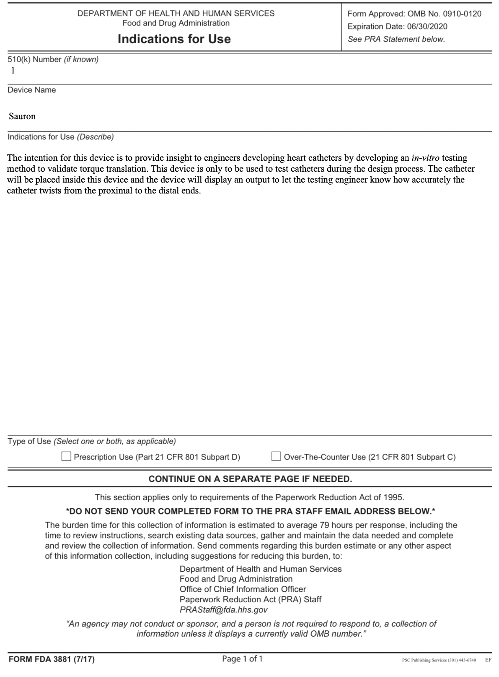

510k Summary
Sauron™ is measurement device that can quantify angular rotation of catheters at both the distal and proximal end. It quantifies the angular rotation through use of magnetic encoders that provide first (distal) and second (proximal) angular rotation values in degrees and then proceeds to create a catheter distal-proximal rotation angle calculation unit that shows extent of similarity between the angular rotations at both ends. It comes in the form of a table setup that serves as a movement restriction unit that provides support for insertion of a wide variety of catheters for their respective measurements. Sauron uses a BNO055 9-DOF IMU, AS5600 Magnetic Encoder, microcontroller, and an LCD Display to display distal-proximal rotation angle calculation unit. The predicate device uses movement restriction unit of a tube shape with a torque sensor at the distal end. The torque experienced is displayed as a serial plot.

Submitted by | Biosense Webster, Inc  MASACath Division  6501 Fakeaddress Court North  Fake City, FL 32311  608-839-4565
Date | November 6, 2022
Contact Person | Alberto Villacrez  Device Design Engineer  av18k@fsu.edu
Device Generic Name  Device Proprietary Name  Classification and Reference | Angular rotation measurement device (for catheters)  Sauron™ MASACath Solutions™ Cardiac Catheter Fine Tuner  21 CFR Not Applicable, Class Not Applicable
Predicate Device  United States Patent Number  Predicate Device Manufacturer  Classification and Reference | Interventional Device Testing Equipment (IDTE2000)  US 9,918,682 B2  Machine Solutions  21 CFR Not Applicable, Class Not Applicable

Device Description

Being able to quantify the amount of rotation at both ends of the catheter will help engineers while designing new catheters. This will also ensure a level of accuracy with the rotation to increase the overall safety, efficiency, and consistency of the device. Physicians who use catheters regularly need this level of accuracy because catheters are used to scope, cauterize, and map the anatomy of the patient. If a doctor is trying to line up where they are about to burn the inside of the patient’s heart to change the electrical impulses and correct the rhythm, it is essential that the distal end does exactly what the proximal end tells it to. A loss in precision can slow down the procedure, increase the sedation time and create more risk for the patient.

For the device to achieve the level of accuracy required, a combination of encoders and magnets was utilized. More specifically a BNO055 9-DOF IMU, AS5600 Magnetic Encoder, microcontroller, and an LCD Display. Both the rotational angle of the tip and handle were measured with this method. Through these measurements a relationship between the rotation of the handle and the rotation of the tip was quantified.

Figure 1: Sauron Schematic
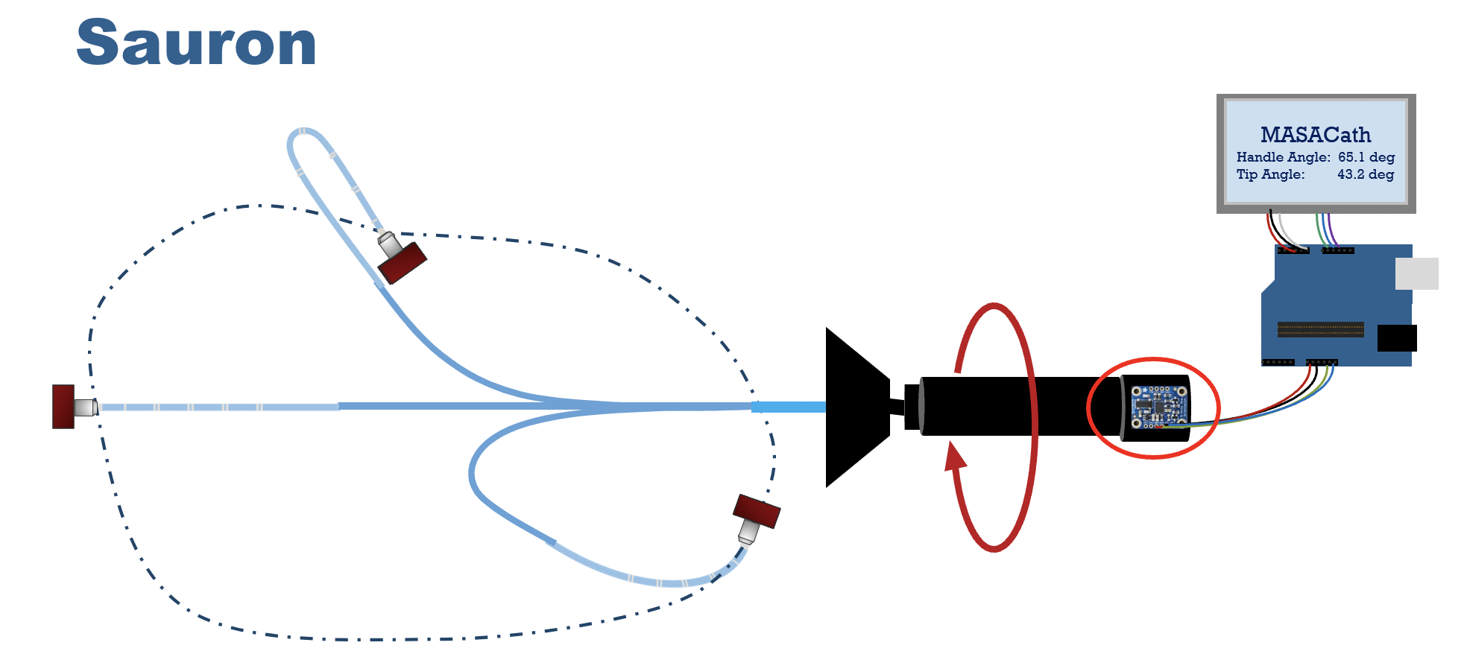Sauron has a magnetic encoder connected to the tip of the catheter while the IMU is attached to the handle. This will collect measurements at both ends with some wiring and display it on the LCD display.

Figure 2: Catheter Handle Schematic
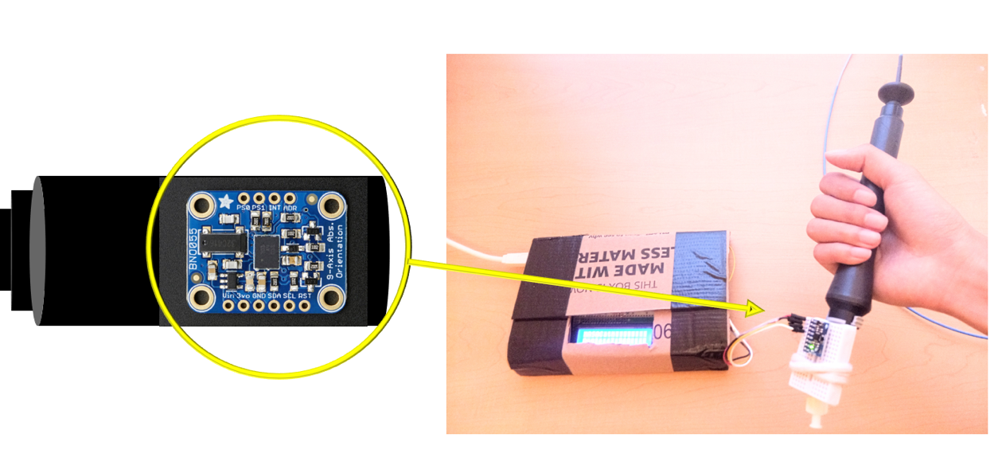

Figure 3: Catheter Tip Schematic
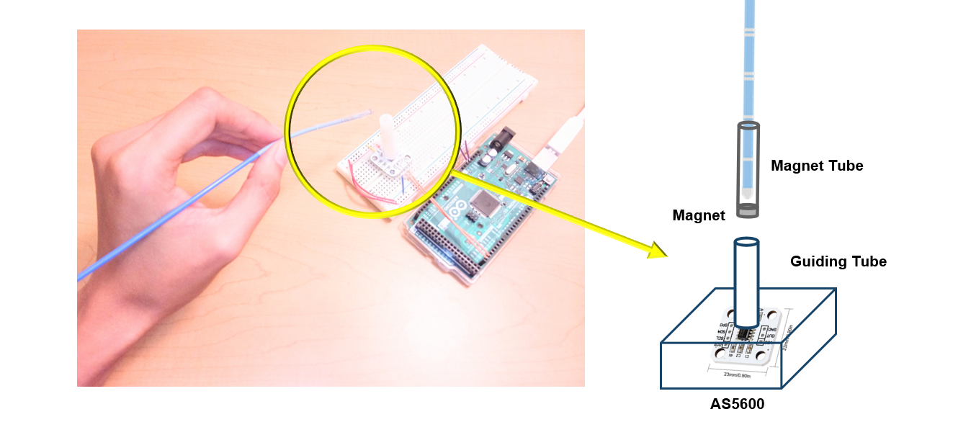

Figure 3: Measurement Display
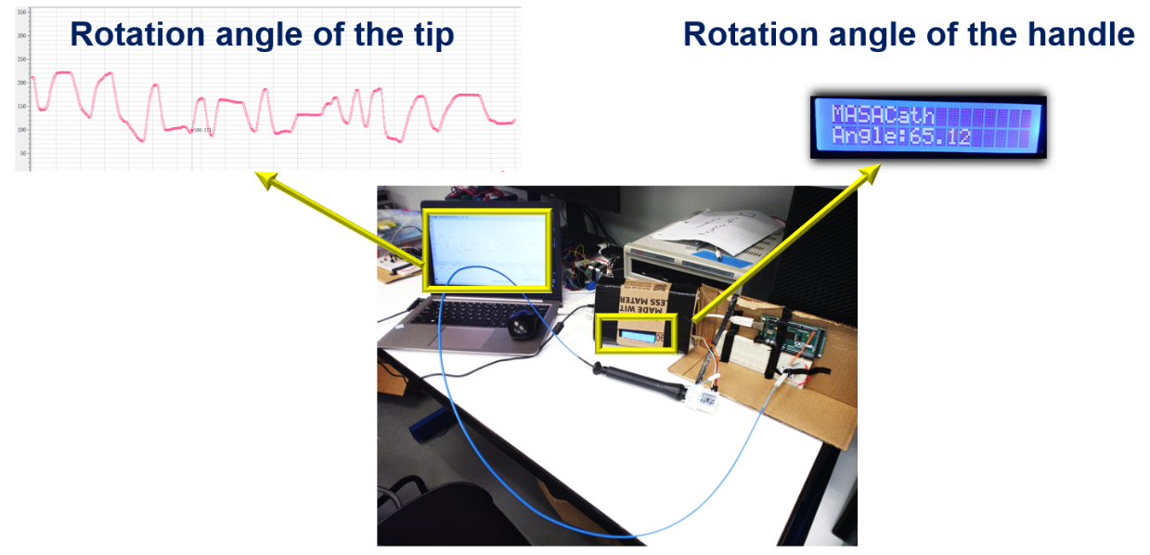

Executive Summary/ Predicate Comparison

3.0 Device description

The device is intended to be used in a manufacturing development setting as a method to determine the ratio of the angular rotation at the proximal (handle) and distal end (tip) of the catheter. The components of this measuring device include a magnetic encoder utilized at the distal end of the catheter and an IMU utilized at the proximal end of the catheter. A comparison between the rotational angle at the proximal and distal end of the catheter will be performed using MATLAB and Arduino IDE then displayed as a serial plotter as well as on an LCD screen. Table 1 outlines the differences and similarities between Sauron and the predicate device.

Table 1. Sample predicate comparison table to outline differences and similarities between the subject and predicate devices

Description | Subject Device:  Sauron | Predicate Device: Interventional Device Testing Equipment (Machine Solutions Company)
Indications for use | Catheter Validation Testing for distal and proximal end angular rotation In Vitro | Catheter Validation Testing for proximal end rotation comparison through a cylindrical tube/catheter holding tray In Vitro
Prescription/over-the- counter use | N/A | N/A
Size(s) | 15 lbs. | 550 lbs.
Battery or mains powered | 5V Battery pack | 208-240 VAC
Distal Angle Measurement | Magnetic Encoder to measure the angle of rotation at three different shaft angles. | 5 inoz – 50 inoz torque sensor
Proximal Angle Measurement | IMU to measure acceleration, orientation, and angular rates, then convert them to rotation angles in three dimensions. | Did not measure rotation at the handle
Data Processing | MATLAB  Arduino IDE | Visual Basic 6.0 - data saved as CSV and PDF
Display | Serial Plotter on Monitor and LCD Screen | Serial Plotter on Monitor and LCD Screen

The Sauron and Interventional Device Testing Equipment (IDTE2000) are equivalent with each device outputting the same data metrics for In Vitro angular rotation catheter testing. The main differences between the devices are the size and sensors utilized in this process. The types of sensors used in each device can output nominally the same data under various testing conditions. The IDTE2000 is much larger and weighs substantially greater than the Sauron; however, these metrics do not affect the overall performance of the devices for their intended use.

3.1 Performance Test Summary

Device performance testing was conducted to verify the functionality of all mechanical and electrical components. Sauron was evaluated with the following tests: continuity, precision detection, measurement trueness and precision, stiffness comparison, durability testing, component fatigue, and electrical safety. A description of each test, the standard satisfied, and the results of the test are summarized in Table 2.

Table 2. A summary of all tests Sauron was subjected to for design validation testing

Test | Description | Standard satisfaction | Results
Continuity | Performance testing of all electrical components in the device to ensure no loss of power, sensor or display malfunction, or harmful fluctuations in voltage/current occur. | ISO-5725 | Pass
Precision Detection | Confirms sensors have a high enough resolution to measure linear deflection within ±0.1mm and angular rotation within ±0.1º. | ISO-5725 | Pass
Measurement Trueness & Precision | Gage R&R study (>10% variation) to ensure accurate and repeatable results can be obtained with the device. | ISO-5725 | Pass
Stiffness Comparison | Stiffness of material used to restrain catheter must be comparable to the stiffness/flexibility of industry-used sheaths to simulate in Vivo conditions. | IEC-60601 | Pass
Durability Tests | Drop, push tests, and lifecycle testing. Confirms device maintains mechanical functionality. | IEC-60601-1 | Pass
Component Fatigue | Sheath flex strength testing to confirm to breaks/tears within 50 flexion cycles and the torsional strength of the adaptors maintain mechanical integrity after repeated use. | IEC-60601-1 | Pass
Electrical Safety | The device does not interfere with itself or any devices in the surrounding environment. The device does not malfunction from the ESD produced by human touch. | IEC 61000 | Pass

Substantial Equivalence Discussion

The predicate device used is the IDTE2000 which is manufactured by Machine Solutions. The Interventional Device Testing Equipment, or the IDTE2000, comparatively and quantitatively tests and records performance features of catheters. The performance features this device can record includes torqueability. Sauron is also a device that will be used to comparatively and quantitatively test and record rotational features of the catheter. Both devices are used as catheter validation testing equipment to quantify the proximal and distal end rotation. Sauron and the IDTE2000 data are both displayed as a serial plotter on a monitor and LCD screen. The catheter can be manipulated into multiple configurations with both the predicate device, the IDTE2000, and Sauron. During performance testing ISO 10555, which is the international standard for intravascular sterile and single-use catheters, was followed by both the IDTE2000 and Sauron. ISO/TS15539, which is the international standard for cardiovascular implants endovascular prostheses, was also followed by both the IDTE2000 and Sauron.

Proposed Labeling

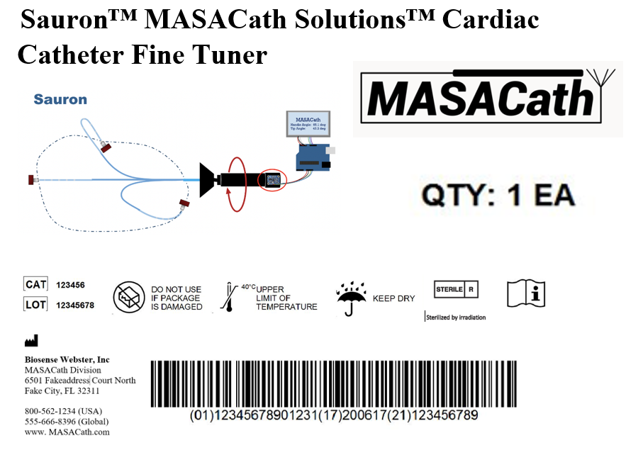

Sterilization

Sterilization of Sauron construct will be achieved using Established Category A sterilization technique of gamma radiation. Gamma radiation will occur in gamma irradiator, a shielded room that contains a source of radiation. A conveyor belt will bring product in and out of the shieled room to expose it to a radiation dose of 25 kGy. A control and safety system will be in place and in accordance with 10 CFR 37 physical protection of radioactive sources is provided and license for Gamma Irradiators will be acquired through USNRC. A desired sterility assurance level (SAL) of 10^-3 will be achieved for our construct a satisfactory metric as Sauron only intended to be in contact with the skin as it functions as a measurement device. Validation of the sterilization cycle will be done through the half cycle method. Once sterilization is completed and validation of sterilization occurs the product Sauron will be enveloped in plastic bag packaging to maintain sterility until it gets to consumer.

Biocompatibility
N/A

Software

8.0 Level of Concern
The level of concern for the software is minor since it is a validation device for a catheter which is a minor concern device. The software component of the device measures raw rotational data from the proximal end or the handle of the catheter and compares the distal or tip response. It does so by performing a t-test between the two data sets and determining if there is a significant difference. In this case more than 2 decimals of difference are too much. This will be done using MATLAB.

8.1 Software Description and Requirements
The software controls the electronics and outputs of the device based on catheter motions. The Arduino integrated development environment (IDE) and MATLAB are used as programming languages. The hardware is consisted of four modules: the Adafruit 9-DOF Absolute Orientation Inertial Measurement Unit (IMU) Fusion Breakout module, the12-bit AS5600 magnetic encoder module, the LCD displace module, and the Arduino Mega 2560 microcontroller module with a resolution of 10 bits. Both sensors use I²C port communication. No operating system is required such as WindowsTM or Mac OS. No other interface is required.

The device will use sensors sent to an Arduino to interpret the raw data from the catheter. If the sensors fail the device will not be able to be calibrated. Without calibration the data would be inaccurate and lead to either false positives or false negatives. In the event of a false negative catheters would be deemed faulty more frequently than they should and slow the development process. If there are false positives, then some devices would be deemed functional when they are not. In the case If the Arduino fails then there could be a short-circuit, an electrical fire, and the user could at worst be electrocuted if no op-amp circuit is implemented. A built-in kill switch in case of overheating can be implemented. The software needs to collect rotational data from the catheter and interpret it. Each portion of the documentation is traceable and can be accounted for.

8.2 Architecture Design Chart
The system of the device consists of one main subsystem (Arduino IDE) and three items (LED Module, IMU Module and Magnetic Encoder Module). Figure 1 shows the architecture of the design.

Figure 2: Sauron Software Architecture
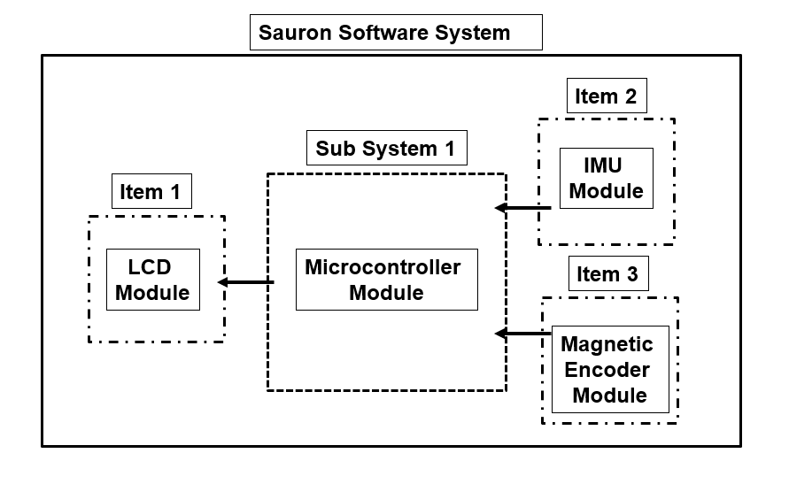
8.3 Software Development
The program is built on Adafruit Sensor library, Adafruit 9DOF library and AS5600 library. Coding standards are encouraged but not required. Software is examined and updated monthly.

8.4 Software Functional / System Test Plan
The software functional test plan is to calibrate the sensors by testing the hardware with a solid rod. Then calculating the rotational difference with the data from the rod. Since this rod should have a one-to-one relationship any deviation from this with the same level of significance would be significant. In the case of compile failure occurs or incorrect angle generated, real-time data is plotted on serial plotter and serial monitor to aid the process of data analysis and debugging. Unit and integration testing is available to ensure that the sensors have been correctly and effectively implemented. Table 2 outlines the possible problems and methods of control.

Table 2. Device Hazard Analysis

Hazard | Severity | Cause | Method of Control | Mitigation | Verification
Incorrect Measurement | 4 | Algorithm Error | Algorithm Verification | Algorithms are designed so that inputs produce correct outputs. Filter implemented so the accuracy improves. | Verify that input result in the correct output.
Incorrect Calibration | 3 | Wrong Calibration Process / Gesture | Alarm | The device has been designed to alarm the user when the calibration is done incorrectly. | Verify that the device alerts the user when 3-step calibration is incomplete.
System Shutdown | 4 | Low Battery | Alarm | The device has been designed to alarm the user when the battery is low. | Verify that the device alerts the user when the battery is at or below 20%

8.5 Cybersecurity Safety
The device cannot connect to the network and does not have remote access. The potential risk of the software is accidental or intentional deletion of the programming files. To prevent this, all data and programming files are required to be uploaded to Microsoft Teams and only shared between team members. Setting up passcode is required for operating system in order to run the program. Public computers are not allowed to install and run the program. The device is safe and effective throughout its life cycle.

Electromagnetic Compatibility and Electrical Safety

The device contains non-conductive support structures, sensors, a microcontroller with software, an LCD display, and a power supply. The support structures need to be coated in an easy to clean and sanitize layer to prevent damage to electrical components. The electrical parts need to be encased in a nonconductive container to prevent electrical interference. The device is intended to be used in a manufacturing testing laboratory environment. There is no wireless technology in the device. There are no RF emitters. The device will be tested to make sure outside interference will not disrupt the function of the device nor cause external harm to users. After the EMC test the device sensor should still function with the same level of accuracy and precision. The sensors still need to function at optimal levels after testing. No allowances required. No modifications required. The electrical components of the device will be clearly labeled. It will detail where the device can be used, safety requirements of the device, and detail potential hazards to the device.

The device must comply with conducted emissions testing. It must be able to not damage the local electrical grid once plugged into the wall. The device must follow the specified emission limits (150 kHz – 30 MHz). This is to protect the local power supply. We will ensure that the power supply matches the needs for the device. The radiated emissions must comply with the specified limits of (30MHz – 5GHz). This ensures that other devices will not be affected by being near the device.

Performance Testing – Bench
A series of mechanical, electrical, and reliability tests were conducted to verify device functionality per the intended use and device conformance to several international standards. Requirements for the international standards below were as follows where applicable:
- ISO 10555 – Standards for intravascular sterile and single-use catheters
- IEC 60601 - Medical Electrical Equipment Standards
- ISO/TS15539 – Cardiovascular Implants Endovascular Prostheses
- ISO 5725 - Accuracy (trueness and precision) of measurement methods and results

10.1 - Electrical Testing
Test | Requirement | Results
Continuity | For the duration of runtime, the device’s control module does not:  - lose power  - have significant fluctuations in voltage/current that could cause harm to user or system  - lose signal/location from sensor modules  - cut out digital display | Pass
Precision Detection | Linear deflections resolution: ±0.1mm  Angular rotation resolution: ±0.1º | Pass

Continuity tests carried out a foundational performance diagnostic on individual and system-wide electrical components. Passing results validated that the constructed circuit adhered to its intended functionality without posing any harm to the system or user. Precision detection ensured that sensors were able to measure small enough differentials in data points to produce accurate results. After electrical tests passed, the integrity and reproducibility of the measurement system were tested using guidelines provided in ISO-5725.

10.2 – Measurement Reliability Testing
Test | Requirements | Result
Measurement Trueness & Precision | Measurement system produces accurate and repeatable results per requirements of:  - Gage R&R Study (>10% variation)  - ISO 5725 guideline tests for trueness & precision | Pass

The reliability tests presented in the previous table confirmed the device’s measurement system produced results with a high level of accuracy and precision in line with requirements laid out in ISO 5725. The device was required to be universally compatible with varied tip locations and catheter models, so the successful Gage R&R Study ensured the device’s measurement system was accurate and more importantly, reproducible across different setups and/or operators.

10.3 - Mechanical Testing
Test | Requirement | Results
Stiffness Comparison | Device sheath material must have comparable stiffness/flexibility rates to industry-used sheaths. | Pass
Durability Tests | Drop & Push Tests per IEC-60601-1.  Lifecycle Testing  - Device maintains mechanical functionality through multiple cycles w/o | Pass
Component Fatigue | Sheath flex Strength:  - no breaks before 50 flexion cycles.  - Adapter Torsional Strength: proximal/distal end adapters maintain mechanical integrity after repeated use. | Pass

Mechanical testing validated the durability of the device to withstand physical disturbances and accuracy of the simulated environment. Material testing of the sheath asserts that the chosen material provides an accurate in vitro simulation of the real in vivo environment the catheters undergo during their operations. The cost-effective and accurate simulation of the in vivo environment provides engineers with the ability to quickly validate design requirements without expensive laboratory equipment. This validated the market need for the device. Durability tests subject the device to inacceptable physical risks such as drops, pushes, and spills. Passing these tests ensures that the device can maintain form and functionality after the forementioned risks. By applying standard test requirements from IEC-6061, the user will remain safe even in the case of a system failure.

Performance Testing – Animal
N/A

Performance Testing - Clinical
N/A

