EML4551C Senior Design II
SD T113 – MASACATH: Operation Manual
Due: 03/03/2023

Device Description

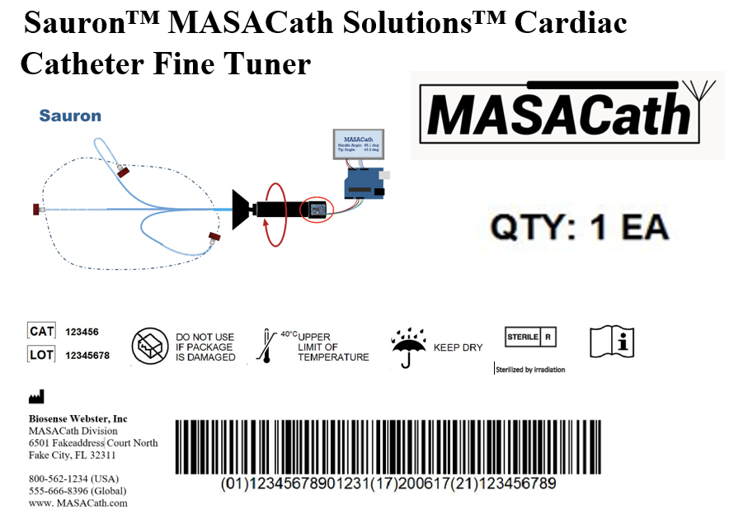

The Sauron Cardiac Catheter Fine Tuner is a rotation measuring device. It contains a BNO055 9-DOF IMU, an AS5600 magnetic encoder, an Arduino Mega 2560 microcontroller, a NEMA-17 stepper motor, 4 LEDs, an OLED Display, the case and relevant 3D printed parts. The purpose of the device is to measure the rotational angle of the cardiac catheter tip and handle. Through these measurements a relationship between the rotation of the handle and the rotation of the tip can be quantified. The device is intended to be used in a manufacturing development setting as a method to determine the ratio of the angular rotation at the proximal (handle) and distal end (tip) of the catheter.

Table 1. Product Information

Description | Device: Sauron
Indications for use | Catheter Validation Testing for distal and proximal end angular rotation In Vitro
Prescription/over-the- counter use | N/A
Size(s) | 10 lbs.
Battery or mains powered | 9V Battery pack
Distal Angle Measurement | Magnetic Encoder to measure the angle of rotation at three different shaft angles.
Proximal Angle Measurement | IMU to measure acceleration, orientation, and angular rates, then convert them to rotation angles in three dimensions.
Data Processing | Arduino IDE
Display | OLED Screen

Software

Software Description
The software controls the electronics and outputs of the device based on catheter motions. The Arduino integrated development environment (IDE) is used as a programming language. No operating system is required such as WindowsTM or Mac OS. No other interface is required.

Software Development
The catheter measuring device code will be developed and updated constantly to ensure that it meets the latest industry standards and provides accurate and reliable measurements. For code download, please visit: https://web1.eng.famu.fsu.edu/me/senior_design/2023/team113/

Hardware
Figure 3 Full Assembly of MASACATH Device (Top View)
Figure 3 Full Assembly of MASACATH Device (Side View)

Electronics

IMU Sensor - Adafruit 9-DOF Absolute Orientation IMU Fusion Breakout - BNO055 - STEMMA QT / Qwiic, Source: Adafruit - IMU
    - Magnetic Encoder – AS5600 Magnetic Encoder Magnetic Induction Angle Measurement Sensor Module 12bit, Source: AS5600 Magnetic Encoder - Amazon
    - Input Motor - Stepper motor - NEMA-17 size - 200 steps/rev, 12V 350mA, Source: Adafruit - NEMA-17

The catheter rotation measuring device is comprised of four main components: the IMU module, motor and motor driver module, display module, and magnetic encoder module. These components are connected to an Arduino IDE microcontroller that serves as the main subsystem for the device. The IMU module is responsible for measuring the rotation of the handle and is connected to the microcontroller via a serial communication protocol. The motor and motor driver module controls the rotation of the catheter tip and is connected to the microcontroller through digital input/output pin. The display module provides a user interface for the device and is connected to the microcontroller via a serial communication protocol. The magnetic encoder module is used to measure the rotation of the catheter tip and is connected to the microcontroller through a digital input/output pin. Figure 4 shows the architecture of the device.

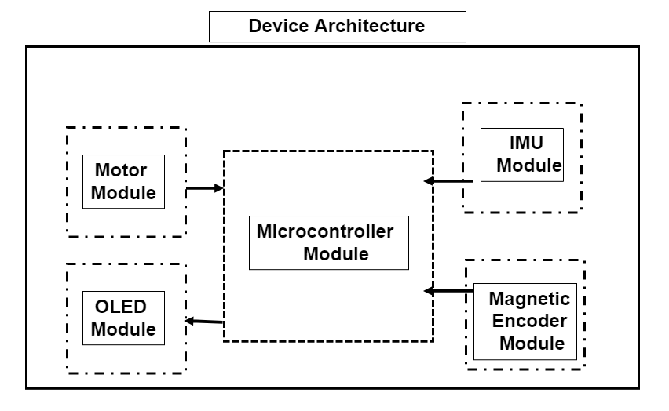
Figure 3.1.1: Device Architecture

To set up the circuit, connect the IMU and magnetic encoder to the microcontroller using the I2C serial communication protocol. Connect the motor and motor driver to the microcontroller using digital input/output pin and ensure that the power supply is connected to the motor driver module. Finally, connect the display module to the microcontroller using the I2C serial communication protocol. Once all components are connected, upload the appropriate code to the microcontroller using the Arduino IDE software. The device is now ready for use. Figure 5 shows how the circuit is set up.

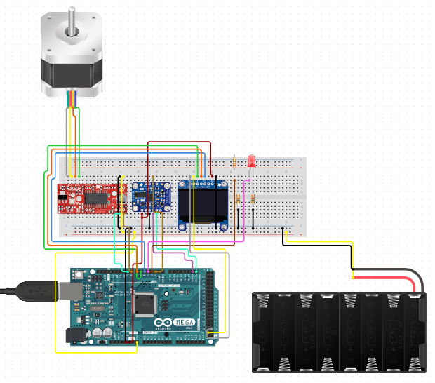
Figure 3.1.2: Circuit Setup

  - Housings and Environment
    - All CAD files are available on the “Biosense Webster: Catheter Calibration and Measurement” Microsoft Teams Page.

    - Neutral Axis of device: +40mm (above baseboard)

    - Tip Housing
- 3D Printed out of standard 1.75mm D PLA.
- Neutral Axis = ground + 40mm.

    - Handle Clamp
- Clamp diameter is compatible for all Biosense Webster catheter models.
- 3D Printed out of standard 1.75mm D PLA.

    - Proximal Environment Base
      - Holds support mounts for catheter handle, sheath handle, stepper motor.
      - Attaches to “3.2.6 Proximal Leaf Base” via dowel pins.

    - Proximal Leaf Base
- Only has flat baseboard with supports level with neutral axis.
- Can be added/removed for different length catheters.
- Made of sealed plywood.

    - Distal Environment Pegboard Enclosure
      - Made of wood/3D printed pegboard.
      - Has drilled “peg holes” that the tip housing secures in to. This allows for the catheter to be bent at various orientations during the test:
        - 0 degrees (straight line)
        - 30 degrees
        - 45 degrees
        - 60 degrees
        - 90 degrees
      - Resin Printed fluid drip-catch.

    - Fluid Drip System
      - Uses gravity to deliver constant flow of fluid (e.g., saline or water) through sheath-catheter interface.
      - Holds Fluid Pouch suspended above system and connected to stop valve on catheter sheath.
      - Outlets from sheath end and falls into fluid drip-catch in “3.2.7 Distal Environment Pegboard Enclosure.”

  - Connectors & Supports
    - Vein Support Beams
      - 3D Printed out of standard 1.75mm D PLA.
    - Motor Coupler
      - 3D Printed out of standard D = 1.75mm PLA.
    - Vein Tubing
      - Soft Polyurethane tubing.
      - ID: 6.25 mm
      - OD: 9.25 mm

  - Compatible Catheters & Sheaths
    - Compatible Biosense Webster Catheters: All catheters with 6F ≤ OD ≤ 8F.

    - Compatible Biosense Webster Sheaths: All models are compatible.

Integration
  - Environment Base
    - Vein Support Structure: screwed to baseboard along neutral axis.
    - Pieces Fit together with dowel pins which verify neutral axis alignment.
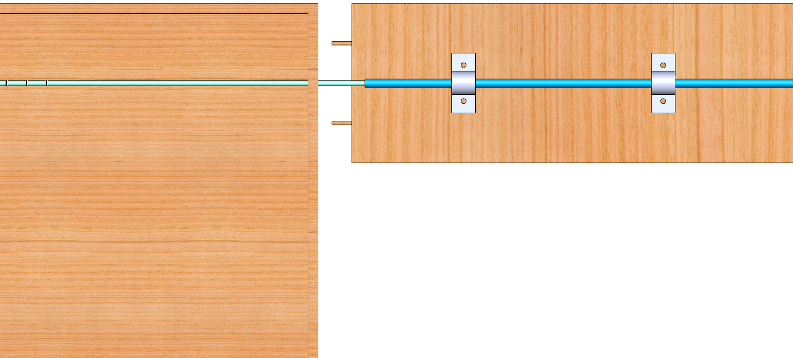
Figure 4.1 Environment Baseboard Connection Method
  - Proximal Module
    - Holds: Stepper Motor & Mount, Handle Clamps & Motor Coupler, Catheter Handle, Catheter Sheath Handle, and IMU.
    - Motor Mount: screwed into baseboard, aligned with neutral axis.
    - Stepper Motor: screwed into motor mount.
    - Handle Clamps & Motor Coupler: coupler end is press fit around motor shaft.
    - Catheter Handle: fitted inside clamp inner diameter, clamp tightened around handle outer diameter.
    - Sheath Handle: aligned with catheter neutral axis, supported by tight clamp screwed to ground.
    - IMU: aligned with neutral axis and glued/screwed into top face of Handle Clamps.
Figure 4.2 Top View of Proximal Module Assembly
  - Tip Module
    - Holds: TIP Module housing, Guiding Tube with Wings, Magnet, Magnetic Encoder, Catheter Tip, 6F-8F Compression Tube.
    - Tip Module Housing (transparent outer structure): rigid chamber with peg on bottom.
      - Peg fits into hole in base at different angles: Red: 0º, Blue: 30º, Green: 45º, Yellow: 60º, Black: 90º.
      - Guiding tube slid through the inlet slot where wings compress, once the wings have cleared inner walls they spring out (like an umbrella). Ensure front face is a distance of ≤1mm away from magnetic encoder.
    - Magnetic Encoder (white rectangle with black extrusion): mounted to back wall of housing, with center point aligned with neutral axis.
    - 6F – 8F Compression Tube (silver inner cylinder): has a series of inner diameters that are filleted to decreasingly sized diameters. Catheter Tip guided inside until hitting stopping wall for specific diameter.
    - Guiding Tube with Wings (transparent inner cylinder with grey wings): compression tube fits snugly within inner chamber of guiding tube. Wings glued to slots on the outer surface.
    - Magnet (red cylinder): glued to front face divot of guiding tube, should be flush with front face.
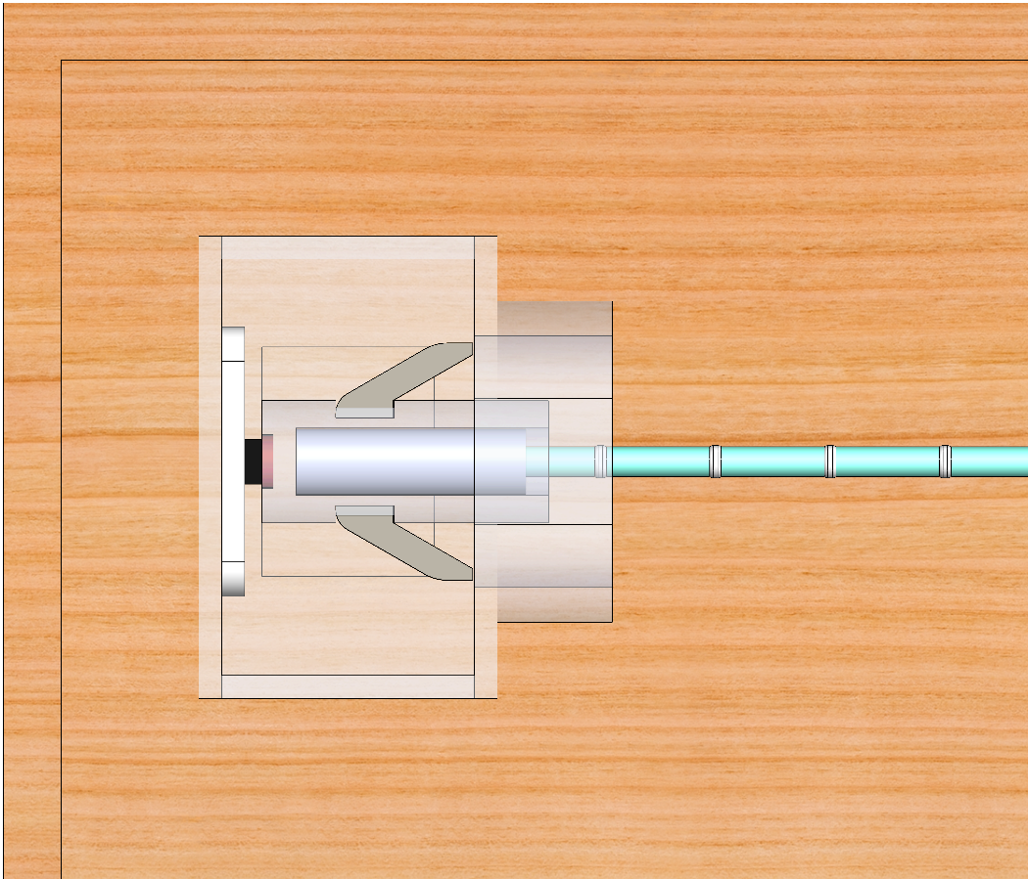
Figure 4.3 Tip Module Assembly

Operation

Setup

Insert catheter sheath into vein tubing and clamp down sheath handle.

Insert Catheter into sheath, ensuring that the tip (distal) end protrudes out from the sheath.
- Tighten Handle clamp around catheter body with IMU side facing directly upward.
  - Ensure the clamp is tight. The neutral axis of the catheter should be aligned with the neutral axis of motor shaft & sheath.
- Insert the tip of catheter into guiding tube until it hits a stop.
  - Ensure fit is tight so there is no slippage between catheter and guiding tube.
- Insert guiding tube (pushing wings down close to out diameter) through tip housing inlet until wings pop out freely inside the housing chamber.
- Check that the water drip container is full and open the valve to let fluid run through the sheath.

Running Test
- Turn on the power to control panel.
- Initialize IMU
  - Manually rotate the catheter handle until green led lights up (means IMU is set to 0 degrees).
- Select Configuration set up (catheter size & sheath size)
- Start the test, IMU and Magnetic Encoder should zero-out, and stepper motor will begin rotation test.
- Data (time, angle, velocity) is displayed to OLED screen as well as stored within Arduino file.

Collecting & Using Data
- Once test is complete, Arduino will output data to MATLAB and the GUI will output:
  - Plot Of Handle and Tip Angle, over rotational displacement
  - Plot of Handle/Tip Angle ratio vs. angular displacement
  - Deviation between readings

Troubleshooting

Sensor Calibration:
- Check wiring schematic (fig. #) to ensure the circuit is built correctly.
- Ensure that neutral axis is level through whole assembly.
- For Magnetic Encoder (tip)
  - Magnet and Encoder front face should be parallel with one another to keep 1D.
  - Magnet MUST be ≤1mm away from the sensor face of magnetic encoder, additionally, magnetic material should be between them.
  - Check that the solder joints have not disconnected.
  - Check the wiring connections: Make sure that the wiring connections are properly connected and that there are no loose or disconnected wires between the Arduino and magnetic encoder. Check for any damage or wear and tear on the wiring.
  - Verify the power supply: Check that the power supply is functioning properly and that the correct voltage(5V) is being supplied by Arduino to the magnetic encoder.
  - Verify the signal output: Verify that the signal output from the magnetic encoder is correct and matches the expected output. Use an oscilloscope or a signal analyzer to check the signal.
  - Check for interference: Magnetic encoders can be sensitive to electromagnetic interference (EMI). Check for any nearby sources of EMI that could be interfering with the encoder's signal. Consider shielding the encoder or moving it further away from any potential sources of interference.
  - Inspect the encoder and magnet for damage: Inspect the encoder and magnet for any visible damage, such as cracks or chips. Any damage to the encoder or magnet can cause errors in the signal output.
  - Check for alignment issues: Verify that the encoder and magnet are properly aligned with one another. Misalignment can cause errors in the signal output.
  - Verify the encoder resolution: Check that the encoder is configured for the correct resolution. If the resolution is incorrect, the signal output will not match the expected output.
  - Consider recalibrating the encoder: If all else fails, consider reboot the system. This may involve powering off the device and restart it again.
- For IMU (handle)
  - With motor powered off – rotate handle until led turns green (within 2mm of 0 deg).
  - Check for Proper Connection: Ensure that the IMU is properly connected to the circuit and that there are no loose or disconnected wires. Check for any damage or wear and tear on the wiring.
  - Check Power Supply: Verify that the power supply is functioning properly and that the IMU is receiving the correct voltage. Use a multimeter to check the voltage level of the power supply.
  - Check LED Indicator: The LED indicator on the IMU should turn green when the device is on. If the LED indicator does not turn green, the IMU may not be properly calibrated. Refer to the manufacturer's instructions for calibration procedures.
  - Verify Calibration: Verify that the IMU is properly calibrated. If the IMU is not properly calibrated, it can cause errors in the orientation and motion measurements of the catheter. Refer to the manufacturer's instructions for calibration procedures.
  - Verify Orientation and Motion Measurements: Use a test jig to verify the orientation and motion measurements of the IMU. If the measurements do not match the expected values, the IMU may be faulty and may need to be replaced.
- For Stepper Motor (input)
  - Test battery/power supply and motor driver with multimeter to ensure the circuit is closed.
  - If the stepper motor is very hot to the touch, unplug system and wait to cool, ensure motor is grounded and test isn’t running in background.

Table 2: Common Errors Troubleshoot Table

Hazard | Cause | Method of Control | Mitigation | Verification
Incorrect Measurement | Algorithm Error | Algorithm Verification | Algorithms are designed so that inputs produce correct outputs. Filter implemented so the accuracy improves. | Verify that input result in the correct output.
Incorrect Calibration | Wrong Calibration Process / Gesture | Alarm | The device has been designed to alarm the user when the calibration is done incorrectly. | Verify that the device alerts the user when 3-step calibration is incomplete.
System Shutdown | Low Battery | Alarm | The device has been designed to alarm the user when the battery is low. | Verify that the device alerts the user when the battery is at or below 20%

Code Errors:
Code errors can occur for various reasons, such as bugs in the software code, hardware failure, or user input errors. Below are the general instructions for dealing with code errors.
- Identify the Error: When a code error occurs, the first step is to identify the error message or code. Look for any error messages displayed on the screen or in log files. Note down the error message or code for future reference.
- Verify User Input: Check for any user input errors that may have caused the error. Verify that the input values are within the acceptable range and that the input format is correct.
- Contact Technical Support: If none of the above steps resolve the error, contact technical support of MASACath for assistance. Provide the error message or code, and any additional information related to the error. Technical support may be able to provide additional troubleshooting steps or escalate the issue to a higher level of support.

System Validation Testing
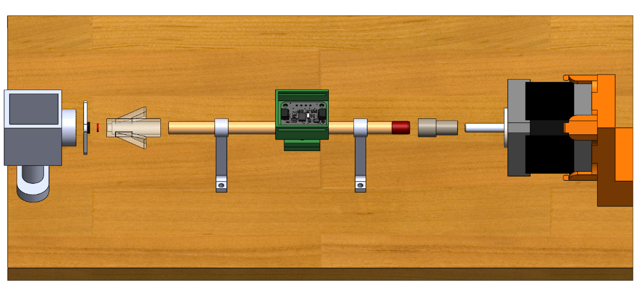
Figure 7.1 Pencil Test Assembly Exploded View
  - The Pencil Test (Straight Beam)
    - Setup
- Attach the magnet to the end of the pencil tape, (tape or glue works)
- Slide the pencil into the support beams ensuring the distance between the Magnet and face of the Magnetic Encoder are <1mm apart.
  - The test can be performed on actual catheter body if it is held straight in tension.
- Attach the IMU clamp to the pencil shaft between the two support beams (try leveling the top face to be parallel with ground to make calibration quicker).
  - Ensure the fit is tight, and that when rotating pencil, the IMU clamp does not slip.
- Attach the motor coupler to other end of pencil and then to the shaft of the Stepper Motor ensuring it is a tight fit (to prevent any slippage).
- Connect the wires to the breadboard and Arduino as shown below in fig. 2.
- Double check that pencil neutral axis is parallel to ground, and when rotating the pencil shaft, there is no frictions between:
  - The support beams and the pencil shaft
  - Pencil tip and tip housing inlet.

    - Running Test & Data Collection
- Ensure the distance between the Magnet and face of Magnetic Encoder are < 1mm apart.
- Turn on Control Panel.
- Manually rotate pencil shaft until IMU outputs 0º (when led light turns from RED -> GREEN).
- Once IMU is calibrated hit “enter” or “begin test”
- The stepper motor will rotate 3.6º or 4 steps, and the angle of the handle and tip will output.
- Step (5) will repeat until the stepper motor reaches 90º.
- Using the data from step 5, insert into MATLAB or Excel to plot the rotation vs time (or steps) to analyze data for non-uniformity.
  - PASS: data between IMU & Magnetic Encoder deviate ≤ ±1 degree from one another.

  - Computer Vision Test
    - Setup
- Use same setup steps (1-6) from (6.1 Pencil Test)
- Attach a colored rod, stick, beam to face of IMU that sticks out high enough to easily clear TIP Housing.
- Setup a camera behind Tip Housing so that it can record the identifier in step 2.
    - Running Test & Data Collection
- Repeat steps 1-3 from “6.1.2 Pencil Test.”
- Repeat step 4 from “6.1.2 Pencil Test” and start the video with the camera.
- Repeat steps 5-7 from “6.1.2 Pencil Test.”
- Upload video file to MATLAB Computer Vision Program and output data.
- Compare the data from pencil test and computer vision test,
  - PASS: readings can only deviate ≥ ±1 degree.

