Madison Burke; Savannah Buro; Amari Deleon; Christopher Hayot; Jake Anthony Vickers; Alberto Villacrez
FAMU-FSU College of Engineering 2525 Pottsdamer St. Tallahassee, FL. 32310

Team 113: Biosense Webster - MASACath
9/9/2022

Abstract
The abstract is a concise statement of the significant contents of your project. The abstract should be one paragraph of between 150 and 500 words. The abstract is not indents.

Keywords: list 3 to 5 keywords that describe your project.

Disclaimer
Your sponsor may require a disclaimer on the report. Especially if it is a government sponsored project or confidential project. If a disclaimer is not required delete this section.

Acknowledgement
These remarks thanks those that helped you complete your senior design project. Especially those who have sponsored the project, provided mentorship advice, and materials. 4

- Paragraph 1 thank sponsor!
- Paragraph 2 thank advisors.
- Paragraph 3 thank those that provided you materials and resources.
- Paragraph 4 thank anyone else who helped you.

Table of Contents
Abstract ii
Disclaimer iii
Acknowledgement iv
List of Tables vii
List of Figures viii
Notation ix
Chapter One: EML 4551C 1
1.1 Project Scope 1
1.2 Customer Needs 3
1.3 Functional Decomposition 3
1.4 Target Summary 3
1.5 Concept Generation 3
Concept 1. 3
Concept 2. 3
Concept 3. 3
Concept 4. 3
Concept n+1. 3
1.6 Concept Selection 3
1.8 Spring Project Plan 3
Chapter Two: EML 4552C 5
2.1 Spring Plan 5
Project Plan. 5
Build Plan. 5
Appendices 6
Appendix A: Code of Conduct 8
Appendix B: Functional Decomposition 14
Appendix C: Target Catalog 15
Appendix A: APA Headings (delete) 15
Appendix B Figures and Tables (delete) 16
Flush Left, Boldface, Uppercase and Lowercase 17
References 18

List of Tables
Table 1 The Word Table and the Table Number are Normal Font and Flush Left. The Caption is Flush Left, Italicized, Uppercase and Lowercase 17

List of Figures
Figure 1. Flush left, normal font settings, sentence case, and ends with a period. 16

Notation
A17 | Steering Column Angle
A27 | Pan Angle
A40 | Back Angle
A42 | Hip Angle
AAA | American Automobile Association
AARP | American Association of Retired Persons
AHP | Accelerator Heel Point
ANOVA | Analysis of Variance
AOTA | American Occupational Therapy Association
ASA | American Society on Aging
BA | Back Angle
BOF | Ball of Foot
BOFRP | Ball of Foot Reference Point
CAD | Computer Aided Design
CDC | Centers for Disease Control and Prevention
CU-ICAR | Clemson University - International Center for Automotive Research
DDI | Driver Death per Involvement Ratio
DIT | Driver Involvement per Vehicle Mile Traveled
Difference | Difference between the calculated and measured BOFRP to H-point
DRR | Death Rate Ratio
DRS | Driving Rehabilitation Specialist
EMM | Estimated Marginal Means
FARS | Fatality Analysis Reporting System
FMVSS | Federal Motor Vehicle Safety Standard
GES | General Estimates System
GHS | Greenville Health System
H13 | Steering Wheel Thigh Clearance
H17 | Wheel Center to Heel Pont
H30 | H-point to accelerator heel point
HPD | H-point Design Tool
HPM | H-point Machine
HPM-II | H-point Machine II
HT | H-point Travel
HX | H-point to Accelerator Heel Point
HZ | H-point to Accelerator Heel Point
IIHS | Insurance Institute for Highway Safety
L6 | BFRP to Steering Wheel Center

Chapter One: EML 4551C

1.1 Project Scope

Project Description

The objective of this project is to design a measuring device to confirm a 1:1 torque translation of cardiac catheters from the proximal to the distal end, leading to increased control precision for physicians.

Key Goals
Create a device that can read the input angular rotation of a catheter (proximal end) and verify that the rotation on the distal end matches with a 1:1 ratio. The device needs to have an accuracy of 1.0 mm and be able to sustain multiple uses. The device and test setup should also be translatable across all Biosense Webster Catheters and test operators.

Primary Market
Biosense Webster and Johnson & Johnson engineering teams have been identified as the primary market for this measurement device. When designing new catheter products or validating existing ones, a commonly occurring problem is that the angular rotation of the proximal end is not accurately translated to the distal end. Design and test engineers will use this device to validate this translation between distal and proximal ends is at a 1:1 ratio.

Secondary Market
The secondary market identified for this measurement device consists of research institutions, medical schools, and other catheter manufacturers. As the device becomes a standard measurement validation device across Biosense Webster Catheters, medical schools and other research institutions may become interested in learning the mechanics behind catheter measurement & calibration, in which the device could be used as a visual teaching aide. Furthermore, other catheter manufacturers in R&D may become interested in purchasing the device and set up, to be used on their own products.

Assumptions
- Used with one catheter at a time.
- Catheters are assumed to be manufactured by Biosense Webster.
- Device is partially or fully handheld?
- Device used consistently.

Stakeholders
Biosense Webster, Johnson & Johnson, Dr. McConomy and Dr. Arce from FAMU-FSU College of Engineering mechanical engineering department and biomedical engineering department are stakeholders for this project since they have an invested interest in the outcome and provide fundings. They are guiding the direction and necessary steps to make this project successful in fulfilling its goal.

1.2 Customer Needs

1.3 Functional Decomposition

1.4 Target Summary

1.5 Concept Generation

Concept 1.

Concept 2.

Concept 3.

Concept 4.

Concept n+1.

1.6 Concept Selection

1.8 Spring Project Plan

Chapter Two: EML 4552C

2.1 Spring Plan

Project Plan.

Build Plan.

Appendices

Appendix A: Code of Conduct

Mission Statement:
Bringing innovative catheter measuring solutions and help ensure a repeatable physician experience with catheter tools during surgery, increasing surgical outcomes and reducing adverse operative complications.

Outside Obligations:
Jake Anthony Vickers: Part time job (10-15 hours per week)
Madison Burke: Part time job (10-15 hours per week)
Savannah Buro: Research (10-15 hours per week)

Team Roles:
Alberto Villacrez [BME]: Bioinstrumentation Engineer, focus on hardware, design, and prototyping
Amari DeLeon [BME]: Biomaterials Engineer, focus on materials and background R&D
Christopher Louis Hayot [BME]: Software and Design Engineer, focus on simulation and software-based needs as well as designing the device.
Jake Anthony Vickers [ME]: Systems & Manufacturing Engineer, focus on control systems and additive manufacturing in design and prototyping.
Madison Burke [BME]: Robotics & Software Engineer, focus on biomedical robotics, design prototyping and software-based needs.
Savannah Buro [BME]: Biomaterials & Testing Engineer
Team members assume responsibility for their respective roles as well as the integration of design considerations from other roles. If other duties need to be assigned, the team will discuss the roles in a meeting and then the duty will be assigned to the member who the team decides is best suited for its completion.

Communication & Project Management:
1. Microsoft Teams
Microsoft Teams will be used as the primary mode of communication and project management within the group. The team chat will be used primarily for quick updates, questions, concerns. The “General” channel will be used to communicate project milestones, major issues, and group meeting scheduling. All members are expected to interact or respond to relevant conversations within 24 hours.
Files will be stored in the shared OneDrive and is accessible through Microsoft Teams as well as the group SharePoint. A detailed naming and storing convention is to be developed at a later date.
2. Email
When communicating to the sponsor(s) there will be a single point-of-contact for the group, which has been assigned to Amari Deleon, unless unable to in which a simple majority will decide who is to be the point-of-contact. The point-of-contact is required to respond to the sponsor within 24 hours of receiving the message and will consult necessary members before sending. This person is also required to CC ALL members in ANY communication between the sponsor(s) and group representative.
For any communication between the group and Dr. McConomy Jake Anthony Vickers will act as the point-of-contact and is also required to CC ALL members in any project related communication.
All professional emails will be conducted through FSU emails.

Scheduling:
All group members will add their weekly schedules to the shared “Team Availability” calendar within Microsoft teams, as well as keep them up to date. Scheduling team meetings can be done by any member.

Attendance & Meetings:
The team is expected to all be present for all team meetings that do not interfere with their “Team Availability” calendar. Weekly Sponsor Meetings, Fridays at 2:00 PM. Attendance will be taken at all meetings.
Notice is expected 3-5 days ahead, if a sponsor meeting will be missed, and 1-2 hours ahead if a casual meeting will be missed. Missing more than 3 meetings (even with notification) will require discussion of all group members. All meeting documents will be added to the shared OneDrive within 24 hours of the meeting to ensure any member not present is able to review meeting content.

Dress Code:
- For online meetings with the sponsor and/or advisor the dress code will be casual unless specified at least 48 hours before the meeting begins.
- At any presentations, the required dress code is, business professional (slacks, button-up shirt, jacket, dress skirts, and blouse)
- For all shadowing events in medical environments, scrubs are required.
- Any scheduled in-person meetings with the sponsor or advisor, the dress code is business casual (collared shirt, pants, sweaters, or blouses)

Amendment Process:
Anyone in the group may propose a change or addition to the Code of Conduct at any time within the project timeline. For a new Amendment to be passed, simple majority vote (4 of 7) must agree to the proposed change before it is added to the Code of Conduct.

Dr. McConomy & Dr. Arce Intervention:
If two or more group members find that one member is not “pulling their weight” then the group will call a general meeting to discuss and attempt to solve the problem.
If the problem is not resolved or continues to persist after the previous meeting, then Dr. McConomy and/or Dr. Arce will be contacted for intervention and mediation.

Statement of Understanding:
I have received, read, and agreed to abide by the Code of Conduct. I understand that all project material along with this Code of Conduct can be found within the group Microsoft Teams page as well as on the group SharePoint page.

Signatures:
Madison Burke: | 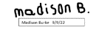
Savannah Buro: | 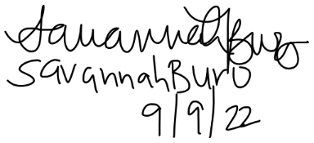
Amari Deleon:
Christopher Hayot:
Jake Anthony Vickers:
Alberto Villacrez: | 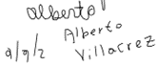

Appendix B: Functional Decomposition

Appendix C: Target Catalog

Appendix A: APA Headings (delete)

Heading 1 is Centered, Boldface, Uppercase and Lowercase Heading

Heading 2 is Flush Left, Boldface, Uppercase and Lowercase Heading

Heading 3 is indented, boldface lowercase paragraph heading ending with a period.

Heading 4 is indented, boldface, italicized, lowercase paragraph heading ending with a period.

Heading 5 is indented, italicized, lowercase paragraph heading ending with a period.

See publication manual of the American Psychological Association page 62

Appendix B Figures and Tables (delete)
The text above the cation always introduces the reference material such as a figure or table. You should never show reference material then present the discussion. You can split the discussion around the reference material, but you should always introduce the reference material in your text first then show the information. If you look at the Figure 1 below the caption has a period after the figure number and is left justified whereas the figure itself is centered.

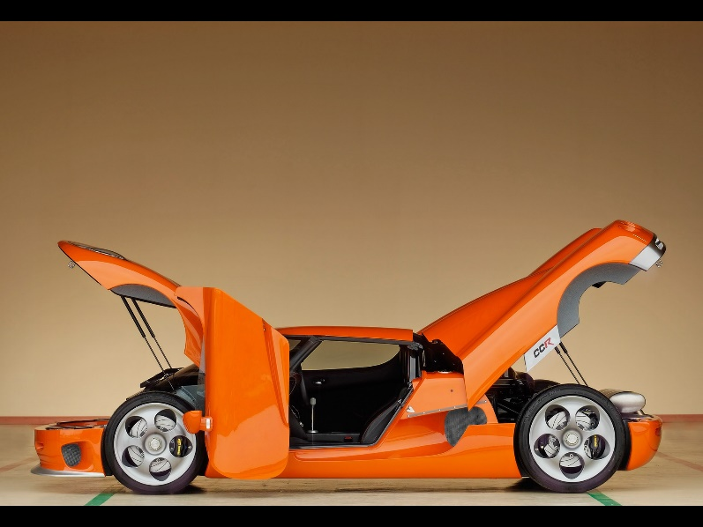
Figure 1. Flush left, normal font settings, sentence case, and ends with a period.
In addition, table captions are placed above the table and have a return after the table number. The second line of the caption provided the description. Note, there is a difference between a return and enter. A return is accomplished with the shortcut key shift + enter. Last, unlike the caption for a figure, a table caption does not end with a period, nor is there a period after the table number.

Table 1
The Word Table and the Table Number are Normal Font and Flush Left. The Caption is Flush Left, Italicized, Uppercase and Lowercase
Level of heading | Format
1 | Centered, Boldface, Uppercase and Lowercase Heading
2 | Flush Left, Boldface, Uppercase and Lowercase
3 | Indented, boldface lowercase paragraph heading ending with a period
4 | Indented, boldface, italicized, lowercase paragraph heading ending with a period.
5 | Indented, italicized, lowercase paragraph heading ending with a period.

References
There are no sources in the current document.

