SD-T113 MASACath - VDR 3 Agenda
Revised Problem Objective
Old: “The objective of the project is to design a testing device to confirm a 1:1 torque translation of cardiac catheter from the handle to the tip of the catheter, leading to increase control precision for physicians.”
New: “Design engineers will use this in vitro measurement device to confirm the rotational relationship between the proximal and distal ends of cardiac catheters to provide increased device reliability during the design process.”
Current State of selected design
The initial prototype and the real-time 3D modeling of the rotational motion of the catheter handle were finished in time. The purpose of this initial rapid prototype is to validate that the selection of sensors can output desired parameters.

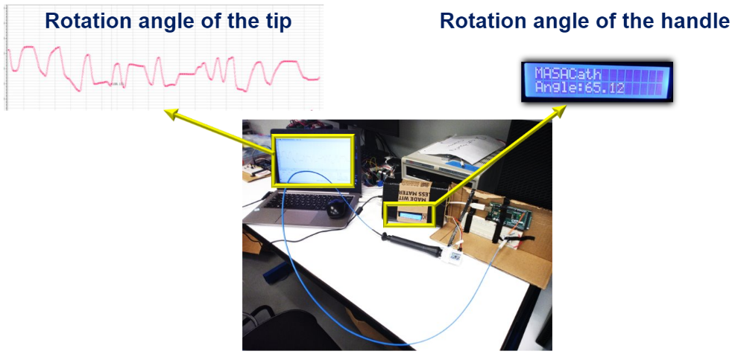

Figure 1: Current Prototype

The current environment build consists of a foam board with divots cut for the catheter shaft, blue foam with a hole to hold the catheter parallel to the ground and limit degrees of freedom. Additionally, our sponsor provided us with a catheter sheath (that is used in clinical settings) to better understand and simulate the catheter motion limitations when in use.
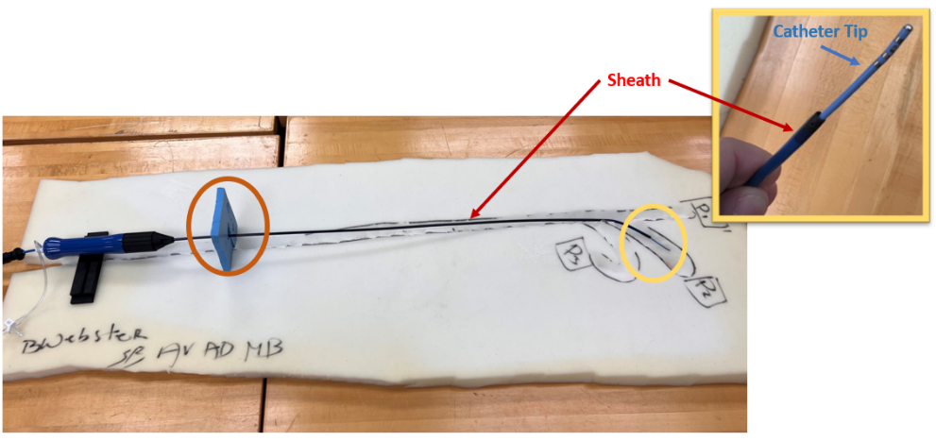

Figure 2: Current Environment Build

A forecast of work ahead
In the upcoming week(s), the environment prototype will be further developed by the following measures:
  - Limitation of system’s degrees of freedom to simplify and benchmark prototype
  - Material selection of the sheath to suitably model the human cardiovascular system
  - Development of proximal and distal end circuits
  - Investigation of possible controller(s) to account for physical errors.
  - We would also like to investigate integrating a torque meter into our current design as shown below, to provide additional parameters for designers to manipulate.
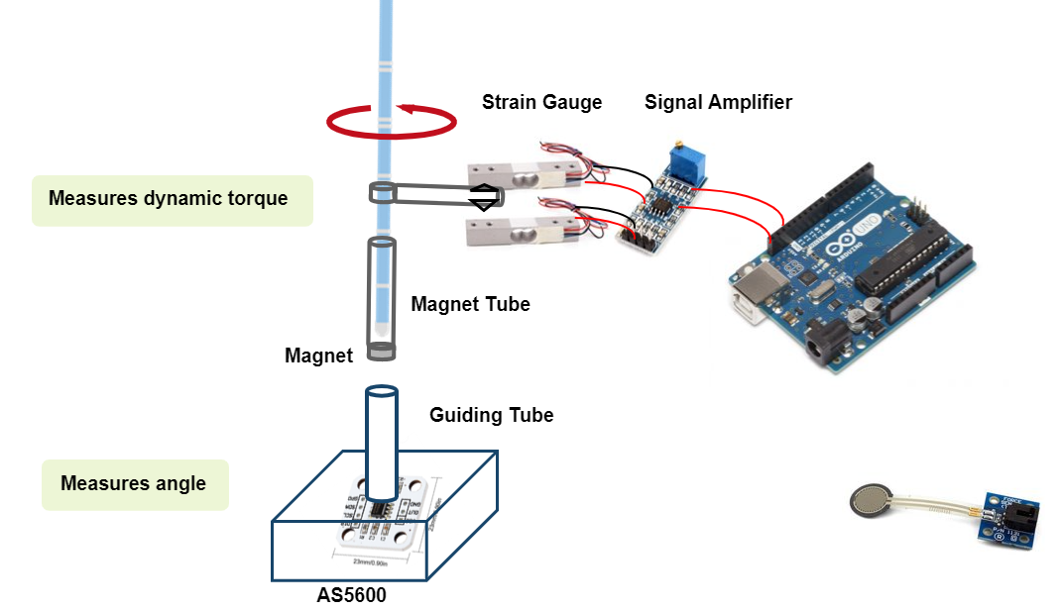
Figure 3 Torque Meter Schematic

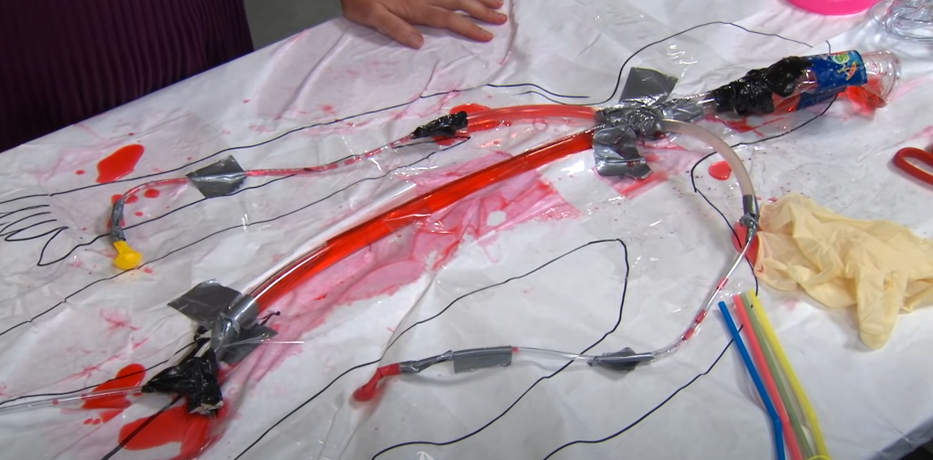
Figure 2 Circulatory System (Environment) from dissection at UF

In the upcoming spring semester, we will start the detail design, with the final quality materials, the environment and model will be built, and verification/validation testing will be performed using benchmarks from our mock 510(k) proposal.
- Problem areas identified
- An accurate torque meter is expensive.
- Control of Project Scope: limiting # of compatible models and/or catheter orientations.
- There is a non-linear degradation of rotation along the length of shaft.
- Identification of all sources of impactful error (friction loss, slippage, sensor resolution, etc.)
- The time delay calculation of the rotational angle.
- The clipping mechanism used in the magnetic encoder module.
- 3D heart modeling and bioprinting (if possible) or soft material printing.

