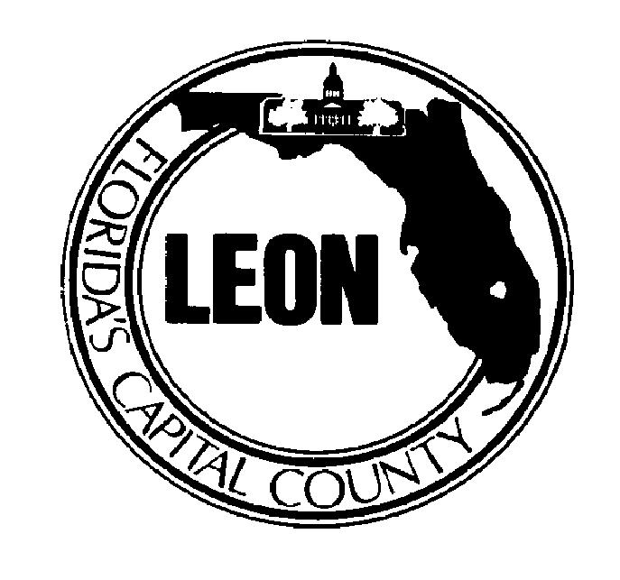
Leon County

Board of

County Commissioners

October 3, 2004 Req. #122B-04
Pos. #2210-10
Design Analyst
(Re-advertisement)
Public Works/Engineer Services/Design
Salary Range: $35,449.81-$59,282.50 Annually*
Excellent Benefits Package

Leon County, Florida is currently seeking qualified applicants for the position of Design Analyst within the Engineering Services Division of the Public Works Department.

ESSENTIAL JOB FUNCTIONS: This position provides Engineering Design Support for a wide variety of Public Works projects including roads, parks and drainage improvements. Coordinates permitting activities with federal, state, and local agencies. Aids in the preparation of plans, specifications, and cost estimates. Determines need for right-of-way and drainage easements. Provides design review of infrastructures to be constructed by others for County acceptance. Conducts field inspections of projects to determine compliance with plans, specifications, and permits. Represents the County on local technical committees, provides technical assistance to other County divisions and officials on engineering matters.

REQUIREMENTS: Requires graduation from a four year college or university with a Bachelor’s degree in civil engineering, or a closely related field. Current certification in Florida as an engineer intern is preferred. Basic knowledge of stormwater and roadway design is desired. Must have a valid Driver’s license and favorable driving record at time of hire. An excellent benefits package is provided. This includes 13 paid holidays, health insurance, opt-out option, life insurance, short term disability, annual leave, sick leave, and deferred compensation.

APPLICATION DEADLINE: Open until filled
*Initial placement may be negotiated up to 25% above the minimum salary based on verified related education, experience, and training above the minimum requirements.
Reasonable accommodations and assistance are available to disabled applicants under the Americans with Disabilities Act (ADA) of 1990.
FOR FURTHER INFORMATION, contact the Leon County Human Resources Division at (850) 487-2220. Applicants are encouraged to visit our Leon County Home Page at http://www.leoncountyfl.gov. Applicants may send inquiries to our E-mail address: Boatwright@leoncountyfl.gov. A completed Leon County Board of County Commissioners application is required and must be postmarked no later than ASAP. APPLY online, in person or by mail to:

Leon County Human Resources Division – Leon County Courthouse, Suite 201, Tallahassee, FL 32301

Preference is given to certain veterans and spouses of veterans as provided by Chapter 295, Laws of Florida.

