Midterm Report

**Team 17**

**Smart Phone Barometric Map**



**Members**:

Xuanchen Xiang, xx16

Ziheng Zhang, zz16c

Robert Minter, rdm14c

Dayreal Brown, db16b

**Faculty Advisor/s**

Dr. Debrunner

**Sponsor/s**

Risk Management Services

**Instructor/s**

Dr. Hooker

10/25/16

**Table of Contents**

Table of Figures* 4

Table of Tables* 5

ABSTRACT 6

ACKNOWLEDGMENTS 7

1. Introduction 8

2. Problem Statement 9

1.1 Initial Problem Statement: 9

1.2 Specifiable Problem Statement: 9

3. Background and Literature Review 10

4. Objectives and Goals: 14

1.3 The needs: 14

1.4 The wants: 14

5. Constraints: 15

6. Deliverables 16

7. Assign Resources 17

1.5 Group Leader: 17

1.6 Team members: 17

1.6.1 Financial Manager 17

1.6.2 Lead CpE: 17

1.6.3 Lead ECE 18

1.6.4 Program Manager 18

8. Product Spec 19

1.7 Design Spec 19

1.8 Performance Spec 19

9. Conceptual Design 20

10. Conclusion 22

References 23

Appendix A: Pressure range in the chamber 24

Appendix B: Schering Bridge 25

Appendix C Parameters of pressure sensor in the smart phone 27

*Biography 28

# **Table of Figures\***

Figure 1: Example Pressure Map [1] 10

Figure 2: Isobars [2] 10

Figure 3: Weather Station Coverage of US [3] 11

Figure 4: Chart of correlating atmospheric pressure and wind speed [4] 12

Figure 5: Group Responsibilities 17

Figure 6: Needs Hierarchy 20

Figure 7: What sensors are needed for mapping 21

Figure 8: Pressure chamber 21

Figure 9: Earths Barometric Pressure Range 24

Figure 10: Schering Bridge 25

Figure 11: HCLGA-16L 27

Figure 12: HCLGA-16L Features 27

# **Table of Tables\***

Table 1: Gantt Chart 16

Table 2: Pairwise comparison of needs 20

# ABSTRACT

Estimation of air pressure is necessary for most valuable surface meteorological phenomena observed regularly. It reflects the deep structure of the overlying atmosphere so that can predict meteorological phenomena. One of the main issues with gathering wind data is that there are not many places that are capable of collecting it. RMS has tasked a team with finding an alternative means of gathering wind data. The team will use smart phones sensors to gather data, though the accuracy of the sensors inside smart phones is unreliable. The rest of the project will be to enhance the accuracy and also, to gather data at the highest update speeds possible. This will allow RMS to better predict natural disasters.

# ACKNOWLEDGMENTS

Big thanks to Dr. Mark Powell, Risk Management Services, Dr. Jerris Hooker, and Dr. Victor Debrunner for all of the help and support in making this project happen!

# Introduction

The weather system on the earth is incredibly complex, and hard to analyze and predict.  As technology advances, the human race develops a greater ability to predict the weather.  The latest development has been the mass integration of smart phones into society.  The reason that this is important is that smart phones have numerous sensors which allows them to be nodes in a sensor network.  Thus creating the potential to improve the collection of meteorological data, and to improve our weather prediction capabilities.  Although it’s possible to obtain data through sensors inside smartphones, the accuracy of the sensors is unreliable. This project is attempting to implement smart phones as sensor nodes, enhance the accuracy of the sensor data, and increase the speed which data is updated.

The overall problem is the need of a more detailed resolution for wind data mapping using pressure readings. Changes in pressure can be observed through isobars and understanding various types of fronts.  The fronts are categorized by the temperature of the air, either warm or cold, and its movement or lack thereof. Pressure can be correlated to wind speed through the relationship of an equation. The only foreseeable constraints on the project are the time limit of April 2017 and a budget of $5000. The work has been properly distributed among the team members based on their areas of experience. The expected performance of the project upon completion should meet the sponsors' desired needs and possibly their wants as well.

# Problem Statement

## Initial Problem Statement:

RMS needs accurate higher resolution wind data to make predictions about natural disasters that occur.

## Specifiable Problem Statement:

The design problem is that currently there are no effective means to gather accurate wind data with the resolution required to perform accurate risk analysis. The specific portion of this problem that we will address will be collecting relevant data and cleaning it up so that it can be used to make wind data predictions. The stakeholders involved are RMS, members of the senior design team, Dr. Hooker, Dr. V. Debrunner, and someone to collect data from. Important design constraints include: time, scope, and budget.

# Background and Literature Review

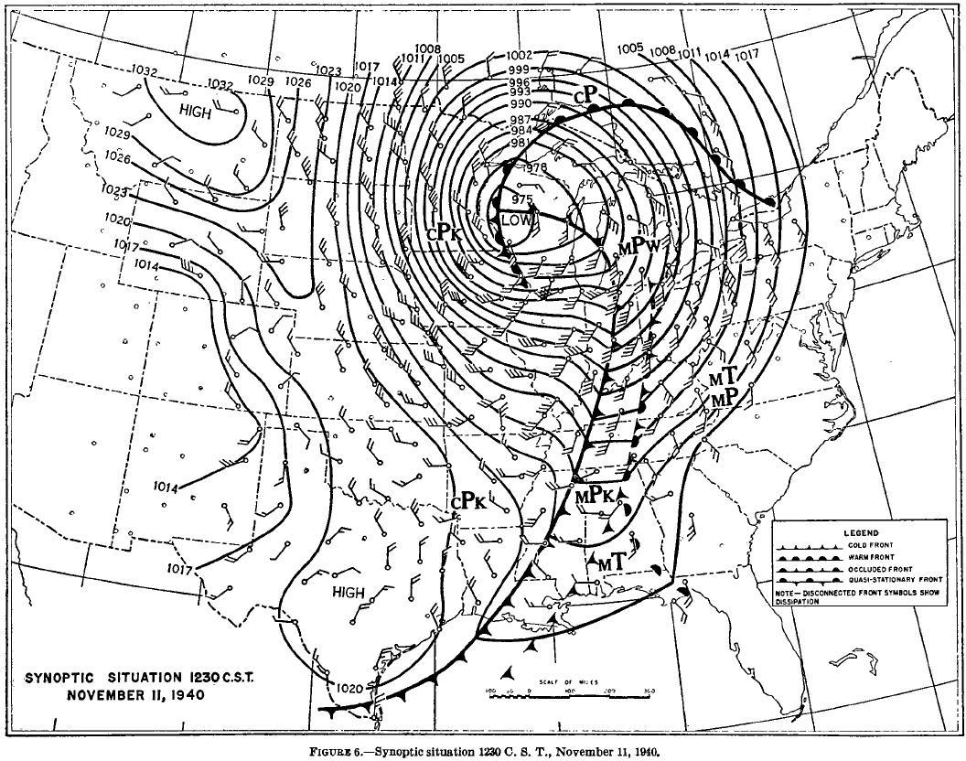

Figure 1: Example Pressure Map [1]

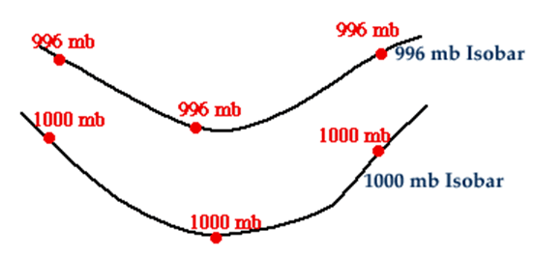

Figure 2: Isobars [2]

**isobar**: an imaginary line or a line on a map or chart connecting or marking places of equal barometric pressure. The closer the bars the more the pressure changes



Figure 3: Weather Station Coverage of US [3]



Figure 4: Chart of correlating atmospheric pressure and wind speed [4]

Convert Pressure to Wind Speed [4]

|  |  |  |
| --- | --- | --- |
|  | $$MpH=\sqrt{\frac{PSF}{0.00256}}$$ | (1) |

Pressure at a given height [5]

|  |  |  |
| --- | --- | --- |
|  | $$P_{h}= P_{0}*e^{\frac{-mgh}{kT}}$$ | (2) |

# Objectives and Goals:

## The needs:

* Accuracy: $±1\frac{hPa}{mb}$.
* Updated speed: new information every 10 min.

## The wants:

* Resolution: $1 \frac{sensor}{kilometer}$.
* Update Speed: new information every second.

# Constraints:

* Time: project must be complete by the end of April 2017.
* Scope: limiting the project to data potentially gathered by cellphones.
* Budget: $5000.

# Deliverables

Table 1: Gantt Chart

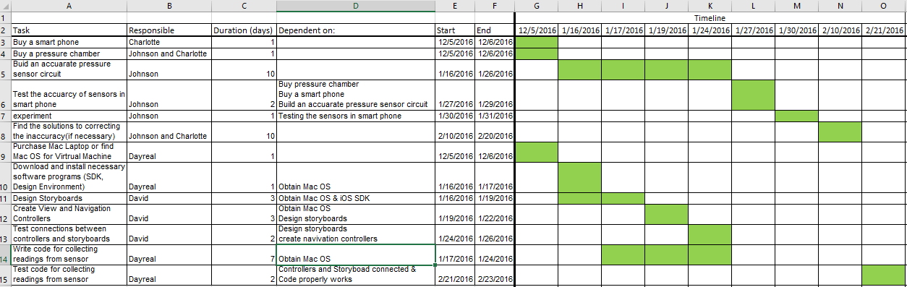

# Assign Resources

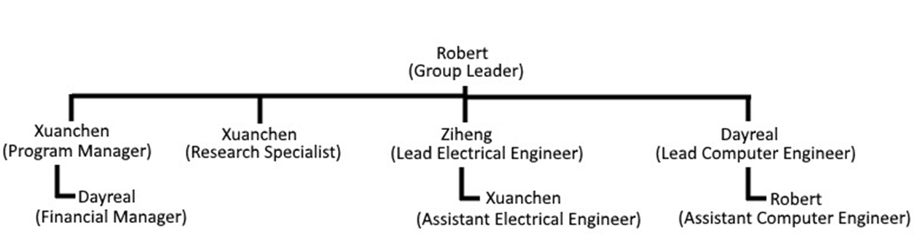

Figure 5: Group Responsibilities

## Group Leader:

Manages the team as a whole; develops a plan and timeline for the project, delegates tasks among group member according to their skill sets; finalizes all documents and provides input on other positions where needed.  The team leader is responsible for promoting synergy and increased teamwork.  If a problem arises, the team leader will act in the best interest of the project. The team leader takes the lead in organizing, planning, and setting up of meetings.  In addition, he is responsible for keeping a record of all correspondence between the group and ‘minutes’ for the meetings. Finally, he gives or facilitatespresentations by individual team members and is responsible for overall project plans and progress

## Team members:

### Financial Manager

Manages the budget and maintains a record of all credits and debits to project account.  Any product or expenditure requests must be presented to the advisor, whom is then responsible for reviewing and the analysis of equivalent/alternate solutions.

### Lead CpE:

Takes charge of the programming design aspects of the project.  Keeps line of communication with the lead ECE.  He is responsible for knowing details of the design, and presenting the options for each aspect to the team for the decision process.  Keeps all design documentation for record and is responsible for gathering all reports.

### Lead ECE

He is responsible of the EE design part in support of the project.  He maintains line of communication with the lead CpE. He Keeps all design documentation for record.

### Program Manager

He keeps the communication flowing, both between team members and Sponsor.  They then relay the information to the team and if the request is granted, order the selection.  A record of these analyses and budget adjustments must be kept.

# Product Spec

## Design Spec

This is not currently applicable to our project.  Once completed our project will not produce a physical device.  However, in the future there will be code we will develop that we can outline here.

## Performance Spec

* The operation range of the application when used should be 1 kilometer (km) with an accuracy of at least 1millibar (mb) when compared to other credible sources such as the National Weather Service or NOAA.
* The resolution.
* Display features would include information for current pressure, location given in longitude and latitude and elevation normalized to sea level.
* The detection capability will be dependent on the sensor being used. At present, the energy efficiency of the application and the process for data transmission are unknown.

# Conceptual Design

Table 2: Pairwise comparison of needs

|  |  |  |  |
| --- | --- | --- | --- |
|  | Data Accuracy | Data Resolution | Update Speed |
| Data Accuracy | 1 | 1 | 1 |
| Data Resolution | 1 | 1 | 1 |
| Update Speed | 1 | 1 | 1 |

*All of our needs are independent and thus priority isn’t necessary

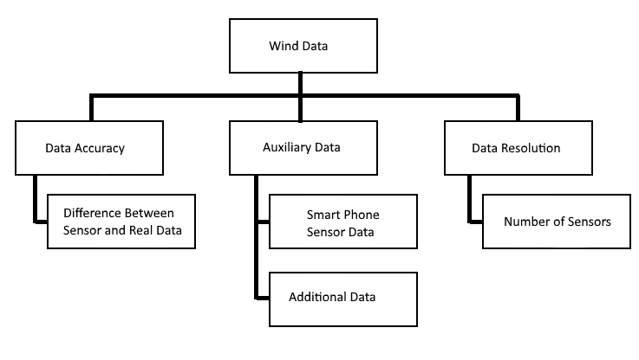

Figure 6: Needs Hierarchy



Figure 7: What sensors are needed for mapping

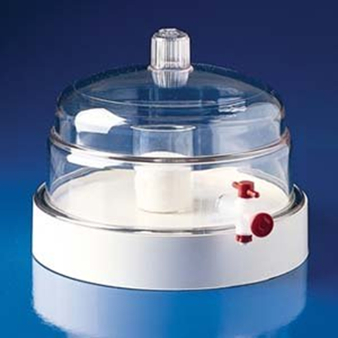

Figure 8: Pressure chamber

Aim:To test the accuracy of pressure sensors in the smart phone.

Means to test the accuracy:Put an accurate pressure sensor and  the smartphone in the chamber at the same time. Compare the value of pressure get from the two.

# Conclusion

In conclusion, the problem this project set out to address was the need for accurate wind data with a higher resolution than currently exists.  The project attempted to solve this problem by using smartphone sensors to gather related data, and then a program to clean up the data and process it into wind data predictions.  Thus far the project has been successful at gathering data and selecting a strategy. Next we must start testing the sensors and writing code to utilize them.

# References

1. <http://www.weather.gov/images/dvn/Past_Events/ArmisticeDayBlizzard/1940Map3.jpg>
2. <http://ww2010.atmos.uiuc.edu/(Gh)/guides/mtr/prs/isb.rxml>
3. <https://www.roc.noaa.gov/wsr88d/maps.aspx>
4. <http://bristolite.com/interfaces/psi_wind.aspx>
5. <http://hyperphysics.phy-astr.gsu.edu/hbase/kinetic/barfor.html>

# Appendix A: Pressure range in the chamber

The normal range of the Earth's air pressure is from 980 millibars (mb) to 1050 mb.  
  
The highest barometric pressure on record was 1083.8 millibars (adjusted to sea level), measured in Agata, Siberia on December 31, 1968. The lowest pressure ever measured was 870 millibars from an October 12th typhoon in the western Pacific Ocean.

                                                                               -------------World Meteorological Organization



Figure 9: Earths Barometric Pressure Range

At the height of 20km, the air pressure becomes 0.5% of that at the sea level.

Pressure range in the experiment:

Highest:1100mb  
Lowest:10mb

# Appendix B: Schering Bridge



Figure 10: Schering Bridge

In this diagram:  
  
C1 = capacitor whose capacitance is to be determined,  
R1 = a series resistance representing the loss in the capacitor C1,  
C2 = a standard capacitor,  
R3 = a non-inductive resistance,  
C4 = a variable capacitor,  
R4 = a variable non-inductive resistance in parallel with the variable capacitor C4.

Now when the Schering Bridge is balanced, then

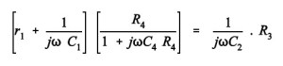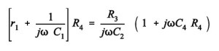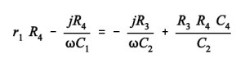

By equating real and imaginary part of the equation we get,

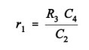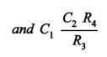

Two independent balance equations are obtained if C4 and R4 are chosen as the variable elements.

The dissipation factor is given by:

6

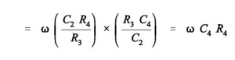

Therefore values of capacitance C1 and its dissipation factor are obtained from the values of bridge elements at balance.

# Appendix C Parameters of pressure sensor in the smart phone



Figure 11: HCLGA-16L

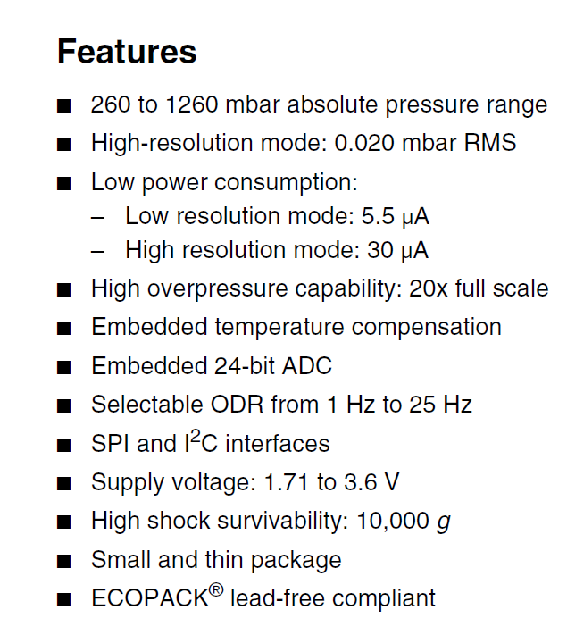

Figure 12: HCLGA-16L Features

# *Biography

**Team Leader:** *David Minter*

* My name is David, and I'm a senior computer engineering major. I have enjoyed the digital logic course track the most from the courses. I plan on getting a masters degree in cybersecurity. And I like eating food, and storm chasing.

**Program Manager:** *Xuanchen Xiang*

* My name is Xuanchen Xiang, from China. I studied at Huazhong University of Science and Technology, now I study at FSU, majoing in electrical engineering. I am interested in smart power grid and electrical equipments. "If you can make it here, you can make it anywhere." is my motto.

**Lead Electrical:** *Ziheng Zhang*

* My name is Zhang Ziheng in Chinese, and Johnson in English. What the barometric smart phone mapping project appeals to me most is that if successful, the APP will be widely used and benefit large sums of people. You know, engineers would get a lot of satisfaction if their products will be accepted.

**Lead Computer:** *Dayreal Brown*

* My Name is Dayreal Brown, a Computer Engineering student at Florida A&M University from Dallas, Texas. I am interested in having a career in software development.