**One Step at a Time: Bridging the Gap between Academia and Industry**

*By: Sarishni P. Patel, Director of Development*

*Summer 2015*

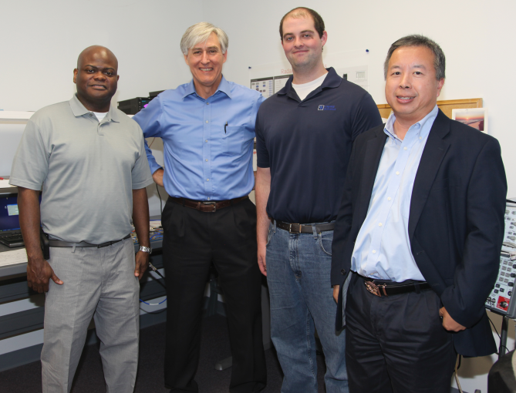

Bridging the gap between academia and industry is at the forefront of any successful relationship between a college and employers. It is something that resonates very deeply with Al Ingle, president of Capital Avionics, and is one of the main reasons his company has chosen to provide two scholarships to the College of Engineering’s Electrical and Computer Engineering (ECE) department.

Ingle’s relationship with the College began serendipitously. His company received a contract to design a new digital-processing-based signal generator at the end of last year, and as any good project manager would, he explored his options to ensure that he was up-to-date with the latest technology and research. In his due diligence, Ingle learned of a microwave theory course offered through the ECE department, and decided to brush up on his knowledge.

*From left to right: Dr. Mark Weatherspoon, Mr. Al Ingle, Mr. Gerard “Jerry” Melanson and Dr. Simon Foo*

This past spring semester, Ingle joined more than 2,500 students on the College’s campus. When asked about his first impression, he said “it looks and feels like a real engineering school when you walk through the front door. You just knew that you were in an engineering environment.”

The experience of sitting in Dr. Mark Weatherspoon’s *Microwave Circuits (EEL5426)* course was a unique and beneficial opportunity for everyone involved. Weatherspoon, fondly referred to as “Spoon” by his students, provided a solid theoretical framework which was coupled with his personal research. Matching theory was Ingle, who on more than one occasion would comment about the real-world application of what was being taught and how Capital Avionics was using this information in their projects. For students, this was a win-win situation since they were able to actualize the application of what they were being taught.

Ingle understands that the relationship between academia and industry needs to be a two way street, and is something that needs to continually develop. “The partnership is crucial because the school has a wealth of talent and resources to help companies like Capital Avionics succeed.”

The talent and resources that Ingle refers to are the amazing faculty with a deep breadth of knowledge, the state-of-the-art research labs, and the quality of students that the College admits every year. With a mission of increasing underrepresented populations in the fields of engineering, the College has a retention rate of 85 percent, and is a leader in female enrollment with nearly 24 percent. More than one third of the undergraduate student population is comprised of African American and Hispanic students.

During his time in class, Ingle was able to form meaningful relationships with not only Weatherspoon, but with Dr. Simon Foo, ECE department chair, and his fellow students. These are relationships that Ingle plans to continue to develop over time. In the past couple of months, Capital Avionics hired two recent alumni from the ECE department, one of whom is Gerard “Jerry” Melanson. Melanson began working for Ingle part-time while he was still in school, and was then offered a full-time position following graduation.

*“I’m inspired to give back because the College is helping my company. Capital Avionics can continue to be successful when we partner with the College, so I might as well give back to help some students who ultimately could come to work for me.”*

*Al Ingle, President*

*Capital Avionics*

“The students are refreshingly energetic and knowledgeable. The school is doing a very good job, and it may be because of the quality of students and their aptitude, but also because the College is giving them every viable opportunity to succeed,” said Ingle.

Ingle plans to continue partnering with the College, and is currently exploring senior design projects with Weatherspoon and Foo. The project would be proposed by Capital Avionics and would involve several different engineering disciplines (software, electrical and computer) working together. In addition to a senior design project and the two scholarships, Ingle is looking to take another class in the fall with Weatherspoon.

Established in 1978, Capital Avionics is a local Tallahassee business whose goal is to be a partner with aircraft owners and help them meet their needs – with hands-on support of their aircraft, comprehensive depot level repairs, technical training of technicians in their geographical area and innovative, state-of-the art test solutions. For more information on Capital Avionics, please visit http://capitalavionics.com.