Batch Reactor
(revised 8/3/05)
PROBLEM STATEMENT
Sodium acetate is being prepared by the following reaction in a batch reactor.

Sodium Hydroxide and ethyl acetate are fed to the reactor at a concentration of 0.1M as an initial charge at 25 C and 101325 Pa. The rate constant is 0.104sec*ltr/mole. Simulate the dynamic batch reactor for 30 minutes and plot the change in concentration of NaOH as it changes with time.

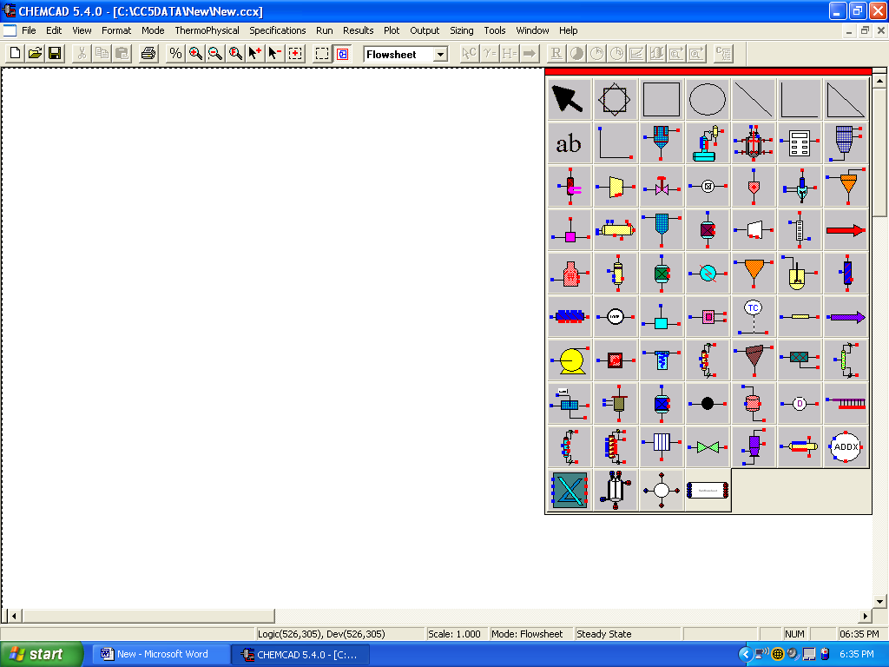

Procedure:

Step 1: Creating the flow sheet
Step 2: Entering the components and formatting engineering units
Step 3: Entering the reactor specs
Step 4: Running the DYNAMIC simulation
Step 5: Retrieving the results

Step 1: Creating the flow sheet

Select and right click on the batch reactor icon (i.e. second row, fifth element) on the workspace. Next click on the change mode bar to change from flowsheet mode to simulation mode to specify the system.

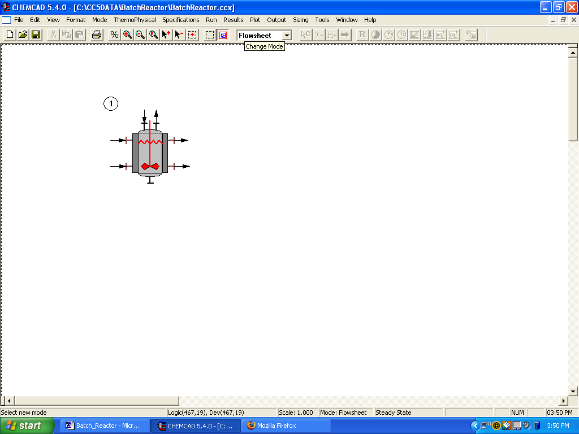

Step 2: Entering the components and formatting engineering units

Go to the Thermophysical on the menu bar and click on Components List. Find sodium hydroxide, ethyl acetate, sodium acetate, ethanol and water from the CHEMCAD components list and add them to the component list.
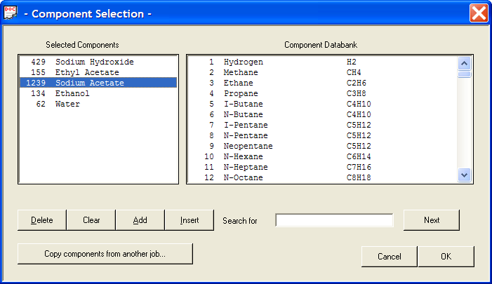
A Thermodynamics Wizard screen will pop up after you press OK. On this screen you must specify the range of the Temperature and the Pressure of the reactor so that CHEMCAD can use the appropriate equations for the species. This will change your answers if not input properly, for this reaction the default settings will work and press OK. You may change the Engineering units first then specify your components.
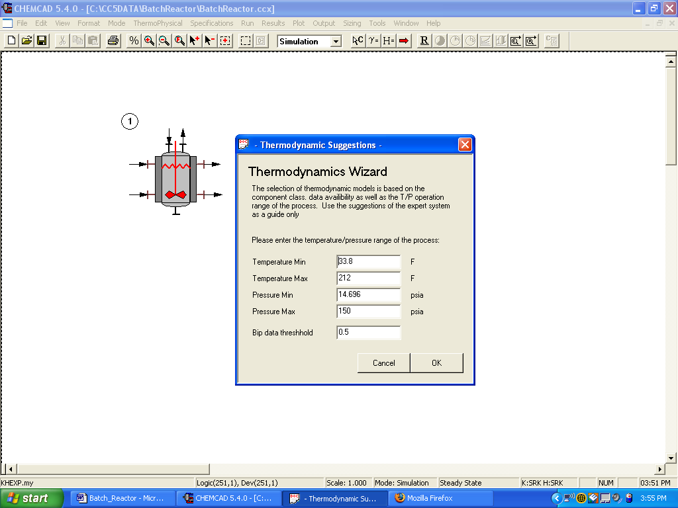

When this is complete Chemcad will ask you if you want to use the electrolyte package. Click No. Then click OK. On the K value option screen click OK. Then some warnings will pop up if you click OK again you will be ready to run the experiment.

Go to the Format menu and click on Engineering Units. Press the SI button to use SI units and then select the desired units for such properties as temperature, pressure etc. Use seconds as the time unit and mols, degrees C, and the other appropriate units.

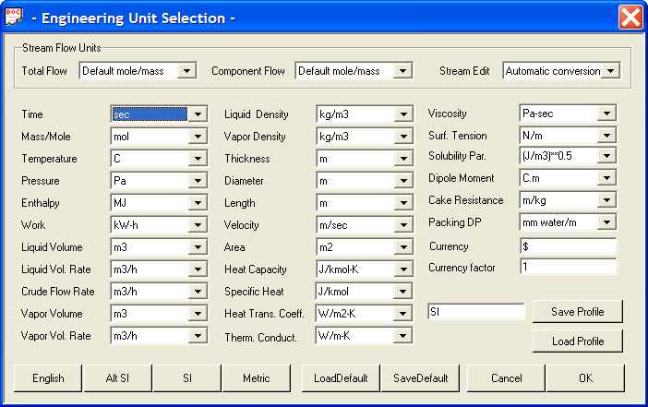

Click OK to continue.

Step 3: Entering the reactor specs

Double click on the reactor. The edit charge/add dialogue box appears. Add the concentrations of the initial charge. Note there is no provision in chemcad to enter the concentration of the species, so enter the number of moles of sodium hydroxide and ethyl acetate as .1 mole each. The amount of water is 1 ltr i.e. 55.55 moles approx. specify the temperature and pressure of the initial charge. Click OK
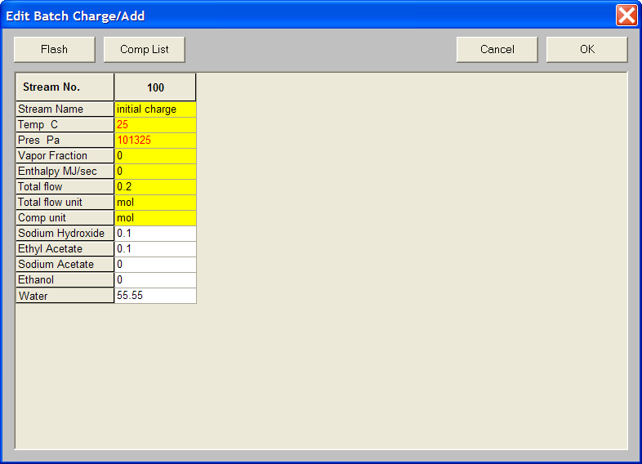

Batch Reactor General Information Page

Click the general information tab

- Number of reactions: As there is only one reaction in the given problem, enter ‘1’
- Dynamic Plot: Deselect the option “Show plot during simulation” as this increases the simulation time and does not save the data to view it later in excel.
- Reactor Phase: select the “liquid only, liquid phase reaction”.
- Kinetic expression : select the standard rate expression
- Thermal Mode : Choose Isothermal option and specify the temperature as 25 C
- Pressure: choose the pressure to be 101325 Pascals.

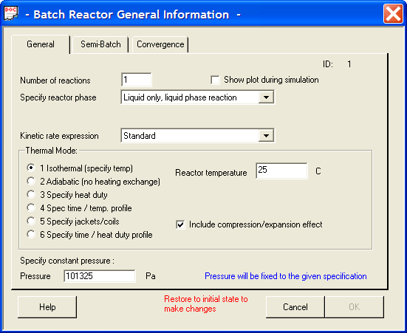

Don’t Click OK yet! There is more to complete in the Convergence TAB page!

CONVERGENCE TAB

- Integration parameters : select the “Semi-implicit RK4 ” method and select the step size as “1” leave the tolerance field empty. Click OK to continue.
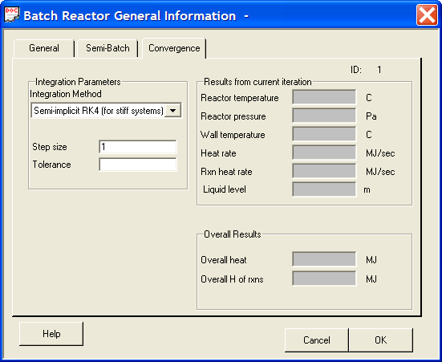

Rate Equation unit Definition page

- Stoichiometric Equation basis: select the “ Use mole basis for stoichiometry and rate eqn” option. Select ‘moles’ as the basis units
- Time unit : select “seconds” as the time units
- Volume unit: select “liters”
- Activation Energy: select “Joules”
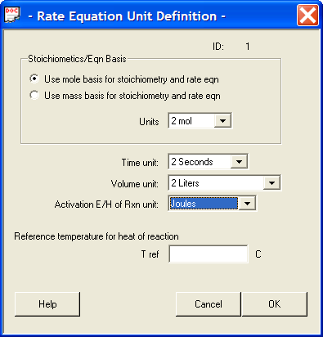
Click OK

Kinetic Data page

We have data for the rate constant. So we can specify the rate constant as the frequency factor and equate the activation energy to zero. Give the stoichiometric coefficients ( negative for reactants and positive for products). Click OK.

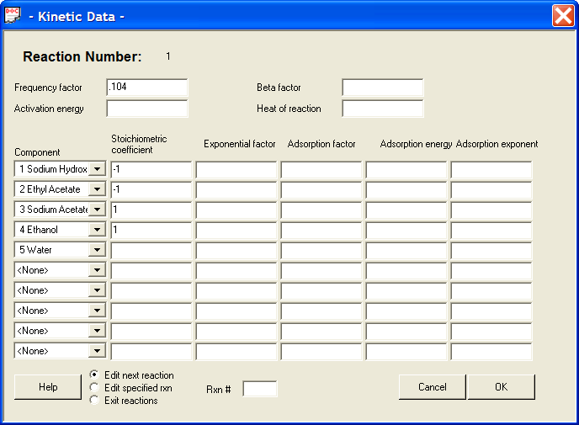

Batch Reactor Run time Plot options
- Plot time : select “ seconds”
- Composition: select “mole”
- Components to plot: select “ sodium hydroxide” and give scale as “1”
- Plot Y scale: select Ymax as “0.1” Ymin as 0 as the number of moles of sodium hydroxide cannot exceed 0.1.
Click OK
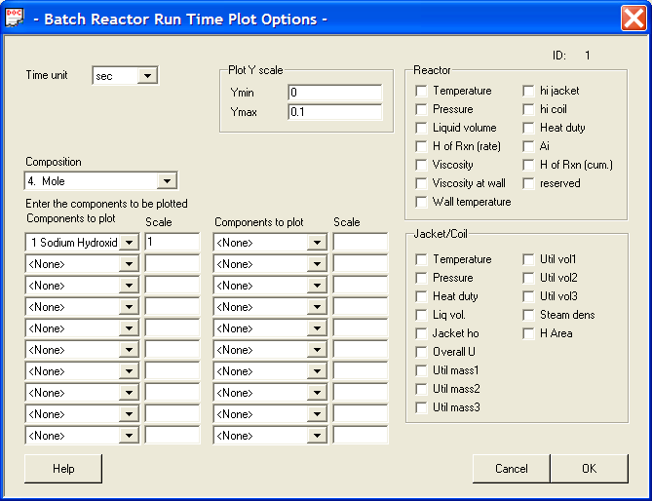

The Batch reactor menu appears
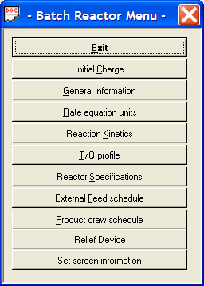
Here you can edit the data entered earlier in the dialogue boxes initial charge, general information, rate equation units, reaction kinetics and set screen information. The rest of the options can be ignored for the present case.

Step 4: running the dynamic simulation
Goto Run and select Dynamics. The following menu appears.
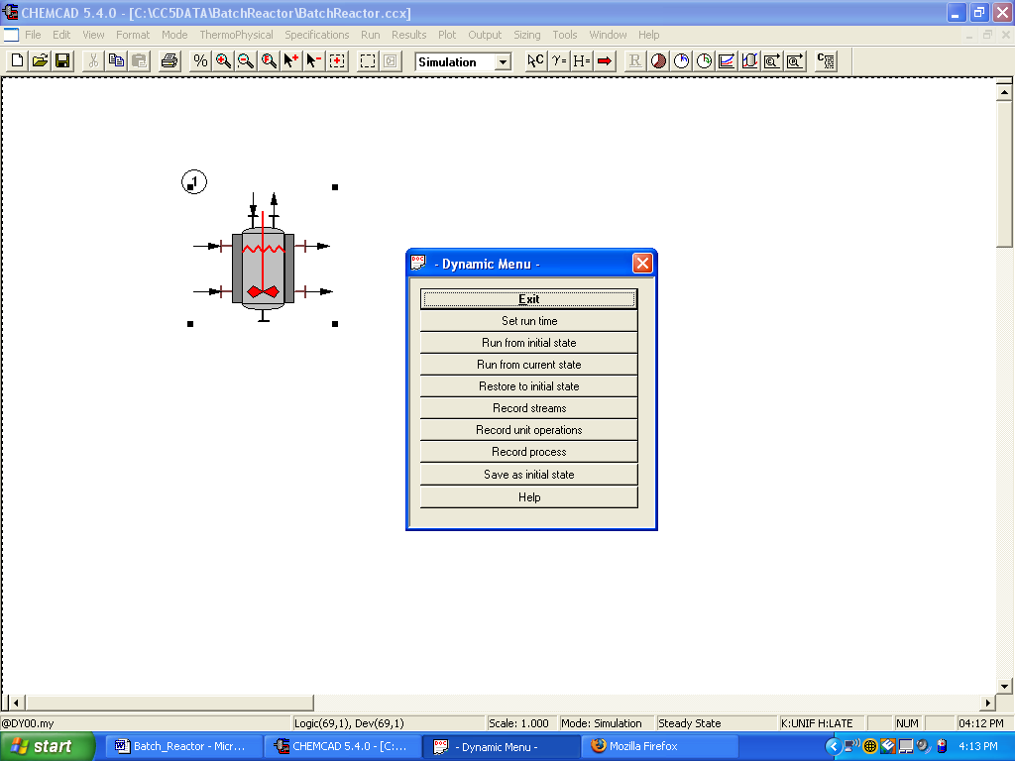

a. set run time: Select the number of operation steps in the general tab as “1” . Select the Step1 tab and set the run time to “30 ” minutes and step size to 0.1 min (i.e. 6sec). Click OK
Note: Make sure that the step size for the plot option( 6 secs) is greater than the step size(1 sec) specified in the convergence Tab of the integration parameters.

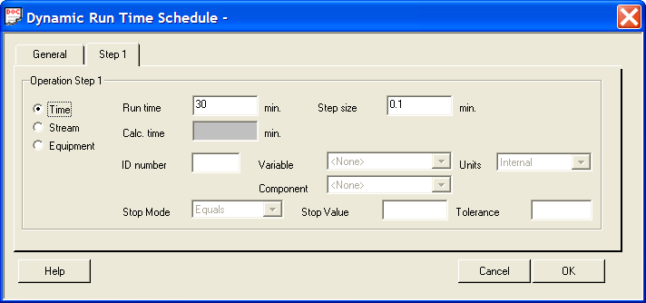

- Record unit operations : Enter the unit operation ID

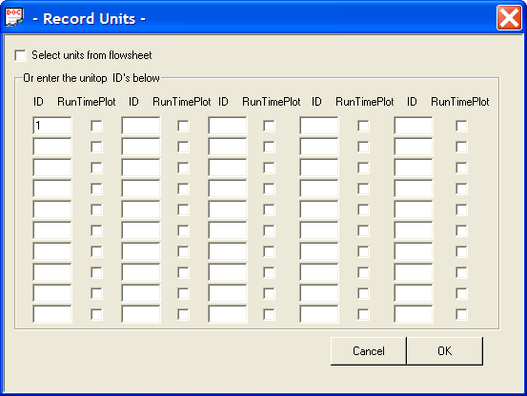

- Run from initial state: select this option to run the simulation with the initial charge specified. The following window appears click Yes to continue.

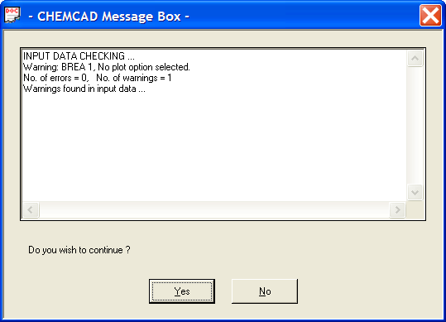

The time for which the simulation is being run is displayed in the Dtime in the display bar at the bottom of the chemcad window at the end of the simulation the following window appears.
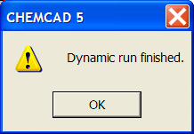
click OK to continue

Step 5: Retrieving the results

Goto plot and select Batch Reactor/DVSL History . This window appears. 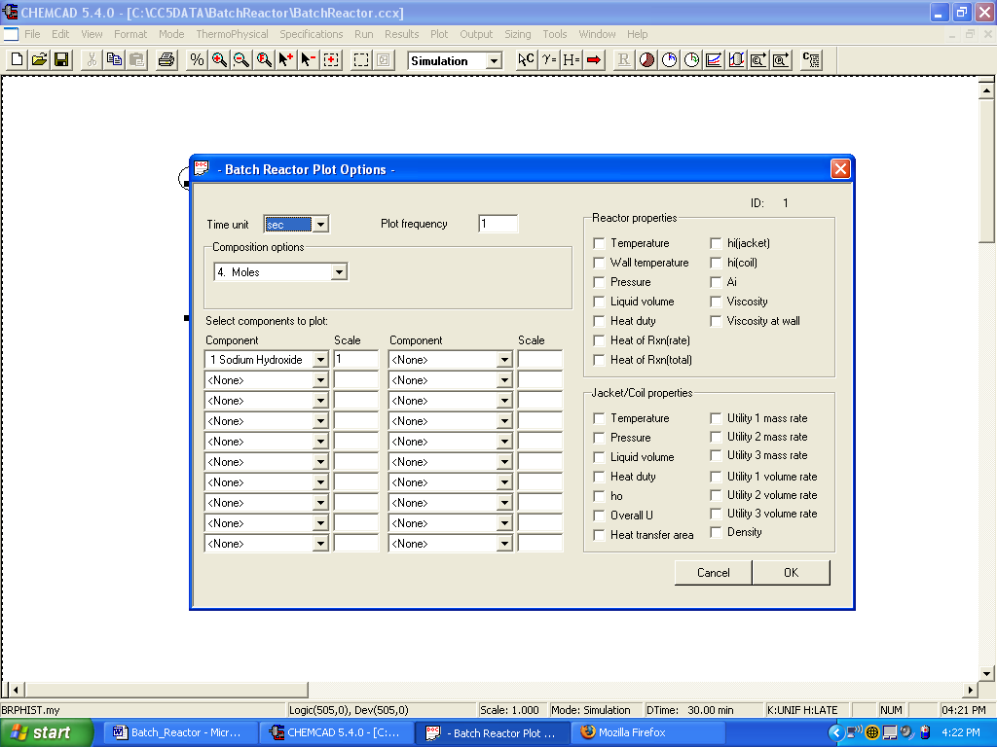 Click ok to continue
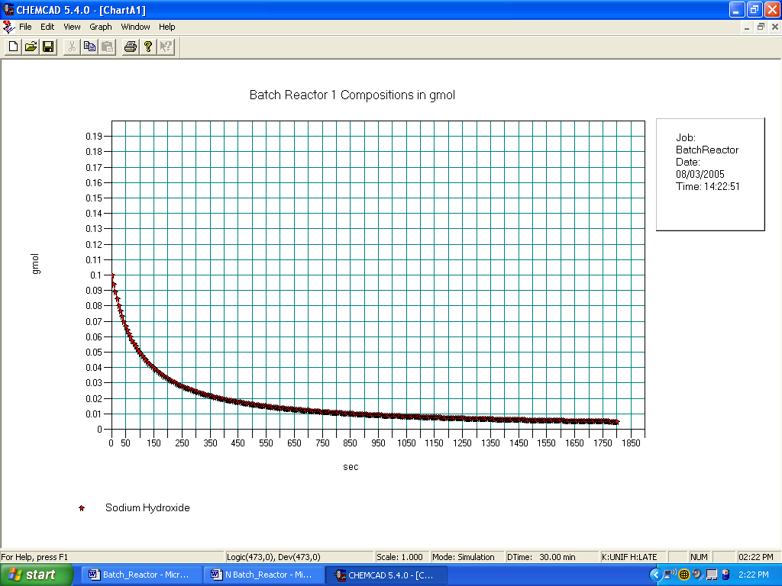

The data can also be selected to a excel sheet by selecting the Graph option from the above window and select the excel .csv file . Chemcad will put this data into an excel file.
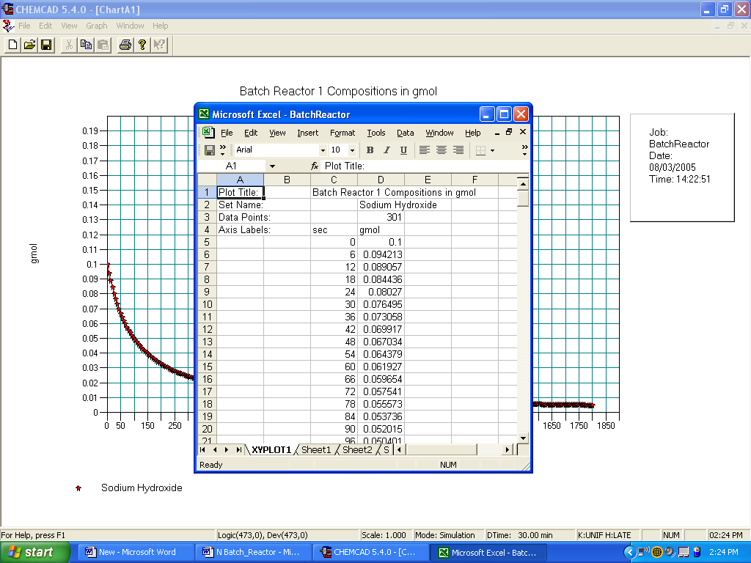

Or the data can be saved in the form of a report. Select output from the main simulation screen and choose report from the chemcad menu. The following menu appears
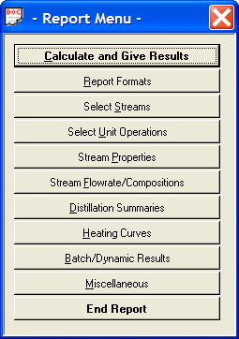

- Report Formats: We have three options F,E,G select the ‘F’ format you can specify the number of digits after the decimal point select ‘4’. For the Overall Report Format Select the Standard Format which gives the report in wordpad. Click Ok.

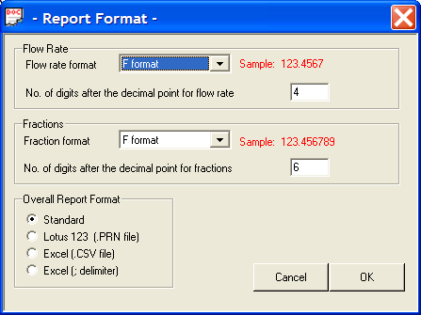

- select unit operations : Enter the unit operation ID

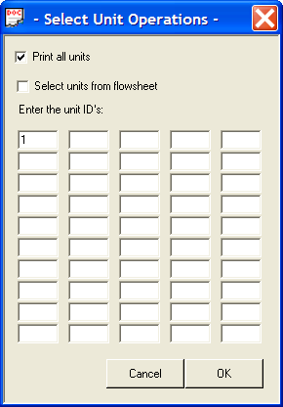
c. Batch/Dynamic Results: select the print operation results and print history from Batch Reactors.
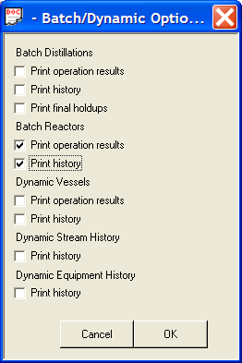
Click OK

Batch Reactor History Options
Plot time : select “ seconds”
Composition: select “mole”
Components to plot: select “ sodium hydroxide” and give scale as “1”
Print frequency 1
Click OK

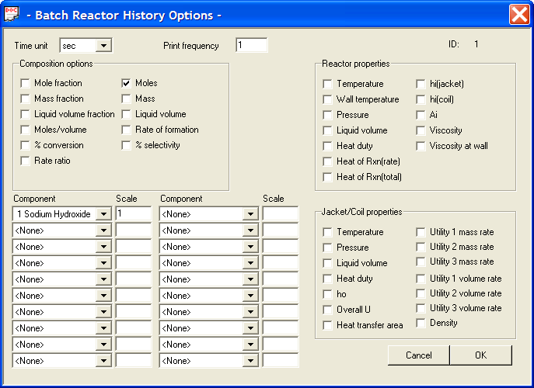

Click on calculate and give results a wordpad containing information about the Batch Reactor is displayed.
