CHEMCAD SCDS Distillation Column

CHEMCAD SUPERTEAM 2005

Experiment 300
ECH4404L

By:
Lakshmi Kastury
Mark Lescher

Introduction

This is a basic tutorial for the creation of an SCDS column using CHEMCAD software version 5.5.0. The initial conditions are specified in the objectives for the Distillation Experiment in the Unit Operations Laboratory Manual (ECH4404L).

Contents

- Starting CHEMCAD
- Creating a process flow diagram
- Specification of engineering units
- Specification of chemical components
- Entering feed stream compositions
- Entering SCDS column specifications
- Warnings
- Running Simulation
- Results

Procedure

- Starting CHEMCAD

  - Double click the CHEMCAD icon to run software.
  - To retrieve an existing file, click on “Open Job” in the “File” menu.
  - Select file, and click on “Open”.
  - To create new file click on “New Job” in the “File” menu.
  - Name new file, “SCDS column” and click “Save”.

- Creating a Process Flow Diagram

  - The initial flow sheet will populate a selection table for various types of equipment. Equipment is listed in alphabetical order.
  - Moving curser through icons will allow for selection of the SCDS distillation column ( 7 down; 4 across)
  - Click on the SCDS Distillation column. This places the column on the flow sheet. Note: Right clicking on mouse will allow for additional selections of the flow arrangements for the SCDS column.
  - Now select the inlet (red) and outlet (blue) flow stream arrows.
  - Click the square labeled stream to connect the arrows to the inlet/outlets streams on column. An example process flow diagram is shown below:

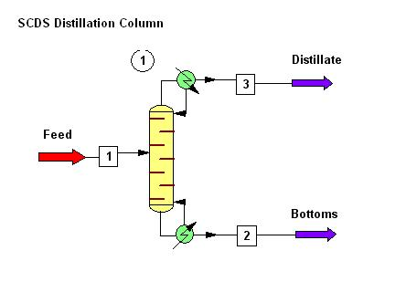
Figure 1 – SCDS Process Flow Diagram

- Specification of Engineering Units

  - Click on “Format” and select “Engineering Units”.
  - Click on SI units and modify as specified below in the red square:

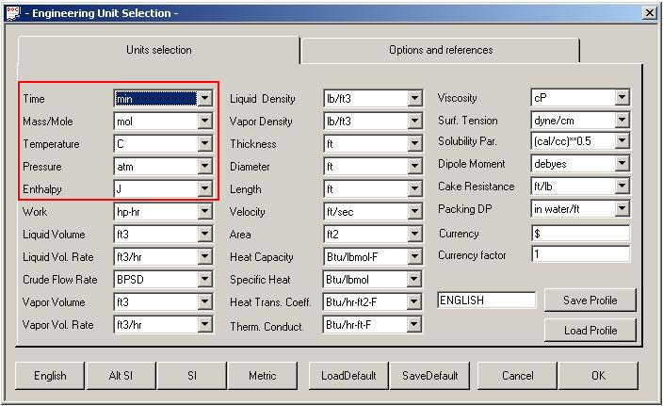
Figure 2

  - Now click on the “Options and references” tab and choose “Mole fractions” for the component flow.

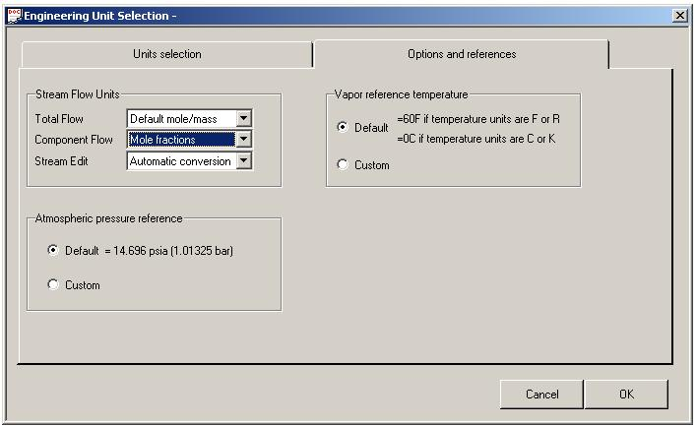
Figure 3
  - Click on “OK” to continue.

- Specification of chemical components

  - Now click on the “Flow sheet” drop down menu and select “Simulation”.
  - Click on “Thermophysical” and select “Component List”.
  - Search for ethanol and list as the first component because it is more volatile. Click to add.
  - Search for n-propanol and click to add.
  - If initial search does not yield the desired chemical, click on next to continue the search. A sample diagram is given below.

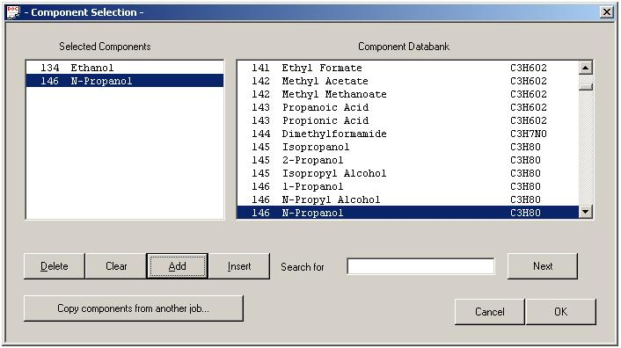
Figure 4

  - Once all components have been added, click “OK.”

  - The following box shown below will appear. Maintain the default specifications and click “OK.”
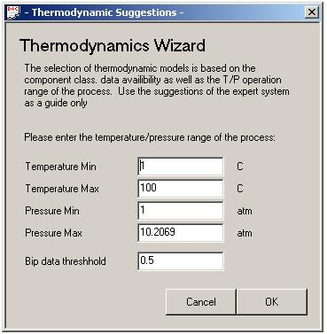
Figure 5

  - Next a box showing the K-value options will appear. Select the “Wilson” option as shown below and click “OK.”

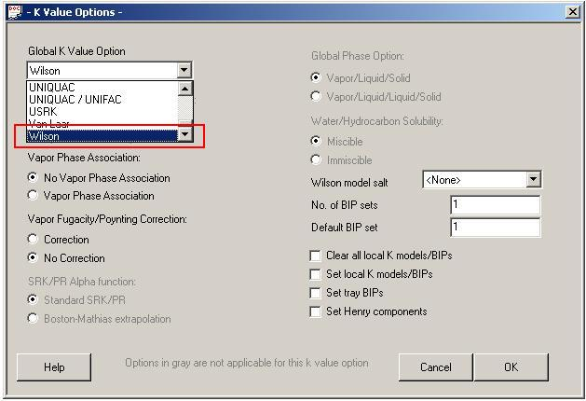
Figure 6
  - The next box that appears is shown below. Maintain the default settings and click “OK”.

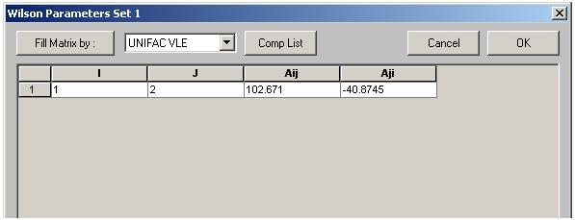
Figure 7

- Entering feed stream compositions

  - Double click on stream number “1”.
  - For stream name enter “feed” and specify the following values for the temperature, pressure, total flow and mole fractions of ethanol and n-propanol.

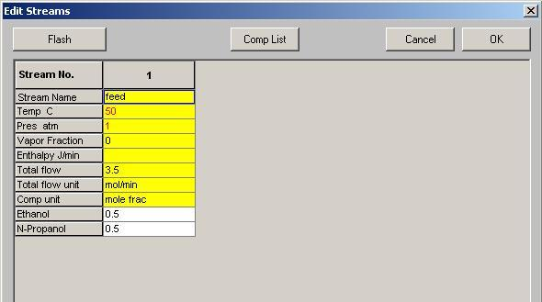
Figure 8

  - Click “Flash” button located in upper left corner.
  - Click “OK”.

- Entering SCDS Column Specifications

  - Double click on “SCDS column”.
  - A screen showing the specifications for the column will appear. Under the tab labeled “General” specify the values as outlined within the red box below. For Subcooled delta T, enter 32.2 C. For the number of stages enter 6, and for the feed stage for stream 1 enter 2.

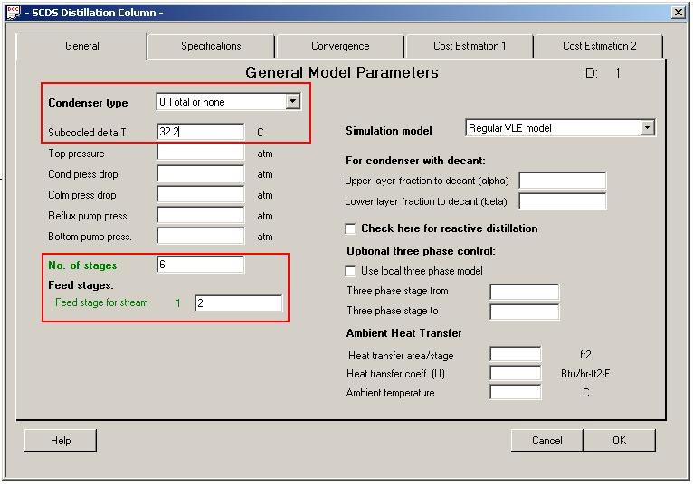
Figure 9

Note:
- Actual number of stages is 6, consisting of 4 trays plus a condenser and a reboiler.
- The “Subcooled delta T” is the temperature difference between the bubble point of the liquid on the top stage (i.e., the condenser) and the temperature of the reflux return stream. For example, suppose the distillate has a composition of x_{D} = 0.716. The bubble point of this stream can be found using CHEMCAD to be 82.2 C. Suppose the reflux stream is at 50 C. Then the “Subcooled delta T” is 82.2 C - 50 C = 32.2 C. [It is emphasized that this feature is different from the Subcooled temperature box in the TOWR module. In TOWR one just enters into the box the temperature of the reflux stream, or in this example 50 C.]

  - Under the tab labeled “Specifications” enter the following options, a diagram is given below.

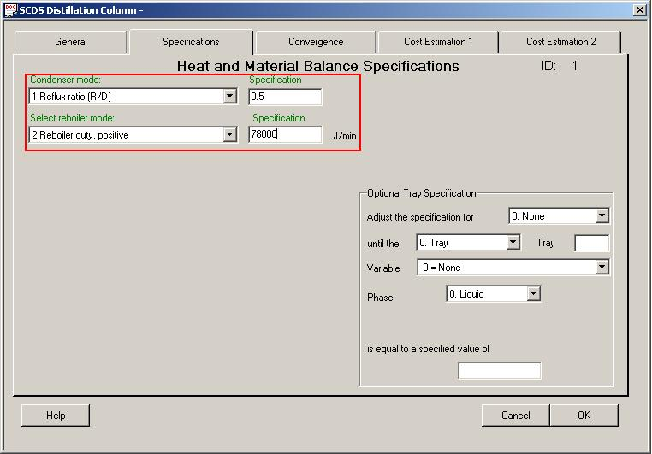
Figure 10

  - For “Condenser mode”, initiate drop down box and select “1 Reflux ratio (R/D)”.
  - Tab to specifications and enter desired ratio “0.5”.
  - For “Reboiler mode”, initiate drop down box and select “2 Reboiler duty positive”.
  - Tab to specifications and enter desired amount "78,000" J/min, which corresponds to 1300 W.

  - Click “OK” to continue.

- Warnings

  - After clicking “OK” a CHEMCAD message box will display several warnings.
  - The figure below shows acceptable warnings. Disregard the warnings and click “Yes” to continue.
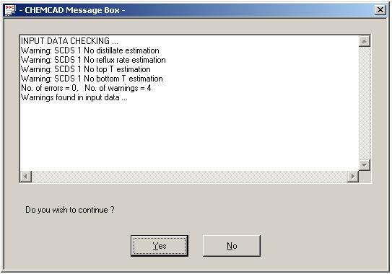
Figure 11

  - Should an error or additional warnings be displayed; this will need to be addressed on a separate basis.

- Running Simulation

  - Click on the “R” in the upper left corner to run the simulation.
  - After it has finished, each stream number may be clicked on to view the final compositions.

- Results

  - Double click on Stream 2 and type “Distillate” for the stream name.
  - Double click on Stream 3 and type “Bottoms” for the stream name.
  - To set the units of each stream for the results, click on the “Results” tab at top, and choose “Set Flow Units”. Choose mole fractions for the flow units.
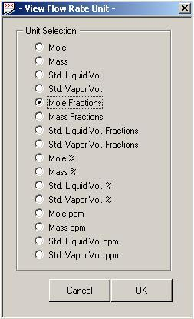
Figure 12

  - Click “OK” to continue.
  - To generate a report of various types of results, click on “Results” on the top menu bar, follow the drop down to the preferred selection A diagram is given below:

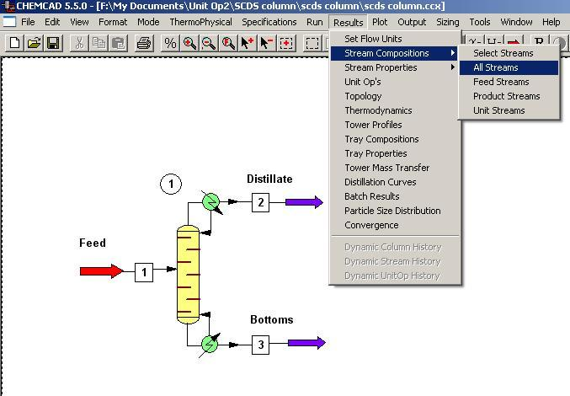
Figure 13

  - The results are generated in a word pad document. Results for the “Stream Compositions” are displayed below:

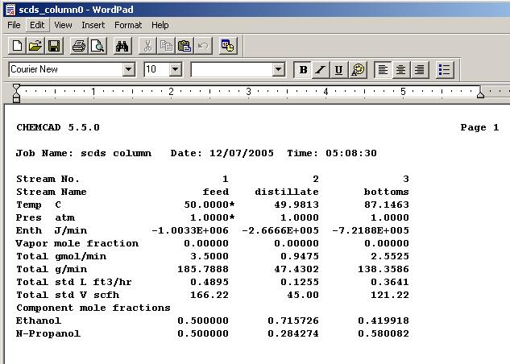
Figure 14

  - When requesting the remaining types of results, make sure to specify the unit operation number for the corresponding results. Results for the “Unit Op’s” are displayed below:

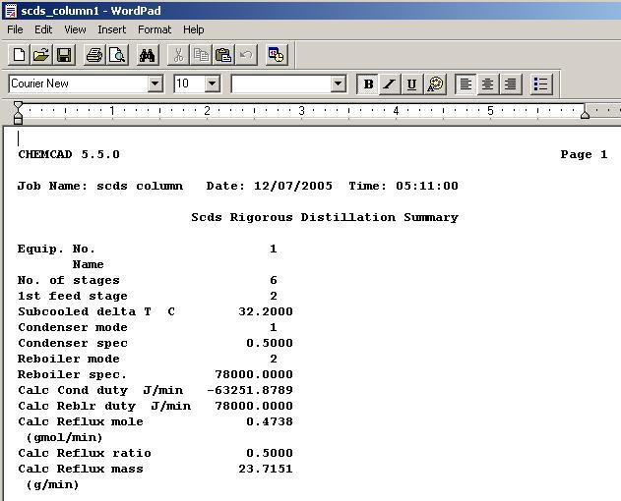
Figure 15

  - Results for the “Tower Profiles” are displayed below:

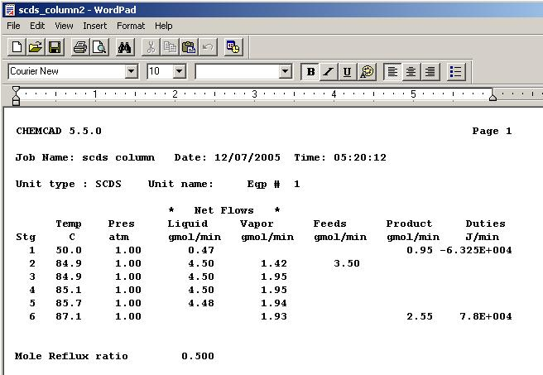
Figure 16

  - Results for the “Tray Compositions” are displayed below:

CHEMCAD 5.5.0 Page 1

Job Name: scds column Date: 12/07/2005 Time: 05:24:24

Unit type : SCDS Unit name: Eqp # 1

Stage # 1 49.98 C 1.00 atm
V Mole frac L Mole frac Y/X
Ethanol 0.00000 0.71573 0.00000
N-Propanol 0.00000 0.28427 0.00000
Total gmol/min 0.0000 0.4738

Stage # 2 84.89 C 1.00 atm
V Mole frac L Mole frac Y/X
Ethanol 0.71573 0.54656 1.30951
N-Propanol 0.28427 0.45344 0.62693
Total gmol/min 1.4213 4.5018

Stage # 3 84.94 C 1.00 atm
V Mole frac L Mole frac Y/X
Ethanol 0.71238 0.54242 1.31334
N-Propanol 0.28762 0.45758 0.62856
Total gmol/min 1.9494 4.4999

Stage # 4 85.14 C 1.00 atm
V Mole frac L Mole frac Y/X
Ethanol 0.70298 0.53087 1.32419
N-Propanol 0.29702 0.46913 0.63314
Total gmol/min 1.9475 4.4955

Stage # 5 85.69 C 1.00 atm
V Mole frac L Mole frac Y/X
Ethanol 0.67663 0.49941 1.35485
N-Propanol 0.32337 0.50059 0.64598
Total gmol/min 1.9430 4.4837

Stage # 6 87.15 C 1.00 atm
V Mole frac L Mole frac Y/X
Ethanol 0.60448 0.41992 1.43951
N-Propanol 0.39552 0.58008 0.68184
Total gmol/min 1.9313 2.5525

Figure 17

  - Results for the “Tray Properties” are displayed below:

CHEMCAD 5.5.0 Page 1

Job Name: scds column Date: 12/07/2005 Time: 05:26:15

Unit type : SCDS Unit name: Eqp # 1

LIQUID Actual Actual Thermal Surface
Average vol rate density viscosity conduct. tension
Stg g/min mol wt ft3/hr lb/ft3 cP Btu/hr-ft-F dyne/cm
1 24 50.06 0.07 47.95 0.7918 0.091 20.451
2 236 52.43 0.68 45.98 0.4678 0.085 17.719
3 236 52.49 0.68 45.98 0.4681 0.085 17.723
4 237 52.65 0.68 45.98 0.4685 0.085 17.727
5 238 53.09 0.68 45.98 0.4695 0.085 17.738
6 138 54.21 0.40 45.97 0.4711 0.084 17.758

Stg Liq H
J/min
1 -1.3333e+005
2 -1.2618e+006
3 -1.2617e+006
4 -1.2615e+006
5 -1.261e+006
6 -7.2188e+005

VAPOR Actual Actual Thermal
Average vol rate density viscosity conduct. Compr.
Stg g/min mol wt ft3/hr lb/ft3 cP Btu/hr-ft-F factor
1 0 0.00 0 0.0000 0.0000 0.000 0.000
2 71 50.06 86 0.1088 0.0102 0.012 0.978
3 98 50.10 119 0.1089 0.0102 0.012 0.978
4 98 50.24 119 0.1091 0.0102 0.012 0.978
5 98 50.60 118 0.1098 0.0101 0.012 0.977
6 100 51.62 118 0.1115 0.0101 0.012 0.977

Stg Vap H
J/min
1 0
2 -3.3674e+005
3 -4.6196e+005
4 -4.6182e+005
5 -4.6161e+005
6 -4.6114e+005
Figure 18

