Extraction Experiment Description

Liquid –liquid extraction involves a solute being transferred from a carrier to the solvent. The method of extraction is based on the differences in solubility and density between each component. In this experiment, water will be used as a solvent to extract ethanol from an ethanol-heptane mixture. The objective of this experiment will be to determine the effects of solvent flow rate on the removal of ethanol from the feed mixture.

Problem Statement:
For a ternary mixture containing water, ethanol, and n-heptane, simulate the Extraction experiment using CHEMCAD. For runs 1-3 use solvent flow rates of 25 g/min, 50 g/min, and 100 g/min respectively. Calculate the compositions of the Extract and Raffinate streams and the percent removal of ethanol for each run.
Temperature = 25 °C
Pressure = 1 atm
X_{E_feed} = 0.4
Feed Flow Rate = 100 g/min

Step 1: Enter the components.

On the File menu click New and save the blank simulation. On the Thermophysical menu click Components List. Find water, ethanol and n-heptane in the component database and add them to the component list. Click OK to continue.

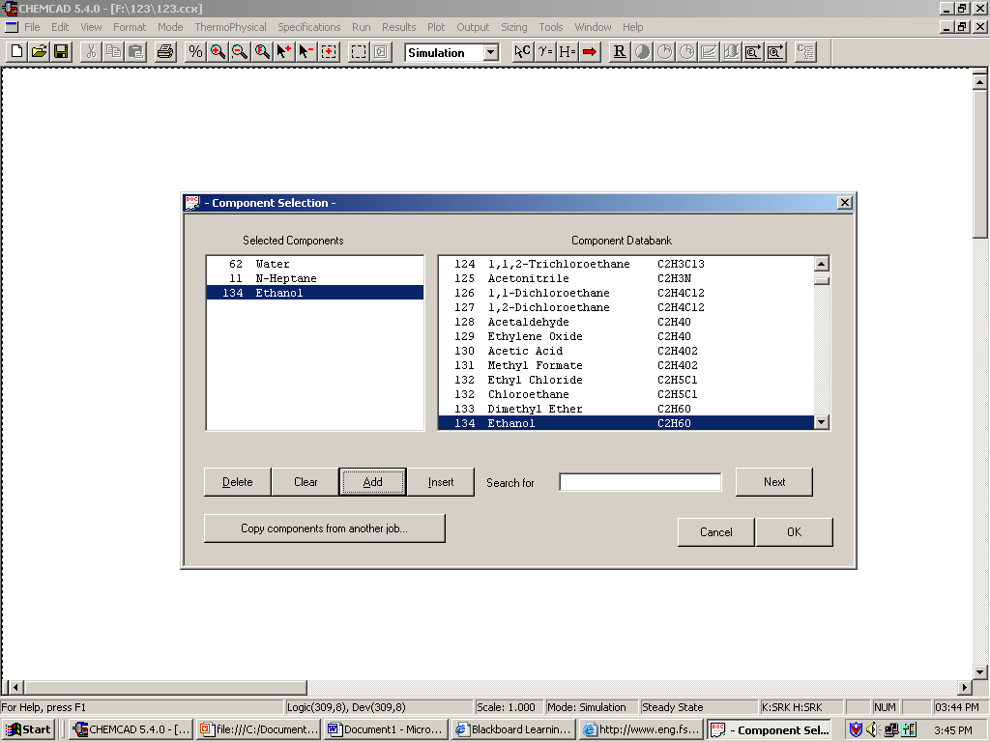

Step 2: Enter the engineering units.

On the Format menu click Engineering Units. Select the desired units according to the specifications of the Extraction Experiment. Click OK to continue.

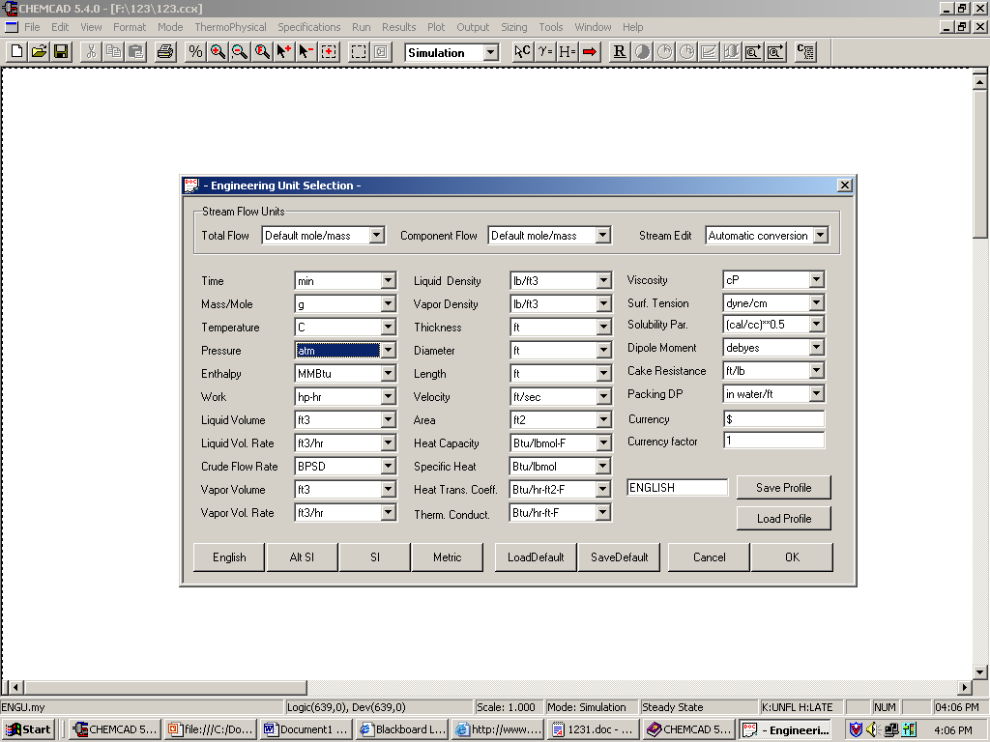

Step 3: Select K-Value method

On the Thermophysical menu click K-Values. Select the UNIFAC LLE method. Click OK to continue.

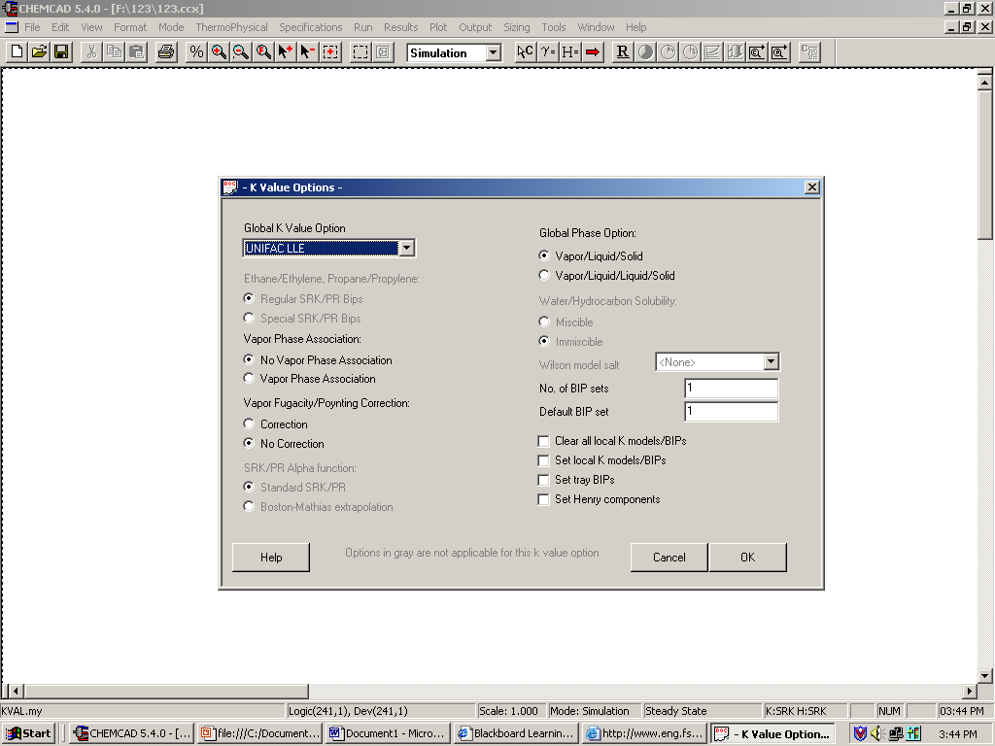

Step 4: Create the flow sheet.
Select and click the Extractor icon on the workspace. Select and click two Feed stream arrows and two Product stream arrows. Connect the arrows to the extraction column by selecting the Stream icon.

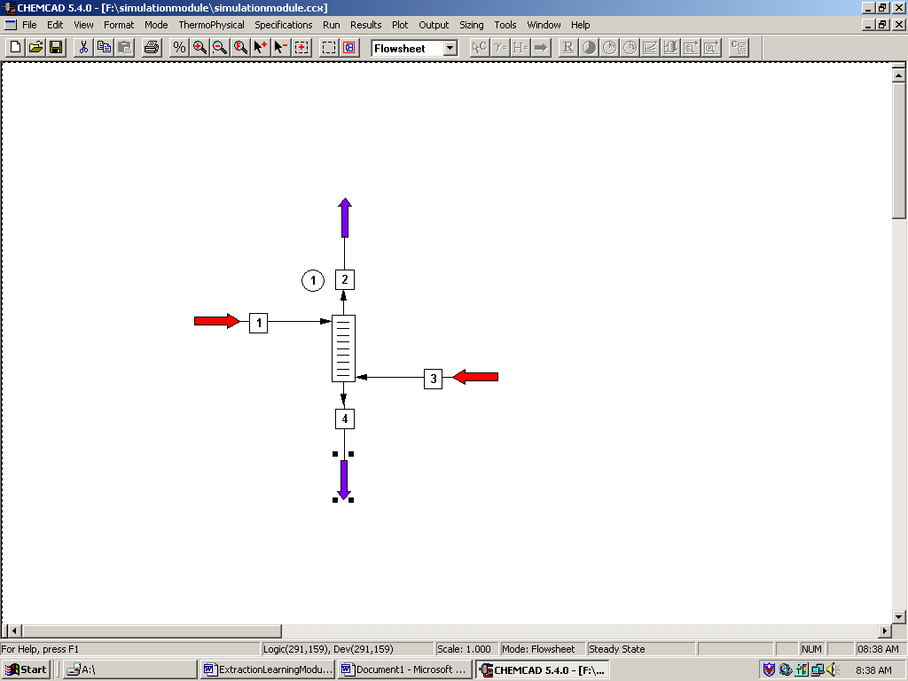

Step 5: Enter the feed and solvent stream composition.
Double click on the feed stream and enter the feed information. The temperature, pressure, total flow rate and component mole fractions are given in the problem statement. Click once on Flash to get the feed stream enthalpy and vapor fraction in feed at the feed conditions.

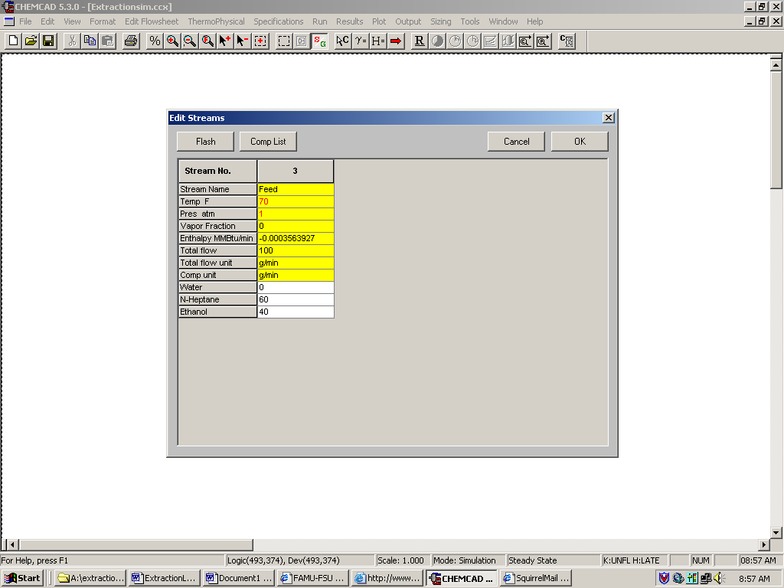

Step 6: Enter the Extractor unit specifications.
Specify the number of stages and the tray numbers for the feed streams. Remember that the stages for the Extractor are numbered from top to bottom. You may want to try running the simulation using different numbers of stages to determine the effect on percent removal of ethanol. Click OK. The next screen will be titled Tray Efficiency Profile. Here, the efficiency of each tray can be specified. If the tray efficiency is unknown or insignificant, these fields can be left blank.

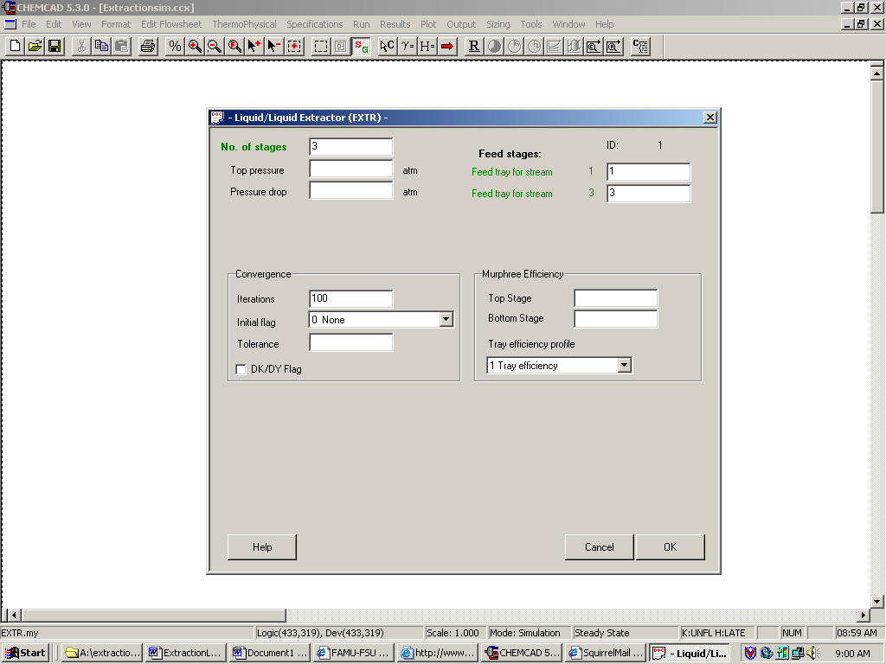

Step 5: Run the simulation and retrieve the results

Click the R on the tool bar to run the simulation. Click on each product stream to view the stream composition. You can also view the stream compositions by clicking once on Results on the menu, selecting Stream Composition and then clicking on All Streams. The results will again be available in a WordPad file. Similarly the Extractor unit results can be obtained by clicking once on Results on the menu, selecting Unit Op’s and then selecting the Extractor unit.

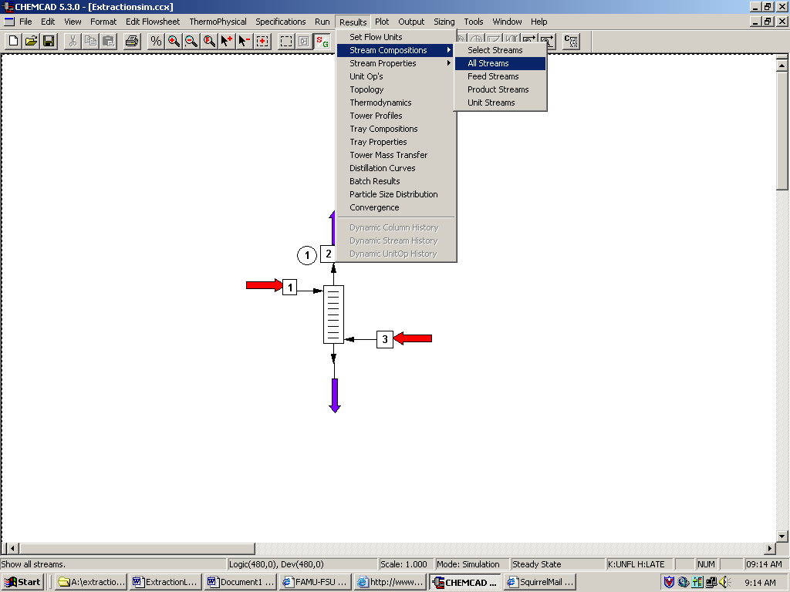

The following results are obtained for the product stream compositions.

