12/12/06
Liu Yujun
Kinetic Reactor

Problem Statement

Sodium acetate is prepared in a continuous reactor from the reaction of sodium hydroxide and ethyl acetate.

Sodium hydroxide and ethyl acetate are fed to the reactor at a concentration of 0.10 mol/L, a temperature of 30 °C and a pressure of 101325 Pa. The rate constant is 0.138 liter/mole*s. The volume of the reactor is 1L and the total feed flowrate is 0.086892 mol/s. Simulate the kinetic reactor and determined the outlet composition at steady state.

Procedure:

Step 1: Creating the flow sheet
Step 2: Entering the components and formatting engineering units
Step 3: Entering the feed stream composition
Step 4: Entering the reactor specification
Step 5: Running the simulation and retrieving the results

Step 1: Creating the flow sheet
Select and left click on the reactor kinetic, feed and product icons on the work place. Connect the three icons using the stream. Next go to change mode bar to change from flowsheet mode to simulation mode.

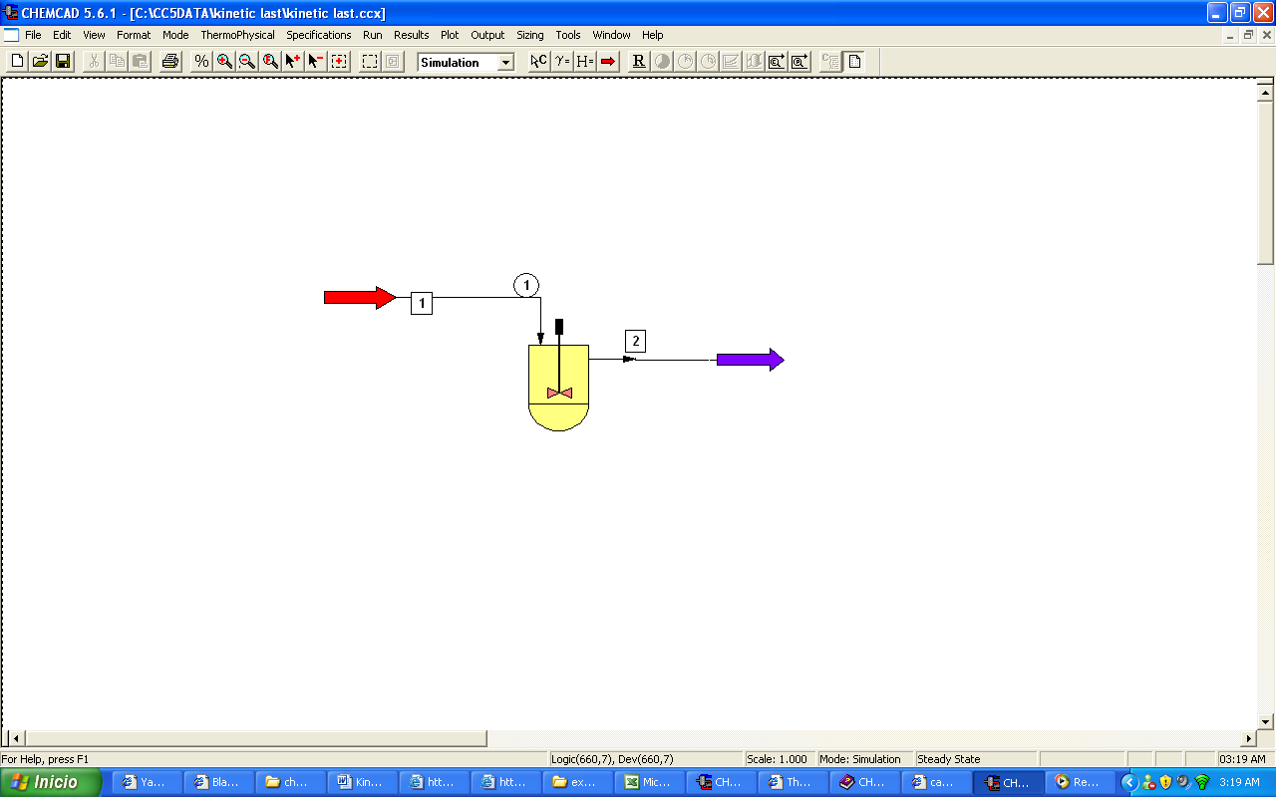

Step 2: Entering the components and formatting engineering units

Go to Thermophisical on the menu bar and click on Component list. Find sodium hydroxide, ethyl acetate, sodium acetate, ethanol and water from the CHEMCAD component list and add them to the component list.

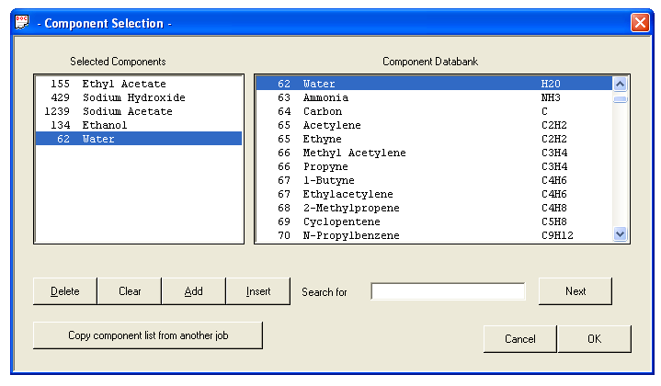

A Thermodynamics Wizard screen will pop up after you press OK. On this screen you must specify the range of the Temperature and the Pressure of the reactor so that CHEMCAD can use the appropriate equations for the species. This will change your answers if not input properly, for this reaction the default settings will work and press OK. You may change the Engineering units first then specify your components.

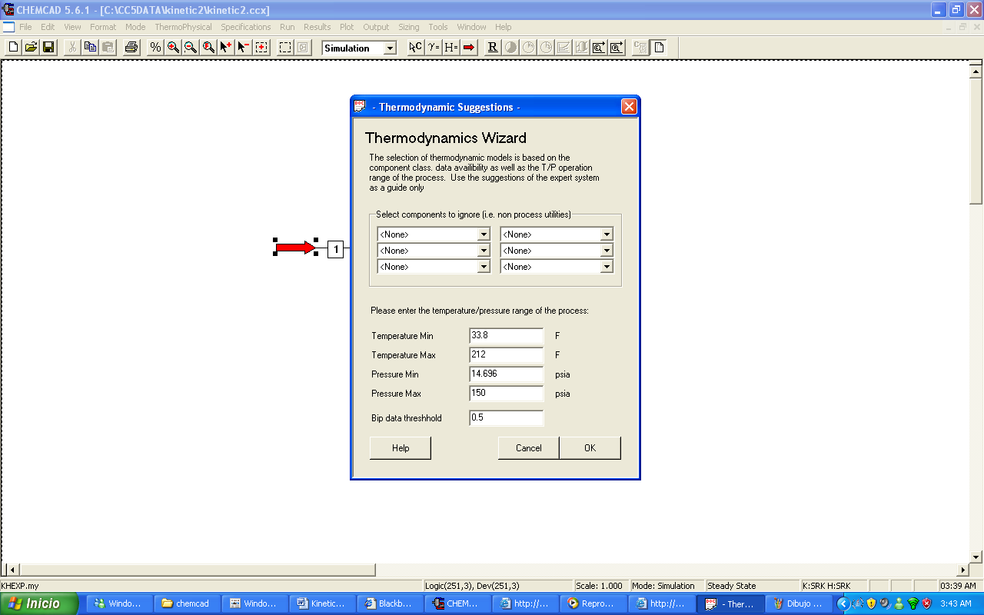

When this is complete CHEMCAD will ask you if you want to use the electrolyte package. Click No. Then click OK. On the K value option screen click OK. Then some warnings will pop up if you click OK again you will be ready to run the experiment.

Go to the Format menu and click on Engineering Units. Press the SI button to use SI units and then select the desired units for such properties as temperature, pressure etc. Use seconds as the time unit and moles, degrees C, and the other appropriate units.

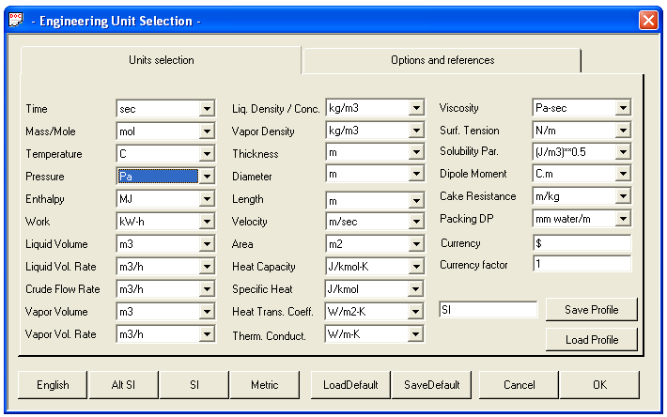

Click OK to continue.

Step 3: Entering the feed stream composition

Double click on the feed stream and enter the feed information (temperature, pressure, total flow rate and component mole fractions) given in the problem statement. Click once on Flash to get the feed stream enthalpy and vapor fraction in feed at the feed conditions. Then click OK.

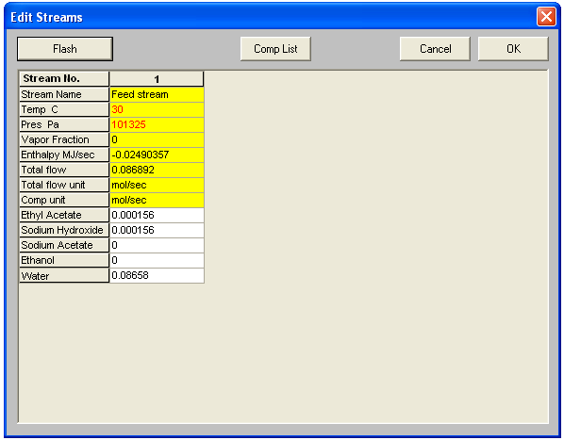

Step 4: Entering the reactor specification

Double click on the kinetic reactor unit. Now set the general specifications as follows:

- Number of reactions: There is only one reaction in the given problem set it to “1”.
- Reactor pressure: We assume that the reactor is operating at atmospheric pressure so we set it to 101325 Pa.
- Pressure Drop: There is no pressure drop so we left it the space blank.
- Kinetic rate expression: Select the standard rate expression.
- Specific reactor type: Select CSTR
- Thermal Mode: Select isothermal and set the temperature to 30 ˚C.
- Specific Calculation Mode: Select specific volume and in the reactor volume set it to 0.001 m³.

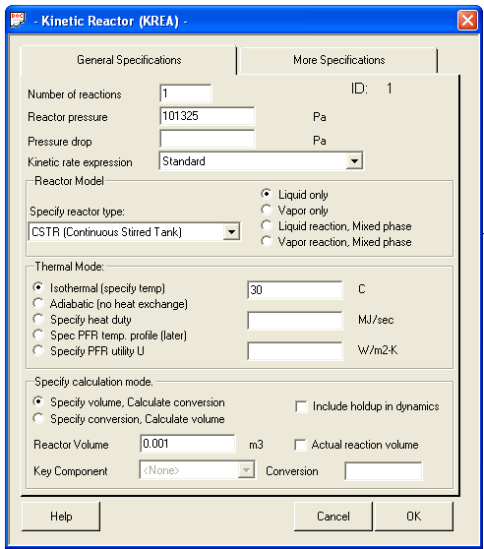

Don’t Click OK yet! There is more to complete in the More Specifications page!

More Specifications

In the Reaction engineering units do the following:
- Concentration option: Select the option mole/volume
- Partial pressure: Select Pascal
- Activation Energy: Select M Joules
- Molar flow: Select K-moles
- Volume: Select Cubic meters
- Mass flow: Select Kg
- Time: Select seconds

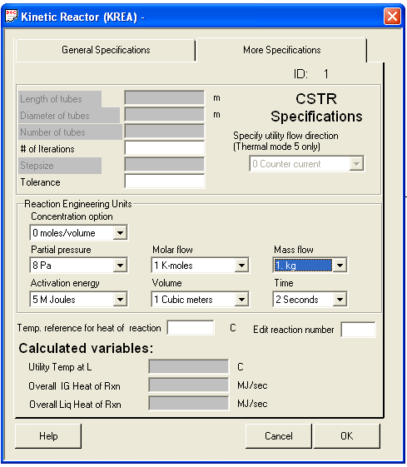

Kinetic Data page
A Kinetic data page will pop up after you press OK. We have data for the rate constant. So we can specify the rate constant as the frequency factor and equate the activation energy to zero. Give the stoichiometric coefficients ( negative for reactants and positive for products). Click OK.
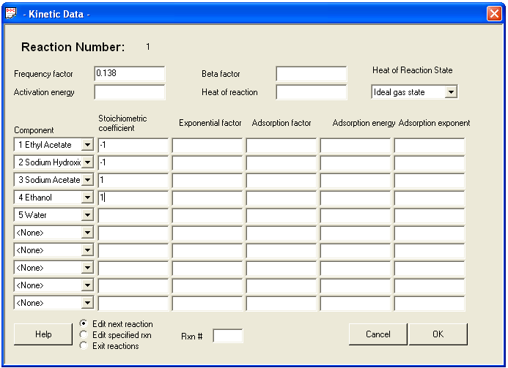

Step 5: Running the simulation and retrieving the results

Go to run and select run all or you can also click on the icon R located next to the edit feed.
To view the product stream compositions, one can either double click on the individual product streams or by clicking Results on the menu bar and selecting Stream Compositions and further selecting All Streams. The results obtained from the latter method will be in a WordPad file.

