ABSORBER

Problem Statement:

A gas mixture of air (4 kmol/hr) and hydrogen sulfide (2 kmol/hr) is to be absorbed by water so that 99% of hydrogen sulfide is recovered from the bottom stream. The absorber has 10 trays. Water enters the absorber from 1st tray at 298 K and 1 atm and gas feed enters from 10th tray at the same temperature and pressure as those of water. Simulate this absorber in CHEMCAD to determine the mole rate of water needed to recover 99% of hydrogen sulfide in the bottom stream.

Procedure:

Step 1: Creating the flow sheet
Step 2: Entering the components and formatting engineering units
Step 3: Entering the feed stream composition
Step 4: Entering the absorber specs
Step 5: Running the simulation and retrieving the results

Step 1: Creating the flow sheet

Select and click feed (2), SCDS column #3 (right click on the regular SCDS icon to find the icon representing absorber mode) and product(2) icons on the workspace. Connect the icons appropriately using Stream. Click once on the S/G icon on the menu bar to switch the simulation mode from Edit Simulation to Run Simulation.

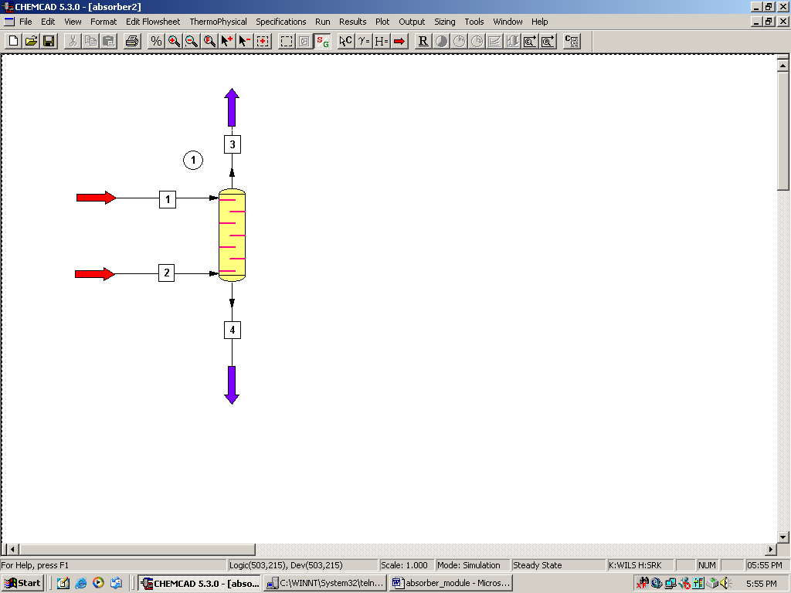

Step 2: Entering the components and formatting engineering units

Go to the Thermophysical on the menu bar and click on Components List. Find air, hydrogen sulfide and water from the CHEMCAD components list and add them to the component list. Go to the Format menu and click on Engineering Units and select the desired units for such properties as temperature, pressure etc. Click OK to continue.

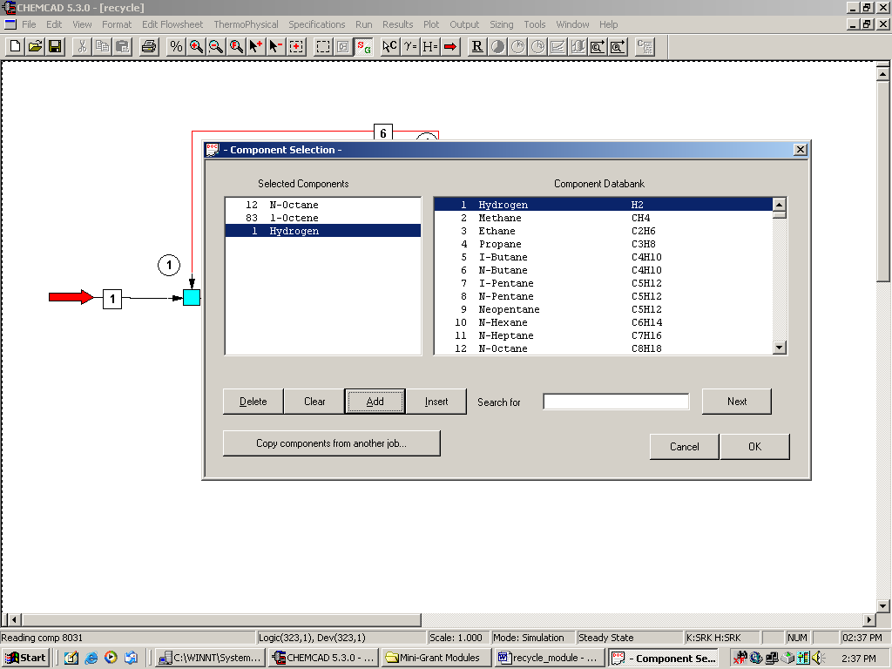

Step 3: Entering the feed stream composition

Double click on the first feed stream (water stream). Enter the feed information (temperature, pressure, and an initial guess, say 100 kmol/hr for flow rate of water) given in the problem statement. Click once on Flash to get the feed stream enthalpy and vapor fraction in feed at the feed conditions.
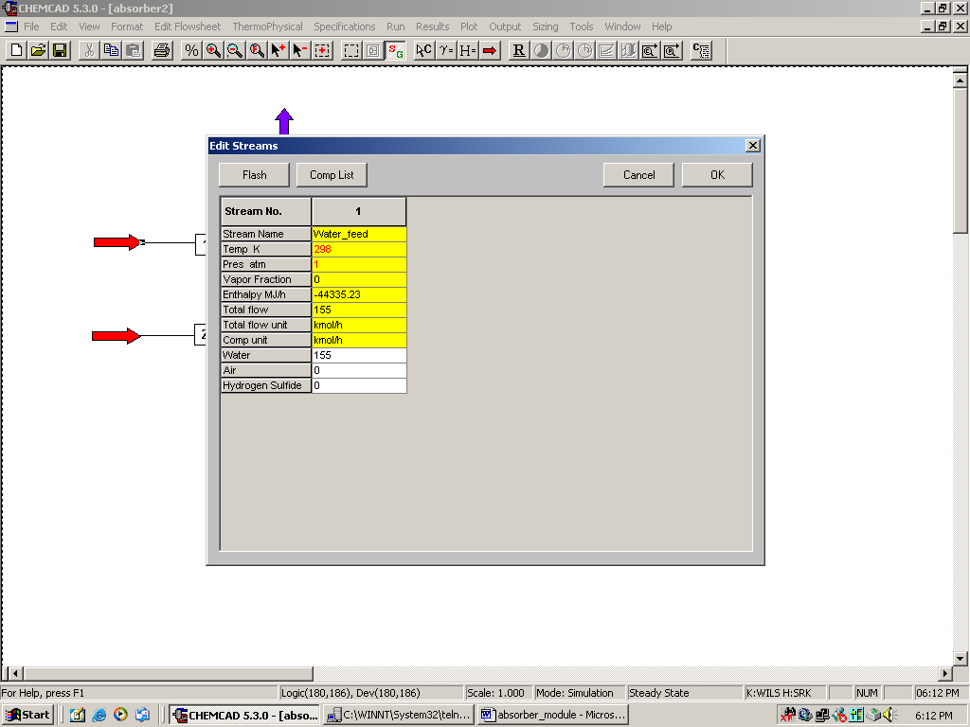

Similarly, enter the feed conditions for the second stream (gas stream).
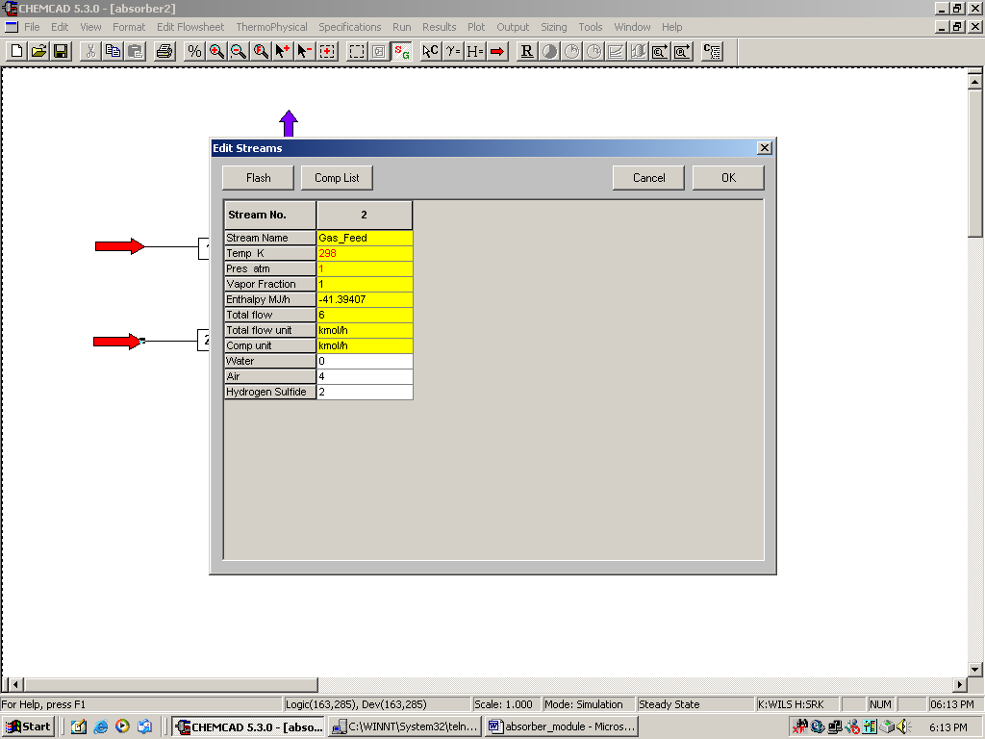

Step 4: Entering the absorber specs

Double click on the SCDS column. This can be used as an absorber.
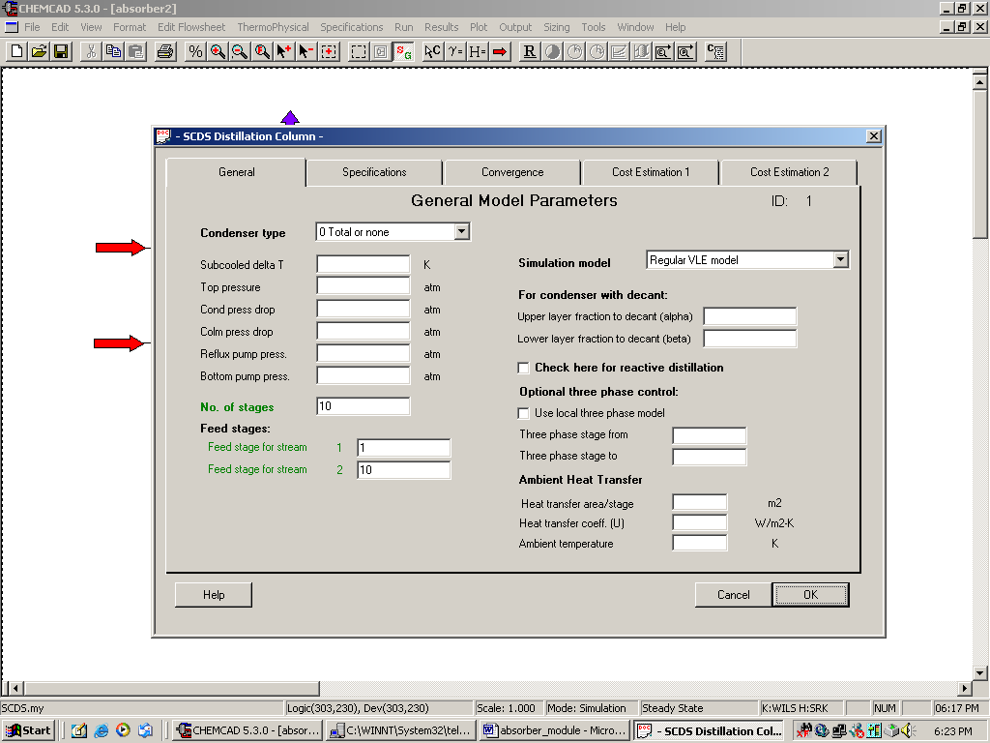

The required inputs in this page are the same as those for a distillation column and are described below:

No. of stages: Enter the number of stages (10)
Feed stage for stream 1: Enter the stage number at which water enters the column (1)
Feed stage for stream 2: Enter the stage number at which gas mixture enters the column (10)

The other inputs on this page are optional and can be neglected.

Don’t click OK yet!

Click on the Specifications tab. Note that the default options for Condenser mode and Reboiler mode are No Condenser and No Reboiler respectively. These options are always left to default when simulating for an absorber using an SCDS column.

Click OK to continue.

Step 5: Running the simulation and retrieving the results:

Now the simulation is ready to be run. Click once on R to run the simulation. Alternatively, one can run the simulation by clicking on Run on the menu bar and selecting Run all. The status of the simulation can be found at the bottom left hand corner of the screen. The message, Run Finished, appears if the run is successfully completed. The product stream properties can be found by double clicking the product streams. At this point, a check is made to see the mole rate of hydrogen sulfide in the bottom stream. If this is more than 1.98 kmol/hr (99% of hydrogen sulfide in feed, as per the problem statement), the guessed flow rate of water is too high. Decrease the flow rate of water in feed stream and repeat the above steps. Conversely, if the mole rate of hydrogen sulfide exiting from the bottom is less than 1.98 kmol/hr, increase the flow rate of water in the feed stream and repeat the above steps until the flow rate of hydrogen sulfide from the bottom is approximately 1.98 kmol/hr.

Alternatively, a sensitivity analysis can made with water feed flow rate as the independent variable and the hydrogen sulfide product flow rate in the bottom as the dependent variable. The plot obtained after running the sensitivity analysis can be used to read the water flow rate at which the flow rate of hydrogen sulfide from the bottom is 1.98 kmol/hr.

It can be verified that the water flow rate to meet the specifications in problem staement is 145 kmol/hr

