DISTILLATION COLUMN

Problem Statement:

A 100 kmol/hr stream of ethanol (50 mol%) and n-propanol (50 mol%) is fed to a continuous distillation column at room temperature (298 K) and atmospheric pressure. The pressure drop across the column is negligible and a reflux ratio of 1.5 is used. About 93 mol% of ethanol in feed and 5 mol% of n-propanol in feed is desired to be present in the distillate stream.

Design a continuous distillation column to meet the desired specifications using Shortcut column in CHEMCAD to report the total number of stages, minimum number of stages, feed stage location, minimum and calculated reflux ratios.

Then use the SCDS column in CHEMCAD (use the data obtained for the feed stage location and the total number of stages previously obtained) to report the final distillate and bottom stream concentrations and the reboiler and condenser heat duties.

Procedure:

Step 1: Creating the flow sheet using the Shortcut column.
Step 2: Entering the components and engineering units
Step 3: Entering the composition of feed stream
Step 4: Entering the shortcut column specs
Step 5: Running the simulation and retrieving the total number of stages, minimum number of stages, feed stage location, minimum and calculated reflux ratios.
Step 6: Changing the flow sheet in order to set up a distillation column simulation using the SCDS
Step 7: Entering the SCDS column specs
Step 8: Running the simulation and retrieving the results

Step 1: Creating the flow sheet

Go to new on the File menu and save the blank simulation. Click on Shortcut column on the CHEMCAD palette and click once on simulation window to paste it. Click on the feed icon on the palette and paste it on the workspace. Similarly, click on the product icon and place it on the workspace (do the product twice as there are two product streams). After making sure that all the necessary icons are placed on the workspace, they can be connected by using stream. CHEMCAD automatically assigns numbers to streams and unit operations the order in which they are placed on the workspace. After completing the flow sheet, change the mode from flowsheet mode to simulation mode by clicking on the pull down menu found on the tool bar and selecting the desired mode. The same menu can be used to toggle between these two simulation modes. Alternatively, one can toggle between Flowsheet and Simulation by selecting the mode tab on the menu bar to achieve the same results.

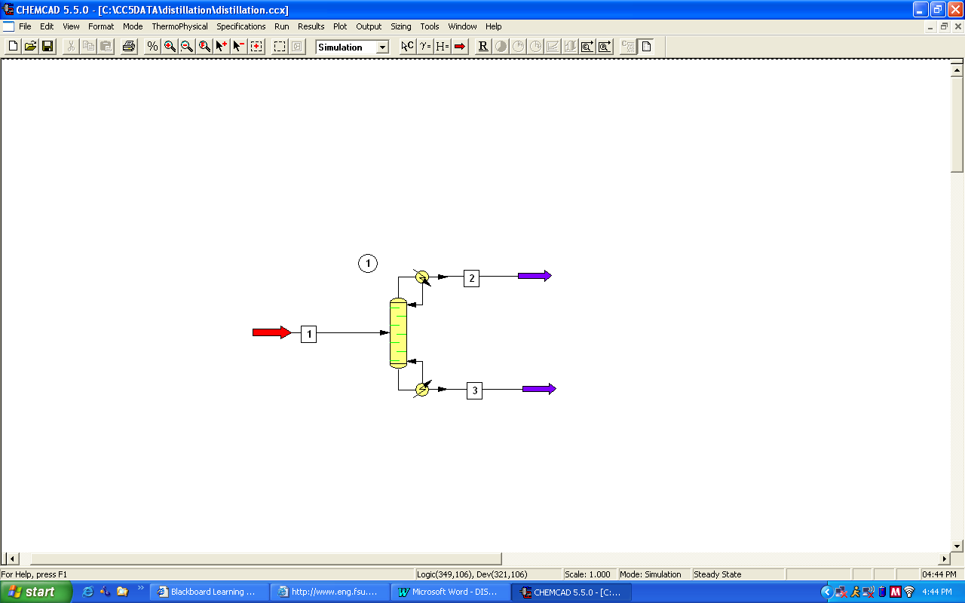

Step 2: Entering the components and engineering units

Go to the Thermophysical on the menu bar and click on Components List. Find ethanol and n-propanol from the CHEMCAD components list and add them to the component list. Go to the Format menu and click on Engineering Units and select the desired units for such properties as temperature, pressure etc. Click OK to continue.

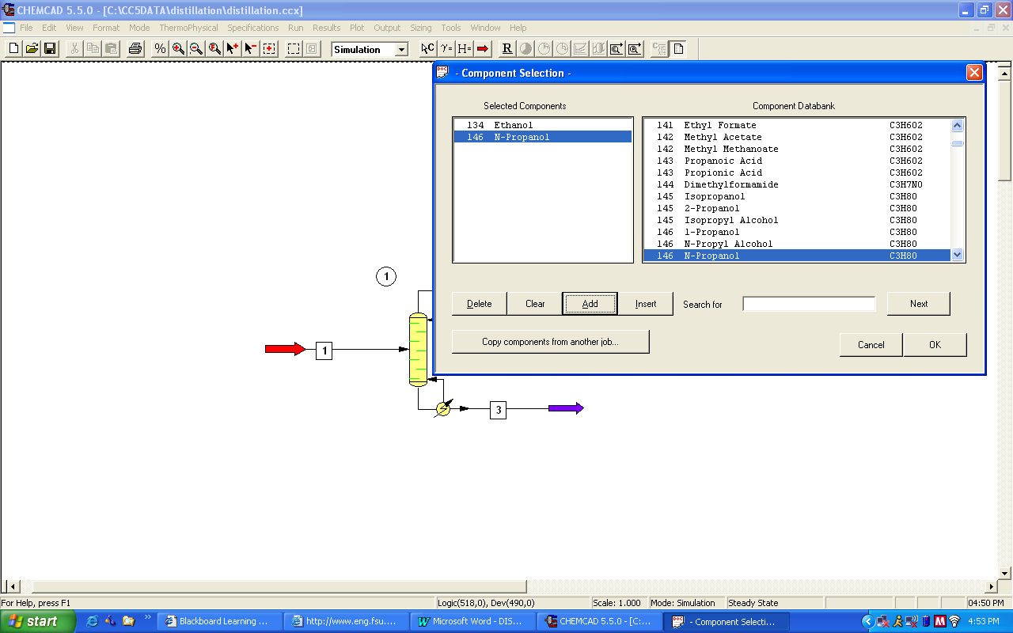

Step 3: Entering the composition of feed stream
Double click on the feed stream and enter the feed information (temperature, pressure, total flow rate and component mole fractions) given in the problem statement. Click once on Flash to get the feed stream enthalpy and vapor fraction in feed at the feed conditions.

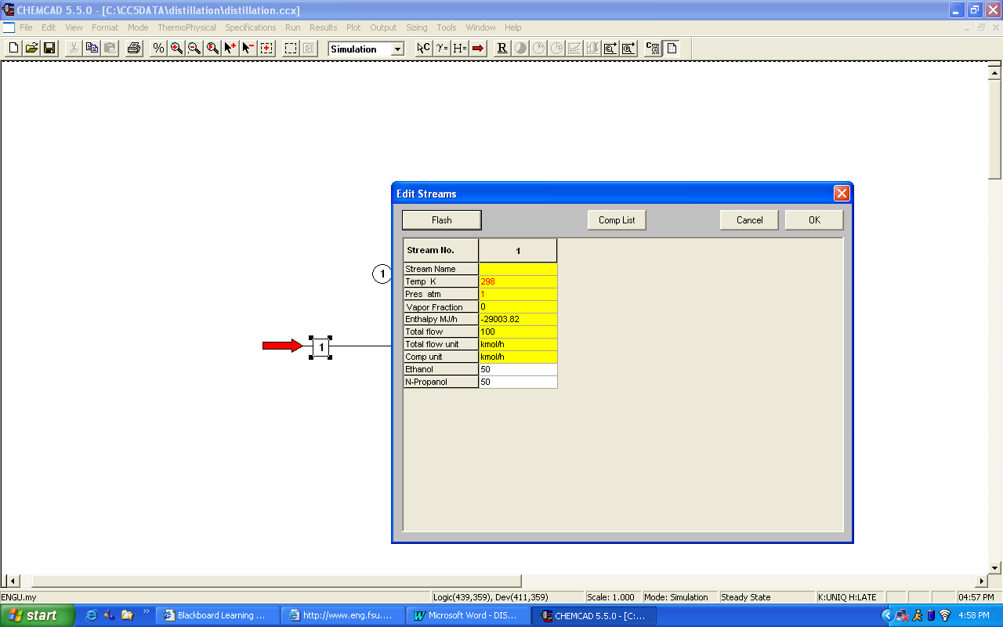

Step 4: Entering the Shortcut column specs

Double click on the ShortCut Column.

1. Select mode:
The Shortcut column can be used for both design and rating of a distillation column. As we need to design a column, option 2 or option 3 can be used for the design mode. Select one of these two and continue.

2. Select condenser type:
As this is not explicitly stated in the problem statement, the condenser can be assumed to be total and can be left to this default option.

3. Column pressure:
As there is negligible pressure drop across the column, one can enter the same pressure as that of the feed stream in this field (1 atm). This can also be left blank and CHEMCAD sets the pressure to default, which is the pressure of the feed stream.

4. Column pressure drop:
This can be left blank.

5. Number of stages:
CHEMCAD calculates the number of stages and stores the calculated number in this box. The user needs to leave this box blank.

6. Reflux ratio:
Enter the value ‘1.5’ in this field.

7. R/Rmin:
One needs to enter only one of the two specs, reflux rato or R/Rmin. As the reflux ratio is specified, this field needs to be left blank.

8. Case study:
This is optional and can be left blank for our purpose.

9. Key component specifications:
- Light key component: Select ‘Ethanol’
- Light key split: Enter ‘0.93’
- Heavy key component: Select ‘n-propanol’
- Heavy key split: Enter ‘0.05’

10. Calculated results:
These are the parameters that CHEMCAD calculates and stores the values of. All these fields need to be left blank.

Click Ok when finished.

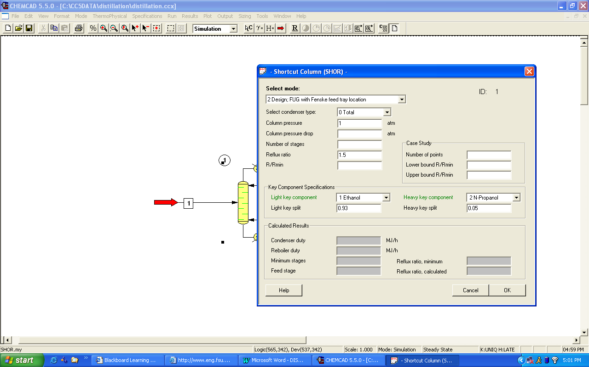

Step 5: Running the simulation and retrieving the results

After entering the available information on the workspace as described in the previous steps, one can run the simulation by clicking on R on the menu bar. Alternatively, one can run the simulation by clicking on Run on the menu bar and selecting Run all. The simulator indicates the same warnings regarding the estimates as before and one can ignore them again and continue with the simulation by clicking on Yes. The status of the simulation can be found at the bottom left hand corner of the screen. The message, Run Finished appears in this place if the run is successfully completed. The results can be obtained by simply scrolling the mouse overtop of the unit op. Alternatively, all the results associated with the shortcut column can be found by clicking on Results menu and selecting Unit Op’s and then the shortcut Column. The results will then be available in a WordPad file.

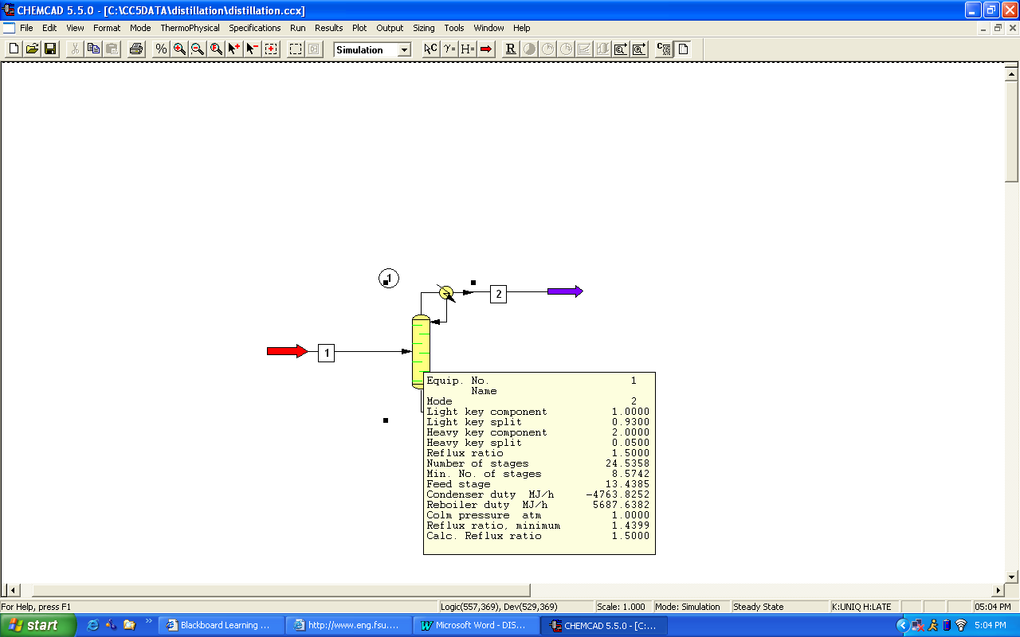

Step 6: Changing the flow sheet in order to set up a distillation column simulation using the SCDS

Click on the pull down menu used to toggle between the simulation and flowsheet modes, and change to the flowsheet mode. Right-click on the shortcut column and select swap unit from the menu that appears. A message will be displayed telling you to pick another unit from the list. Click ok and proceed to pick the SCDS column and place it where the shortcut column is located. Return to simulation mode.
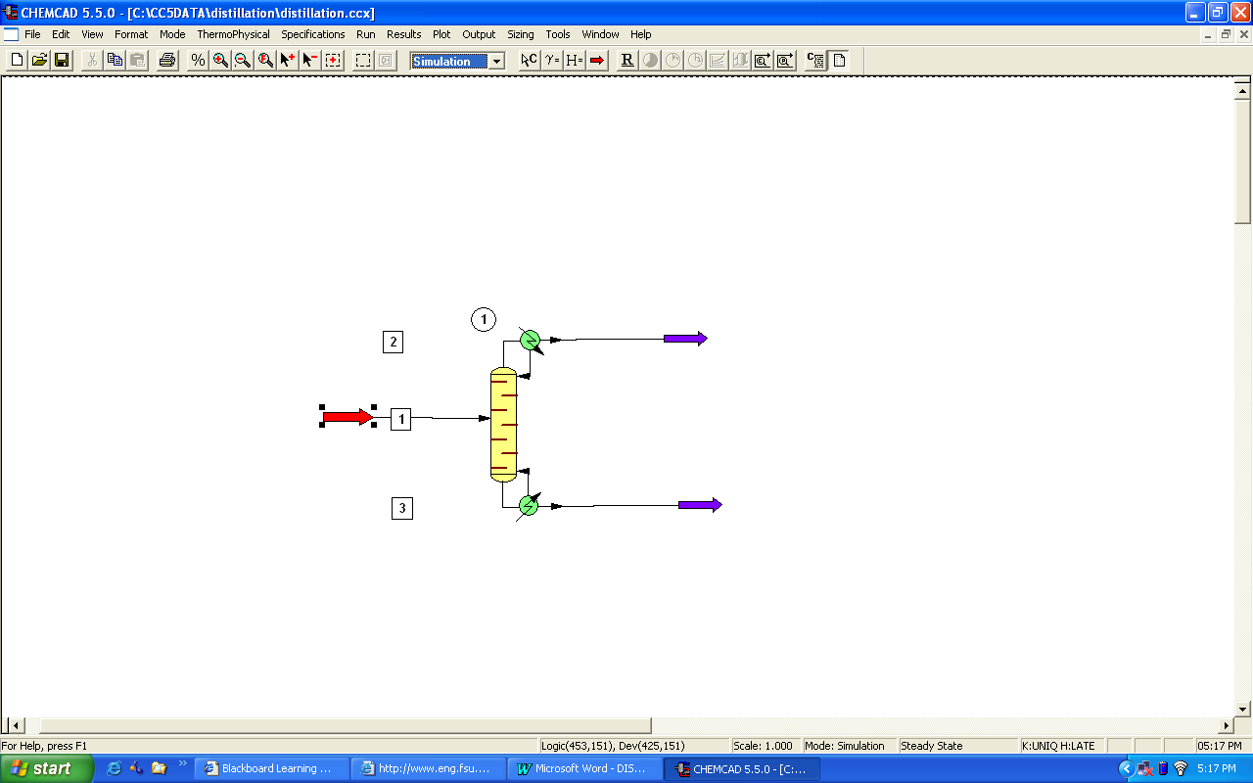

Step 7: Entering the SCDS column specs

Double click on the SCDS Column.

1. General:

The only information available to us that could be filled in this window is the number of stages (25) and feed stage for stream 1 (13th tray). These are the only two required areas in this window. The other information such as Subcooled delta T, Top pressure, Cond Press drop, Colm press drop, Reflux pump press, Bottom pump press are all optional and one can enter values for these parameters when available. An important aspect of CHEMCAD columns is that CHEMCAD numbers the trays from top to bottom. So, tray-1 is the condenser and tray N (N=24 in this case) is the reboiler as far as CHEMCAD simulations are concerned.

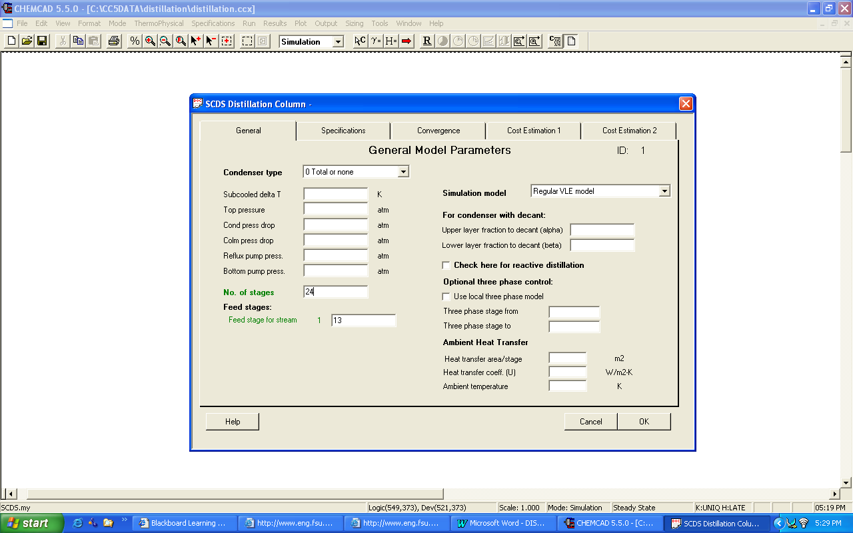

Wait before you click OK!! There are more specs to fill out in this window!!!

2. Specifications:

It is necessary to give the simulator two specifications, one for Condenser mode and the other for Reboiler mode in order for it to run. There are several options available to choose from in the specifications of each of these modes, depending on the nature of the problem. (One can drop the arrow that is located on both these fields to get familiar with all the options available) The two specifications given in the problem statement are as follows:

- Reflux ratio of 1.5, which corresponds to the Condenser mode
- Bottom stream n-propanol composition of 93 mol%, which corresponds to the Reboiler mode.

Select option ‘1’ (Reflux ratio (R/D) for Condenser mode and enter the value ‘1.5’ in the box provided for Specification. Similarly, Select option ‘6’ (Bottom component mole fraction) for Reboiler mode, enter the value ‘0.93’ in the box provided for Specification, and then choose n-propanol for Component.

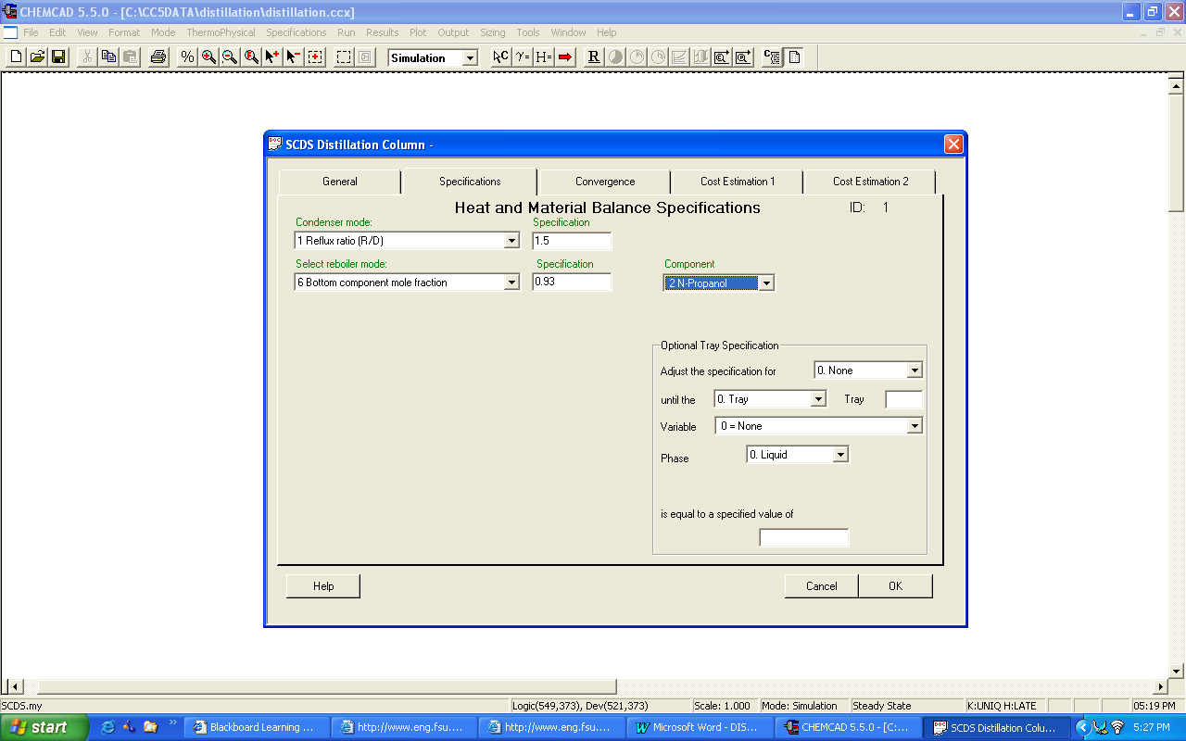

3. Convergence:
In the cases where good estimates (e.g. previously determined values) for various parameters such as Distillate rate and Reflux rate, the estimates can be made known to the simulator in this Convergence tab. Good estimates for various parameters can make the simulation converge faster and even give more accurate results. However it is better to give no estimates rather than giving inaccurate estimates. As our problem statement does not mention anything about estimated parameters, these fields can well be left blank. However, from the shortcut-column used to estimate the number of stages and the feed tray location, we also obtain estimates for these values. These estimates may be used in this simulation, however they are not required.

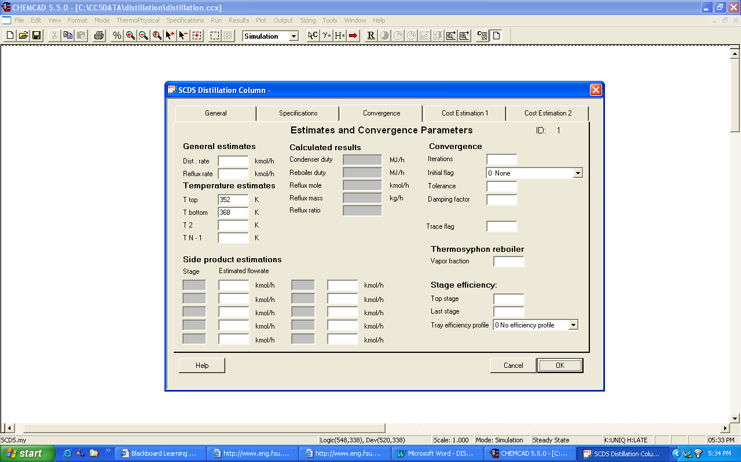

4. Cost estimation 1 and 5. Cost estimation 2
These two tabs, as the names indicate, are used for cost estimation and are not needed for the purpose of this simulation and hence can be left blank.
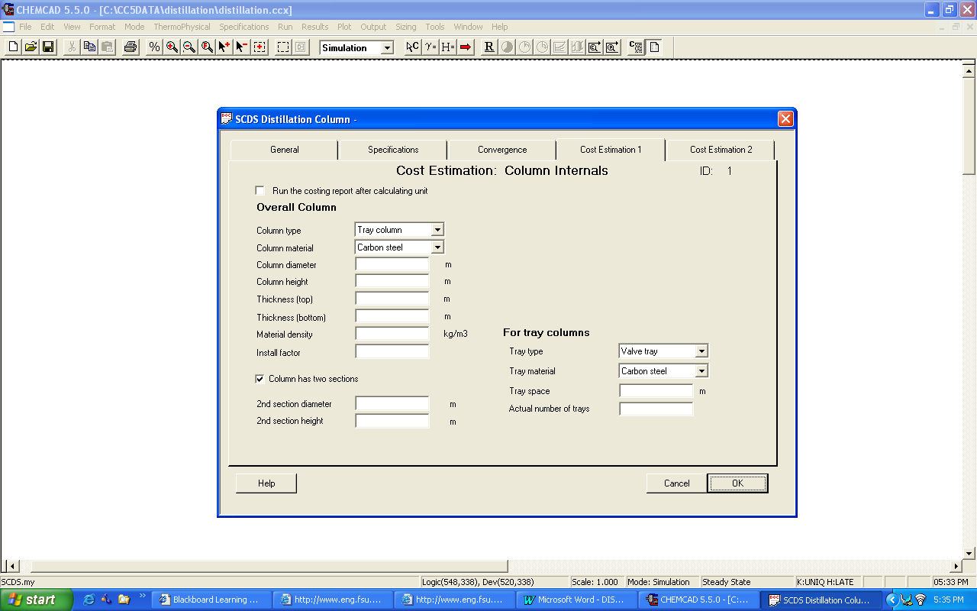

Click OK to continue. If the values for estimated parameters are not entered under Convergence tab, CHEMCAD indicates some warnings.

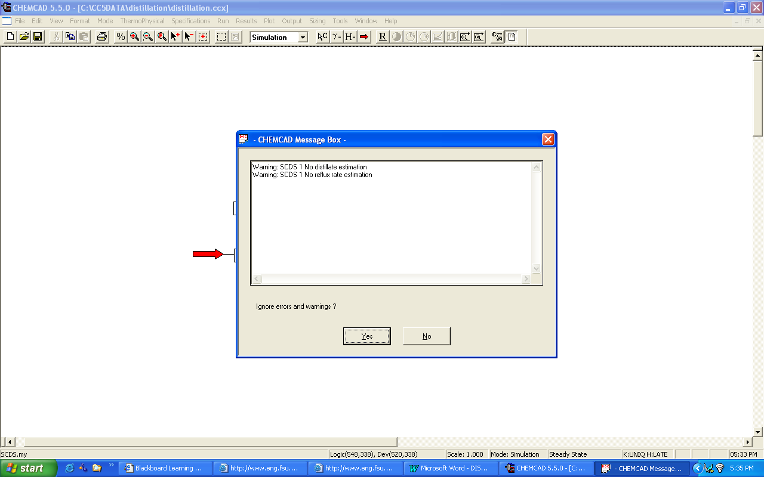

These can be safely ignored for our purpose without any loss of accuracy by clicking on Yes.

Step 8: Running the simulation and retrieving the results

After entering the available information on the workspace as described in the previous steps, one can run the simulation by clicking on R on the menu bar. Alternatively, one can run the simulation by clicking on Run on the menu bar and selecting Run all. The simulator indicates the same warnings regarding the estimates as before and one can ignore them again and continue with the simulation by clicking on Yes. The status of the simulation can be found at the bottom left hand corner of the screen. The message, Run Finished appears in this place if the run is successfully completed. To view the product stream compositions, one can either double click on the individual product streams, scroll overtop of the stream number, or by clicking Results on the menu bar and selecting Stream Compositions and further selecting All Streams. The results obtained from the latter method will be in a WordPad file.

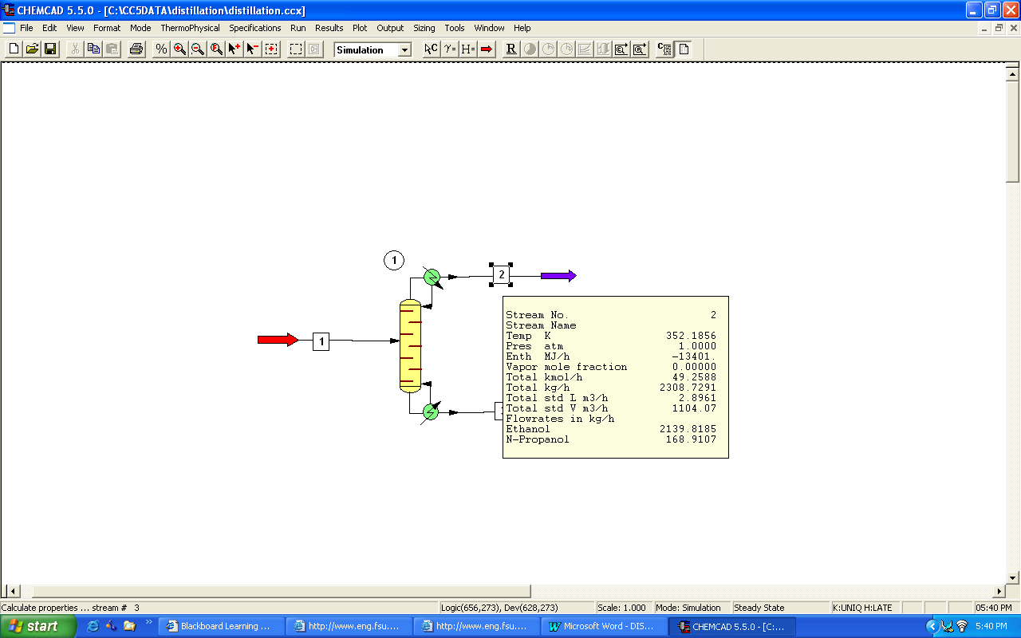
FLOW SUMMARIES

Stream No. 1 2 3
Stream Name
Temp K 298.0000 352.1856 368.3411
Pres atm 1.0000 1.0000 1.0000
Enth MJ/h -29004. -13401. -14680.
Vapor mole fraction 0.00000 0.00000 0.00000
Total kmol/h 100.0000 49.2588 50.7412
Flowrates in kmol/h
Ethanol 50.0000 46.4481 3.5519
N-Propanol 50.0000 2.8107 47.1893

The results associated with the SCDS column can be found by scrolling the mouse overtop of the unit op. Alternatively, all the results associated with the SCDS column can be found by clicking on Results menu and selecting Unit Op’s and then the SCDS Column. The results will then be available in a WordPad file.

