CSTR: Reaction Rate Kinetics

The Problem Statement:

Reaction:
Decomposition of di-t-butyl peroxide (DTBP) to acetone and ethane
$$({\text{CH}}_{3})_{3}\text{COOC}({\text{CH}}_{3})_{3}→2({\text{CH}}_{3})_{2}\text{CO}+C_{2}H_{6}$$

Reaction kinetics:
$$\begin{aligned}k_{c}=2\text{.}\text{095}∗{\text{10}}^{−2}{\text{min}}^{−1} \\ −r_{A}=k_{c}C_{A}\end{aligned}$$

Reaction conditions:
Temperature 154.6 ºC
Pressure 491.8 mmHg

Feed and initial conditions:
100 kmol/h of (DTBP) at 110 ºC and 760 mmHg

Information for steady state:
- Reaction is isothermal
- Conversion with respect to DTBP is 85%
- Reference temperature for heat of reaction is 25 ºC

Perform a simulation to determine the volume of the reactor at steady state to achieve the desired conversion, the steady state heat duty and the steady-state mole rates of components in the product stream.

Procedure:

Step 1: Creating the Flow sheet
Step 2: Formatting Engineering Units and Selecting Components
Step 3: Entering the feed stream composition
Step 4: Entering the reactor specs
Step 5: Running the simulation and retrieving the results

Step 1: Creating the flow sheet

From the File menu select New, save to desired directory. Select and click the kinetic reactor, feed and product icons on the workspace. Connect the three using the stream icon.

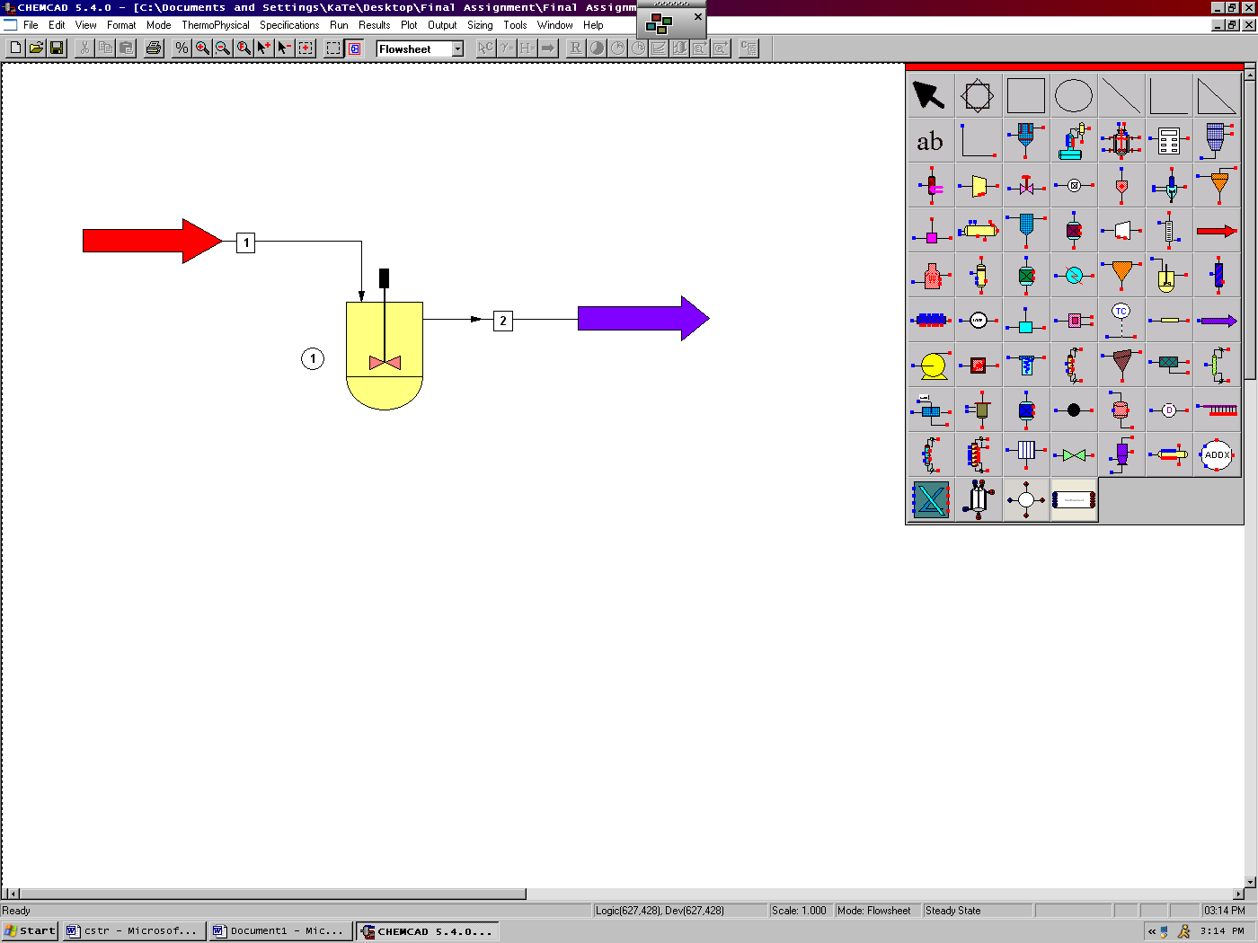

Step 2: Formatting Engineering Units and Selecting Components

At the top of the screen change the scroll down menu from Flowsheet to Simulation. Go to the Format menu and select Engineering Units. Use the SI option at the bottom to convert all units at the same time. The desired units for each category may also be selected individually. Click OK to continue.
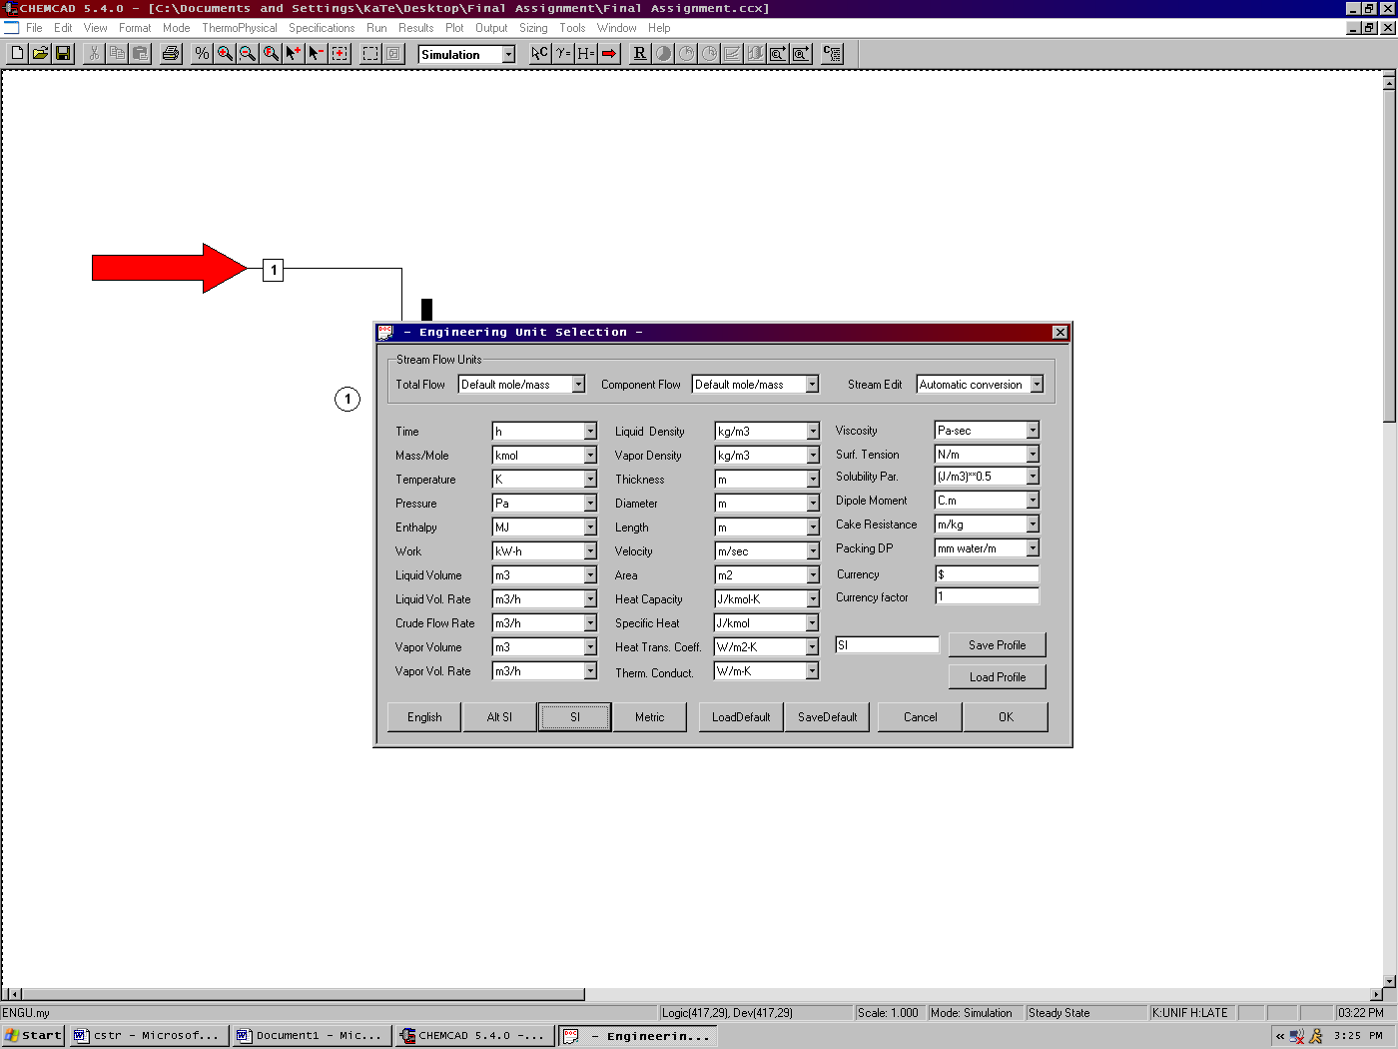

Next Go to Thermophysical on the menu bar and click on Components List. Find DTBP (Di tertiary butyl peroxide), acetone, and ethane from the CHEMCAD components list and add them to the component list. Click OK to continue.

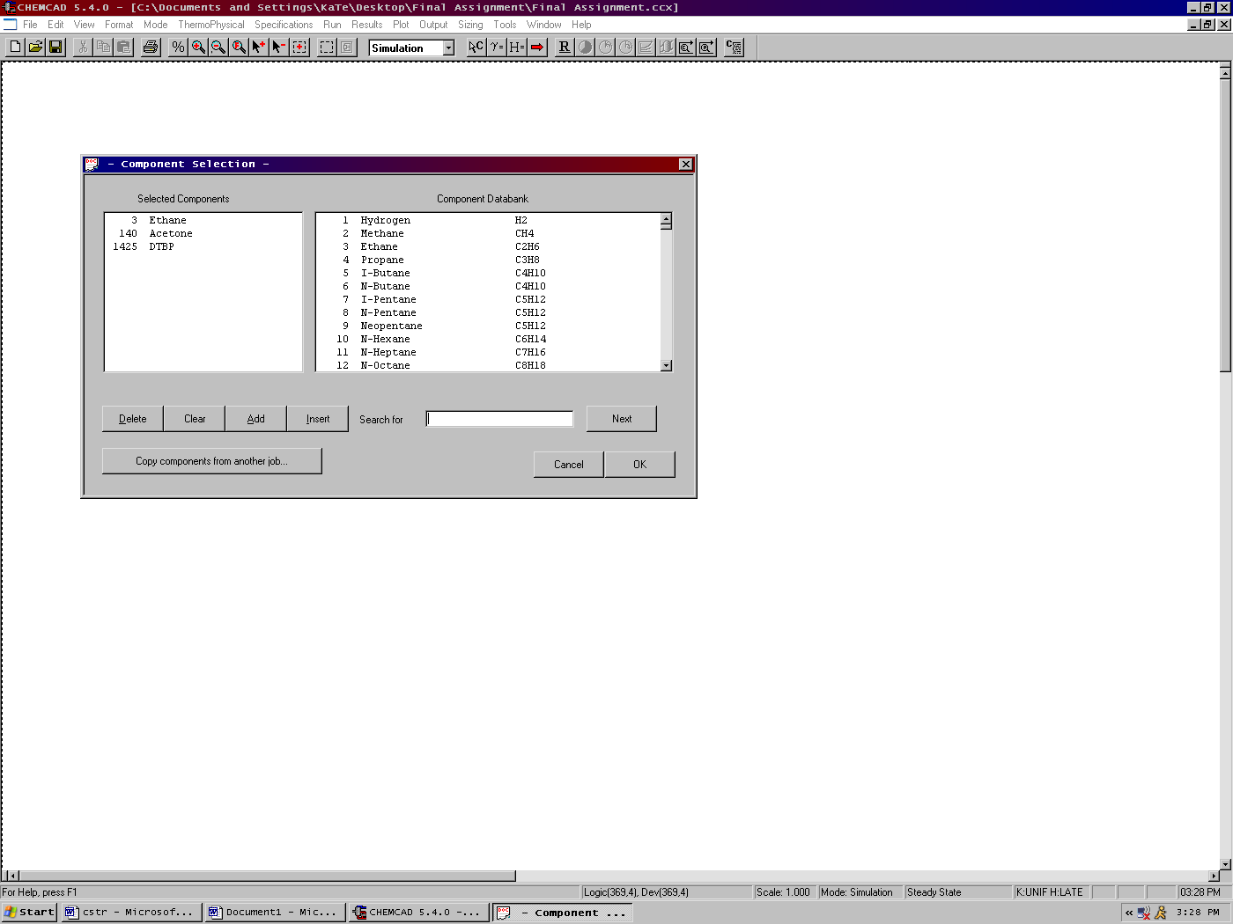

The Thermodynamics Wizard will then appear, enter the desired information. Click OK to Continue. The K-Value Wizard can be accessed any time by clicking on the Thermophysical menu and then scrolling down to K-Value Wizard. Click OK. On the second screen select the SRK equation of state if the UNIFAC equation of state does not work. Click OK.

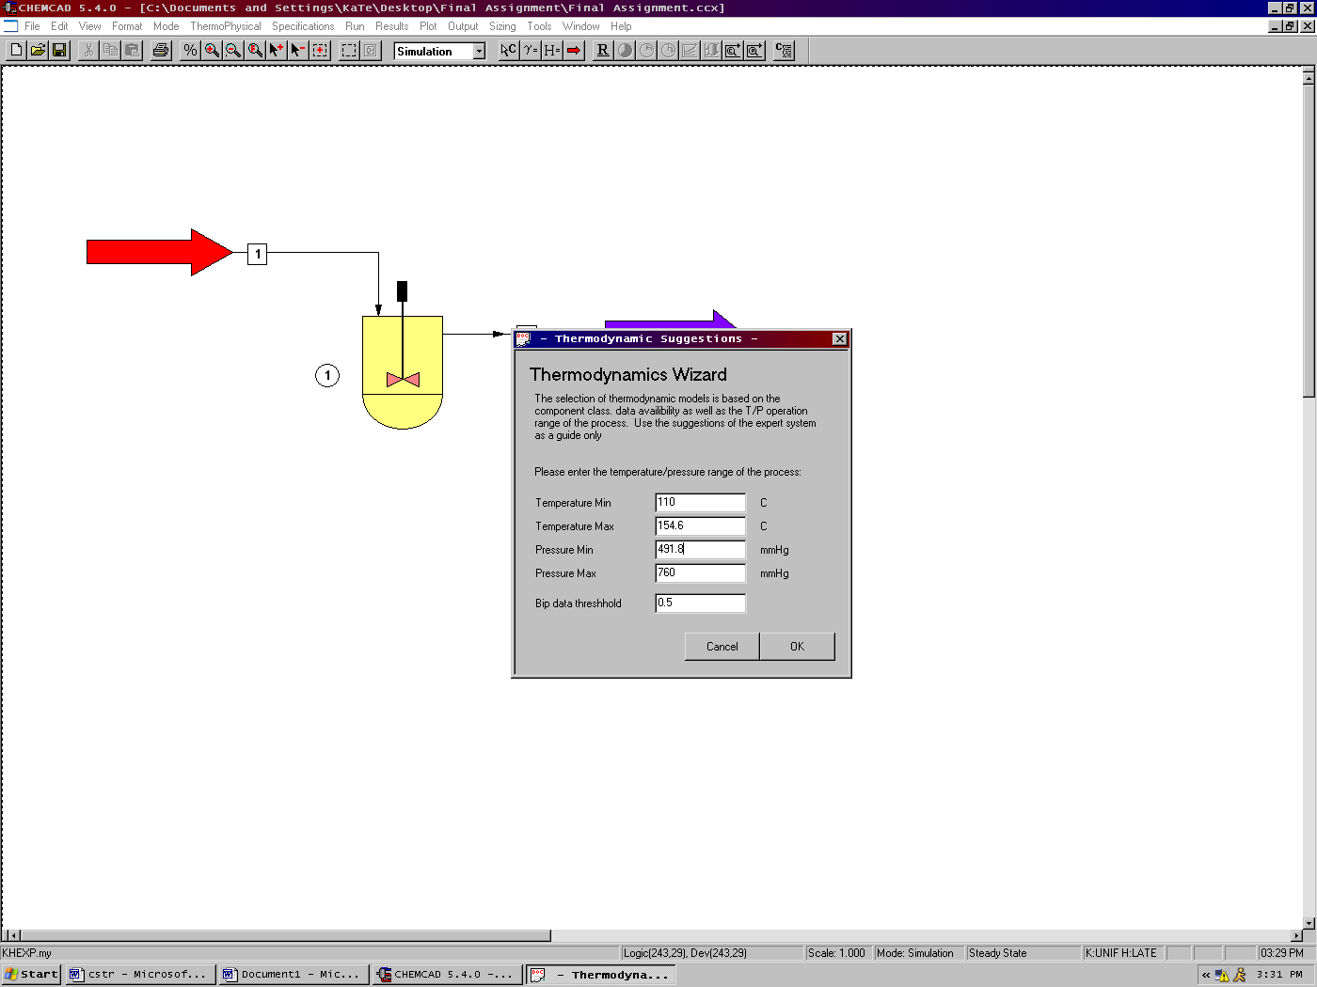

Step 3: Entering the feed stream composition

Double click on the feed stream and enter the feed information (temperature, pressure, total flow rate and component mole fractions) given in the problem statement. Click once on Flash to get the feed stream enthalpy and vapor fraction in feed at the feed conditions. Click OK. Click on the Exit stream and input the isothermal temperature and pressure. Click Flash. Click OK.

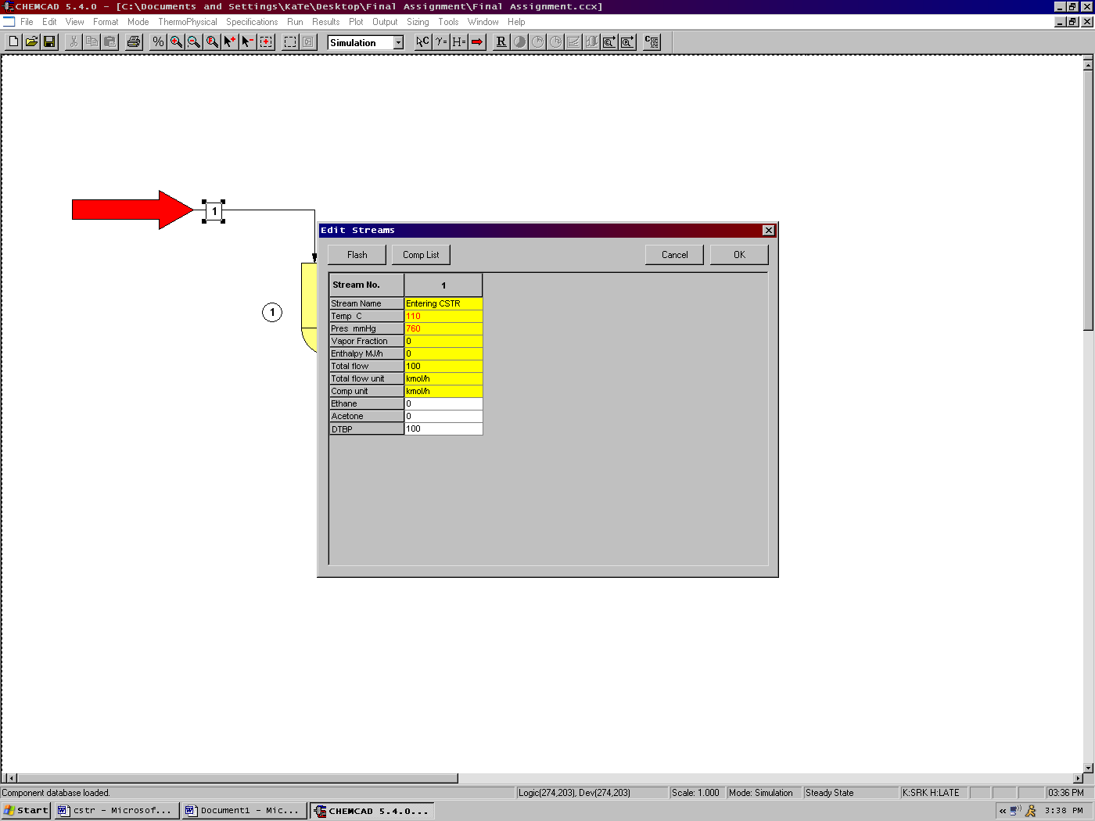

Step 4: Entering the reactor specs

Double click on the reactor.

General Specifications Page:

Number of reactions: As there is only one reaction in the problem statement, enter ‘1’

Reactor Pressure: Enter the reactor pressure as given in the problem statement (491.8 mmHg)

Pressure Drop: As there is no pressure drop specified within the reactor. Leave this blank.

Kinetic Rate Expression: There are two options for this. The default option (Standard) is used when the rate equation is in standard Arrhenius form. The other option (User Specified) is used when the rate law is not in its standard form and the user needs to enter this manually. For more information on this, the user can always click on the help button that appears at the bottom left corner on this page. For this problem, the kinetic rate expression is given to the user. So, the User Specified option should be selected.

Reaction Phase: As the reactant, DTBP and one product, ethane, are in vapor phase at reaction pressure and temperature and the other product, acetone is in liquid phase, Vapor Reaction, Mixed Phase radio button should be selected.

Specify Reactor Type: As the reactor described in the problem statement is a CSTR, CSTR should be selected form the drop box.

Thermal Mode: As the temperature of the reaction is given as 154.6 ºC, Isothermal option should be selected.

Specify Calculation Mode: As the desired conversion is given in the problem statement, Specify Conversion, Calculate Volume option should be selected.

Reactor Volume: This needs to left blank as this is the value that is required to be calculated in the simulation.

Key Component: The key component to specify conversion is DTBP and this is selected from the drop box.

Conversion: The conversion with respect to the key component, DTBP is given as 85% and this conversion (0.85) is entered in this field.

Don’t Click OK yet! There is more to complete in the More Specifications page!

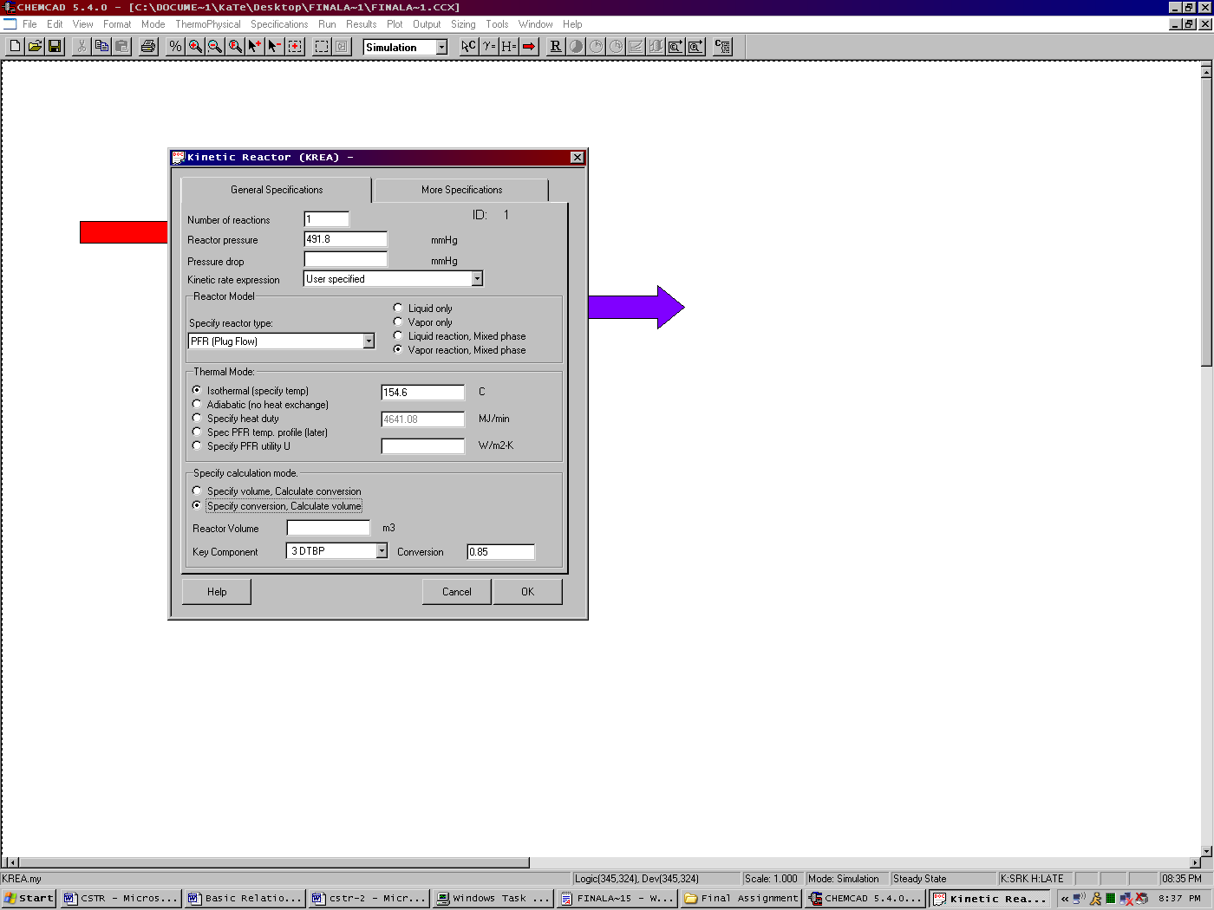

More Specifications:
# of Iterations and Tolerance can be left blank as these are optional fields.

Reaction Engineering Units: Change the units so that the units are consistent with the rate law (Change time units to min)

Temperature reference for heat of reaction: Enter 25 ºC in this field.

Edit reaction number: Can be left blank.

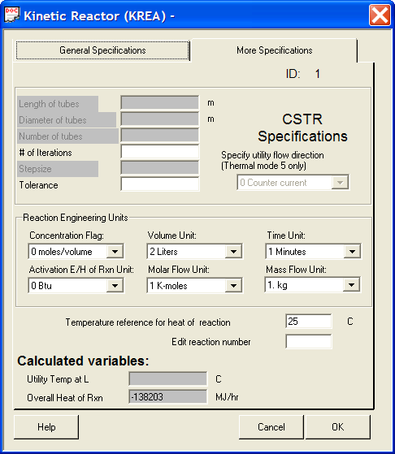

Click OK after completing the specifications page. A new window will appear and the stoichiometric coefficients should be entered in this window. Remember Reactants are negative (-), while products are positive (+). Click OK after entering the coefficients.

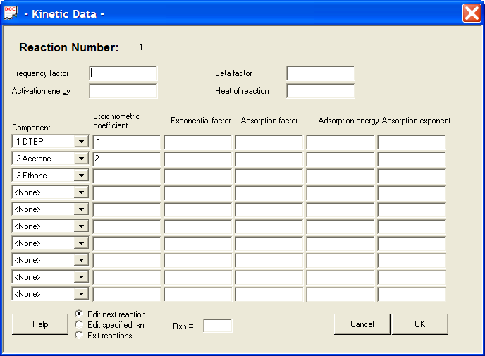

Because the User Specified option is selected for kinetic rate expression, another window with the title Unit: 1-User Rate Expressions appears. If a separate Visual Basic code is available, the user can browse those files using options available on File path tab. For most practical purposes, the user can go directly to the Rxn1 tab and complete the information as follows:

Name for the Chemical Reaction: DTBP decomposition
Variables for User Rate Expressions: CHEMCAD supplies the user with the variables described in this section to be used for user rate expressions.
Write User Rate Expression: 0.02095*C003

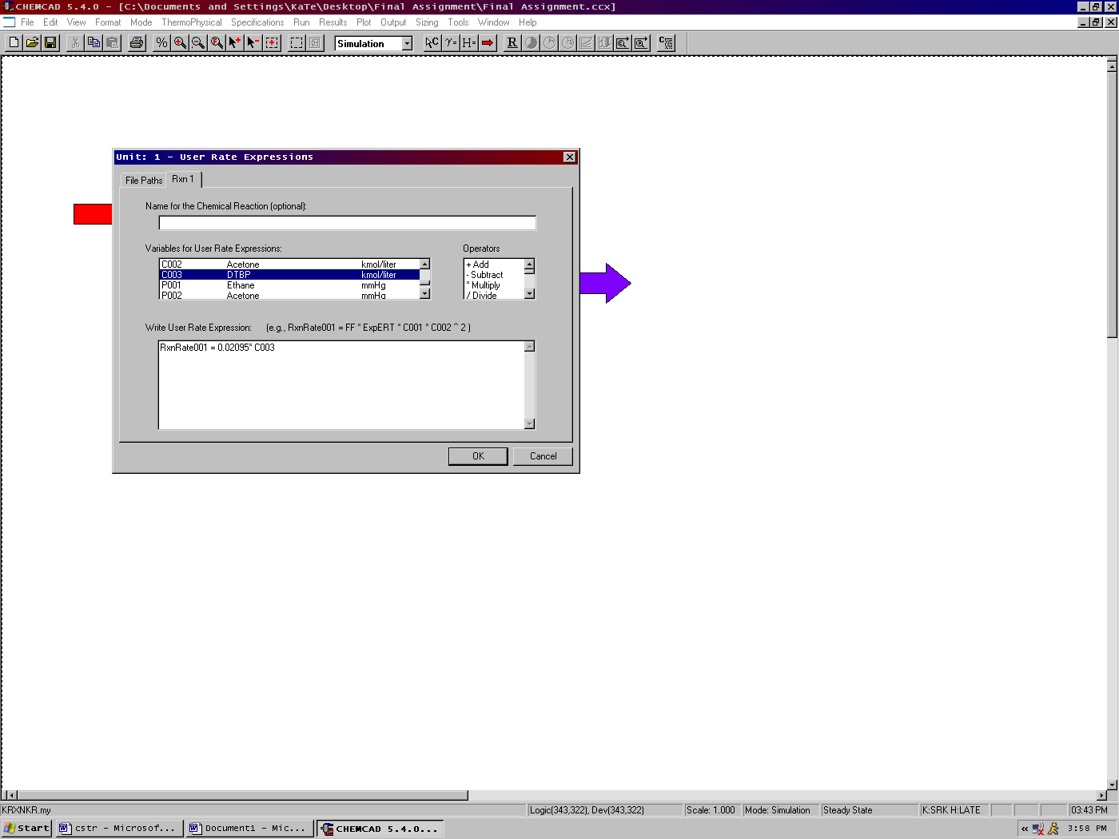

Click OK when finished. The following window will appear to confirm that we are allowing the cookies from an existing excel file so that the Visual Basic program accesses the rate expression specified by us. Click on Yes to continue.

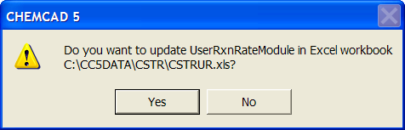

Step 5: Running the simulation and retrieving the results:
Now the simulation is ready to run. Click once on R at the top of the screen to run the simulation. Alternatively, one can run the simulation by clicking on Run on the menu bar and selecting Run all. The status of the simulation can be found at the bottom left hand corner of the screen. The message, Run Finished appears in this place if the run is successfully completed. The volume of the reactor for the desired conversion can be found from the General specifications page (double click on the reactor for this screen) to be 6.53e4 m³. Alternatively, all the results associated with the Unit operation, CSTR can be found by clicking Results on the menu and selecting Unit Op’s and entering the number the CSTR is associated with (‘1’ in this case) on the flow sheet. The CSTR results will then be available in a WordPad file.

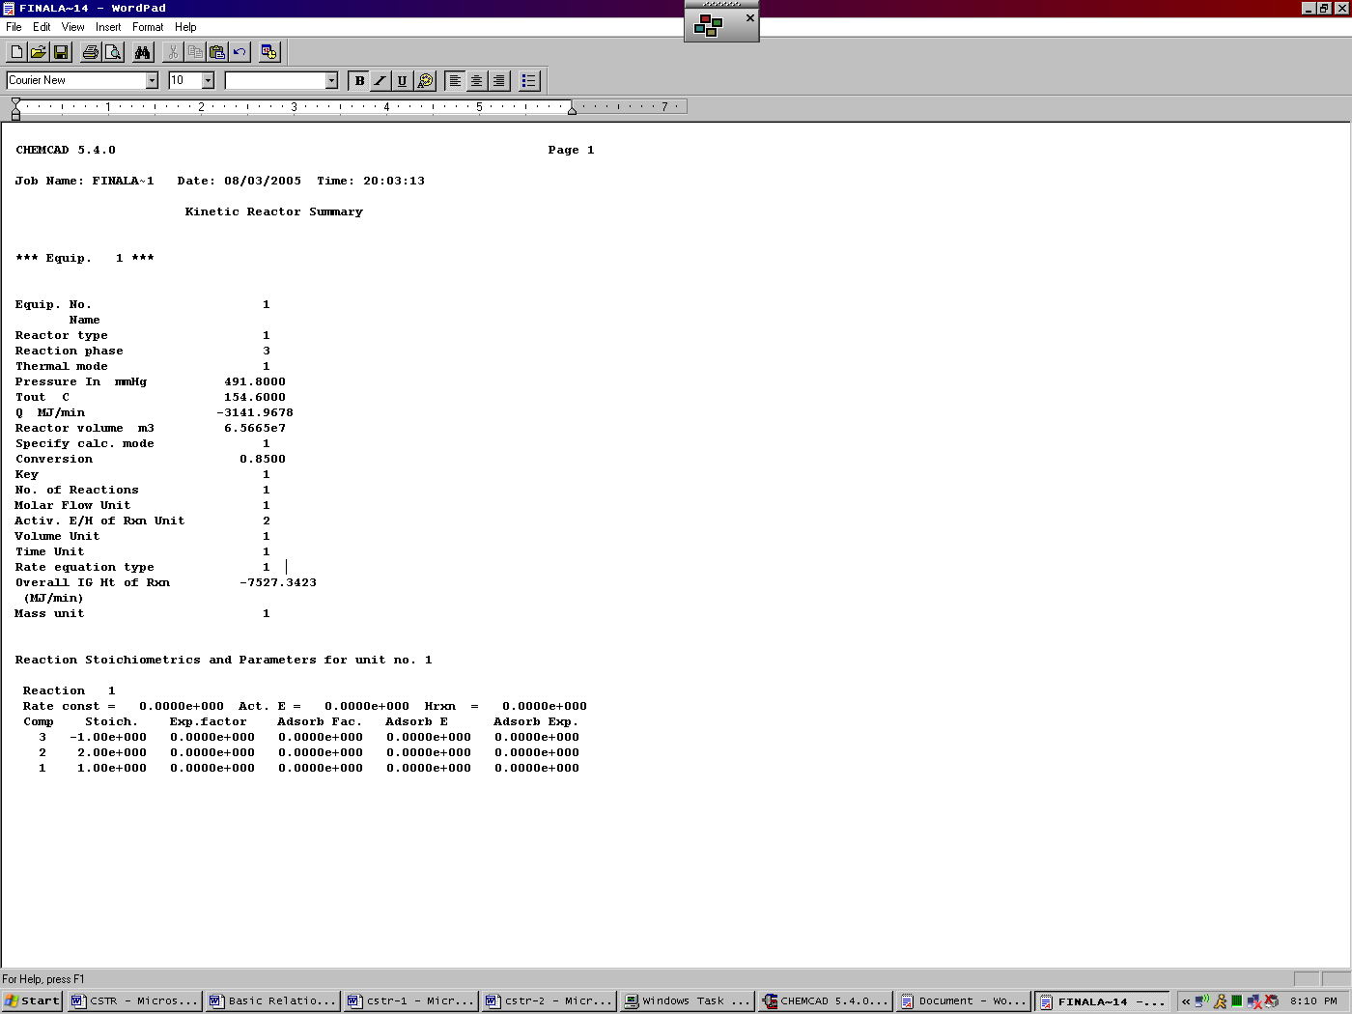

Similarly, the product stream properties can found either by clicking once on the product stream or by clicking once on Results on the menu, selecting Stream Composition and then clicking on All Streams. The results will again be available in a WordPad file.

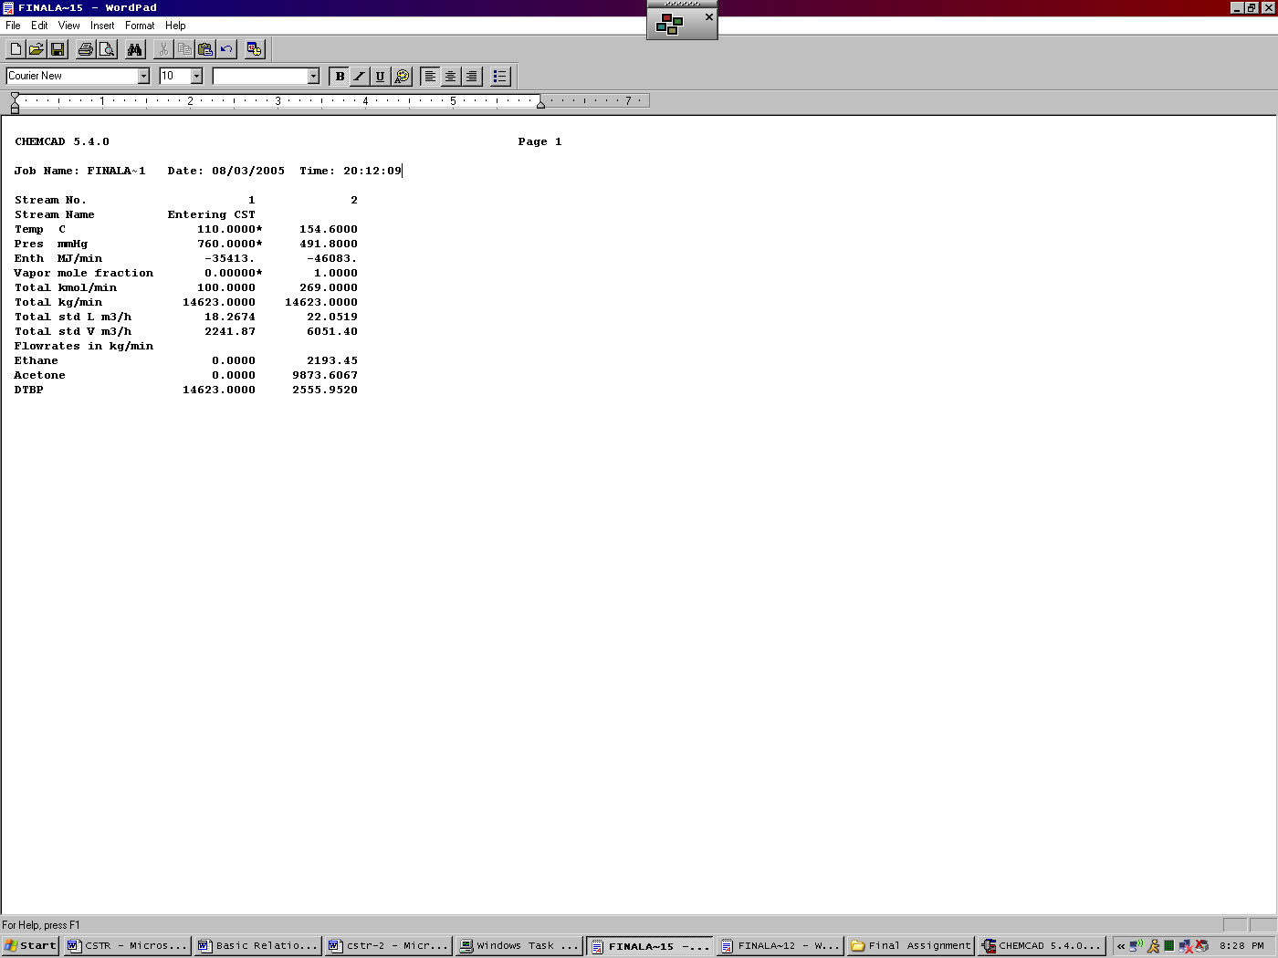

You Are Done!

A few hints:

If CHEMCAD gives you a 0 slope error, you need to make sure your More Specifications have been typed in correctly.

You may have to run the reactor as a PFR then as a CSTR.

If you get a mass balance error make sure your reaction rate and stoichiometric coefficients are typed in correctly.

If you have checked all of the above and you are still getting an error, you may want to close CHEMCAD and try again. Sometimes the program stops taking your corrections. You may actually have to close the program several times before you get it to run.

