DISTILLATION COLUMN
(Written by Celina Dozier)

Problem Statement:

A 2000 kmol/hr stream of acetone (25%), isopropanol (12.5%), di-isopropyl ether (2.5%), and water (60%) is fed to a continuous distillation column at room temperature (298 K) and atmospheric pressure. The column has 30 trays (including reboiler and condenser) and the feed enters at the 15th tray. A reflux ratio of 2.5 is used for the column and a high recovery and purity of acetone is desired in the distillate stream.

Set up a distillation column simulation using SCDS in CHEMCAD and report the final distillate and bottom stream concentrations and the reboiler and condenser heat duties.

Procedure:

Step 1: Creating the flow sheet.
Step 2: Entering the components and engineering units.
Step 3: Entering the composition of feed stream.
Step 4: Entering the SCDS column specs.
Step 5: Running the simulation and retrieving the results.
Step 1: Creating the flow sheet.
- Go to new on the File menu and save the blank simulation.
- Click on SCDS Column on the CHEMCAD palette and click once on simulation window to paste it.
- Click on the feed icon on the palette and paste it on the workspace. Similarly, click on the product icon and place it on the workspace twice (one for the distillate and one for the bottoms).
- Connect the streams by using stream from the palette.
- CHEMCAD automatically assigns numbers to streams and unit operations the order in which they are placed on the workspace. It is best to change the unit operation to a three-digit number (ex. 100) and leave the streams as one-digit numbers to distinguish them.
- Click on the arrow next to the word “Flowsheet” in the menu and change to “Simulation.”

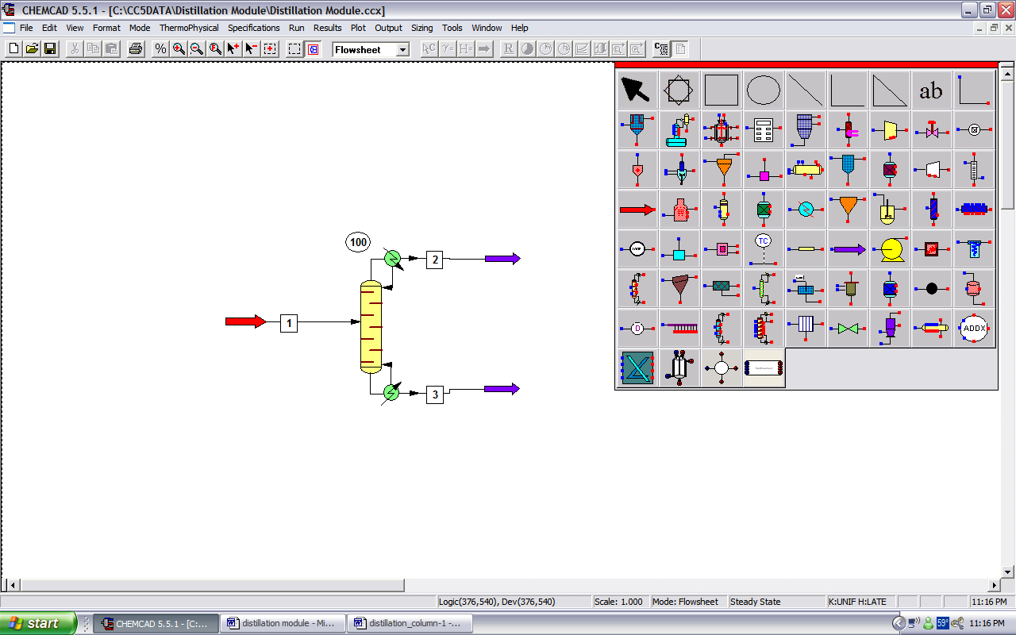

Step 2: Entering the components and engineering units

- Go to the Thermophysical on the menu bar and click on Components List.
- Type in isopropanol, acetone, diisopropyl ether, and water to add them to the components list.
- Click OK.
- Go to the Format menu and click on Engineering Units and select the desired units for such properties as temperature, pressure etc.
- Click OK.
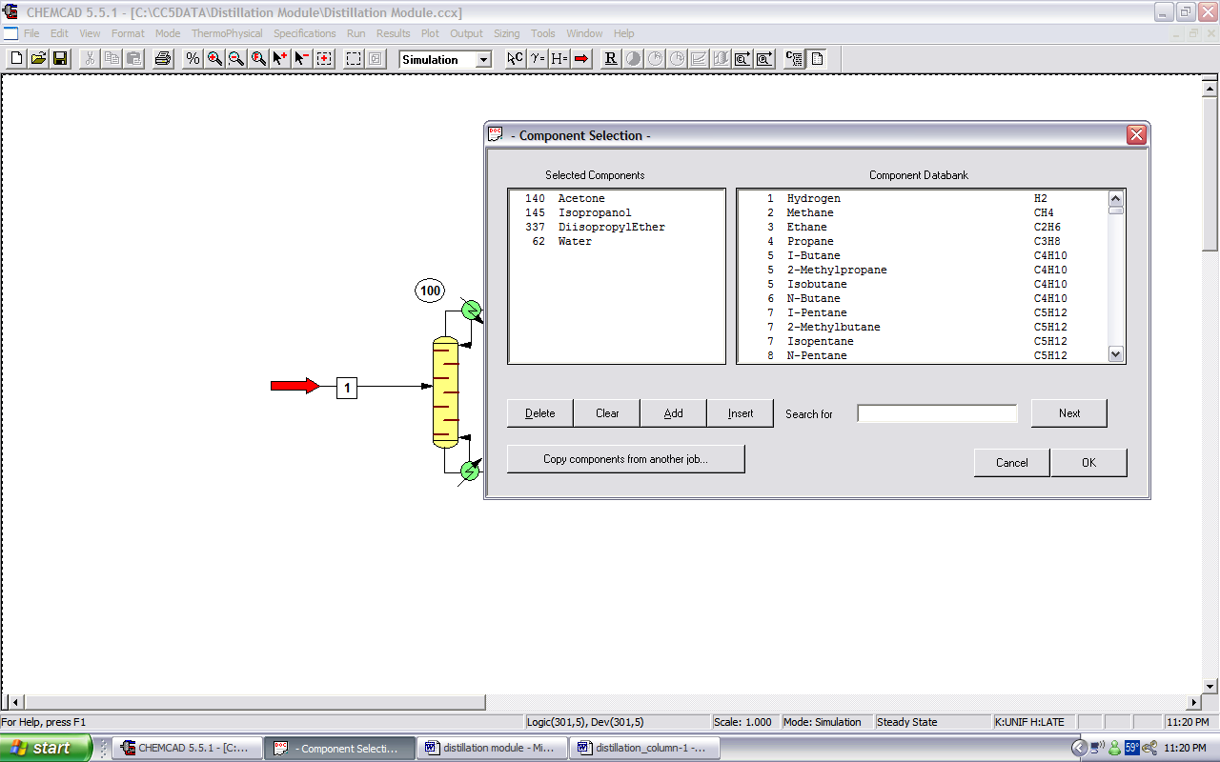

Step 3: Entering the composition of feed stream

- Double click on the feed stream and enter the feed information (temperature, pressure, total flow rate and component mole fractions) given in the problem statement.
- Click once on Flash to get the feed stream enthalpy and vapor fraction in feed at the feed conditions.
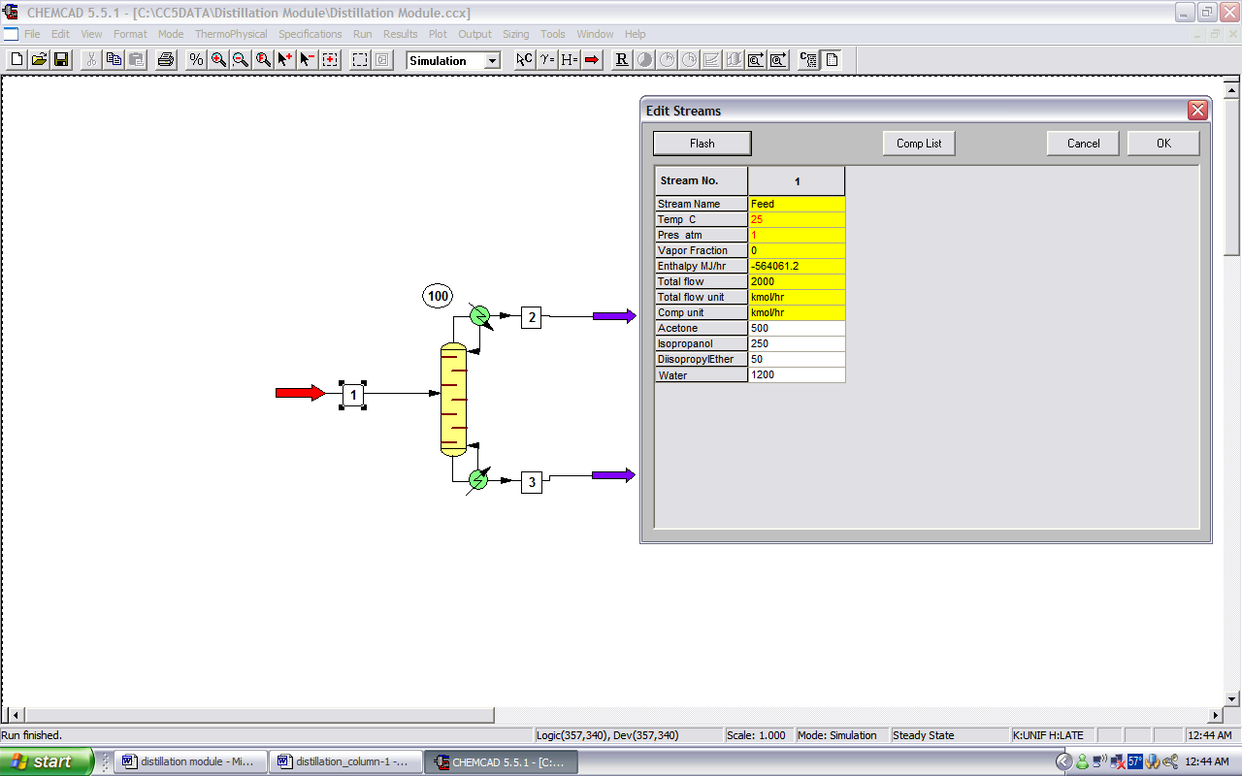

Step 4: Entering the SCDS Column specs

Double click on the SCDS Column.

1. General Tab:

- Enter the number of stages (30) and the feed stage for stream 1 (15). The other items on the left side of the screen can be ignored, but for future reference, can be entered when the information is available.
- On the right side of the screen, it is safe to assume Regular VLE Model for the application.
- NOTE: An important aspect of CHEMCAD columns is that CHEMCAD numbers the trays from top to bottom. So, Tray 1 is the condenser and Tray N (N=30 in this case) is the reboiler as far as CHEMCAD simulations are concerned.
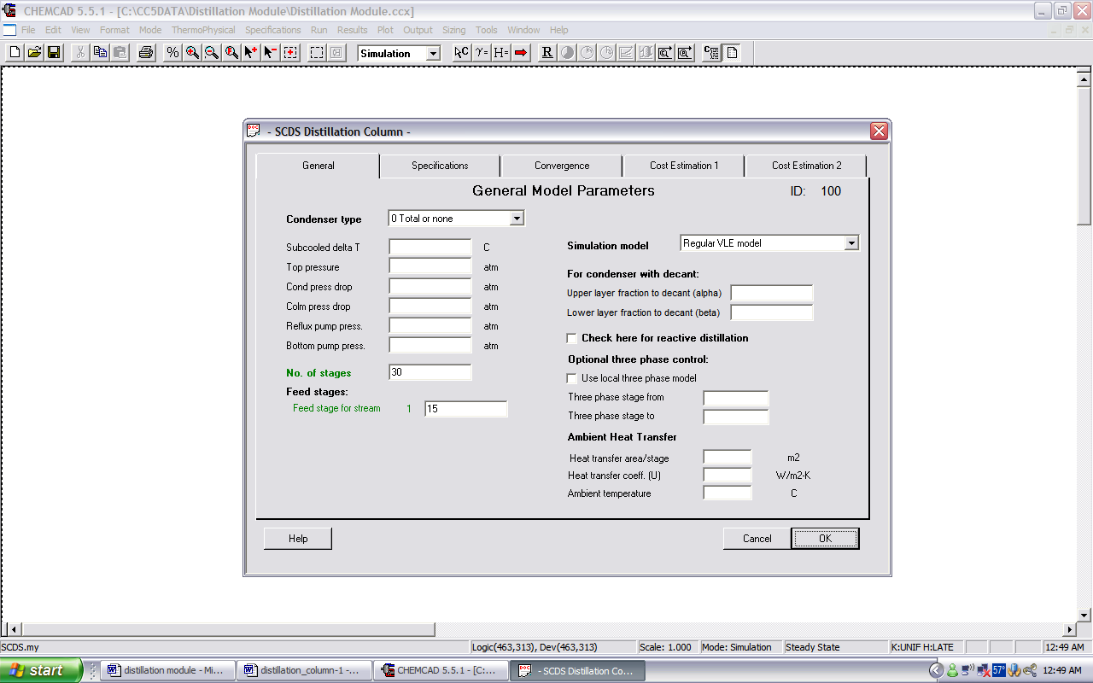

2. Specifications:

- For Condenser mode, click on the arrow next to “0 No Condenser.”
- Select “1 Reflux Ratio (R/D)” and enter the given reflux ratio from the problem statement (2.5).
- For Reboiler mode, click the arrow next to “0 No Reboiler.”
- Select “6 Bottom component mole fraction” and a desired mole fraction of isopropanol in the bottoms stream (0.99).
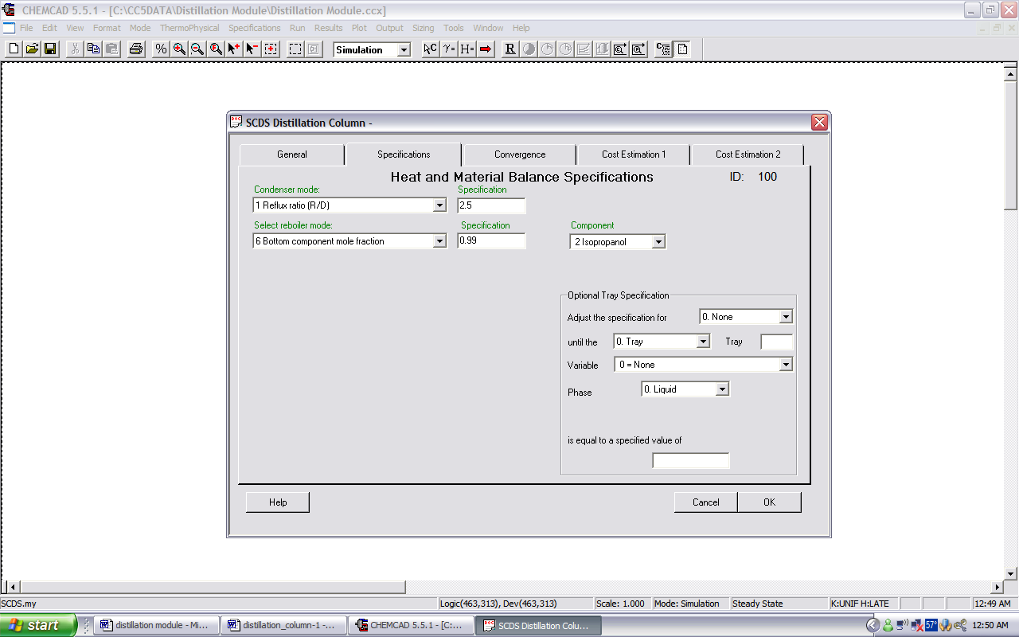

3. Convergence:
- Generally, these fields are left blank unless specific information is given.

4. Cost estimation 1 and Cost estimation 2
- If the project you are working on asks for cost estimates, it will be good to insert necessary information here to use as a comparison with CapCost.
- Otherwise, these tabs are generally left blank.

Click OK at the bottom of the window.
Another window will pop-up notifying you of warnings. These can be ignored.
If there are errors, do not ignore them. Go back to the SCDS Distillation parameters window and make sure that you have entered all the information correctly.
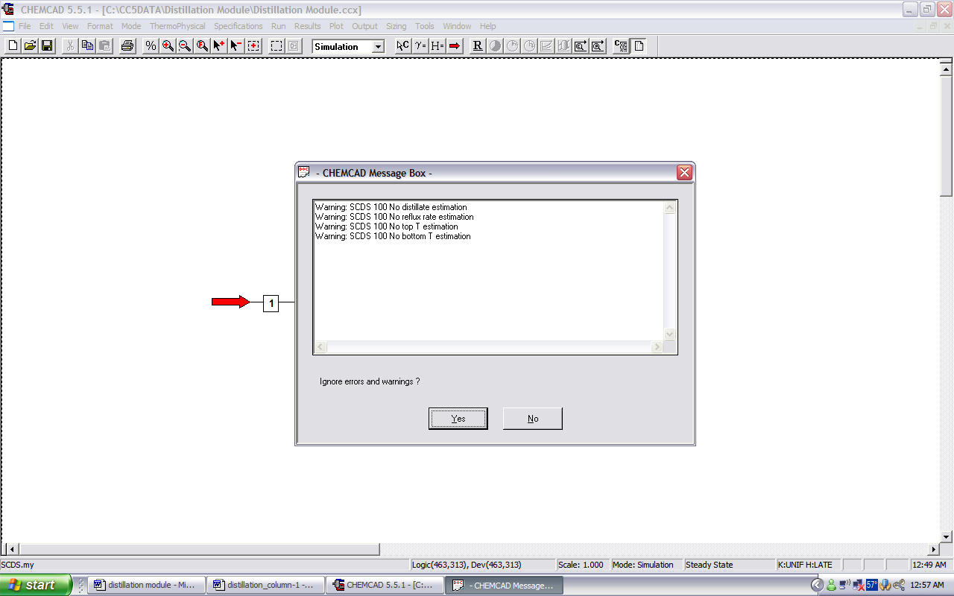

Step 5: Running the simulation and retrieving the results

- Run the simulation by clicking on R on the menu bar. Alternatively, one can run the simulation by clicking on Run on the menu bar and selecting Run all. The simulator indicates the same warnings regarding the estimates as before and one can ignore them again and continue with the simulation by clicking on Yes.
- A message window will pop-up indicating that the column did not converge. This means that CHEMCAD was not able to complete the necessary iterations given the specifications for this column.
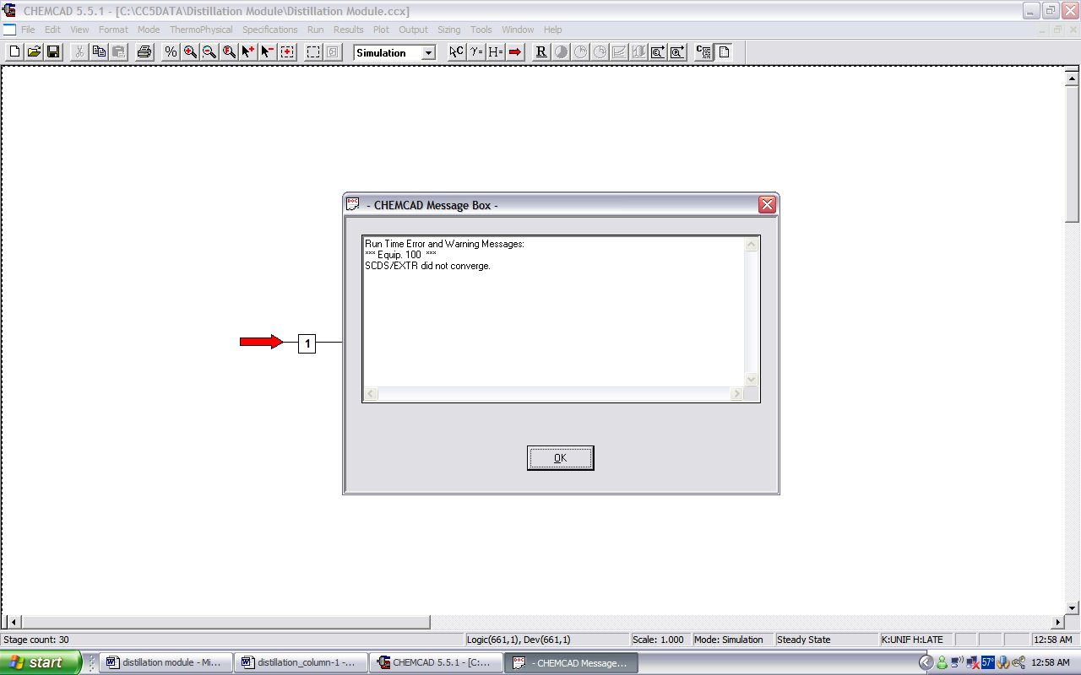

We will now explore ways to fix such errors.
Solution 1: Change the Reboiler Mode.
- Double-click on the SCDS Column.
- Click on the Specifications Tab.
- Change mode to “Bottom component Mole fraction.”
- Type 0.70 as the specification.
- Choose Isopropanol as the component.
- Click OK at the bottom of the screen.
- Run the simulation by clicking on R on the menu bar.
- A message at the bottom of the screen will say “Run Finished.”
- To retrieve the results, press “Alt+U+S+A” on the keyboard. A window will show the results.
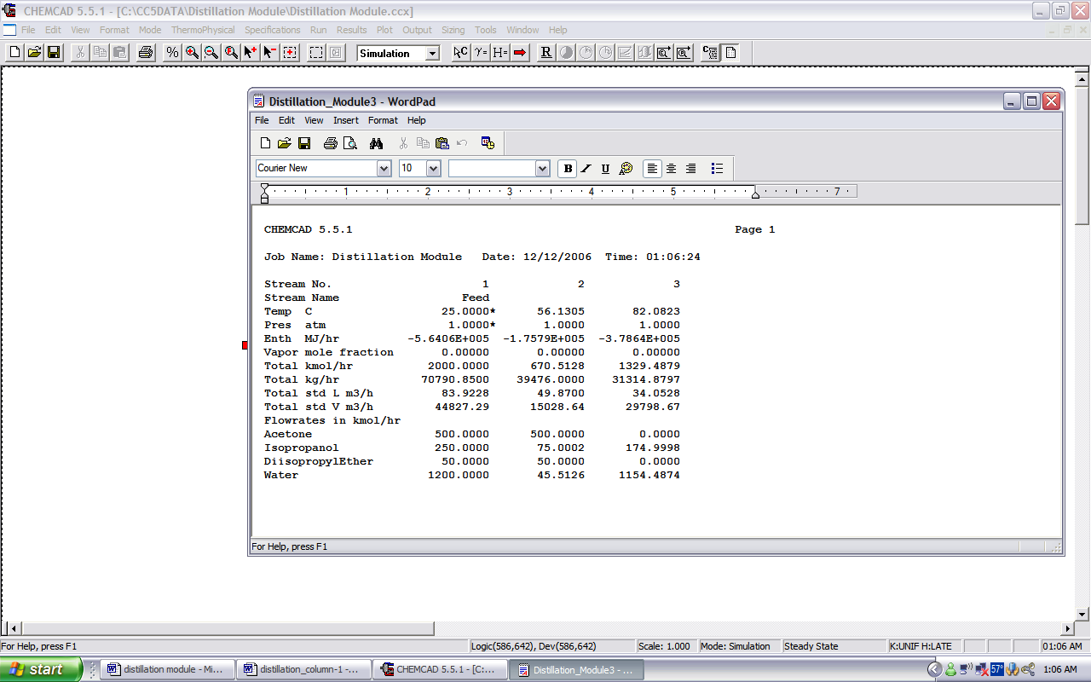

Even though the simulation ran successfully, the separation is poor. There are 75 kmol/hr in the distillate stream. Another change must be made.

Solution 2: Use Shortcut Column to determine specifications.

Using a shortcut column first is a good way to get a rough estimate of the specifications needed to obtain the desired results. Refer to the CHEMCAD Module on Shortcut Column to learn how to simulate using this unit operation. Use a Reflux Ratio of 2.5, a light key split of 0.99 for acetone, heavy key split of 0.01 for isopropanol.

- After running the simulation, double click on the column again.
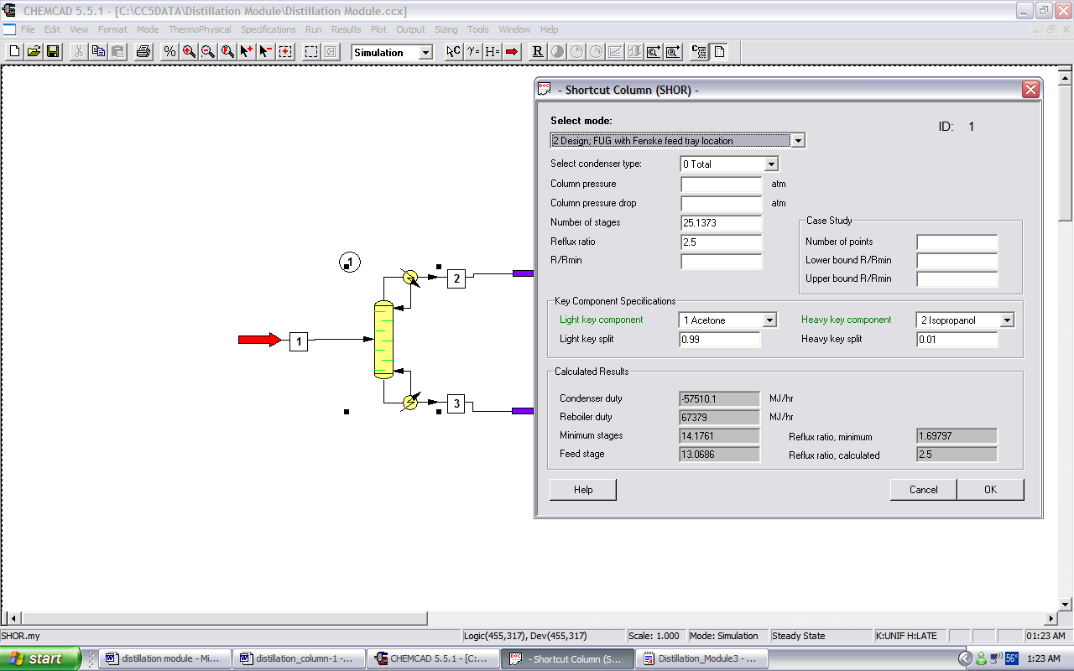
- Write down the parameters for number of stages, feed stage, reboiler duty, and feed stage.
- On the Menu, change to “Flowsheet” mode.
- Using the mouse, draw a box around the column only.
- Press delete on the keyboard.
- Insert the SCDS column in its place and connect the streams.
- Change to “Simulation” Mode.
- Double-click on the column.
- In the General tab, insert the number of stages and the feed stage.
- In the Specifications tab, insert the reflux ratio as 2.5 in “Condenser Mode” and the reboiler duty in the “Reboiler Mode.”
- Click OK.
- Click Yes on the CHEMCAD Message Box to ignore the warnings.
- Run the simulation by clicking on R on the menu bar.
- Retrieve the results by pressing “Alt+U+S+A” on the keyboard.
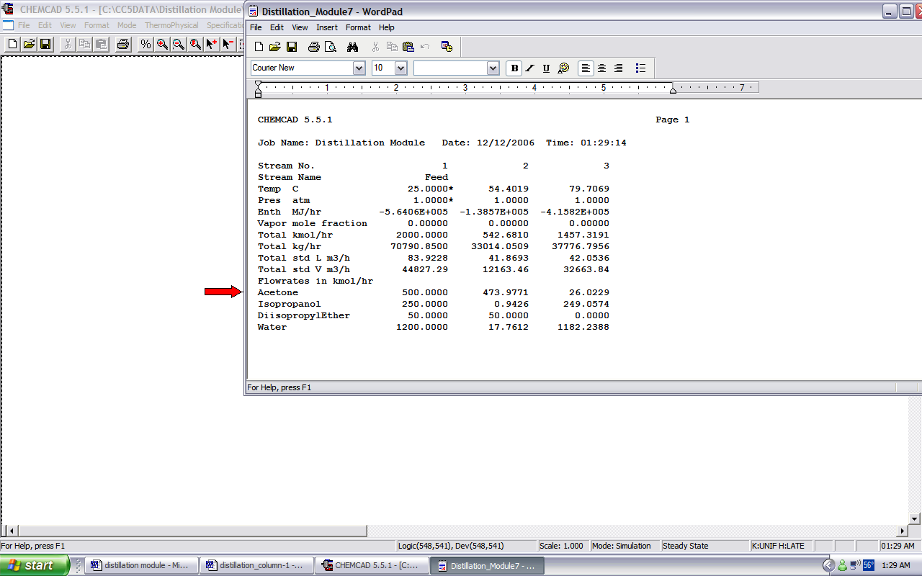

These results are satisfactory since only a small amount of isopropanol is in the distillate stream.

Final Notes:
The purpose of this module was to illustrate some of the types of errors that may be encountered when using a distillation column in CHEMCAD. There are many traps that a user could easily fall into. The key is to play around with the specifications and to use common sense (e.g. a column can’t feasibly be a mile long).

Another way this simulation could be altered is to decrease the amount of water in the feed. The user is left to find the optimum conditions for this situation.

