DISTILLATION COLUMN

Problem Statement:

A 100 kmol/hr stream of ethanol (50 mol%) and n-propanol (50 mol%) is fed to a continuous distillation column at room temperature (298 K) and atmospheric pressure. The column has 20 trays (including reboiler and condenser) and the feed enters at the 10th tray. A reflux ratio of 1.5 is used for the column and a bottom stream with 93% n-propanol is desired.

Set up a distillation column simulation using SCDS in CHEMCAD and report the final distillate and bottom stream concentrations and the reboiler and condenser heat duties.

Procedure:

Step 1: Creating the flow sheet
Step 2: Entering the components and engineering units
Step 3: Entering the composition of feed stream
Step 4: Entering the SCDS column specs
Step 5: Running the simulation and retrieving the results

Step 1: Creating the flow sheet

Go to new on the File menu and save the blank simulation. Click on SCDS Column on the CHEMCAD palette and click once on simulation window to paste it. Click on the feed icon on the palette and paste it on the workspace. Similarly, click on the product icon and place it on the workspace (do the product twice as there are two product streams). After making sure that all the necessary icons are placed on the workspace, they can be connected by using stream. CHEMCAD automatically assigns numbers to streams and unit operations the order in which they are placed on the workspace. After completing the flow sheet, click once in the S/G icon found on the menu bar so that the simulation is changed from edit mode to run mode. The same icon can be used to toggle between these two simulation modes. Alternatively, one can toggle between Edit Flowsheet and Run Simulation on the menu bar to achieve the same.

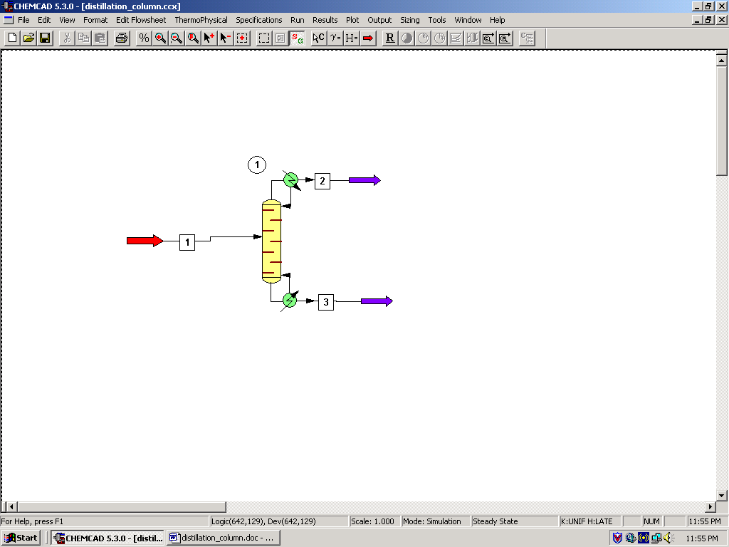

Step 2: Entering the components and engineering units

Go to the Thermophysical on the menu bar and click on Components List. Find ethanol and n-propanol from the CHEMCAD components list and add them to the component list. Go to the Format menu and click on Engineering Units and select the desired units for such properties as temperature, pressure etc. Click OK to continue.

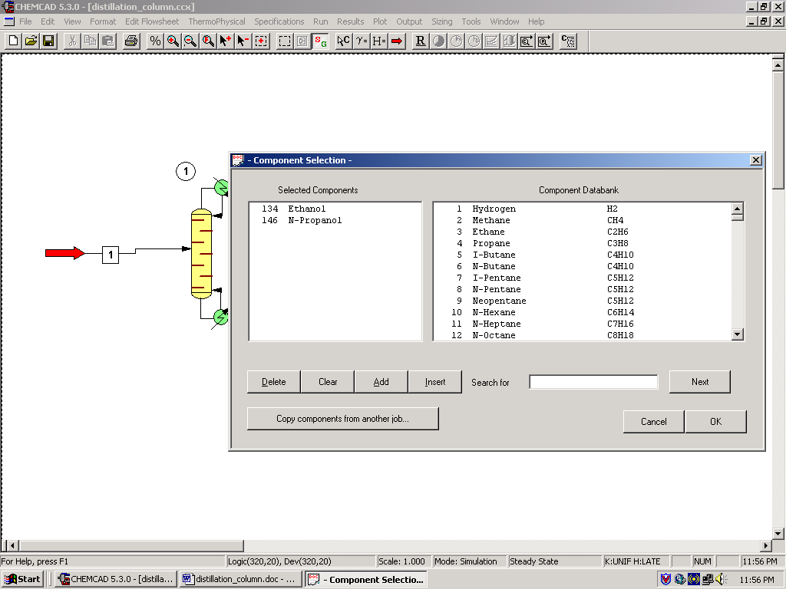

Step 3: Entering the composition of feed stream

Double click on the feed stream and enter the feed information (temperature, pressure, total flow rate and component mole fractions) given in the problem statement. Click once on Flash to get the feed stream enthalpy and vapor fraction in feed at the feed conditions.

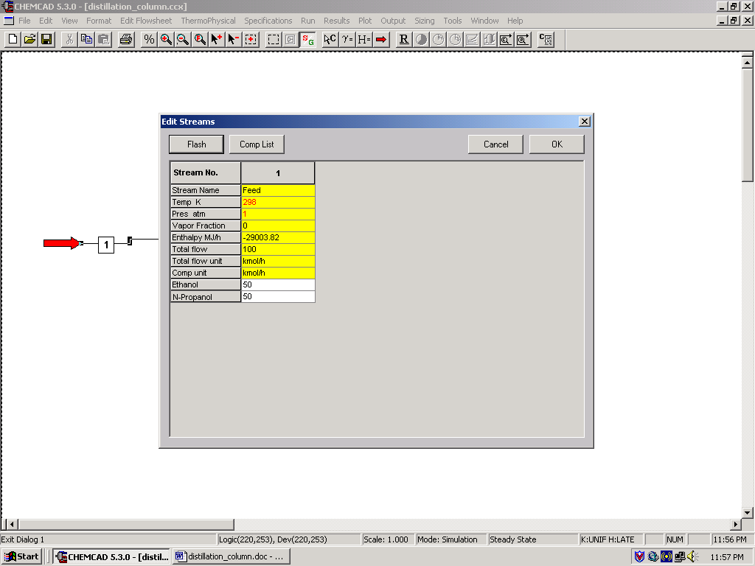

Step 4: Entering the SCDS Column specs

Double click on the SCDS Column.

1. General:

The only information available to us that could be filled in this window is the number of stages (20) and feed stage for stream 1 (10th tray). These are the only two required areas in this window. The other information such as Subcooled delta T, Top pressure, Cond Press drop, Colm press drop, Reflux pump press, Bottom pump press are all optional and one can enter values for these parameters when available. An important aspect of CHEMCAD columns is that CHEMCAD numbers the trays from top to bottom. So, tray-1 is the condenser and tray N (N=20 in this case) is the reboiler as far as CHEMCAD simulations are concerned.

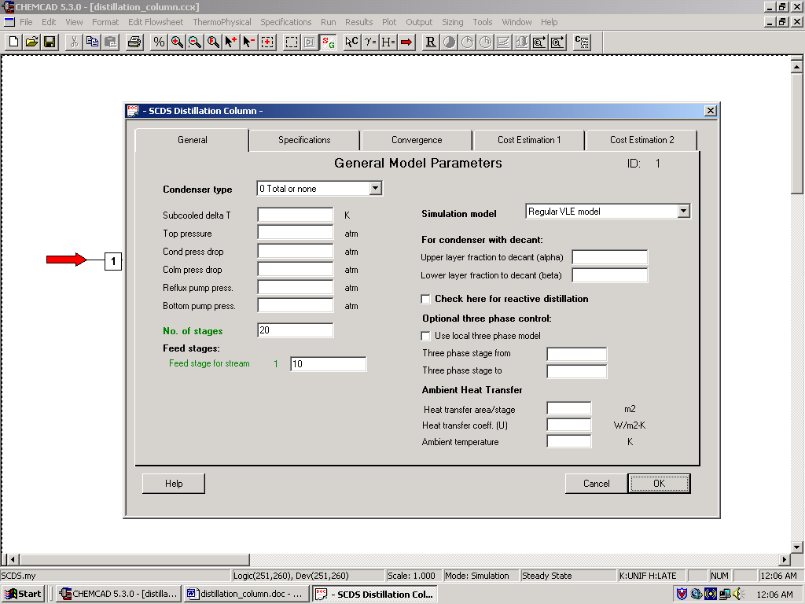

Wait before you click OK!! There are more specs to fill out in this window!!!

2. Specifications:

It is necessary to give the simulator two specifications, one for Condenser mode and the other for Reboiler mode in order for it to run. There are several options available to choose from in the specifications of each of these modes, depending on the nature of the problem. (One can drop the arrow that is located on both these fields to get familiar with all the options available) The two specifications given in the problem statement are as follows:

- Reflux ratio of 1.5, which corresponds to the Condenser mode
- Bottom stream n-propanol composition of 93 mol%, which corresponds to the Reboiler mode.

Select option ‘1’ (Reflux ratio (R/D) for Condenser mode and enter the value ‘1.5’ in the box provided for Specification. Similarly, Select option ‘6’ (Bottom component mole fraction) for Reboiler mode, enter the value ‘0.93’ in the box provided for Specification, and then choose n-propanol for Component.

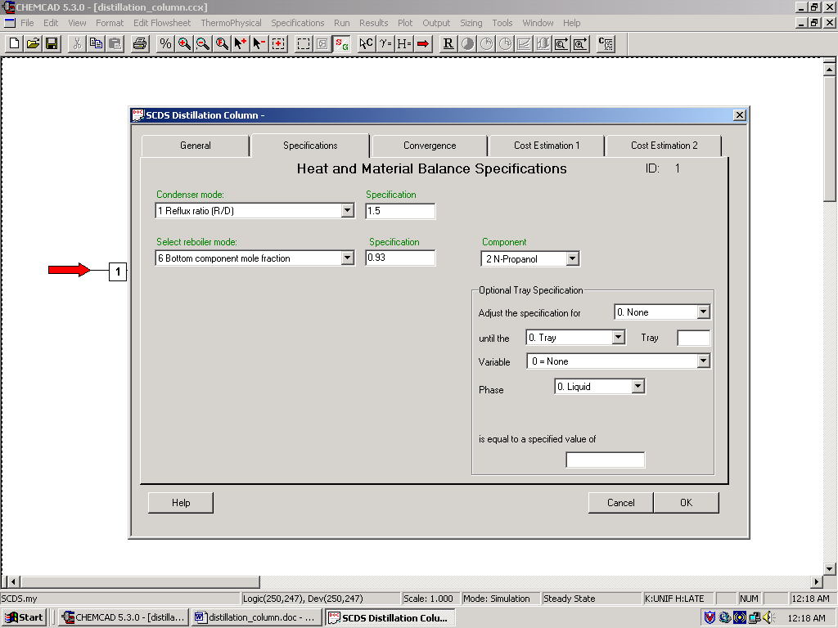

3. Convergence:
In the cases where good estimates (e.g. previously determined values) for various parameters such as Distillate rate and Reflux rate, the estimates can be made known to the simulator in this Convergence tab. Good estimates for various parameters can make the simulation converge faster and even give more accurate results. However it is better to give no estimates rather than giving inaccurate estimates. As our problem statement does not mention anything about estimated parameters, these fields can well be left blank.

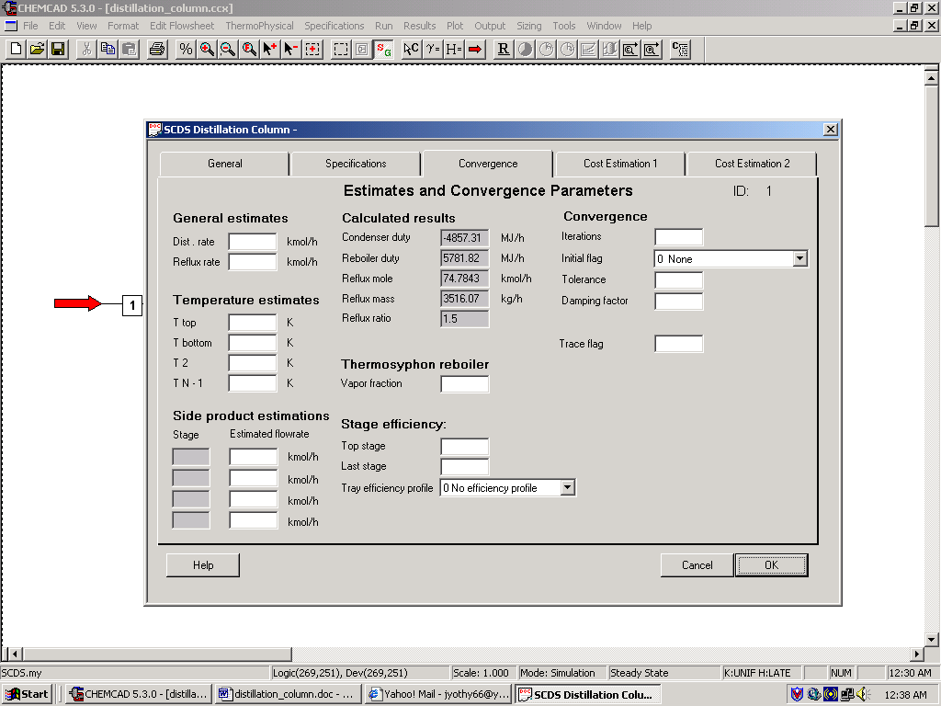

4. Cost estimation 1 and 5. Cost estimation 2

These two tabs, as the names indicate, are used for cost estimation and are not needed for the purpose of this simulation and hence can be left blank.

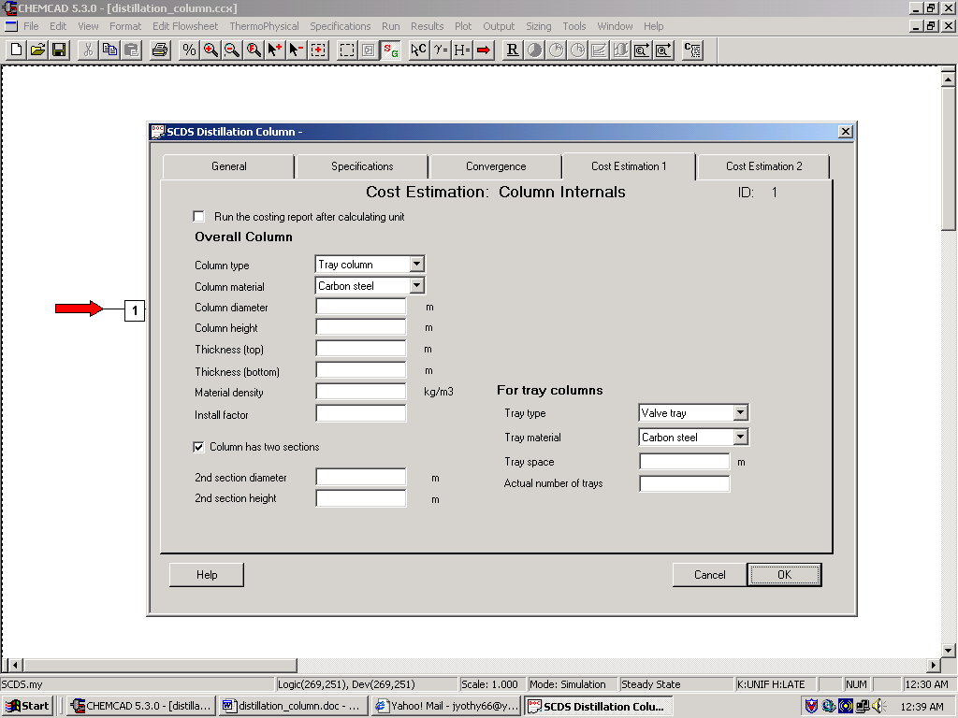

Click OK to continue. As the values for estimated parameters are not entered under Convergence tab, CHEMCAD indicates some warnings.

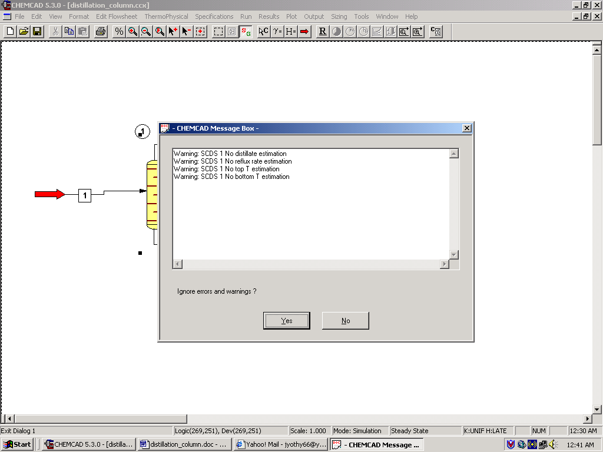

These can be safely ignored for our purpose without any loss of accuracy by clicking on Yes.

Step 5: Running the simulation and retrieving the results

After entering the available information on the workspace as described in the previous steps, one can run the simulation by clicking on R on the menu bar. Alternatively, one can run the simulation by clicking on Run on the menu bar and selecting Run all. The simulator indicates the same warnings regarding the estimates as before and one can ignore them again and continue with the simulation by clicking on Yes. The status of the simulation can be found at the bottom left hand corner of the screen. The message, Run Finished appears in this place if the run is successfully completed. To view the product stream compositions, one can either double click on the individual product streams or by clicking Results on the menu bar and selecting Stream Compositions and further selecting All Streams. The results obtained from the latter method will be in a WordPad file.

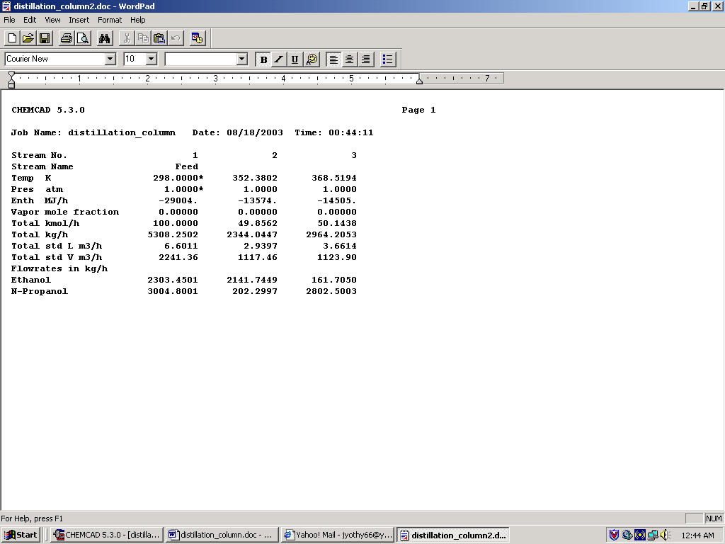

All the results associated with the SCDS column can be found by clicking on Results menu and selecting Unit Op’s and then the SCDS Column. The results will then be available in a WordPad file.

