Flash Calculations

Problem Statement:

A 1 kmol/hr stream of benzene (40 mol%), toluene (30 mol%), and O-xylene (30 mol%) enters a flash unit at 373 K and 1 atm.

Answer the following using CHEMCAD simulations.

- The flash unit operates at 385 K and 1 atm. What is the composition of liquid and vapor streams exiting the flash unit?
- The flash unit operates at 385 K and it is desired to have a vapor fraction of 40%. What is the pressure at which the flash unit operates and what is the composition of the liquid and vapor streams exiting the flash unit?
- The flash unit operates at 1 atm and it is desired to have a vapor fraction of 30%. What is the temperature at which the flash unit operates and what is the composition of the liquid and vapor streams exiting the flash unit?
- The flash unit operates at 1 atm and it is desired that the split fraction of toluene in the liquid phase to be 0.65. Compute the temperature at which the flash unit operates and the composition of the liquid and vapor streams exiting the flash unit?

Procedure:

Step 1: Creating the flow sheet
Step 2: Entering the components and formatting engineering units
Step 3: Entering the feed stream composition
Step 4: Entering the flash unit specs
Step 5: Running the simulation and retrieving the results

Step 1: Creating the flow sheet

Select and click the Flash, feed and product (twice) icons on the workspace. Connect the three using the stream. Click once on the S/G icon on the menu bar to switch the simulation mode from Edit Simulation to Run Simulation.

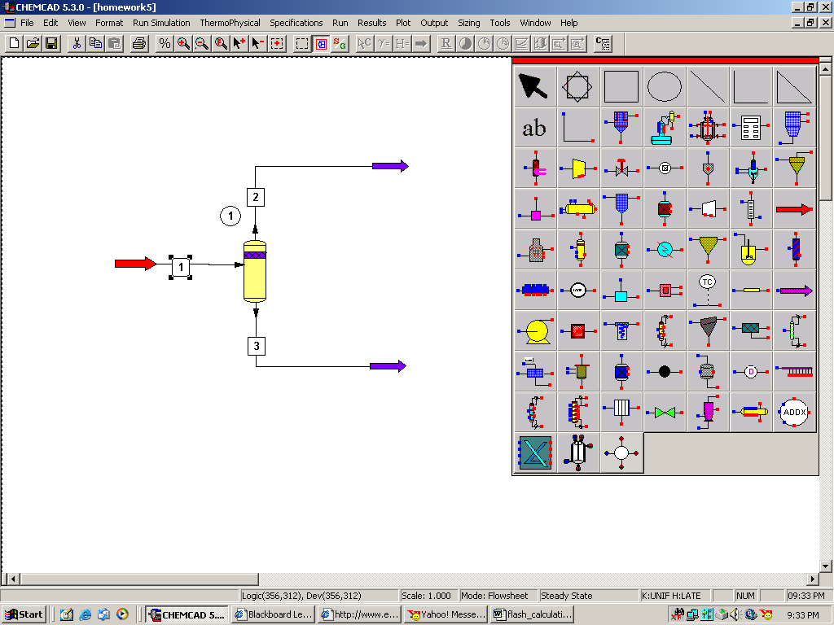

Step 2: Entering the components and formatting engineering units

Go to the Thermophysical on the menu bar and click on Components List. Find benzene, toluene and O-xylene from the CHEMCAD components list and add them to the component list. Go to the Format menu and click on Engineering Units and select the desired units for such properties as temperature, pressure etc. Use SI option to convert all units at the same time. Click OK to continue.

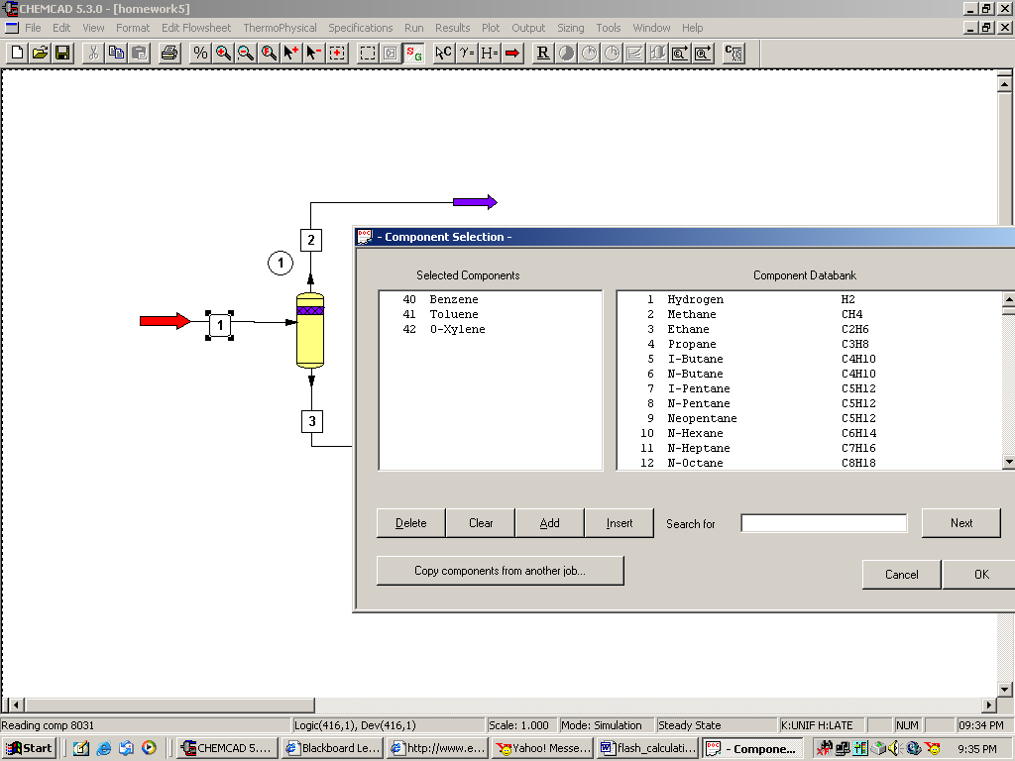

Step 3: Entering the feed stream composition

Double click on the feed stream and enter the feed information (temperature, pressure, total flow rate and component mole fractions) given in the problem statement. Click once on Flash to get the feed stream enthalpy and vapor fraction in feed at the feed conditions.

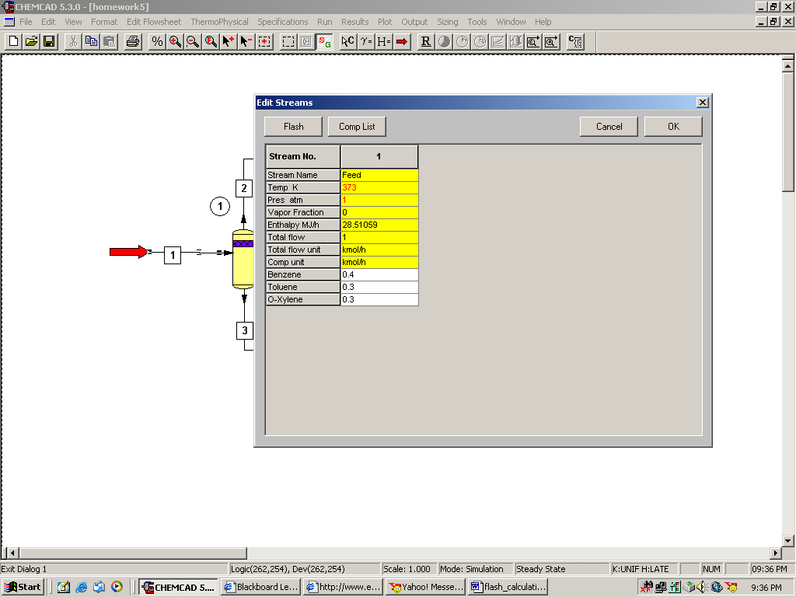

Step 4: Entering the flash unit specs

Double click on the reactor.

Question 1:
Select option 2 (Specify T & P; Calculate V/F and Heat) and enter the temperature (385 K) and pressure (1 atm) as given in problem statement.

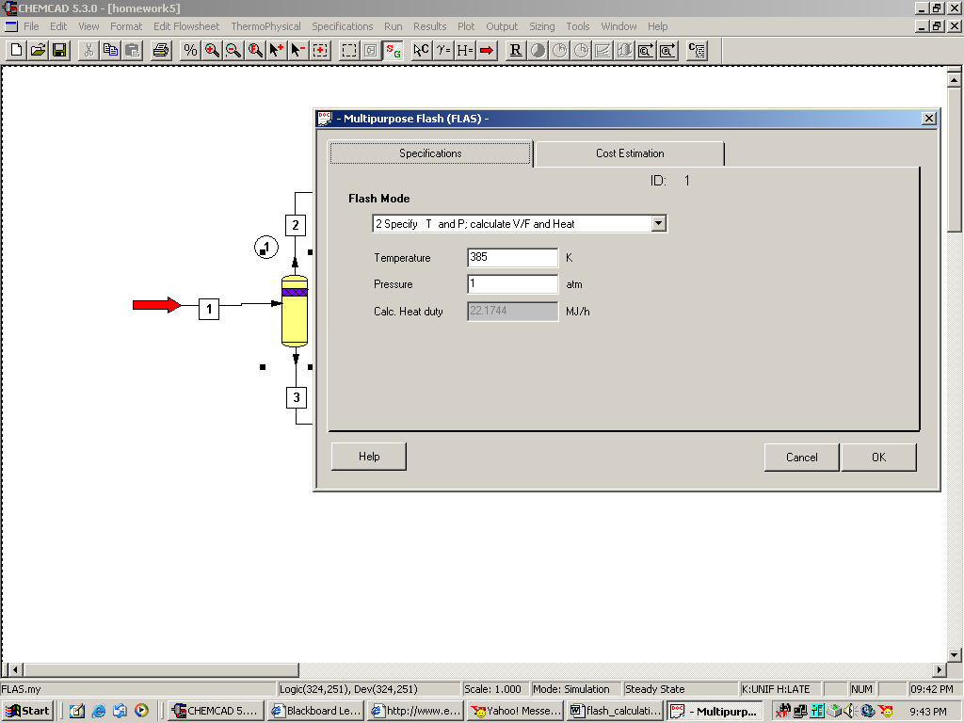

Click OK to continue, go to step 5.

Question 2:
Select option 4 (Specify V/F & T; Calculate P and Heat) and enter the vapor fraction (0.4) and temperature (385 K) as given in problem statement.

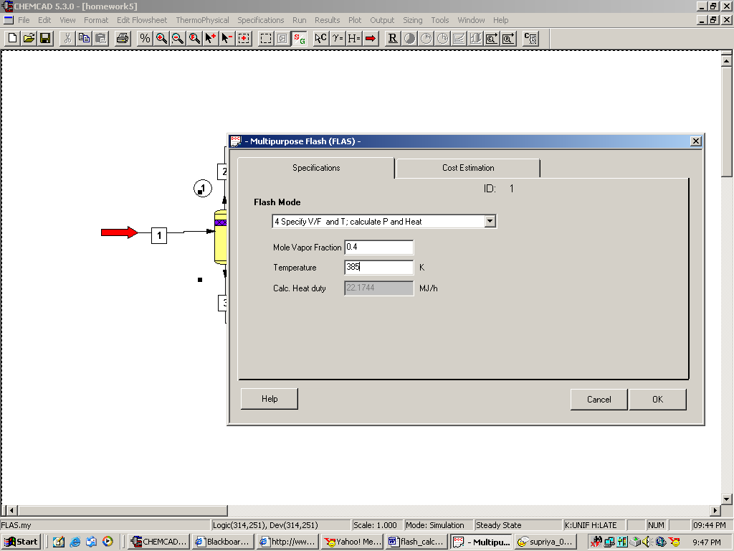

Click OK to continue, go to step 5.

Question 3:
Select option 1 (Specify V/F & P; Calculate T and Heat) and enter the vapor fraction (0.3) and pressure (1 atm) as given in problem statement.

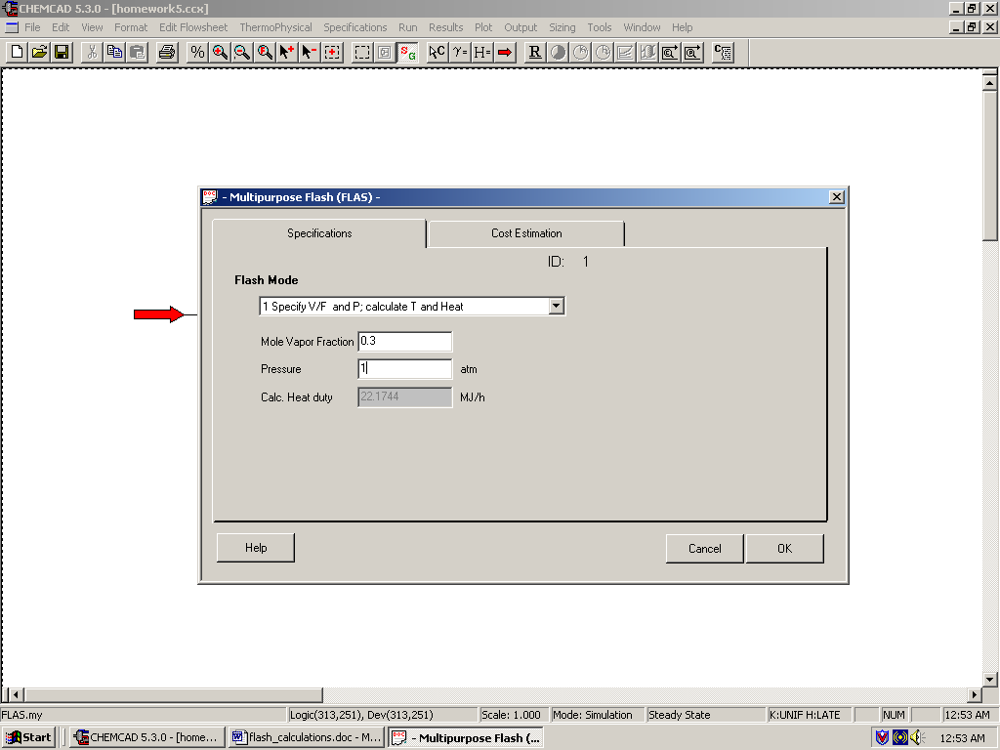

Click OK to continue, go to step 5.

Question 4:
Select option 2 (Specify T & P; Calculate V/F and Heat) and enter the pressure (1 atm) and leave the temperature space blank.

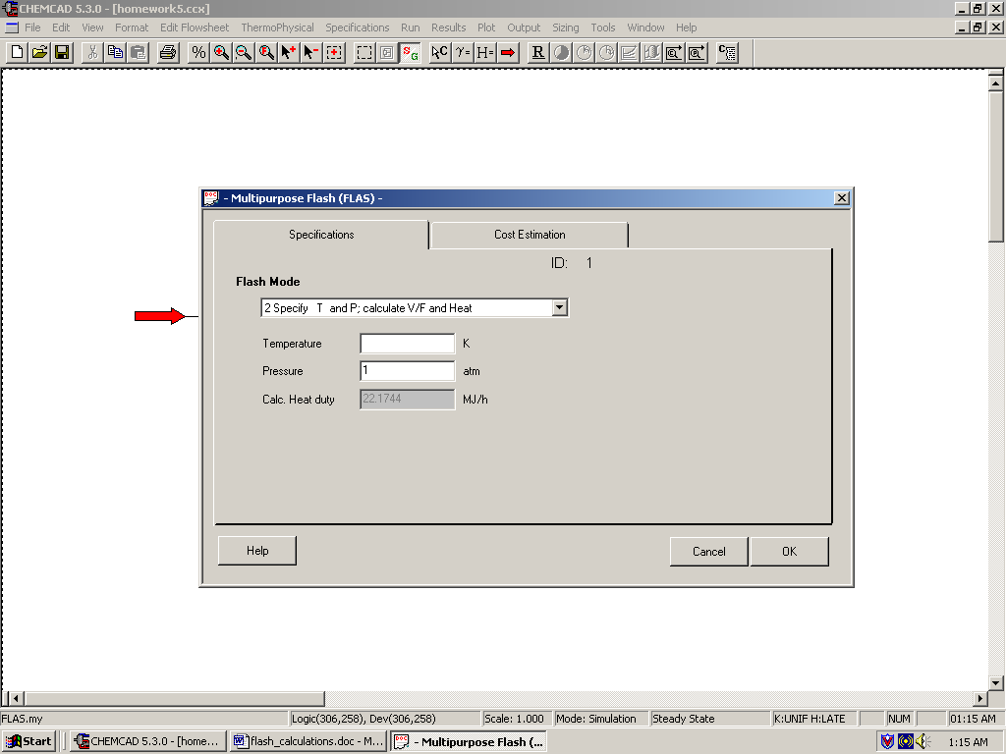

Click OK to continue.

We need to find the temperature at which the liquid stream coming from the bottom of the flash unit contains 65% of the toluene in feed. The feed has 0.3 kmol/hr of toluene.

So, the amount of toluene that must be present in liquid stream= 0.3*0.65
= 0.195 kmol/hr

In order to find out the temperature of the flash column at which the liquid product stream has 0.195 kmol/hr of toluene, we can make use of the sensitivity study option available in CHEMCAD and plot the flash column temperature versus the mole rate of toluene in the liquid stream. We can then read the plot to find out the required temperature.

Go to Run menu and select Sensitivity Study
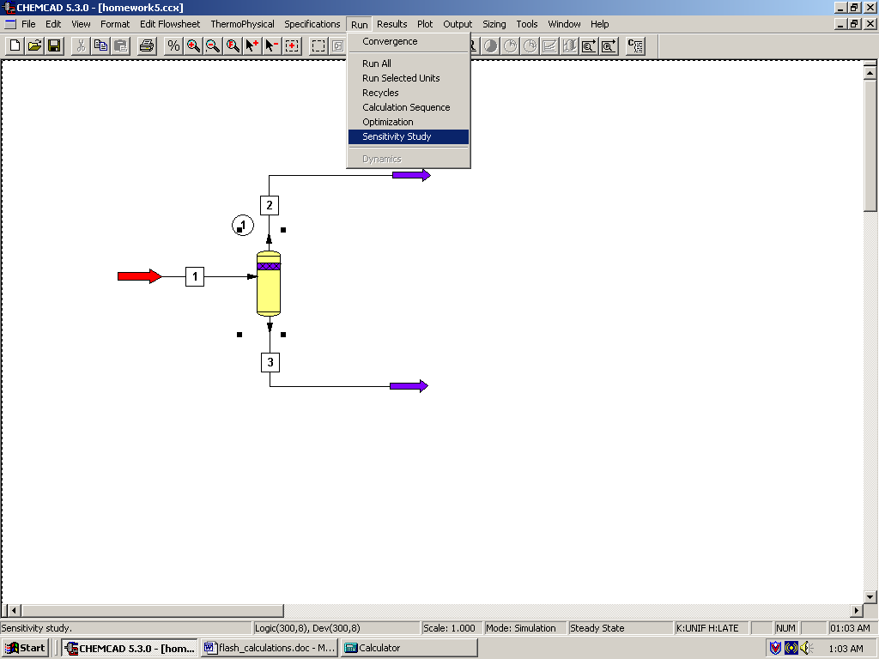

The following window appears.
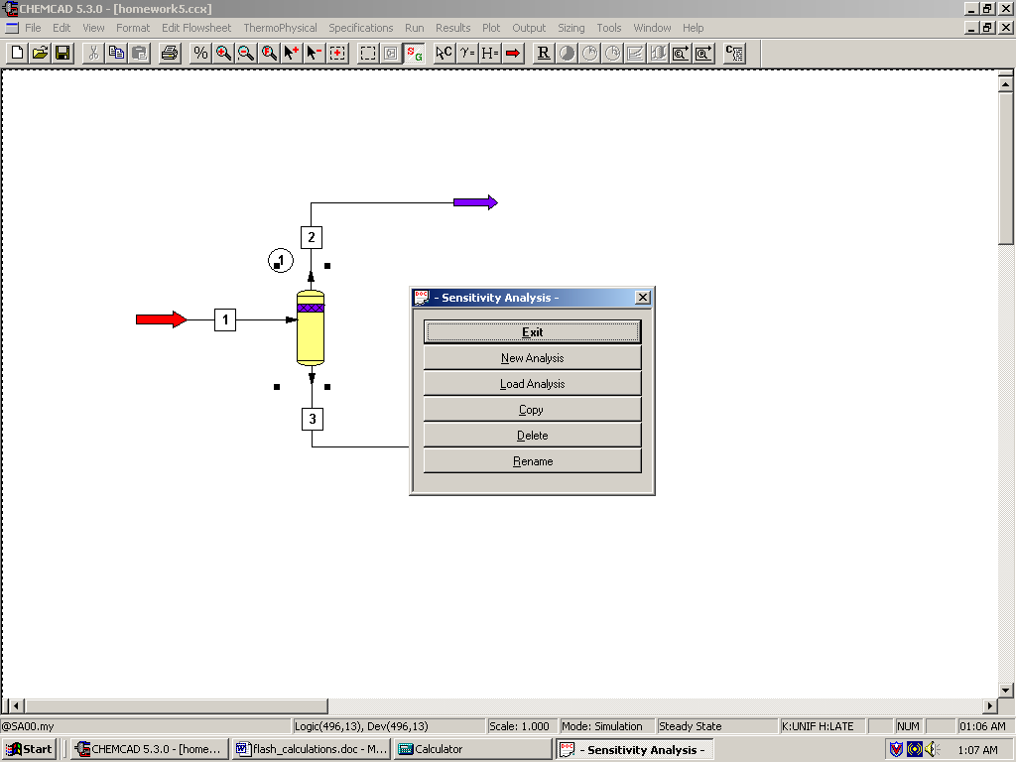
Click on New Analysis and give a name to the analysis. The following window appears.

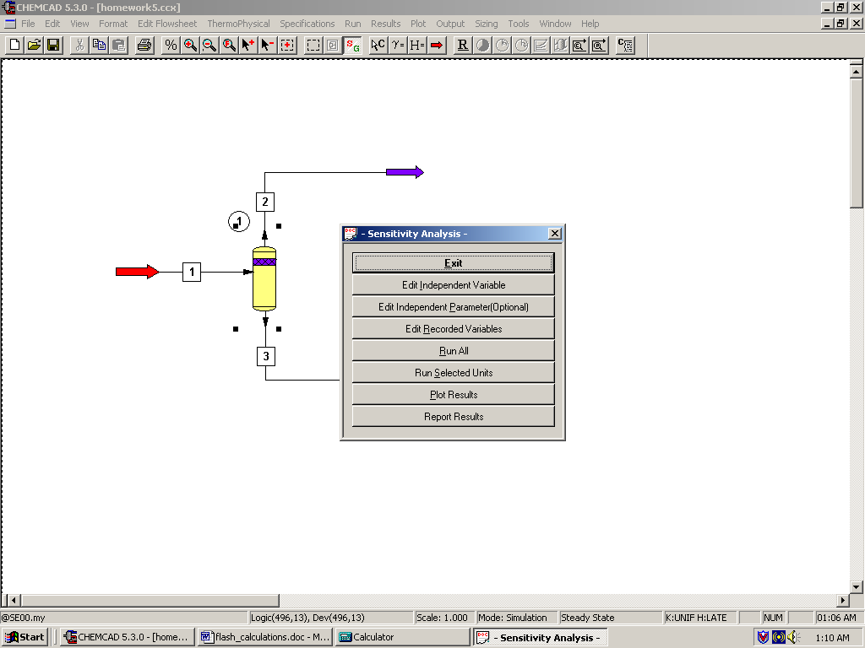

Click on Edit Independent Variable.

Independent Variable:
We have to choose flash column temperature as the independent variable.

Type: select the radio button Equipment
ID: Enter the ID number corresponding to the flash unit (‘1’ in this case)
Variable: Select “Param 1”. This corresponds to the first parameter (flash unit temperature) that we left blank in the specifications page of flash unit.
Variable Name: Type “Temperature of the flash unit” in this box
Variable Units: Select option 2, Temperature.
In the next couple of blocks, we need to specify CHEMCAD a range of values for temperature to be plotted. As the feed enters the flash unit at 373 K, the flash unit temperature will most certainly be more than 373 K.

So, intuitively, we can Vary this variable from 375 to 425 in 100 equal steps. Please keep in mind that the greater the number of steps we specify to CHEMCAD, the longer it takes for the sensitivity study to complete.

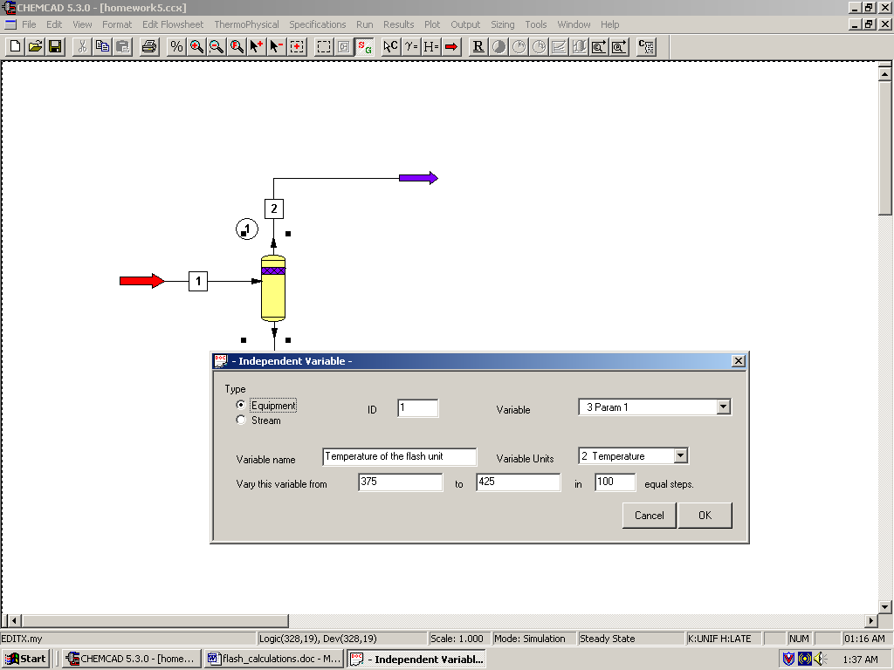

Click on OK to continue.

Now, click on Edit Recorded Variables. Here we need to specify to CHEMCAD that we want the toluene mole rate in the liquid stream calculated for each value of temperature within the range given in the Independent Variable page.

Select Stream radio button corresponding to Type under Dependent Variable 1. Enter ‘3’ for the ID number. This number corresponds to the liquid stream coming out of the flash unit in your flow sheet. Select Component mole rate for Variable. Select Toluene for Comp and select Mole rate for Variable units. Give a name for this dependent variable (“Toluene mole rate in liquid stream” in this case).

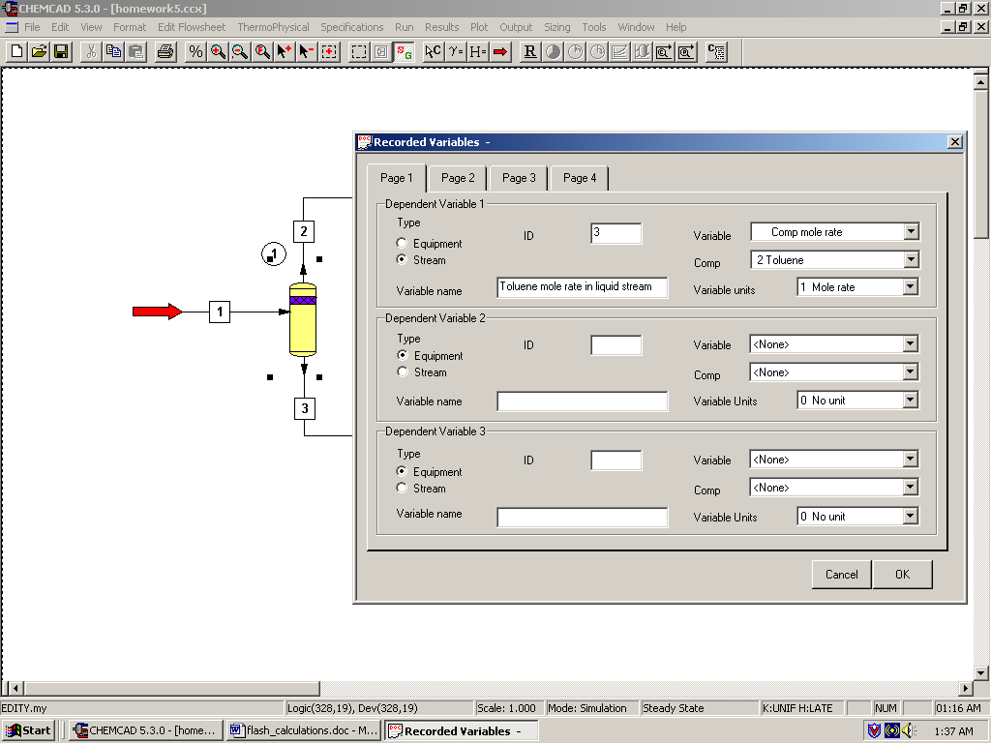

Click OK to continue.
Click on Run all to run the sensitivity study for the temperature range given in the specification. The following window appears again after the run is complete.

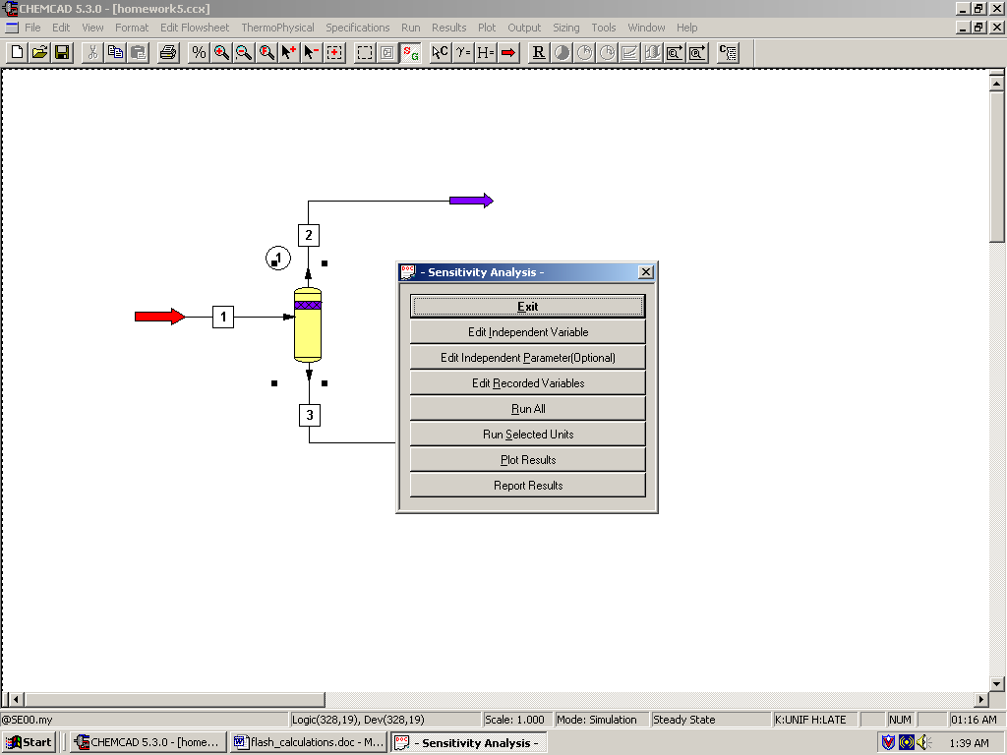
Click on Plot Results.

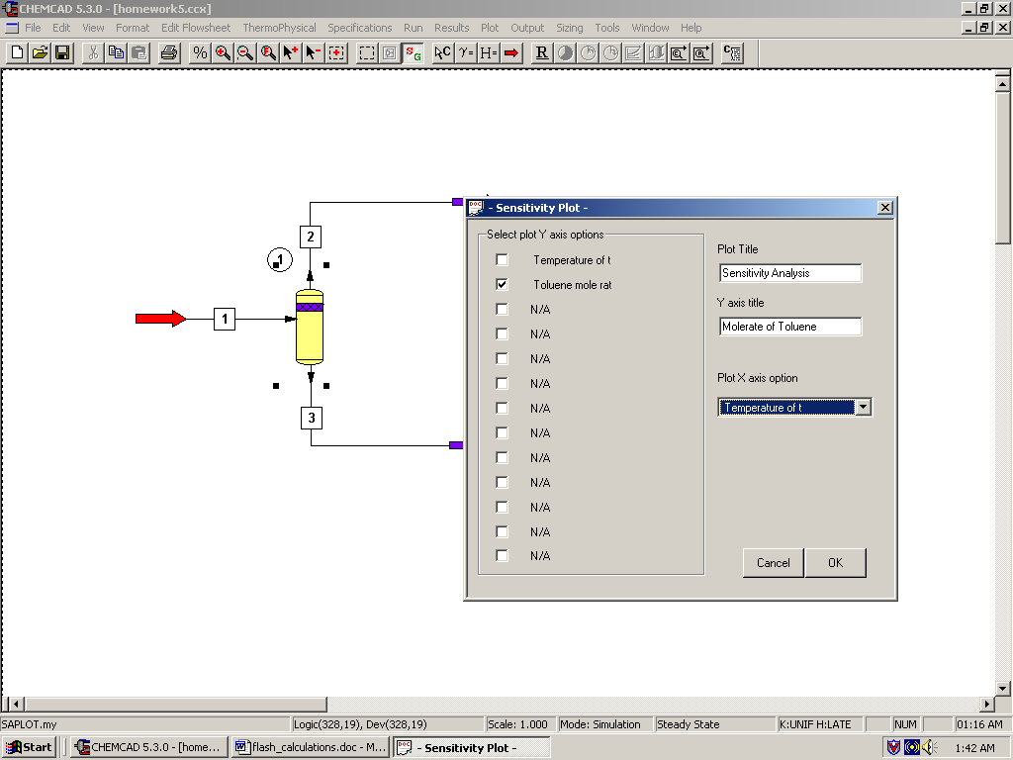

In the window that appears, select mole rate of toluene as the variable to be plotted on y-axis (default option). Give a label to y-axis under Y axis title. Click on OK to continue.

The results are displayed as a graph as well as in a WordPad file.

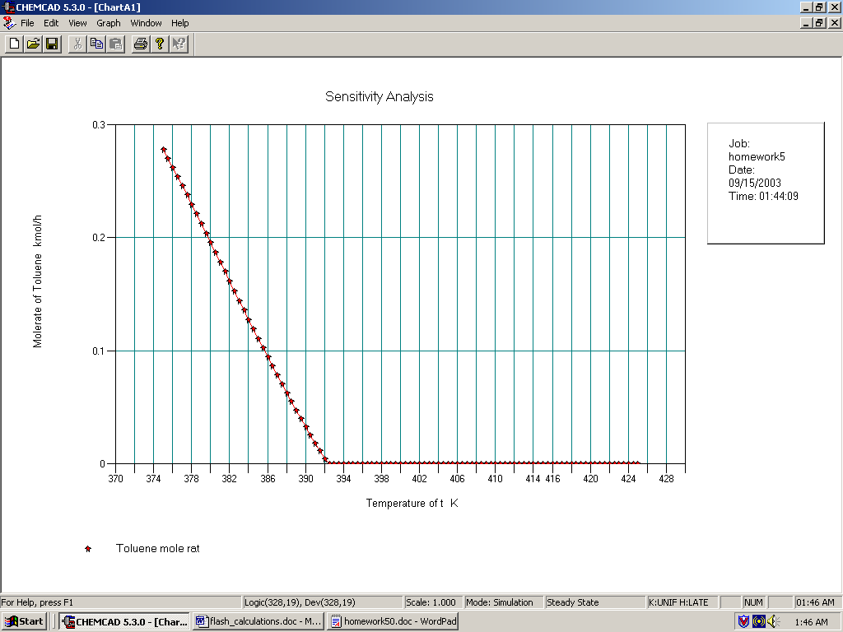

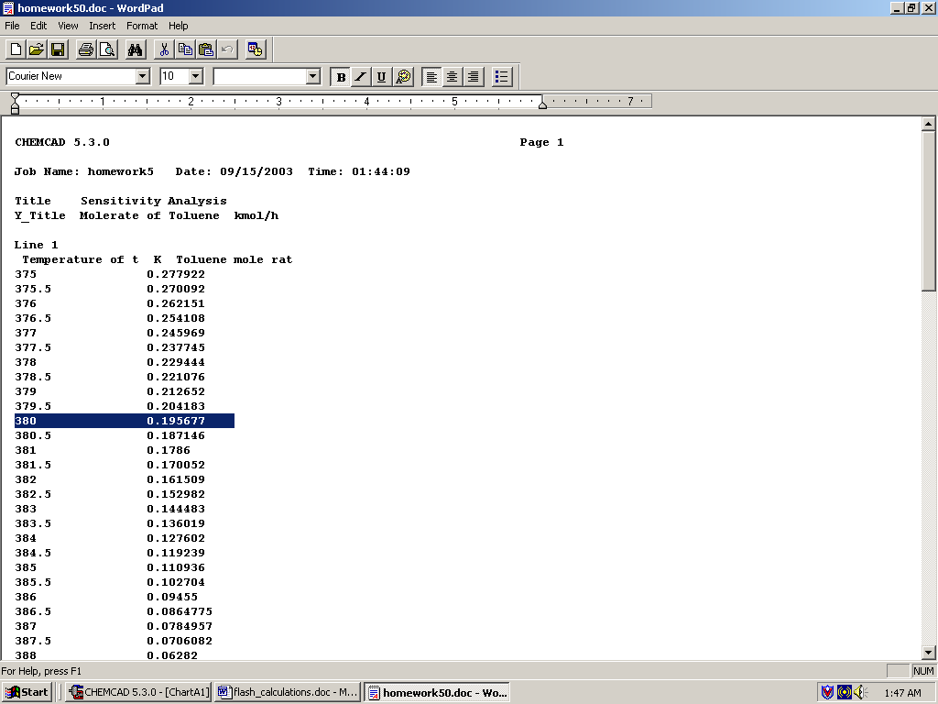

We can look up the temperature corresponding to a toluene flow rate in liquid stream of 0.195 kmol/hr to be approximately 380 K.
Step 5: Running the simulation and retrieving the results:

Click on R to run the simulation. For question 4, after completing step 4, double click on the flash unit and enter the temperature as 380 K (as obtained from step 4).

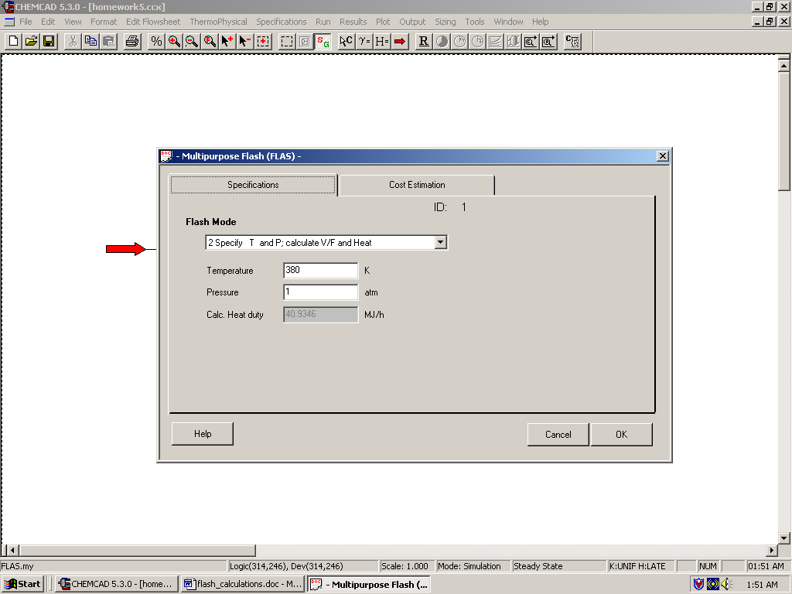

Click OK and then click on R to run the simulation. The product stream properties can found either by clicking once on the product streams or by clicking once on Results on the menu, selecting Stream Composition and then clicking on All Streams. The results will again be available in a WordPad file. Similarly the flash unit results can be obtained by clicking once on Results on the menu, selecting Unit Op’s and then selecting the flash unit.

The following results are obtained for question 4.

