FLOW SHEET

Problem Statement:
A stream containing a mixture of several organic compounds is sent to a Divider. The Divider has three product streams. The first product stream is sent to a continuous distillation column with top and bottom products after pumping. The second product stream from the divider is sent to a Gibbs reactor with one product stream. The third product stream from the divider is sent to a tank through a pipe. The outlet streams from the distillation column, reactor and the tank are the final products of this phase of the process.

Draw a flowsheet in CHEMCAD corresponding to this process. Use SCDS column for distillation column. Label each unit operation on the flow sheet.

Procedure:
Step1: Creating a new job in CHEMCAD
Step 2: Collecting all the icons in the workspace
Step 3: Connecting the icons with stream
Step 4: Labeling the flowsheet

Step1: Creating a new job in CHEMCAD
Open CHEMCAD and save a new job in a desired folder.
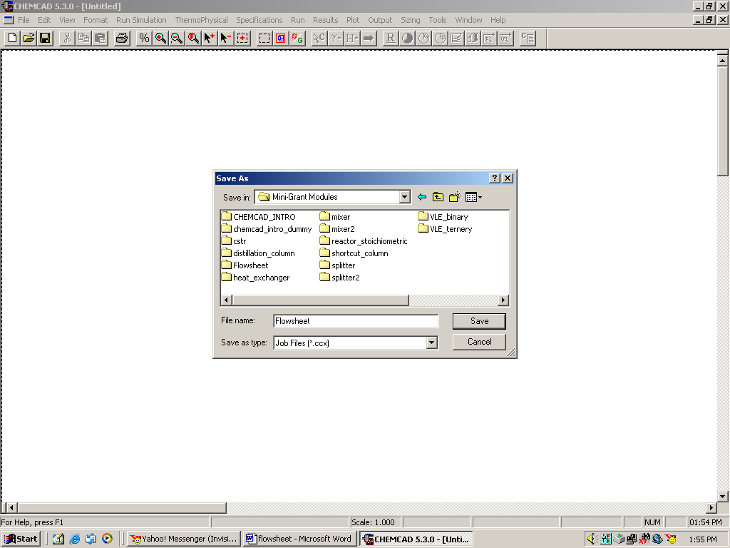
Step 2: Collecting all the icons in the workspace
All the icons starting from Baghouse filter (found in the second row and third column) are arranged in alphabetical order. The following icons are needed for our flowsheet:

- Feed icon (for Divider)
- Divider
- Pump
- SCDS Column
- Product (two, for SCDS)
- Gibbs reactor
- Product (one, for Gibbs reactor)
- Pipe simulator
- Tank
- Product (one, for Tank)

To place an icon in the workspace, click once on that icon in the palette, and when the cursor becomes a tiny square, click it once on the workspace to paste that icon. Select and place all these icons in the workspace.

Feed: This is located in the 4th row and 7th column on the palette.

Divider: This is located in the 4th row and 1st column on the palette. In order to find a divider with one feed stream and three product streams, right click on the Divider icon on the palette, and click on Divider#5.

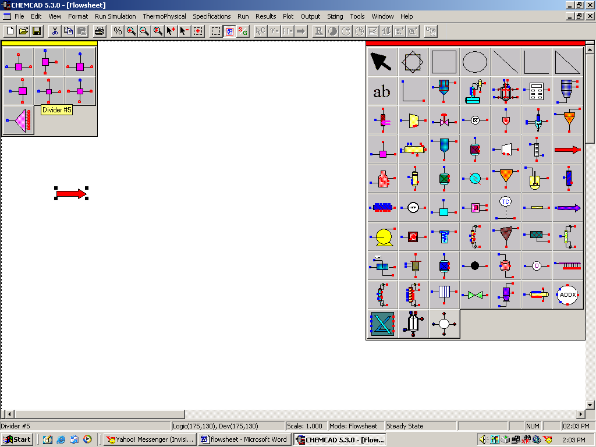

Pump: This is located in the 7th row and 1st column on the palette.

SCDS Column: This is located in the 7th row and 4th column on the palette.

Product: This is located in the 6th row and 7th column on the palette.

Gibbs Reactor: This is located in the 5th row and 3rd column on the palette.

Pipe Simulator: This is located in the 6th row and 6th column on the palette.

Tank: This is located in the 8th row and 5th column on the palette.
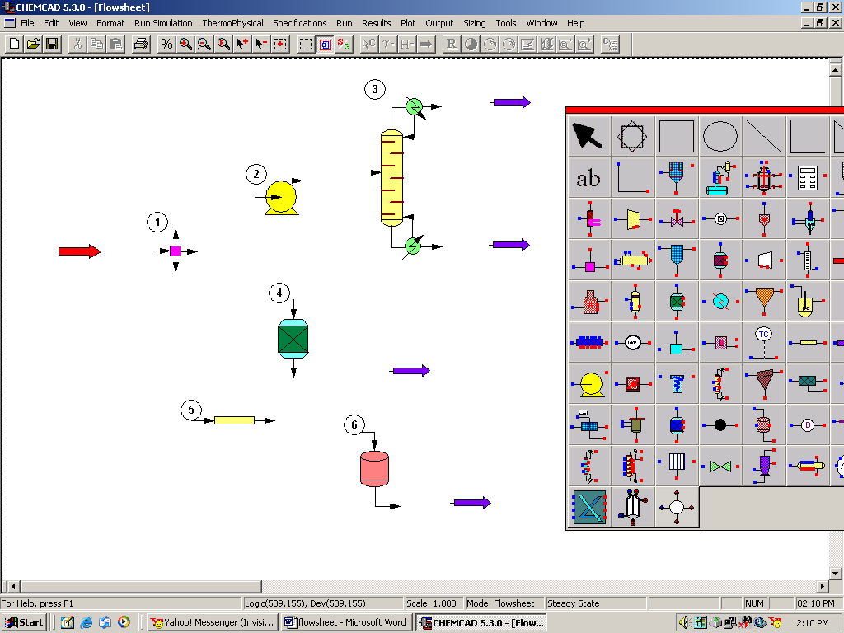

Step 3: Connecting the icons with stream

Click once on stream located in the 2nd row and 2nd column on the palette. The cursor then becomes a +. Click once on the inlet of the first feed in front of the Divider and then drag the stream to the inlet of the Divider to complete drawing the stream. Similarly join all the icons. The following figure depicts the flow sheet while connecting outlet of the Tank to the final Product.

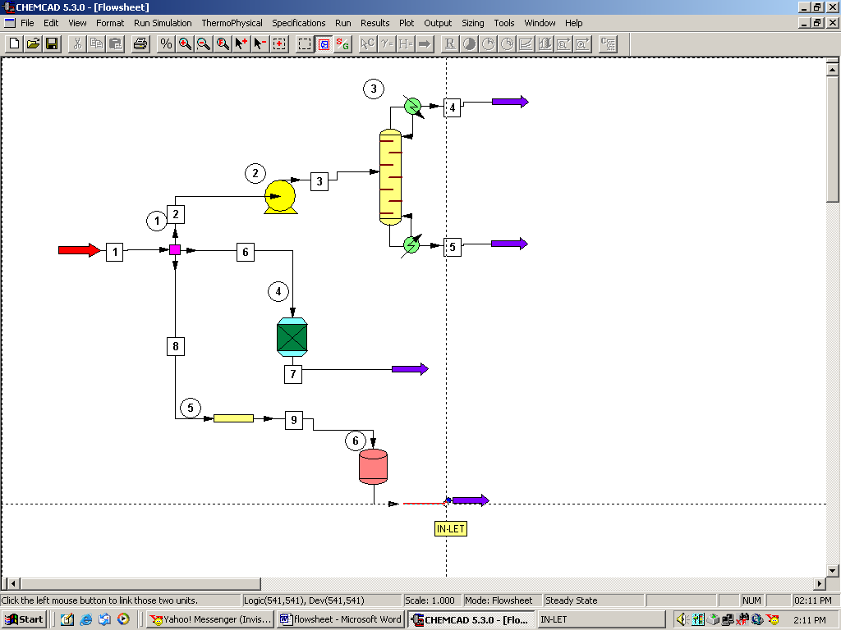

Step 4: Labeling the flow sheet

Select Text icon located in the second row and second column and type in the names of each unit operation. One can go to the Format menu and select Font to change the font style and size as desired. The following final flow sheet is obtained after the labeling is complete.

