HEAT EXCHANGER

Problem Statement:

A 100 kmol/hr stream of benzene at room temperature (298 K) is fed to a heat exchanger at atmospheric pressure. A 100 kmol/hr steam at 398 K, also at atmospheric pressure, is used to heat up the liquid benzene to 350 K prior to sending it in to a reactor. Due to the piping, there is a 0.08 atm pressure drop on both the benzene and steam product lines.

Set up a heat exchanger simulation in CHEMCAD and report the product stream temperatures and vapor fractions, heat duty of the heat exchanger and the LMTD (Log Mean Temperature Difference) for this heat exchange.

Procedure:

Step 1: Creating the flow sheet
Step 2: Entering the components and engineering units
Step 3: Entering the composition of feed stream
Step 4: Entering the heat exchanger specs
Step 5: Running the simulation and retrieving the results

Step 1: Creating the flow sheet

Go to new on the File menu and save the blank simulation. Right click on Heat exchanger on the CHEMCAD palette and select a heat exchanger with two inlet streams and two outlet streams. Click once on simulation window to paste it. Click on the feed icon on the palette and paste it on the workspace. Similarly, click on the product icon and place it on the workspace (for the vertical feed and product icons, one can right click on the feed/product icons and select the appropriate icons). After making sure that all the necessary icons are placed on the workspace, they can be connected by using stream. CHEMCAD automatically assigns numbers to streams and unit operations the order in which they are placed on the workspace. After completing the flow sheet, click once in the S/G icon found on the menu bar so that the simulation is changed from edit mode to run mode. The same icon can be used to toggle between these two simulation modes. Alternatively, one can toggle between Edit Flowsheet and Run Simulation on the menu bar to achieve the same.

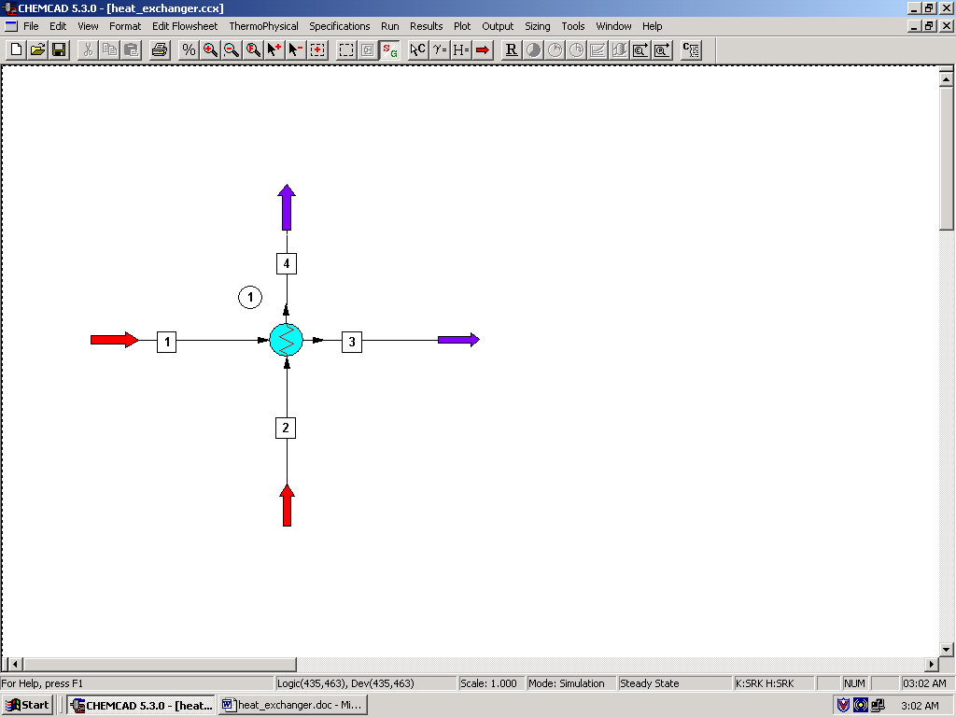

Step 2: Entering the components and engineering units

Go to the Thermophysical on the menu bar and click on Components List. Find benzene and water from the CHEMCAD components list and add them to the component list. Go to the Format menu and click on Engineering Units and select the desired units for such properties as temperature, pressure etc. Click OK to continue.

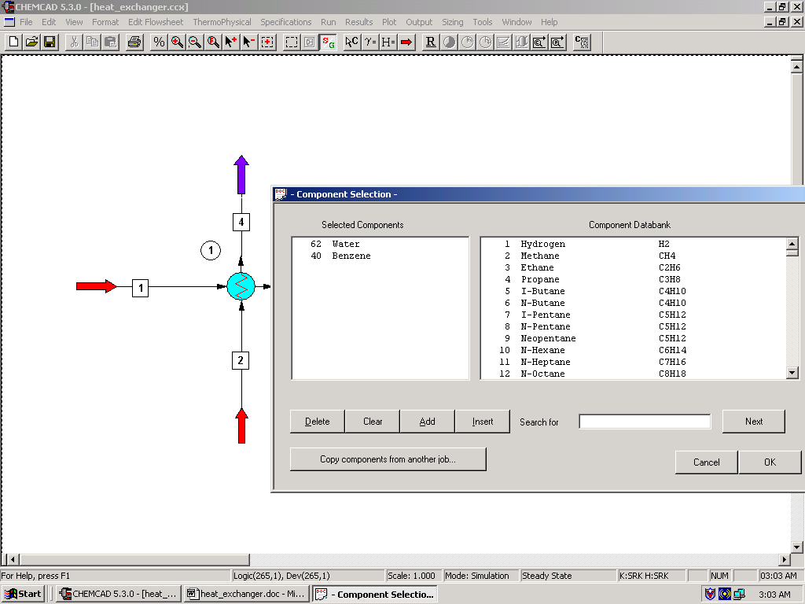

Step 3: Entering the composition of feed stream

Double click on the feed streams and enter the feed information (temperature, pressure and total flow rate) given in the problem statement. Click once on Flash to get the feed stream enthalpy and vapor fraction in feed at the feed conditions.

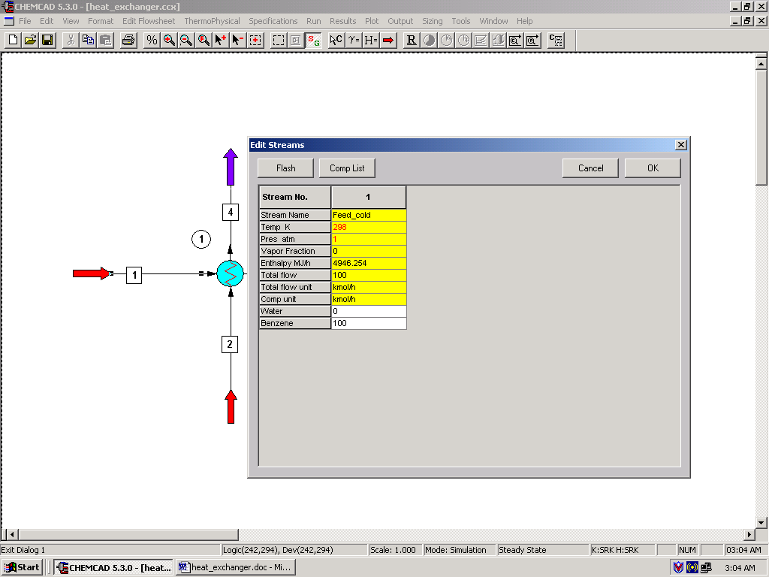

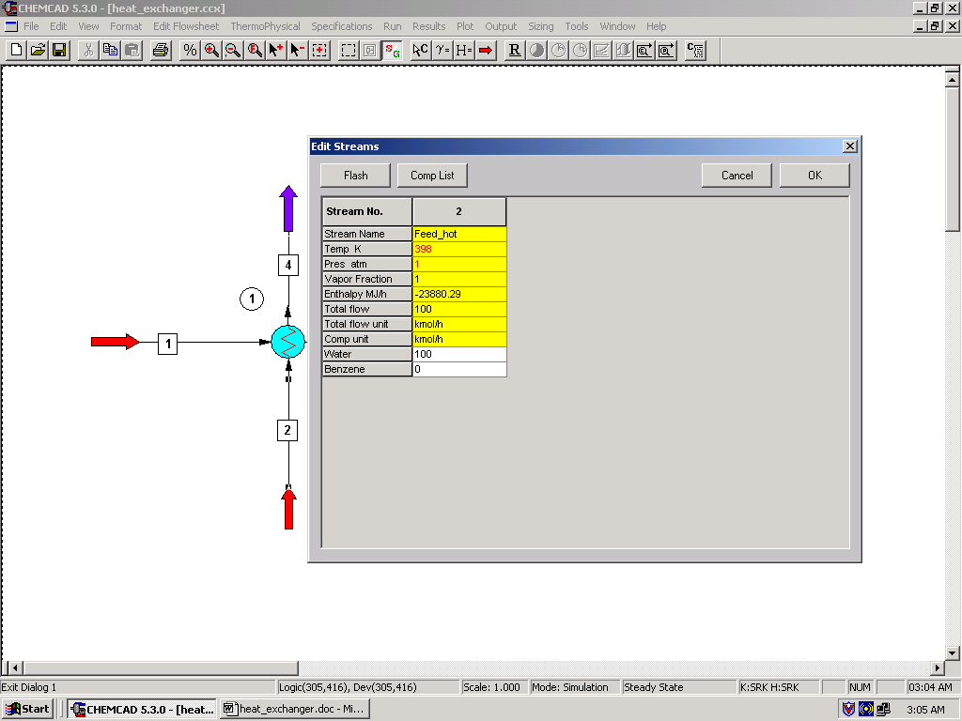

Step 4: Entering the SCDS Column specs

Double click on the Heat exchanger.

Calculation Modes:
These three modes can be left to the default settings and the reader is encouraged to learn more about other options for the calculation modes by clicking on Help button located on the bottom left corner.

Pressure drops:
Enter the value ‘0.08’ for the pressure drop in both the streams, as given in the problem statement.

Enter one specification only:
One can enter value for any one of the specifications listed in this field. From the problem statement, it can be seen that the requirement for this particular heat exchanger is a 350 K temperature for the benzene stream. Enter ‘350’ in the box next to the stream number corresponding to the benzene product.

Note:
Miscellaneous settings and Cost estimations fields are optional and can be left blank, as pertinent information is not provided in the problem statement.

Click on Ok to continue.

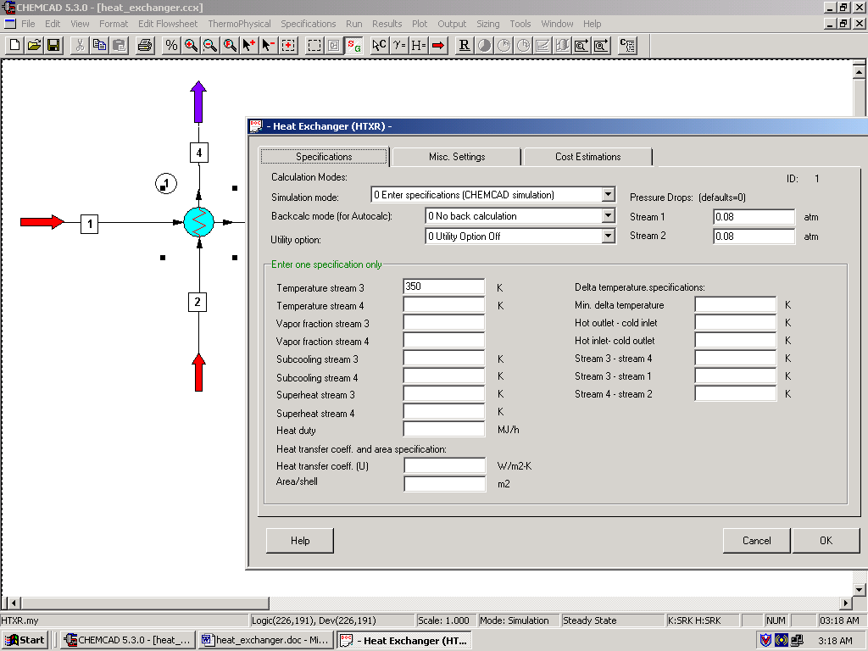

Step 5: Running the simulation and retrieving the results

After entering the available information on the workspace as described in the previous steps, one can run the simulation by clicking on R on the menu bar. Alternatively, one can run the simulation by clicking on Run on the menu bar and selecting Run all. The status of the simulation can be found at the bottom left hand corner of the screen. The message, Run Finished appears in this place if the run is successfully completed. To view the product stream properties, one can either double click on the individual product streams or by clicking Results on the menu bar and selecting Stream Compositions and further selecting All Streams. The results obtained from the latter method will be in a WordPad file.

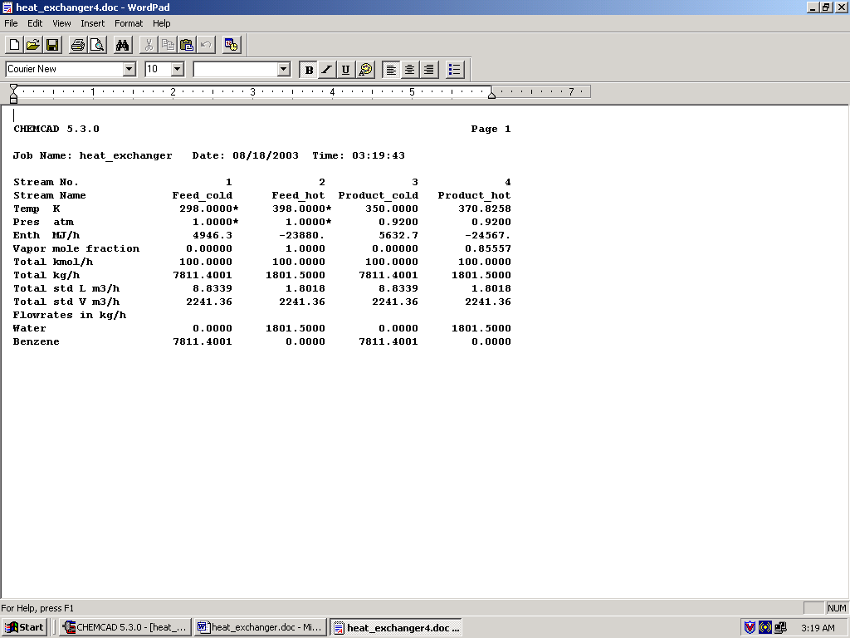

All the results associated with the heat exchanger can be found by clicking on Results menu and selecting Unit Op’s and then the heat exchanger. The results will then be available in a WordPad file.

