CHEMCAD INTRODUCTION

Contents:
How do you get there?
How to start and save a new job?
Whats in the menu?
Some neat tricks and CHEMCAD Facts to know
Understanding the Instruction modules

How do you get there?
If you are using the college machines, Click Start, go to Programs, then click on Engineering, select CHEMCAD 5.3.x. If you have CHEMCAD on your PC, Click Start, go to Programs, select CHEMCAD 5.3.x.

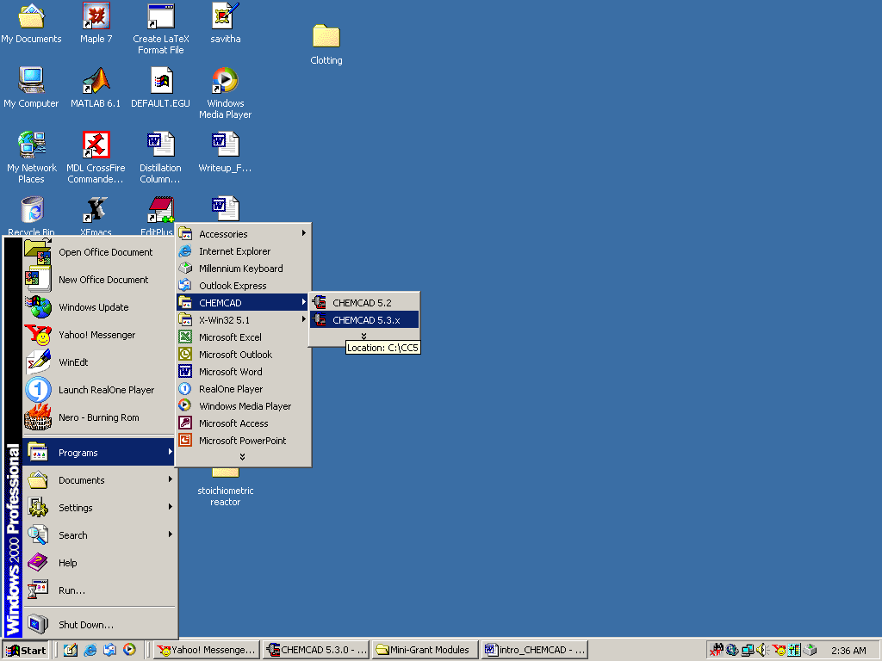

How to start and save a new job?

After the CHEMCAD window is opened, go to File menu and select New Job.

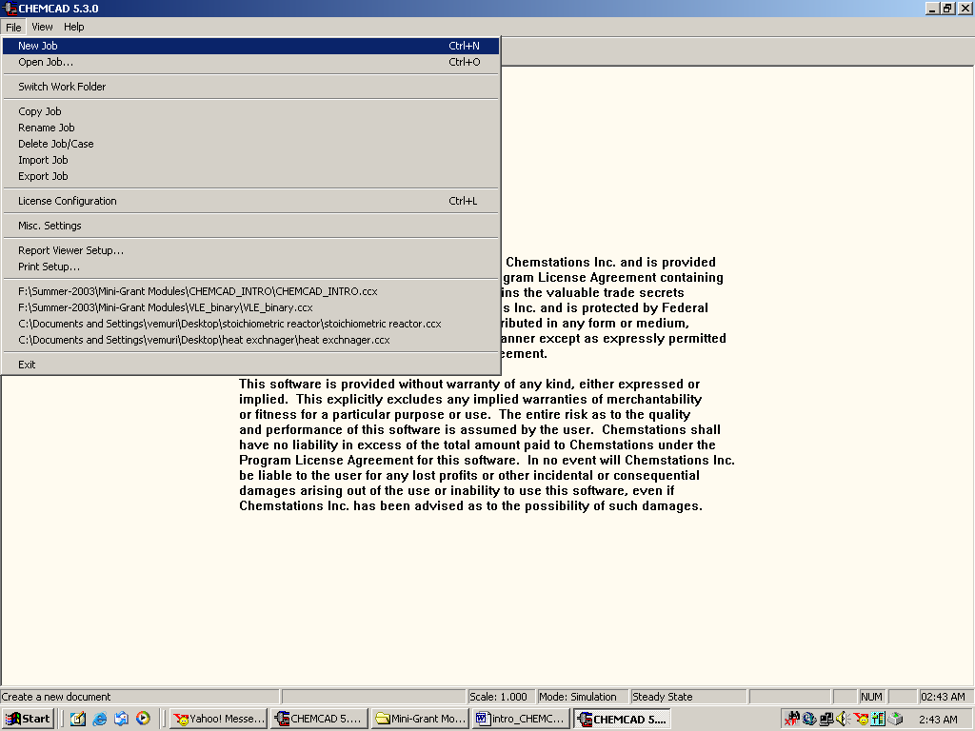

Browse to the desired folder and give a title to your new job. Click on Save to complete creating the new job.

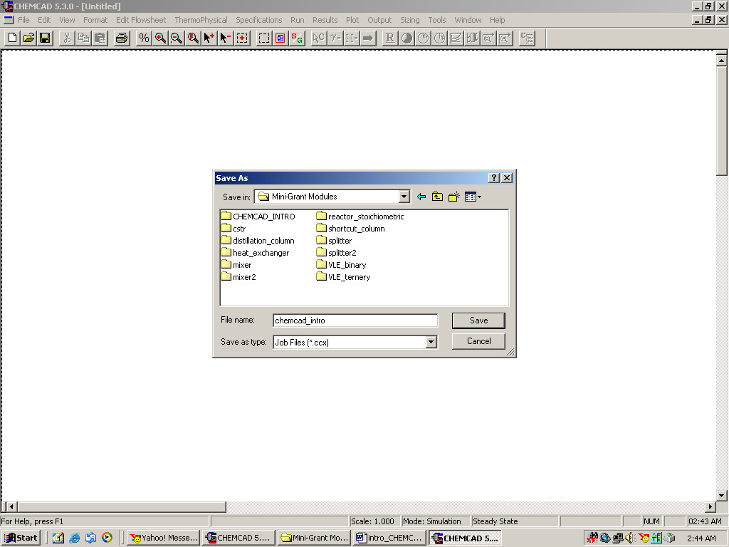

Whats in the menu?

Some of the important and most commonly used menu items are described here. (The user is recommended to actually get a hands on practice of all the menu items to be familiar with CHEMCAD) Before continuing to read this section of instructions, be sure to start CHEMCAD and save a new job.

File:
This menu is primarily used to create a new job, to open or close an existing job, to save, import or export jobs, to print the job, and to exit out of CHEMCAD. (All these options under the menu are self-explanatory and will not be explained in detail)
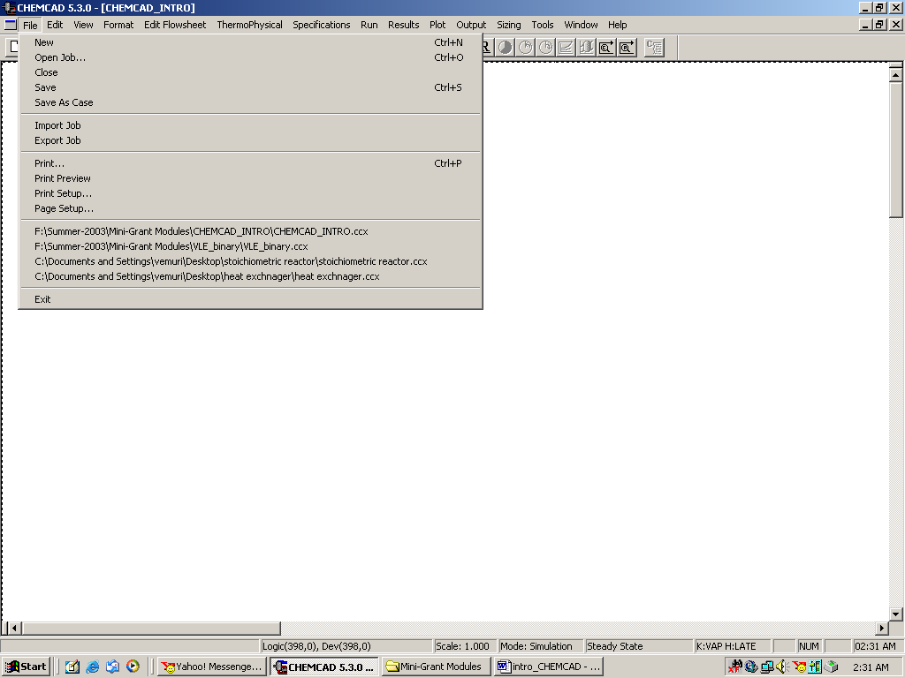

Edit:

This menu is usually selected for editing of the flow sheets. This is occasionally used to find UnitOp’s in the flow sheet (specially in case of a process with large number of UnitOps). Another important option available under this menu is the Symbol Builder, which can be used to create complex geometrical shapes. These can be copied and pasted back on to the CHEMCAD simulation window at any stage as desired by the user.

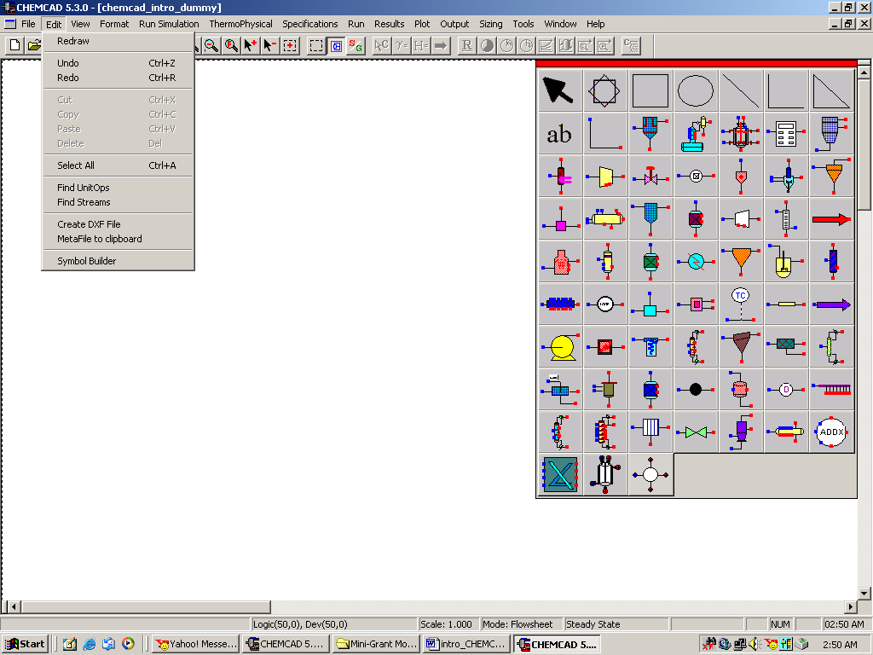

Format:

This is a very useful menu and often used in all the instruction modules to set/change the engineering units. (this can be done by selecting Engineering Units under this menu).

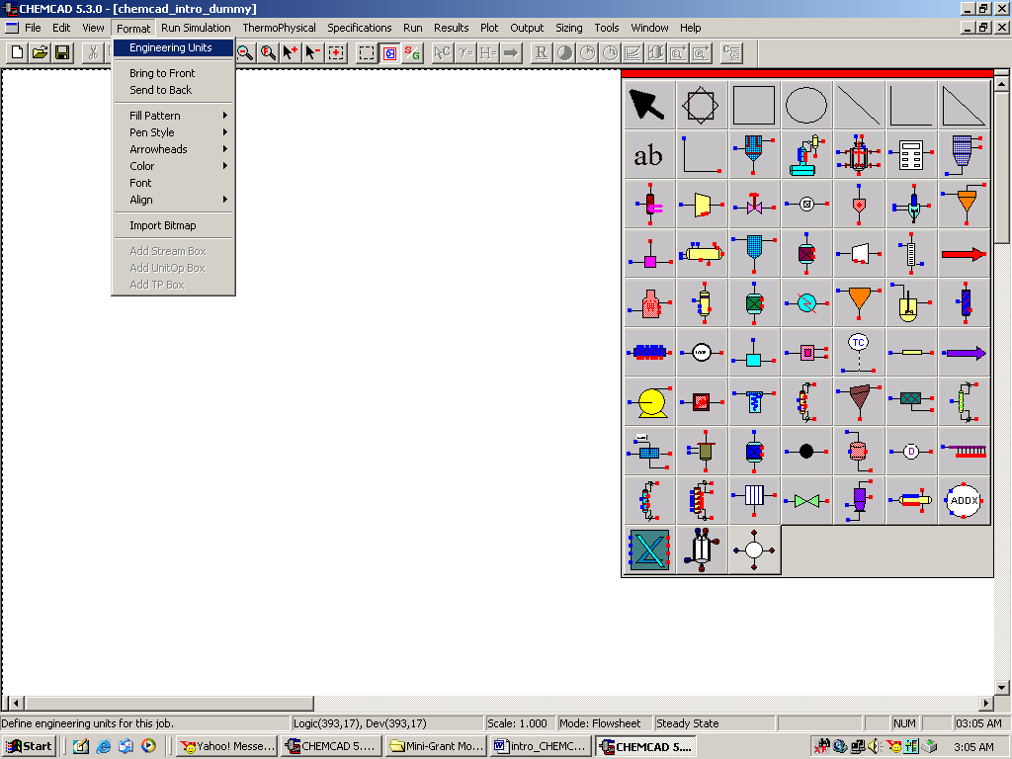

Some of the less commonly employed applications are

Fill pattern: This can be used to alter the appearance of any UnitOp icon on the flow sheet. One can draw horizontal, vertical or diagonal lines, add/delete filling, etc. One can actually try this feature by clicking on any UnitOp icon on the CHEMCAD palette and clicking once again on the workspace to paste it. Select that unit operation and go to Format. Click on Fill pattern to try to change the appearance of that UnitOp icon by adding or removing filling/lines etc.

Try this out!
The following figure has a Gibbs Reactor (this icon can be found in the fifth row and third column of the palette) after it has been made hollow (just the appearance) and after the addition of Diagonal cross.

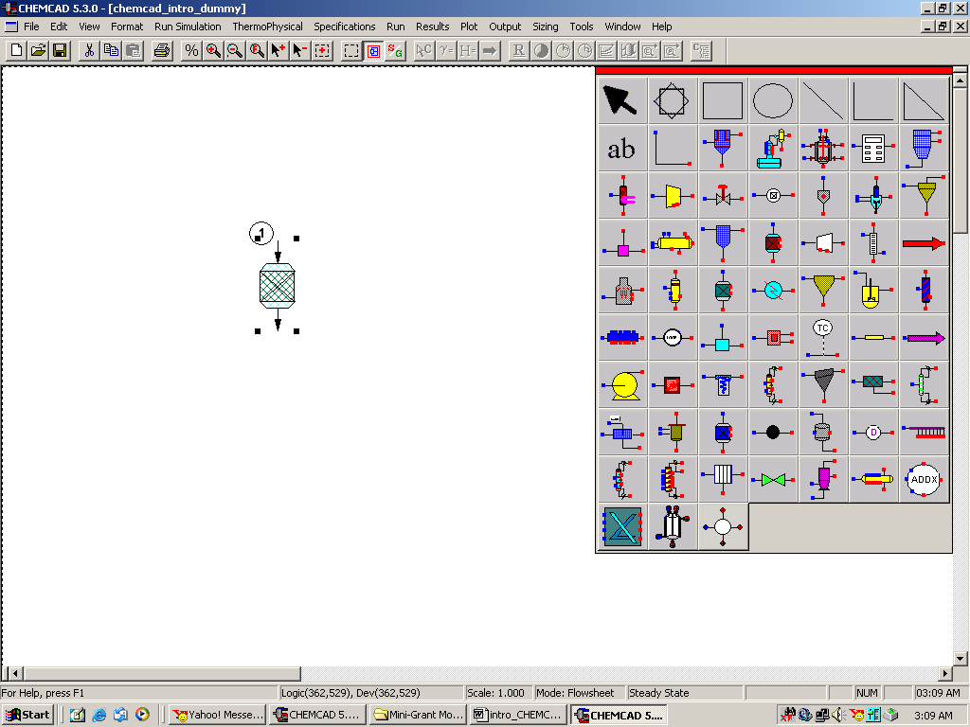

Pen style: This can be used to alter the pen style, specially that of any streams on the flow sheet.

Try this out!
The following figure has three streams, one normal (default), one thicker and one with Dash-Dot pattern.

A stream can be drawn in these three simple steps:
1. Click once on Feed icon (located in the fourth row and seventh column on the palette)
and click again on the work space to paste it.
2. Click once on the Product icon (located in the sixth row and seventh column on the
palette) and click again on the work space to paste it.
3. Click once on Stream(located in the second row and second column on the palette), a
cursor with + sign appears. Click this once on the Feed arrow and drag the stream line
to the Product arrow)

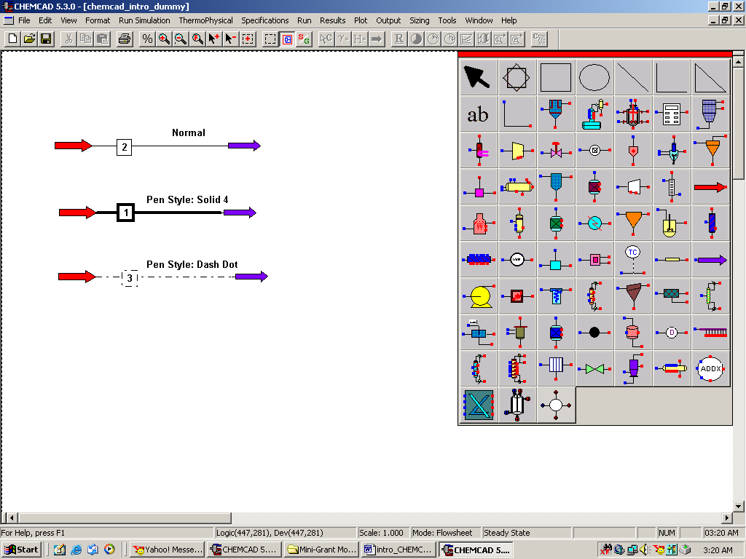

Run Simulation:
This menu item toggles between Run simulation and Edit flowsheet. The flowsheet can be edited only when this menubar shows Edit flowsheet (Each time the simulation is in Edit flowsheet mode, the CHEMCAD symbol palette will be visible). The S/G icon that can be seen in the bottom row of the main menu also has the same function as the Run Simulation.

Thermophysical:
This is also a frequently used menu bar and some of the most important applications are as follows:

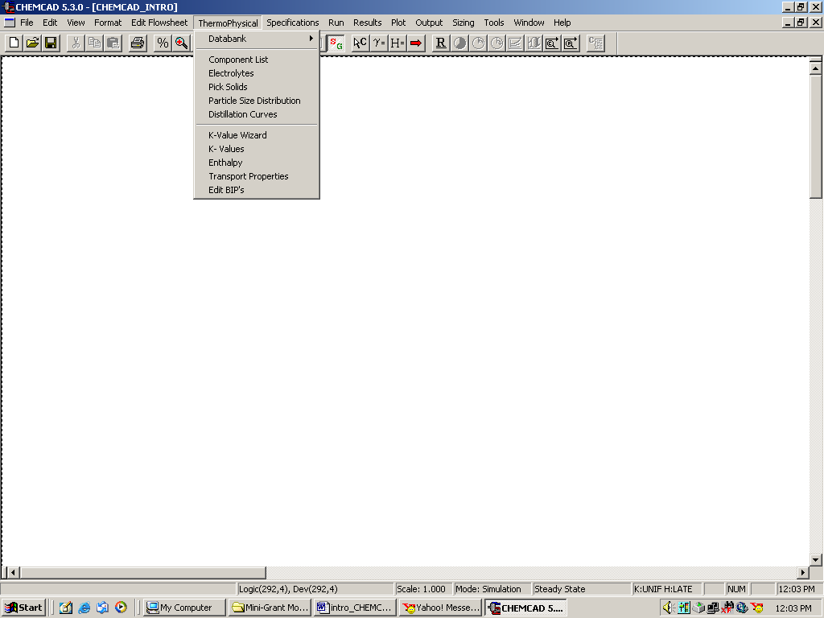

Databank: With this, one can get into the CHEMCAD database and view all the properties associated with each component found in the database. One can also create a new component that is not found in the existing database using various empirical methods such as UNIFAC and UNIQUAC.

Component List: Using this option, one can select the components to be used in the flow sheet from CHEMCAD database. When Component list is selected, the following window appears. One can type in the name of the component in the dialogue box provided in the bottom. Once CHEMCAD finds that component, one can click on Add to add it to the components list. One can also browse in to other CHEMCAD files and copy components from those files by clicking on Copy components from another job. The Delete icon on the bottom left corner can be used to delete any components previously added to the database. The icon, Clear, as the name indicates, clears all the components from the Selected Components list and the user will have to start over and enter the desired components again. The Insert icon can be used to arrange the components in a specific order.

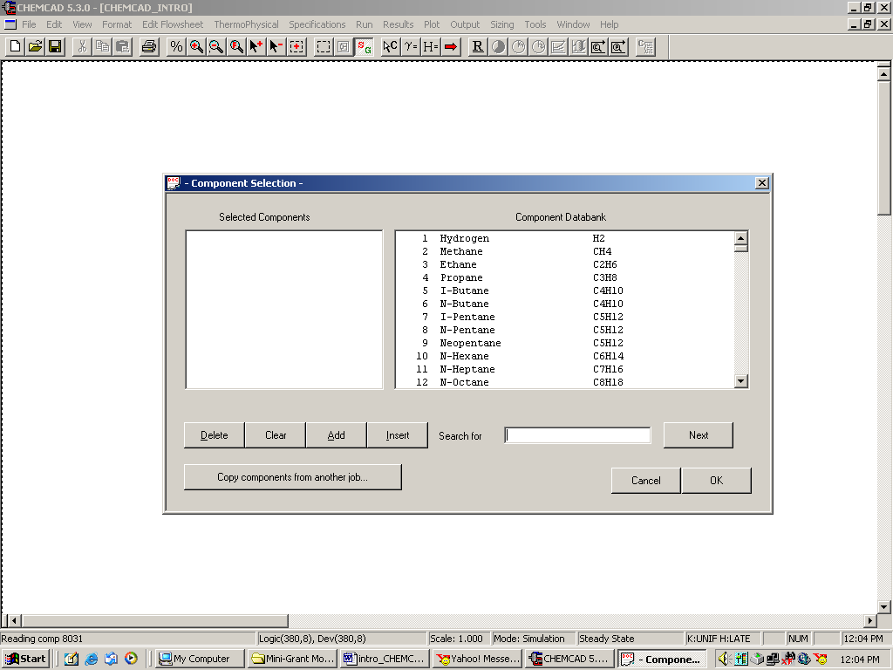

K-Values:
This option is very frequently used when simulating distillation columns and when VLE data is desired. One can specify the desired K-Value methods for the calculation of the VLE data in this field. (This is explained in greater detail in the instruction module titled “VLE data for binary systems”.

Run:
This menu is used when
- When a simulation needs to be changed from steady state to dynamic mode (The procedure to do this will be explained in detail in the instruction modules for dynamic simulations)
- All the unit operations in the flow sheet need to be run (by selecting Run All)
- When just a few selected unit operations areto be run (by selecting Run Selected Units)

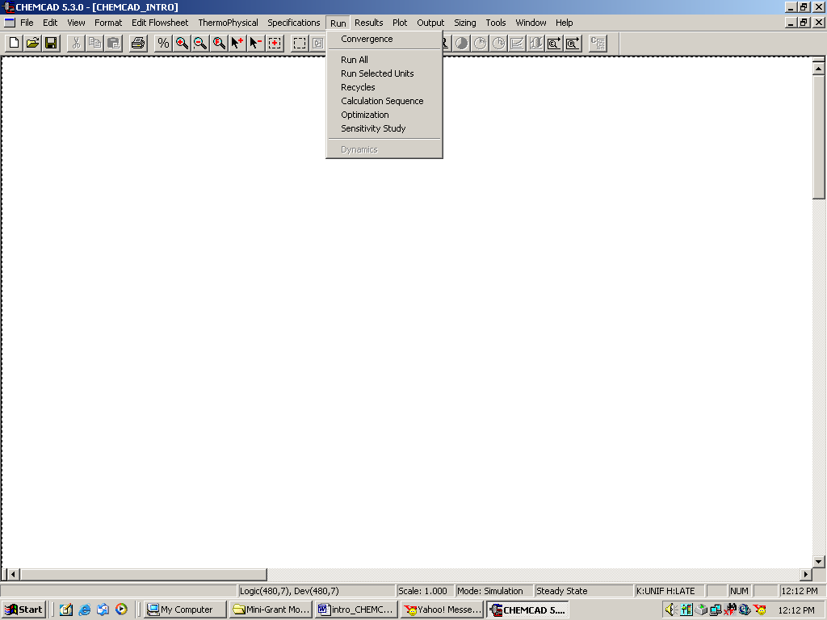

Results:
This menu item also is very frequently used to retrieve the results after a simulation. The sub-items in this menu bar allow one to print the results specific to a stream, unit operation, and also the results associated with each unit operation. In addition to these, there are several options for printing out the thermodynamic properties, tower profiles and tray properties in case of the simulation of towers etc. This section is explained for each individual unit operation in their corresponding instruction modules.

Help:
This is the easiest and most efficient method of finding out more information about CHEMCAD and its simulation applications. One can select Help topics and type in the key words in the search field to search for any information available in the CHEMCAD manuals. An alternative to this would be to go to www.chemstations.net and go to Support and then click on Manuals or one can go to Bulletin board to post any questions about CHEMCAD.

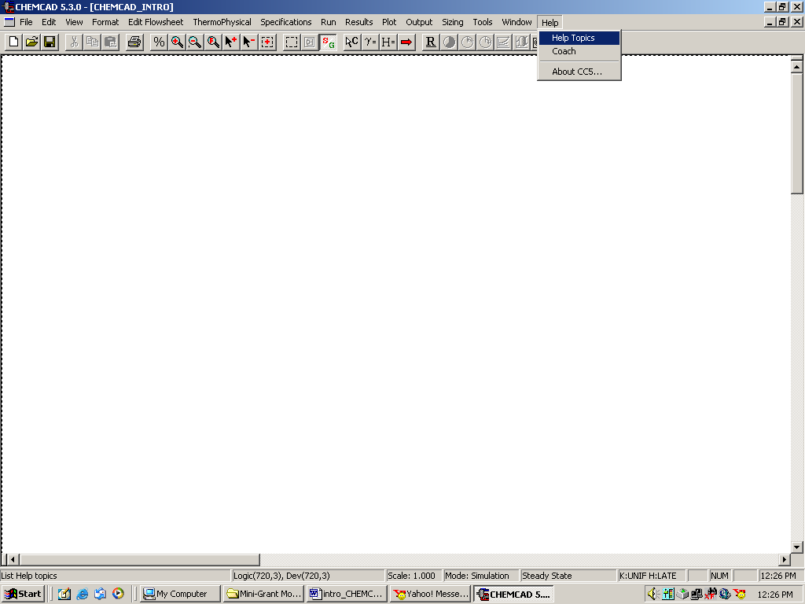

Some Neat Tricks and CHEMCAD Facts to Know:

- The CHEMCAD simulation actually comprises of several files, not just the one with flow sheet. All these files need to be available for CHEMCAD for it to successfully run the simulation. CHEMCAD always stores all the files associated with a given simulation in the same folder, each time a new simulation is saved. So, when exporting or importing CHEMCAD files from one folder to the other, one has to export or import the entire folder containing all the files associated with that specific simulation.

- The key F1 is for help. One can browse through the table of contents for a desired help file or one can simply type in the key words to search.

- If you are stuck in drawing a stream or if a specific unit operation does not respond when editing (CHEMCAD Window freezes), start the flowsheet over under a new filename and proceed.

- The key F6 is for unit conversion. This is an alternative to changing the Engineering Units under Format menubar. This key can also be used while editing a stream or unit operation property. The following figure demonstrates the use of this key. A stream is double-clicked to enter the properties and the temperature units as formatted are in F. If the F6 key is pressed when entering temperature in the stream properties wondow, a window with all units of temperature appears as shown in the figure. Then one can simply type in temperature in any units (say in K) and click Enter to view the corresponding temperature in F as calculated by CHEMCAD. When we click OK, the simulator actually places the number in F in the appropriate box in the stream property window.

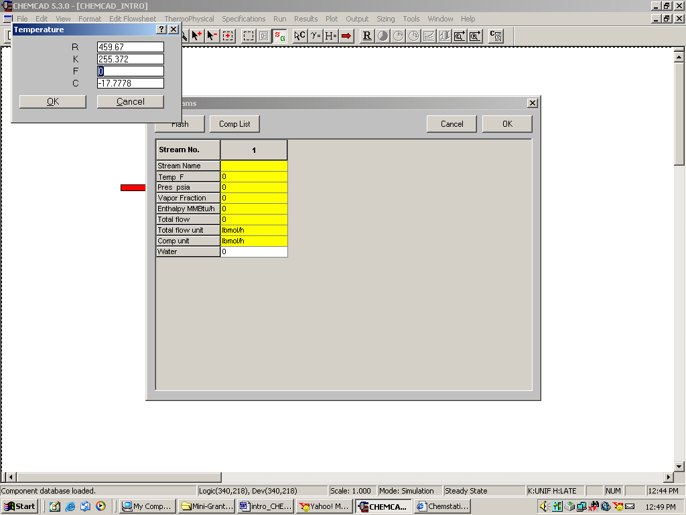

- The key F7 is for calculator.

Understanding the Instruction modules:

All the instruction modules are located in the CHEMCAD folder of the course website. Effort has been made to make sure that all these modules are reader-friendly and it is assumed that the reader has no prior knowledge of CHEMCAD. For returning users, these modules may prove to be of less significance. All the key words or unit operations used by CHEMCAD are always indicated in italics for easy reference. The actual CHEMCAD figures are provided after almost every major instruction for a quick reference. If unexpected errors occur in CHEMCAD while following these instructions, the user can start over form Step 1 of the instructions. All the instruction modules have been tried and tested before and the user is recommended to read the instructions carefully before attempting the simulation.

