RECYCLE

Problem Statement:

The following flow diagram describes the synthesis of n-octane into 1-octene and hydrogen. The feed conditions and the specifications for each major unit operation are described in the flow diagram.

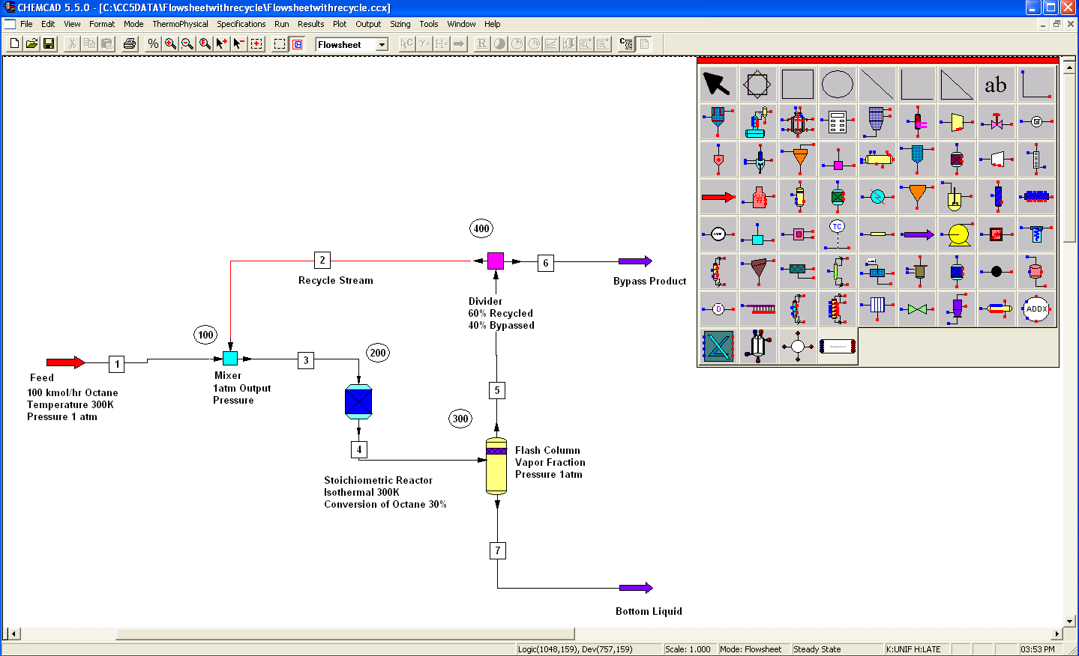

Perform a steady state simulation of this flow network and report the composition and condition of the all the intermediate, recycle and product streams.

Procedure:
Step 1: Creating the Flow Sheet
Step 2: Entering the Components
Step 3: Formatting Engineering Units
Step 4: Entering the feed stream composition
Step 5: Entering the mixer specs
Step 6: Entering the reactor specs
Step 7: Entering the flash column specs
Step 8: Entering the divider specs
Step 9: Running the simulation and retrieving the results

Step 1: Creating the Flow Sheet

Select and click the feed, mixer, stoichiometric reactor, flash, divider and product(2) icons on the workspace. Right click on each unit and click on Edit ID to change the unit numbers to 3 digit numbers.

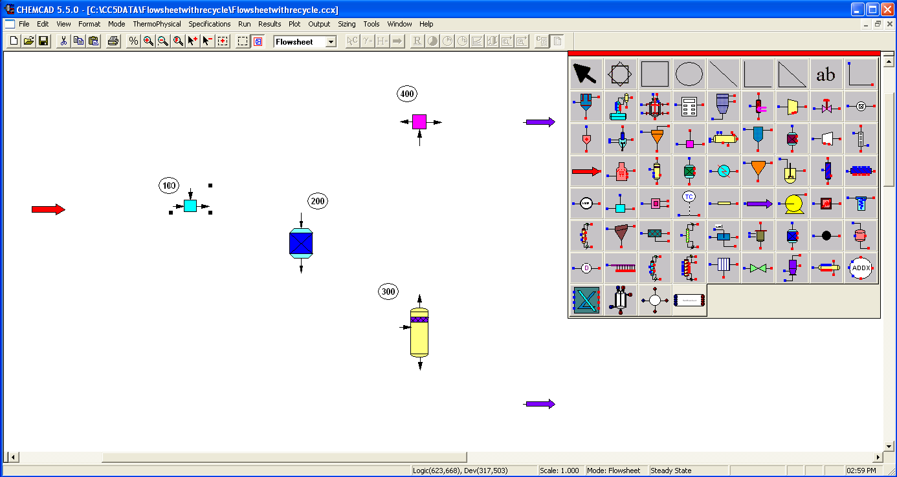

Connect all the unit operations appropriately using Stream. Click once on the S/G icon on the menu bar to switch the simulation mode from Edit Simulation to Run Simulation. Note that one of the streams on the flow sheet is in red, indicating the presence of recylce in the flow sheet.

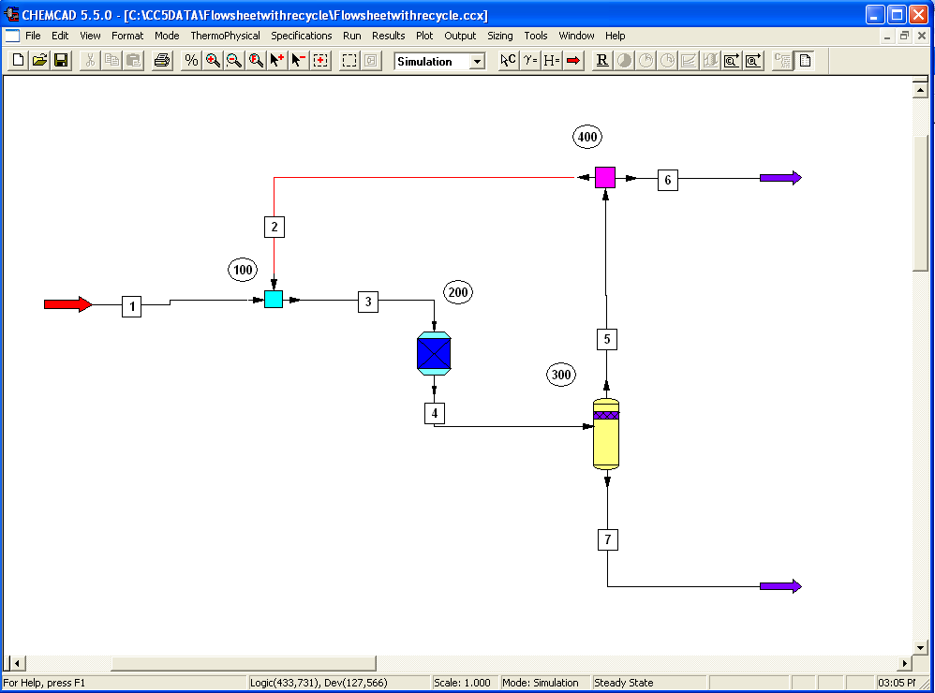

Step 2: Entering the Components
Go to the Thermophysical on the menu bar and click on Components List. Find n-octane, 1-octene and hydrogen from the CHEMCAD components list and add them to the component list.

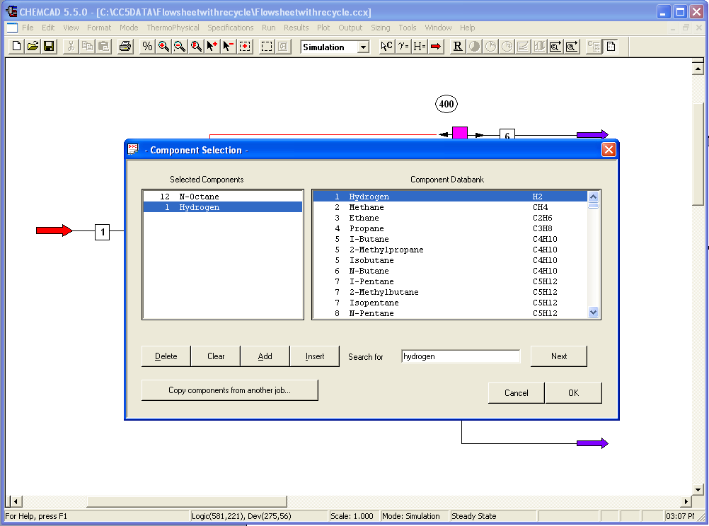

Once OK is pressed the thermodynamics wizard will pop up. If the thermodynamics model to be used is not known, than input the temperature and pressure range for which the system shall be run, and press OK.
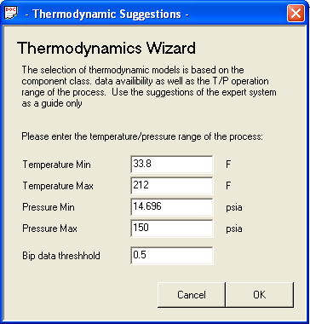

If the thermodynamic model to be used is known, press OK, and input the correct thermodynamic model on the following screen.
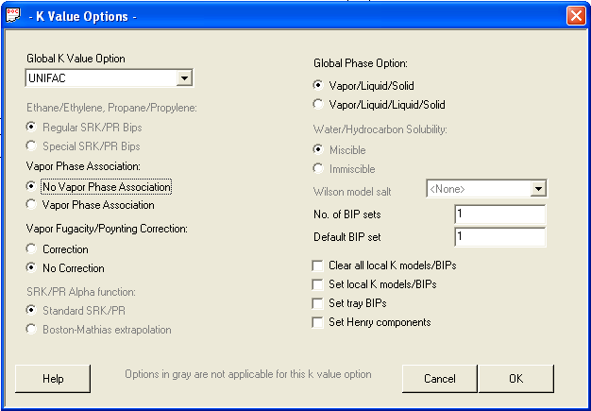

3. Formatting Engineering Units

Go to the Format menu and click on Engineering Units and select the desired units for such properties as temperature, pressure etc. Or if all units are SI, click on the SI units tab. Click OK to continue.

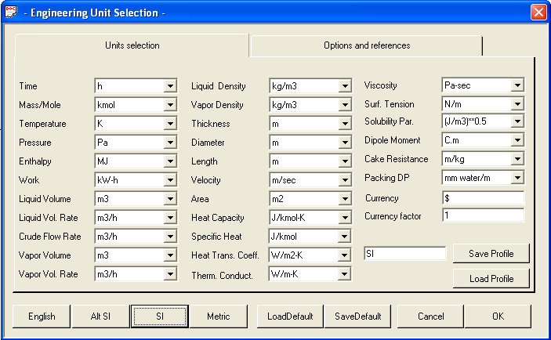

Step 4: Entering the feed stream composition

Double click on the feed stream and enter the feed information (temperature, pressure, total flow rate and component mole fractions) given in the problem statement. Click once on Flash to get the feed stream enthalpy and vapor fraction in feed at the feed conditions.

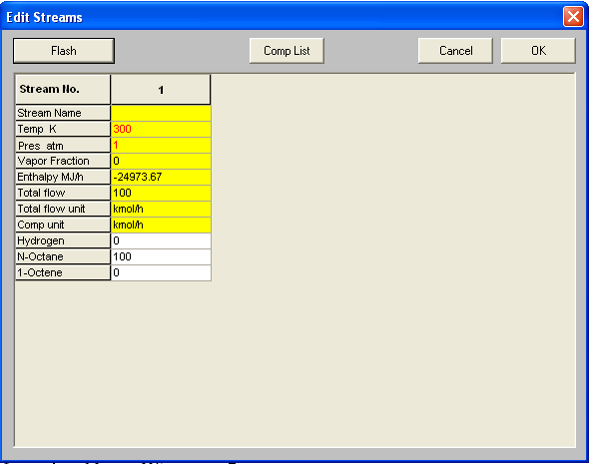

Step 5: Entering the mixer specs

Double click on the Mixer. Enter 1atm as the output pressure and click OK.

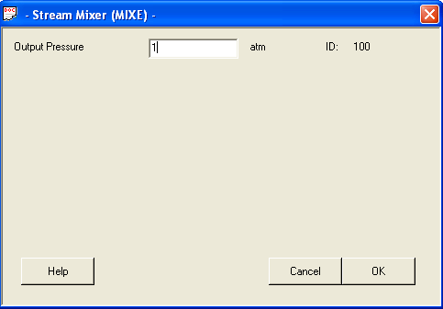

Step 6: Entering the Reactor Specs

Double click on the Stoichiometric Reactor. Under the General Specifications tab, enter the following information.

Specify Thermal Mode:
Select the radio button corresponding to Isothermal and enter 300K in the box provided.

Key Component:
Select N-Octane from the drop box

Fractional Conversion:
Enter 0.3 in the space provided

Heat of Reaction, Reactor Pressure and Calc. H. of Reac. are all left blank and the system can be left as ideal gas state.

Stoichiometric Coefficients:
Choose option 0, mole base (default) and enter the stoichiometric coefficients corresponding to all the components in the spaces provided as shown in the following figure. The reactant N-Octane is entered as a negative number and the products Hydrogen and 1-Octene are entered positive.

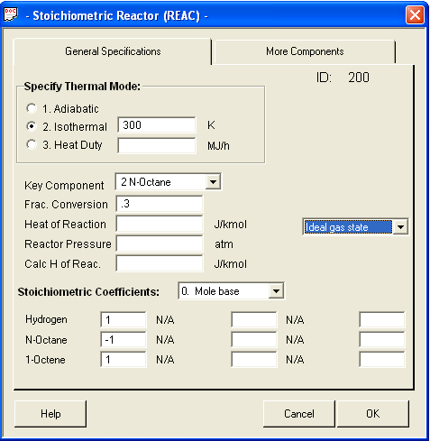

Step 7: Entering the Flash Column Specs

Double click on the Flash column. Under the Specifications tab, choose option 1, Specify V/F and P; Calculate T and Heat, as the problem statement contains the information on pressure and vapor fraction.

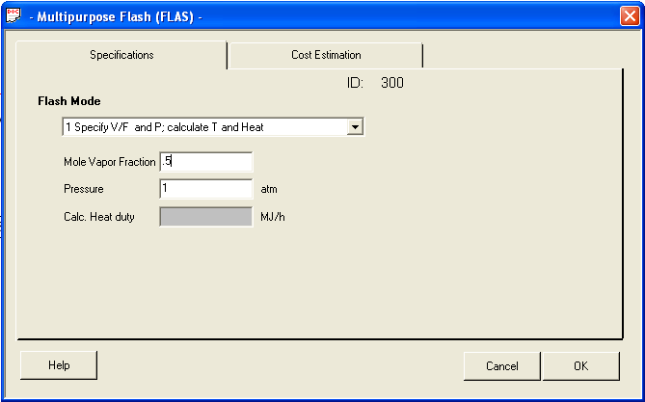

The cost estimation tab can be ignored, press OK.

Step 8: Entering the Divider Specs

Double click on the Divider. The specifications given in the problem statement say that 60% of the flow coming into the divider is recycled and 40% is bypassed.
Choose option 0, Flow ratio, for the split basis. Identify the bypass stream (stream 2) and recycle stream (stream 2) on the flowsheet and enter 0.4 and 0.6 respectively as shown in the figure.
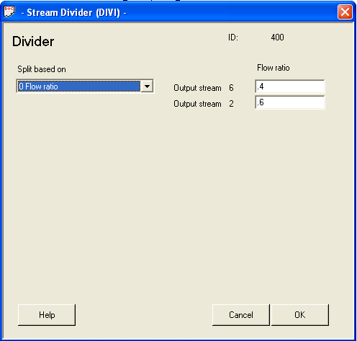

Step 9: Running the Simulation and Retrieving the Results:

Now the simulation is ready to be run. Click once on R to run the simulation. Alternatively, one can run the simulation by clicking on Run on the menu bar and selecting Run all. The status of the simulation can be found at the bottom left hand corner of the screen. The message, Recycle calculation has converged, appears if the run is successfully completed. Note: Recycle calculations can be tricky and convergence may not always be obtained from running the system a single time. Simply press the run button multiple times until convergence is obtained. If flow streams are not changing the system may not be set up correctly.

Stream properties can found either by clicking once on the product stream or by clicking once on Results on the menu, selecting Stream Composition and then clicking on All Streams. The results will again be available in a WordPad file.

