MIXER

Problem Statement:

Mixer
Benzene (A)
Toluene
Xylene
Mixed Stream

Benzene Stream: 10 kmol Benzene, 0.5 kmol Toluene, 0.25 kmol Xylene
Toluene Stream: 20 kmol Toluene, 1 kmol Xylene, 0.5 kmol Benzene
Xylene Stream: 30 kmol Xylene, 1.5 kmol Benzene, 0.75 kmol Toluene

All feed streams are at room temperature (25 ºC) and atmospheric pressure (1 atm). Mixer has a pressure of 2 atm. Find the composition and temperature of the mixed stream.

Procedure:

Step 1: Creating a new job in CHEMCAD
Step 2: Drawing the flow sheet
Step 3: Components and Engineering units
Step 4: Entering the feed stream composition
Step 5: Entering the Mixer specs
Step 6: Running the simulation and retrieving the results

Step1: Creating a new job in CHEMCAD

The first step is to create a new job in CHEMCAD. This can be done by opening CHEMCAD window and clicking newjob from File menu. Each new CHEMCAD file is automatically opened in a separate folder and all the files associated files are stored in this folder.

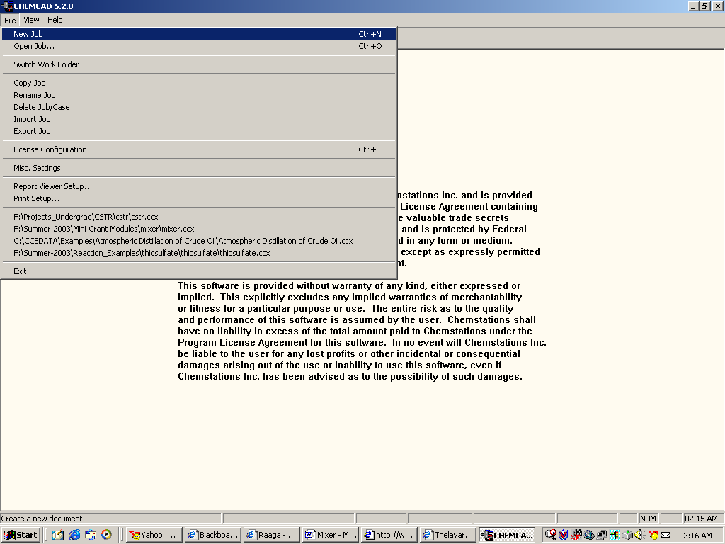

Once a new job is successfully saved in CHEMCAD, the CHEMCAD palette with the icons of unit operations appears as follows.

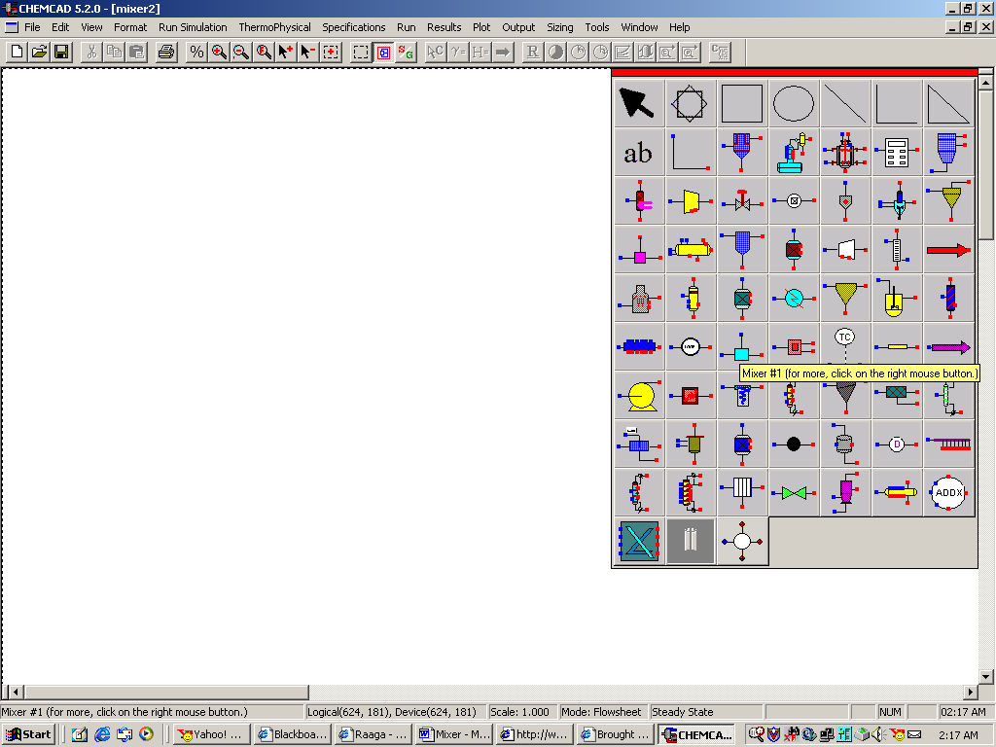

Step2: Drawing the Flow sheet

In the CHEMCAD palette, the unit operations are listed in alphabetical order for easy access. Right click on Mixer from the unit operations palette and then select the icon with three feed streams and one product stream (Mixer#5). This icon can be placed on the workspace by clicking once. Right click on the Feed icon from the palette and select the feed arrows in desired directions and click on the workspace to paste. Similarly, click on Product icon and paste it on to the simulation page. Using stream on the palette, connect the feeds to the inputs of the mixer and the product to the output. Always draw the streams from the input to the output. After all the icons are connected using stream, click once on the workspace to view the palette. CHEMCAD automatically assigns numbers to the streams the order in which they are drawn.

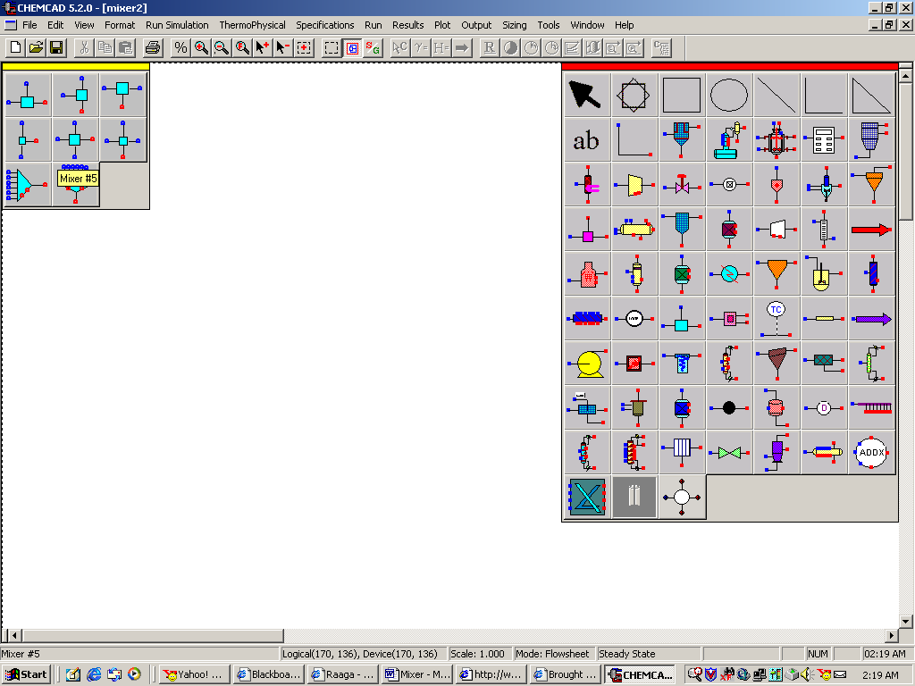

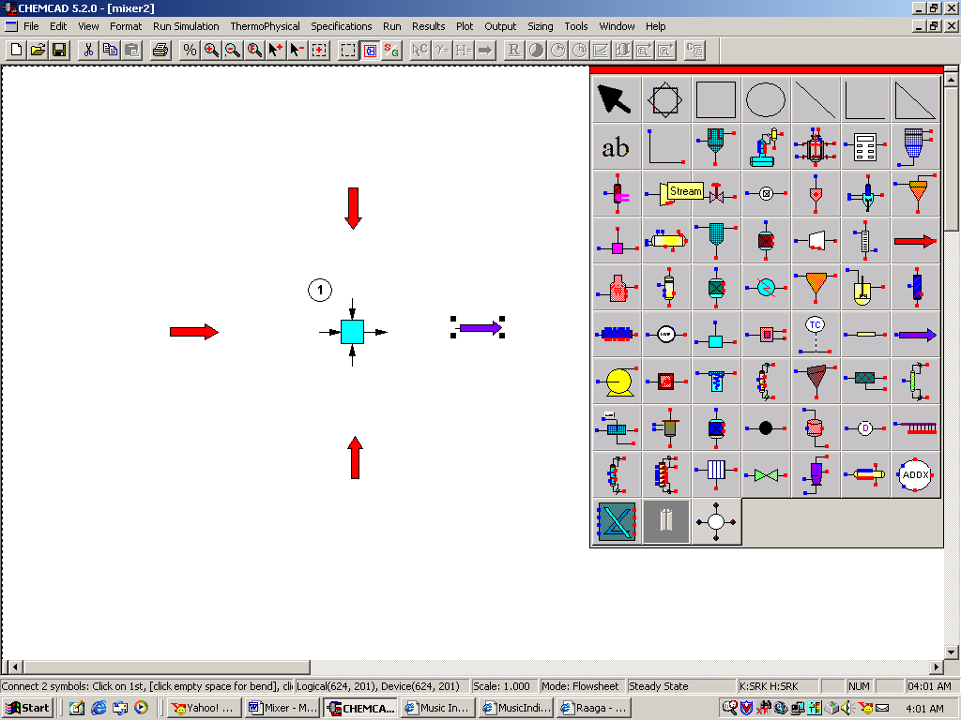

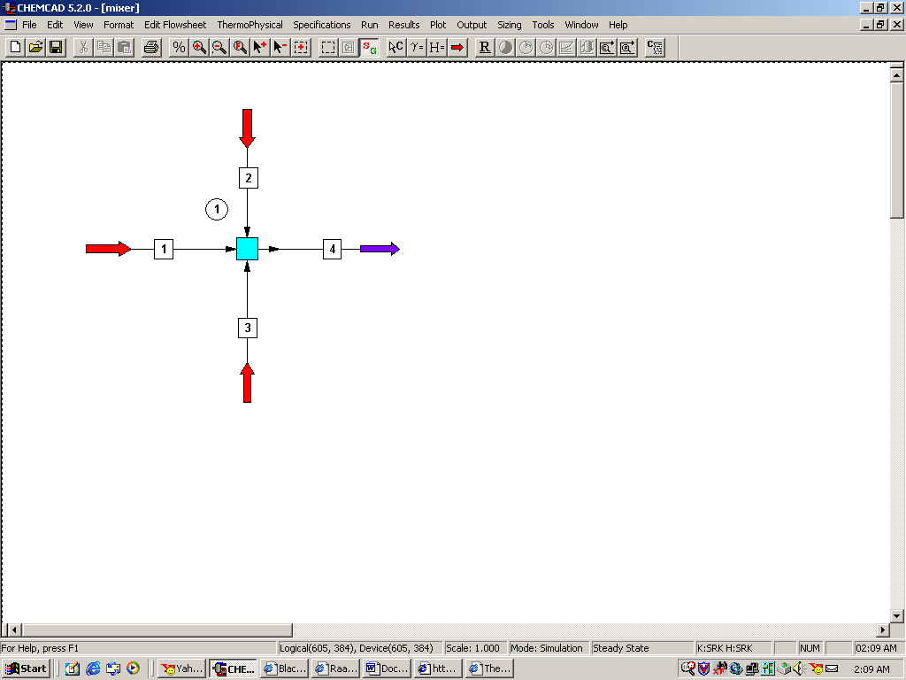

Step 3: Entering the components and formatting engineering units

Change the simulation mode from Edit Simulation to Run Simulation by clicking once on the S/G icon found on the menu bar. The same icon can be used to toggle between these two simulation modes. Then, go to Thermophysical on the menu bar and select Component list. Select the three desired components (Benzene, Toluene and Xylene for this example) and them to the component list. The search for the components in the database can be made by typing the name of the component in the dialogue box provided in the window. The order in which the components are entered will be the order in which components are displayed at any stage of the simulation. Go to the Format menu and click on Engineering Units and select the desired units for such properties as temperature, pressure etc. Click OK to continue. Save the simulation at the end of each step to make sure that no information is lost in the event of system failure.

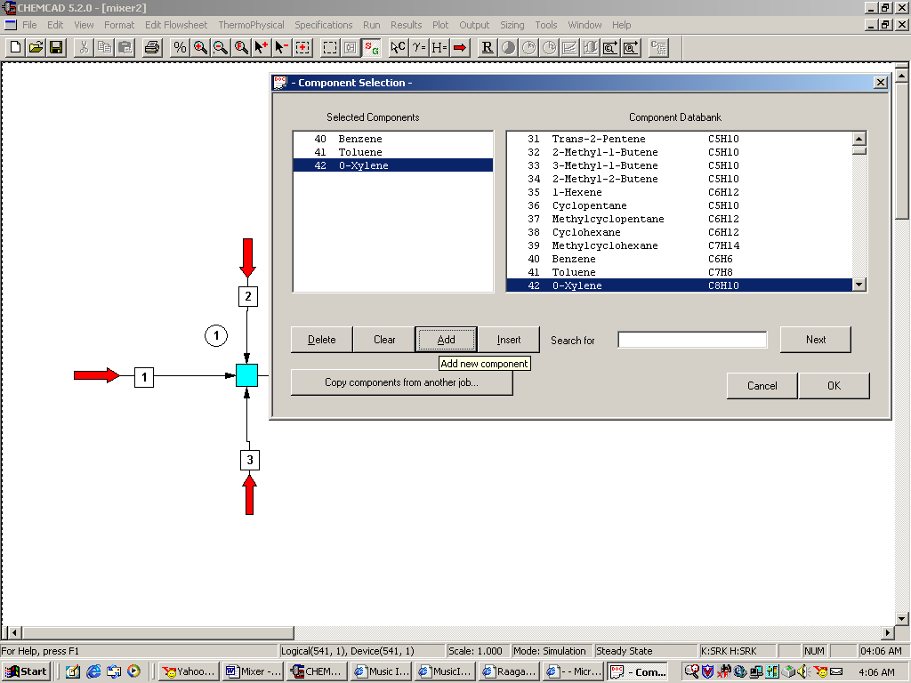

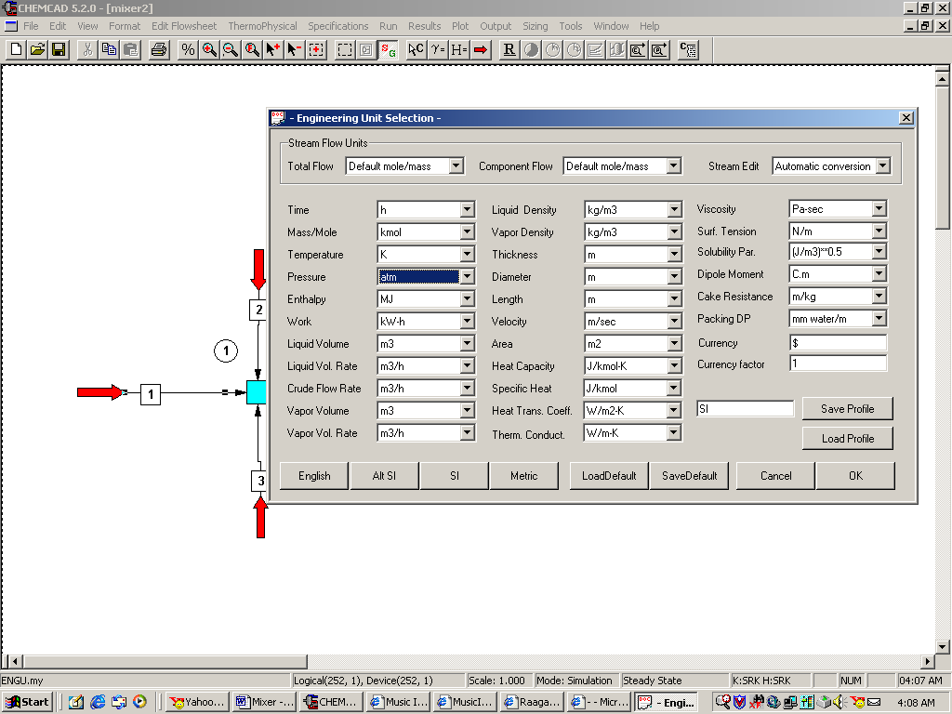

Step 4: Entering the composition of feed streams

Double click on each of the feed streams and enter the name, temperature, pressure and composition corresponding to each stream as given in problem statement. Click once on Flash button at the end of entering information for each feed stream to get the feed stream enthalpy and vapor fraction in feed at the feed conditions.

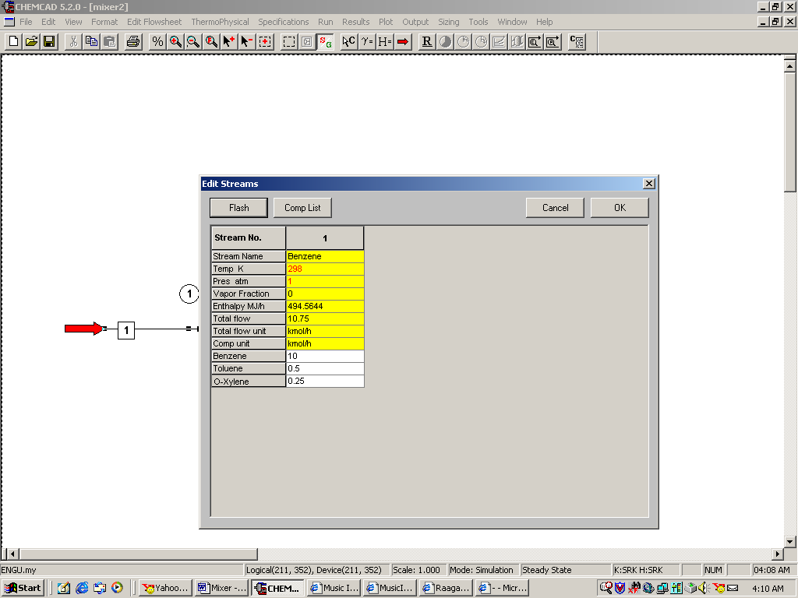

Step 5: Entering the Mixer specs

After entering the feed streams information, double click on mixer and enter the Output Pressure as 2 atm as given in the problem statement. Click ok to continue.

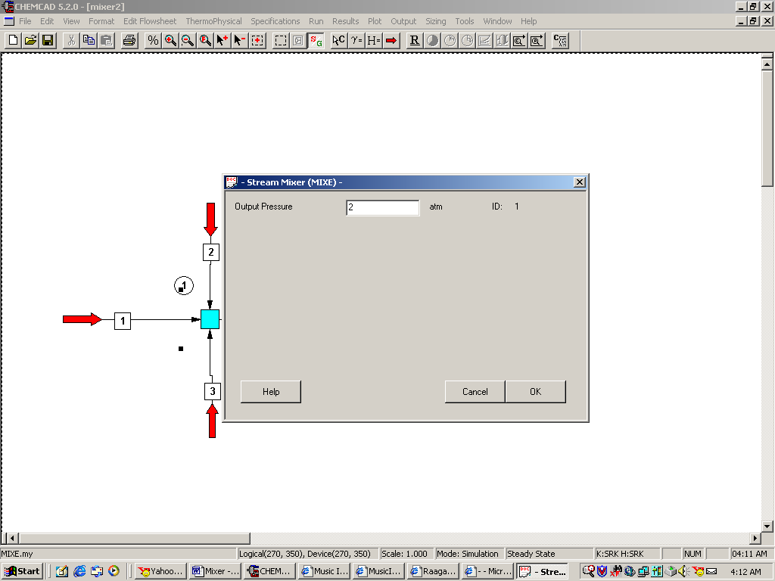

Step 6: Running the simulation and retrieving the results

Go to Run menu and select Run all to run this simulation. Alternatively, any steady state simulation can be run by simply clicking R on the menu bar. The status of the program can be found from the bottom left hand corner of the workspace. Once the simulation is complete, the message Run Finished appears on the bottom left hand corner. The quality and composition of the final product stream can be found by double clicking on the product stream.

