MIXER-SETTLER

Problem Statement:

If a 100 kg of a solution of acetic acid and water containing 30% acid is to be extracted three times with isopropyl ether at 20 ºC and 1 atm, using 40 kg of solvent in each stage, determine the quantities and compositions of various streams.

(Illustration 10.1, R.E. Treybal, Mass-Transfer Operations)

Note:
The problem stated above needs simulation of three extraction columns with one stage connected to each other in series. The Extractor in CHEMCAD does not allow a simulation with only one stage and needs more than one stage for the simulation to converge. In order to get around this problem, one can use an liquid-liquid flash unit (LLV Flash) in CHEMCAD in conjunction with a mixer. As the flash column only allows one feed stream, mixer facilitates the two feed streams (solution and solvent) to enter into the flash as one stream.This combination will directly correspond to the simulation of an extractor with one stage.

Procedure:

Step 1: Creating the flow sheet
Step 2: Entering the components and formatting engineering units
Step 3: Entering the feed streams composition
Step 4: Entering the mixer specs
Step 5: Entering the flash column specs
Step 6: Running the simulation and retrieving the results

Step 1: Creating the flow sheet

Select and click the feed(4 no.s), mixer(3 no.s), LLV flash(3 no.s), and product(7) icons on the workspace. Connect all the unit operations appropriately using Stream as shown in the following figure. Click once on the S/G icon on the menu bar to switch the simulation mode from Edit Simulation to Run Simulation.

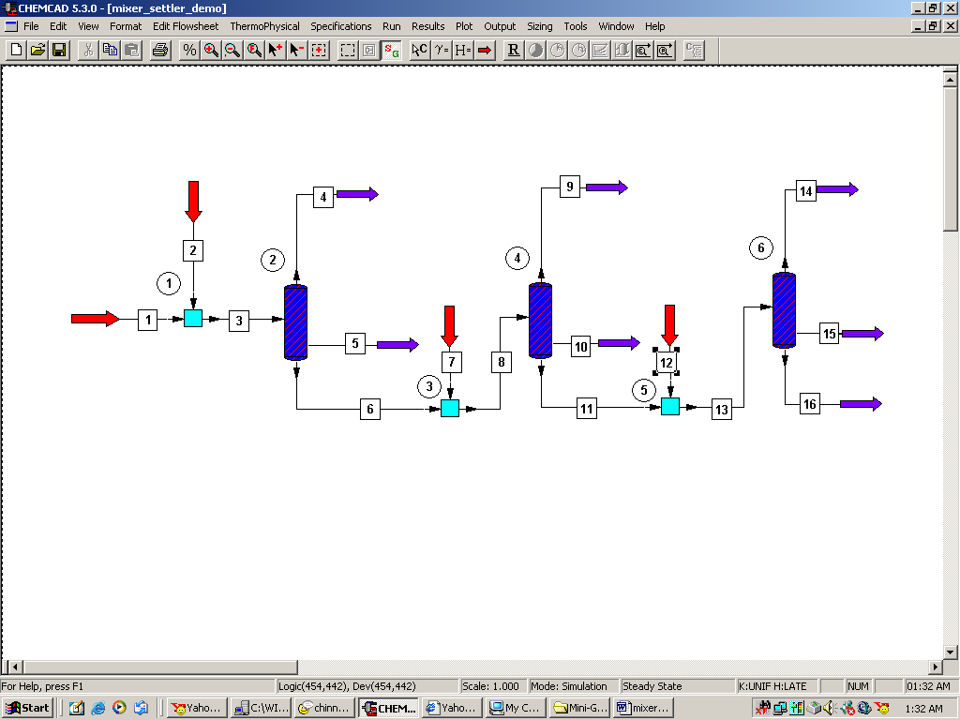

Step 2: Entering the components and formatting engineering units

Go to the Thermophysical on the menu bar and click on Components List. Find acetic acid, water and isopropyl ether from the CHEMCAD components list and add them to the component list. Go to the Format menu and click on Engineering Units and select the desired units for such properties as temperature, pressure etc. Click OK to continue.

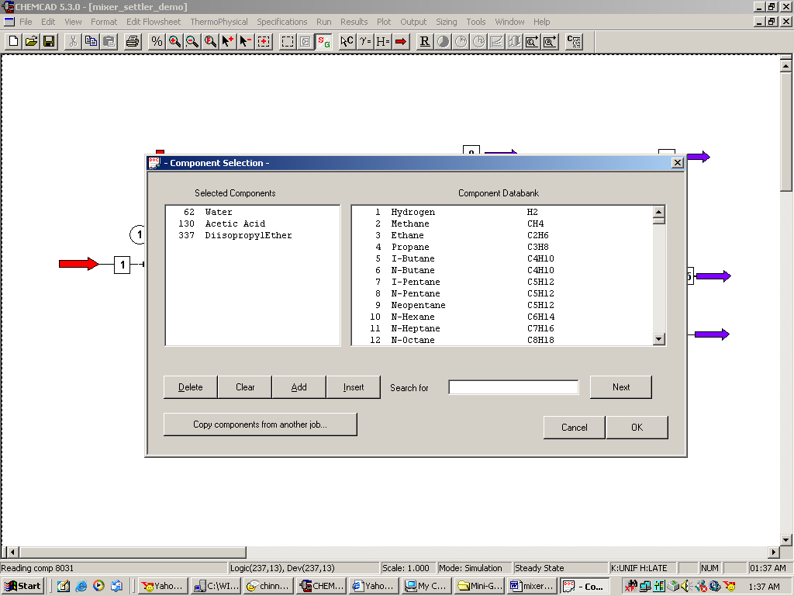

Step 3: Entering the feed stream composition

There are four feed streams in the flow sheet. The first feed stream is that of the mixture of acetic acid and water going in to the first mixer. This stream has 30 kg/hr acetic acid, 70 kg/hr water at 20 ºC and 1 atm. Enter this information in the appropriate fields and click once on flash and then click OK.

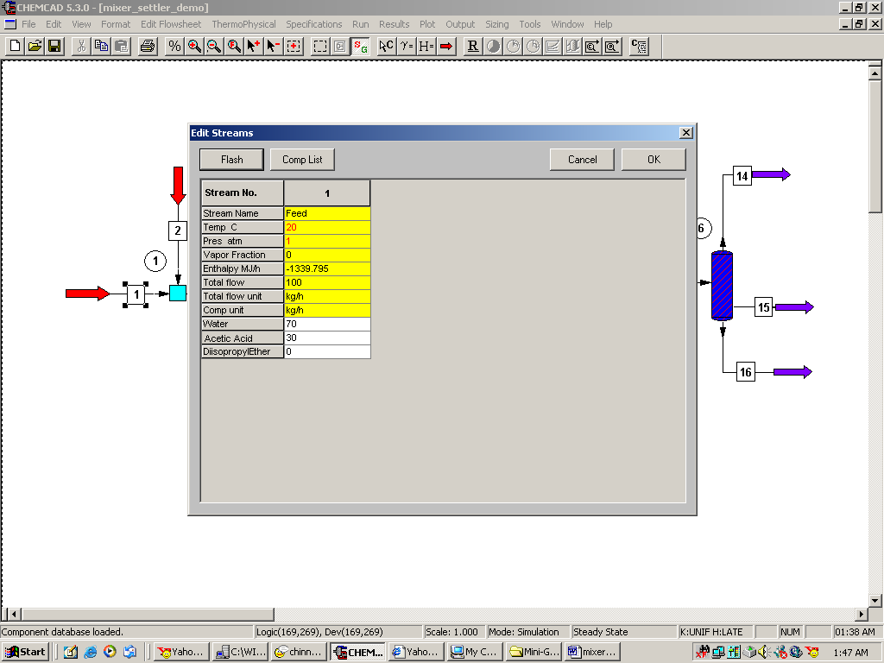

The second feed stream is that of the solvent going to the first mixer. This stream has 40 kg/hr of isopropyl ether at 20 ºC and 1 atm as well. Enter this information in the appropriate fields and click once on flash and then click OK.

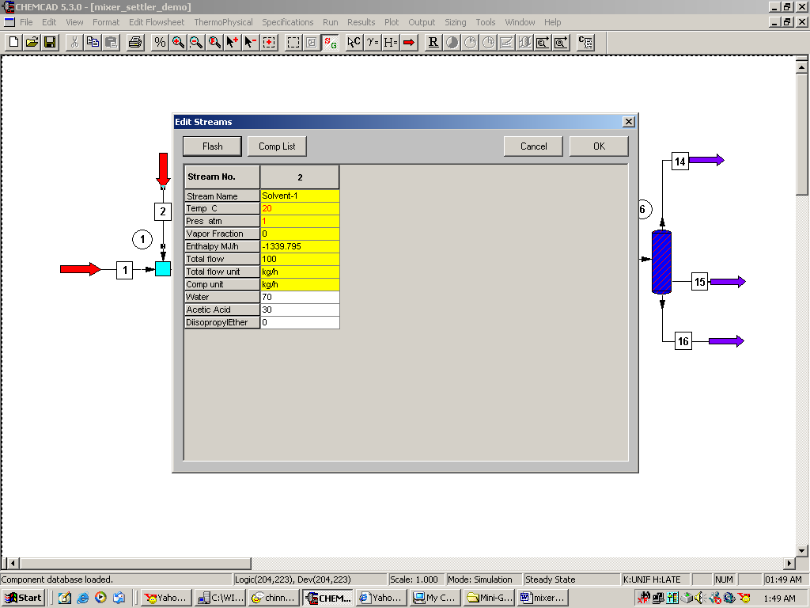

Solvent with the exact same properties as sent in the previous stream (solvent feed stream going into the first mixer, stream 2 in my case) is sent into the second and third mixers (streams 7 and 12 in my case). In other words, streams 2, 7, and 12 going into mixers with unitop ID 1,3, and 5 respectively are identical.

Step 4: Entering the mixer specs

Double click on the Mixer. Enter 1atm as the output pressure and click OK.

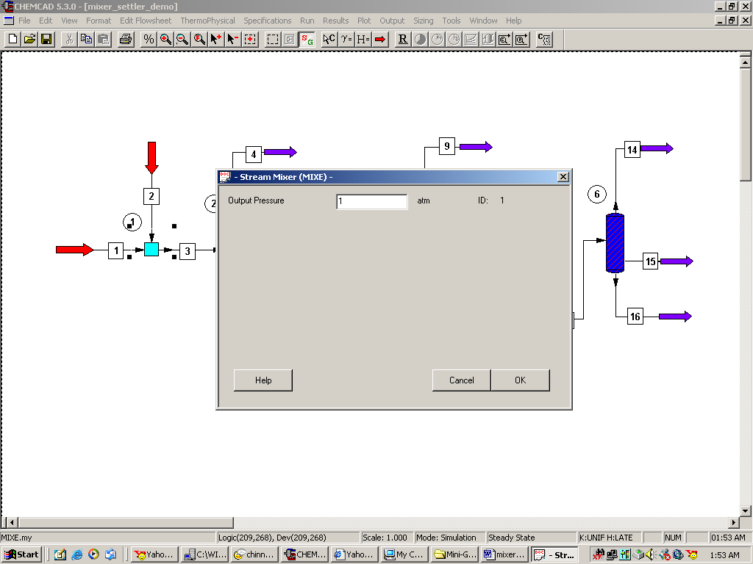

Repeat the same for the other two mixers as well.

Step 5: Entering the LLV Flash specs

There are three flash columns in the flowsheet the specifications for each of them are identical and are as given below.

Flash Mode: Select option 1, Specify T and P; Calculate V/F and Heat
Temperature: Enter 20 ºC
Pressure: Enter 1 atm
Single phase option: option 0, Program default

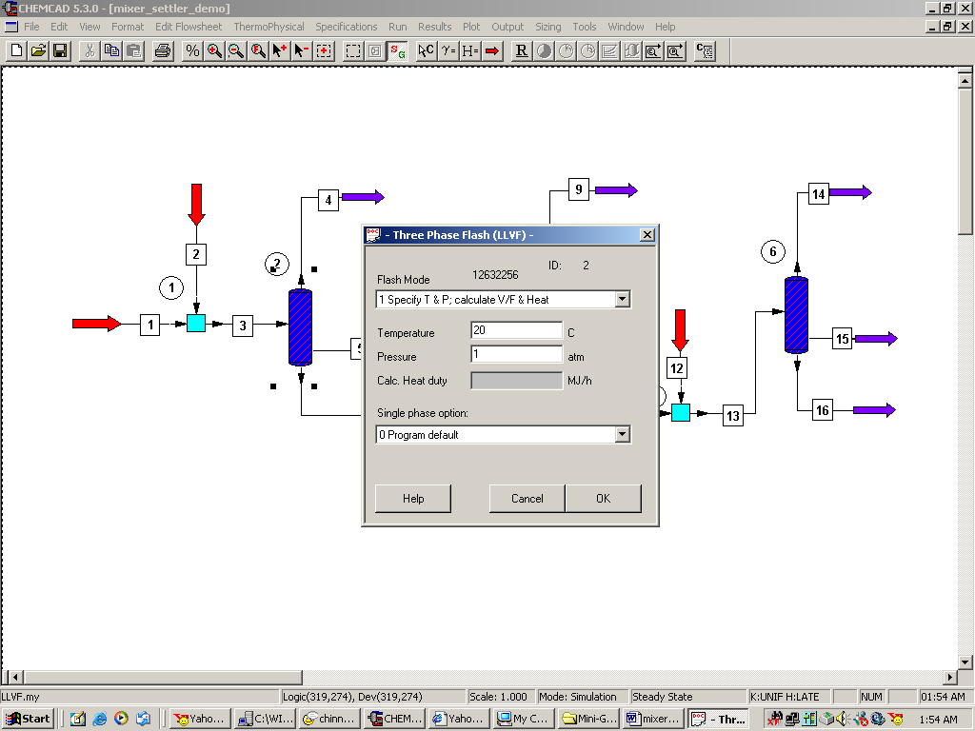

Click on OK to continue and repeat this step for the other two flash columns in the flowsheet as well.

Step 6: Running the simulation and retrieving the results:

Now the simulation is ready to be run. Click once on R to run the simulation. Alternatively, one can run the simulation by clicking on Run on the menu bar and selecting Run all. The status of the simulation can be found at the bottom left hand corner of the screen. The message, Run Finished, appears if the run is successfully completed. The stream properties can found either by clicking once on the product stream or by clicking once on Results on the menu, selecting Stream Composition and then clicking on All Streams. The results will be available in a WordPad file.

