Plug Flow Reactor with Multiple Reactions
(revised 8/3/05)
THE PROBLEM STATEMENT
Allyl chloride is to be produced in a 12-ft. long 2-in ID tube operating at isothermal PFR. The feed is a 4:1 molar ratio of propylene to chlorine and enters at a feed rate of 0.85 lbmole/hr and 2 atm of pressure and temperature of 1000 Rankine. The reactor pressure is assumed to be constant.
……………………Reaction1
…………………………Reaction2
The rate constants have units of lbmoles/(hr-ft³-atm²) and are:
where T is in degrees Rankine and R is in Btu/(lbmole ºR). The rate expressions are
Calculate
- The exiting stream concentrations from the reactor.
- Plot the change in concentration of the reactants and products along the volume of the reactor.

Procedure:

Step 1: Creating the flow sheet
Step 2: Entering the components and formatting engineering units
Step 3: Entering the feed stream composition
Step 4: Entering the reactor specs
Step 5: Running the simulation and retrieving the results

Step 1: Creating the flow sheet

Select and right click on the kinetic reactor and choose the kinetic reactor #2 (plug flow reactor), feed and product icons on the workspace. Connect the three using the stream. Click on the drop down menu that currently says Flowsheet and change it to Simulation.

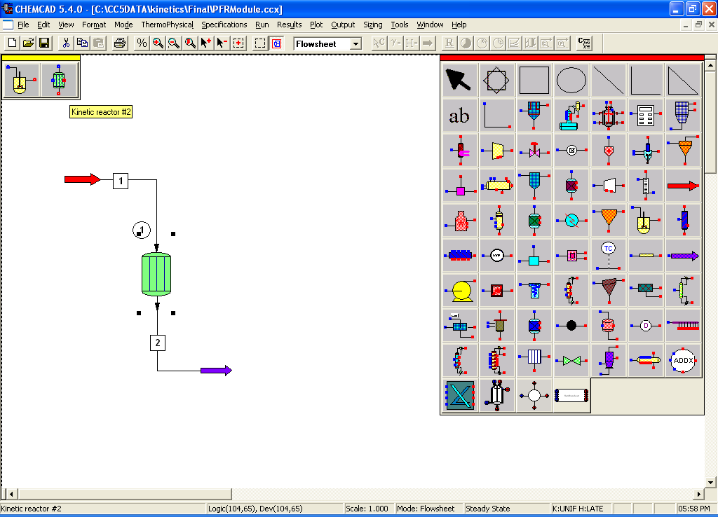

Step 2: Entering the components and formatting engineering units

Go to the Format menu and click on Engineering Units and select the desired units for such properties as R for temperature, and atm for pressure etc. Use English units option to convert all units at the same time. Click OK to continue.
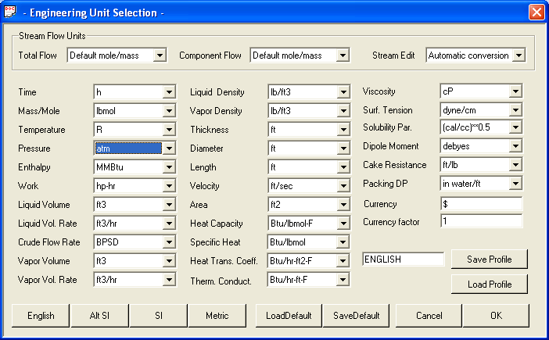

Go to the Thermophysical on the menu bar and click on Components List. Find propylene, chlorine, hydrogen chloride, allylchloride and 1,2-DiCl-Propane from the CHEMCAD component databank and click Add.

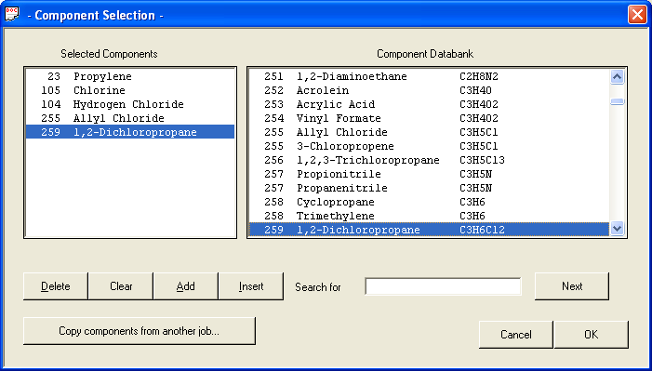

When the Thermodynamic Suggestions window appears, input the desired ranges of temperatures and pressures, then click OK. (Also click OK through the next 3 windows that pop up.)
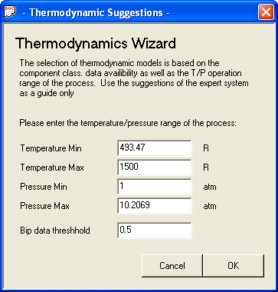

Step 3: Entering the feed stream composition

Double click on the feed stream and enter the feed information (temperature, pressure, total flow rate and component mole fractions) given in the problem statement. Click once on Flash to get the feed stream enthalpy and vapor fraction in feed at the feed conditions.

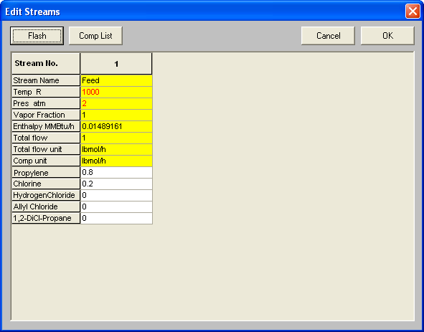

Step 4: Entering the reactor specs
Double click on the reactor.

General Specifications Page:

a. Number of reactions: Since there are two reactions in the given problem, enter ‘2’

b. Reactor Pressure: Enter the reactor pressure as given in the problem statement (2 atm)

c. Pressure Drop: There is no pressure drop in the reactor given in the problem statement.

d. Kinetic Rate Expression: There are two options for this. The default option (Standard) is used when the rate equation is in standard form. The other option (User Specified) is used when the rate law is not in its standard form and the user needs to enter this manually. For more information on this, the user can always click on the help button that appears at the bottom left corner on this page. For this problem, the kinetic rate expression is given, so select the (User Specified) option.

e. Reaction Phase: Since the reactants and products are in vapor phase, click on the vapor only option.

f. Specify Reactor Type: As the reactor described in the problem statement is a plug flow reactor, PFR should be selected form the drop box.

g. Thermal Mode: As the temperature of the reaction is given at 1000 Rankine, select isothermal and imput 1000 in the box next to it.

h. Specify Calculation Mode: As the conversion is to be calculated, Specify Volume, Calculate Conversion option should be selected.

i. Reactor Volume: This can be left blank or can be calculated. The volume can be specified as a combination of the reactor diameter and length in more specifications.

j. Key Component: The key component is to be specified when we choose the Specify conversion, Calculate volume option. So this can be left blank

k. Conversion: This needs to be left blank, as this is the value that is calculated in the simulation.

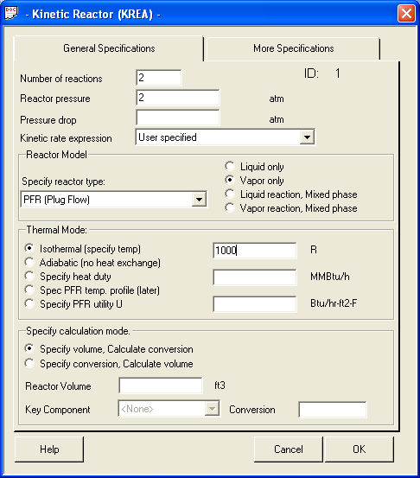

Don’t Click OK yet! There is more to complete in the More Specifications page!

More Specifications:

Length of tubes: Enter the Length of the reactor specified in the problem statement (12 ft)

Diameter of tubes: Enter the Length of the reactor (note: convert 2 inches to feet = 0.1667 ft)

Number of tubes: Enter ‘1’

# of steps, Stepsize and Tolerance can be left blank as these are optional fields.

Reaction Engineering Units: Change the units so that the units are consistent with the rate law (Change time units to minutes
Temperature reference for heat of reaction: Can be left blank. Chemcad chooses the default reference temperature.

Edit reaction number: Can be left blank.

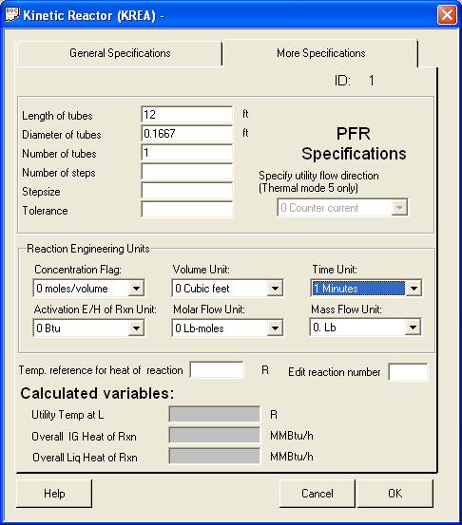

Click OK after completing the specifications page. A new window appears and the stoichiometric coefficients for Reaction 1 (The reaction number is displayed on the top left hand corner of this window) of all the components are entered in this window as shown in the following figures. Also, enter the values in for the activation energy and the frequency factor as shown below. Click OK after entering these coefficients.

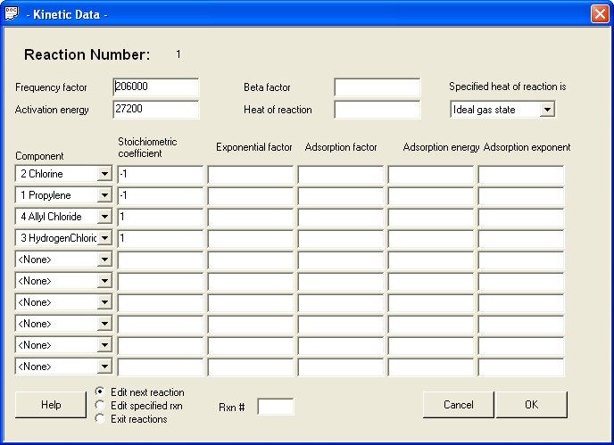

Similarly, enter the stoichiometric constants for reaction 2 and click OK.

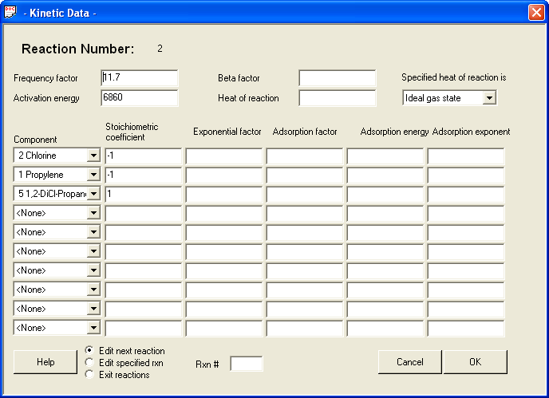

As the User Specified option is selected for kinetic rate expression, another window with the title User Rate Expressions appears. If a separate Visual Basic code is available, the user can browse those files using options available on File path tab. For most practical purposes, the user can go directly to the Rxn1 tab or the Rxn2 tab:

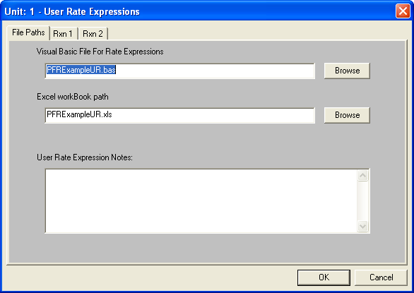

Select the Rxn1 Tab and enter the rate expression for the reaction1.

Name for the Chemical Reaction: Allyl Chloride formation

Variables for User Rate Expressions: CHEMCAD supplies the user with the variables described in this section to be used for user rate expressions.

Write User Rate Expression: RxnRate001 = FF * ExpERT * P001 * P002

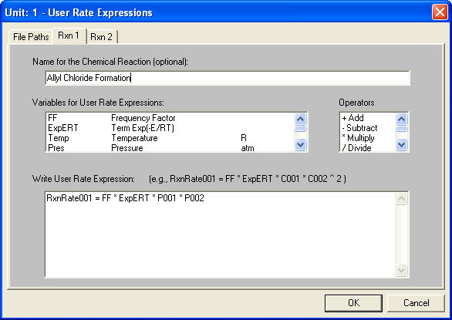

Select the Rxn2 Tab and enter the rate expression for the reaction2.

Name for the Chemical Reaction: 1,2- DiCl-propane formation

Write User Rate Expression: RxnRate001 = FF * ExpERT * P001 * P002

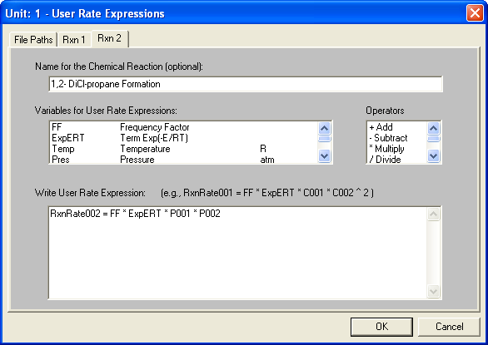

Click OK when finished. A window appears to confirm that we allow the cookies from an existing excel file so that the Visual Basic program accesses the rate expression specified by us. Click on Yes to continue.

Step 5: Running the simulation and retrieving the results:

Now the simulation is ready to be run. Click once on R to run the simulation. Alternatively, one can run the simulation by clicking on Run on the menu bar and selecting Run all. The status of the simulation can be found at the bottom left hand corner of the screen. The message, Run Finished appears in this place if the run is successfully completed.

The product stream properties can be found either by double clicking on the product stream or by clicking once on Results on the menu, selecting Stream Composition and then clicking on All Streams. The results will be available in a WordPad file.
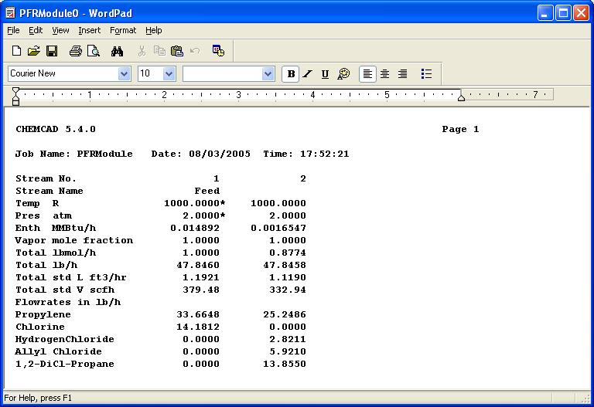

To plot the concentrations along the volume of the reactor, Select plot from the toolbar and then choose plug flow reactor profile. The following screen will appear.

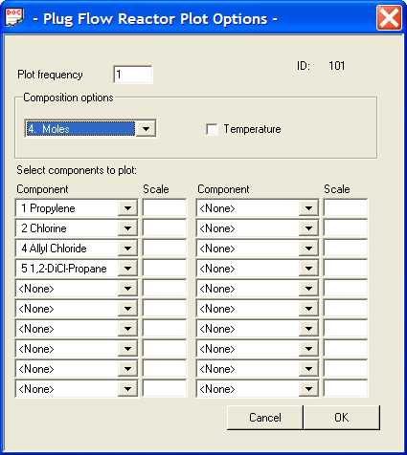

Plot Frequency: select a value of ‘1’.

Composition Option: Since we want the compositions in moles choose moles. The temperature change along the reactor can also be plotted. Since ours is an isothermal case we need not select it.

Select Component to Plot: Select all the components of which we want to see the change in concentration. Click OK.

The following graph plots the change in concentration along the reactor volume.

